**Operating System and Design (19CS2106S)**

**Lab- 11**

**Pre-Lab**

1. **Creating and Destroying Mutexes: pthread_mutex_init (mutex,attr) pthread_mutex_destroy (mutex)**

#include <stdio.h>

#include <pthread.h>

int done = 0;

void* worker(void* arg) {

printf("this should print first\n");

done = 1;

return NULL;

}

int main(int argc, char *argv[]) {

pthread_t p;

pthread_create(&p, NULL, worker, NULL);

while (done == 0)

;

printf("this should print last\n");

return 0;

}

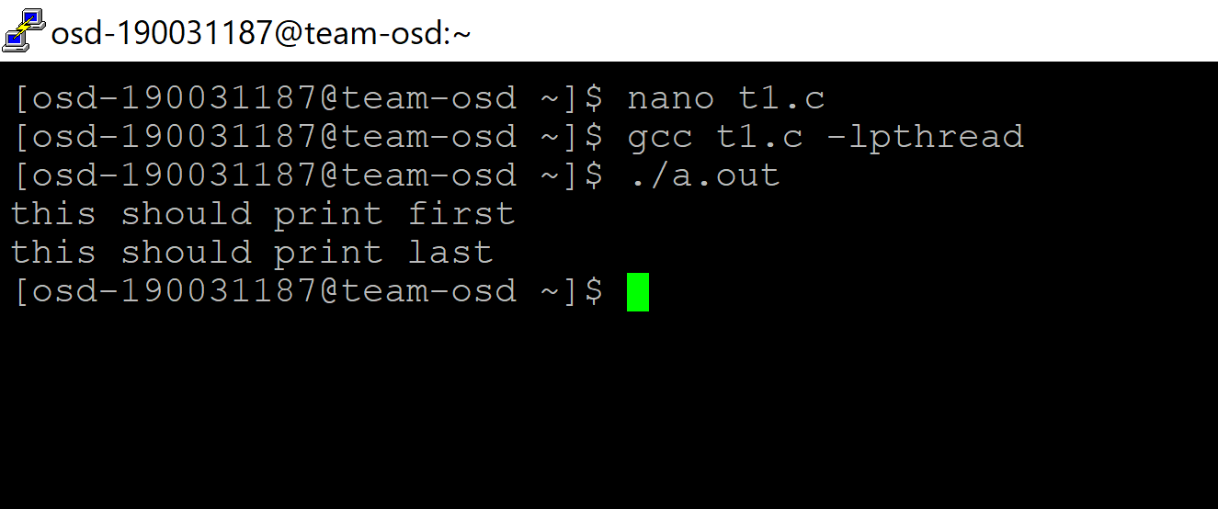

1. **Locking and Unlocking Mutexes: pthread_mutex_lock (mutex) pthread_mutex_trylock (mutex)**

#include <stdio.h>

#include <pthread.h>

typedef struct __synchronizer_t {

pthread_mutex_t lock;

pthread_cond_t cond;

int done;

} synchronizer_t;

synchronizer_t s;

void signal_init(synchronizer_t *s) {

pthread_mutex_init(&s->lock, NULL);

pthread_cond_init(&s->cond, NULL);

s->done = 0;

}

void signal_done(synchronizer_t *s) {

pthread_mutex_lock(&s->lock);

s->done = 1;

pthread_cond_signal(&s->cond);

pthread_mutex_unlock(&s->lock);

}

void signal_wait(synchronizer_t *s) {

pthread_mutex_lock(&s->lock);

while (s->done == 0)

pthread_cond_wait(&s->cond, &s->lock);

pthread_mutex_unlock(&s->lock);

}

void* worker(void* arg) {

printf("this should print first\n");

signal_done(&s);

return NULL;

}

int main(int argc, char *argv[]) {

pthread_t p;

signal_init(&s);

pthread_create(&p, NULL, worker, NULL);

signal_wait(&s);

printf("this should print last\n");

return 0;

}

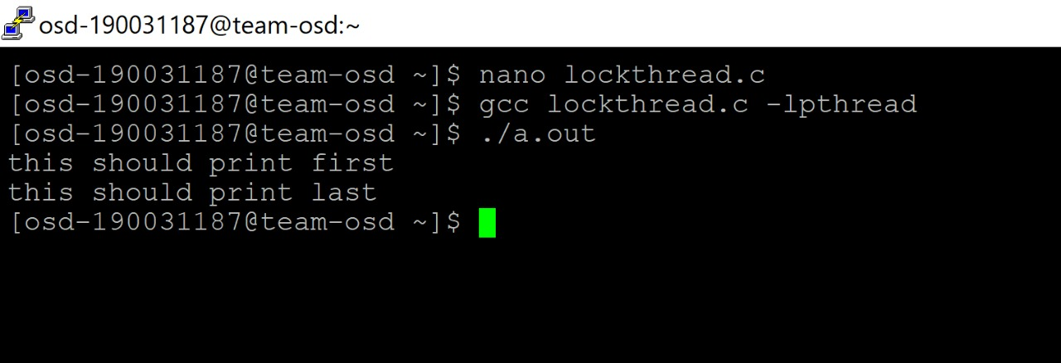

1. **Synchronizing Threads with POSIX Semaphores: sem_init, sem_open sem_wait sem_post sem_getvalue sem_destroy**

**Semaphores:**

[Semaphores](https://www.softprayog.in/programming/semaphore-basics) are used for process and thread synchronization. Semaphores are clubbed with message queues and shared memory under the Interprocess Communication (IPC) facilities in Unix-like systems such as Linux.

**sem_init**

#include <semaphore.h>

int sem_init (sem_t *sem, int pshared, unsigned int value);

sem_init is the equivalent of sem_open for unnamed semaphores. One defines a variable of type sem_t and passes its pointer as sem in the sem_init call.

**sem_open**

#include <fcntl.h>

#include <sys/stat.h>

#include <semaphore.h>

sem_t *sem_open (const char *name, int oflag);

sem_t *sem_open (const char *name, int oflag,

mode_t mode, unsigned int value);

sem_open is the call to get started for a semaphore. sem_open opens an existing semaphore or creates a new semaphore and opens it for further operations.

**sem_post**

#include <semaphore.h>

int sem_post (sem_t *sem);

sem_post increments the semaphore. It provides the [V operation](https://www.softprayog.in/programming/semaphore-basics#semop) for the semaphore. It returns 0 on success and -1 on error.

**sem_wait**

#include <semaphore.h>

int sem_wait (sem_t *sem);

sem_wait decrements the semaphore pointed by sem. If the semaphore value is non-zero, the decrement happens right away. If the semaphore value is zero, the call blocks till the time semaphore becomes greater than zero and the decrement is done. sem_wait returns zero on success and -1 on error.

**sem_getvalue**

#include <semaphore.h>

int sem_getvalue (sem_t *sem, int *sval);

sem_getvalue gets the value of semaphore pointed by sem. The value is returned in the integer pointed by sval. It returns 0 on success and -1 on error, with errno indicating the actual error.

**sem_destory**

#include <semaphore.h>

int sem_destroy (sem_t *sem);

sem_destroy destroys the unnamed semaphore pointed by sem.

**In-Lab**

1. **Illustrate how mutex is used for thread synchronization, print the counter variable upon each increment which is in the critical section. (Two threads update a global shared variable with and without synchronization).**

#include <pthread.h>

static volatile int glob = 0; /* "volatile" prevents compiler optimizations

of arithmetic operations on 'glob' */

static void * /* Loop 'arg' times incrementing 'glob' */

threadFunc(void *arg)

{

int loops = *((int *) arg);

int loc, j;

for (j = 0; j < loops; j++) {

loc = glob;

loc++;

glob = loc;

}

return NULL;

}

int

main(int argc, char *argv[])

{

pthread_t t1, t2;

int loops, s;

loops = strtol(argv[1], NULL, 10);

s = pthread_create(&t1, NULL, threadFunc, &loops);

if (s != 0){

perror("pthread_create fail");

exit(1);}

s = pthread_create(&t2, NULL, threadFunc, &loops);

if (s != 0){

perror("pthread_create fail");

exit(2);}

s = pthread_join(t1, NULL);

if (s != 0){

perror("pthread_join fail");

exit(1);}

s = pthread_join(t2, NULL);

if (s != 0){

perror("pthread_join fail");

exit(1);}

printf("glob = %d\n", glob);

exit(0);

}

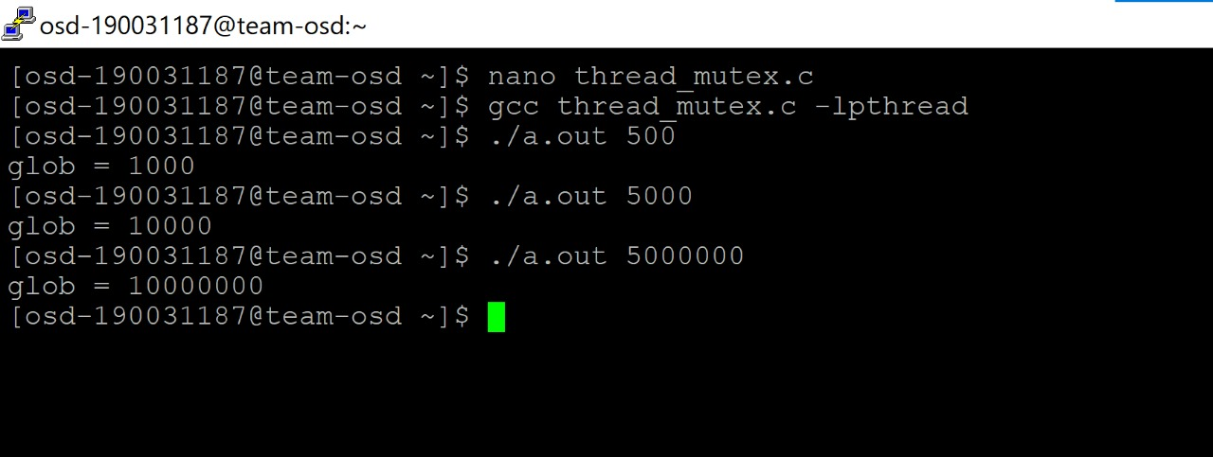

1. **Write a UNIX system program to implement concurrent Linked List**

#include <stdio.h>

#include <stdlib.h>

#include <pthread.h>

typedef struct __node_t {

int key;

struct __node_t *next;

} node_t;

// basic list structure (one used per list)

typedef struct __list_t {

node_t *head;

pthread_mutex_t lock;

} list_t;

void List_Init(list_t *L) {

L->head = NULL;

pthread_mutex_init(&L->lock, NULL);

}

void List_Insert(list_t *L, int key) {

// synchronization not needed

node_t *new = malloc(sizeof(node_t));

if (new == NULL) {

perror("malloc");

return;

}

new->key = key;

// just lock critical section

pthread_mutex_lock(&L->lock);

new->next = L->head;

L->head = new;

pthread_mutex_unlock(&L->lock);

}

int List_Lookup(list_t *L, int key) {

int rv = -1;

pthread_mutex_lock(&L->lock);

node_t *curr = L->head;

while (curr) {

if (curr->key == key) {

rv = 0;

break;

}

curr = curr->next;

}

pthread_mutex_unlock(&L->lock);

return rv; // now both success and failure

}

void List_Print(list_t *L) {

node_t *tmp = L->head;

while (tmp) {

printf("%d ", tmp->key);

tmp = tmp->next;

}

printf("\n");

}

int main(int argc, char *argv[])

{

list_t mylist;

List_Init(&mylist);

List_Insert(&mylist, 10);

List_Insert(&mylist, 30);

List_Insert(&mylist, 5);

List_Print(&mylist);

printf("In List: 10? %d 20? %d\n",

List_Lookup(&mylist, 10), List_Lookup(&mylist, 20));

return 0;

}

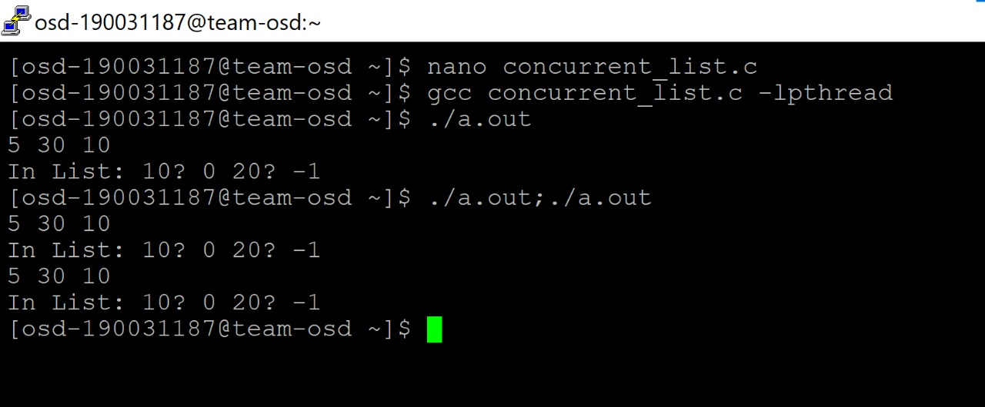

**Post-Lab**

1. **Write a Unix System program to make A Parent Waiting for Its Child using semaphores.**

#include <stdio.h>

#include <unistd.h>

#include <pthread.h>

#include <semaphore.h>

sem_t done;

void *

child(void *arg) {

sleep(5);

printf("child\n");

sem_post(&done);

return NULL;

}

int

main(int argc, char *argv[]) {

pthread_t p;

printf("parent: begin\n");

sem_init(&done,0, 0);

pthread_create(&p, NULL, child, NULL);

sem_wait(&done);

printf("parent: end\n");

return 0;

}

