Operating System Design – 19CS2106S

Lab Experiment - 2

Pre-Lab 2:

* Write the description for the following

getpid: Return the current process’s pid

getppid: Obtains a parent process's ID number getuid and getgid get the user or group ID of the process, respectively.

getegid- get the effective group ID

geteuid - get the effective user ID errno, a global variable that holds the numeric code of the last system call error perror (), a subroutine that describes system call errors.

Moving in a File: lseek () dup:Duplicate fd

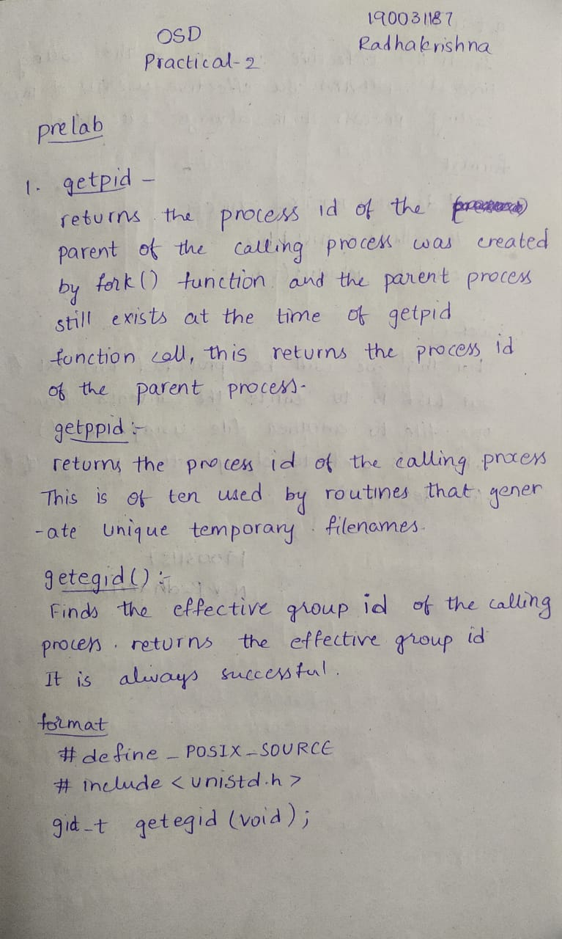

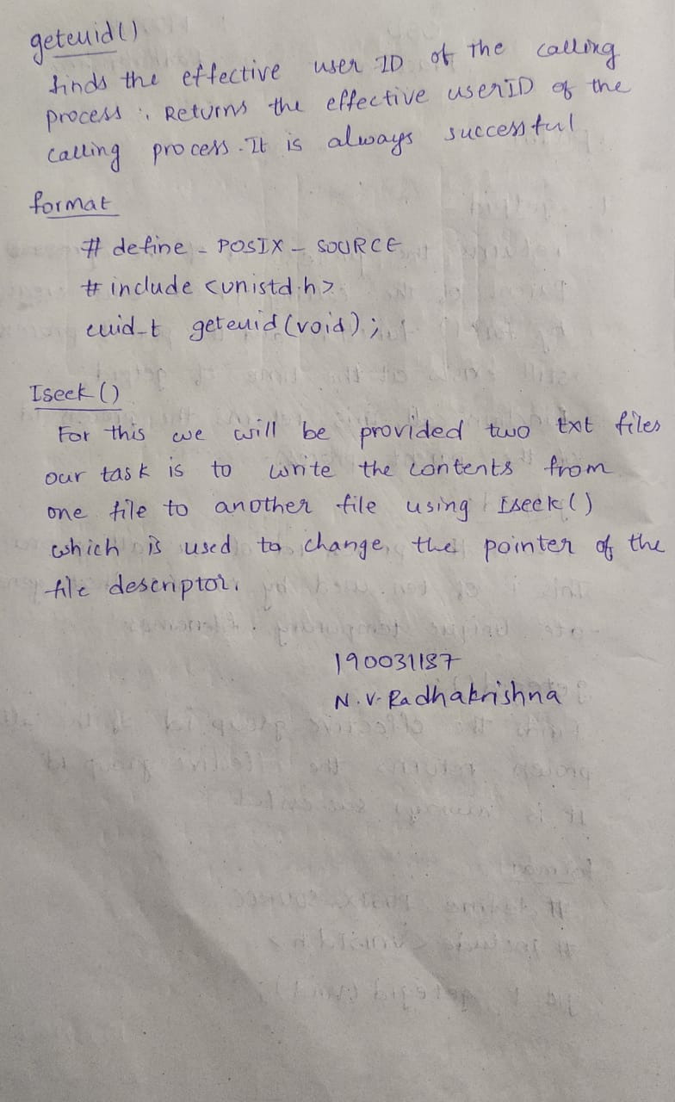

In-Lab 2:

* ccp.c: Copying a File. Show a pictorial arrangement of File Descriptor, File and Inode tables for a single process that has two different files open.

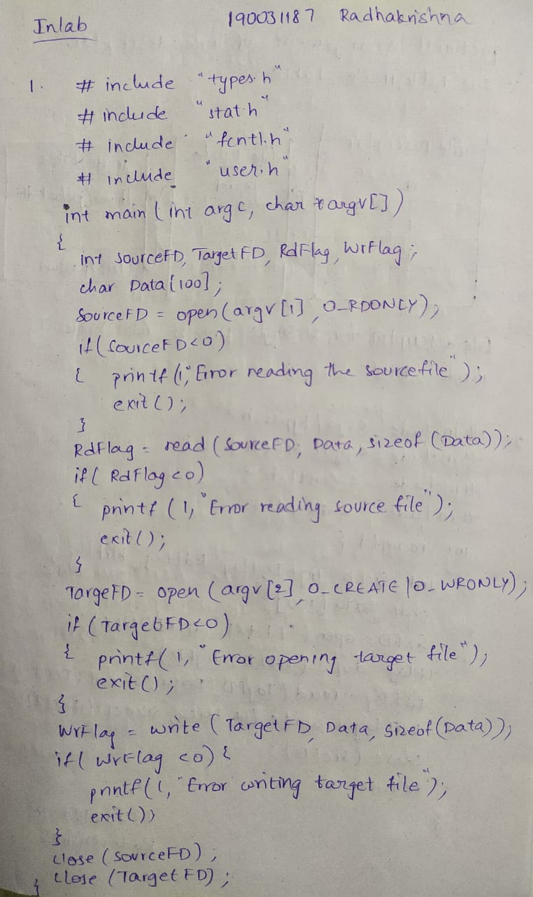

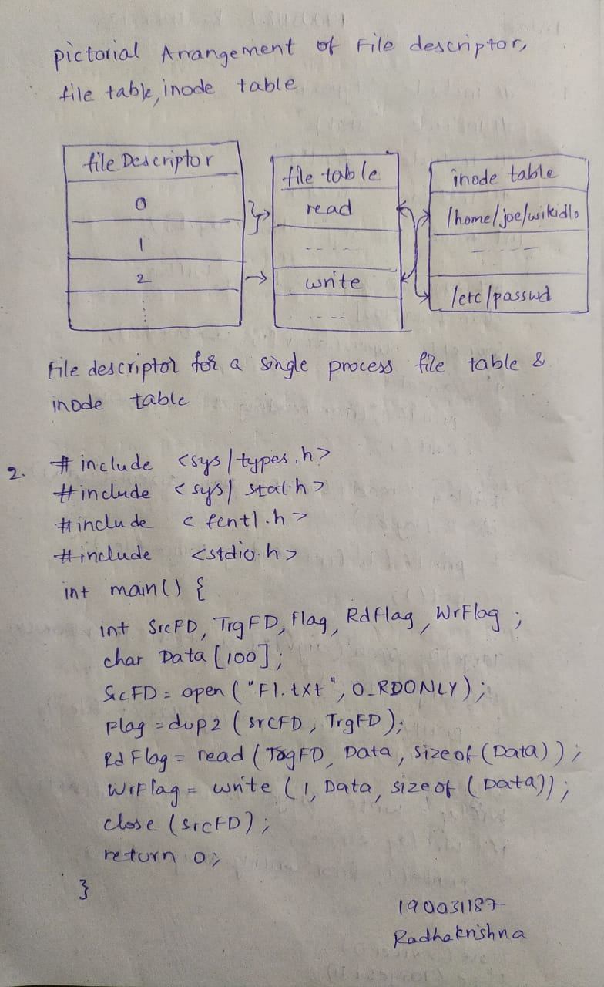

**OUTPUT CP.C**

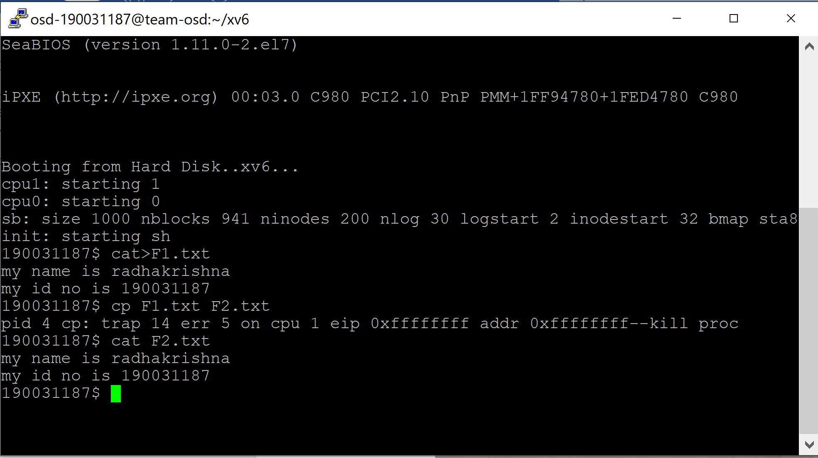

* Write a system program which will opens files in the parent and uses dup2 in the child to reassign the descriptors .



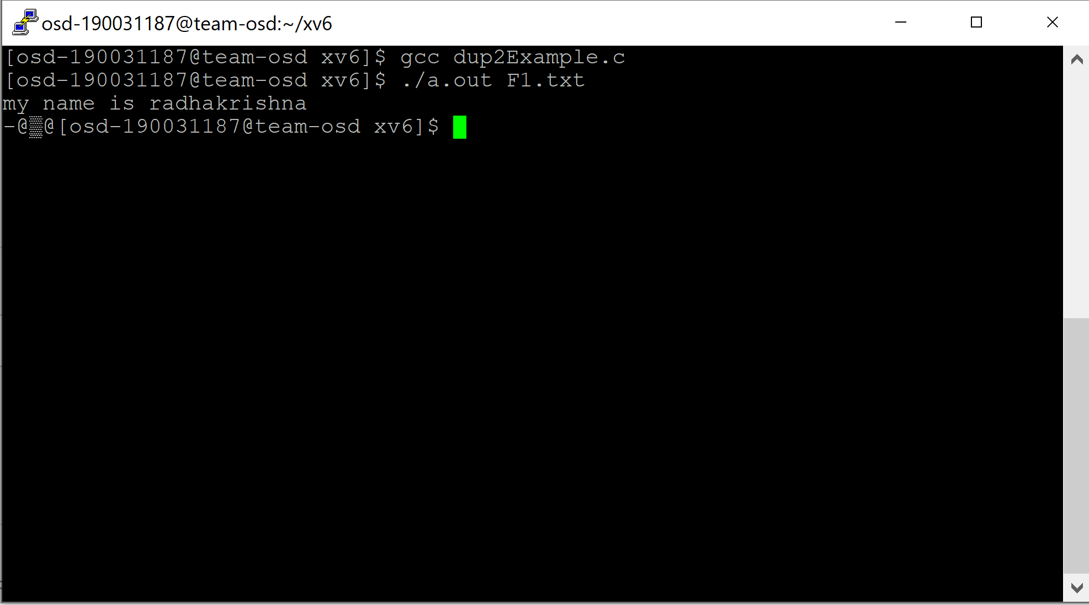

Post-Lab 2:

* show_error s.c: Displaying system call errors with perror Filename provided as argument

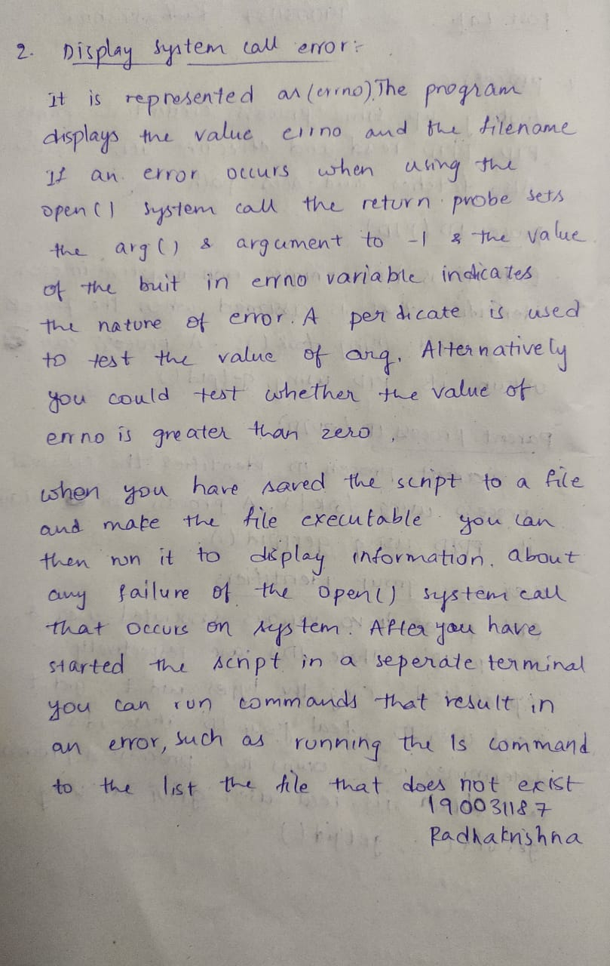

* process.c: Looking Up Some Process Credentials Prints PID, PPID, real and effective UIDs and GIDs Also fetches and sets PATH.

