**Operating System and Design (19CS2106S)**

**Lab- 5**

**Pre-Lab**

Reading Directory Information: **opendir (), readdir (), and closedir ()**

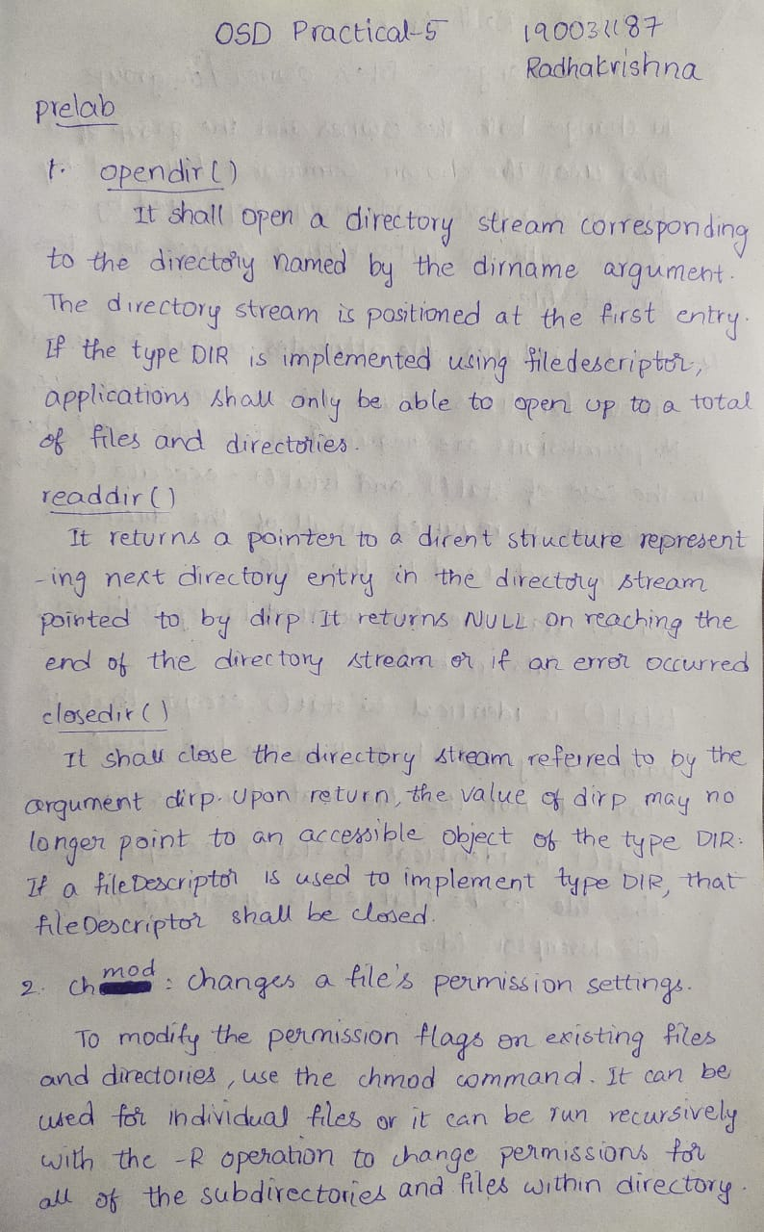

**chown:** Changes a file's owner and/or group.

`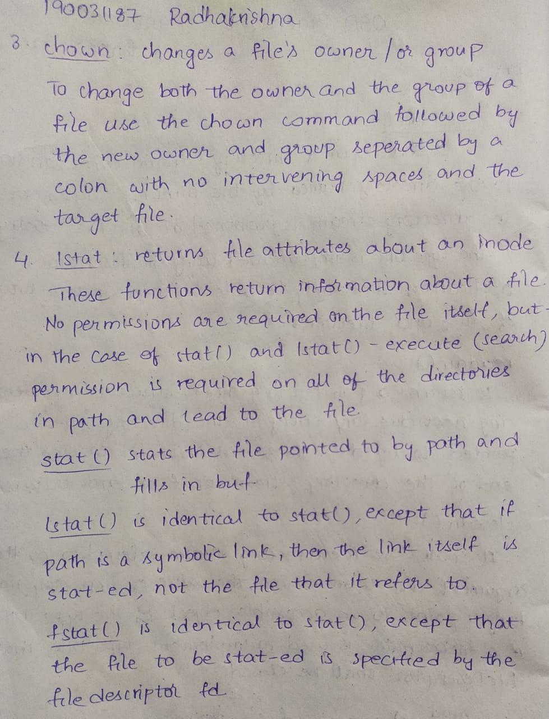

**chmod:** Changes a file's permission settings.



**lstat:** returns file attributes about an inode



**IN-LAB**

1. attributes.c -- Uses lstat call and struct stat to display file attributes.

**CODE**

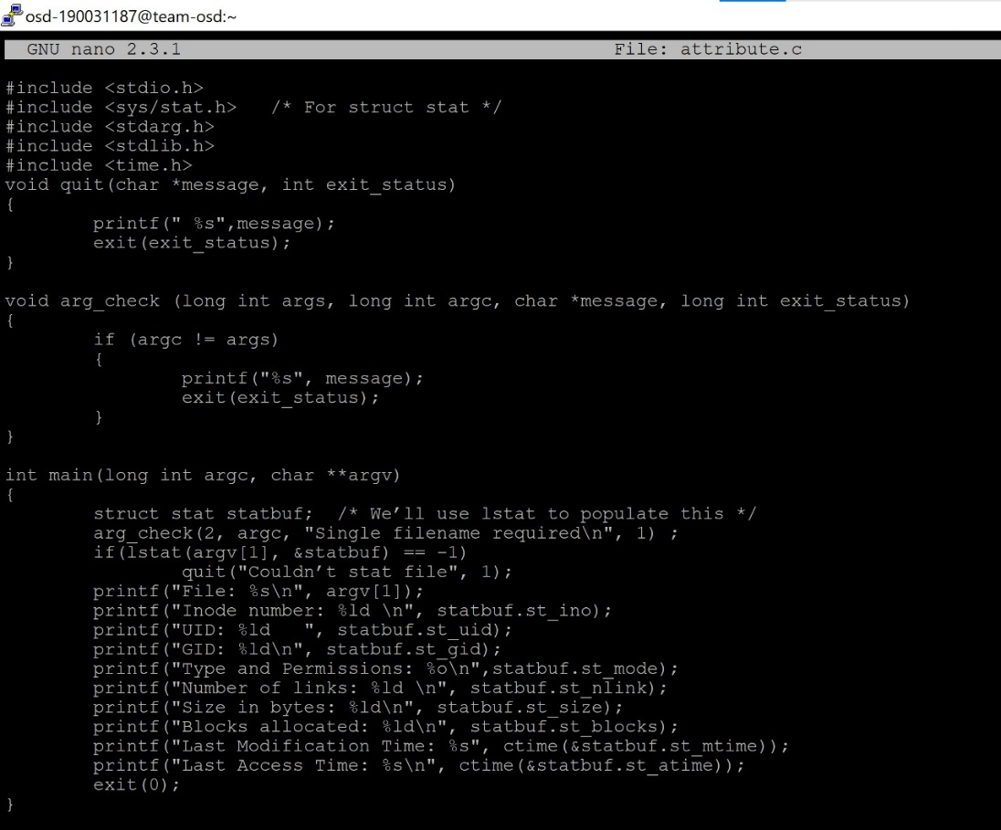

**OUTPUT**

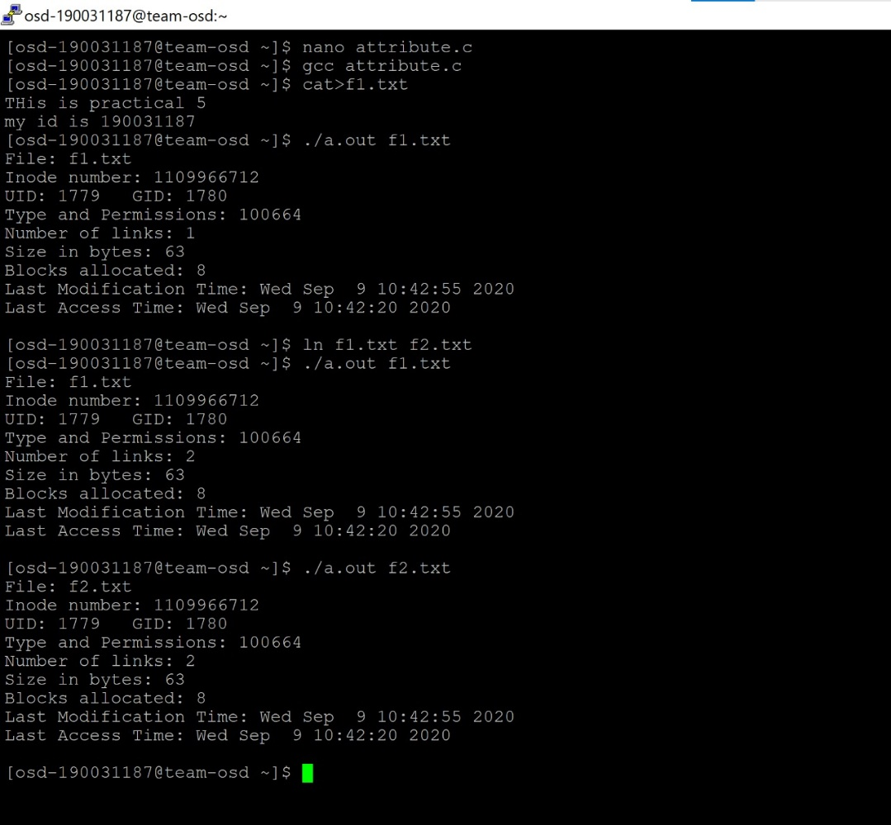

1. lsdir.c -- Lists only directories - Uses S_IFMT and S_ISDIR macros

**CODE**

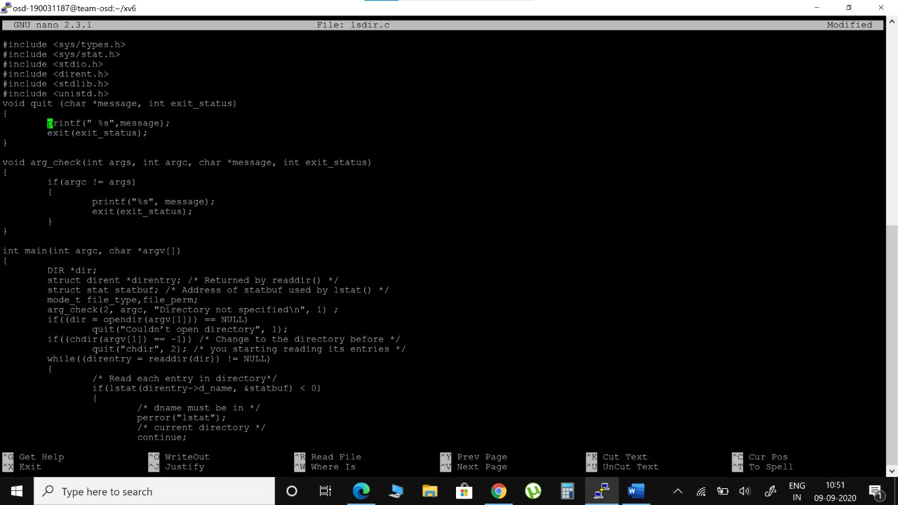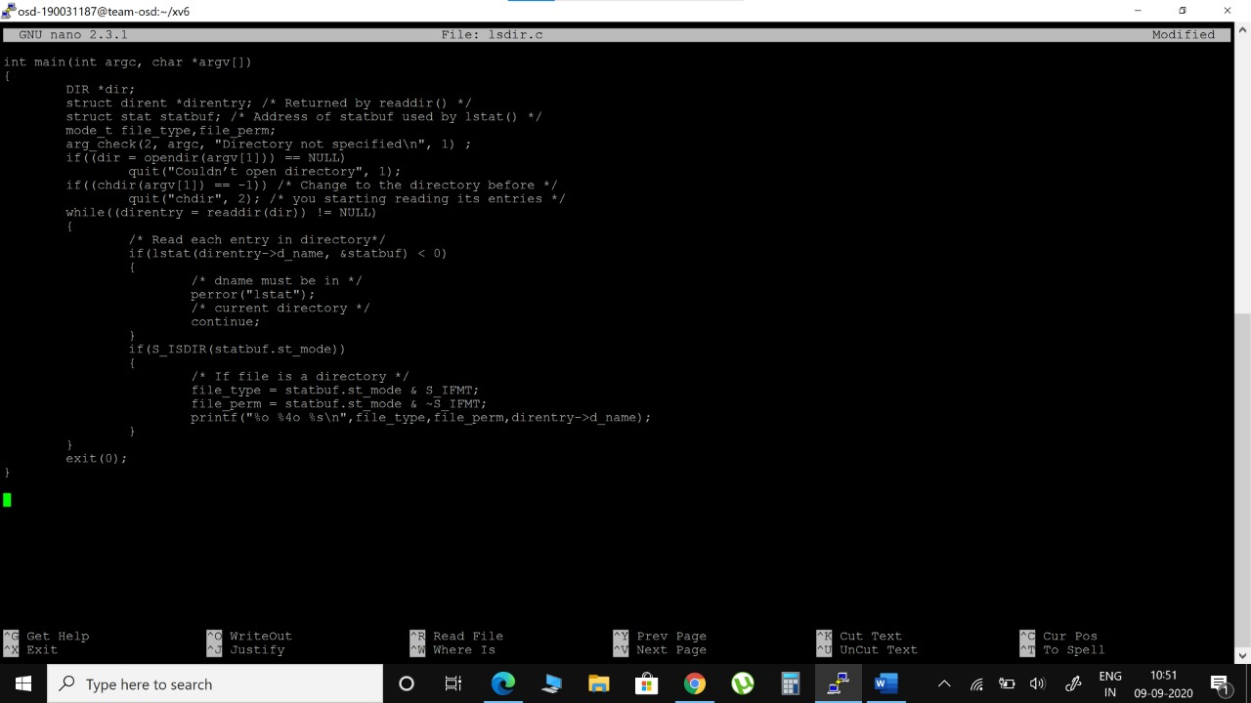

**OUTPUT**

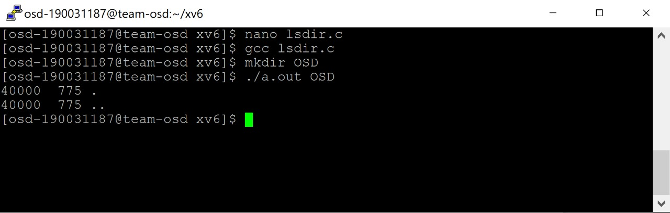

**Post-Lab**

1. mychown.c -- change the group of the file.

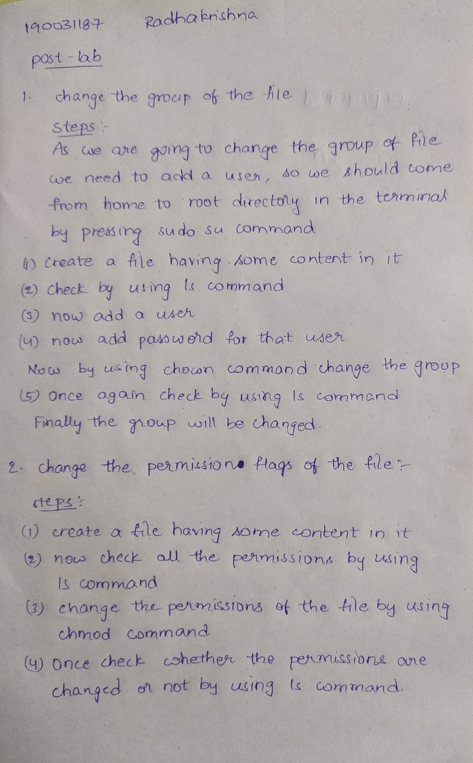

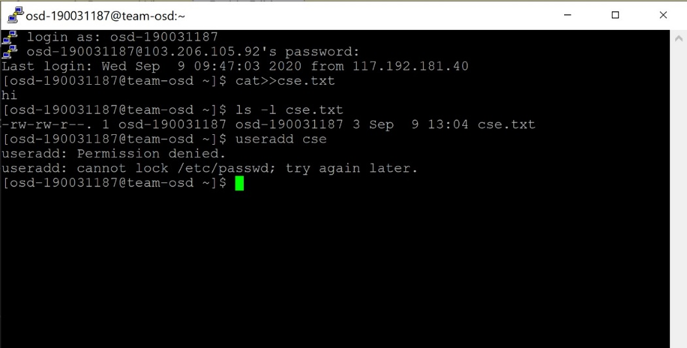

The reason why it is not working here. I don’t have the permission to add a new user

1. mychmod.c -- changed the permission flags of the file.

`

