**Operating System and Design (19CS2106S)**

**Lab- 6**

**Pre-Lab**

POSIX signals. sigaction: This call specifies the signal handler. Two of the arguments to this call specify a structure that is also named sigaction. alarm: The alarm call is used in the next example to set a timer that generates the SIGALRM signal after the timeout period. The library function sleep uses alarm.pause: This is somewhat like the shell’s read statement. It holds up program execution until a signal is received. kill: You can send a signal to a process using this system call. A library function, raise, uses kill to send any signal to the current process.

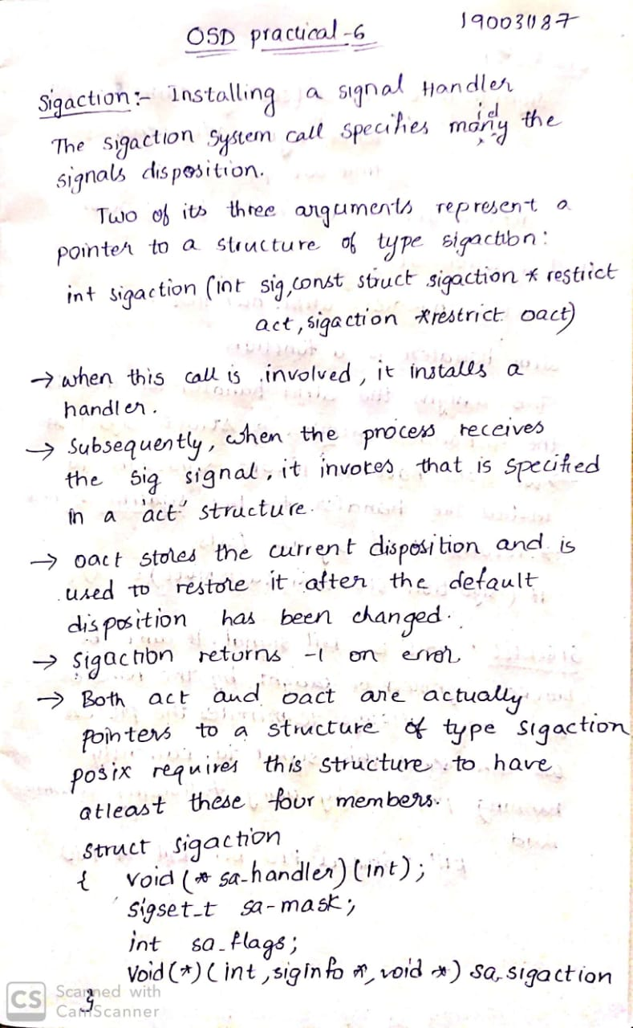

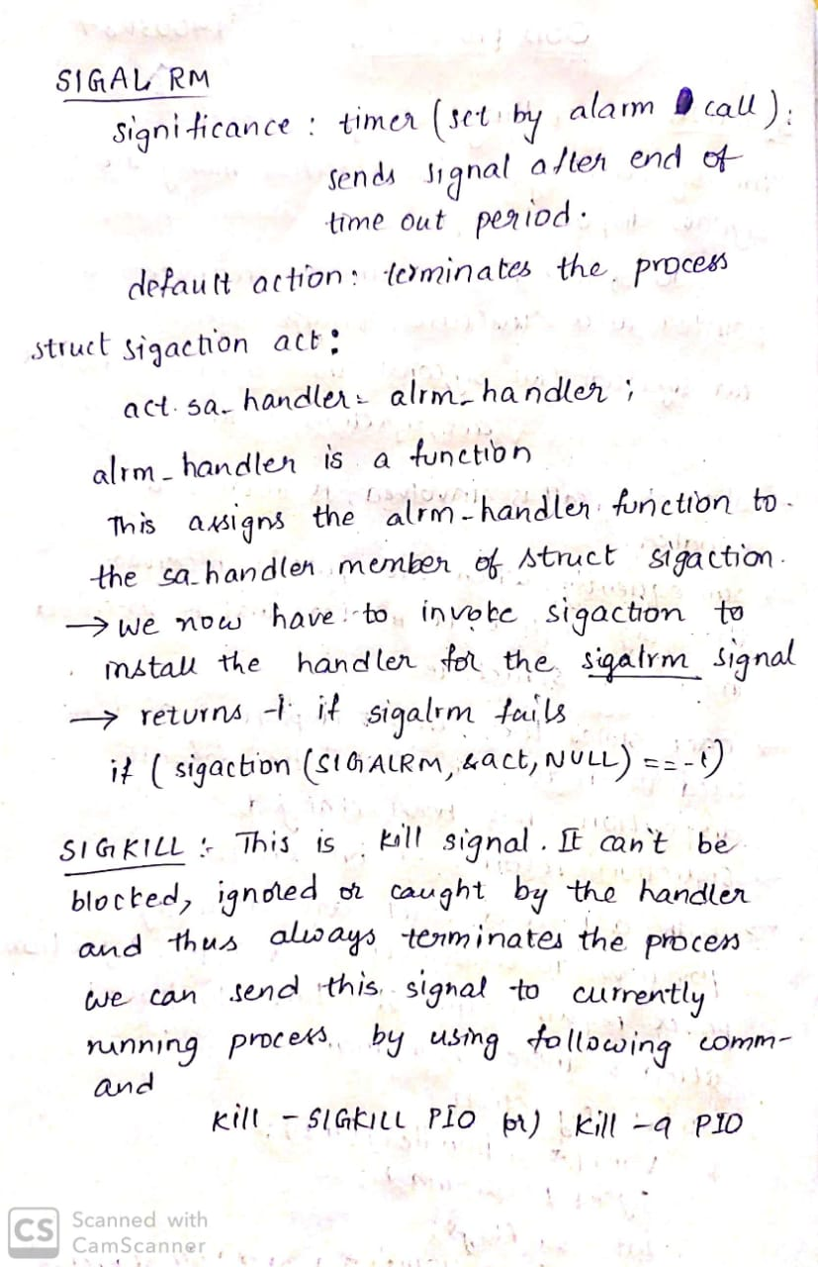

**In-Lab**

1. signal.c -- Waits for 5 seconds for user input and then
2. Generates SIGALRM that has a handler specifiedkillproce ss.c -- Uses fork and exec to run a user-defined programand kills it if it doesn’t complete in 5 seconds.

1) signal.c :

Code:

[#include](tg://search_hashtag/?hashtag=include) <stdio.h>

[#include](tg://search_hashtag/?hashtag=include) <sys/stat.h> /* For struct stat */

[#include](tg://search_hashtag/?hashtag=include) <stdarg.h>

[#include](tg://search_hashtag/?hashtag=include) <stdlib.h>

[#include](tg://search_hashtag/?hashtag=include) <time.h>

[#include](tg://search_hashtag/?hashtag=include) <unistd.h>

[#include](tg://search_hashtag/?hashtag=include) <signal.h> [#define](tg://search_hashtag/?hashtag=define) BUFSIZE 100 void alrm_handler(int signo); /* Prototype declaration */ char buf[BUFSIZE] = "foo\0"; /* Global variable */

void quit(char *message, int exit_status)

{

printf(" %s",message);

exit(exit_status);

}

int main (void) { int n; struct sigaction act; [act.sa](http://act.sa/)_handler = alrm_handler; /* Specify handler */ if (sigaction(SIGALRM, &act, NULL) == -1) /* Install handler */ quit("sigalrm", 1); fprintf(stderr, "Enter filename: "); alarm(5); /* Set alarm clock; will deliver */

n = read(STDIN_FILENO, buf, BUFSIZE); /* SIGALRM in 5 seconds */ if (n > 1) /* Will come here if user inputs */

fprintf(stderr, "Filename: %s\n", buf); /* string within 5 seconds */ exit(0);

}

void alrm_handler(int signo)

{

fprintf(stderr, "\nSignal %d received, default filename: %s\n", signo, buf); exit(1); }

Output:-

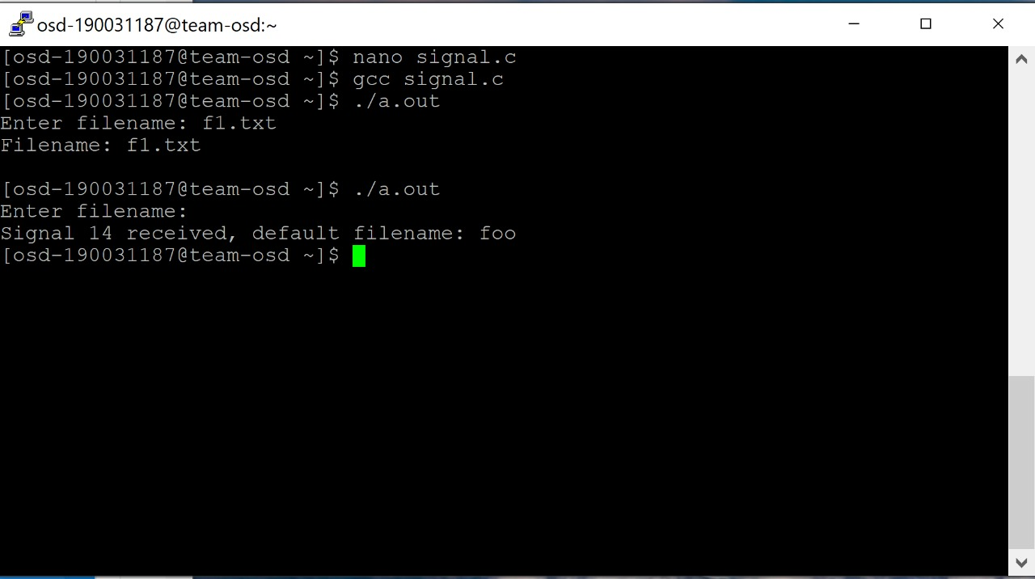

2) killprocess.c:

Code:-

[#include](tg://search_hashtag/?hashtag=include) <stdio.h>

[#include](tg://search_hashtag/?hashtag=include) <sys/types.h>

[#include](tg://search_hashtag/?hashtag=include) <sys/wait.h>

[#include](tg://search_hashtag/?hashtag=include) <signal.h> [#include](tg://search_hashtag/?hashtag=include) <stdlib.h>

pid_t pid;

int main (int argc, char **argv) {

int i, status;

void death_handler(int signo); /* A common signal handler this time */

struct sigaction act; [act.sa](http://act.sa/)_handler = death_handler; sigaction(SIGCHLD, &act, NULL); /* Disposition for these two signals */ sigaction(SIGALRM, &act, NULL); /* set to enter a single handler */

switch (pid = fork()) { case -1: fprintf(stderr, "Fork error\n"); case 0: execvp(argv[1], &argv[1]); /* Execute command */ perror("exec"); break; default: alarm(5); /* Will send SIGALRM after 5 seconds */ pause(); /* Will return when SIGCHLD signal is received */

fprintf(stderr, "Parent dies\n");

} exit(0);

}

void death_handler(int signo) { /* This common handler picks up the */

int status; /* exit status for normal termination */ /* but sends the SIGTERM signal if */ switch (signo) { /* command doesn’t complete in 5 seconds */ case SIGCHLD: waitpid(-1, &status, 0); /* Same as wait(&status); */

fprintf(stderr, "Child dies; exit status: %d\n",

WEXITSTATUS(status)); break; case SIGALRM: if (kill(pid, SIGTERM) == 0)

fprintf(stderr, "5 seconds over, child killed\n");

}

}

Output:-

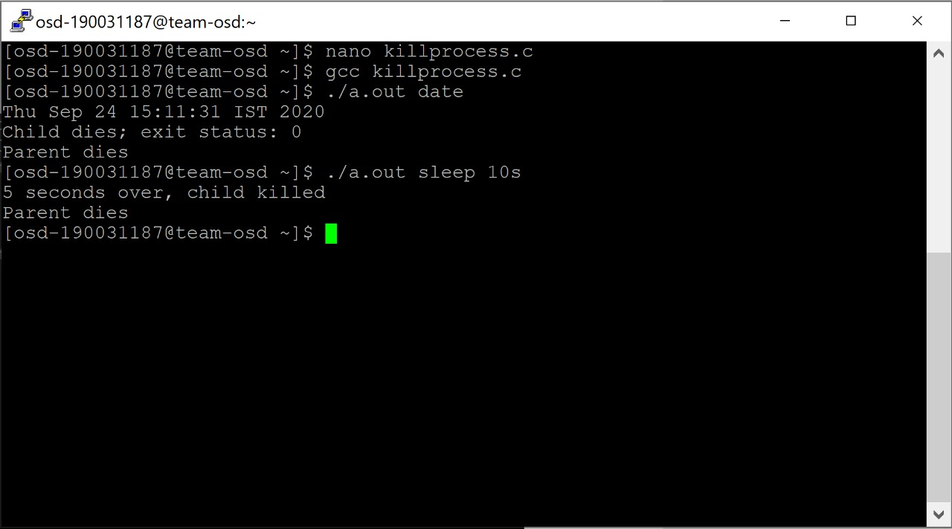

**Post-Lab**

1. mynice.c: A child process inherits its priority value from its parent, and change it by using nice ()
2. program to demonstrate time and times System Call.

**mynice.c:**

**Code:**

[#include](tg://search_hashtag/?hashtag=include) <stdio.h> main ()

{

printf ("original priority\n"); system ("ps -l"); /* Execute a ps */ nice (0); /* Add 0 to my priority */ printf ("running at priority 0\n"); system ("ps -l"); /* Execute another ps */ nice (10); /* Add 10 to my priority */ printf ("running at priority 10\n");

system ("ps -l"); /* Execute the last ps */

}

Output:

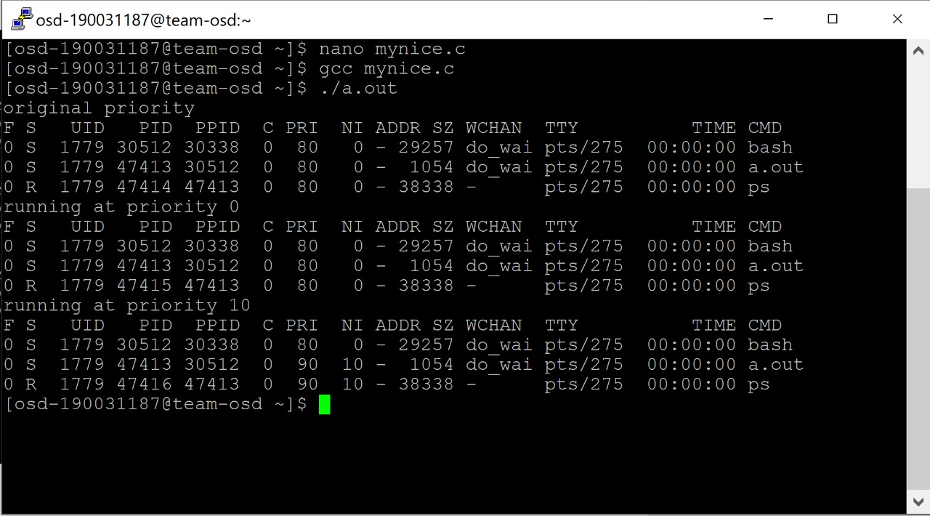

2) **time.c:**

**Code:**

[#include](tg://search_hashtag/?hashtag=include) <stdio.h> /* printf */

[#include](tg://search_hashtag/?hashtag=include) <time.h> /* time_t, struct tm, difftime, time, mktime */

int main ()

{

time_t timer; struct tm y2k = {0}; double seconds; [y2k.tm](http://y2k.tm/)_hour = 0; [y2k.tm_](http://y2k.tm/)min = 0; [y2k.tm_](http://y2k.tm/)sec = 0; [y2k.tm](http://y2k.tm/)_year = 100; [y2k.tm](http://y2k.tm/)_mon = 0; [y2k.tm](http://y2k.tm/)_mday = 1; time(&timer); /* get current time; same as: timer = time(NULL) */ seconds = difftime(timer,mktime(&y2k));

printf ("%.f seconds since January 1, 2000 in the current timezone", seconds); return 0;

}

Output:

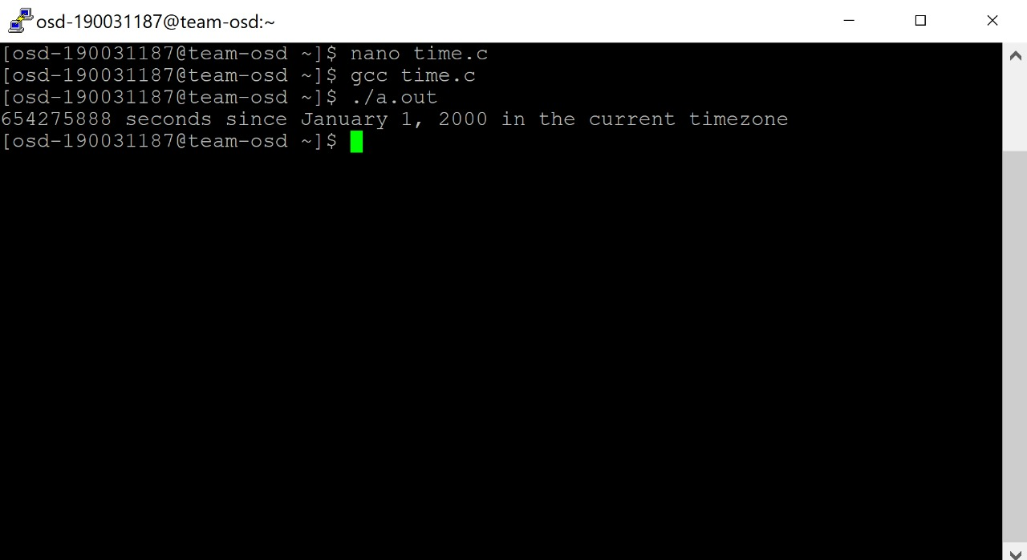

**times.c:**

**Code:**

[#include](tg://search_hashtag/?hashtag=include) <stdio.h>

[#include](tg://search_hashtag/?hashtag=include) <unistd.h>

[#include](tg://search_hashtag/?hashtag=include) <sys/times.h> [#include](tg://search_hashtag/?hashtag=include) <time.h>

int main() { struct tms times_start, times_end; clock_t times_start_retval, times_end_retval; clock_t clock_start, clock_end;

int i;

/* clock called first and last, so estimates using "clock" should be slightly longer than estimates using "times" */ if((clock_start = clock()) == -1) { perror("starting clock"); return -1;

}

if((times_start_retval = times(&times_start)) == -1) { perror("starting times");

return -1;

}

for(i = 100000000; i; i--); // do work

if((times_end_retval = times(&times_end)) == -1) { perror("ending timer"); return -1;

}

printf("Times using the clock system call\n"); printf("clock start: %li\nclock end: %li\n", clock_start, clock_end); printf("elapsed: %li\n\n", clock_end - clock_start);

printf("Times using the times system call\n"); printf("System start: %li\nUser start: %li, start retval: %li\n", times_start.tms_stime, times_start.tms_utime, times_start_retval); printf("System end: %li\nUser end: %li, end retval: %li\n", times_end.tms_stime, times_end.tms_utime, times_end_retval); printf("elapsed: %li\n\n", times_end_retval - times_start_retval);

return 0;

}

Output:

