**Operating System and Design (19CS2106S)**

**Lab- 7**

**In-Lab**

1. Write a program to display the address space of various segments (stack, heap, data ...etc) and show that memory address a programmer see is virtual not real.

**CODE**

**#include<stdio.h>**

**#include<malloc.h>**

**int glb_uninit; /* Part of BSS Segment -- global uninitialized variable, at runtime it is**

**initialized to zero */**

**int glb_init = 10;**

**/* Part of DATA Segment -- global initialized variable */**

**void foo(void)**

**{**

**static int num = 0;**

**/* stack frame count */**

**int autovar;**

**/* automatic variable/Local variable */**

**int *ptr_foo = (int*)malloc(sizeof(int));**

**if (++num == 4)**

**/* Creating four stack frames */**

**return;**

**printf("Stack frame number %d: address of autovar: %p\n", num, & autovar);**

**printf("Address of heap allocated inside foo() %p\n",ptr_foo);**

**foo();**

**/* function call */**

**}**

**int main()**

**{**

**char *p, *b, *nb;**

**int *ptr_main = (int*)malloc(sizeof(int));**

**printf("Text Segment:\n");**

**printf("Address of main: %p\n", main);**

**printf("Address of afunc: %p\n",foo);**

**printf("Stack Locations:\n");**

**foo();**

**printf("Data Segment:\n");**

**printf("Address of glb_init: %p\n", & glb_init);**

**printf("BSS Segment:\n");**

**printf("Address of glb_uninit: %p\n", & glb_uninit);**

**printf("Heap Segment:\n");**

**printf("Address of heap allocated inside main() %p\n",ptr_main);**

**return 0;**

**}**

**OUTPUT**

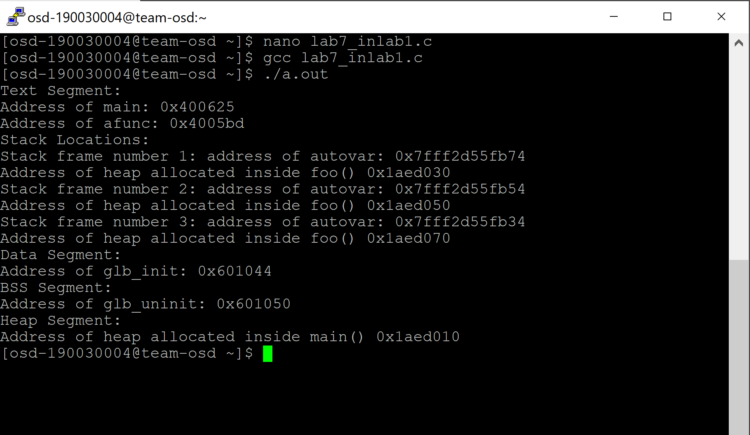

1. Develop a program to illustrate the effect of free() on the program break. This program allocates multiple blocks of memory and then frees some or all of them, depending on its (optional) command-line arguments.

**CODE**

**#define MAX_ALLOCS 1000000**

**#include <stdio.h> /* Standard I/O functions */**

**#include <stdlib.h> /* Prototypes of commonly used library functions,plus EXIT_SUCCESS and EXIT_FAILURE constants */**

**#include <unistd.h> /* Prototypes for many system calls */**

**#include <errno.h> /* Declares errno and defines error constants */**

**#include <string.h> /* Commonly used string-handling functions */**

**int main(int argc, char *argv[]){**

**char *ptr[MAX_ALLOCS];**

**int freeStep, freeMin, freeMax, blockSize, numAllocs,j;**

**printf("\n");**

**if (argc < 3 || strcmp(argv[1], "--help") == 0){**

**printf("%s num-allocs block-size [step [min [max]]]\n" argv[0]);**

**exit(5); }**

**numAllocs = strtol(argv[1], NULL, 10);**

**if (numAllocs > MAX_ALLOCS){**

**printf("num-allocs > %d\n", MAX_ALLOCS);**

**exit(5); }**

**blockSize = strtol(argv[2], NULL, 10);**

**freeStep = (argc > 3) ? strtol(argv[3], NULL, 10): 1;**

**freeMin = (argc > 4) ? strtol(argv[4], NULL, 10) : 1;**

**freeMax = (argc > 5) ? strtol(argv[5], NULL, 10) : numAllocs;**

**if (freeMax > numAllocs){ printf("free-max > num-allocs\n");**

**exit(5); }**

**printf("Initial program break: %10p\n", sbrk(0));**

**printf("Allocating %d*%d bytes\n", numAllocs, blockSize);**

**for (j = 0; j < numAllocs; j++) {ptr[j] = malloc(blockSize);**

**if (ptr[j] == NULL){ perror("malloc");**

**exit(5); }}**

**printf("Program break is now: %10p\n", sbrk(0));**

**printf("Freeing blocks from %d to %d in steps of %d\n",freeMin, freeMax, freeStep);**

**for (j = freeMin -1;**

**j < freeMax;**

**j += freeStep)free(ptr[j]);**

**printf("After free(), program break is: %10p\n", sbrk(0));**

**exit(10);**

**OUTPUT**

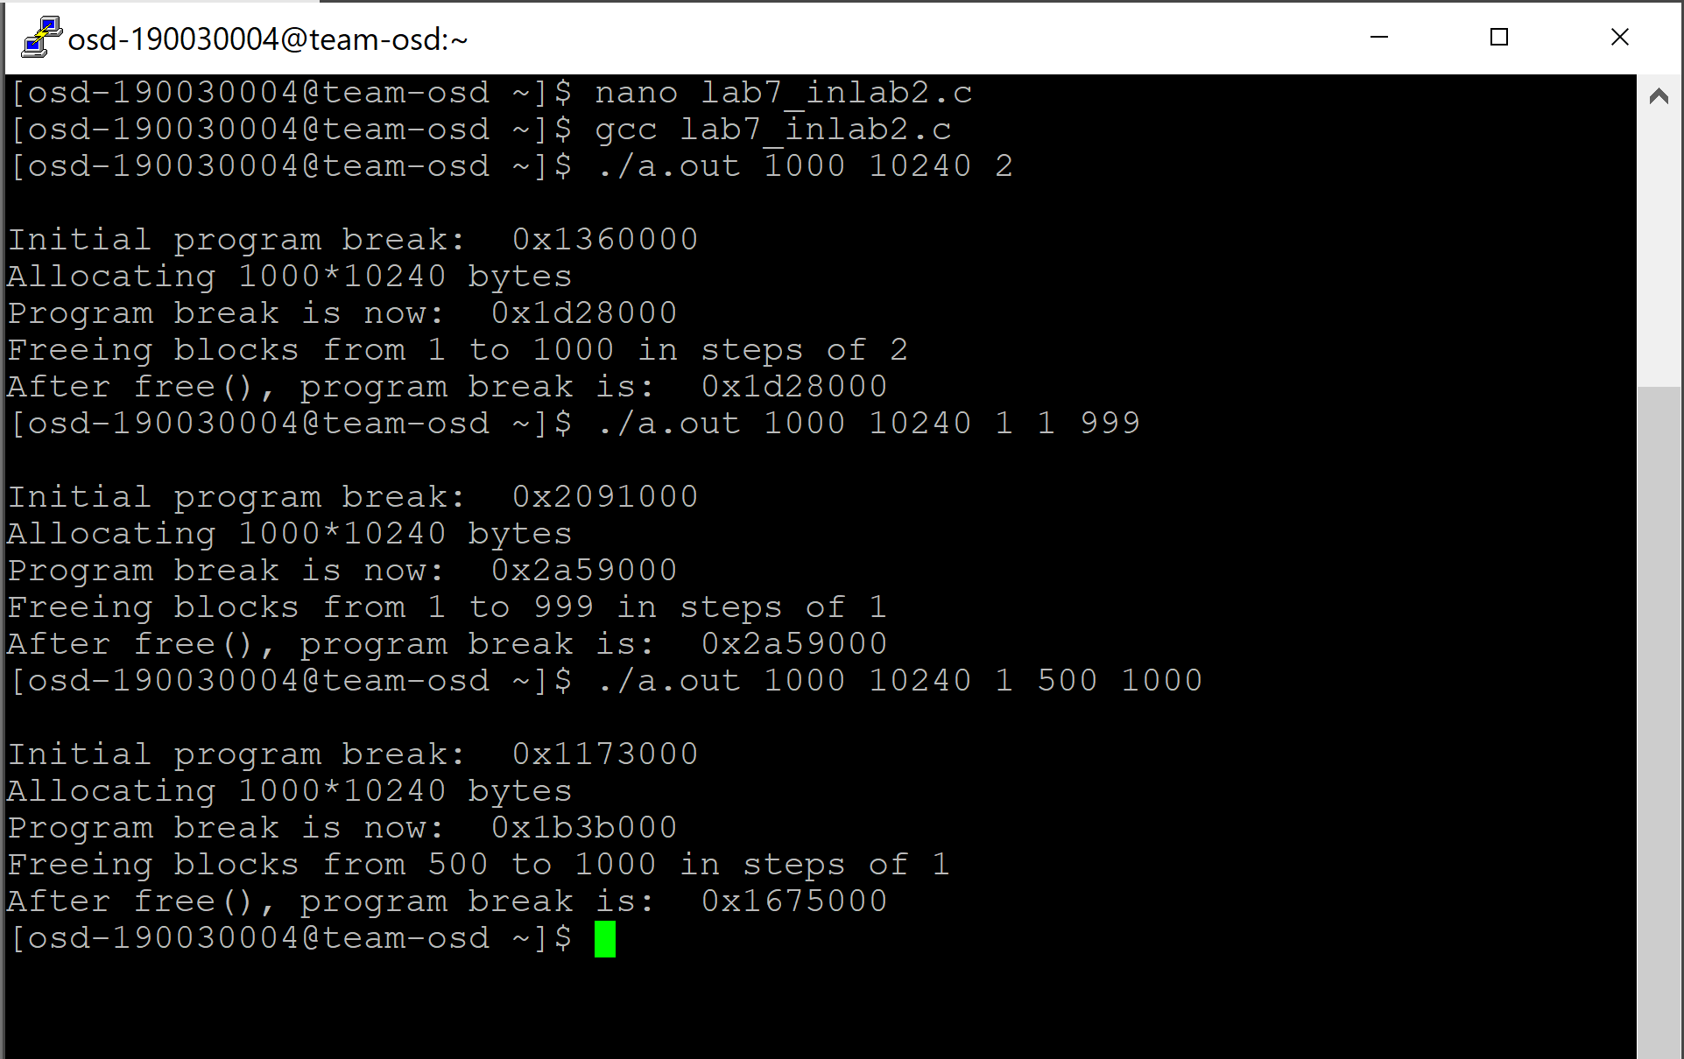

**Post-Lab**

1. Write a simple memory allocator: memalloc is a simple memory allocator. Which uses your own malloc(), calloc(), realloc() and free() implemented using system calls.

**CODE**

**#include <sys/types.h> /* Type definitions used by many programs */**

**#include <stdio.h> /* Standard I/O functions */**

**#include <stdlib.h> /* Prototypes of commonly used library functions,plus EXIT_SUCCESS and EXIT_FAILURE constants */**

**#include <unistd.h> /* Prototypes for many system calls */**

**#include <errno.h> /* Declares errno and defines error constants */**

**#include <string.h> /* Commonly used string-handling functions */**

**extern char end;**

**void *my_malloc (size_t);**

**void my_free(void *);**

**struct blk {size_t size;**

**struct blk *prev;**

**struct blk *next;};**

**struct blk *first = NULL;**

**struct blk *last = NULL;**

**void *my_malloc (size_t size) {size_t required_size = size + sizeof(struct blk);**

**struct blk *curr = first;**

**while (curr != NULL && curr->size < required_size) {curr = curr->next;**

**}if (curr == NULL) {void *new = sbrk((intptr_t) required_size);**

**if (new == (void *) -1) { return NULL; }**

**struct blk *new_blk = (struct blk *) new;**

**new_blk->size = required_size;**

**return (void *) (new_blk + 1);}**

**if (curr == first) { first = first->next; }**

**else { curr->prev->next = curr->next; }**

**if (curr == last) { last = last->prev; }**

**else {curr->next->prev = curr->prev; }if (curr->size > required_size + sizeof(struct blk)) {struct blk *left = (struct blk *) (((char *) curr) + required_size);**

**left->size = curr->size -required_size;**

**curr->size = required_size;**

**my_free((char *) (left + 1));}return (void *) (curr + 1);}**

**void my_free (void *ptr) {struct blk *blk_ptr = ((struct blk *) ptr) -1;**

**if (first == NULL) {first = last = blk_ptr;return;}if (blk_ptr < first) {blk_ptr->prev = NULL;**

**if (((char *) blk_ptr) + blk_ptr->size == (char *) first) {blk_ptr->size += first->size;**

**blk_ptr->next = first->next;}**

**else {first->prev = blk_ptr;blk_ptr->next = first;}first = blk_ptr;return;}**

**if (blk_ptr > last) {if (((char *) last) + last->size == (char *) blk_ptr) {last->size += blk_ptr->size;}**

**else {blk_ptr->next = NULL;**

**blk_ptr->prev = last;**

**last->next = blk_ptr;**

**last = blk_ptr;}**

**return;}**

**struct blk *curr = first;**

**while (curr < blk_ptr) {curr = curr->next;}**

**struct blk *before = curr->prev;**

**if (((char *) before) + before->size == (char *) blk_ptr) {before->size += blk_ptr->size;**

**blk_ptr = before;}**

**else {blk_ptr->prev = before;**

**before->next = blk_ptr;}**

**if (((char *) blk_ptr) + blk_ptr->size == (char *) curr) {blk_ptr->size += curr->size;**

**blk_ptr->next = curr->next;**

**curr->next->prev = blk_ptr;**

**} else {blk_ptr->next = curr;**

**curr->prev = blk_ptr;}}**

**#define MAX_ALLOCS 1000000**

**int main (int argc, char *argv[]) {**

**/* copied from free_and_sbrk.c --licensed by Michael Kerrisk under the GPLv3 */**

**char *ptr[MAX_ALLOCS];**

**int freeStep, freeMin, freeMax, blockSize, numAllocs, j;**

**printf("\n");**

**if (argc < 3 || strcmp(argv[1], "--help") == 0) {printf("%s num-allocs block-size [step [min [max]]]\n", argv[0]);**

**perror("num-allocs block-size");}**

**numAllocs = strtol(argv[1], NULL, 10);**

**if (numAllocs > MAX_ALLOCS) {printf("num-allocs > %d\n", MAX_ALLOCS);**

**perror("num-allocs");}**

**blockSize = strtol(argv[2], NULL, 10);**

**freeStep = (argc > 3) ? strtol(argv[3], NULL, 10) : 1;**

**freeMin = (argc > 4) ? strtol(argv[4], NULL, 10) : 1;**

**freeMax = (argc > 5) ? strtol(argv[5], NULL, 10): numAllocs;**

**if (freeMax > numAllocs) {perror("free-max > num-allocs");}**

**printf("Initial program break: %10p\n", sbrk(0));**

**printf("Allocating %d*%d bytes\n", numAllocs, blockSize);**

**for (j = 0; j < numAllocs; j++) {**

**ptr[j] = my_malloc(blockSize);**

**if (ptr[j] == NULL) {perror("malloc");}**

**printf("%10p\n", sbrk(0));}**

**printf("Program break is now: %10p\n", sbrk(0));**

**printf("Freeing blocks from %d to %d in steps of %d\n",freeMin, freeMax, freeStep);**

**for (j = freeMin -1; j < freeMax; j += freeStep) {my_free(ptr[j]);}**

**printf("After my_free(), program break is: %10p\n", sbrk(0));**

**exit(EXIT_SUCCESS);}**

**OUTPUT**

