Operating System Design – 19CS2106S

Skill Experiment – 1

1. What Is the Shell, Navigation, Exploring the System, Compiling Programs.

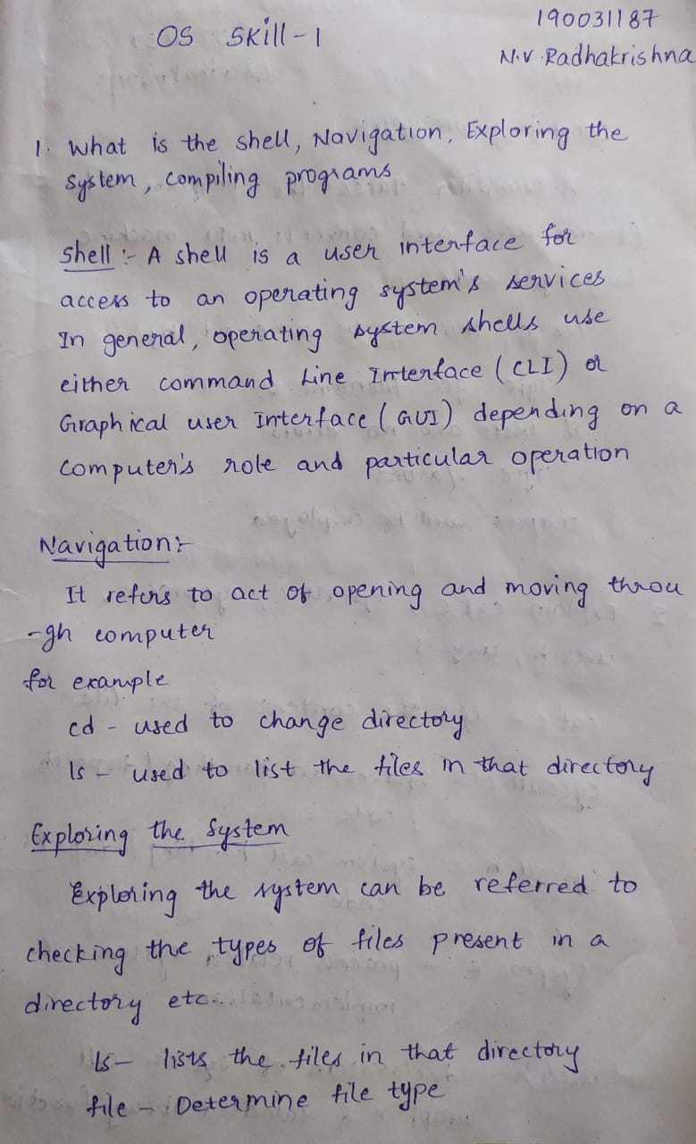

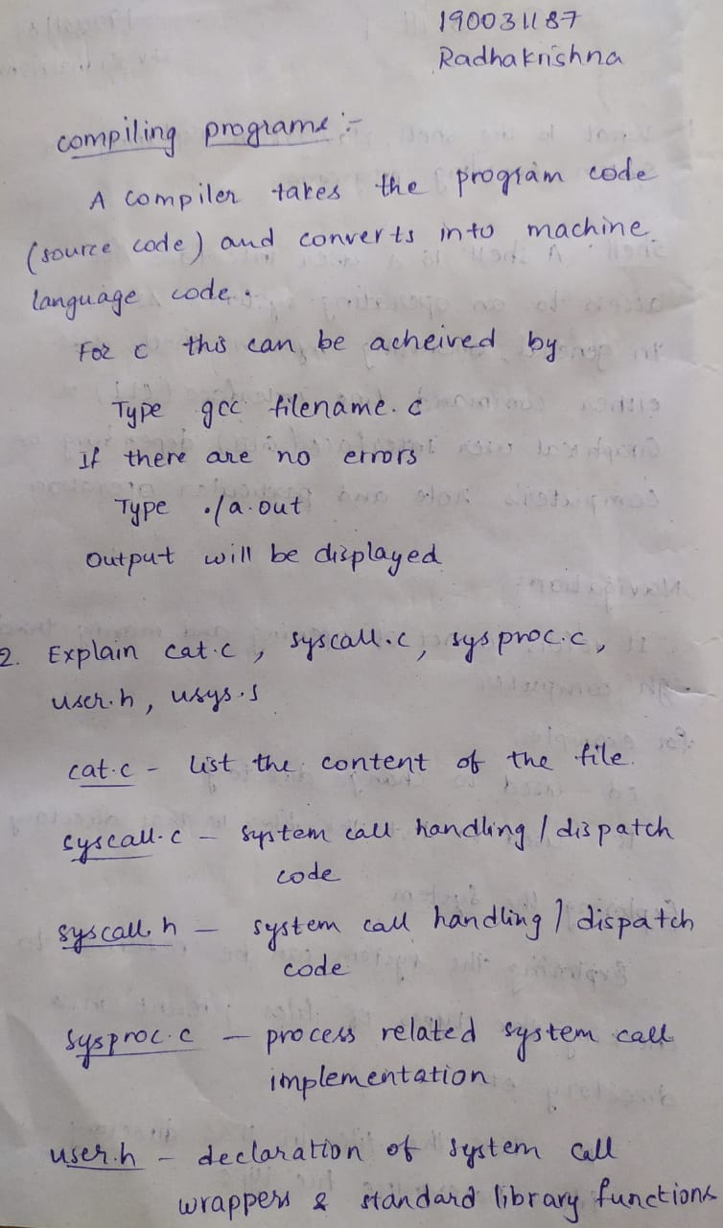

1. cat.c syscall.c syscall.h sysproc.c user.h usys.S

  


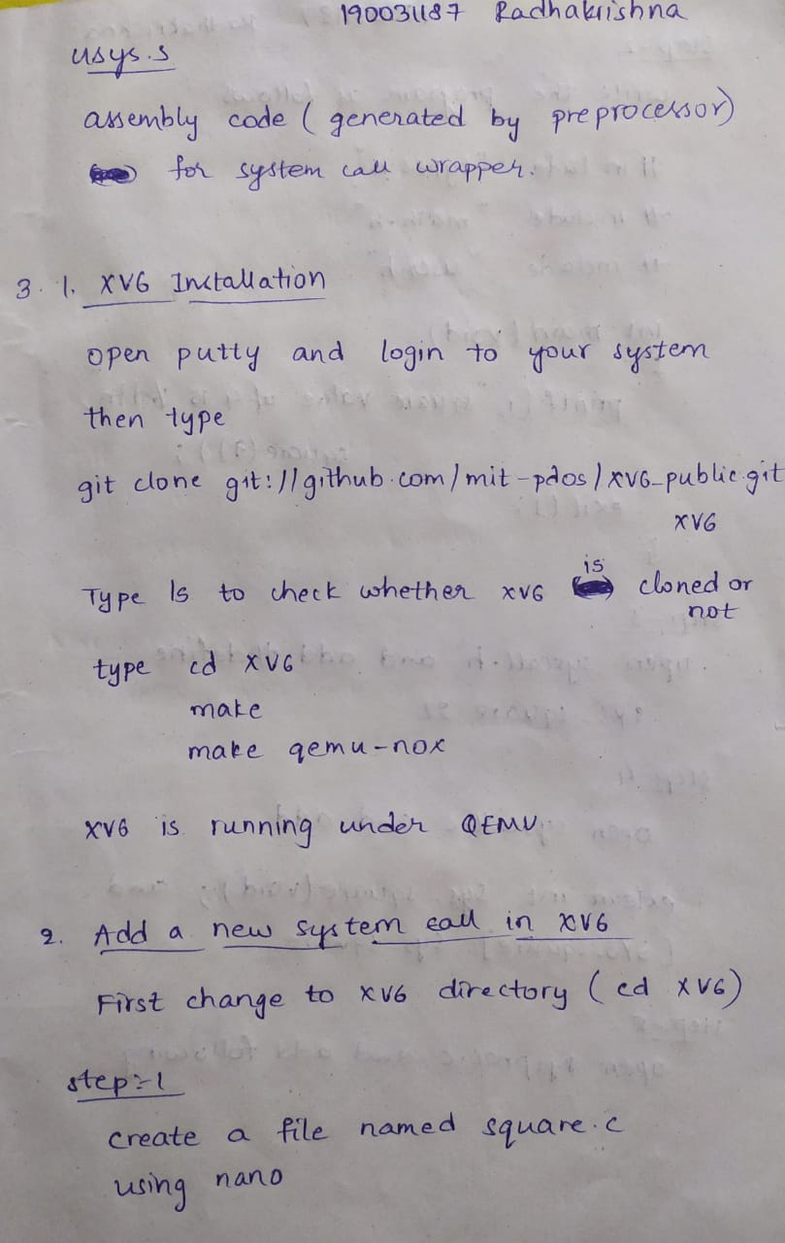

1. 1. XV6 Installation 2. add-a-newsystem-call-inxv6





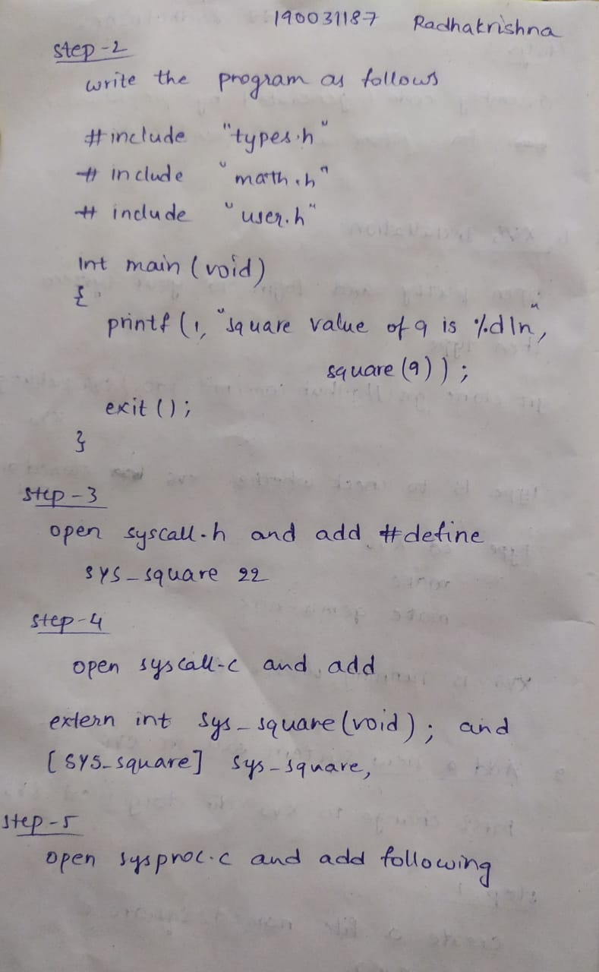

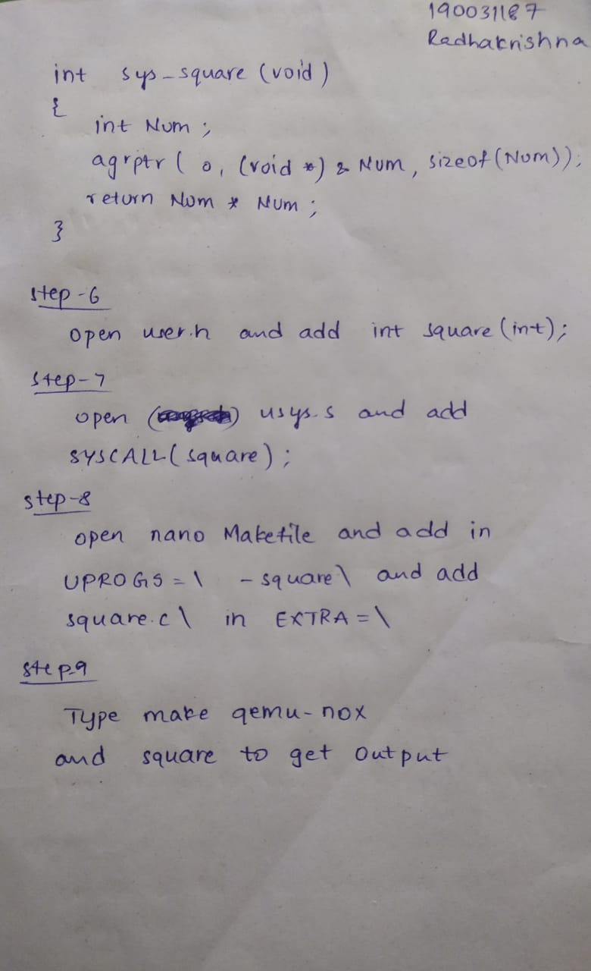

**OUTPUT**

