**OSD Skill-10**

**Procedure to add shared memory IPC to xv6**

Step 1:

git clone <https://github.com/hayleejane3/shared-memory-xv6>

Step 2:

cd shared-memory-xv6

Step 3:

ls

Step 4:

vi Makefile

Delete following code from Makefile line 54 to 72

# If the makefile can't find QEMU, specify its path here

#QEMU :=

# Try to infer the correct QEMU if not specified

ifndef QEMU

QEMU := $(shell if which qemu 1> /dev/null 2> /dev/null; \

then echo qemu; exit; \

else \

qemu=/u/c/s/cs537-2/ta/tools/qemu; \

if test -x $$qemu; then echo $$qemu; exit; fi; fi; \

echo "***" 1>&2; \

echo "*** Error: Couldn't find a working QEMU executable." 1>&2; \

echo "*** Is the directory containing the qemu binary in your " 1>&2; \

echo "*** PATH or have you tried setting the QEMU variable in " 1>&2; \

echo "*** Makefile?" 1>&2; \

echo "***" 1>&2; exit 1)

endif

Add the following code inplace of above code

# QEMU = qemu-system-i386

# Try to infer the correct QEMU

ifndef QEMU

QEMU = $(shell if which qemu > /dev/null; \

then echo qemu; exit; \

elif which qemu-system-i386 > /dev/null; \

then echo qemu-system-i386; exit; \

elif which qemu-system-x86_64 > /dev/null; \

then echo qemu-system-x86_64; exit; \

else \

qemu=/Applications/Q.app/Contents/MacOS/i386-softmmu.app/Contents/MacOS/i386-softmmu; \

if test -x $$qemu; then echo $$qemu; exit; fi; fi; \

echo "***" 1>&2; \

echo "*** Error: Couldn't find a working QEMU executable." 1>&2; \

echo "*** Is the directory containing the qemu binary in your PATH" 1>&2; \

echo "*** or have you tried setting the QEMU variable in Makefile?" 1>&2; \

echo "***" 1>&2; exit 1)

endif

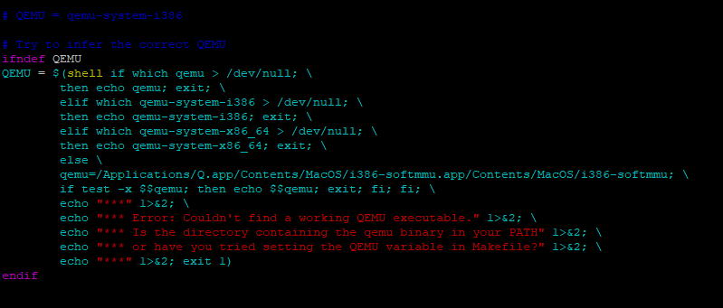

Step 5:

$ cd user

Step 6:

$ls

Step 7:

vi test_shm.c

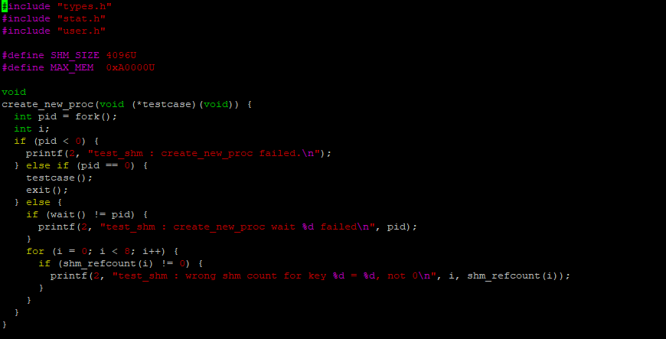

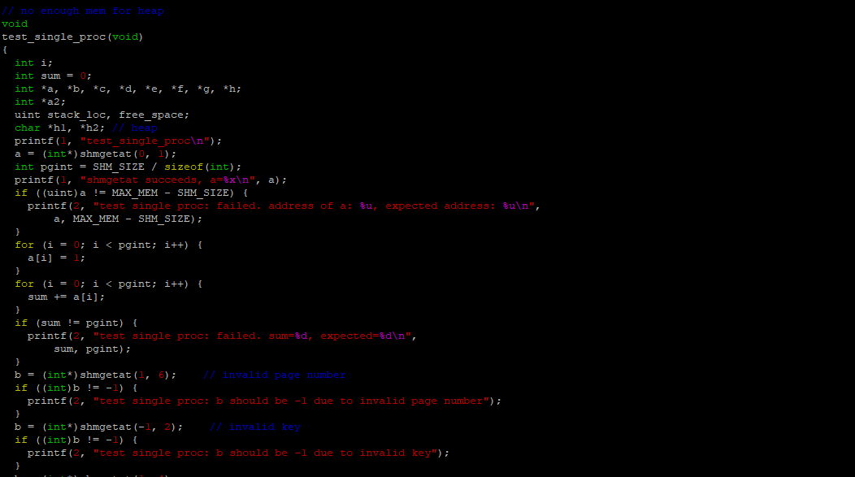

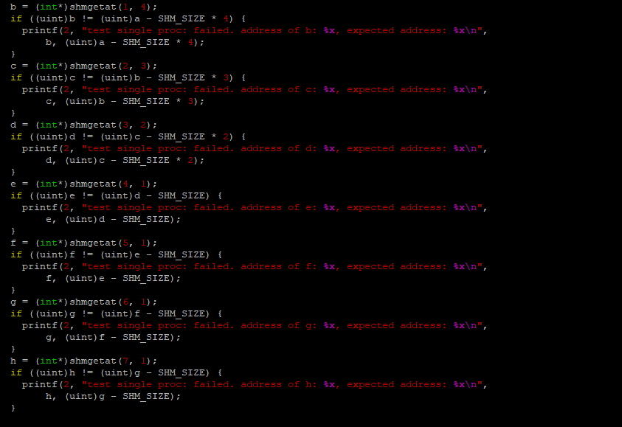

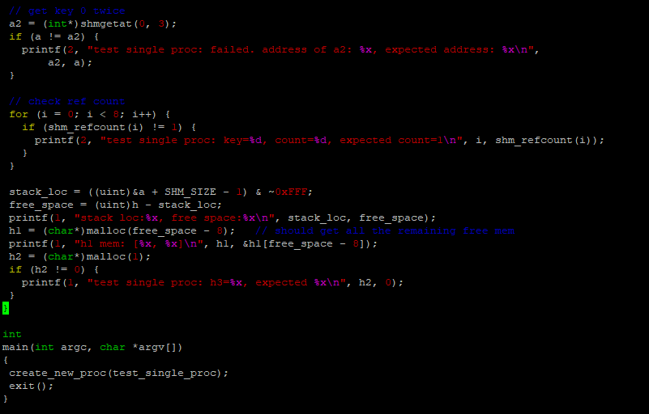

Step 8:

vi makefile.mk

add test_shm after zombie in USER_PROGS list of makefile.mk

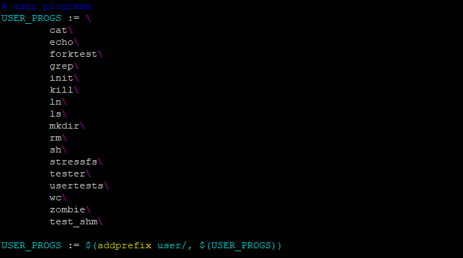

Step 9:

$ cd ..

Step 10:

$make qemu-nox

$ls

$test_shm

**OUTPUT**

