Operating System Design Skill Experiment – 4

1. Seeing the World as The Shell Sees It, Advanced Keyboard Tricks, Permissions

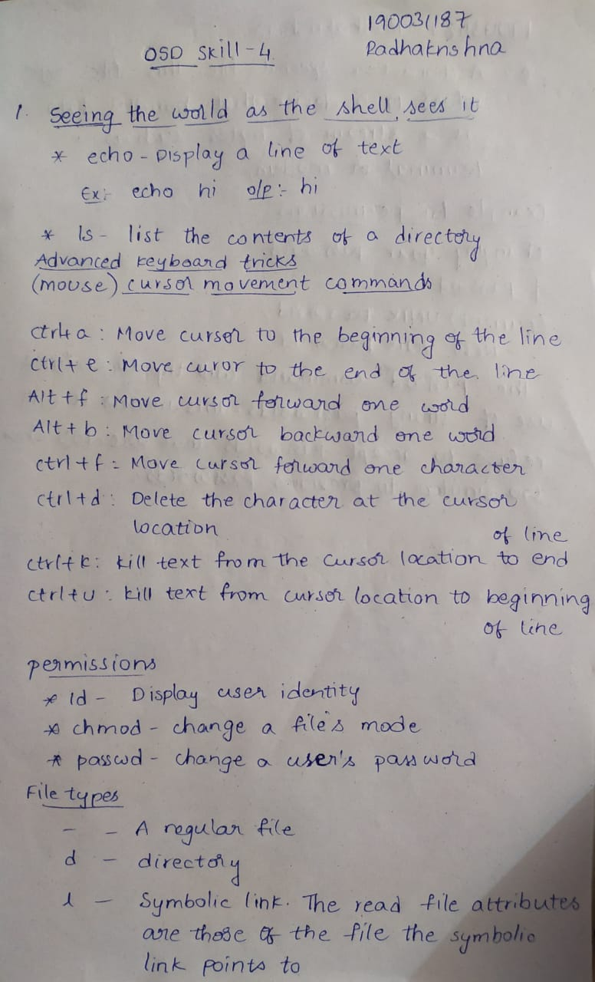

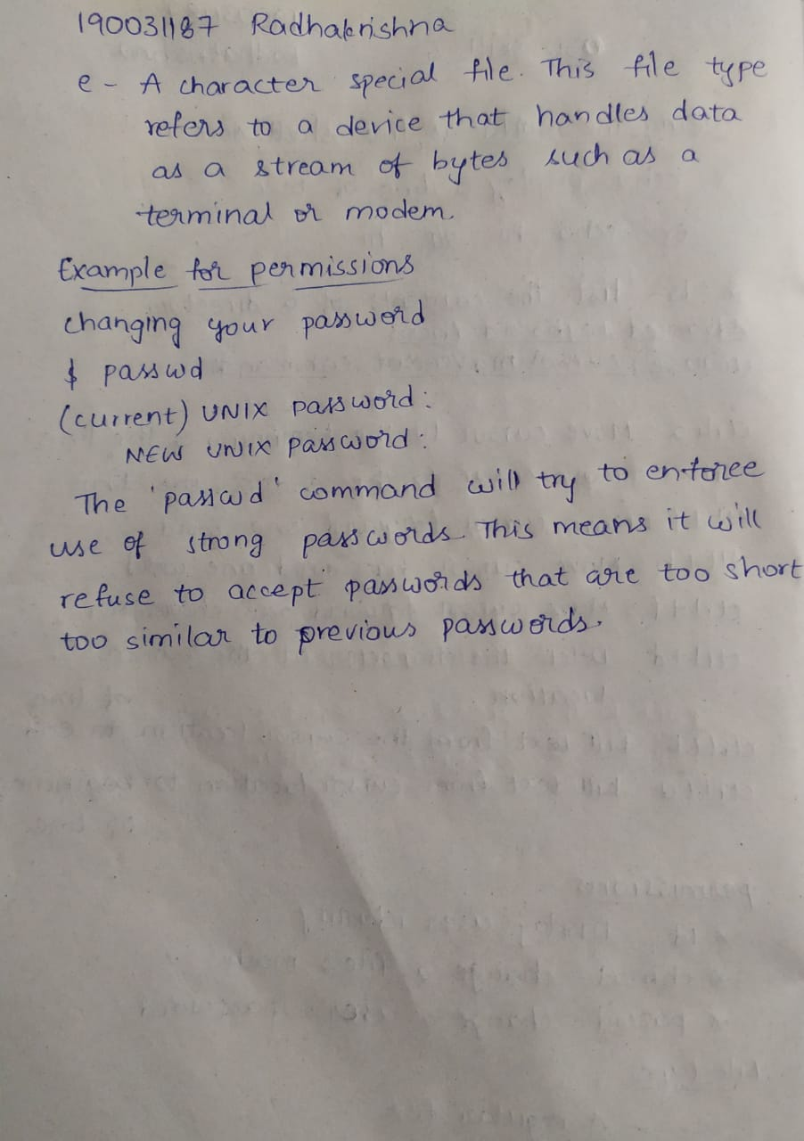

1. ln.c , rm.c, mkdir.c (Xv6 design & implementation. (xv6 source code))

**ln.c**

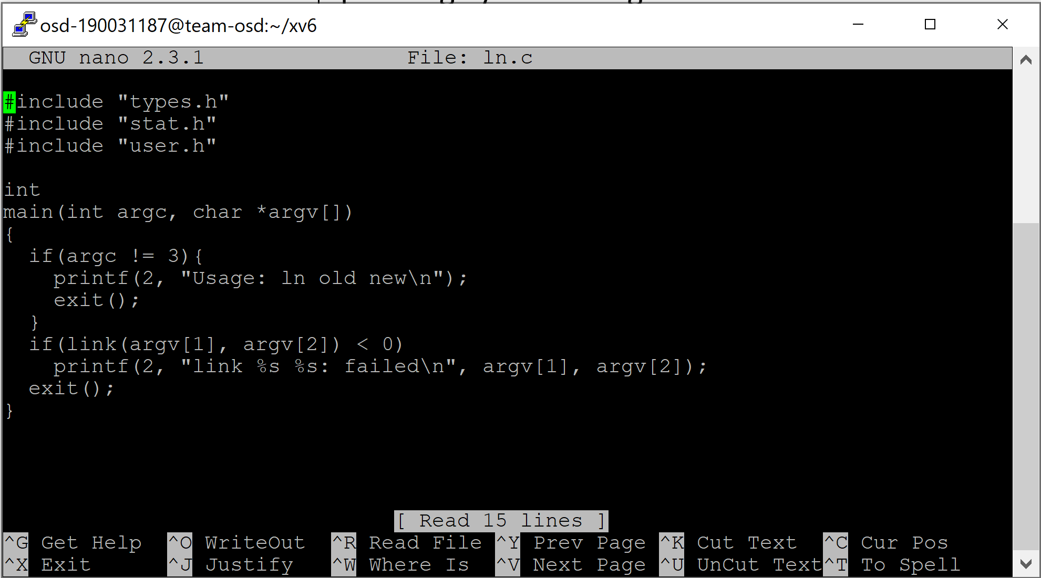

**OUTPUT**

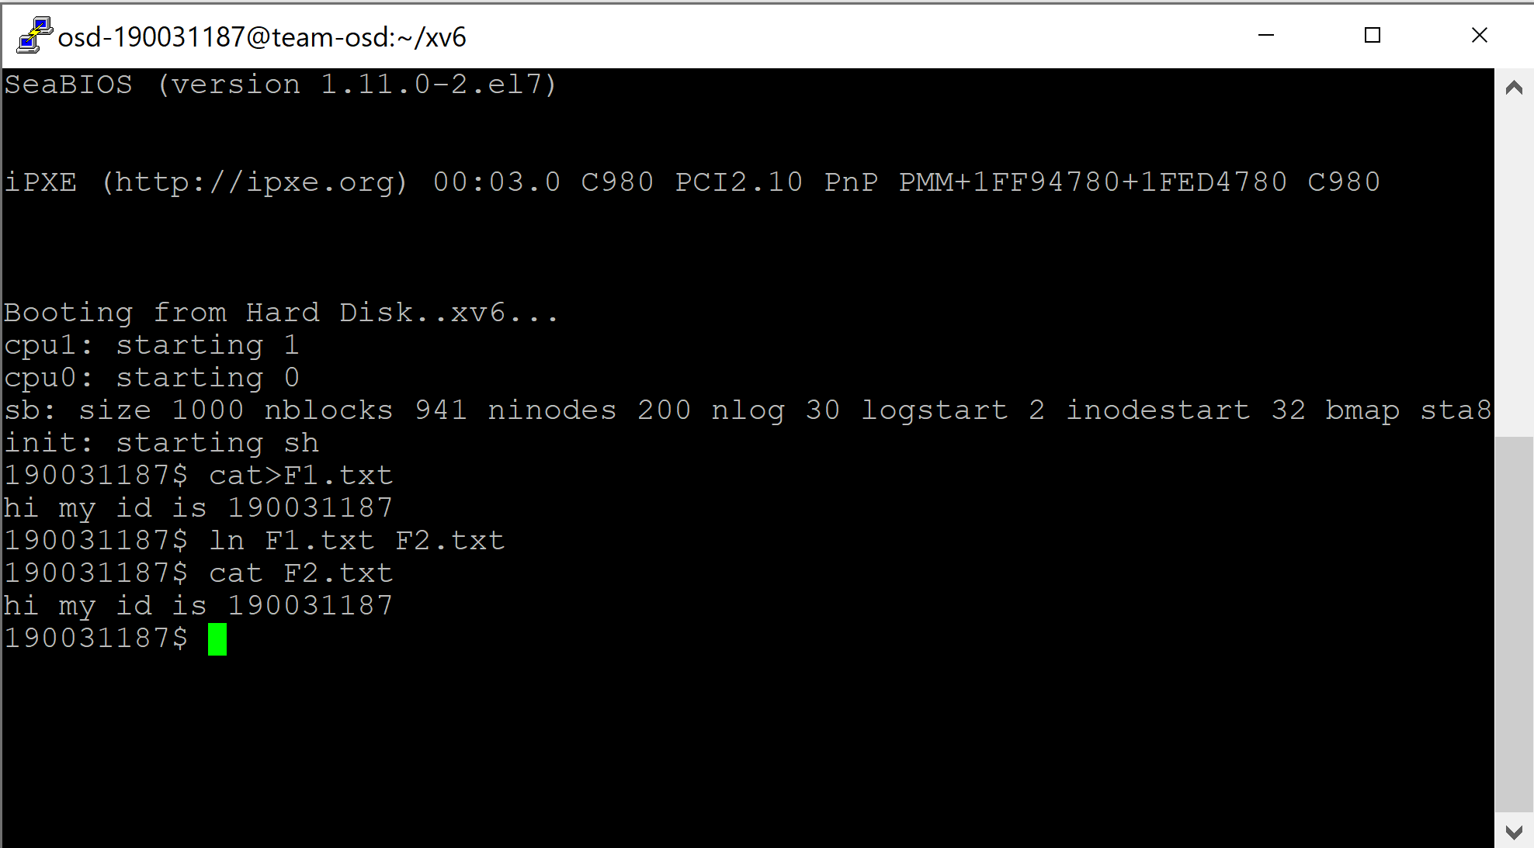

**rm.c**

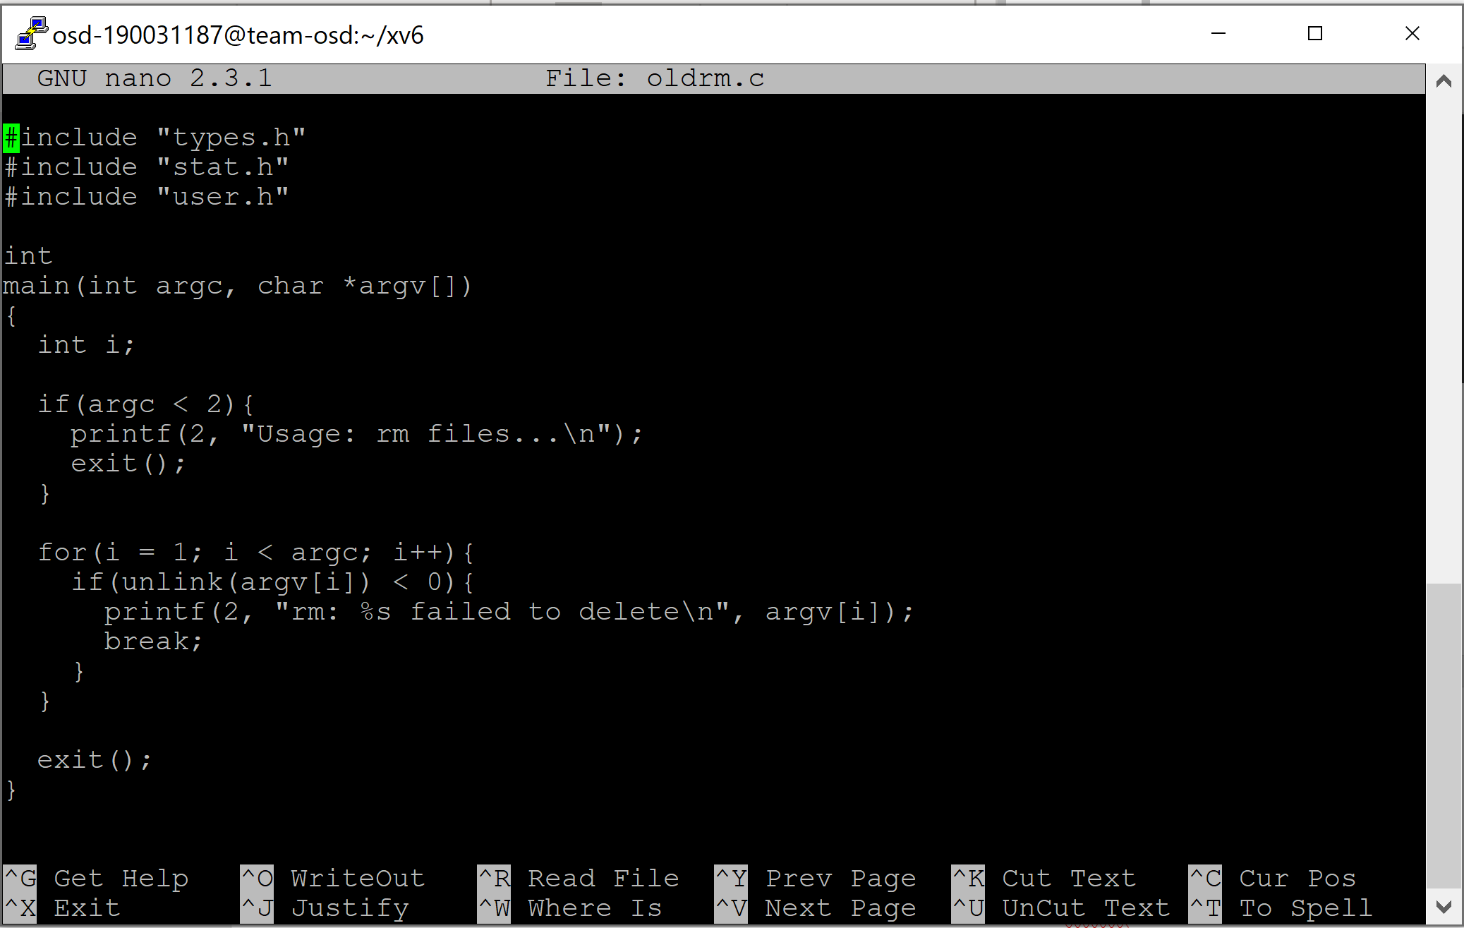

**OUTPUT**

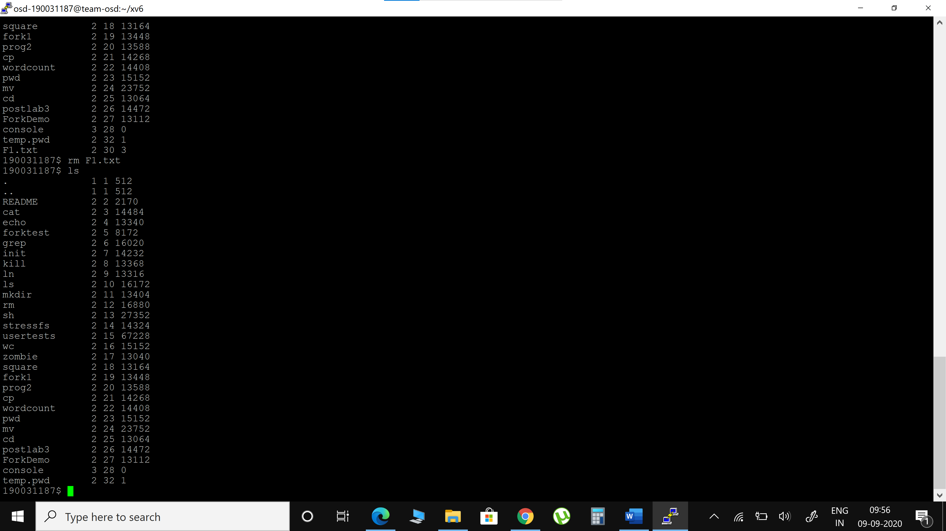

**mkdir.c**

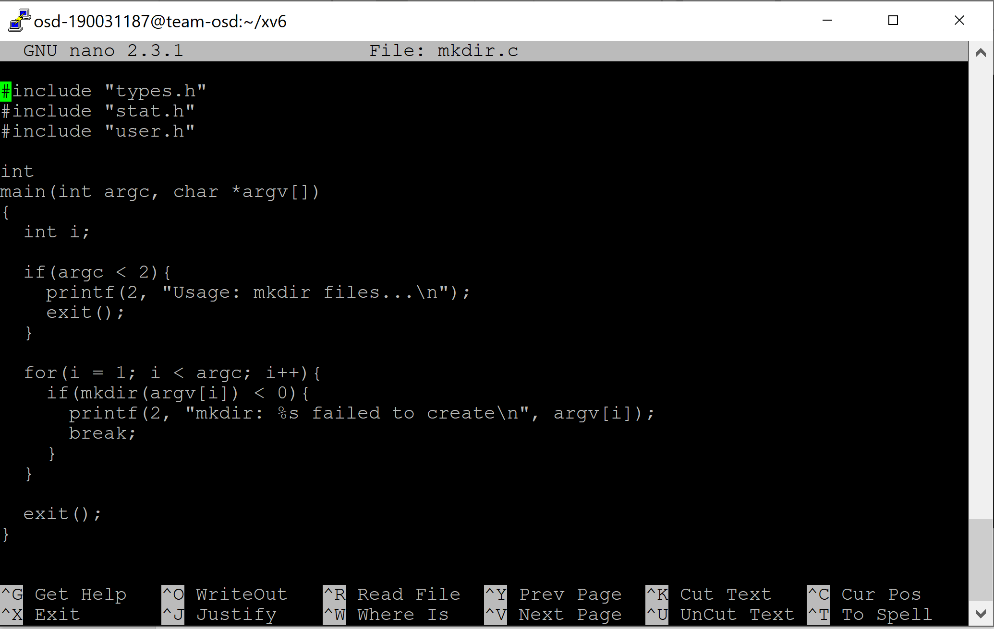

**OUTPUT**

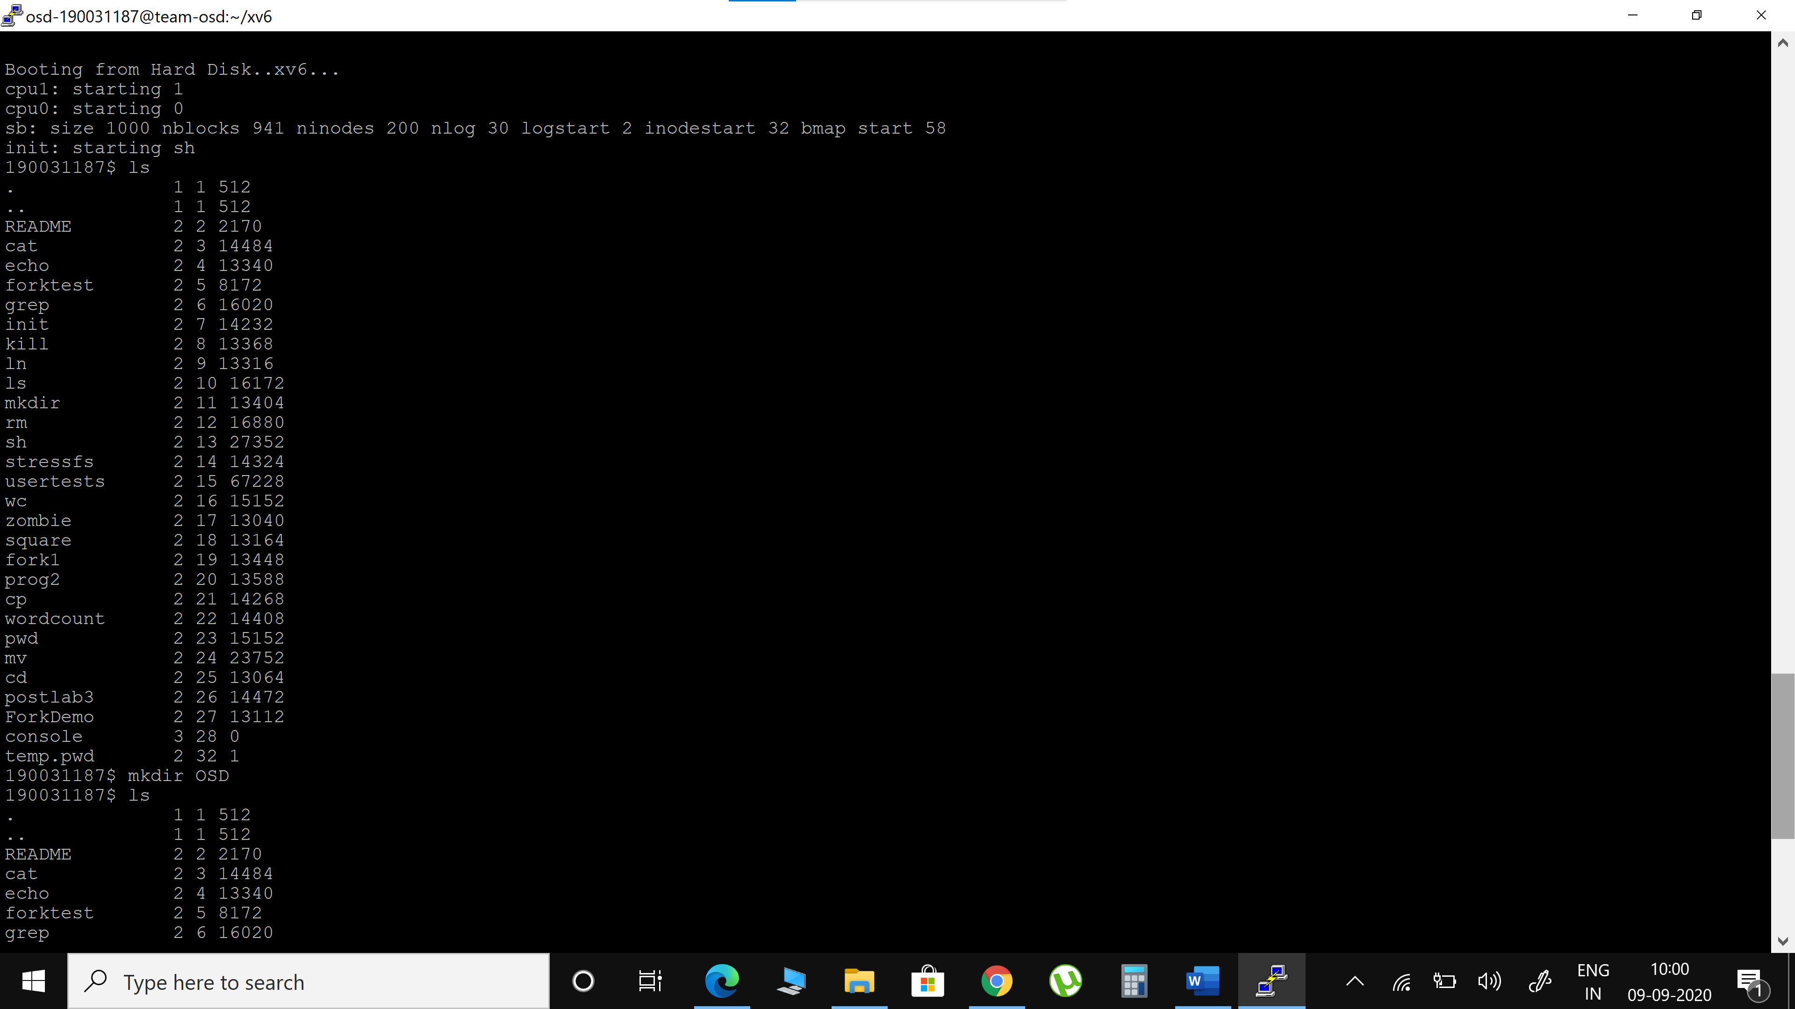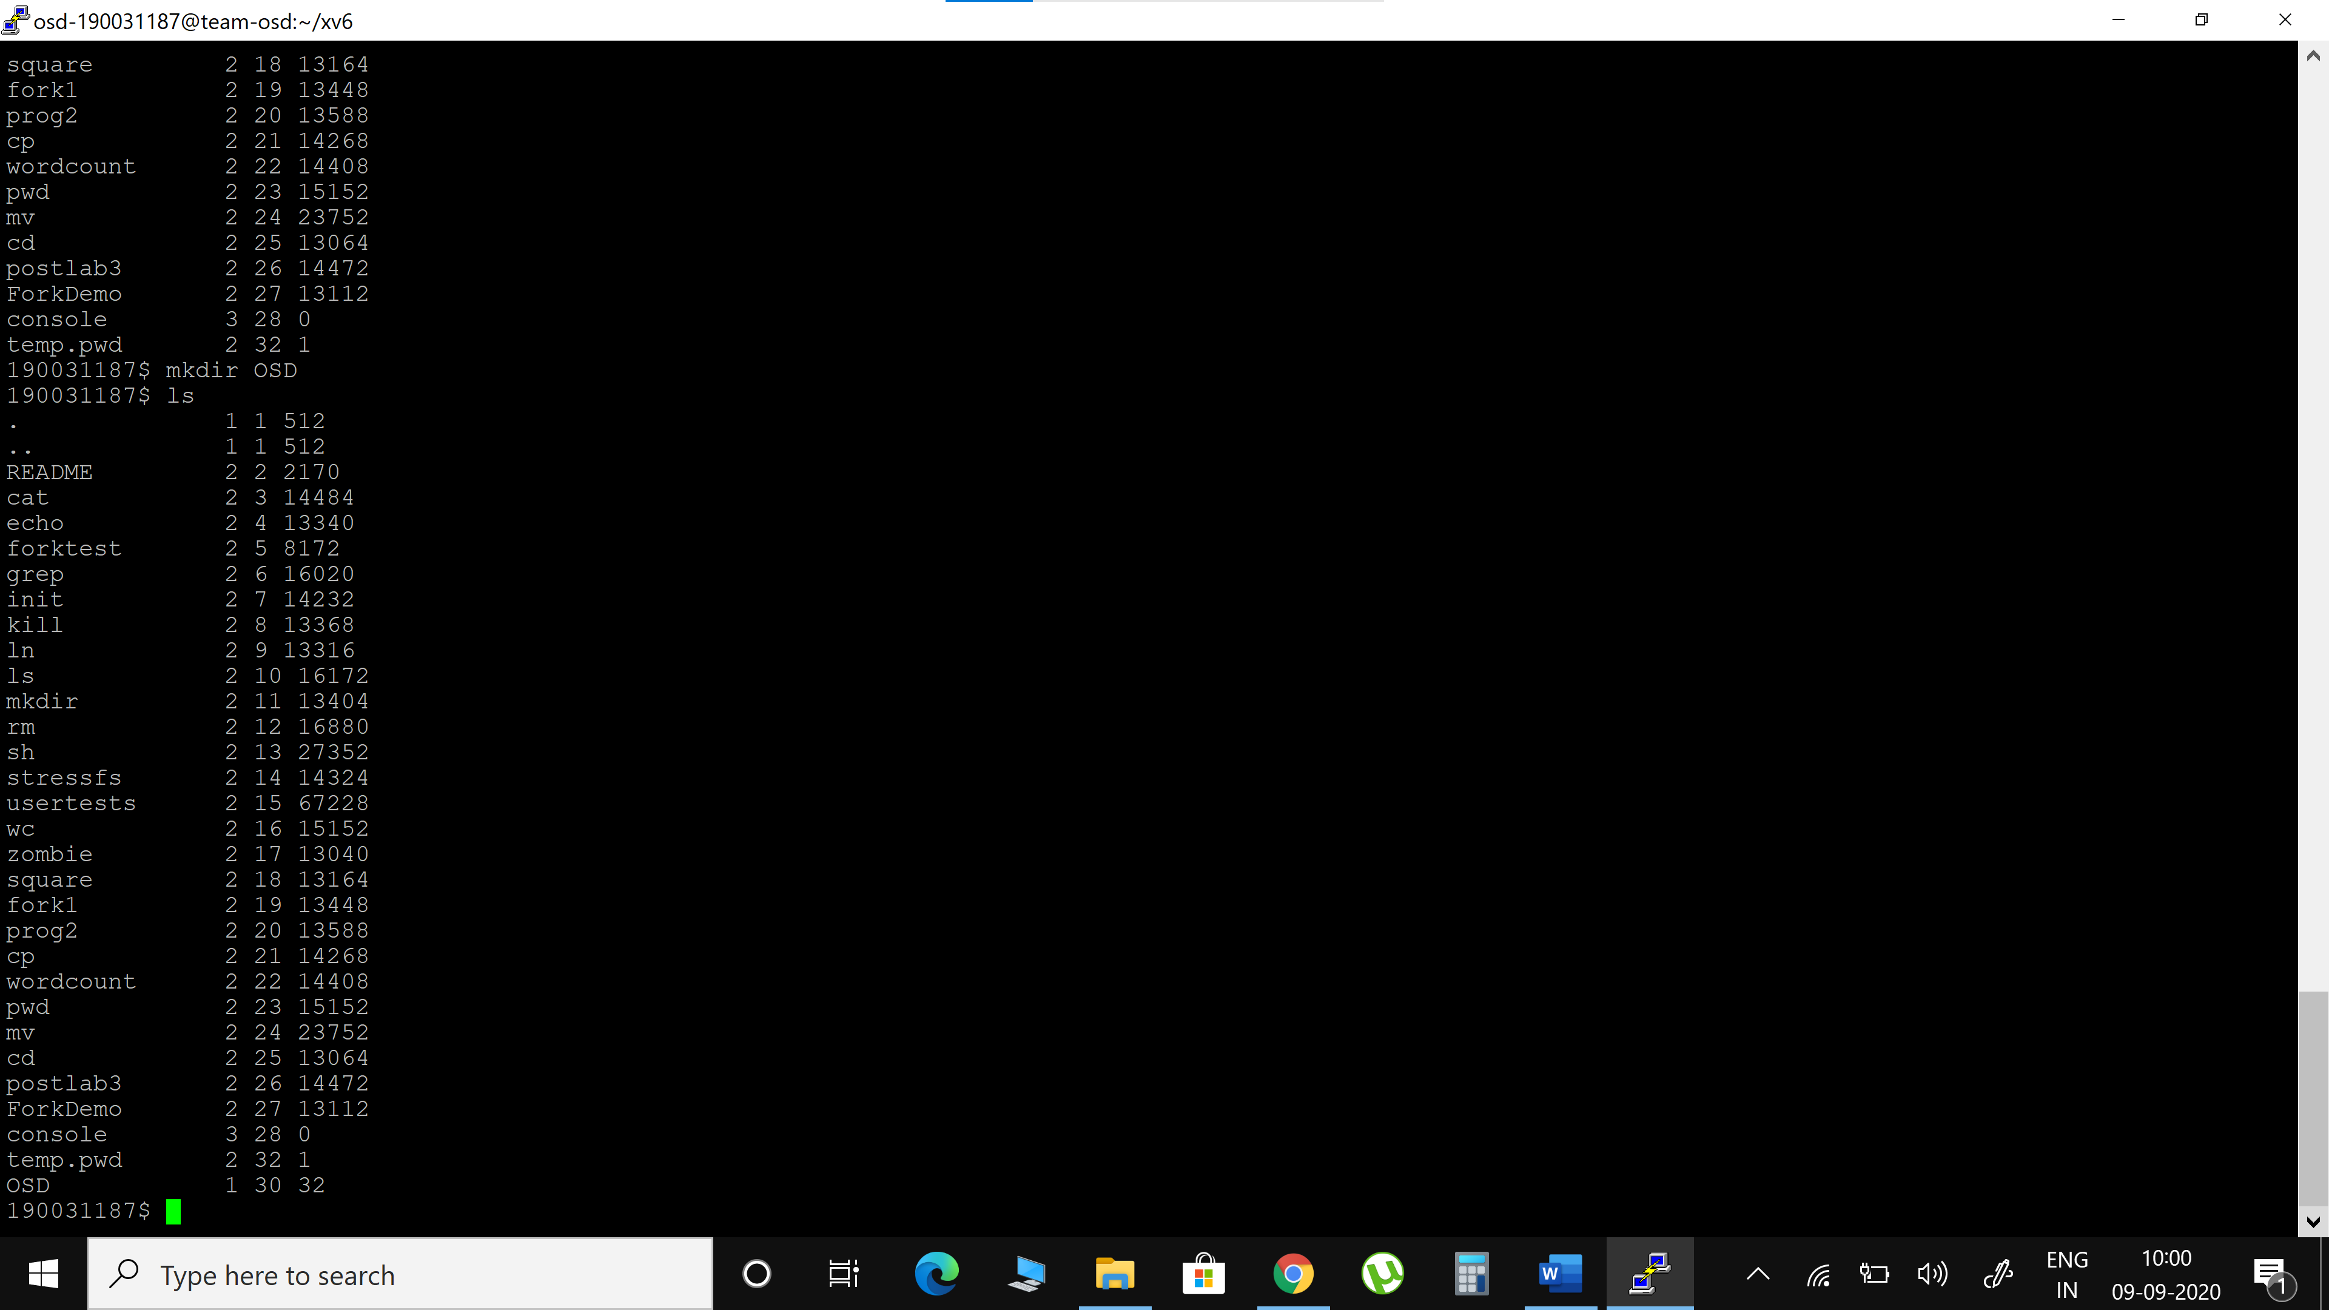

1. rm, getpinfo (xv6 customization)

**rm.c**

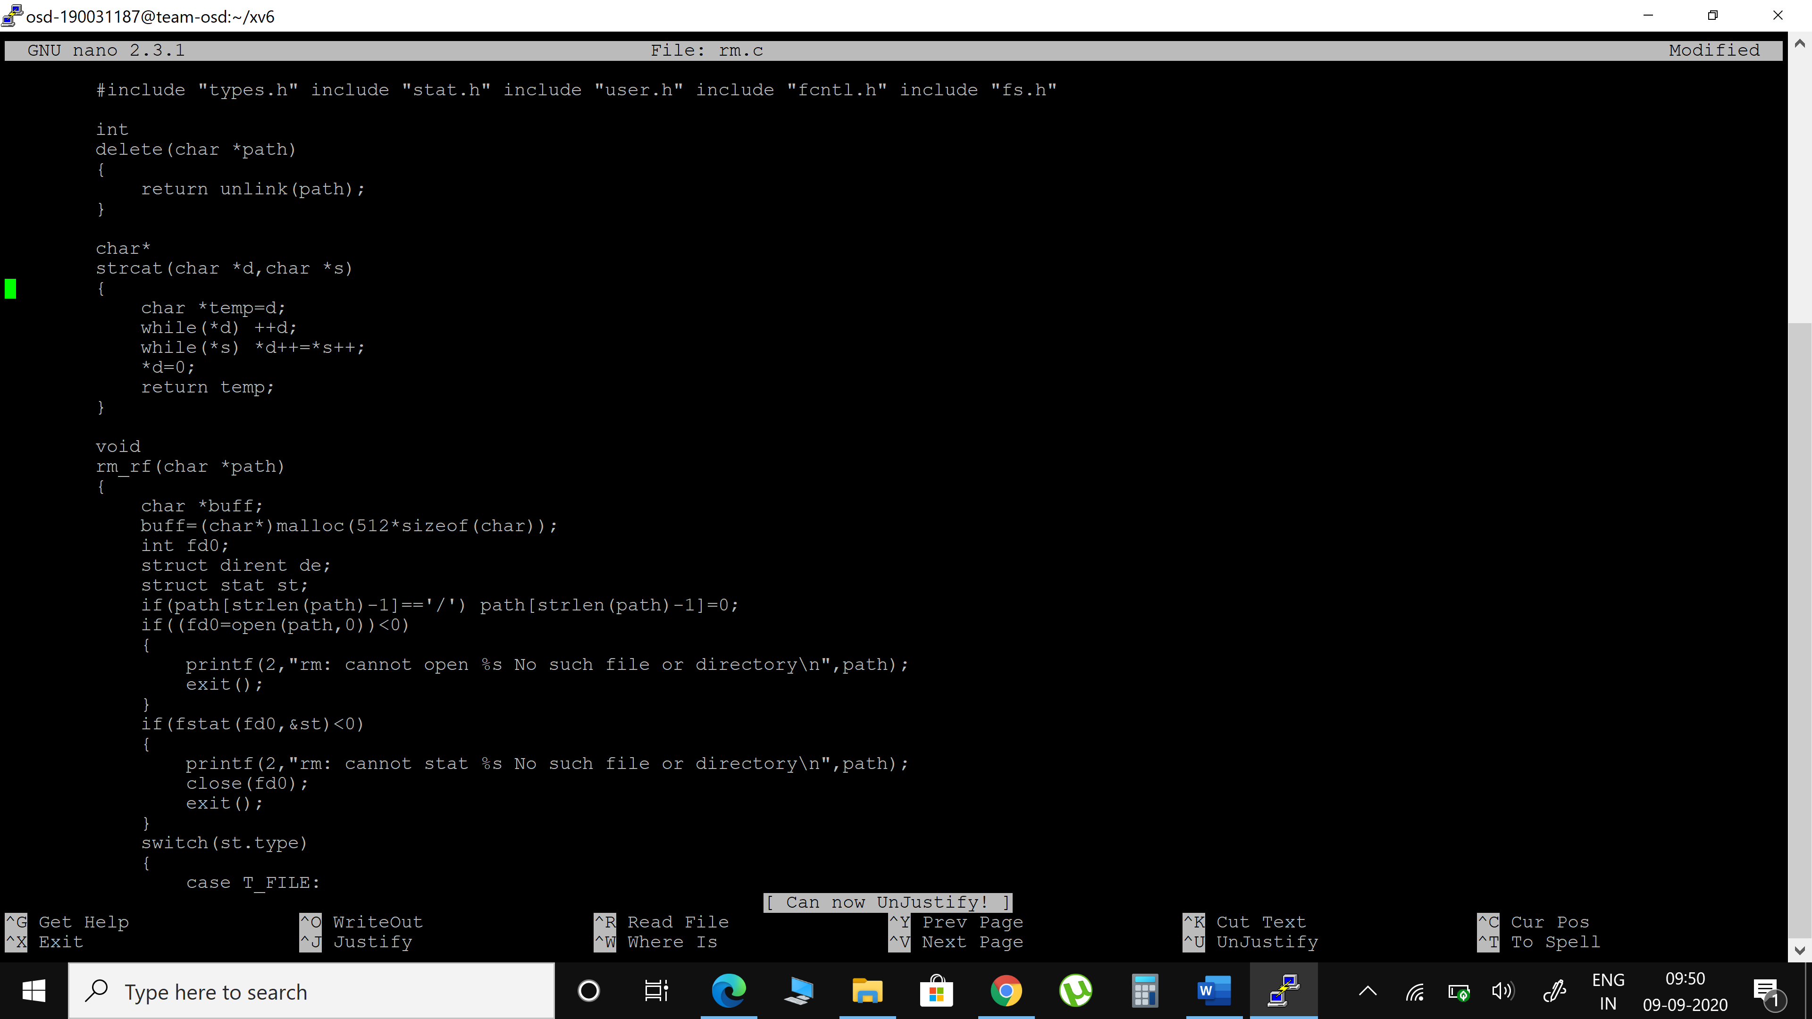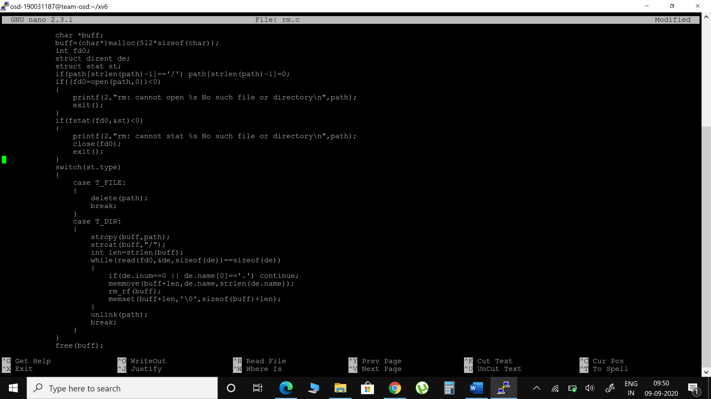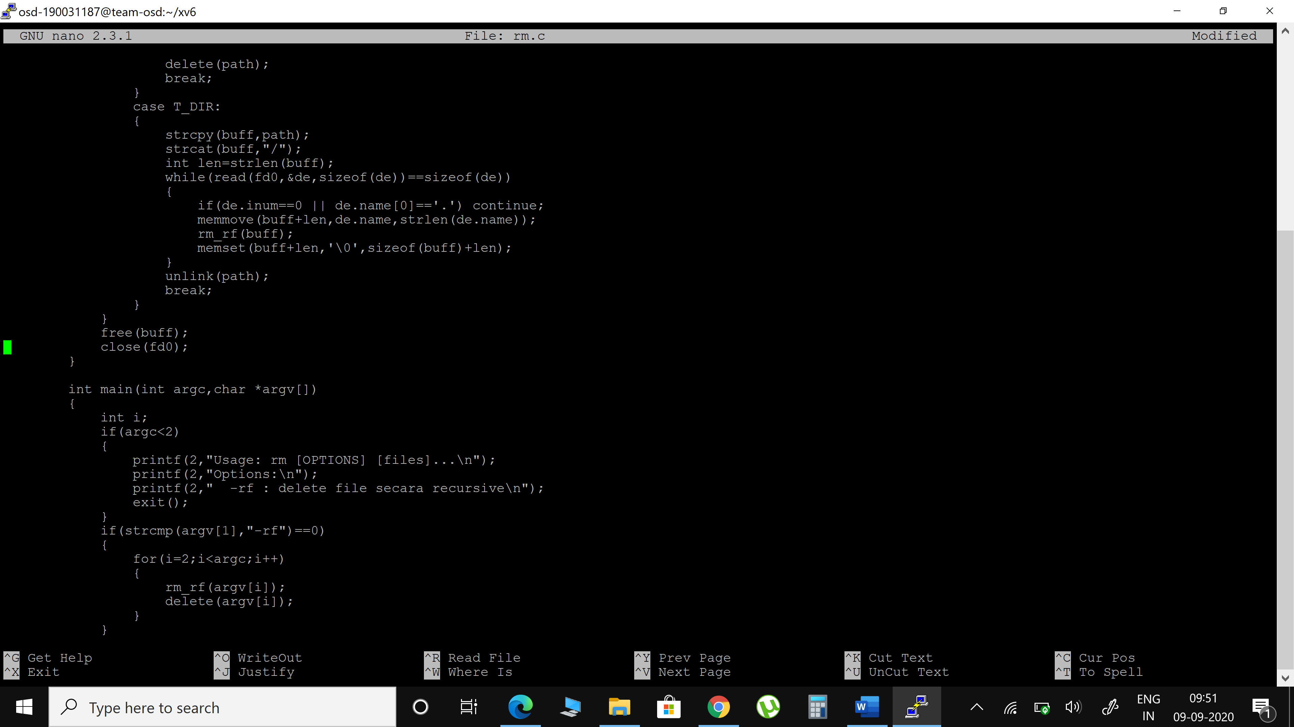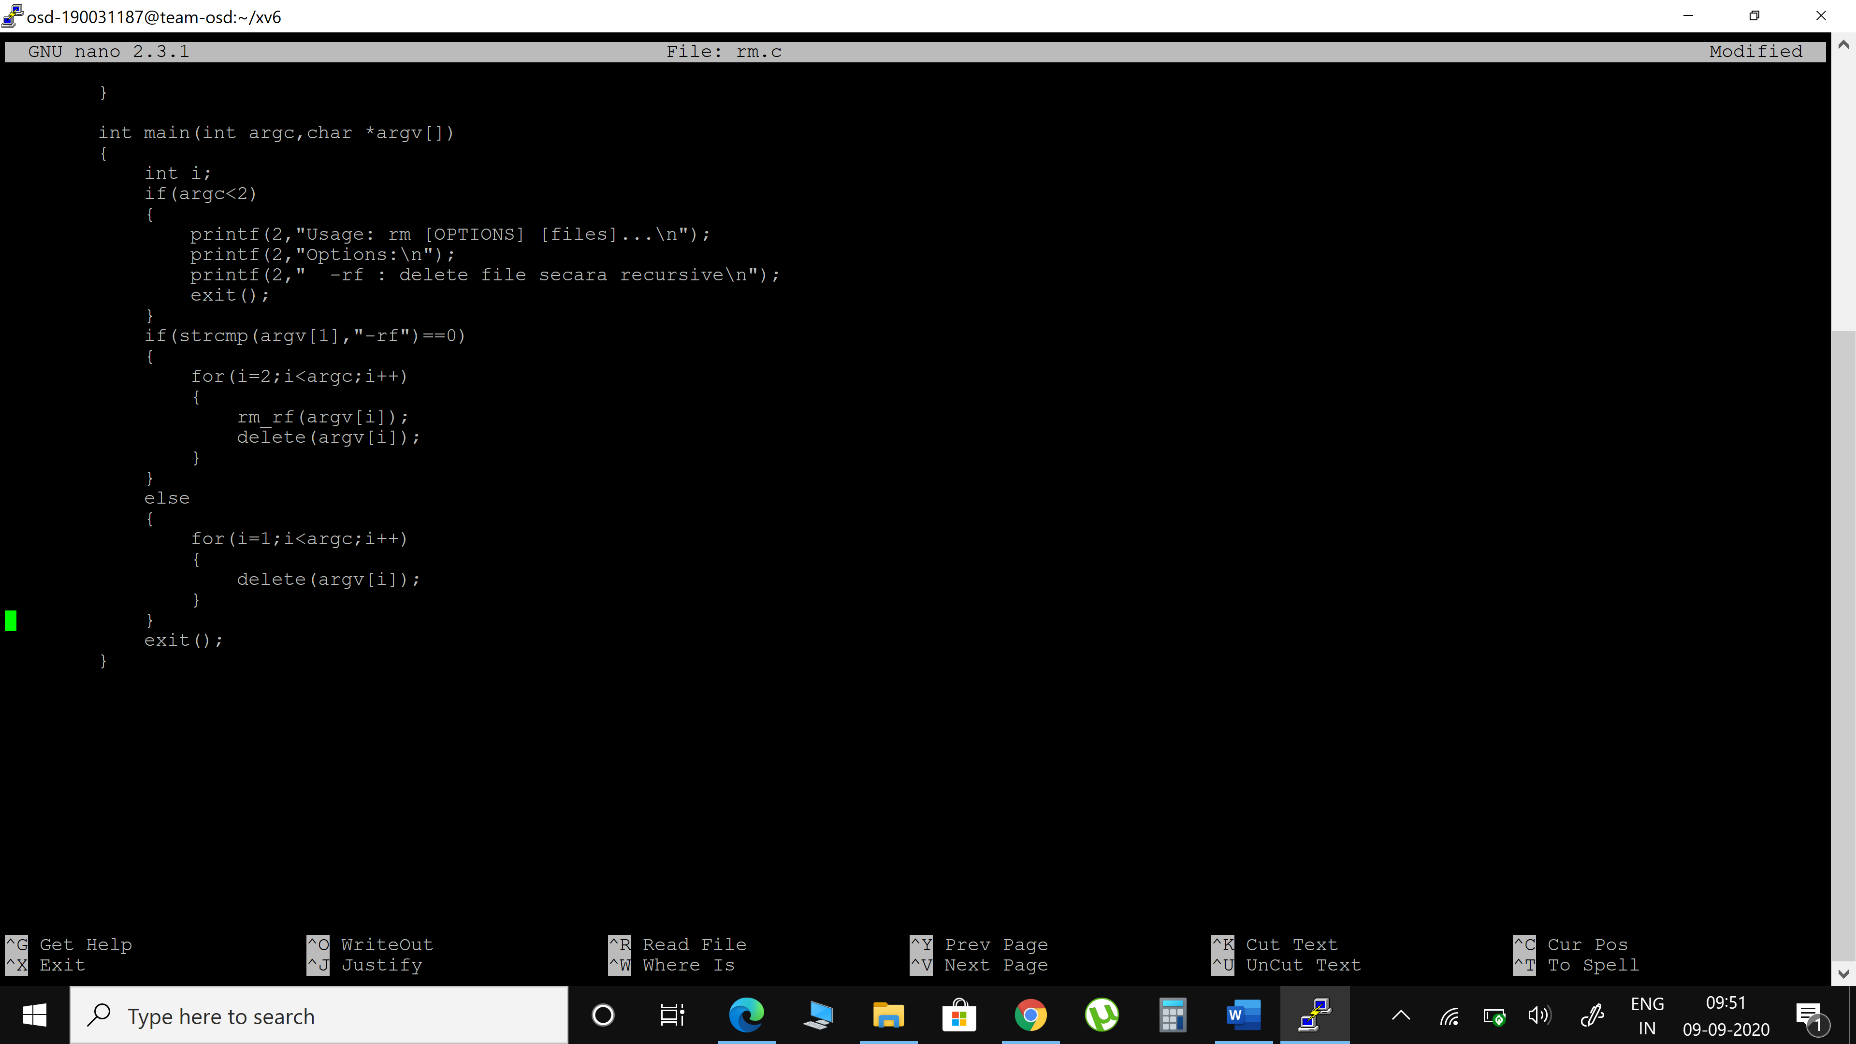

**OUTPUT**



**getpinfo**

1. Open syscall.h and add the following

#define SYS_getpinfo 22

1. Open defs.h and add the following in //proc.c section

int getpinfo (void);

1. open user.h file

add in systemcall section

int getpinfo (void);

1. open proc.c and add the following function:

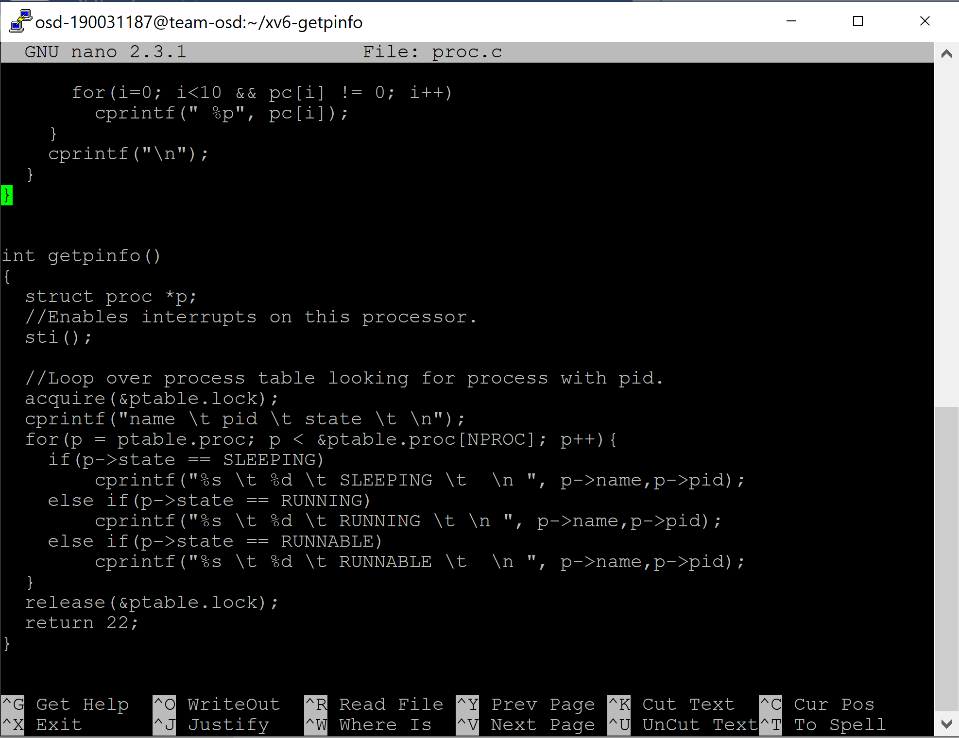

1. open sysproc.c and add following function:

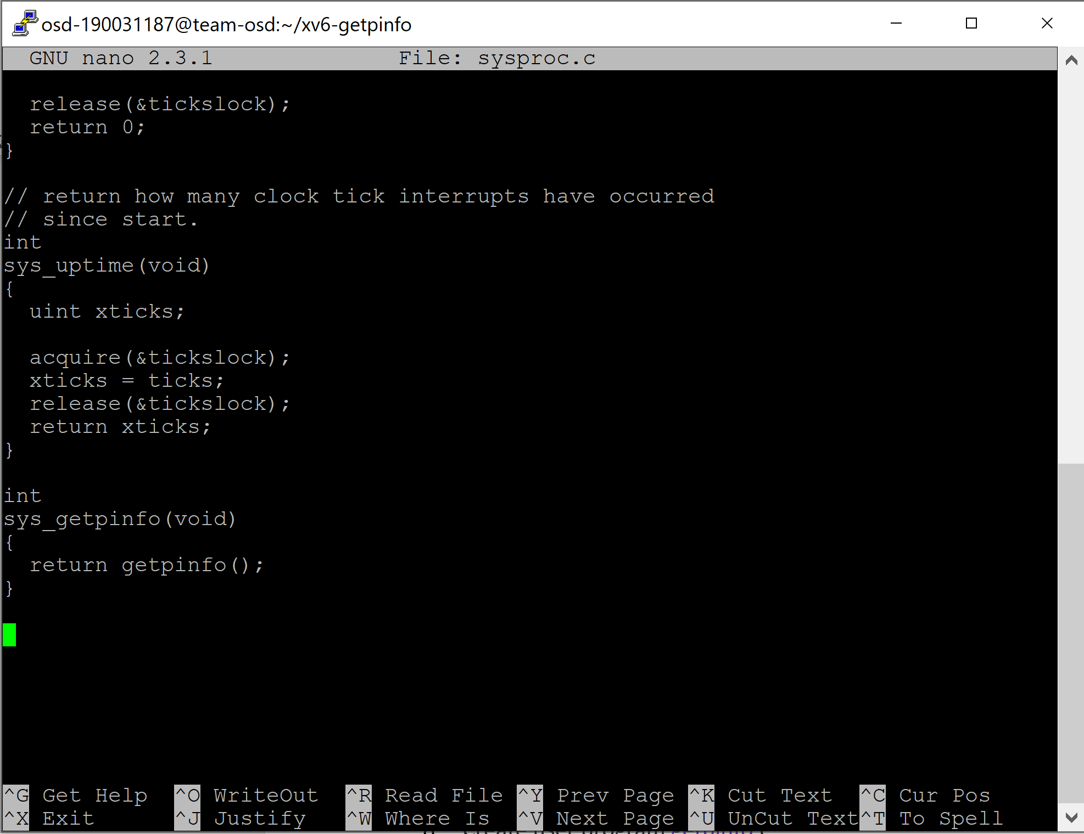

1. open usys.S and add the following

SYSCALL(getpinfo)

1. open the **syscall.c** file and add the following

//Add this where the other system calls are defined in syscall.c

extern int sys_getpinfo(void);

//Add this inside static int (*syscalls[])(void)

[SYS_getpinfo] sys_getpinfo,

1. Create user program getpinfo.c

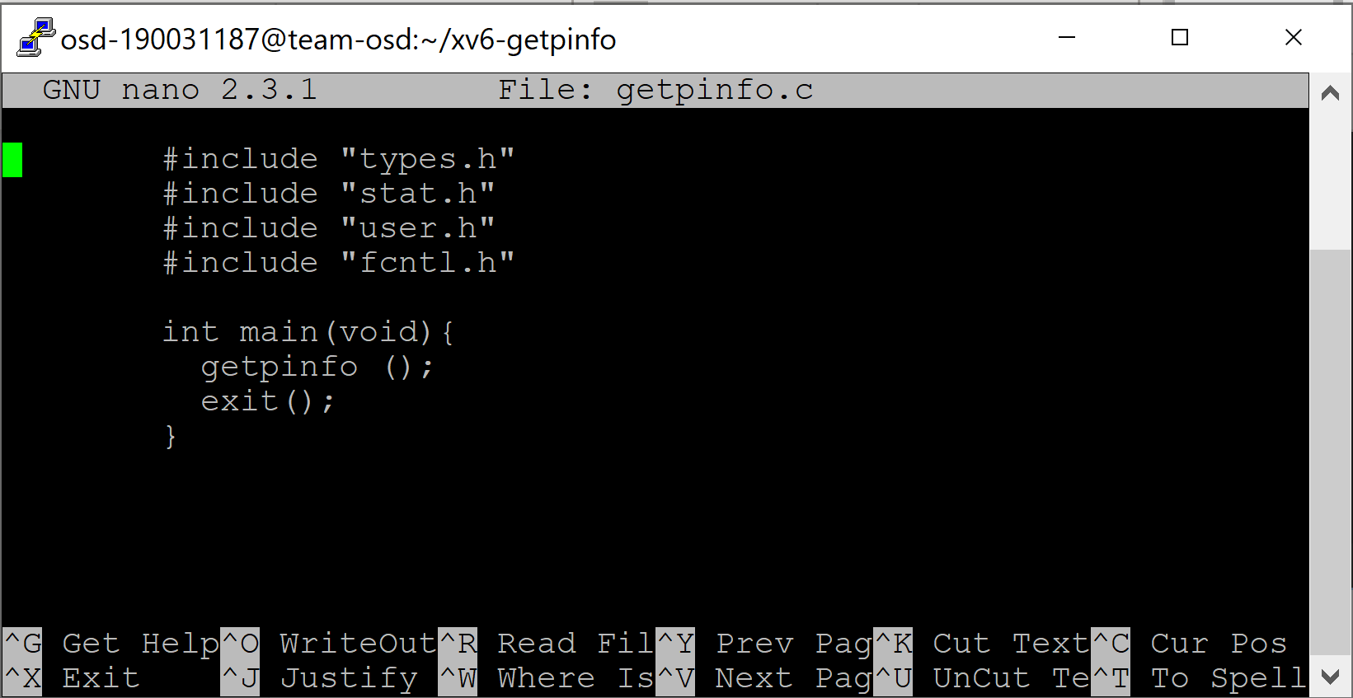

1. nano Makefile

Add getpinfo\ to uprogs

Add getpinfo.c to Extra

1. make
2. make qemu-nox
3. $ getpinfo

**OUTPUT**

