**Operating Systems Design 19CS2106S**

**Session – 6**

**ALM**

1. Given a disk-block size of 4 KB and block-pointer address value of 4 bytes, what is the largest file size (in bytes) that can be accessed using 10 direct addresses and one indirect block?

**Solution:**

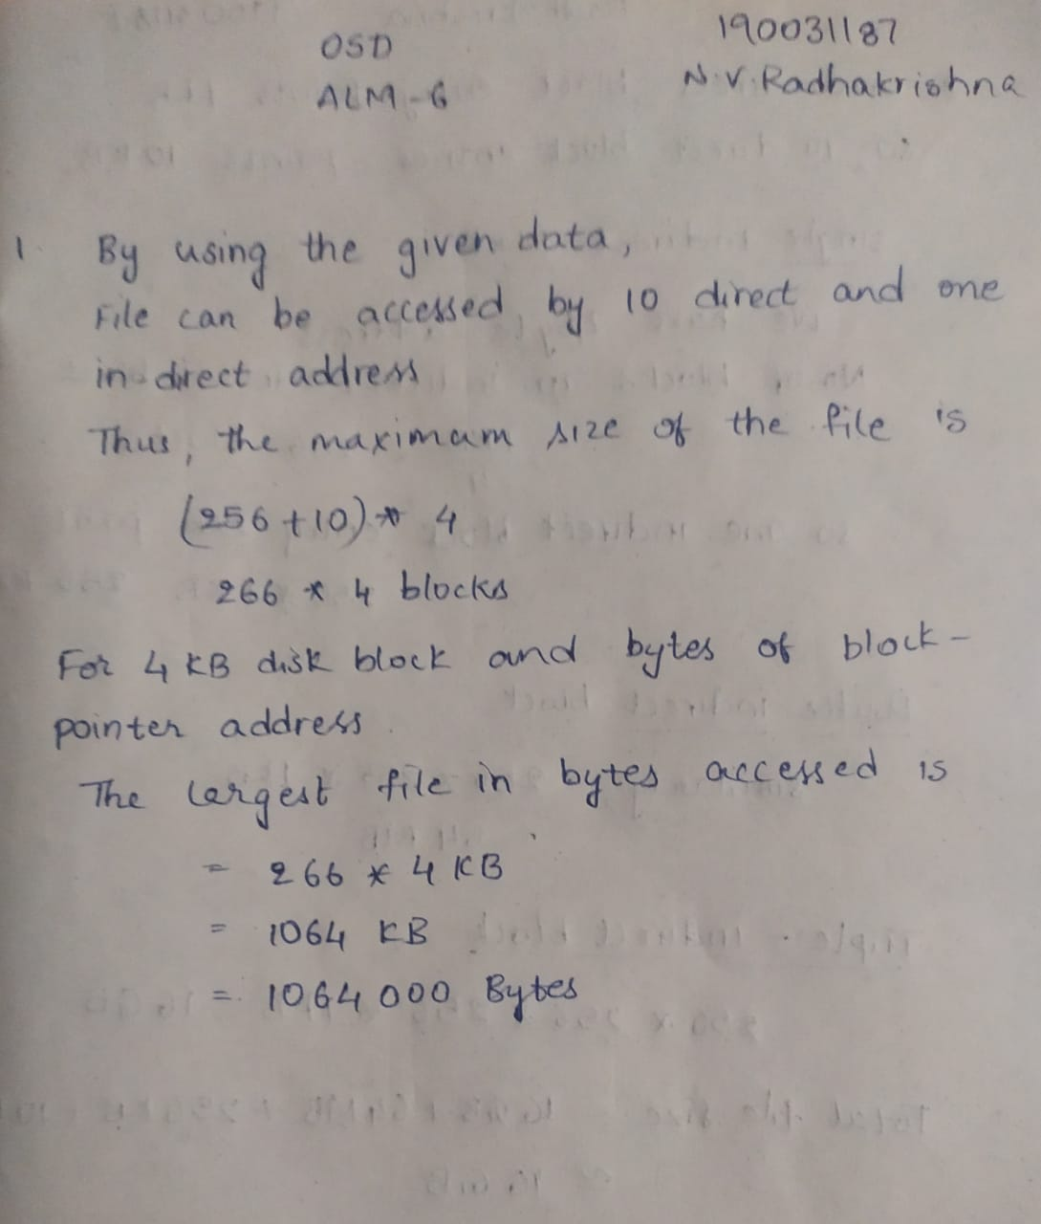

1. A UNIX file system has 1-KB blocks and 4-byte disk addresses. What is the maximum file size if i-nodes contain 10 direct entries, and one single, double, and triple indirect entry each?

**Solution:**

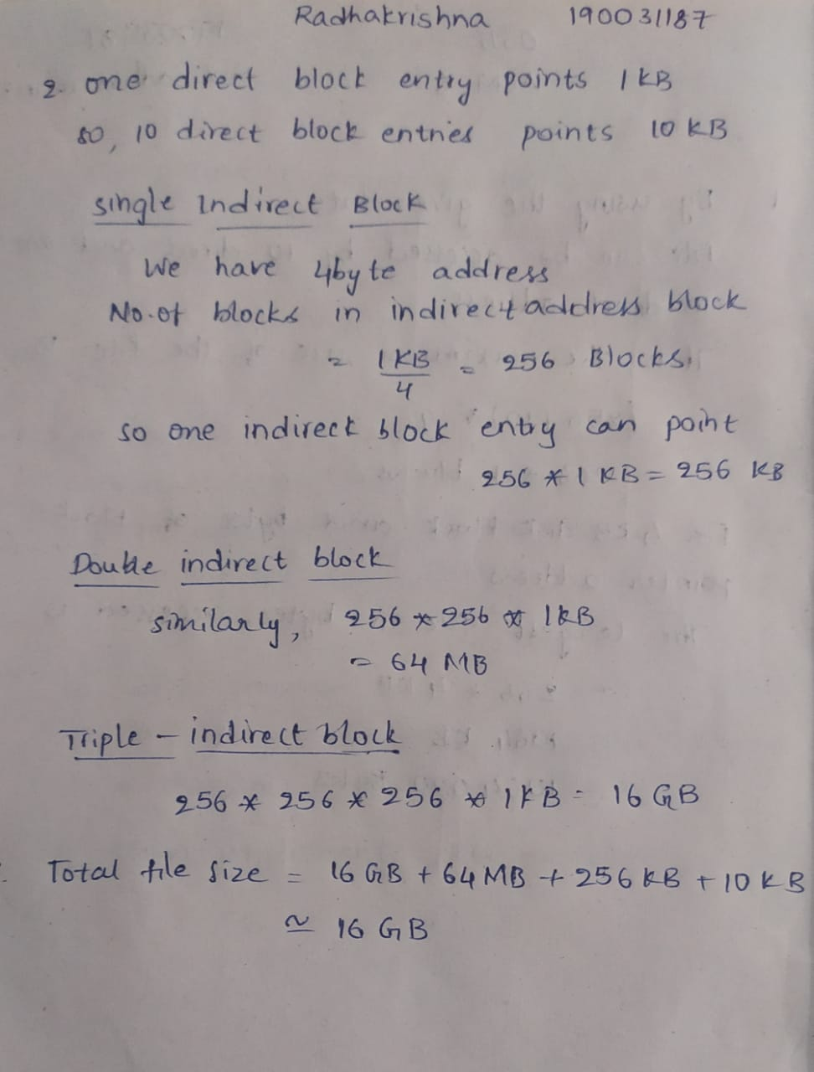

1. How many disk operations are needed to fetch the i-node for afile with the path name */usr/ast/courses/os/handout.t*? Assume that the i-node for the root directory is in memory, but nothing else along the path is in memory. Also assume that all directories fit in one disk block.

**Solution:**

