A SKILLING PROJECT OUTPUT SCREENSHOTS

Submitted towards the professional course

19CS2106A Operating System Design

Nerella Venkata Radhakrishna (190031187)

BACHELOR OF TECHNOLOGY

Branch: Computer Science and Engineering



NOVEMBER 2020

Department of Computer Science and Engineering

K L Deemed to be University,

Green Fields, Vaddeswaram,

Guntur District, A.P., 522502.

**TASK-1 | Shell**

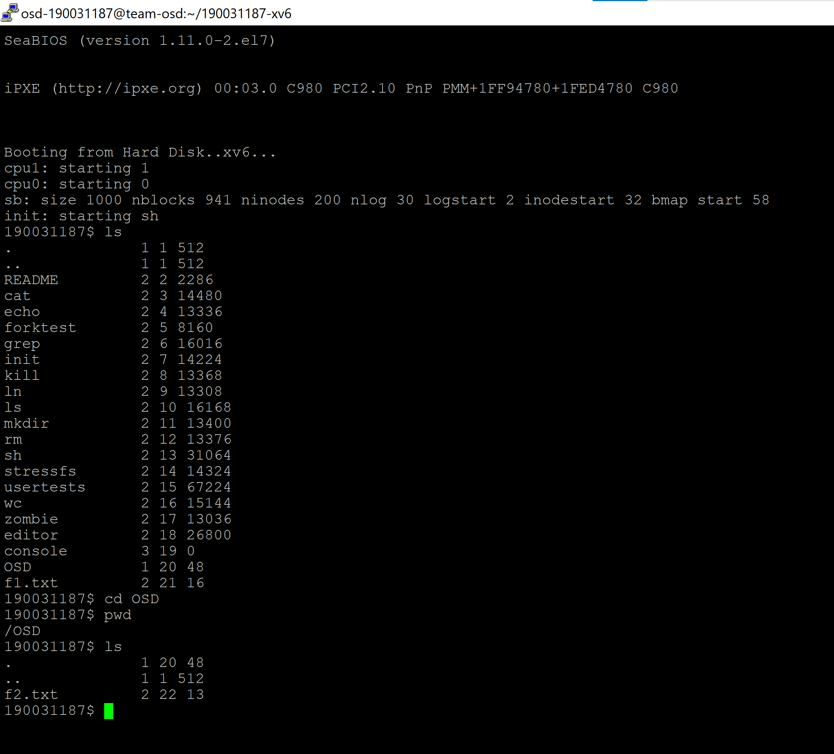

**TASK-2 | editor**

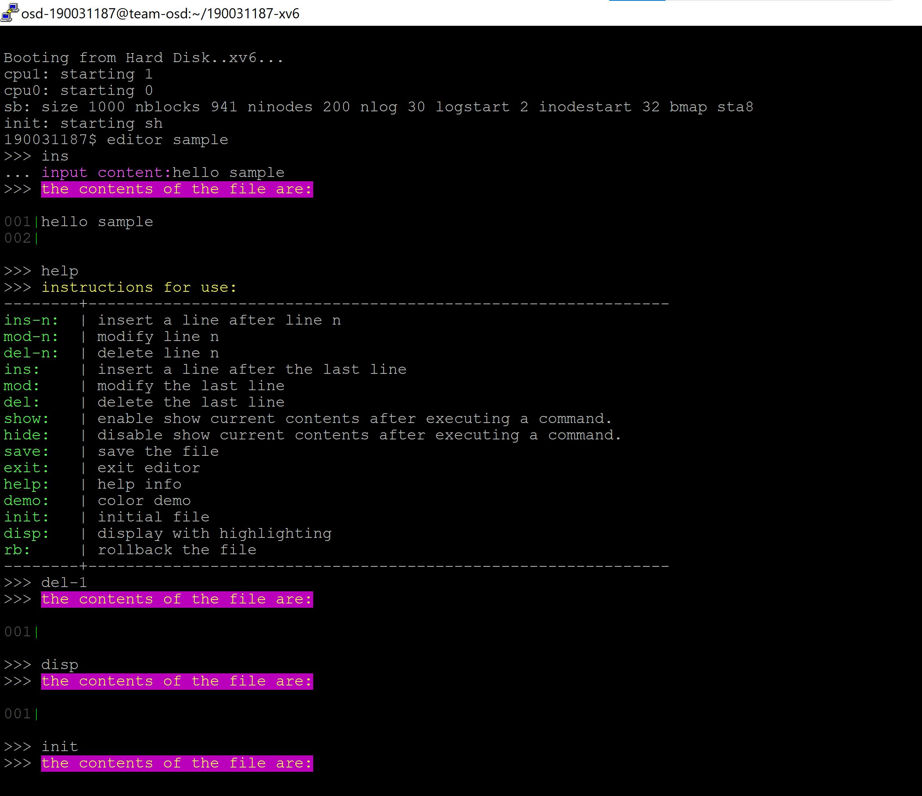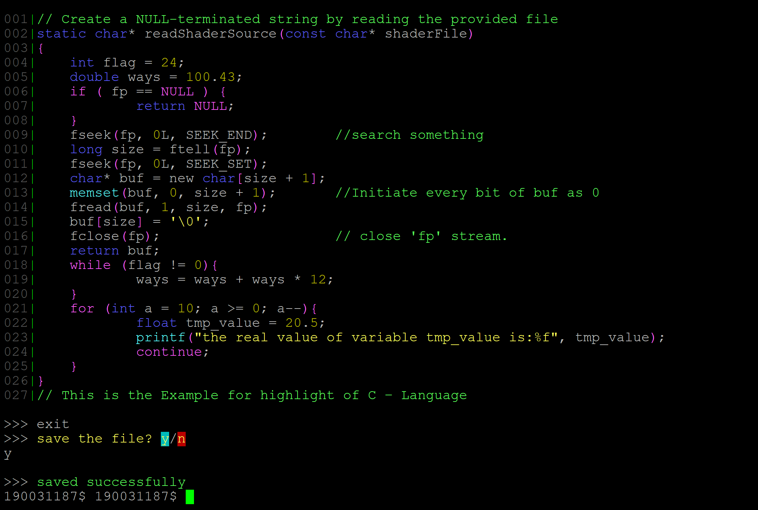

**TASK-3 | ls**

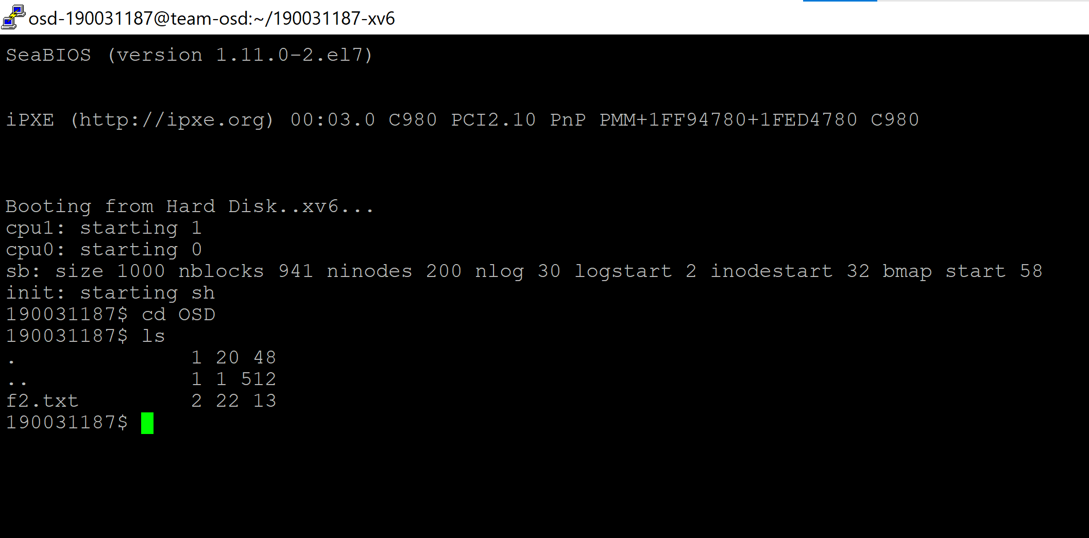

**Porting xv6 with POSIX compliance + VFS + ulibc + ACPI | Task-4**

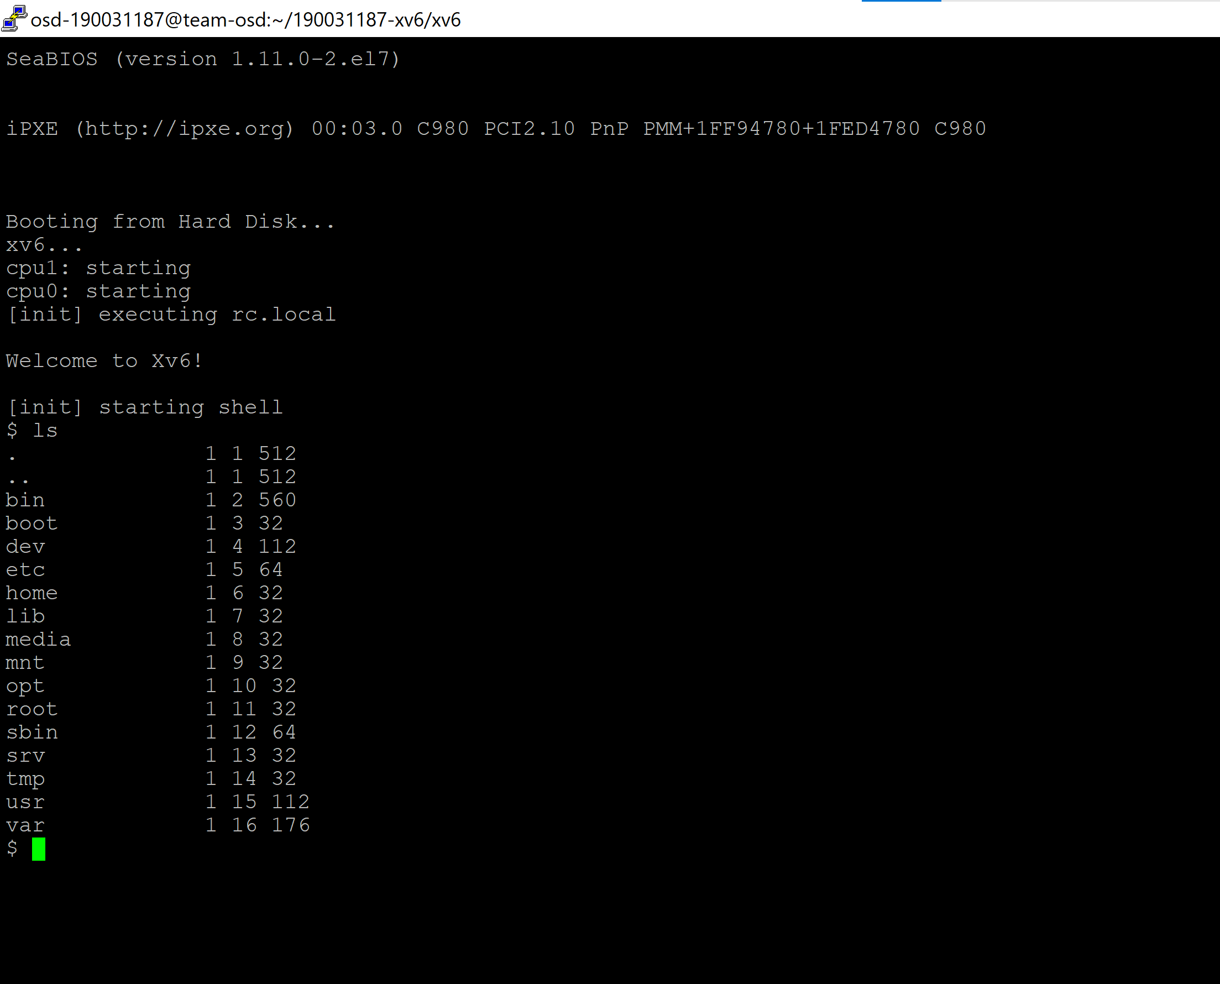

**TASK-5 | Mirrored RAID feature**

