IMPLEMENTATION OF **SHELL, EDITOR, LS, Porting xv6 with POSIX compliance + VFS + ulibc + ACPI, AND Mirrored RAID feature** IN XV6.

A SKILLING PROJECT REPORT

Submitted towards the professional course

19CS2106A Operating System Design

Nerella Venkata Radhakrishna (190031187)

BACHELOR OF TECHNOLOGY

Branch: Computer Science and Engineering



NOVEMBER 2020

Department of Computer Science and Engineering

K L Deemed to be University,

Green Fields, Vaddeswaram,

Guntur District, A.P., 522502.

TABLE OF CONTENTS

|  |  |
| --- | --- |
| CHAPTER NO. | TITLE |
| 1 | What is XV6? |
| 2 | SRS |
| 3 | Data Flow Diagram |
| 4 | Modules Description |
| 5 | Codes with output |
| 6 | Conclusion |

WHAT IS XV6?

**xv6** is a modern reimplementation of Sixth Edition Unix in ANSI C for multiprocessor x86 and RISC-V systems.

**Purpose:** Unlike Linux or BSD, xv6 is simple enough to cover in a semester, yet still contains the important concepts and organization of Unix.[2] Rather than study the original V6 code, the course uses xv6 since PDP-11 machines are not widely available and the original operating system was written in archaic pre-ANSI C.

Xv6 can be cloned into your system with the below command

➔ git clone https://github.com/mit-pdos/xv6-public.git

**System Requirements Specification**

# **1 Introduction**

## 1.1 Purpose

* Run an improvised version of the MIT XV6 basic OS
* Implement most common Command Line Interface functionalities in XV6
* Enhance smooth operation of the XV6
* Ensure security for the all the documents which will be saved in XV6

## 1.2 Scope

With the decrease in the number of people actually learning to work with the base OS like XV6 due to its lack of functionality even for educational purposes. We took it upon ourselves to create a Shell in XV6 with all the functionalities which we think is absolutely necessary for us someone to use it properly without any problem.

## 1.3 Overview of the system

The system focuses on improving the already existing open source XV6-public OS distribution by MIT on GitHub and use create the basic shell functionalities like Copying, Moving and Editing files and also to display all running process. This means we create a basic working Editor and add extra functionalities into it while at the same time implementing all missing common Linux commands.

# **2 General Requirements**

* Basic XV6 – use the MIT XV6 as a base code and make it run
* Copy – Implement a copy function to copy files from one location to another
* Move – enable moving a file from one location to another using the function
* Head – display first 10 lines of any file
* Tail – Display last 10 lines of any file
* Editor – Create a basic editor to create and modify files
* Process Display – display all running process

# **3 Functional Requirements**

## 3.1 Necessary requirements

* The user should have general computer knowledge
* The users should have a popular Linux Distribution
* User should have a virtualization command like Qemu or Qemu-KVD
* User should be comfortable with working on a sole Command-Line Interface without any mouse usage

## 3.2 Technical requirements

## Linux Distro with QEMU or any other Virtualization support must be installed.

# **4 Interface requirements**

**4.1 Software Requirements**

Visual Studio Code – A basic editor for modifying the code

## 4.2 Hardware Requirements

* Intel core i3 processor at 2.0 GHz or higher
* 256 MB RAM or higher
* 256 GB of Hard disk

# **6 Performance Requirements**

* Response time of the system should be as quick as possible.
* In case of technical issues, the system should try to handle it without entering Panic State

# **7 References**

* XV6 MIT PDOS
* COL331/COL633 Operating Systems Course Lecture Videos.
* XV6 Survival Guide
* XV6 Code Sheet

**Data Flow Models**

# **Level 0 DFD**

**TABLE DESCRIPTIONS**

# Main Memory

The RAM and HDD/SSD parts of an OS where all data is finally stored. It does not lose any data even when the OS enters a panic state or is shut down. It has a logical memory address or physical memory address. The RAM houses all files which are for immediate access while the HDD/SSD houses the rest.

# Buffers

The buffers are streams or intermediate storages that house all data for display or modification. The stream 2 is connected straight to the output terminal and is used for displaying in the Terminal. The other streams are used to carry around information and commands from all devices and the CPU.

# Structures

This Data Store stores all necessary structures required for functioning of a CPU. This table has predefined structures and cannot be modified unless the change is done directly to the source code. This data store houses the structures of Process Statistics or File Structures and is used for initiation of all core functionalities of a system.

## Level 1 DFD

## 

## Level 2 DFD

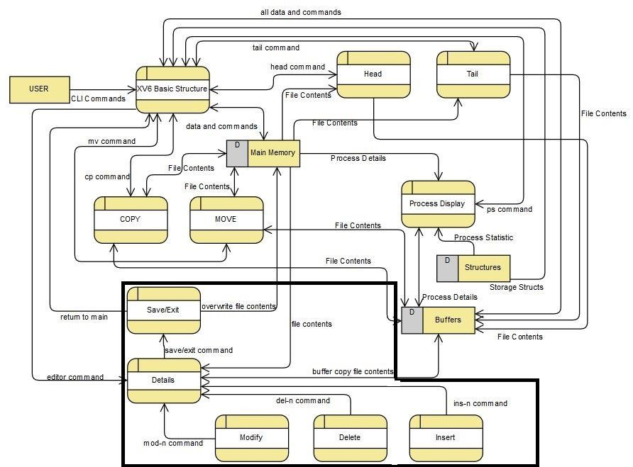

**MODULES DESCRIPTION**

## Shell

## Shell is the primary user interface to traditional Unix – like systems including XV6. The shell is an ordinary program (user level) that reads commands from the user and executes them. The xv6 shell is a simple implementation of the essence of the Unix Bourne shell. And It is a program that executes the other programs. It is user interface for access to an operating system service.

## Editor

Syntax: editor file1 or bedit file1 mode

Mandatory Parameters: file1

This module is used to open a basic editor that can be used to create a new file or view and modify an existing file. The editor can be used to insert, modify or delete a particular line. It can also be used to insert a huge block of text. The editor can also be used to add lines at end of the file. The editor displays the number of lines at each line and that can be used to specify after which line you need to insert or modify. When invoked, the editor goes to fetch the filename and if its non-existent, it then goes on to create a file of the given name. It then prints the whole text along with line numbers and then shows all possible options to choose from and execute. At the end, you can choose to exit with or without saving all changes.

**POSIX**

The Portable Operating System Interface (POSIX) is an IEEE standard that helps compatibility and portability between operating systems. Theoretically, POSIX compliant source code should be seamlessly portable. In the real world, application transition often runs into system specific issues.

**VFS**

The Virtual File System (also known as the Virtual Filesystem Switch) is the software layer in the kernel that provides the filesystem interface to user space programs. It also provides an abstraction within the kernel which allows different filesystem implementations to coexist.

**Ulibc**

It is a small C standard library intended for Linux kernel-based operating systems for embedded systems and mobile devices.

**ACPI**

ACPI, known as a Hardware Abstraction Layer (HAL) in embedded computing, is an abstraction layer between the operating system, platform firmware and hardware. This allows the OS and the platform to evolve independently. The core of the Linux ACPI implementation comes from ACPICA (ACPI Component Architecture).

These are basically enchantments (special features) to help in improvising a better a xv6.

**Mirrored Raid**

RAID Mirroring means an exact clone (or mirror) of the same data writing to two drives. A minimum two number of disks are more required in an array to create RAID1 and it's useful only, when read performance or reliability is more precise than the data storage capacity.

Here we perform two tests for Mirrored Raid Feature.

**Shell Code | Task - 1:**

// Shell.

#include "types.h"

#include "user.h"

#include "param.h"

#include "mmu.h"

#include "fcntl.h"

#include "proc.h"

#include "spinlock.h"

#define NELEM(x) (sizeof(x)/sizeof((x)[0]))

// Parsed command representation

#define EXEC 1

#define REDIR 2

#define PIPE 3

#define LIST 4

#define BACK 5

#define NULL 0

#define MAXARGS 10

// #define INT_MAX 2147483647

/// By Us

char *strcat(char *strg1, char *strg2)

{

char *start = strg1;

while(*strg1 != '\0')

{

strg1++;

}

while(*strg2 != '\0')

{

*strg1 = *strg2;

strg1++;

strg2++;

}

*strg1 = '\0';

return start;

}

struct cmd {

int type;

};

struct execcmd {

int type;

char *argv[MAXARGS];

char *eargv[MAXARGS];

};

struct redircmd {

int type;

struct cmd *cmd;

char *file;

char *efile;

int mode;

int fd;

};

struct pipecmd {

int type;

struct cmd *left;

struct cmd *right;

};

struct listcmd {

int type;

struct cmd *left;

struct cmd *right;

};

struct backcmd {

int type;

struct cmd *cmd;

};

/// pwd

struct directory{

char string[100];

struct directory *Next;

struct directory *Before;

};

int fork1(void); // Fork but panics on failure.

void panic(char*);

struct cmd *parsecmd(char*);

struct {

struct spinlock lock;

struct proc proc[NPROC];

} ptable;

///Build Directory

struct directory* CreateNode(char *Str)

{

struct directory* Temp = malloc(sizeof(struct directory));

//Temp->string = malloc(sizeof(Str));

strcpy(Temp->string,Str);

Temp->Before = Temp->Next = NULL;

return Temp;

}

// Execute cmd. Never returns.

void

runcmd(struct cmd *cmd)

{

int p[2];

struct backcmd *bcmd;

struct execcmd *ecmd;

struct listcmd *lcmd;

struct pipecmd *pcmd;

struct redircmd *rcmd;

char Point[] = "/" ;

if(cmd == 0)

exit();

switch(cmd->type){

default:

panic("runcmd");

case EXEC:

ecmd = (struct execcmd*)cmd;

if(ecmd->argv[0] == 0)

exit();

exec(strcat(Point,ecmd->argv[0]), ecmd->argv);

printf(2, "exec %s failed\n", ecmd->argv[0]);

break;

case REDIR:

rcmd = (struct redircmd*)cmd;

close(rcmd->fd);

if(open(rcmd->file, rcmd->mode) < 0){

printf(2, "open %s failed\n", rcmd->file);

exit();

}

runcmd(rcmd->cmd);

break;

case LIST:

lcmd = (struct listcmd*)cmd;

if(fork1() == 0)

runcmd(lcmd->left);

wait();

runcmd(lcmd->right);

break;

case PIPE:

pcmd = (struct pipecmd*)cmd;

if(pipe(p) < 0)

panic("pipe");

if(fork1() == 0){

close(1);

dup(p[1]);

close(p[0]);

close(p[1]);

runcmd(pcmd->left);

}

if(fork1() == 0){

close(0);

dup(p[0]);

close(p[0]);

close(p[1]);

runcmd(pcmd->right);

}

close(p[0]);

close(p[1]);

wait();

wait();

break;

case BACK:

bcmd = (struct backcmd*)cmd;

if(fork1() == 0)

runcmd(bcmd->cmd);

break;

}

exit();

}

int

getcmd(char *buf, int nbuf)

{

printf(2, "$ ");

memset(buf, 0, nbuf);

gets(buf, nbuf);

if(buf[0] == 0) // EOF

return -1;

return 0;

}

int

main(void)

{

static char buf[100];

int fd;

// Assumes three file descriptors open.

while((fd = open("console", O_RDWR)) >= 0){

if(fd >= 3){

close(fd);

break;

}

}

struct directory *Head_Directory = CreateNode("/");

struct directory *Curr = Head_Directory;

struct directory *prev = NULL;

// Read and run input commands.

while(getcmd(buf, sizeof(buf)) >= 0){

if(buf[0] == 'c' && buf[1] == 'd' && buf[2] == ' '){

// Clumsy but will have to do for now.

// Chdir has no effect on the parent if run in the child.

buf[strlen(buf)-1] = 0; // chop \n

int returnStatus = chdir(buf+3);

if(returnStatus < 0) {

printf(2, "cannot cd %s\n", buf + 3);

} else {/// By US

if(buf[3] == '/' && buf[4] == NULL)

{

Curr = Head_Directory;

Curr->Next = NULL;

prev = NULL;

continue;

}

if(buf[3] == '.' && buf[4] == '.')

{

if(Curr != Head_Directory)

{

if(Curr->Before == Head_Directory)

{

Curr = Head_Directory;

Curr->Next = NULL;

prev = NULL;

continue;

}

Curr = Curr->Before->Before;

Curr->Next = NULL;

prev = Curr->Before;

}

continue;

}

if(buf[3] == '.' && buf[4] == NULL)

{

continue;

}

int Flag = 0,i,k;

for(i = 4;i<strlen(buf);i++)

{

if(buf[i] == '/')

{

Flag = 1;

break;

}

}

struct directory *Next;

if(Flag){

char buffer[100];

if (buf[3] == '/')

{

Curr = Head_Directory;

Curr->Next = NULL;

prev = NULL;

}

for(i=3,k=0;i<strlen(buf);i++)// YET TO BE PERFECTED(several directory climb)

{

if ((strlen(buf) == i || i == 3) && buf[i] == '/'){

continue;

}

if (buffer[k-1] == '\0')

k=0;

if(buf[i] != '/'){

buffer[k++] = buf[i];

printf(1,"%s\n",buffer);

continue;

}

else

{

buffer[k++] = '\0';

if((i != 3 && buf[i] == '/') && Curr != Head_Directory)

{

Next = CreateNode("/");

Curr->Next = Next;

Curr->Before = prev;

prev = Curr;

Next->Before = Curr;

Curr = Curr->Next;

}

Next = CreateNode(buffer);

Curr->Next = Next;

Curr->Before = prev;

prev = Curr;

Next->Before = Curr;

Curr = Curr->Next;

}

}

if (buf[strlen(buf)] != '/'){

Next = CreateNode("/");

Curr->Next = Next;

Curr->Before = prev;

prev = Curr;

Next->Before = Curr;

Curr = Curr->Next;

Next = CreateNode(buffer);

Curr->Next = Next;

Curr->Before = prev;

prev = Curr;

Next->Before = Curr;

Curr = Curr->Next;

}

continue;

}

if (buf[3] == '/' )

{

Curr = Head_Directory;

Curr->Next = NULL;

prev = NULL;

Next = CreateNode(buf+4);

Curr->Next = Next;

Curr->Before = prev;

prev = Curr;

Next->Before = Curr;

Curr = Curr->Next;

continue;

}

if (Curr != Head_Directory && buf[3] != '/'){

Next = CreateNode("/");

Curr->Next = Next;

Curr->Before = prev;

prev = Curr;

Next->Before = Curr;

Curr = Curr->Next;

}

Next = CreateNode(buf+3);

Curr->Next = Next;

Curr->Before = prev;

prev = Curr;

Next->Before = Curr;

Curr = Curr->Next;

}

continue;

}

if(buf[0] == 'p' && buf[1] == 'w' && buf[2] == 'd')

{

struct directory *iter = Head_Directory;

while(iter)

{

printf(1,iter->string);

iter = iter->Next;

}

printf(1,"\n");

continue;

}

if(buf[0] == 'p' && buf[1] == 's')

{

static char *states[] = {

[UNUSED] "unused",

[EMBRYO] "embryo",

[SLEEPING] "sleep ",

[RUNNABLE] "runble",

[RUNNING] "run ",

[ZOMBIE] "zombie"

};

char *state;

struct proc *p;

printf(1, "F S UID PID PPID SZ WCHAN COMD\n");

for (p = ptable.proc; p < &ptable.proc[NPROC]; p++) {

if (p->state == UNUSED)

continue;

if (p->state >= 0 && p->state < NELEM(states) && states[p->state])

state = states[p->state];

else

state = "???";

printf(1, "2 %s Root %d %d %d %d %s\n", state, p->pid, p->parent->pid,p->sz,p->chan, p->name);

}

continue;

}

if(fork1() == 0)

runcmd(parsecmd(buf));

wait();

}

exit();

}

void

panic(char *s)

{

printf(2, "%s\n", s);

exit();

}

int

fork1(void)

{

int pid;

pid = fork();

if(pid == -1)

panic("fork");

return pid;

}

//PAGEBREAK!

// Constructors

struct cmd*

execcmd(void)

{

struct execcmd *cmd;

cmd = malloc(sizeof(*cmd));

memset(cmd, 0, sizeof(*cmd));

cmd->type = EXEC;

return (struct cmd*)cmd;

}

struct cmd*

redircmd(struct cmd *subcmd, char *file, char *efile, int mode, int fd){

struct redircmd *cmd;

cmd = malloc(sizeof(*cmd));

memset(cmd, 0, sizeof(*cmd));

cmd->type = REDIR;

cmd->cmd = subcmd;

cmd->file = file;

cmd->efile = efile;

cmd->mode = mode;

cmd->fd = fd;

return (struct cmd*)cmd;

}

struct cmd*

pipecmd(struct cmd *left, struct cmd *right)

{

struct pipecmd *cmd;

cmd = malloc(sizeof(*cmd));

memset(cmd, 0, sizeof(*cmd));

cmd->type = PIPE;

cmd->left = left;

cmd->right = right;

return (struct cmd*)cmd;

}

struct cmd*

listcmd(struct cmd *left, struct cmd *right)

{

struct listcmd *cmd;

cmd = malloc(sizeof(*cmd));

memset(cmd, 0, sizeof(*cmd));

cmd->type = LIST;

cmd->left = left;

cmd->right = right;

return (struct cmd*)cmd;

}

struct cmd*

backcmd(struct cmd *subcmd)

{

struct backcmd *cmd;

cmd = malloc(sizeof(*cmd));

memset(cmd, 0, sizeof(*cmd));

cmd->type = BACK;

cmd->cmd = subcmd;

return (struct cmd*)cmd;

}

//PAGEBREAK!

// Parsing

char whitespace[] = " \t\r\n\v";

char symbols[] = "<|>&;()";

int

gettoken(char **ps, char *es, char **q, char **eq)

{

char *s;

int ret;

s = *ps;

while(s < es && strchr(whitespace, *s))

s++;

if(q)

*q = s;

ret = *s;

switch(*s){

case 0:

break;

case '|':

case '(':

case ')':

case ';':

case '&':

case '<':

s++;

break;

case '>':

s++;

if(*s == '>'){

ret = '+';

s++;

}

break;

default:

ret = 'a';

while(s < es && !strchr(whitespace, *s) && !strchr(symbols, *s))

s++;

break;

}

if(eq)

*eq = s;

while(s < es && strchr(whitespace, *s))

s++;

*ps = s;

return ret;

}

int

peek(char **ps, char *es, char *toks)

{

char *s;

s = *ps;

while(s < es && strchr(whitespace, *s))

s++;

*ps = s;

return *s && strchr(toks, *s);

}

struct cmd *parseline(char**, char*);

struct cmd *parsepipe(char**, char*);

struct cmd *parseexec(char**, char*);

struct cmd *nulterminate(struct cmd*);

struct cmd*

parsecmd(char *s)

{

char *es;

struct cmd *cmd;

es = s + strlen(s);

cmd = parseline(&s, es);

peek(&s, es, "");

if(s != es){

printf(2, "leftovers: %s\n", s);

panic("syntax");

}

nulterminate(cmd);

return cmd;

}

struct cmd*

parseline(char **ps, char *es)

{

struct cmd *cmd;

cmd = parsepipe(ps, es);

while(peek(ps, es, "&")){

gettoken(ps, es, 0, 0);

cmd = backcmd(cmd);

}

if(peek(ps, es, ";")){

gettoken(ps, es, 0, 0);

cmd = listcmd(cmd, parseline(ps, es));

}

return cmd;

}

struct cmd*

parsepipe(char **ps, char *es)

{

struct cmd *cmd;

cmd = parseexec(ps, es);

if(peek(ps, es, "|")){

gettoken(ps, es, 0, 0);

cmd = pipecmd(cmd, parsepipe(ps, es));

}

return cmd;

}

struct cmd*

parseredirs(struct cmd *cmd, char **ps, char *es)

{

int tok;

char *q, *eq;

while(peek(ps, es, "<>")){

tok = gettoken(ps, es, 0, 0);

if(gettoken(ps, es, &q, &eq) != 'a')

panic("missing file for redirection");

switch(tok){

case '<':

cmd = redircmd(cmd, q, eq, O_RDONLY, 0); break;

case '>':

cmd = redircmd(cmd, q, eq, O_WRONLY|O_CREATE, 1);

break;

case '+': // >>

cmd = redircmd(cmd, q, eq, O_WRONLY|O_CREATE, 1);

break;

}

}

return cmd;

}

struct cmd*

parseblock(char **ps, char *es)

{

struct cmd *cmd;

if(!peek(ps, es, "("))

panic("parseblock");

gettoken(ps, es, 0, 0);

cmd = parseline(ps, es);

if(!peek(ps, es, ")"))

panic("syntax - missing )");

gettoken(ps, es, 0, 0);

cmd = parseredirs(cmd, ps, es);

return cmd;

}

struct cmd*

parseexec(char **ps, char *es)

{

char *q, *eq;

int tok, argc;

struct execcmd *cmd;

struct cmd *ret;

if(peek(ps, es, "("))

return parseblock(ps, es);

ret = execcmd();

cmd = (struct execcmd*)ret;

argc = 0;

ret = parseredirs(ret, ps, es);

while(!peek(ps, es, "|)&;")){

if((tok=gettoken(ps, es, &q, &eq)) == 0)

break;

if(tok != 'a')

panic("syntax");

cmd->argv[argc] = q;

cmd->eargv[argc] = eq;

argc++;

if(argc >= MAXARGS)

panic("too many args");

ret = parseredirs(ret, ps, es);

}

cmd->argv[argc] = 0;

cmd->eargv[argc] = 0;

return ret;

}

// NUL-terminate all the counted strings.

struct cmd*

nulterminate(struct cmd *cmd)

{

int i;

struct backcmd *bcmd;

struct execcmd *ecmd;

struct listcmd *lcmd;

struct pipecmd *pcmd;

struct redircmd *rcmd;

if(cmd == 0)

return 0;

switch(cmd->type){

case EXEC:

ecmd = (struct execcmd*)cmd;

for(i=0; ecmd->argv[i]; i++)

*ecmd->eargv[i] = 0;

break;

case REDIR:

rcmd = (struct redircmd*)cmd;

nulterminate(rcmd->cmd);

*rcmd->efile = 0;

break;

case PIPE:

pcmd = (struct pipecmd*)cmd;

nulterminate(pcmd->left);

nulterminate(pcmd->right);

break;

case LIST:

lcmd = (struct listcmd*)cmd;

nulterminate(lcmd->left);

nulterminate(lcmd->right);

break;

case BACK:

bcmd = (struct backcmd*)cmd;

nulterminate(bcmd->cmd);

break;

}

return cmd;

}

**OUTPUT:**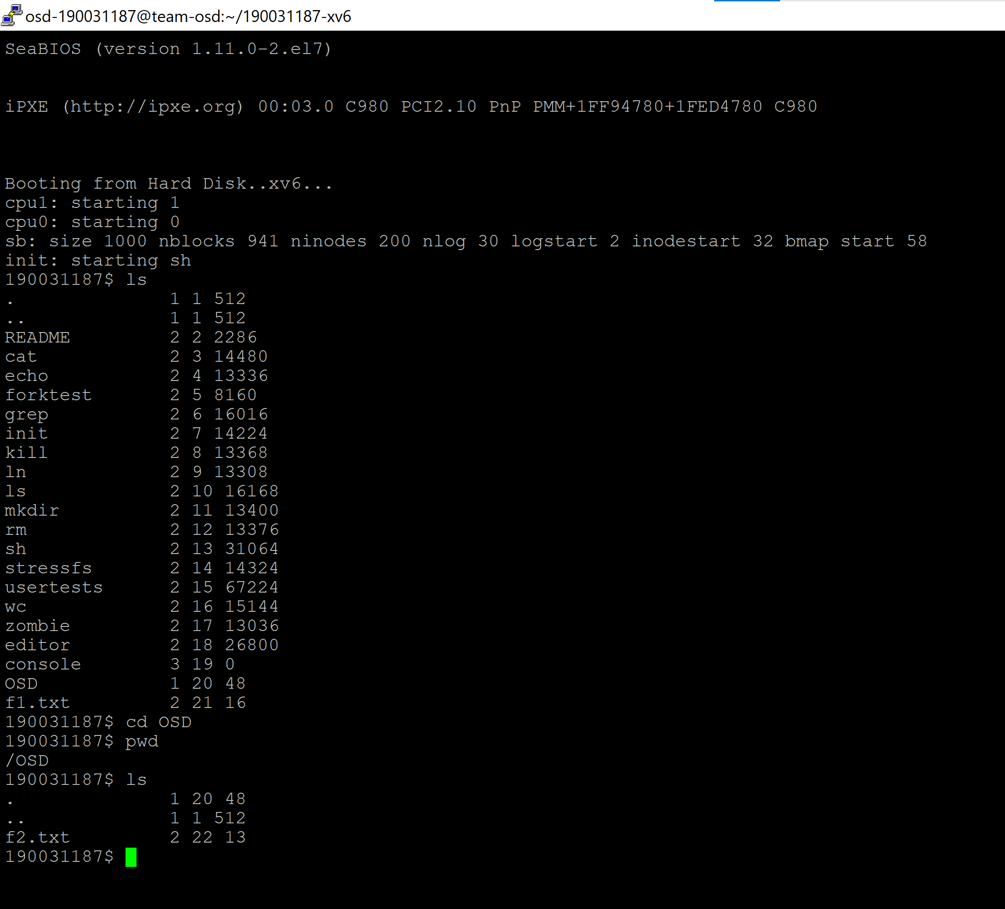

**Observation and Analysis:**

In Old shell pwd and ls was not working inside a directory. Here we observe, that an improvised shell is being used and was checked if properly working or not by executing one of the commands from list above.

🡪mkdir OSD

🡪cd OSD

🡪pwd

🡪ls

**Editor Code | Task-2:**

#include "types.h"

#include "stat.h"

#include "user.h"

#include "fcntl.h"

#include "fs.h"

#define BUF_SIZE 256

#define MAX_LINE_NUMBER 256

#define MAX_LINE_LENGTH 256

#define MAX_ROLLBAKC_STEP 20

#define NULL 0

// define some color variables

#define NONE "\e[0m"

#define BLACK "\e[0;30m"

#define L_BLACK "\e[1;30m"

#define RED "\e[0;31m"

#define L_RED "\e[1;31m"

#define GREEN "\e[0;32m"

#define L_GREEN "\e[1;32m"

#define YELLOW "\e[0;33m"

#define L_YELLOW "\e[1;33m"

#define BLUE "\e[0;34m"

#define L_BLUE "\e[1;34m"

#define PURPLE "\e[0;35m"

#define L_PURPLE "\e[1;35m"

#define CYAN "\e[0;36m"

#define L_CYAN "\e[1;36m"

#define GRAY "\e[0;37m"

#define WHITE "\e[1;37m"

char* strcat_n(char* dest, char* src, int len);

int get_line_number(char *text[]);

void show_text(char *text[]);

void com_ins(char *text[], int n, char *extra, int flag);

void com_mod(char *text[], int n, char *extra, int flag);

void com_del(char *text[], int n, int flag);

void com_help(char *text[]);

void com_save(char *text[], char *path);

void com_exit(char *text[], char *path);

void com_create_new_file(char *text[], char *path);

void com_display_color_demo();

void com_init_file(char *text[], char *path);

void show_text_syntax_highlighting(char *text[]);

void com_rollback(char *text[], int n);

void record_command(char *command);

int stringtonumber(char* src);

void number2string(int num, char array[]);

int changed = 0;

int auto_show = 1;

int line_number = 0;

char *command_set[MAX_ROLLBAKC_STEP] = {};

int upper_bound = -1;

int main(int argc, char *argv[]) {

int is_new_file = 0;

if (argc == 1) {

printf(1, ">>> \e[1;31mplease input the command as [editor file_name]\n\e[0m");

exit();

}

char *text[MAX_LINE_NUMBER] = {};

text[0] = malloc(MAX_LINE_LENGTH);

memset(text[0], 0, MAX_LINE_LENGTH);

int fd = open(argv[1], O_RDONLY);

if (fd != -1) {

//printf(1, ">>> \e[1;33mfile exist\n\e[0m");

char buf[BUF_SIZE] = {};

int len = 0;

while ((len = read(fd, buf, BUF_SIZE)) > 0) {

int i = 0;

int next = 0;

int is_full = 0;

while (i < len) {

for (i = next; i < len && buf[i] != '\n'; i++)

;

strcat_n(text[line_number], buf+next, i-next);

if (i < len && buf[i] == '\n') {

if (line_number >= MAX_LINE_NUMBER - 1)

is_full = 1;

else {

line_number++;

text[line_number] = malloc(MAX_LINE_LENGTH);

memset(text[line_number], 0, MAX_LINE_LENGTH);

}

}

if (is_full == 1 || i >= len - 1)

break;

else

next = i + 1;

}

if (is_full == 1)

break;

}

close(fd);

} else{

com_create_new_file(text, argv[1]);

is_new_file = 1;

}

if(!is_new_file && auto_show){

show_text_syntax_highlighting(text);

}

char input[MAX_LINE_LENGTH] = {};

while (1)

{

//printf(1, ">>> \e[1;33mplease input command:\n\e[0m");

printf(1, ">>> \e[1;33m\e[0m");

memset(input, 0, MAX_LINE_LENGTH);

gets(input, MAX_LINE_LENGTH);

int len = strlen(input);

input[len-1] = '\0';

len --;

int pos = MAX_LINE_LENGTH - 1;

int j = 0;

for (; j < 8; j++)

{

if (input[j] == ' ')

{

pos = j + 1;

break;

}

}

if (input[0] == 'i' && input[1] == 'n' && input[2] == 's')

{

if (input[3] == '-'&&stringtonumber(&input[4])>=0)

{

com_ins(text, stringtonumber(&input[4]), &input[pos], 1);

line_number = get_line_number(text);

}

else if(input[3] == ' '||input[3] == '\0')

{

com_ins(text, line_number+1+1, &input[pos], 1);

line_number = get_line_number(text);

}

else

{

//printf(1, ">>> \033[1m\e[43;31minvalid command.\e[0m\n");

printf(1, ">>> \033[1m\e[41;33minvalid command.\e[0m\n");

//com_help(text);

}

}

//mod

else if (input[0] == 'm' && input[1] == 'o' && input[2] == 'd')

{

if (input[3] == '-'&&stringtonumber(&input[4])>=0)

com_mod(text, atoi(&input[4]), &input[pos], 1);

else if(input[3] == ' '||input[3] == '\0')

com_mod(text, line_number + 1, &input[pos], 1);

else {

printf(1, ">>> \033[1m\e[41;33minvalid command.\e[0m\n");

//com_help(text);

}

}

//del

else if (input[0] == 'd' && input[1] == 'e' && input[2] == 'l') {

if (input[3] == '-'&&stringtonumber(&input[4])>=0)

{

com_del(text, stringtonumber(&input[4]), 1);

line_number = get_line_number(text);

}

else if(input[3]=='\0')

{

com_del(text, line_number + 1, 1);

line_number = get_line_number(text);

}

else

{

printf(1, ">>> \033[1m\e[41;33minvalid command.\e[0m\n");

//com_help(text);

}

}

else if (strcmp(input, "show") == 0)

{

auto_show = 1;

printf(1, ">>> \e[1;33menable show current contents after text changed.\n\e[0m");

}

else if (strcmp(input, "hide") == 0)

{

auto_show = 0;

printf(1, ">>> \e[1;33mdisable show current contents after text changed.\n\e[0m");

}

// rollback

else if(strcmp(input, "rb") == 0){

com_rollback(text, 1);

}

else if (strcmp(input, "help") == 0)

com_help(text);

// save

else if (strcmp(input, "save") == 0 || strcmp(input, "CTRL+S\n") == 0)

com_save(text, argv[1]);

else if (strcmp(input, "exit") == 0)

com_exit(text, argv[1]);

else if (strcmp(input, "demo") == 0)

com_display_color_demo();

else if (strcmp(input, "init") == 0)

com_init_file(text, argv[1]);

else if(strcmp(input, "disp") == 0){

show_text_syntax_highlighting(text);

}

else if(strcmp(input, "normaldisp") == 0){

show_text(text);

}

else

{

printf(1, ">>> \033[1m\e[41;33minvalid command.\e[0m\n");

//com_help(text);

}

}

exit();

}

char* strcat_n(char* dest, char* src, int len)

{

if (len <= 0)

return dest;

int pos = strlen(dest);

if (len + pos >= MAX_LINE_LENGTH)

return dest;

int i = 0;

for (; i < len; i++)

dest[i+pos] = src[i];

dest[len+pos] = '\0';

return dest;

}

void show_text(char *text[])

{

printf(1, ">>> \033[1m\e[45;33mthe contents of the file are:\e[0m\n");

printf(1, "\n");

int j = 0;

for (; text[j] != NULL; j++)

if(strcmp(text[j], "\n") == 0){

printf(1, "\e[1;30m%d%d%d\e[0m\e[0;32m|\e[0m\n", (j+1)/100, ((j+1)%100)/10, (j+1)%10);

}

else{

printf(1, "\e[1;30m%d%d%d\e[0m\e[0;32m|\e[0m%s\n", (j+1)/100, ((j+1)%100)/10, (j+1)%10, text[j]);

}

printf(1, "\n");

}

int get_line_number(char *text[])

{

int i = 0;

for (; i < MAX_LINE_NUMBER; i++)

if (text[i] == NULL)

return i - 1;

return i - 1;

}

int stringtonumber(char* src)

{

int number = 0;

int i=0;

int pos = strlen(src);

for(;i<pos;i++)

{

if(src[i]==' ') break;

if(src[i]>57||src[i]<48) return -1;

number=10*number+(src[i]-48);

}

return number;

}

void number2string(int num, char array[]) {

char array_rvs[20] = {};

int i, sign;

if ((sign = num)<0) // record the sign

num = -num; // make num into positive number

i = 0;

do {

array_rvs[i++] = num % 10 + '0'; // fatch the next number

} while ((num /= 10)>0); // delete this number

if (sign<0)

array_rvs[i++] = '-';

array_rvs[i] = '\0';

int length = strlen(array_rvs);

int j;

for (j = 0; j < length; j++) {

array[j] = array_rvs[length - 1 - j];

}

array[length] = '\0';

}

void com_ins(char *text[], int n, char *extra, int flag)

{

if (n <= 0 || n > get_line_number(text) + 1 + 1)

{

printf(1, ">>> \033[1m\e[41;33minvalid line number\e[0m\n");

return;

}

char input[MAX_LINE_LENGTH] = {};

if (*extra == '\0')

{

printf(1, "... \e[1;35minput content:\e[0m");

gets(input, MAX_LINE_LENGTH);

input[strlen(input)-1] = '\0';

}

else

strcpy(input, extra);

char *part4 = malloc(MAX_LINE_LENGTH);

if(flag){

strcpy(part4, text[n-1]);

}

int i = MAX_LINE_NUMBER - 1;

for (; i > n-1; i--)

{

if (text[i-1] == NULL)

continue;

else if (text[i] == NULL && text[i-1] != NULL)

{

text[i] = malloc(MAX_LINE_LENGTH);

memset(text[i], 0, MAX_LINE_LENGTH);

strcpy(text[i], text[i-1]);

}

else if (text[i] != NULL && text[i-1] != NULL)

{

memset(text[i], 0, MAX_LINE_LENGTH);

strcpy(text[i], text[i-1]);

}

}

// couldn't understand what this code block means

// maybe it allocates space for text[n-1] to avoid none space of text[n-1]

if (text[n-1] == NULL)

{

text[n-1] = malloc(MAX_LINE_LENGTH);

if (text[n-2][0] == '\0')

{

memset(text[n-1], 0, MAX_LINE_LENGTH);

strcpy(text[n-2], input);

changed = 1;

if (auto_show == 1)

show_text_syntax_highlighting(text);

return;

}

}

memset(text[n-1], 0, MAX_LINE_LENGTH);

strcpy(text[n-1], input);

changed = 1;

if(flag){

// record the command into command_set

char *command = malloc(MAX_LINE_LENGTH);

char part1[] = "ins-";

char part2[10];

number2string(n, part2);

char part3[] = " \0";

strcat_n(part1, part2, strlen(part2));

strcat_n(part1, part3, strlen(part3));

strcat_n(part1, part4, strlen(part4));

strcpy(command, part1);

record_command(command);

}

if (auto_show == 1)

show_text_syntax_highlighting(text);

}

void com_mod(char *text[], int n, char *extra, int flag)

{

if (n <= 0 || n > get_line_number(text) + 1)

{

printf(1, ">>> \033[1m\e[41;33minvalid line number\e[0m\n");

return;

}

char input[MAX_LINE_LENGTH] = {};

if (*extra == '\0')

{

printf(1, "... \e[1;35minput content:\e[0m");

gets(input, MAX_LINE_LENGTH);

input[strlen(input)-1] = '\0';

}

else

strcpy(input, extra);

char *part4 = malloc(MAX_LINE_LENGTH);

if(flag){

strcpy(part4, text[n-1]);

}

memset(text[n-1], 0, MAX_LINE_LENGTH);

strcpy(text[n-1], input);

changed = 1;

if(flag){

// record the command into command_set

char *command = malloc(MAX_LINE_LENGTH);

char part1[] = "mod-";

char part2[10];

number2string(n, part2);

char part3[] = " \0";

strcat_n(part1, part2, strlen(part2));

strcat_n(part1, part3, strlen(part3));

strcat_n(part1, part4, strlen(part4));

strcpy(command, part1);

record_command(command);

}

if (auto_show == 1)

show_text_syntax_highlighting(text);

}

void com_del(char *text[], int n, int flag)

{

if (n <= 0 || n > get_line_number(text) + 1)

{

//printf(1, "n: %d\n", n);

printf(1, ">>> \033[1m\e[41;33minvalid line number\e[0m\n");

return;

}

char *part4 = malloc(MAX_LINE_LENGTH);

if(flag){

strcpy(part4, text[n-1]);

}

memset(text[n-1], 0, MAX_LINE_LENGTH);

int i = n - 1;

for (; text[i+1] != NULL; i++)

{

strcpy(text[i], text[i+1]);

memset(text[i+1], 0, MAX_LINE_LENGTH);

}

if (i != 0)

{

free(text[i]);

text[i] = 0;

}

changed = 1;

if(0){

char part1[] = "del-";

char part2[10];

number2string(n, part2);

char part3[] = " \0";

strcat_n(part1, part2, strlen(part2));

strcat_n(part1, part3, strlen(part3));

char* part5 = malloc(MAX_LINE_LENGTH);

memset(part5, 0, MAX_LINE_LENGTH);

strcat_n(part5, part1, strlen(part1));

strcat_n(part5, part4, strlen(part4));

record_command(part5);

}

if (auto_show == 1)

show_text_syntax_highlighting(text);

}

void com_save(char *text[], char *path)

{

unlink(path);

int fd = open(path, O_WRONLY|O_CREATE);

if (fd == -1)

{

printf(1, ">>> \033[1m\e[41;33msave failed, file can't open:\e[0m\n");

//setProgramStatus(SHELL);

exit();

}

if (text[0] == NULL)

{

close(fd);

return;

}

write(fd, text[0], strlen(text[0]));

int i = 1;

for (; text[i] != NULL; i++)

{

printf(fd, "\n");

write(fd, text[i], strlen(text[i]));

}

close(fd);

printf(1, ">>> \e[1;32msaved successfully\e[0m\n");

changed = 0;

return;

}

void com_exit(char *text[], char *path)

{

while (changed == 1)

{

printf(1, ">>> \e[1;33msave the file?\e[0m \033[1m\e[46;33my\e[0m/\033[1m\e[41;33mn\e[0m\n");

char input[MAX_LINE_LENGTH] = {};

gets(input, MAX_LINE_LENGTH);

input[strlen(input)-1] = '\0';

if (strcmp(input, "y") == 0)

com_save(text, path);

else if(strcmp(input, "n") == 0)

break;

else

printf(2, ">>> \e[1;31mwrong answer?\e[0m\n");

}

int i = 0;

for (; text[i] != NULL; i++)

{

free(text[i]);

text[i] = 0;

}

exit();

}

// create new file

void com_create_new_file(char *text[], char *path){

int fd = open(path, O_WRONLY|O_CREATE);

if(fd == -1){

printf(1, ">>> \e[1;31mcreate file failed\e[0m\n");

exit();

}

}

void com_display_color_demo(){

printf(1, ">>> \e[1;33mcolor demo:\n\e[0m");

printf(1, "----------------+-------------------------------+-----------------------\n");

printf(1, "L_BLACK: | \e[1;30mI am happy.\e[0m | \e[1;30m\\e[1;30m\e[0m\n");

printf(1, "BLACK: | \e[0;30mI am happy.\e[0m | \e[0;30m\\e[0;30m\e[0m\n");

printf(1, "RED: | \e[0;31mI am happy.\e[0m | \e[0;31m\\e[0;31m\e[0m\n");

printf(1, "L_RED: | \e[1;31mI am happy.\e[0m | \e[1;31m\\e[1;31m\e[0m\n");

printf(1, "GREEN: | \e[0;32mI am happy.\e[0m | \e[0;32m\\e[0;32m\e[0m\n");

printf(1, "L_GREEN: | \e[1;32mI am happy.\e[0m | \e[1;32m\\e[1;32m\e[0m\n");

printf(1, "YELLOW: | \e[0;33mI am happy. \e[0m | \e[0;33m\\e[0;33m\e[0m\n");

printf(1, "L_YELLOW: | \e[1;33mI am happy. \e[0m | \e[1;33m\\e[1;33m\e[0m\n");

printf(1, "BLUE: | \e[0;34mI am happy. \e[0m | \e[0;34m\\e[0;34m\e[0m\n");

printf(1, "L_BLUE: | \e[1;34mI am happy. \e[0m | \e[1;34m\\e[1;34m\e[0m\n");

printf(1, "PURPLE: | \e[0;35mI am happy. \e[0m | \e[0;35m\\e[0;35m\e[0m\n");

printf(1, "L_PURPLE: | \e[1;35mI am happy. \e[0m | \e[1;35m\\e[1;35m\e[0m\n");

printf(1, "CYAN: | \e[0;36mI am happy. \e[0m | \e[0;36m\\e[0;36m\e[0m\n");

printf(1, "L_CYAN: | \e[1;36mI am happy. \e[0m | \e[1;36m\\e[1;36m\e[0m\n");

printf(1, "GRAY: | \e[0;37mI am happy. \e[0m | \e[0;37m\\e[0;37m\e[0m\n");

printf(1, "WHITE: | \e[1;37mI am happy. \e[0m | \e[1;37m\\e[1;37m\e[0m\n");

printf(1, "----------------+-------------------------------+-----------------------\n");

}

void com_help(char *text[])

{

printf(1, ">>> \e[1;33minstructions for use:\n\e[0m");

printf(1, "--------+--------------------------------------------------------------\n");

printf(1, "\e[1;32mins-n:\e[0m | insert a line after line n\n");

printf(1, "\e[1;32mmod-n:\e[0m | modify line n\n");

printf(1, "\e[1;32mdel-n:\e[0m | delete line n\n");

printf(1, "\e[1;32mins:\e[0m | insert a line after the last line\n");

printf(1, "\e[1;32mmod:\e[0m | modify the last line\n");

printf(1, "\e[1;32mdel:\e[0m | delete the last line\n");

printf(1, "\e[1;32mshow:\e[0m | enable show current contents after executing a command.\n");

printf(1, "\e[1;32mhide:\e[0m | disable show current contents after executing a command.\n");

printf(1, "\e[1;32msave:\e[0m | save the file\n");

printf(1, "\e[1;32mexit:\e[0m | exit editor\n");

printf(1, "\e[1;32mhelp:\e[0m | help info\n");

printf(1, "\e[1;32mdemo:\e[0m | color demo\n");

printf(1, "\e[1;32minit:\e[0m | initial file\n");

printf(1, "\e[1;32mdisp:\e[0m | display with highlighting\n");

printf(1, "\e[1;32mrb:\e[0m | rollback the file\n");

printf(1, "--------+--------------------------------------------------------------\n");

}

void com_init_file(char *text[], char *path){

char *buf[MAX_LINE_NUMBER] = {};

int i;

for(i = 0; i < MAX_LINE_NUMBER; i++){

buf[i] = malloc(MAX_LINE_LENGTH);

}

strcpy(buf[0], "// Create a NULL-terminated string by reading the provided file");

strcpy(buf[1], "static char* readShaderSource(const char* shaderFile)");

strcpy(buf[2], "{");

strcpy(buf[3], " int flag = 24;");

strcpy(buf[4], " double ways = 100.43;");

strcpy(buf[5], " if ( fp == NULL ) {");

strcpy(buf[6], " return NULL;");

strcpy(buf[7], " }");

strcpy(buf[8], " fseek(fp, 0L, SEEK_END); //search something");

strcpy(buf[9], " long size = ftell(fp);");

strcpy(buf[10], " fseek(fp, 0L, SEEK_SET);");

strcpy(buf[11], " char* buf = new char[size + 1];");

strcpy(buf[12], " memset(buf, 0, size + 1); //Initiate every bit of buf as 0");

strcpy(buf[13], " fread(buf, 1, size, fp);");

strcpy(buf[14], " buf[size] = '\\0';");

strcpy(buf[15], " fclose(fp); // close 'fp' stream.");

strcpy(buf[16], " return buf;");

strcpy(buf[17], " while (flag != 0){");

strcpy(buf[18], " ways = ways + ways * 12;");

strcpy(buf[19], " }");

strcpy(buf[20], " for (int a = 10; a >= 0; a--){");

strcpy(buf[21], " float tmp_value = 20.5;");

strcpy(buf[22], " printf(\"the real value of variable tmp_value is:%f\", tmp_value);");

strcpy(buf[23], " continue;");

strcpy(buf[24], " }");

strcpy(buf[25], "}");

strcpy(buf[26], "// This is the Example for highlight of C – Language ");

for(i = 0; i <= 26; i++){

text[i] = malloc(MAX_LINE_LENGTH);

strcpy(text[i], buf[i]);

}

line_number = get_line_number(text);

show_text_syntax_highlighting(text);

changed = 1;

}

void show_text_syntax_highlighting(char *text[]){

printf(1, ">>> \033[1m\e[45;33mthe contents of the file are:\e[0m\n");

printf(1, "\n");

int j = 0;

for (; text[j] != NULL; j++){

printf(1, "\e[1;30m%d%d%d\e[0m\e[0;32m|\e[0m", (j+1)/100, ((j+1)%100)/10, (j+1)%10);

int pos = 0;

int a;

for(a = 0; a < MAX_LINE_LENGTH; a++){

if(text[j][a] != ' '){

pos = a;

break;

}

}

if(strcmp(text[j], "\n") == 0){

printf(1, "\n");

}

else if(text[j][pos] == '/' && text[j][pos+1] == '/'){

printf(1, "\e[1;32m%s\n\e[0m", text[j]);

}

else{

int mark = 0;

int flag_annotation = 0;

while(mark < MAX_LINE_LENGTH && text[j][mark] != NULL){

// do something with 'mark' and print all the statements

// by the way of one letter by one letter

// judge annotation

if(flag_annotation){

printf(1, "\e[1;32m%c\e[0m", text[j][mark++]);

//mark++;

continue;

}

// numbers

if(text[j][mark] >= '0' && text[j][mark] <= '9'){

printf(1, "\033[0;33m%c\033[0m", text[j][mark]);

mark++;

}

// printf

else if((mark+5)<MAX_LINE_LENGTH && text[j][mark] == 'p' && text[j][mark+1] == 'r'

&& text[j][mark+2] == 'i' && text[j][mark+3] == 'n' && text[j][mark+4] == 't'

&& text[j][mark+5] == 'f'){

printf(1, "\e[1;36m%c\e[0m", text[j][mark]);

printf(1, "\e[1;36m%c\e[0m", text[j][mark+1]);

printf(1, "\e[1;36m%c\e[0m", text[j][mark+2]);

printf(1, "\e[1;36m%c\e[0m", text[j][mark+3]);

printf(1, "\e[1;36m%c\e[0m", text[j][mark+4]);

printf(1, "\e[1;36m%c\e[0m", text[j][mark+5]);

mark = mark + 6;

}

// int

else if((mark+2)<MAX_LINE_LENGTH && text[j][mark] == 'i' && text[j][mark+1] == 'n'

&& text[j][mark+2] == 't'){

// highlighting 'int' string

printf(1, "\e[1;34m%c\e[0m", text[j][mark]);

printf(1, "\e[1;34m%c\e[0m", text[j][mark+1]);

printf(1, "\e[1;34m%c\e[0m", text[j][mark+2]);

mark = mark + 3;

}

// float

else if((mark+4)<MAX_LINE_LENGTH && text[j][mark] == 'f' && text[j][mark+1] == 'l' && text[j][mark+2] == 'o'

&& text[j][mark+3] == 'a' && text[j][mark+4] == 't'){

printf(1, "\e[1;34m%c\e[0m", text[j][mark]);

printf(1, "\e[1;34m%c\e[0m", text[j][mark+1]);

printf(1, "\e[1;34m%c\e[0m", text[j][mark+2]);

printf(1, "\e[1;34m%c\e[0m", text[j][mark+3]);

printf(1, "\e[1;34m%c\e[0m", text[j][mark+4]);

mark = mark + 5;

}

// double

else if((mark+5)<MAX_LINE_LENGTH && text[j][mark] == 'd' && text[j][mark+1] == 'o' && text[j][mark+2] == 'u'

&& text[j][mark+3] == 'b' && text[j][mark+4] == 'l' && text[j][mark+5] == 'e'){

printf(1, "\e[1;34m%c\e[0m", text[j][mark]);

printf(1, "\e[1;34m%c\e[0m", text[j][mark+1]);

printf(1, "\e[1;34m%c\e[0m", text[j][mark+2]);

printf(1, "\e[1;34m%c\e[0m", text[j][mark+3]);

printf(1, "\e[1;34m%c\e[0m", text[j][mark+4]);

printf(1, "\e[1;34m%c\e[0m", text[j][mark+5]);

mark = mark + 6;

}

// char

else if((mark+3)<MAX_LINE_LENGTH && text[j][mark] == 'c' && text[j][mark+1] == 'h' && text[j][mark+2] == 'a'

&& text[j][mark+3] == 'r'){

printf(1, "\e[1;34m%c\e[0m", text[j][mark]);

printf(1, "\e[1;34m%c\e[0m", text[j][mark+1]);

printf(1, "\e[1;34m%c\e[0m", text[j][mark+2]);

printf(1, "\e[1;34m%c\e[0m", text[j][mark+3]);

mark = mark + 4;

}

// if

else if((mark+1)<MAX_LINE_LENGTH && text[j][mark] == 'i' && text[j][mark+1] == 'f'){

printf(1, "\e[1;35m%c\e[0m", text[j][mark]);

printf(1, "\e[1;35m%c\e[0m", text[j][mark+1]);

mark = mark + 2;

}

// else

else if((mark+3)<MAX_LINE_LENGTH && text[j][mark] == 'e' && text[j][mark+1] == 'l' && text[j][mark+2] == 's'

&& text[j][mark+3] == 'e'){

printf(1, "\e[1;35m%c\e[0m", text[j][mark]);

printf(1, "\e[1;35m%c\e[0m", text[j][mark+1]);

printf(1, "\e[1;35m%c\e[0m", text[j][mark+2]);

printf(1, "\e[1;35m%c\e[0m", text[j][mark+3]);

mark = mark + 4;

}

// else if

else if((mark+5)<MAX_LINE_LENGTH && text[j][mark] == 'e' && text[j][mark+1] == 'l' && text[j][mark+2] == 's'

&& text[j][mark+3] == 'e' && text[j][mark+4] == ' ' && text[j][mark+5] == 'i' && text[j][mark+6] == 'f'){

printf(1, "\e[1;35m%c\e[0m", text[j][mark]);

printf(1, "\e[1;35m%c\e[0m", text[j][mark+1]);

printf(1, "\e[1;35m%c\e[0m", text[j][mark+2]);

printf(1, "\e[1;35m%c\e[0m", text[j][mark+3]);

printf(1, "\e[1;35m%c\e[0m", text[j][mark+4]);

printf(1, "\e[1;35m%c\e[0m", text[j][mark+5]);

printf(1, "\e[1;35m%c\e[0m", text[j][mark+6]);

mark = mark + 7;

}

else if((mark+2)<MAX_LINE_LENGTH && text[j][mark] == 'f' && text[j][mark+1] == 'o' && text[j][mark+2] == 'r'){

// highlighting 'int' string

printf(1, "\e[1;35m%c\e[0m", text[j][mark]);

printf(1, "\e[1;35m%c\e[0m", text[j][mark+1]);

printf(1, "\e[1;35m%c\e[0m", text[j][mark+2]);

mark = mark + 3;

}

else if((mark+4)<MAX_LINE_LENGTH && text[j][mark] == 'w' && text[j][mark+1] == 'h' && text[j][mark+2] == 'i'

&& text[j][mark+3] == 'l' && text[j][mark+4] == 'e'){

printf(1, "\e[1;35m%c\e[0m", text[j][mark]);

printf(1, "\e[1;35m%c\e[0m", text[j][mark+1]);

printf(1, "\e[1;35m%c\e[0m", text[j][mark+2]);

printf(1, "\e[1;35m%c\e[0m", text[j][mark+3]);

printf(1, "\e[1;35m%c\e[0m", text[j][mark+4]);

mark = mark + 5;

}

// long

else if((mark+3)<MAX_LINE_LENGTH && text[j][mark] == 'l' && text[j][mark+1] == 'o' && text[j][mark+2] == 'n'

&& text[j][mark+3] == 'g'){

printf(1, "\e[1;34m%c\e[0m", text[j][mark]);

printf(1, "\e[1;34m%c\e[0m", text[j][mark+1]);

printf(1, "\e[1;34m%c\e[0m", text[j][mark+2]);

printf(1, "\e[1;34m%c\e[0m", text[j][mark+3]);

mark = mark + 4;

}

// {}[]()

else if(text[j][mark] == '{' || text[j][mark] == '}' || text[j][mark] == '[' || text[j][mark] == ']'

|| text[j][mark] == '(' || text[j][mark] == ')'){

printf(1, "\e[1;35m%c\e[0m", text[j][mark]);

mark++;

}

// static

else if((mark+5)<MAX_LINE_LENGTH && text[j][mark] == 's' && text[j][mark+1] == 't' && text[j][mark+2] == 'a'

&& text[j][mark+3] == 't' && text[j][mark+4] == 'i' && text[j][mark+5] == 'c'){

printf(1, "\e[1;34m%c\e[0m", text[j][mark]);

printf(1, "\e[1;34m%c\e[0m", text[j][mark+1]);

printf(1, "\e[1;34m%c\e[0m", text[j][mark+2]);

printf(1, "\e[1;34m%c\e[0m", text[j][mark+3]);

printf(1, "\e[1;34m%c\e[0m", text[j][mark+4]);

printf(1, "\e[1;34m%c\e[0m", text[j][mark+5]);

mark = mark + 6;

}

// const

else if((mark+4)<MAX_LINE_LENGTH && text[j][mark] == 'c' && text[j][mark+1] == 'o' && text[j][mark+2] == 'n'

&& text[j][mark+3] == 's' && text[j][mark+4] == 't'){

printf(1, "\e[1;34m%c\e[0m", text[j][mark]);

printf(1, "\e[1;34m%c\e[0m", text[j][mark+1]);

printf(1, "\e[1;34m%c\e[0m", text[j][mark+2]);

printf(1, "\e[1;34m%c\e[0m", text[j][mark+3]);

printf(1, "\e[1;34m%c\e[0m", text[j][mark+4]);

mark = mark + 5;

}

// memset

else if((mark+5)<MAX_LINE_LENGTH && text[j][mark] == 'm' && text[j][mark+1] == 'e' && text[j][mark+2] == 'm'

&& text[j][mark+3] == 's' && text[j][mark+4] == 'e' && text[j][mark+5] == 't'){

printf(1, "\e[1;36m%c\e[0m", text[j][mark]);

printf(1, "\e[1;36m%c\e[0m", text[j][mark+1]);

printf(1, "\e[1;36m%c\e[0m", text[j][mark+2]);

printf(1, "\e[1;36m%c\e[0m", text[j][mark+3]);

printf(1, "\e[1;36m%c\e[0m", text[j][mark+4]);

printf(1, "\e[1;36m%c\e[0m", text[j][mark+5]);

mark = mark + 6;

}

// //

else if((mark+1)<MAX_LINE_LENGTH && text[j][mark] == '/' && text[j][mark] == '/'){

printf(1, "\e[1;32m%c\e[0m", text[j][mark]);

printf(1, "\e[1;32m%c\e[0m", text[j][mark+1]);

mark = mark + 2;

flag_annotation = 1;

}

// NULL

else if((mark+3)<MAX_LINE_LENGTH && text[j][mark] == 'N' && text[j][mark+1] == 'U' && text[j][mark+2] == 'L'

&& text[j][mark+3] == 'L'){

printf(1, "\e[1;35m%c\e[0m", text[j][mark]);

printf(1, "\e[1;35m%c\e[0m", text[j][mark+1]);

printf(1, "\e[1;35m%c\e[0m", text[j][mark+2]);

printf(1, "\e[1;35m%c\e[0m", text[j][mark+3]);

mark = mark + 4;

}

// character string

else if(text[j][mark] == '"'){

int tmp_pos = mark+1;

int end = -1;

while(tmp_pos < MAX_LINE_LENGTH){

if(text[j][tmp_pos] == '"'){

end = tmp_pos;

break;

}

else{

tmp_pos++;

}

}

int inter;

for(inter = mark; inter <= end; inter++){

printf(1, "\e[1;33m%c\e[0m", text[j][inter]);

}

mark = end + 1;

}

// single character

else if(text[j][mark] == '\''){

int tmp_pos = mark+1;

int end = -1;

while(tmp_pos < MAX_LINE_LENGTH){

if(text[j][tmp_pos] == '\''){

end = tmp_pos;

break;

}

else{

tmp_pos++;

}

}

int inter;

for(inter = mark; inter <= end; inter++){

printf(1, "\e[1;33m%c\e[0m", text[j][inter]);

}

mark = end + 1;

}

// continue

else if((mark+5)<MAX_LINE_LENGTH && text[j][mark] == 'c' && text[j][mark+1] == 'o' && text[j][mark+2] == 'n'

&& text[j][mark+3] == 't' && text[j][mark+4] == 'i' && text[j][mark+5] == 'n' && text[j][mark+6] == 'u'

&& text[j][mark+7] == 'e'){

printf(1, "\e[1;35m%c\e[0m", text[j][mark]);

printf(1, "\e[1;35m%c\e[0m", text[j][mark+1]);

printf(1, "\e[1;35m%c\e[0m", text[j][mark+2]);

printf(1, "\e[1;35m%c\e[0m", text[j][mark+3]);

printf(1, "\e[1;35m%c\e[0m", text[j][mark+4]);

printf(1, "\e[1;35m%c\e[0m", text[j][mark+5]);

printf(1, "\e[1;35m%c\e[0m", text[j][mark+6]);

printf(1, "\e[1;35m%c\e[0m", text[j][mark+7]);

mark = mark + 8;

}

// return

else if((mark+5)<MAX_LINE_LENGTH && text[j][mark] == 'r' && text[j][mark+1] == 'e' && text[j][mark+2] == 't'

&& text[j][mark+3] == 'u' && text[j][mark+4] == 'r' && text[j][mark+5] == 'n'){

printf(1, "\e[1;34m%c\e[0m", text[j][mark]);

printf(1, "\e[1;34m%c\e[0m", text[j][mark+1]);

printf(1, "\e[1;34m%c\e[0m", text[j][mark+2]);

printf(1, "\e[1;34m%c\e[0m", text[j][mark+3]);

printf(1, "\e[1;34m%c\e[0m", text[j][mark+4]);

printf(1, "\e[1;34m%c\e[0m", text[j][mark+5]);

mark = mark + 6;

}

else{

printf(1, "%c\e[0m", text[j][mark]);

mark++;

}

}

printf(1, "\n");

}

}

printf(1, "\n");

}

void com_rollback(char *text[], int n){

// rollback the command

if(upper_bound < 0){

printf(1, ">>> \033[1m\e[41;33mcouldn't rollback\e[0m\n");

return;

}

char *input = malloc(MAX_LINE_LENGTH);

strcpy(input, command_set[upper_bound]);

upper_bound--;

// searching the first space of command

int pos = MAX_LINE_LENGTH - 1;

int j = 0;

for (; j < 10; j++) {

if (input[j] == ' ')

{

pos = j + 1;

break;

}

}

// deal 'ins' command

if (input[0] == 'i' && input[1] == 'n' && input[2] == 's')

{

// the line to be deleted

int line = stringtonumber(&input[4]);

com_del(text, line, 0);

line_number = get_line_number(text);

}

// deal 'mod' command

else if (input[0] == 'm' && input[1] == 'o' && input[2] == 'd')

{

// the line to be modified

int line = stringtonumber(&input[4]);

// the content of mod

char *content = &input[pos];

com_mod(text, line, content, 0);

line_number = get_line_number(text);

}

// deal 'del' command

else if (input[0] == 'd' && input[1] == 'e' && input[2] == 'l')

{

// the line to be deleted

int line = stringtonumber(&input[4]);

// the content of deletion

char *content = &input[pos];

com_ins(text, line, content, 0);

line_number = get_line_number(text);

}

}

void record_command(char *command){

if((upper_bound+1) < MAX_ROLLBAKC_STEP){

command_set[upper_bound+1] = malloc(MAX_LINE_LENGTH);

strcpy(command_set[upper_bound+1], command);

upper_bound++;

}

else{

int i;

for(i = 1; i < MAX_ROLLBAKC_STEP; i++){

strcpy(command_set[i-1], command_set[i]);

}

strcpy(command_set[upper_bound], command);

upper_bound = MAX_ROLLBAKC_STEP - 1;

}

}

**OUTPUT:**

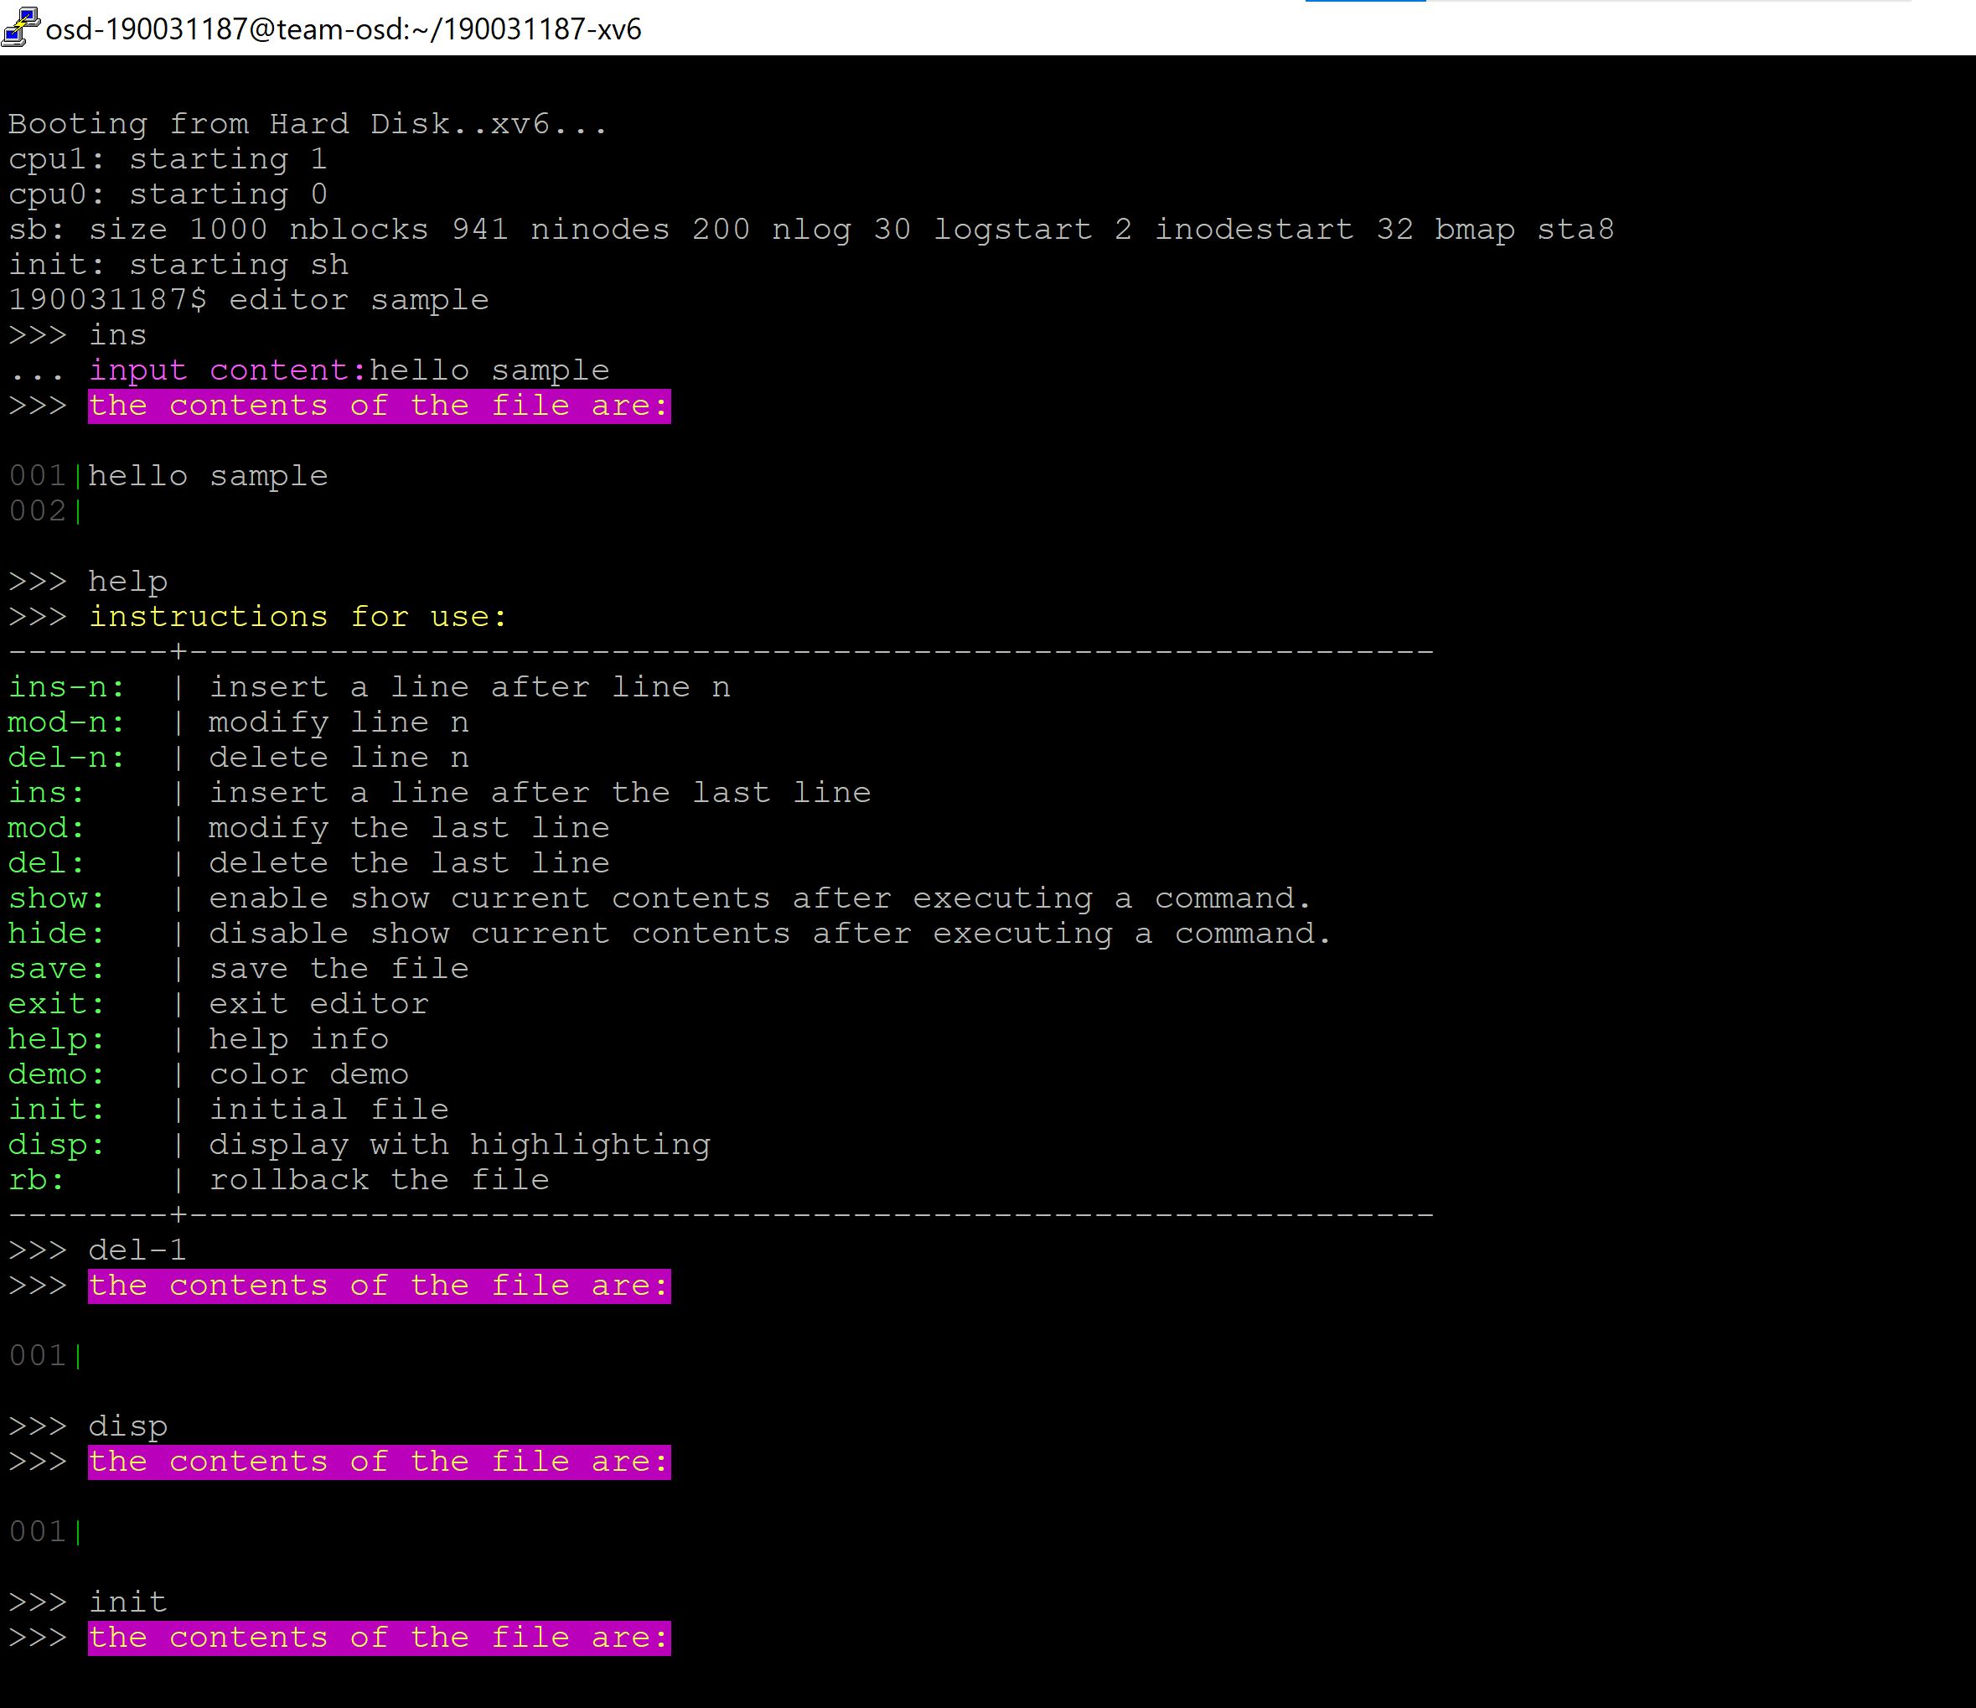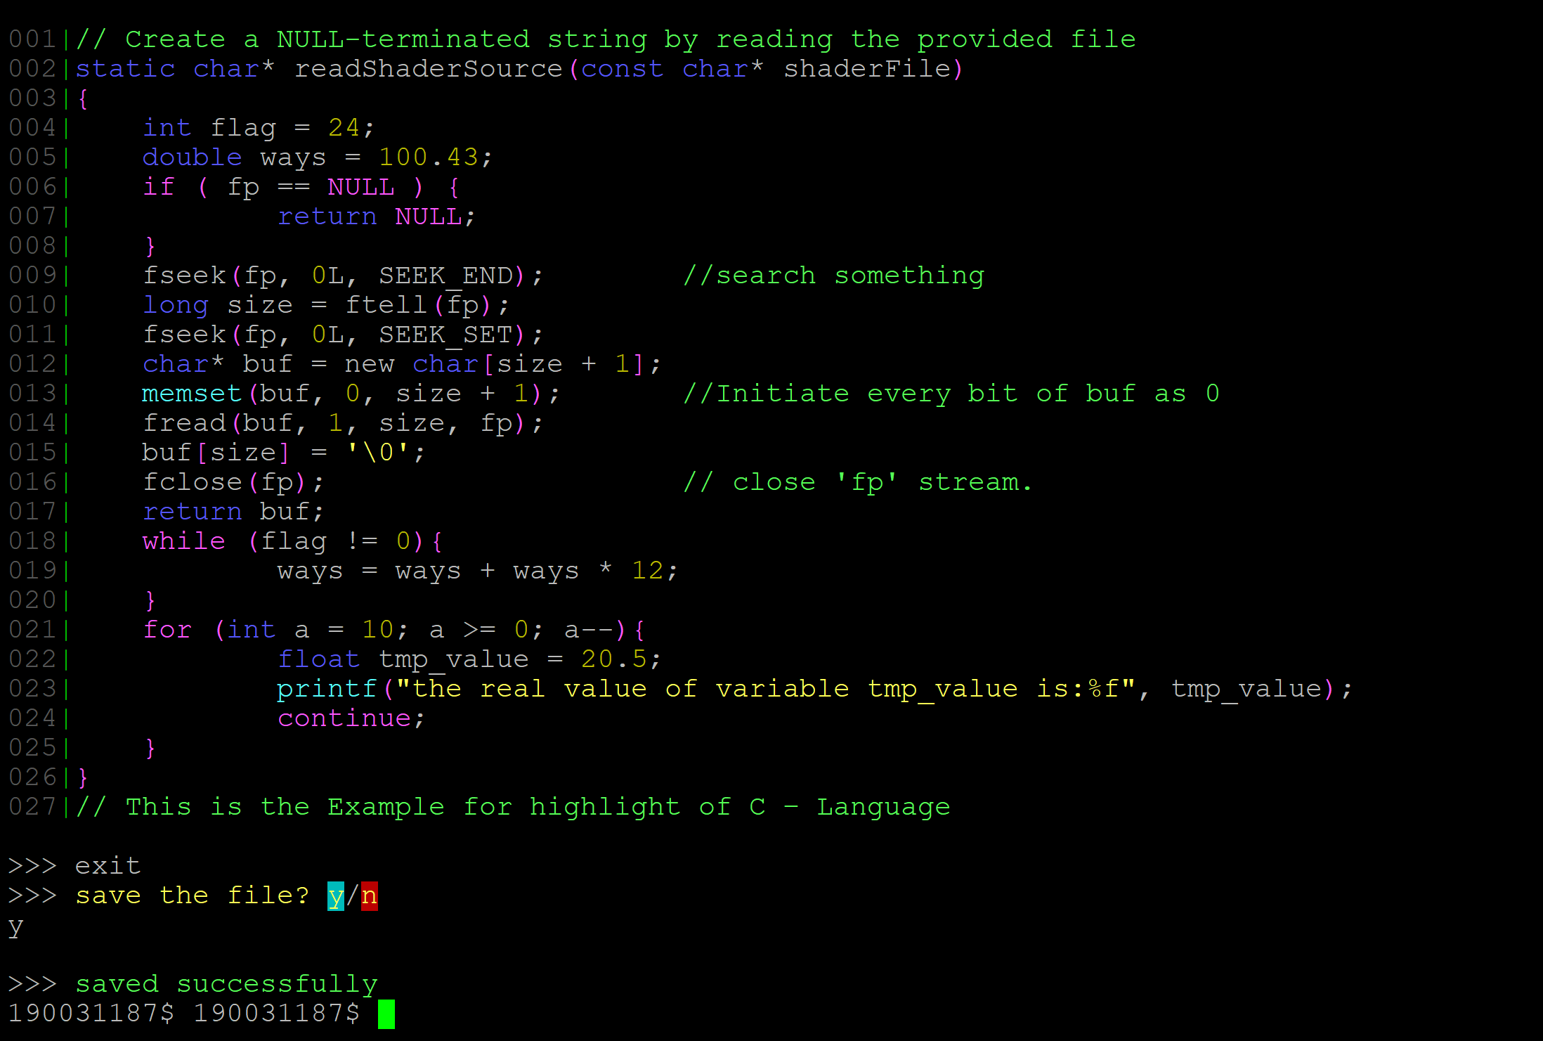

**Observation and Analysis:**

Here a file **sample** is created by using the editor command. After execution, the editor also asks whether to **save** the file or not and exits the editor by command **exit**. We can also try the **ins-n** command which takes a parameter called line from user to insert or delete in a particular line. If you need any command description **help** command displays all the commands along with their description. **disp** command displays the content in the file. It also highlights c language.

**ls.c Code | Task-3:**

/*ls.c*/

#include "types.h"

#include "stat.h"

#include "user.h"

#include "fs.h"

char*

fmtname(char *path)

{

static char buf[DIRSIZ+1];

char *p;

// Find first character after last slash.

for(p=path+strlen(path); p >= path && *p != '/'; p--)

;

p++;

// Return blank-padded name.

if(strlen(p) >= DIRSIZ)

return p;

memmove(buf, p, strlen(p));

memset(buf+strlen(p), ' ', DIRSIZ-strlen(p));

return buf;

}

void

ls(char *path)

{

char buf[512], *p;

int fd;

struct dirent de;

struct stat st;

if((fd = open(path, 0)) < 0){

printf(2, "ls: cannot open %s\n", path);

return;

}

if(fstat(fd, &st) < 0){

printf(2, "ls: cannot stat %s\n", path);

close(fd);

return;

}

switch(st.type){

case T_FILE:

printf(1, "%s %d %d %d\n", fmtname(path), st.type, st.ino, st.size);

break;

case T_DIR:

if(strlen(path) + 1 + DIRSIZ + 1 > sizeof buf){

printf(1, "ls: path too long\n");

break;

}

strcpy(buf, path);

p = buf+strlen(buf);

*p++ = '/';

while(read(fd, &de, sizeof(de)) == sizeof(de)){

if(de.inum == 0)

continue;

memmove(p, de.name, DIRSIZ);

p[DIRSIZ] = 0;

if(stat(buf, &st) < 0){

printf(1, "ls: cannot stat %s\n", buf);

continue;

}

printf(1, "%s %d %d %d\n", fmtname(buf), st.type, st.ino, st.size);

}

break;

}

close(fd);

}

int

main(int argc, char *argv[])

{

int i;

if(argc < 2){

ls(".");

exit();

}

for(i=1; i<argc; i++)

ls(argv[i]);

exit();

}

**OUTPUT:**

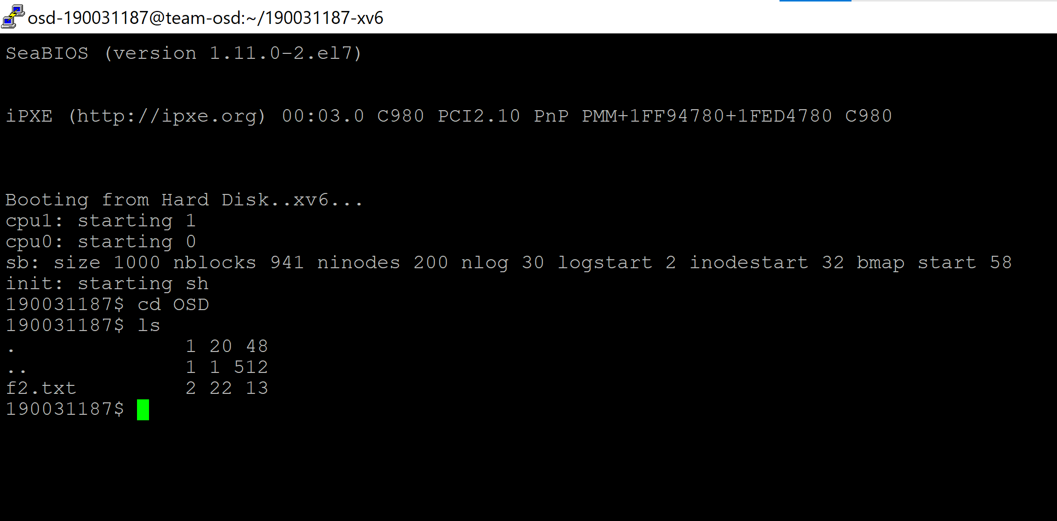

**Observation and Analysis:**

Here we observe the ls command working by creating a folder/directory by using ‘mkdir’ command and creating a sample.txt file in the directory and use ls to list the text file.

**Porting xv6 with POSIX compliance + VFS + ulibc + ACPI | Task-4:**

1. First clone the repository from GitHub to your local repository.  
   -> git clone https://github.com/NewbiZ/xv6
2. Open Makefile and make following changes

line 61; QEMU = qemu-system-i386

line 62; qemu: distrib/distrib.img disk.img

line 63; $(LOG_CMD) $(QEMU) -nographic -serial mon:stdio -hdb distrib/distrib.img disk.img -smp 2 -m 512 $(QEMUEXTRA)

1. Type make qemu-nox

**OUTPUT**

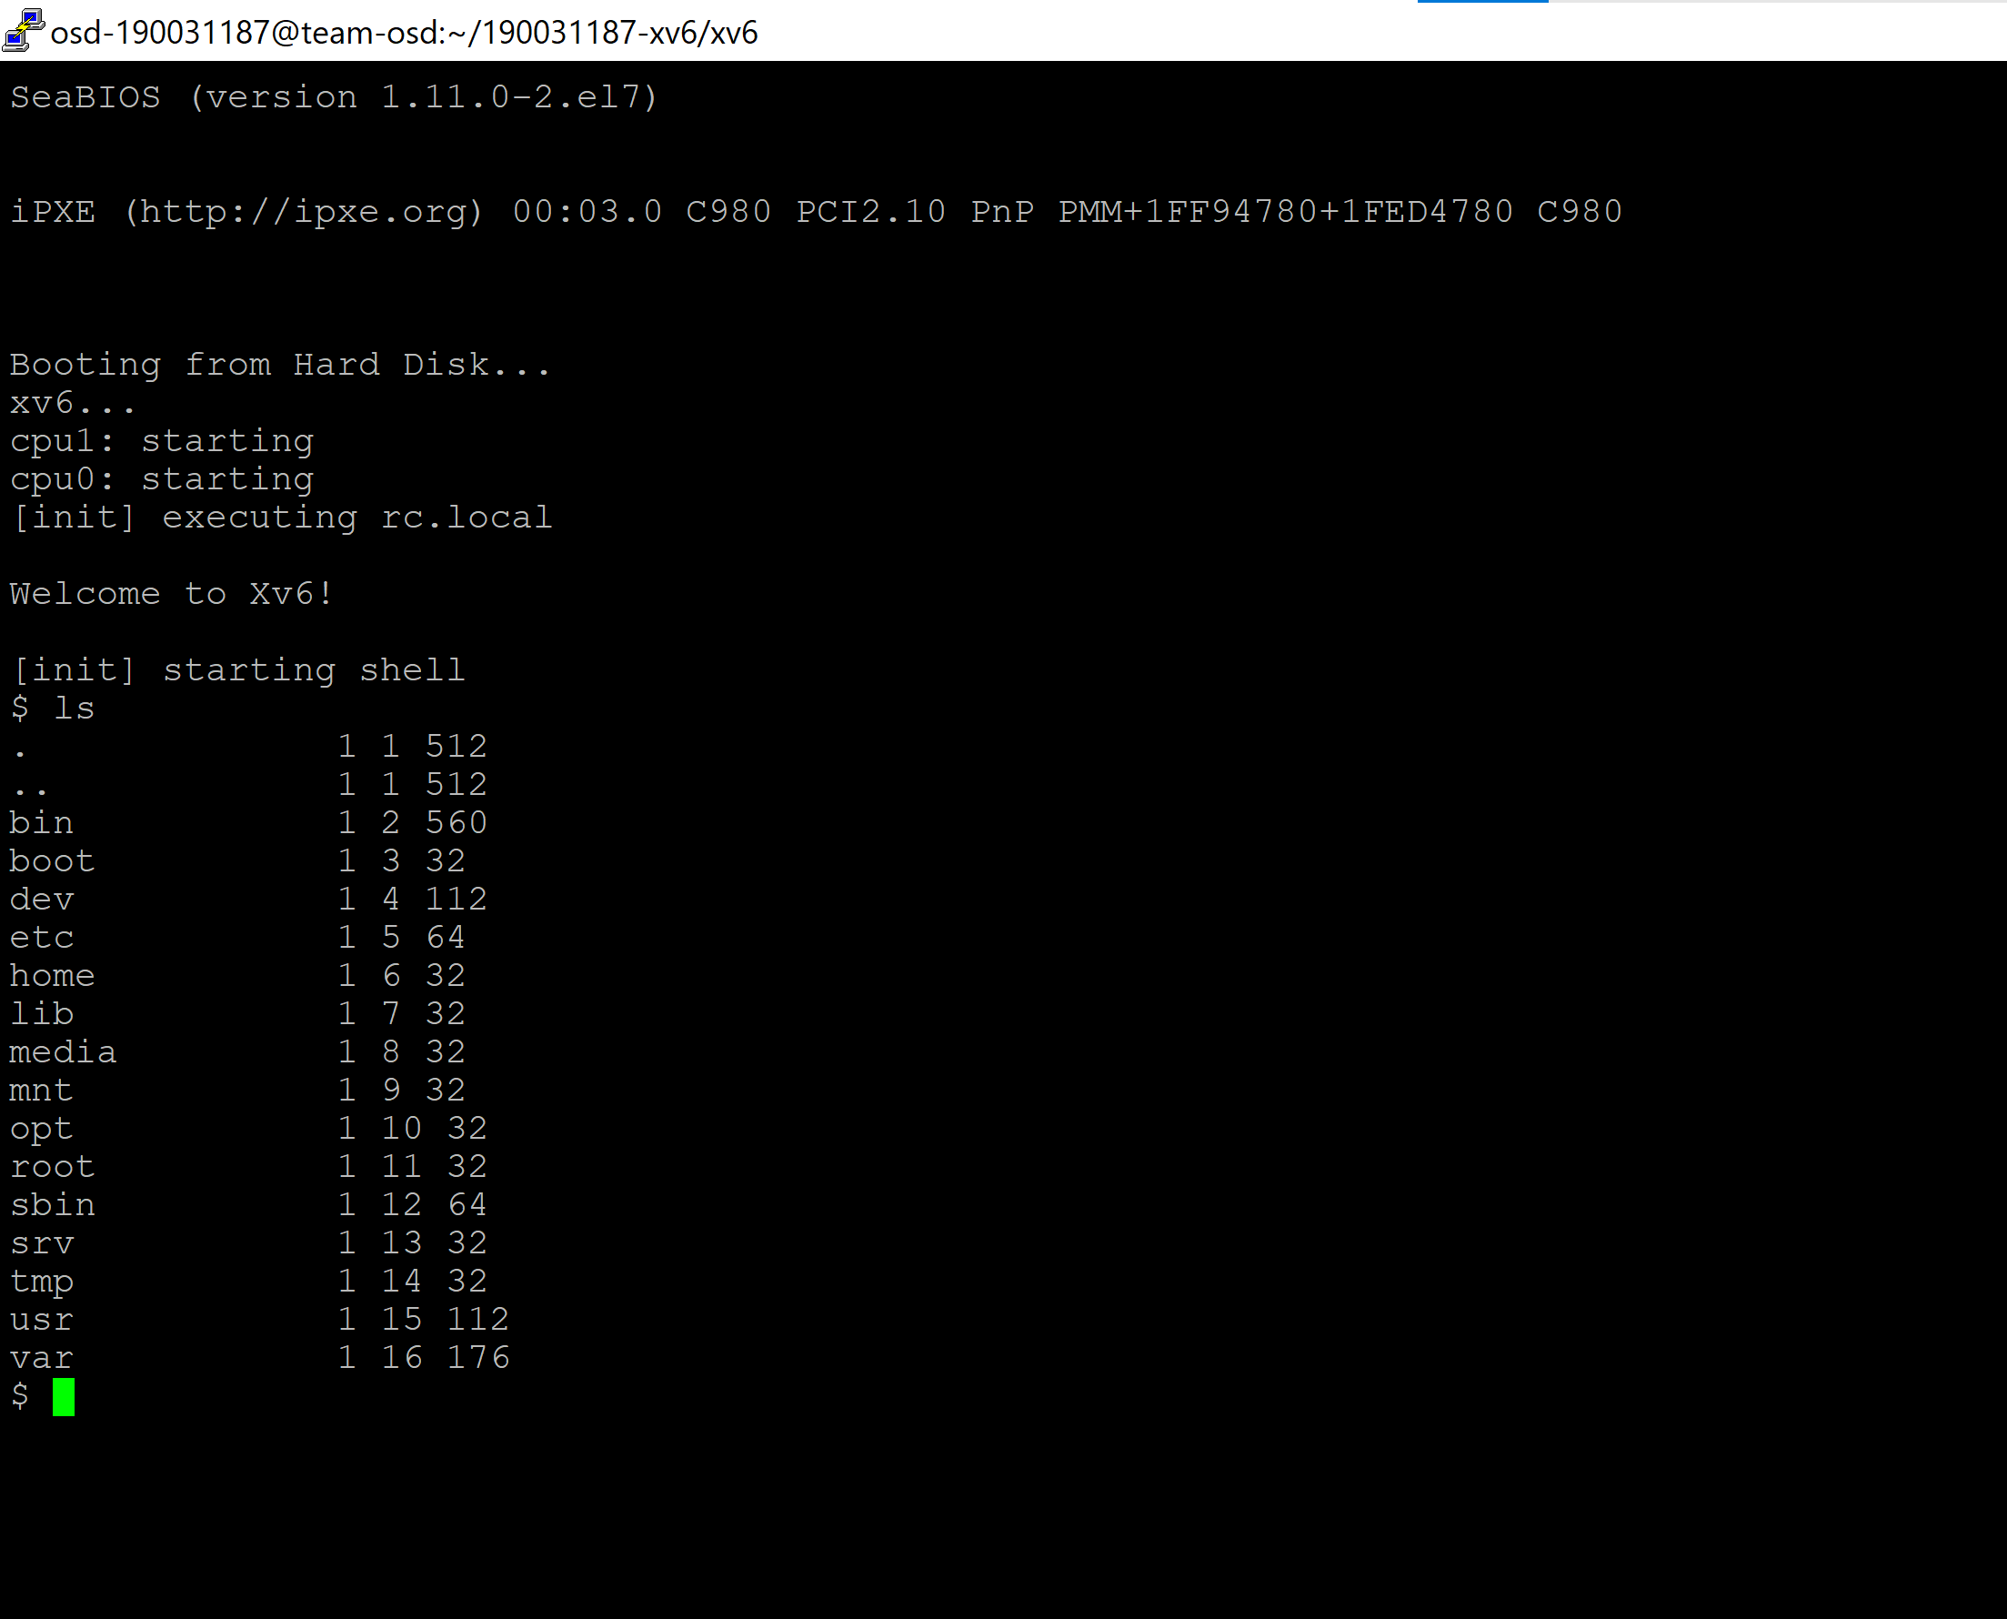

**Mirrored Raid Feature | Task 5:**

1. First clone the repository from GitHub to your local repository.  
   -> git clone [**https://github.com/aditvenk/xv6_file_system**](https://github.com/aditvenk/xv6_file_system)
2. Now change the directory to the created or clone directory. Now we have to modify the code in the **Makefile**. In **Makefile**, from lines 54 to 72 **replace the old code with new code.**

# If the makefile can't find QEMU, specify its path here  
#QEMU :  
# Try to infer the correct QEMU if not specified

ifndef QEMU

QEMU := $(shell if which qemu 1> /dev/null 2> /dev/null; \

then echo qemu; exit; \

else \

qemu=/u/c/s/cs537-2/ta/tools/qemu; \

if test -x $$qemu; then echo $$qemu; exit; fi; fi; \

echo "***" 1>&2; \

echo "*** Error: Couldn't find a working QEMU executable." 1>&2; \

echo "*** Is the directory containing the qemu binary in your " 1>&2; \

echo "*** PATH or have you tried setting the QEMU variable in " 1>&2; \

echo "*** Makefile?" 1>&2; \

echo "***" 1>&2; exit 1)

endif

**//Add the following code in place of above code**

# QEMU = qemu-system-i386  
# Try to infer the correct QEMU

ifndef QEMU

QEMU = $(shell if which qemu > /dev/null; \

then echo qemu; exit; \

elif which qemu-system-i386 > /dev/null; \

then echo qemu-system-i386; exit; \

elif which qemu-system-x86_64 > /dev/null; \

then echo qemu-system-x86_64; exit; \

else \

qemu=/Applications/Q.app/Contents/MacOS/i386-softmmu.app/Contents/MacOS/i386-softmmu; \

if test -x $$qemu; then echo $$qemu; exit; fi; fi; \

echo "***" 1>&2; \

echo "*** Error: Couldn't find a working QEMU executable." 1>&2; \

echo "*** Is the directory containing the qemu binary in your PATH" 1>&2; \

echo "*** or have you tried setting the QEMU variable in Makefile?" 1>&2; \

echo "***" 1>&2; exit 1)

endif

1. Now go to user directory. And create a new file named, **tester.c**. And write the **below code** in it.

// Do not modify this file. It will be replaced by the grading scripts

// when checking your project.

#include "types.h"

#include "stat.h"

#include "user.h"

#include "fcntl.h"

int

main(int argc, char *argv[])

{

printf(1, "mirrored fs test \n");

/*

int fd;

fd = open("echo", O_CREATE);

if (fd < 0)

exit();

close(fd);

*/

/*

struct stat st;

if (stat("echo", &st) < 0) {

printf(1, "stat failure" );

exit();

}

printf(1, "stat output: \n");

printf(1, "type = %d, dev = %d, inode-num = %d, nlink = %d, size = %d \n", st.type, st.dev, st.ino, st.nlink, st.size);

printf(1, "logical_size = %d, physical_size = %d \n", st.logical_size, st.physical_size);

*/

int fd;

char buf[128];

fd = open ( "temp.txt", O_CREATE | O_MIRRORED | O_RDWR);

if (fd < 0) {

printf(1, "open failed \n");

exit();

}

int j=0;

char temp[512];

for (j=0; j<512; j++){

temp[j] = 'x';

}

for (j=0;j<7;j++) {

if (write(fd, temp, 512) != 512) {

printf(1, "Write failed \n");

exit();

}

}

printf(1, "write done\n");

close(fd);

fd = open ( "temp.txt", O_MIRRORED | O_RDONLY);

if (fd < 0)

exit();

int i = read(fd, buf, 10);

if (i != 10) {

printf(1, "read failed \n");

exit();

}

printf(1, "read text = %s ", buf);

close(fd);

//unlink("temp.txt");

exit();

}

1. create another file named, **tester.c**. And write the **below code** in it.

#include "types.h"

#include "stat.h"

#include "user.h"

#include "fcntl.h"

#include "fs.h"

int ppid;

#define assert(x) if (x) {} else {\

printf(1, "%s: %d ", __FILE__, __LINE__); \

printf(1, "assert failed (%s)\n", # x); \

printf(1, "TEST FAILED\n"); \

kill(ppid); \

exit(); \

}

Int main(int argc, char *argv[])

{

ppid = getpid();

int fd;

int size = 512;

int n = (MAXFILE * BSIZE) / size / 2;

int i, j;

char buf[size];

int r;

//printf(1, "buffer size: %d\n", size);

//printf(1, "file size: %d\n", n * size);

//printf(1, "create mirrored file\n");

fd = open("out", O_CREATE | O_MIRRORED | O_RDWR);

assert(fd >= 0);

memset(buf, 0, size);

//printf(1, "writing file\n");

for (i = 0; i < n; i++) {

buf[0] = (char)('A' + i);

printf(1, "Writing %s \n", buf);

r = write(fd, buf, size);

assert(r == size);

}

//printf(1, "reopening read only\n");

r = close(fd);

assert(r == 0);

fd = open("out", O_RDONLY);

assert(fd >= 0);

//printf(1, "reading file\n");

for (i = 0; i < n; i++) {

r = read(fd, buf, size);

assert(r == size);

printf(1, "Reading %s \n", buf);

assert(buf[0] == (char)('A' + i));

for (j = 1; j < size; j++) {

assert(buf[j] == 0);

}

}

printf(1, "TEST PASSED\n");

exit();

}

1. Type make qemu-nox

**OUTPUT:**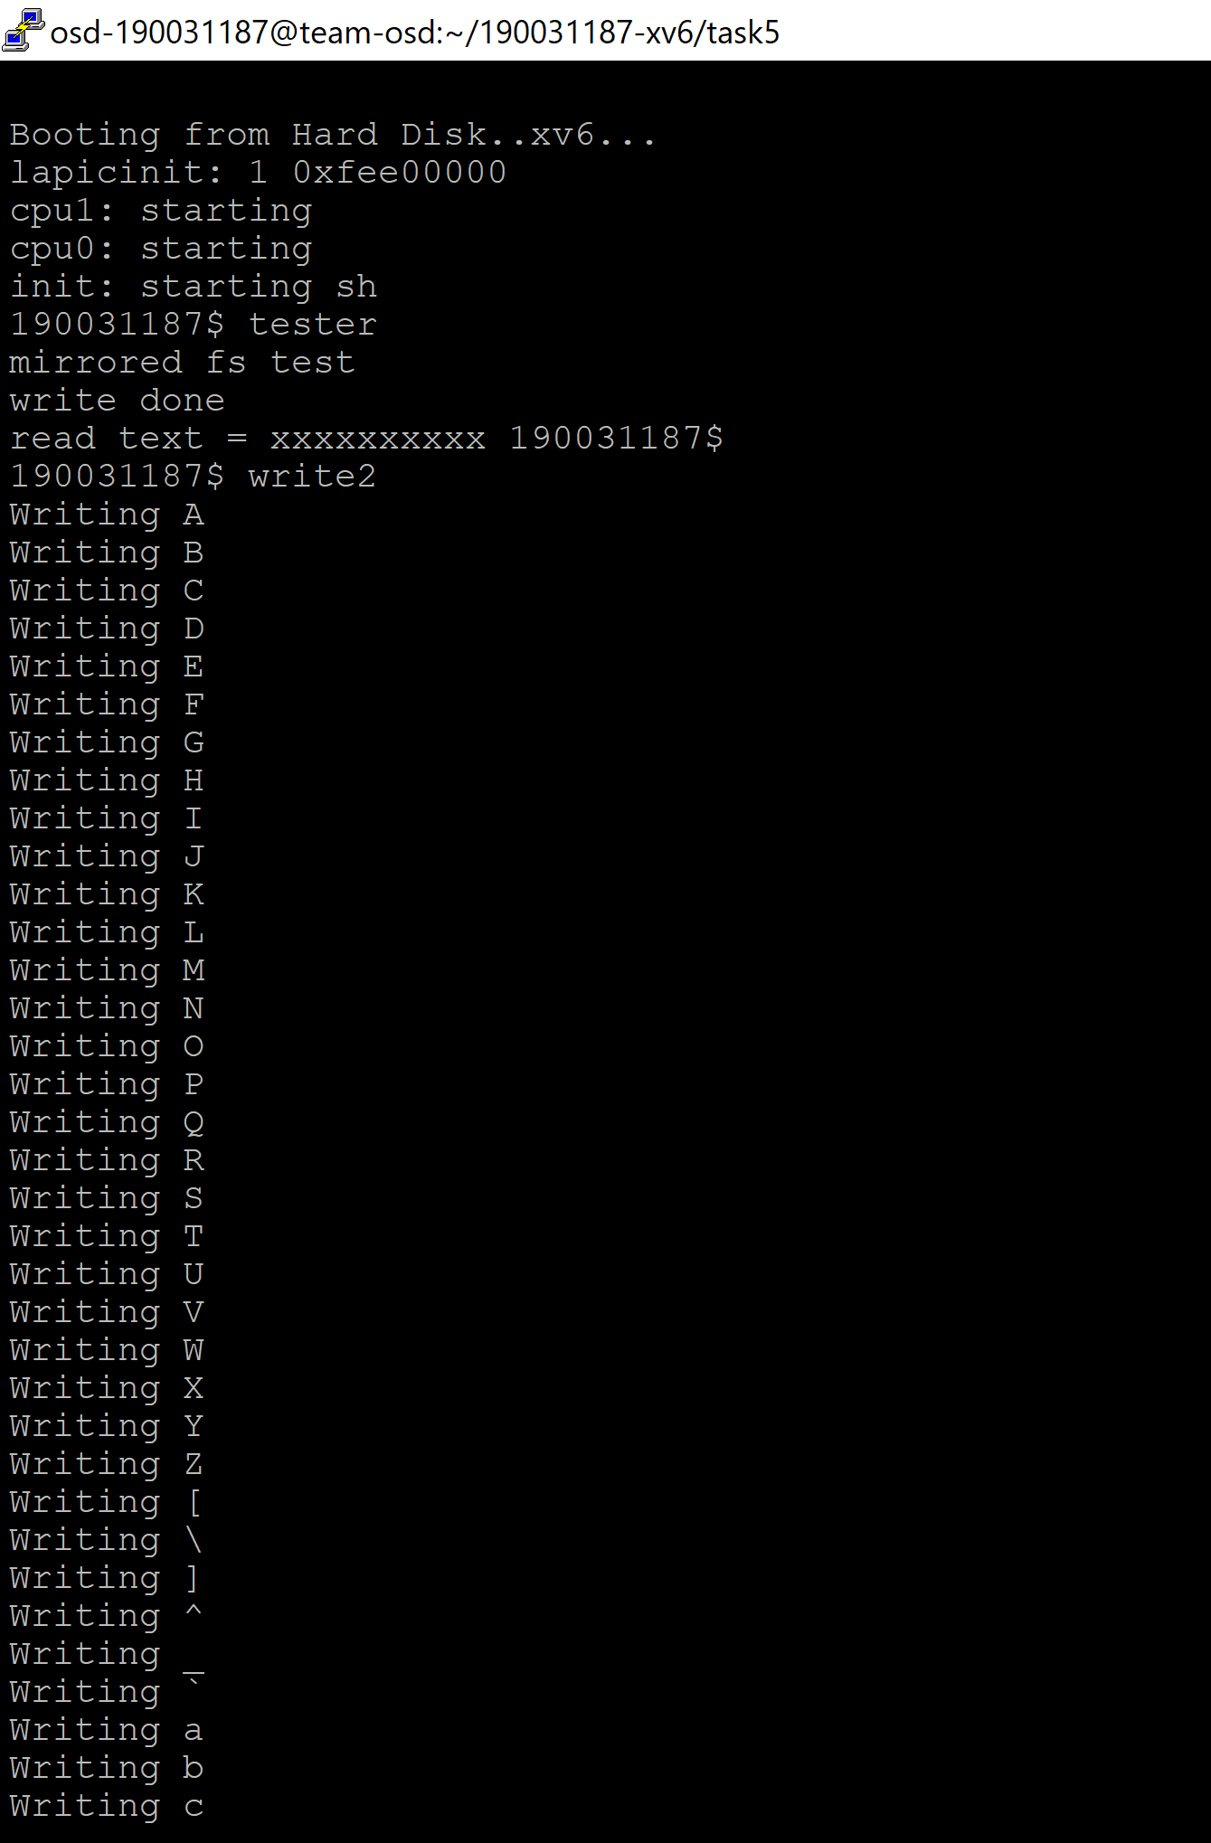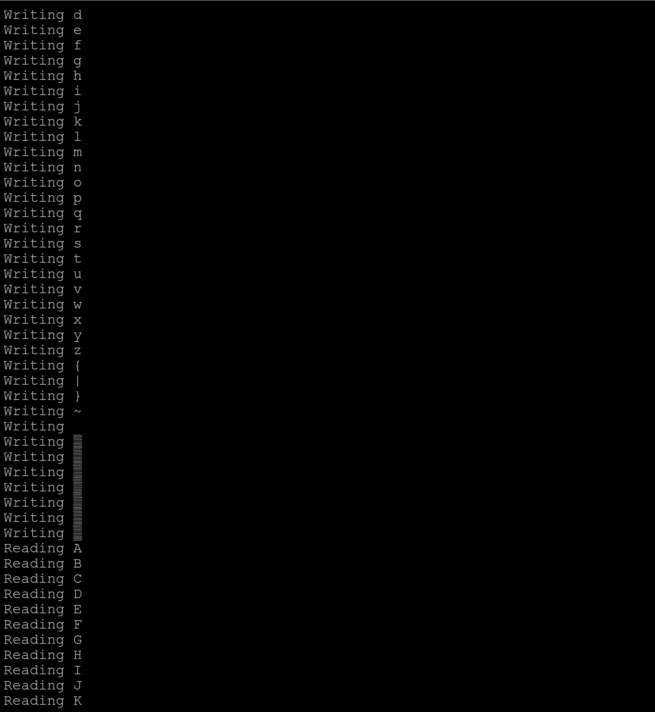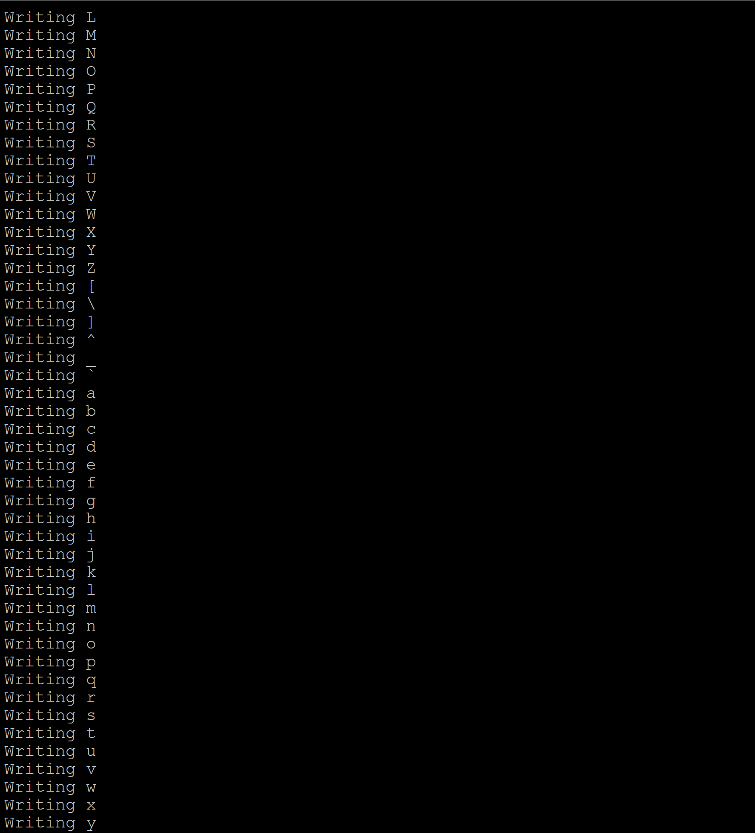

**Observation and Analysis:**

Here the first test writes a series of X of form XXXXXXXX and the same is read below. Hence a mirrored raid feature. Next, we write all the alphabets and symbols, and the mirrored raid feature reads all the written alphabets and symbols in same order. Hence both the above tests prove our Mirrored Raid feature by performing tests.

**CONCLUSION**

I successfully created a basic XV6 shell with what I believes to be necessary for a common usage. I learnt a lot from working with a basic Operating System and would like to thank everyone for this opportunity. The journey to modifying the XV6 and implementing my own shell was a very interesting and eventful one and even though sometimes, my code was like a shot in the dark, I believe that I achieved what I wanted to in the end.