**RPA INSEM SKILL EXAM**

**Use Case 1:**

**Create a task bot to demonstrate Prompt Actions (You MUST create task bot with all four actions).**

**Step-1:**

Select Create a bot and Enter the name of the bot.

**Step-2:**

**Demonstration for Prompt For Value**

Search Prompt in actions.

Drag and Drop **For Value**

Enter the prompt window caption, prompt window message and Assign a variable to it.

Now Display the Variable with the help of message box.

**Step-3:**

**Demonstration for Prompt For Yes/No**

Search Prompt in actions.

Drag and Drop **For Yes/No**

Enter the prompt window caption, prompt window message and Assign a variable to it.

Now Display the Variable with the help of message box.

**Step-4:**

**Demonstration for Prompt For File**

Search Prompt in actions.

Drag and Drop **For File**

Enter the prompt window caption, prompt window message and Assign a variable to it.

Now Display the Variable with the help of message box.

**Step-5:**

**Demonstration for Prompt For Folder**

Search Prompt in actions.

Drag and Drop **For File**

Enter the prompt window caption, prompt window message and Assign a variable to it.

Now Display the Variable with the help of message box.

**Code:**

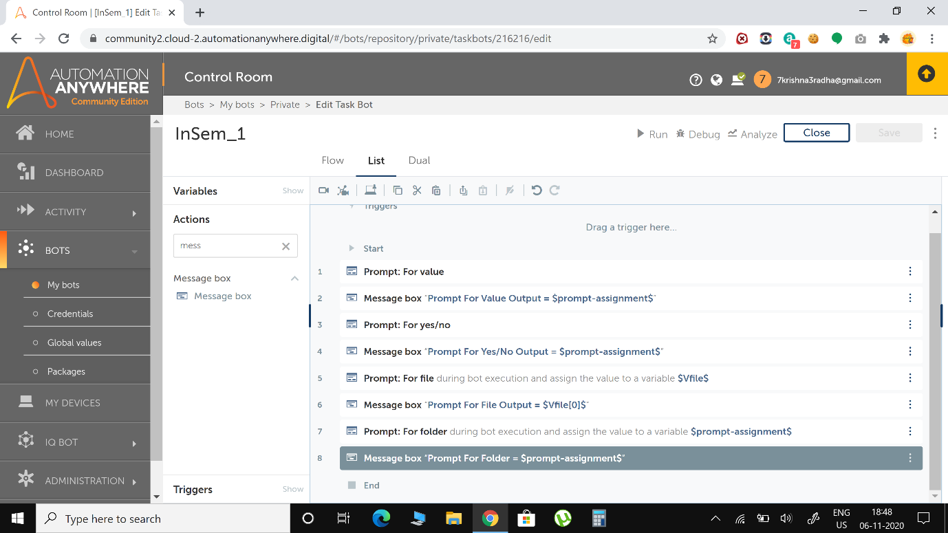

**Output Screenshots:**

**Prompt for Value Output**

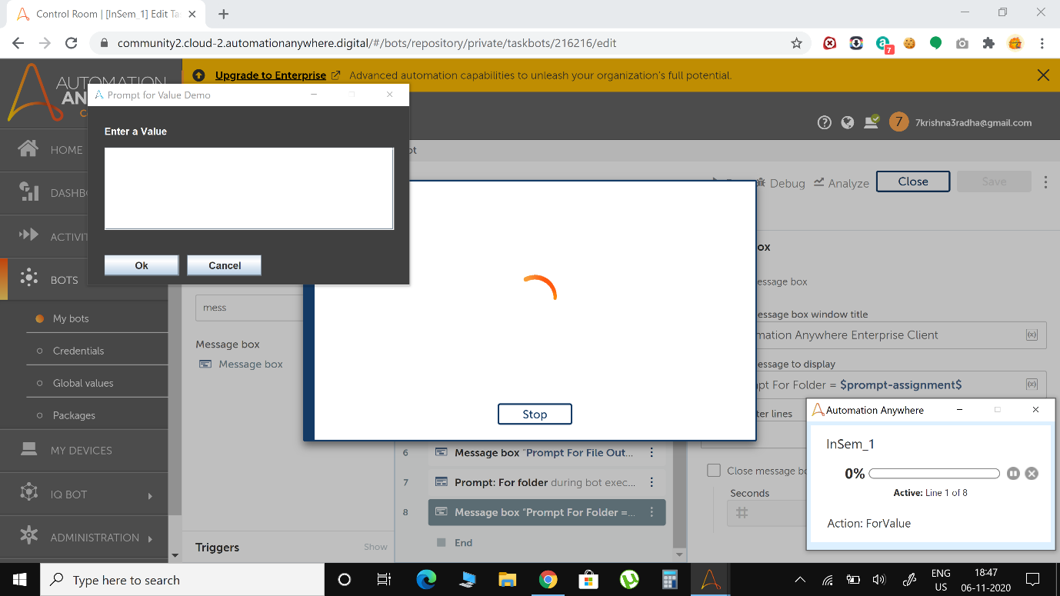

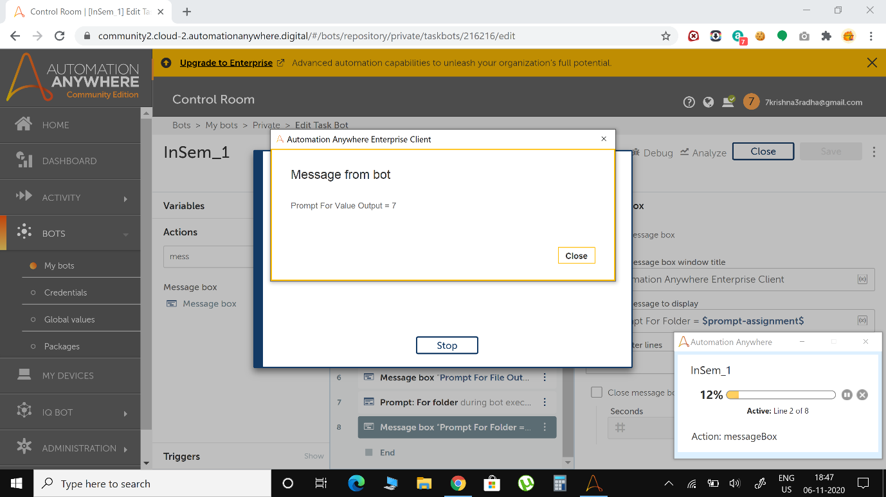

**Prompt for Yes/No Output**

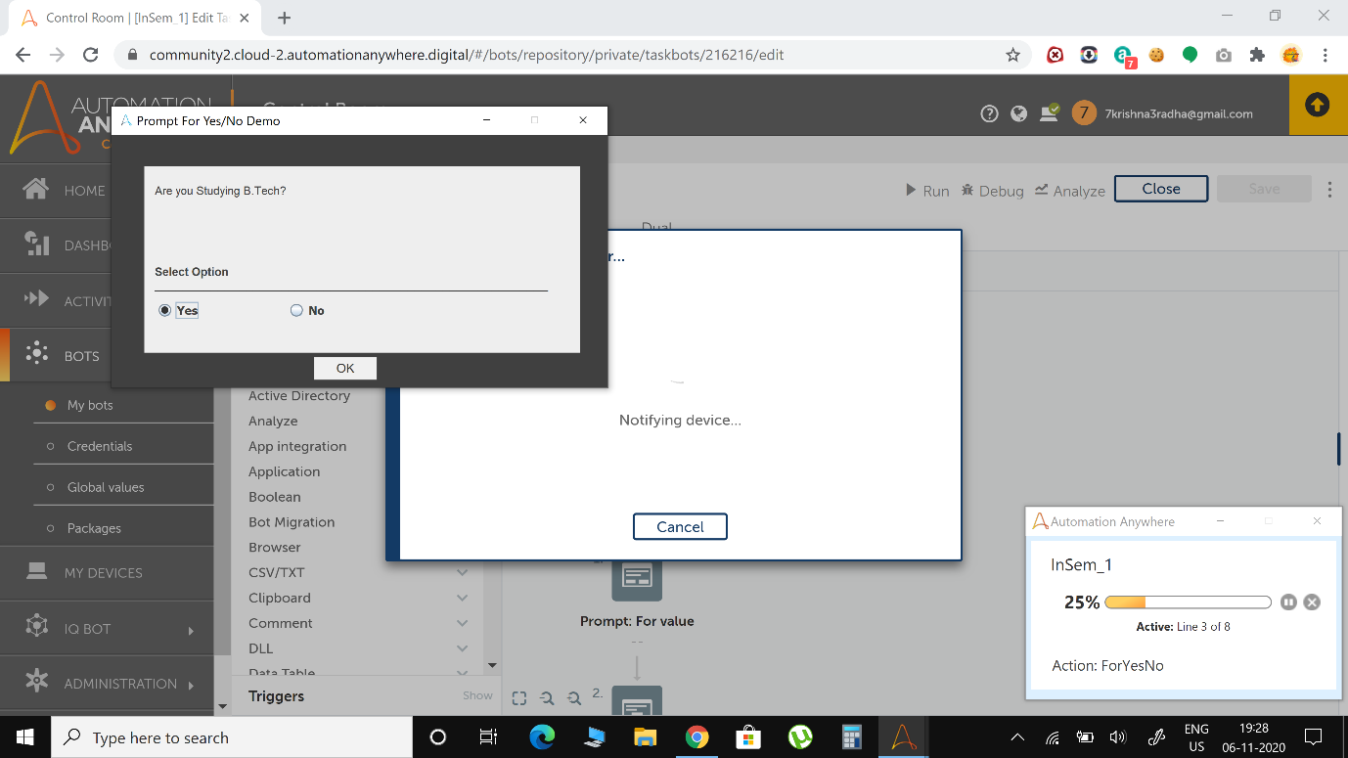

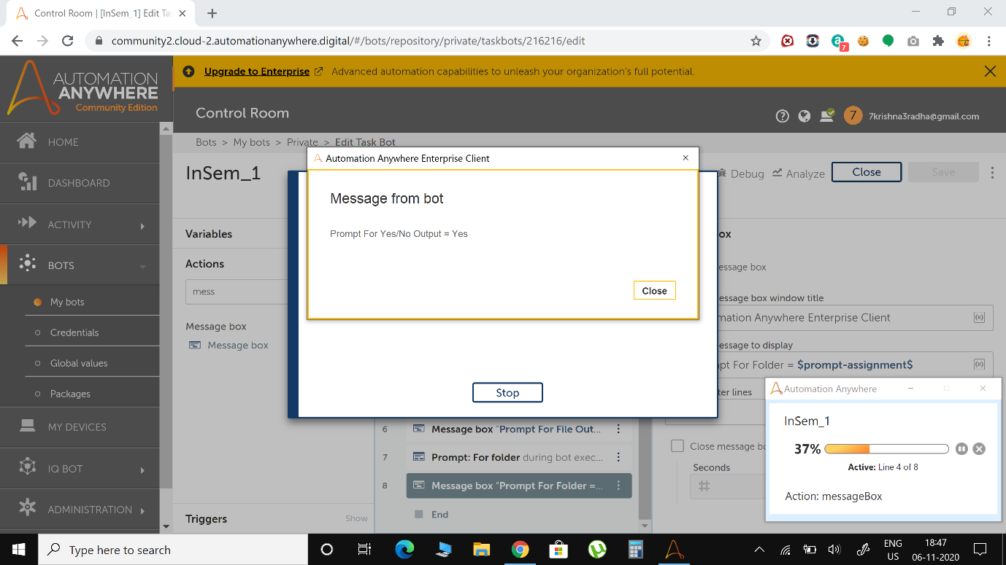

**Prompt For File Output**

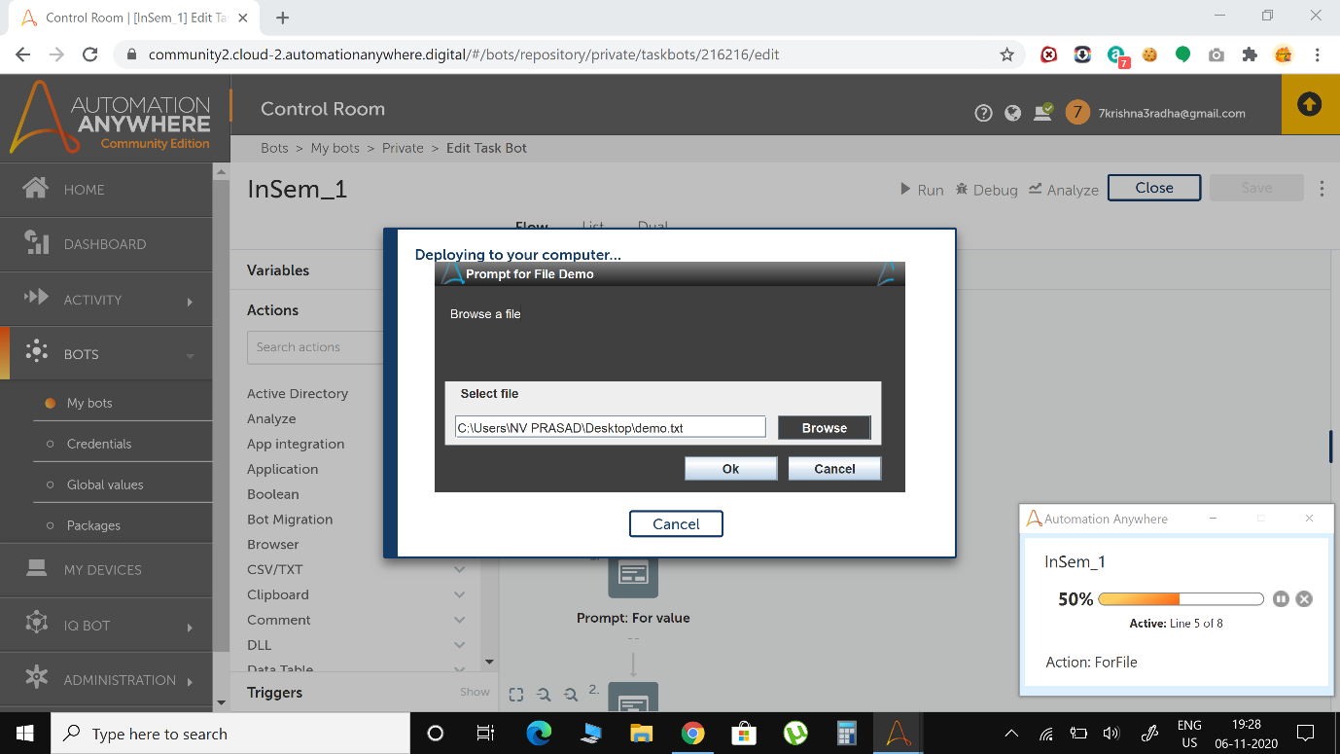

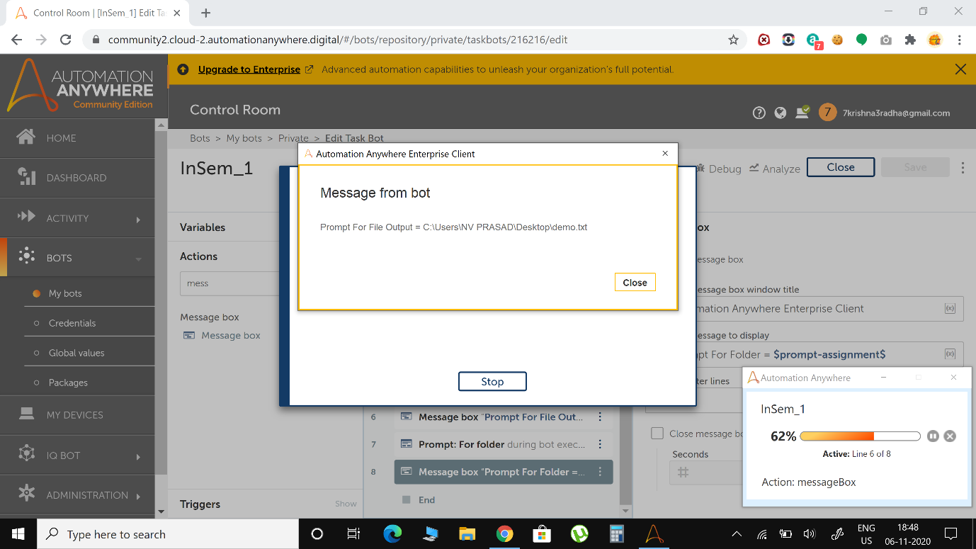

**Prompt for Folder Output**

