**RPA INSEM SKILL EXAM**

**Use Case 2:**

**Create a task bot to convert given negative number to positive number.**

**Steps:**

* To convert a Negative Number to Positive Number we need to Use **if condition**
* Use **Prompt for value** To accept the value from the User
* Now Convert this String value to Number Using **To Number** available under String Actions
* Now Search for If in actions Add the input variable and keep the condition to less than and Last Value to 0. This means that the **If condition** workswhen the Input value is less than 0
* Now inside the **if condition** Use **Assign** under Number Actions and keep **–{{Variable name}}** This Converts the negative value to positive value
* After the **If condition** is over Convert the Final Output Variable to String to Display (Message box accepts only String type variables) Use **To String Under Number**
* Use **Message Box** to display the Output

**Code:**

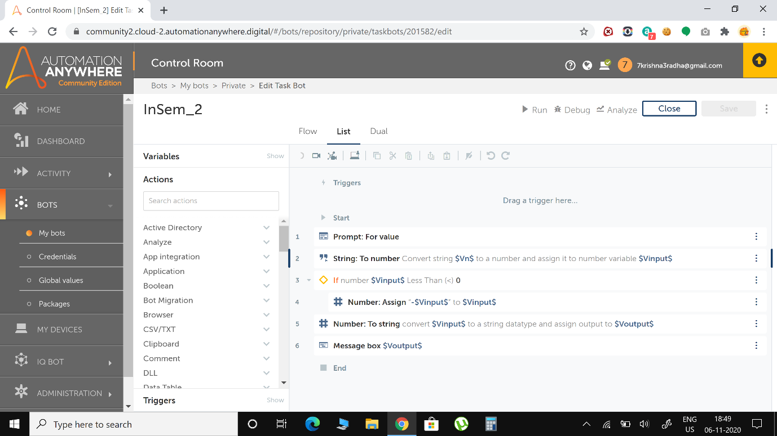

**Output Screenshots**

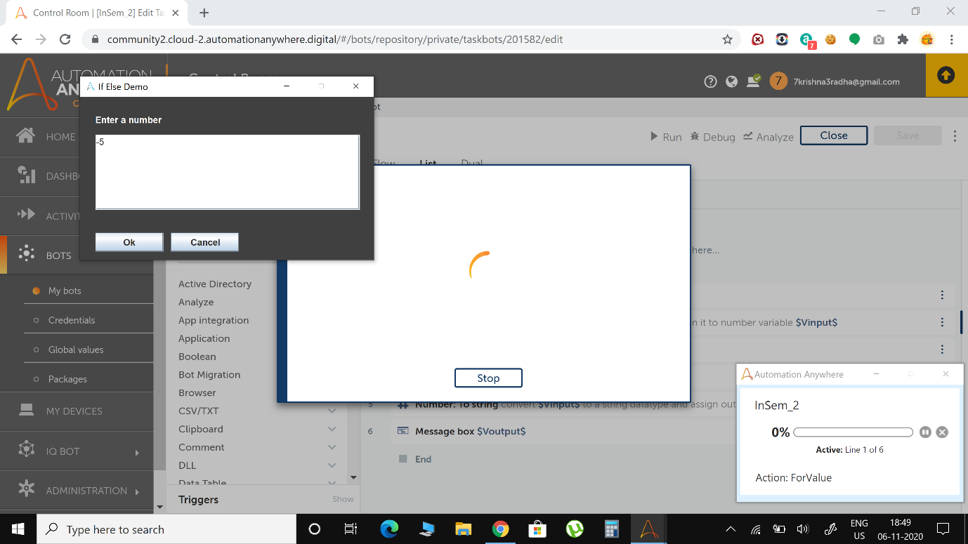

**I entered -5 as Input**

**And the Out I got was 5**

