**Download & Installation Process of StarUML Software**

1. 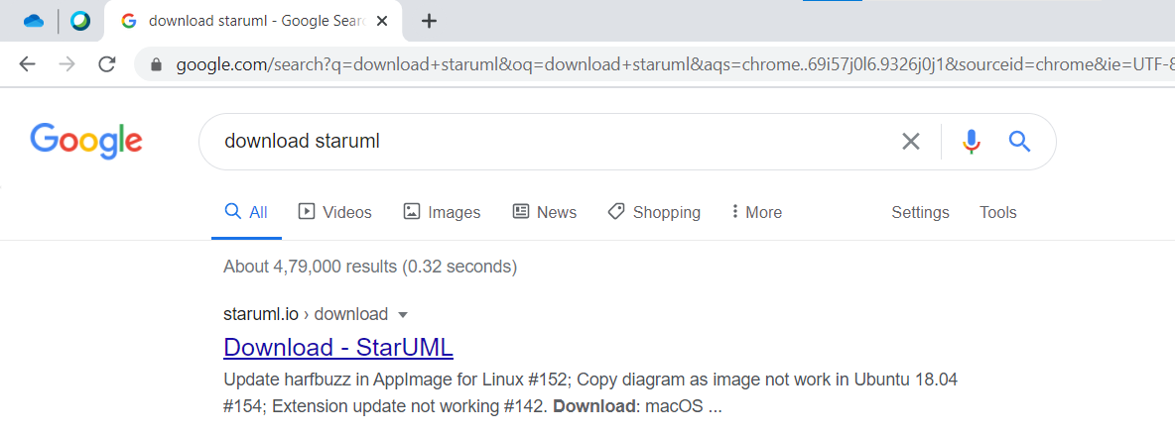**First Google “Download StarUML” as Shown below.**
2. 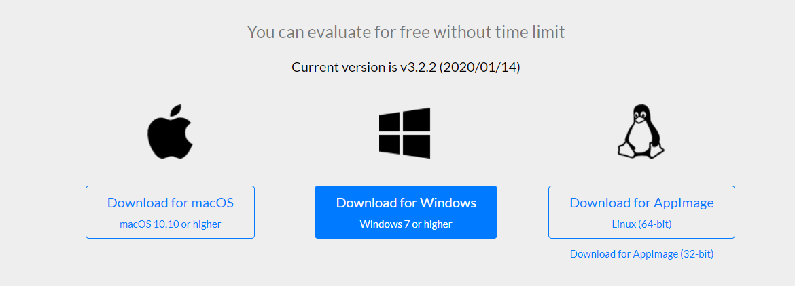**Open the First link & Select for which platform you would like to download!**
3. **After clicking on “Download for {Your Choice of OS Platform}”. The Download will be start.**

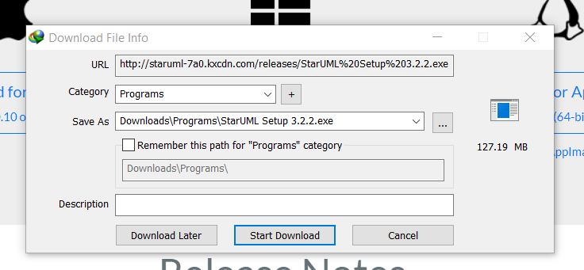

1. **Open the downloaded file & then pop up window will be appearing, For that click “YES”.**

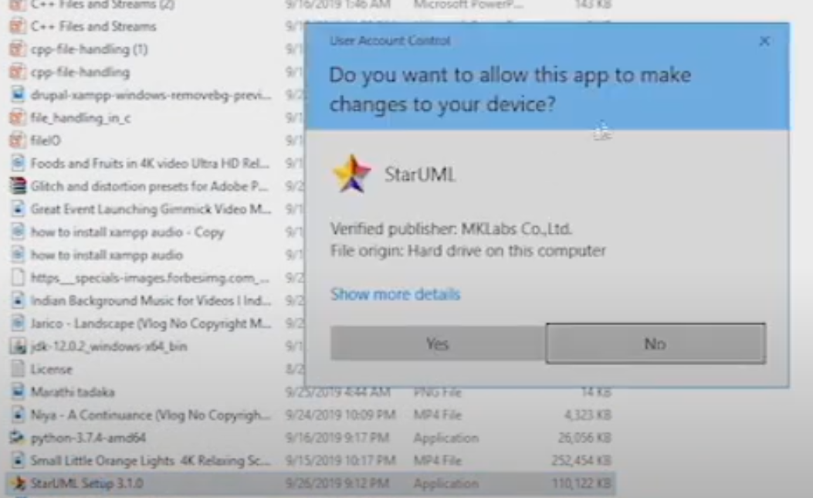

1. **Then installation will be done by itself.**

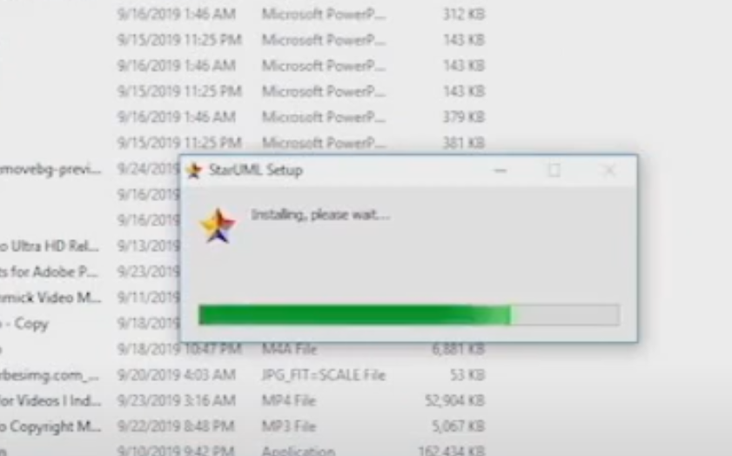

1. **After Successful installation, The StarUML will be opened. And If you like to Register that’s your wish else you can also use this software by just closing the inner pop up window in it!**

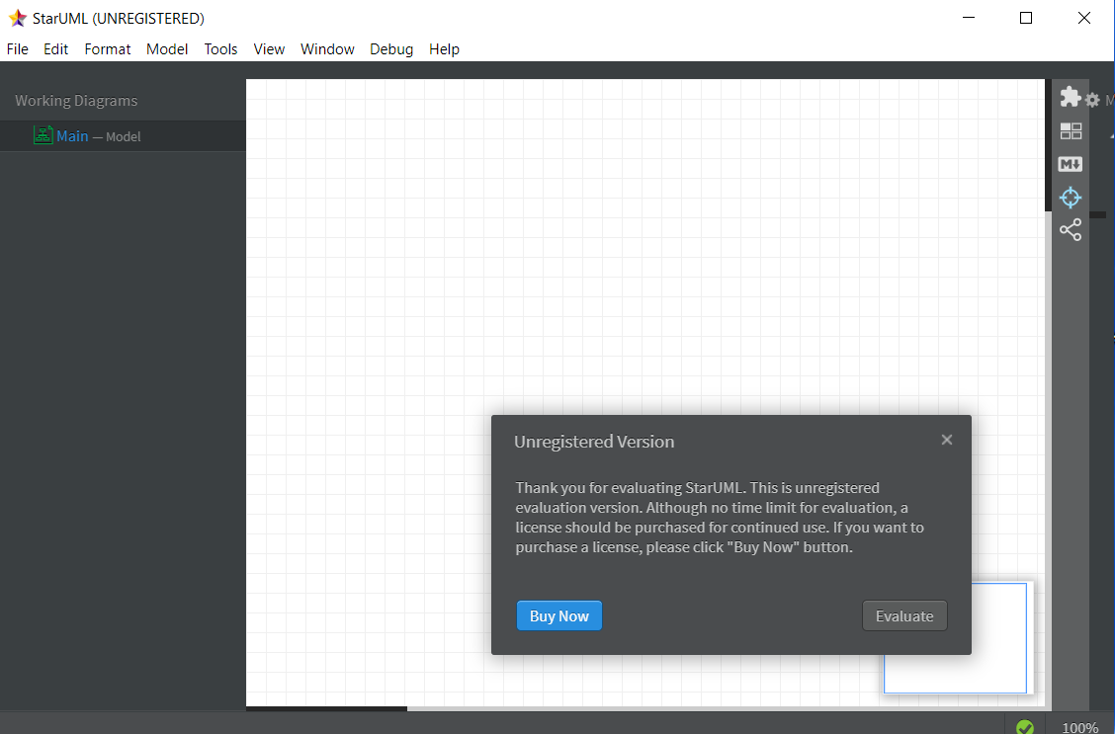

**Working with Use Case Diagram**

**To create a Use Case Diagram:**

1. **Select first an element where a new Use Case Diagram to be contained as a child.**
2. **Select Model | Add Diagram | Use Case Diagram in Menu Bar or select Add Diagram | Use Case Diagram in Context Menu.**

**In Use Case Diagram, you can use following elements.**

* [**Package**](https://staruml.readthedocs.io/en/latest/modeling-with-uml/working-with-package-diagram.html#uml-package)
* [**Use Case Subject**](https://staruml.readthedocs.io/en/latest/modeling-with-uml/working-with-use-case-diagram.html#uml-use-case-subject)
* [**Actor**](https://staruml.readthedocs.io/en/latest/modeling-with-uml/working-with-use-case-diagram.html#uml-actor)
* [**Use Case**](https://staruml.readthedocs.io/en/latest/modeling-with-uml/working-with-use-case-diagram.html#uml-use-case)
* [**Extension Point**](https://staruml.readthedocs.io/en/latest/modeling-with-uml/working-with-use-case-diagram.html#uml-extension-point)
* [**Association**](https://staruml.readthedocs.io/en/latest/modeling-with-uml/working-with-class-diagram.html#uml-association)
* [**Dependency**](https://staruml.readthedocs.io/en/latest/modeling-with-uml/working-with-class-diagram.html#uml-dependency)
* [**Generalization**](https://staruml.readthedocs.io/en/latest/modeling-with-uml/working-with-class-diagram.html#uml-generalization)
* [**Include**](https://staruml.readthedocs.io/en/latest/modeling-with-uml/working-with-use-case-diagram.html#uml-include)
* [**Extend**](https://staruml.readthedocs.io/en/latest/modeling-with-uml/working-with-use-case-diagram.html#uml-extend)

## **Use Case Subject**

**To create an Use Case Subject:**

1. **Select Use Case Subject in Toolbox.**
2. **Drag on the diagram as the size of Use Case Subject.**

## **Actor**

**To create an Actor:**

1. **Select Actor in Toolbox.**
2. **Drag on the diagram as the size of Actor.**

**To create an Actor (model element only) by Menu:**

1. **Select an Element where a new Actor to be contained.**
2. **Select Model | Add | Actor in Menu Bar or Add | Actor in Context Menu.**

**To edit an Actor, you can do following actions:**

* **Use**[**Quick Edit for Classifier**](https://staruml.readthedocs.io/en/latest/reference/quick-edits.html#quick-edit-classifier)**by double-click or press Enter on a selected Actor.**
* **Add Attribute - See**[**Attribute**](https://staruml.readthedocs.io/en/latest/modeling-with-uml/working-with-class-diagram.html#uml-attribute)
* **Add Operation - See**[**Operation**](https://staruml.readthedocs.io/en/latest/modeling-with-uml/working-with-class-diagram.html#uml-operation)

**To suppress Attributes, see**[**Suppress Attributes**](https://staruml.readthedocs.io/en/latest/editing-elements-and-diagrams.html#format-suppress-attributes)**.**

**To suppress Operations, see**[**Suppress Operations**](https://staruml.readthedocs.io/en/latest/editing-elements-and-diagrams.html#format-suppress-operations)**.**

**To hide Operation signatures, see**[**Show Operation Signature**](https://staruml.readthedocs.io/en/latest/editing-elements-and-diagrams.html#format-show-operation-signature)**.**

## **Use Case**

**To create an Use Case:**

1. **Select Use Case in Toolbox.**
2. **Drag on the diagram as the size of Use Case.**

**To create an Use Case (model element only) by Menu:**

1. **Select an Element where a new Use Case to be contained.**
2. **Select Model | Add | Use Case in Menu Bar or Add | Use Case in Context Menu.**

**To edit an Use Case, you can do following actions:**

* **Use quick-edit-usecase by double-click or press Enter on a selected Use Case.**
* **Add Extension Point - See**[**Extension Point**](https://staruml.readthedocs.io/en/latest/modeling-with-uml/working-with-use-case-diagram.html#uml-extension-point)**.**

**To suppress Attributes, see**[**Suppress Attributes**](https://staruml.readthedocs.io/en/latest/editing-elements-and-diagrams.html#format-suppress-attributes)**.**

**To suppress Operations, see**[**Suppress Operations**](https://staruml.readthedocs.io/en/latest/editing-elements-and-diagrams.html#format-suppress-operations)**.**

**To hide Operation signatures, see**[**Show Operation Signature**](https://staruml.readthedocs.io/en/latest/editing-elements-and-diagrams.html#format-show-operation-signature)**.**

## **Extension Point**

**To add an Extension Point:**

1. **Select an Use Case.**
2. **Select Model | Add | Extension Point in Menu Bar or Add | Extension Point in Context Menu.**

**To edit an Extension Point, you can do following actions:**

* **Use**[**Quick Edit for Extension Point**](https://staruml.readthedocs.io/en/latest/reference/quick-edits.html#quick-edit-extension-point)**by double-click or press Enter on a selected Extension Point.**

## **Include**

**To create an Include:**

1. **Select Include in Toolbox.**
2. **Drag from a Use Case and drop on another Use Case (to be included).**

## **Extend**

**To create an Extend:**

1. **Select Extend in Toolbox.**
2. **Drag from a Use Case (to be extended) and drop on another Use Case.**