**STATE CHART DIAGRAM FOR LIBRARY MANAGEMENT SYSTEM**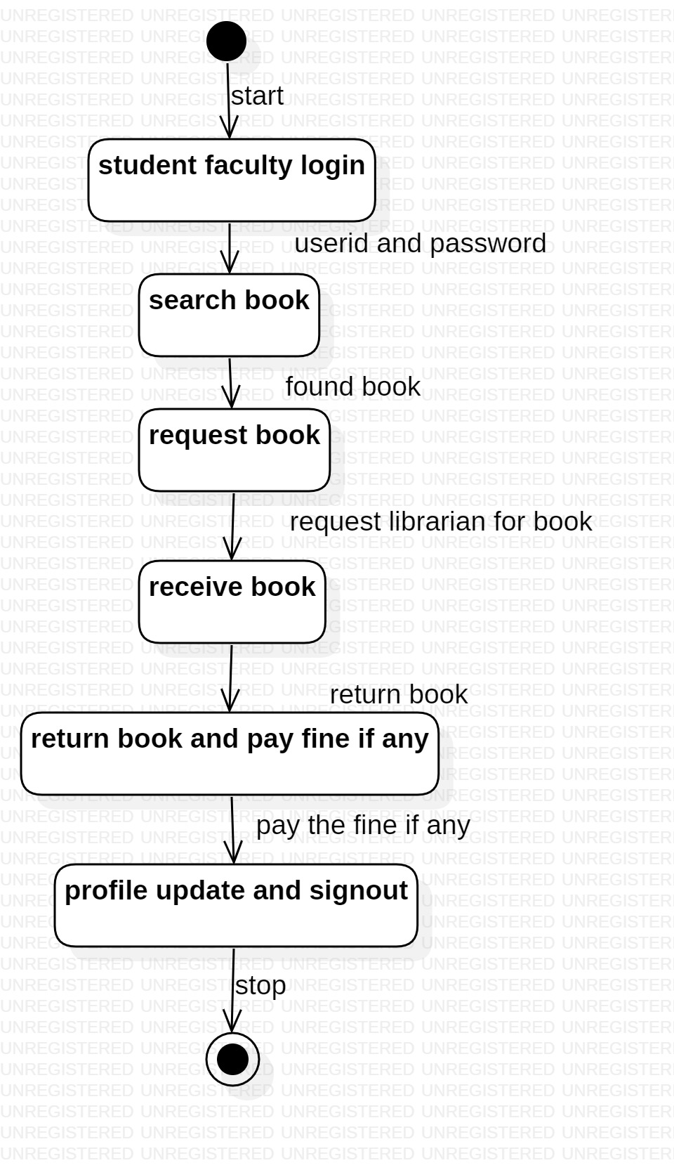

**SEQUENCE DIAGRAM FOR LIBRARY MANAGEMENT SYSTEM** 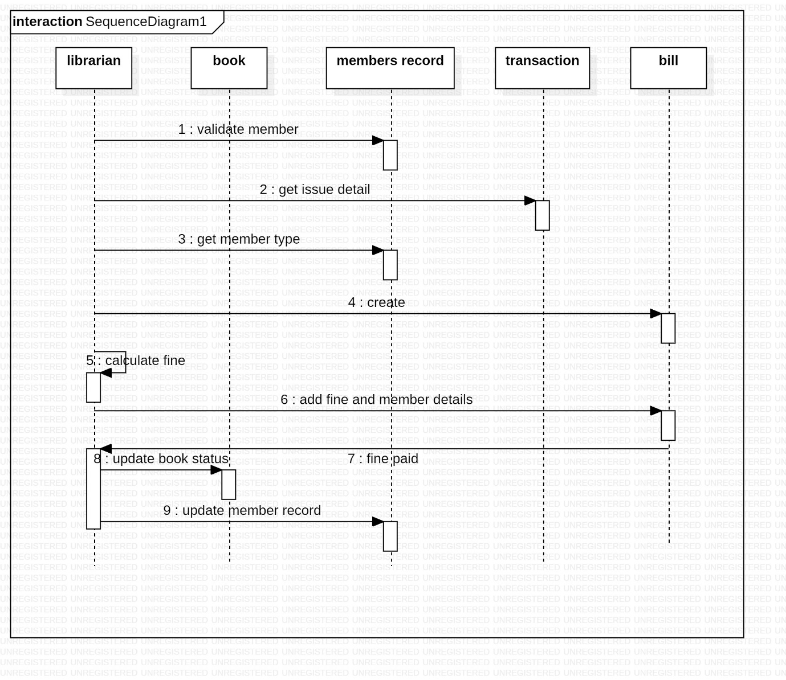

**CLASS DIAGRAM FOR LIBRARY MANAGEMENT SYSTEM** 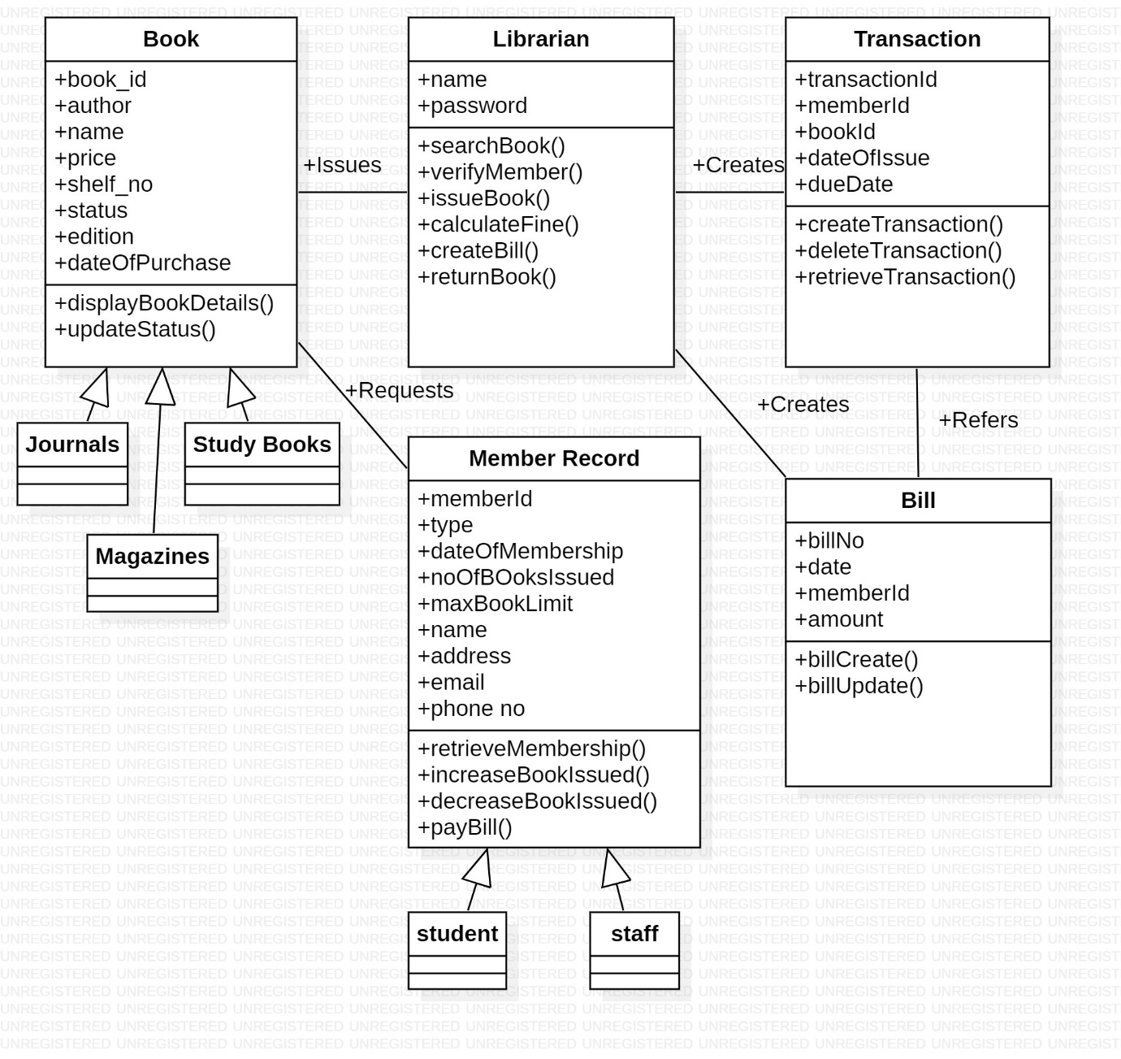

**ACTIVITY DIAGRAM OF LIBRARY MANAGEMENT SYSTEM**

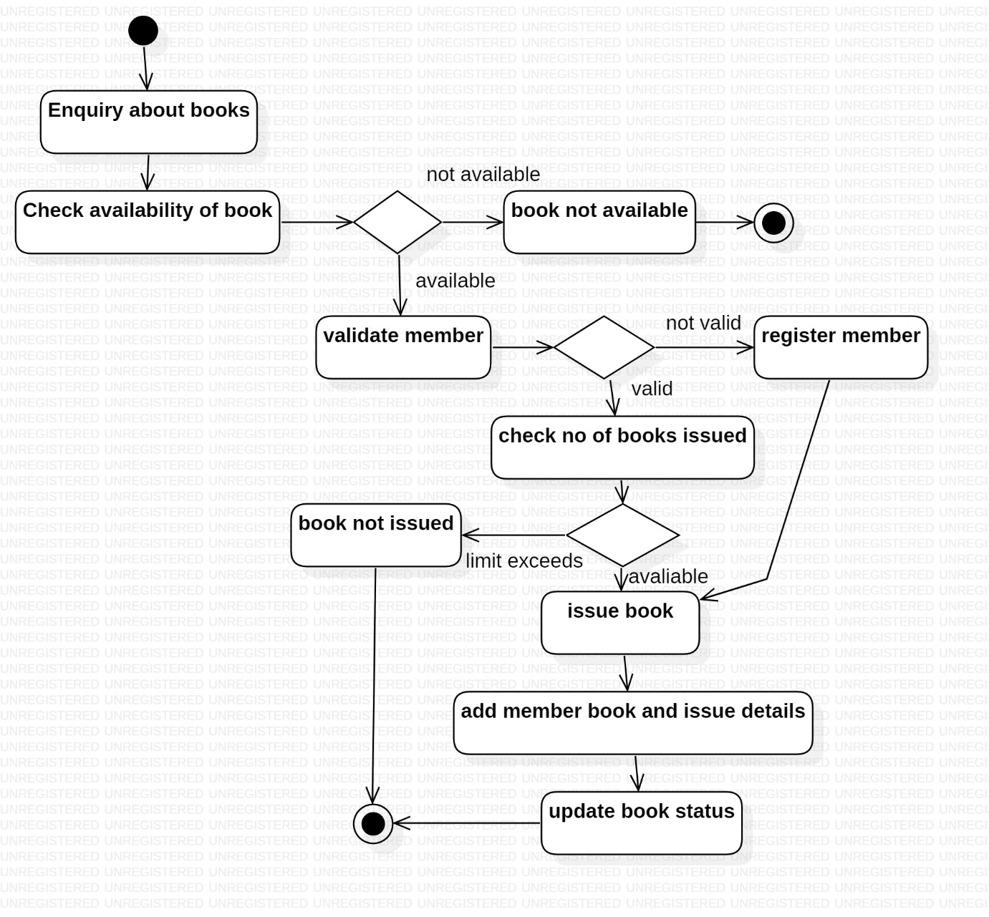

**Use Case Diagram for Library Management System**

