**Software Engineering**

**Tutorial – 3**

**University Admission Process**

**Sequence diagram:**

A sequence diagram shows object interactions arranged in time sequence. It depicts the objects and classes involved in the scenario and the sequence of messages exchanged between the objects needed to carry out the functionality of the scenario. ... Sequence diagrams are sometimes called event diagrams or event scenarios.

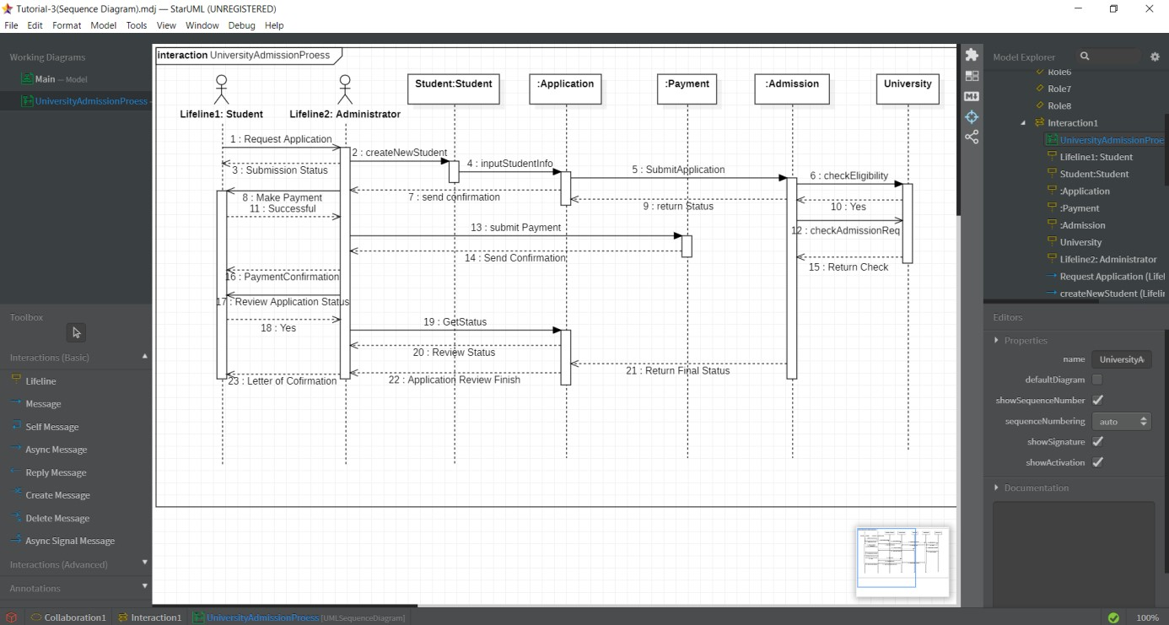

**Use-case diagram:**

A UML use case diagram is the primary form of system/software requirements for a new software program underdeveloped. Use cases specify the expected behavior (what), and not the exact method of making it happen (how). Use cases once specified can be denoted both textual and visual representation (i.e. use case diagram). A key concept of use case modeling is that it helps us design a system from the end user's perspective. It is an effective technique for communicating system behavior in the user's terms by specifying all externally visible system behavior.

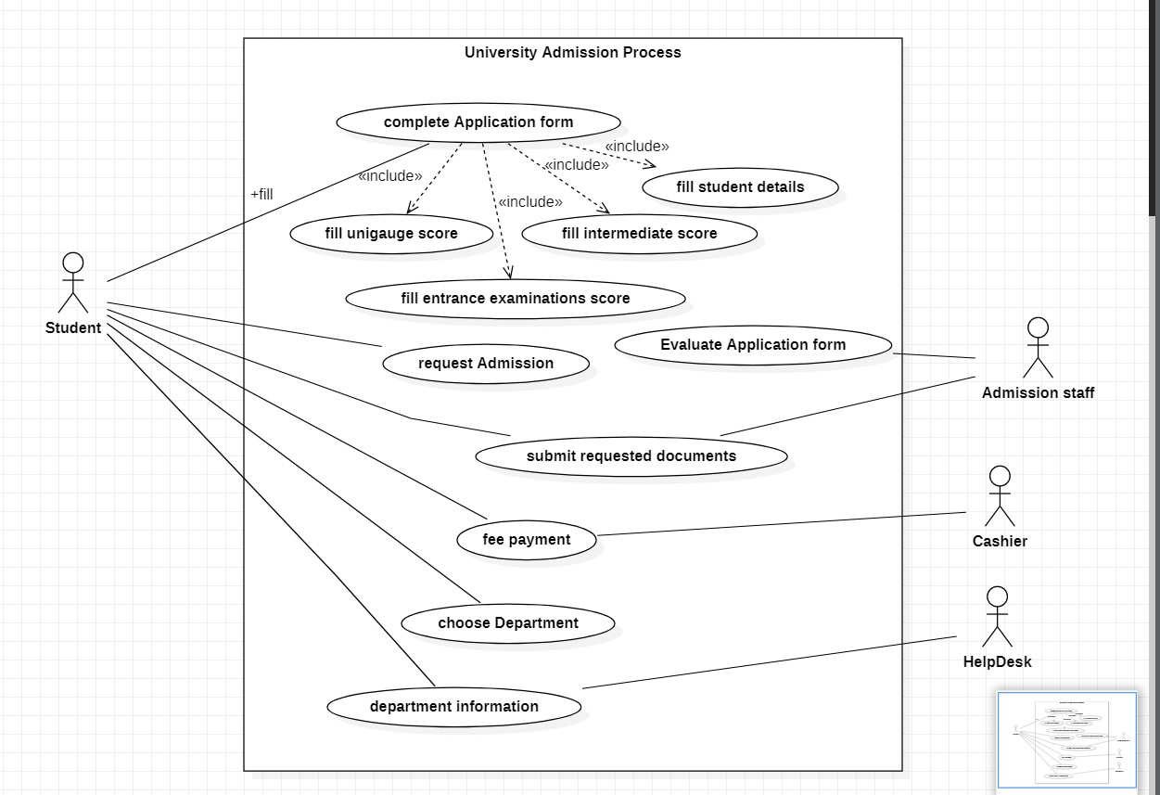

**Activity diagram:**

Activity diagram is another important

diagram in UML to describe the dynamic aspects of the system. Activity diagram is basically a flowchart to represent the flow from one activity to another activity. The activity can be described as an operation of the system.

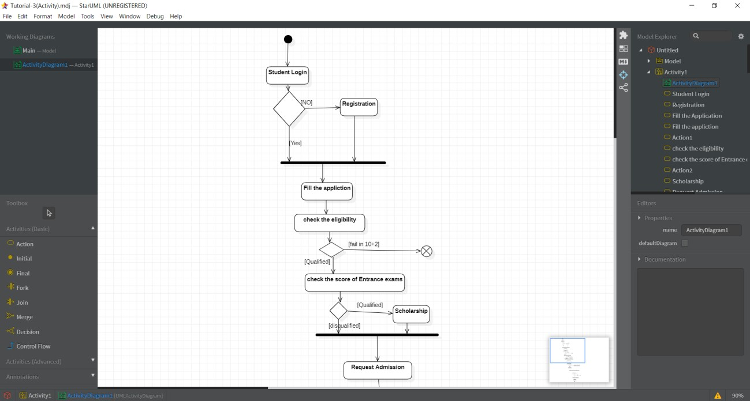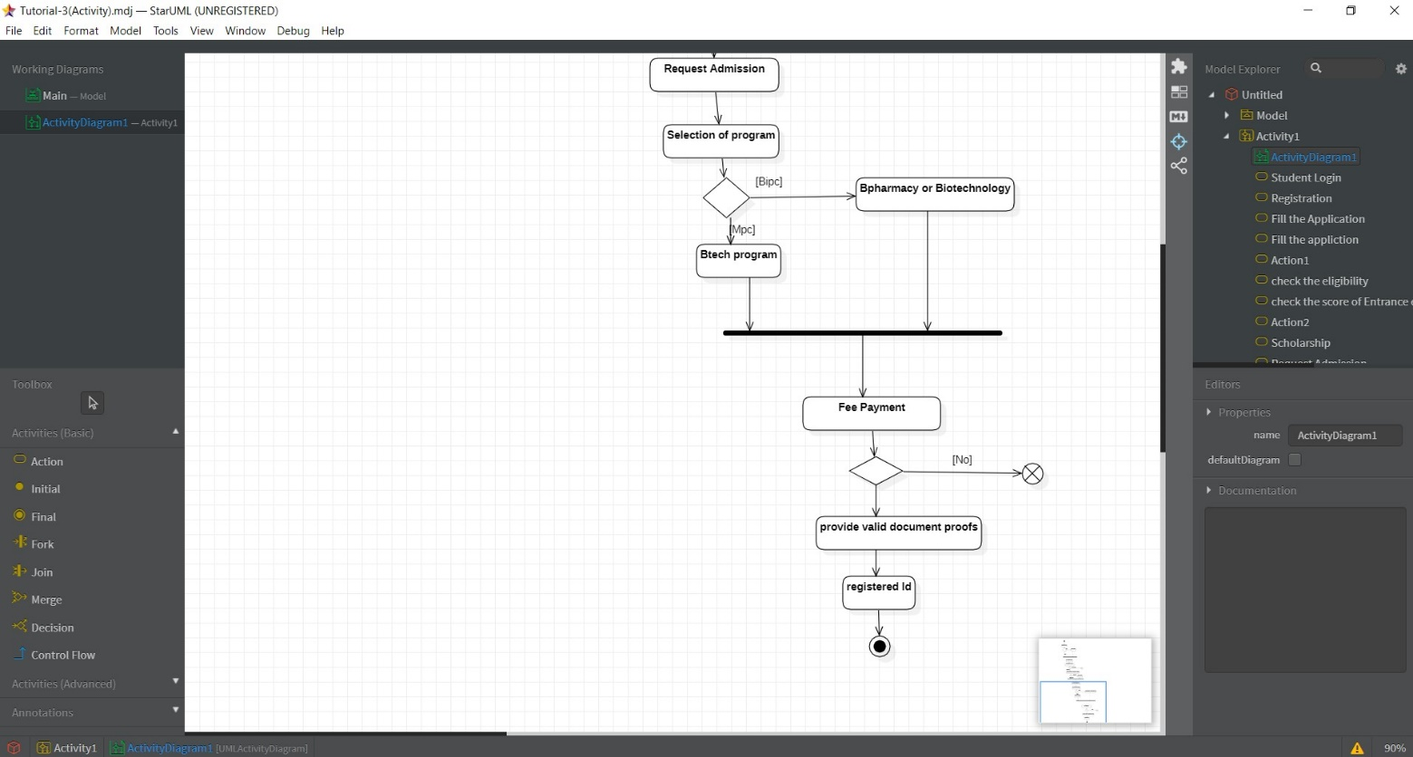

**Class diagram:**

Class diagram is a static diagram. It represents the static view of an application. Class diagram is not only used for visualizing, describing, and documenting different aspects of a system but also for constructing executable code of the software application.

Class diagram describes the attributes and operations of a class and also the constraints imposed on the system. The class diagrams are widely used in the modeling of objectoriented systems because they are the only UML diagrams, which can be mapped directly with objectoriented languages.

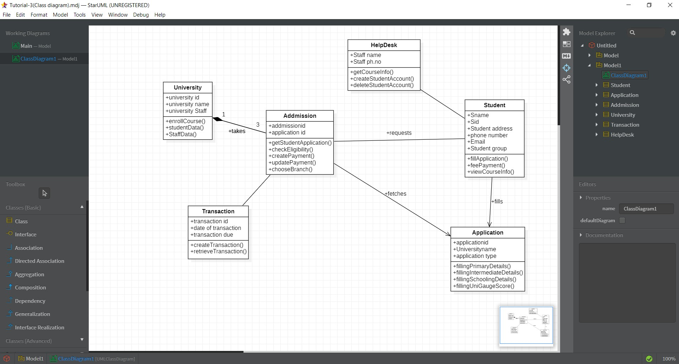

**State chart diagram:**

Statechart diagram is one of the five UML diagrams used to model the dynamic nature of a system. They define different states of an object during its lifetime and these states are changed by events. Statechart diagrams are useful to model the reactive systems. Reactive systems can be defined as a system that responds to external or internal events.

Statechart diagram describes the flow of control from one state to another state. States are defined as a condition in which an object exists and it changes when some event is triggered. The most important purpose of Statechart diagram is to model lifetime of an object from creation to termination.

