**Software Engineering**

**Tutorial-4**

**Prelab**

**1. UML diagram that specifies sequences/ steps of operations to be performed**

A. Activity diagram

1. Use case diagram
2. Class diagram
3. E-R case diagram

ANS) –B. Usecase diagram

**2. Which of the following statement is true?**

1. Use case diagram is a dynamic model of interaction between actors and product in a use case
2. Use case Description is a static model of use case supported by a product
3. All of the mentioned
4. None of the mentioned

ANS) – D. None of the mentioned

**3.A UML diagram that facilitates requirements gathering and interacts between system and external users, is called as**

1. Flowchart diagram
2. Sequence diagram
3. Use case diagram
4. Data flow diagram

ANS) – C. Use case diagram

**4.Who consider diagrams as a type of Class diagram, component diagram, object diagram, and deployment diagram?**

1. Structural
2. behavioral
3. non-behavioral
4. non structural

ANS) –A Structural

**5.__________ represented by In UML diagrams, relationship between component parts and object.**

1. ordination
2. aggregation
3. segregation
4. increment

ANS) –B Aggregation

**InLab**

**Use-Case Diagram:**

A UML use case diagram is the primary form of system/software requirements for a new software program underdeveloped. Use cases specify the expected behavior (what), and not the exact method of making it happen (how). Use cases once specified can be denoted both textual and visual representation (i.e. use case diagram). A key concept of use case modeling is that it helps us design a system from the end user's perspective. It is an effective technique for communicating system behavior in the user's terms by specifying all externally visible system behavior.

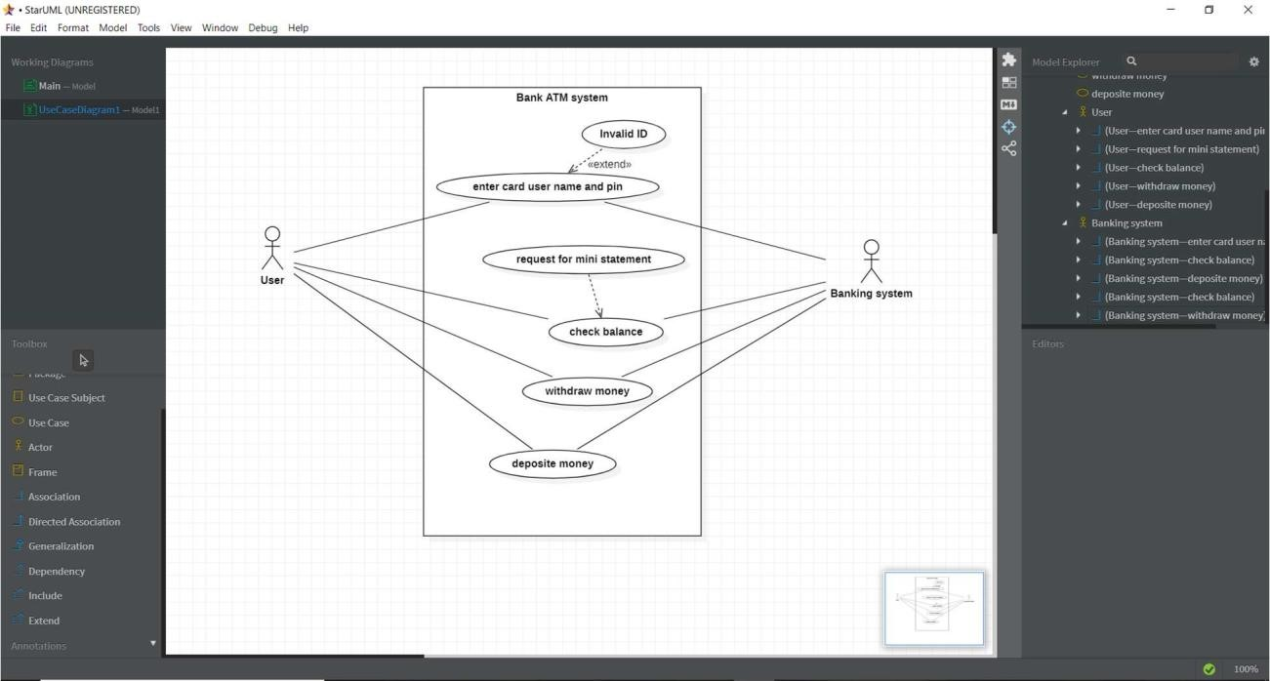

**Class Diagram:**

Class diagram is a static diagram. It represents the static view of an application. Class diagram is not only used for visualizing, describing, and documenting different aspects of a system but also for constructing executable code of the software application. Class diagram describes the attributes and operations of a class and also the constraints imposed on the system. The class diagrams are widely used in the modeling of objectoriented systems because they are the only UML diagrams, which can be mapped directly with objectoriented languages.

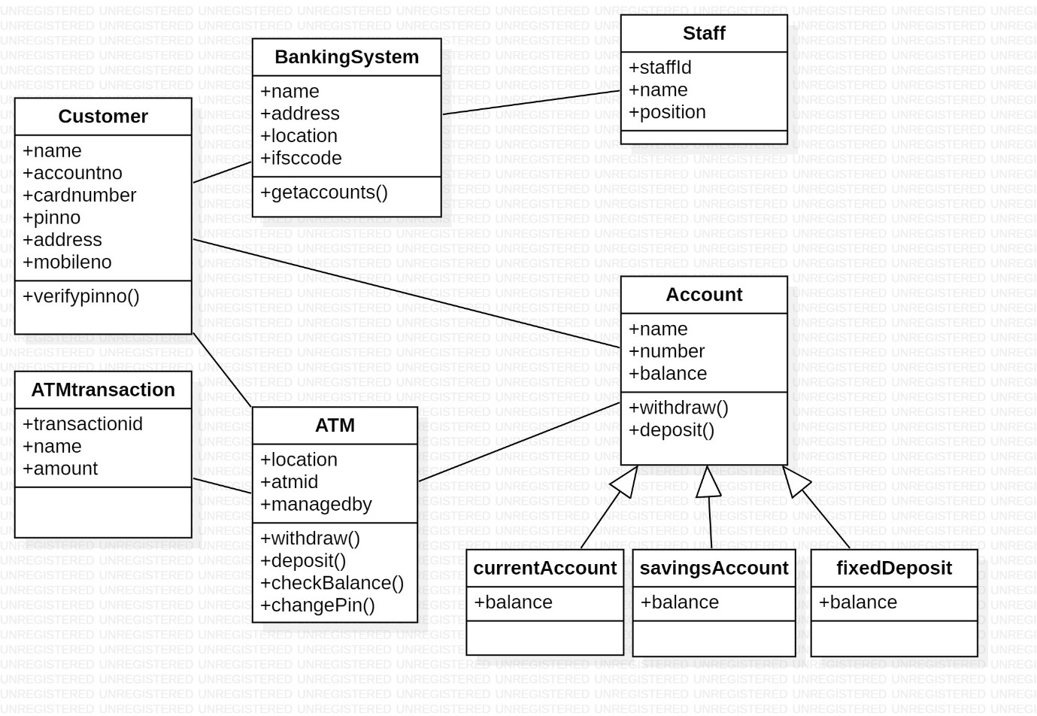

**Sequence Diagram:**

Sequence diagram: A sequence diagram shows object interactions arranged in time sequence. It depicts the objects and classes involved in the scenario and the sequence of messages exchanged between the objects needed to carry out the functionality of the scenario. ... Sequence diagrams are sometimes called event diagrams or event scenarios.

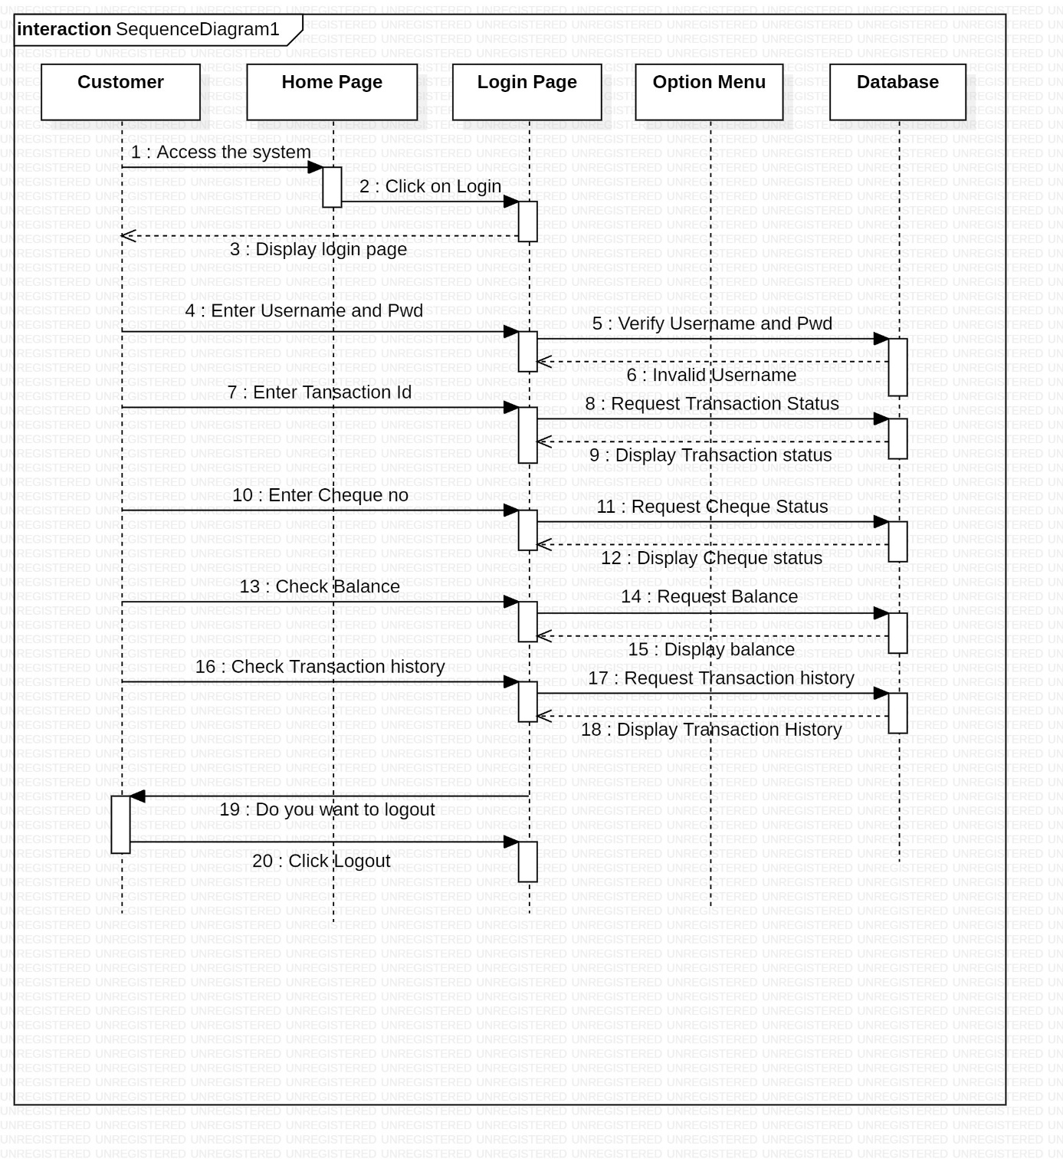

**State Chart Diagram:**

Statechart diagram is one of the five UML diagrams used to model the dynamic nature of a system. They define different states of an object during its lifetime and these states are changed by events. Statechart diagrams are useful to model the reactive systems. Reactive systems can be defined as a system that responds to external or internal events. Statechart diagram describes the flow of control from one state to another state. States are defined as a condition in which an object exists and it changes when some event is triggered. The most important purpose of Statechart diagram is to model lifetime of an object from creation to termination.

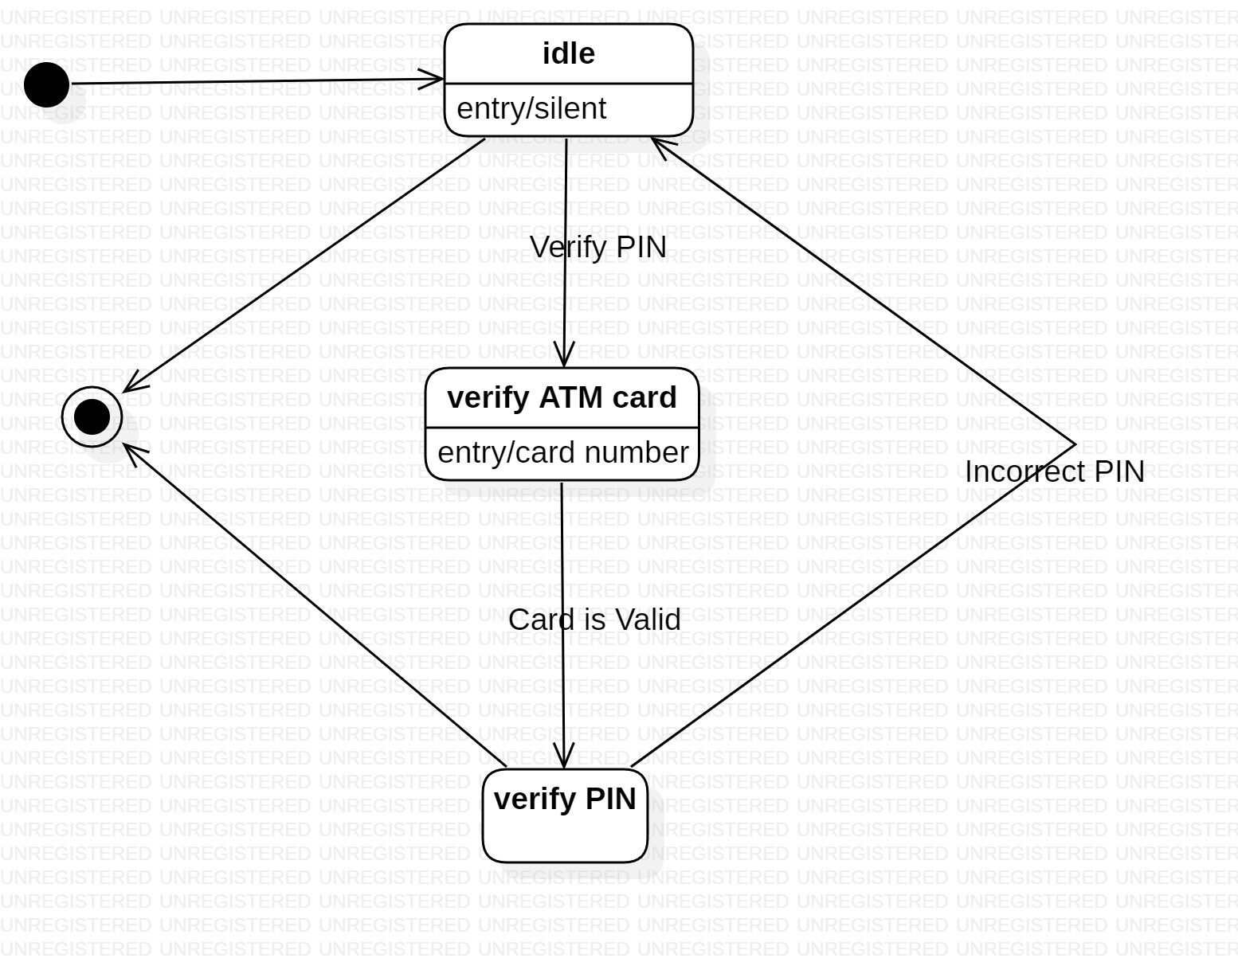

**Activity Diagram:**

Activity diagram is another important diagram in UML to describe the dynamic aspects of the system. Activity diagram is basically a flowchart to represent the flow from one activity to another activity. The activity can be described as an operation of the system.

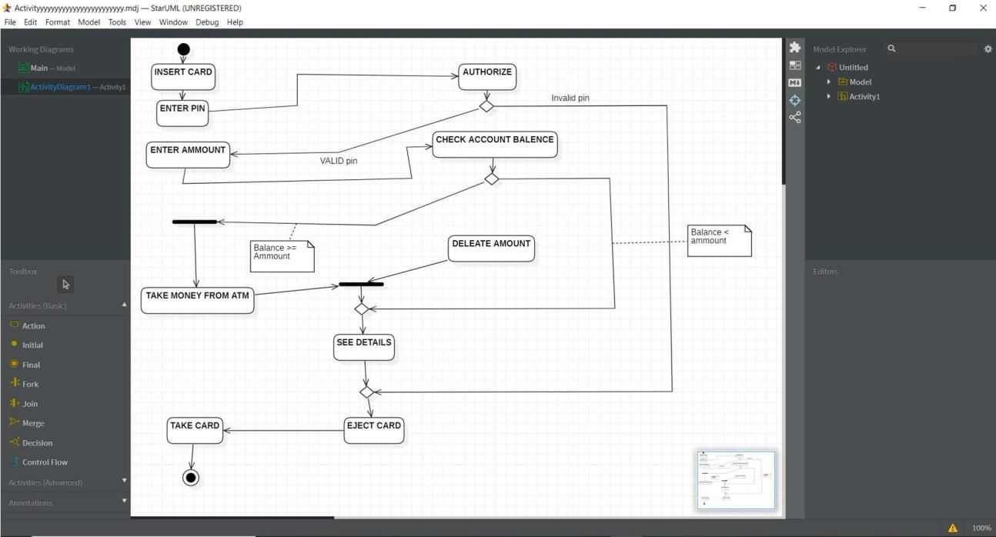

**PostLab**

**Use-Case Diagram:**

A UML use case diagram is the primary form of system/software requirements for a new software program underdeveloped. Use cases specify the expected behavior (what), and not the exact method of making it happen (how). Use cases once specified can be denoted both textual and visual representation (i.e. use case diagram). A key concept of use case modeling is that it helps us design a system from the end user's perspective. It is an effective technique for communicating system behavior in the user's terms by specifying all externally visible system behavior.

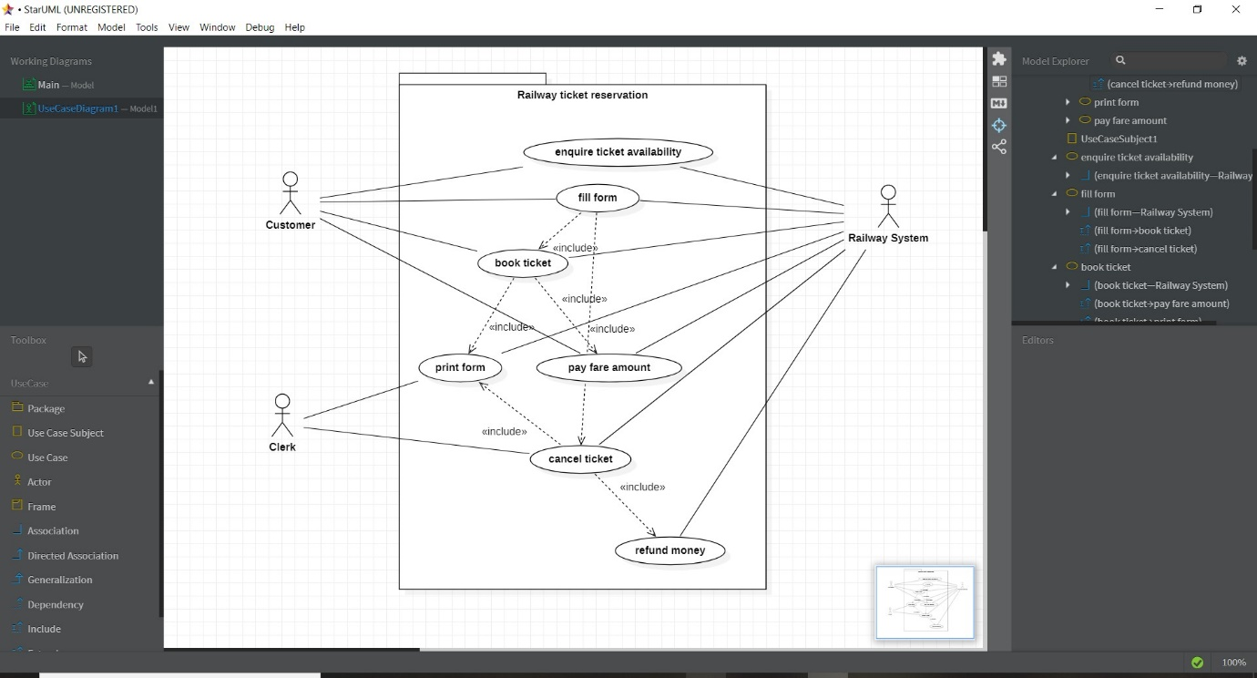

**Class Diagram:**

Class diagram is a static diagram. It represents the static view of an application. Class diagram is not only used for visualizing, describing, and documenting different aspects of a system but also for constructing executable code of the software application. Class diagram describes the attributes and operations of a class and also the constraints imposed on the system. The class diagrams are widely used in the modeling of objectoriented systems because they are the only UML diagrams, which can be mapped directly with objectoriented languages.

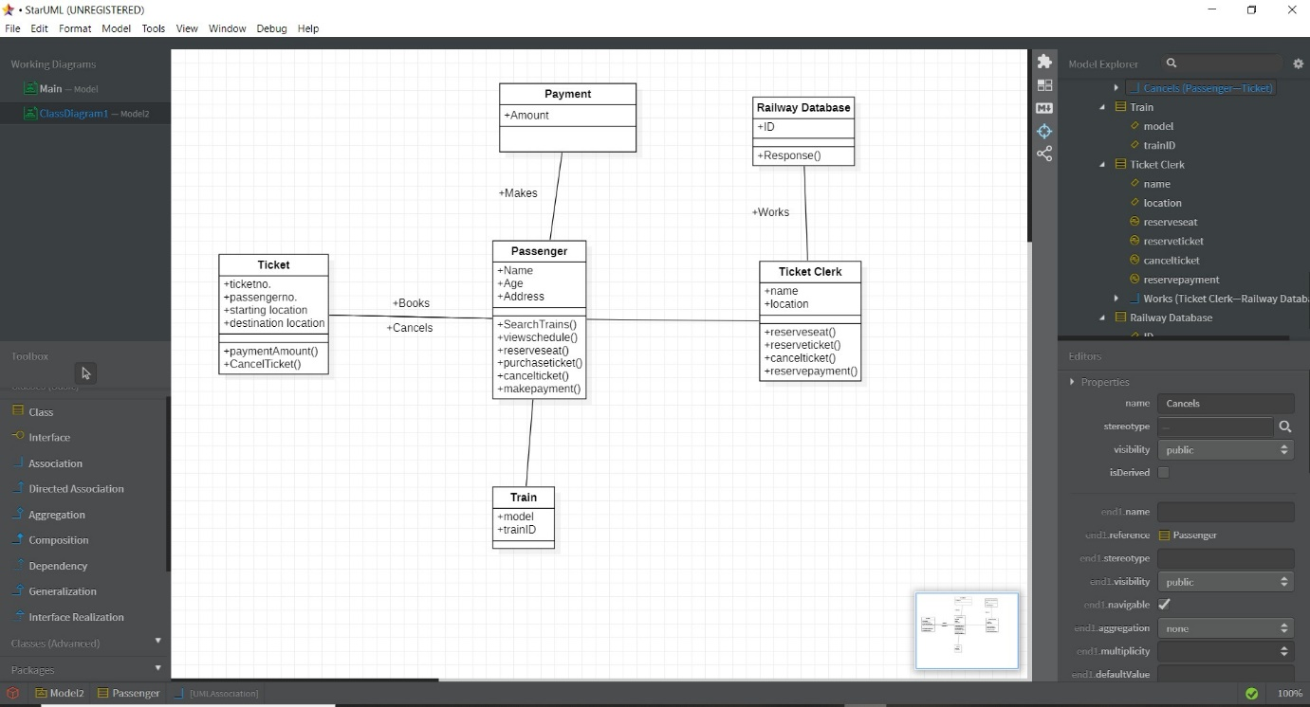

**Sequence Diagram:**

Sequence diagram: A sequence diagram shows object interactions arranged in time sequence. It depicts the objects and classes involved in the scenario and the sequence of messages exchanged between the objects needed to carry out the functionality of the scenario. ... Sequence diagrams are sometimes called event diagrams or event scenarios.

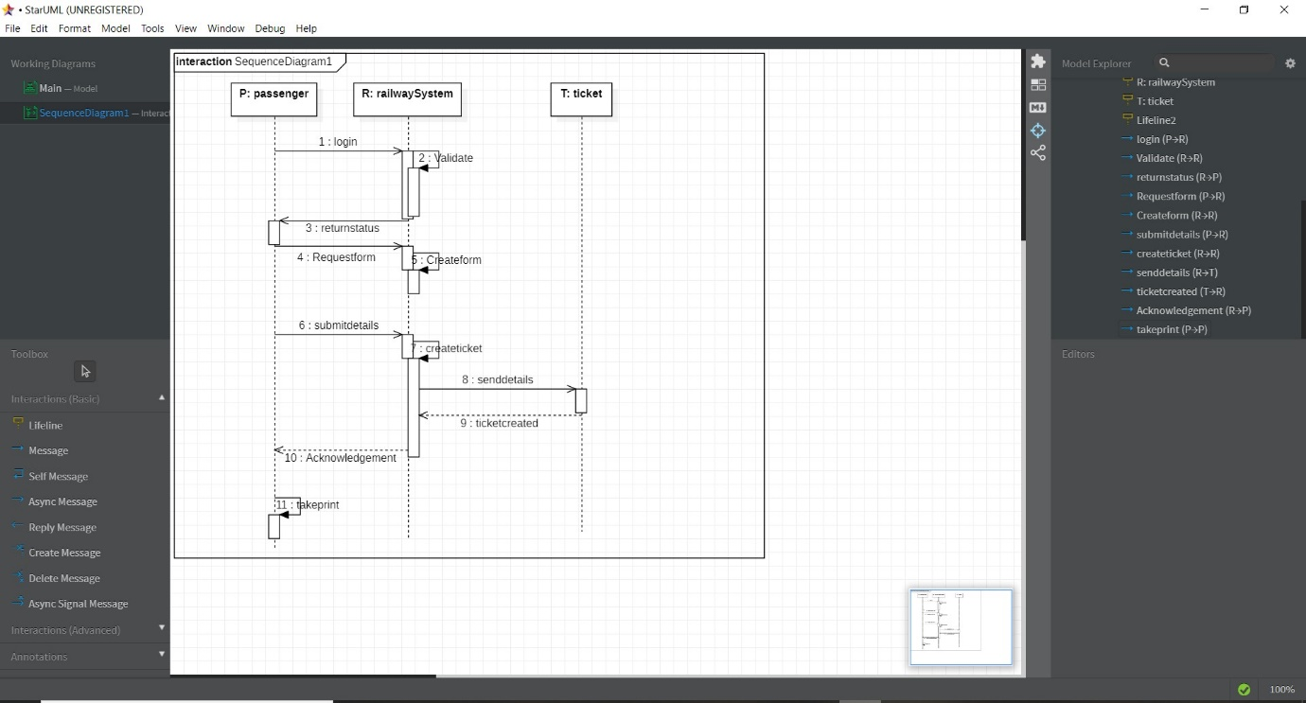

**State Chart Diagram:**

Statechart diagram is one of the five UML diagrams used to model the dynamic nature of a system. They define different states of an object during its lifetime and these states are changed by events. Statechart diagrams are useful to model the reactive systems. Reactive systems can be defined as a system that responds to external or internal events. Statechart diagram describes the flow of control from one state to another state. States are defined as a condition in which an object exists and it changes when some event is triggered. The most important purpose of Statechart diagram is to model lifetime of an object from creation to termination.

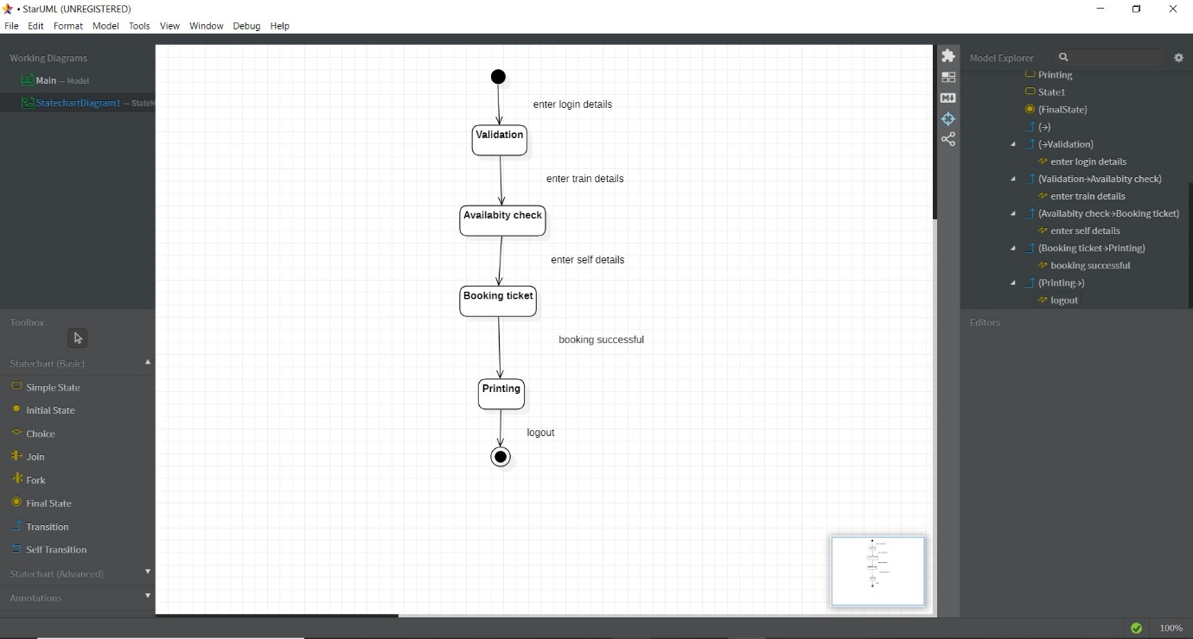

**Activity Diagram:**

Activity diagram is another important diagram in UML to describe the dynamic aspects of the system. Activity diagram is basically a flowchart to represent the flow from one activity to another activity. The activity can be described as an operation of the system.

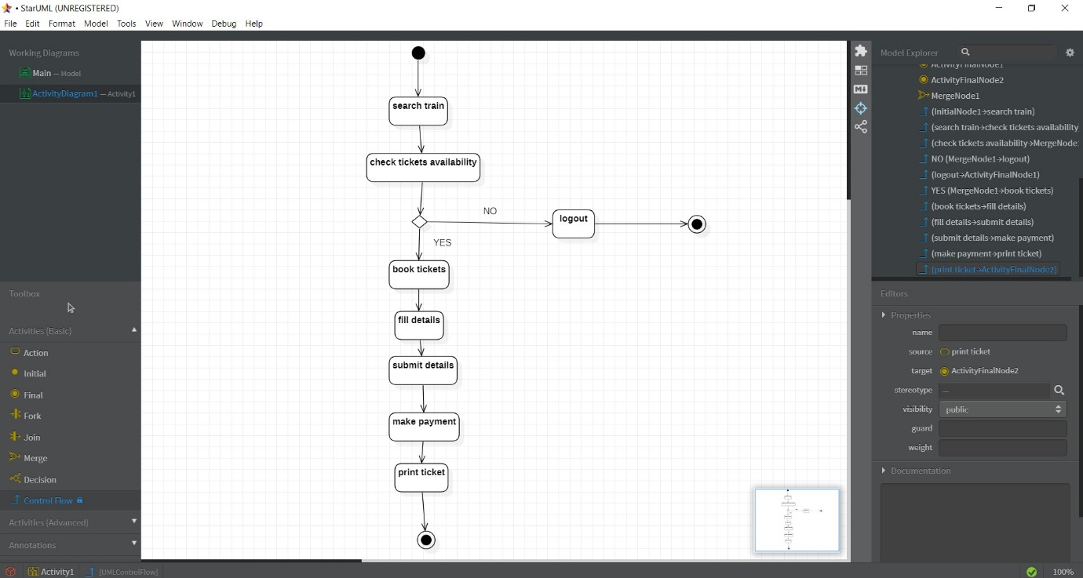

**1.Which type they considered Activity diagram, use case diagram, collaboration diagram, and sequence diagram as?**

1. non-behavioral
2. non-structural
3. structural
4. behavioral

ANS)—D. behavioral

**2.Which diagram is used to show interactions between messages are classified as?**

1. activity
2. state chart
3. collaboration
4. object lifeline

ANS) –C. collaboration

**3. Which diagrams are used to distribute files, libraries, and tables across topology of the hardware**

1. deployment
2. use case
3. sequence
4. collaboration

ANS) –A deployment

**4.Which diagram that helps to show Dynamic aspects related to a system?**

1. sequence
2. interaction
3. deployment
4. use case

ANS) –B interaction

**5. Simple name in UML Class and objects consist of __________.**

1. Letters
2. Digits
3. Punctuation Characters
4. All of the mentioned

ANS)—D All the mentioned