**1.Explain the terms software and characteristics of Software**

**Software** is defined as collection of computer programs, procedures, rules and data. Software Characteristics are classified into six major components:

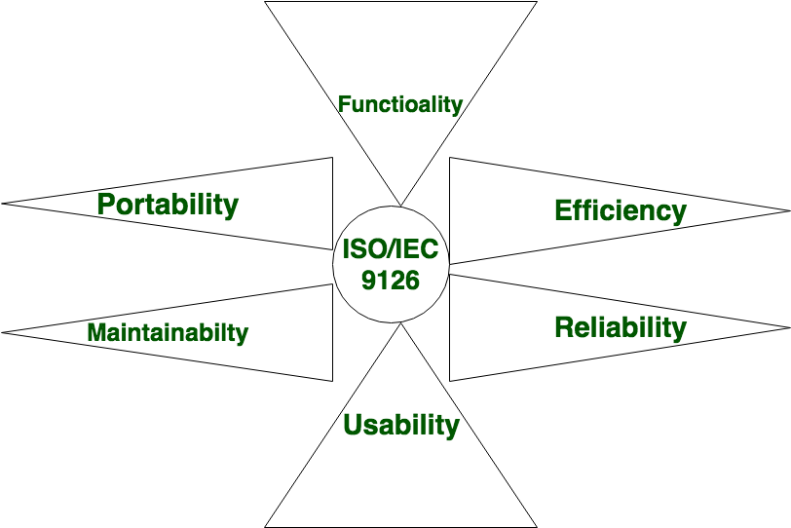

These components are described below:

* **Functionality:**  
  It refers to the degree of performance of the software against its intended purpose.

Required functions are:

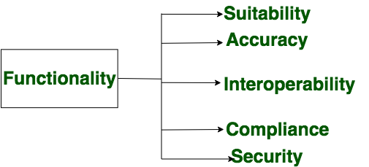

* **Reliability:**  
  A set of attribute that bear on capability of software to maintain its level of performance under the given condition for a stated period of time.

Required functions are:

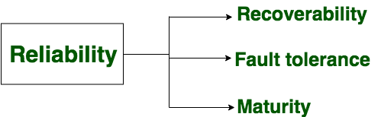

* **Efficiency:**  
  It refers to the ability of the software to use system resources in the most effective and efficient manner.the software should make effective use of storage space and executive command as per desired timing requirement.

Required functions are:

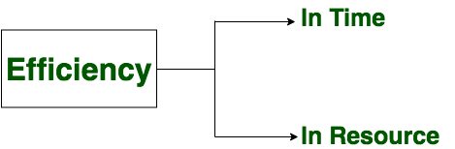

* **Usability:**  
  It refers to the extent to which the software can be used with ease.the amount of effort or time required to learn how to use the software.

Required functions are:

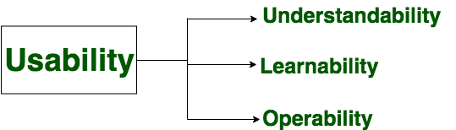

* **Maintainability:**  
  It refers to the ease with which the modifications can be made in a software system to extend its functionality, improve its performance, or correct errors.

Required functions are:

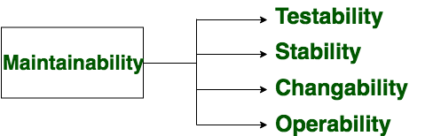

* **Portability:**  
  A set of attribute that bear on the ability of software to be transferred from one environment to another, without or minimum changes.

Required functions are:

