1. **Software engineering is defined as a process of analyzing user requirements and then designing, building, and testing software application which will satisfy those requirements.**

**Software is: (1) instructions (computer programs) that when executed provide desired features, function, and performance; (2) data structures that enable the programs to adequately manipulate information, and (3) descriptive information in both hard copy and virtual forms that describes the operation and use of the programs.**

**7.** 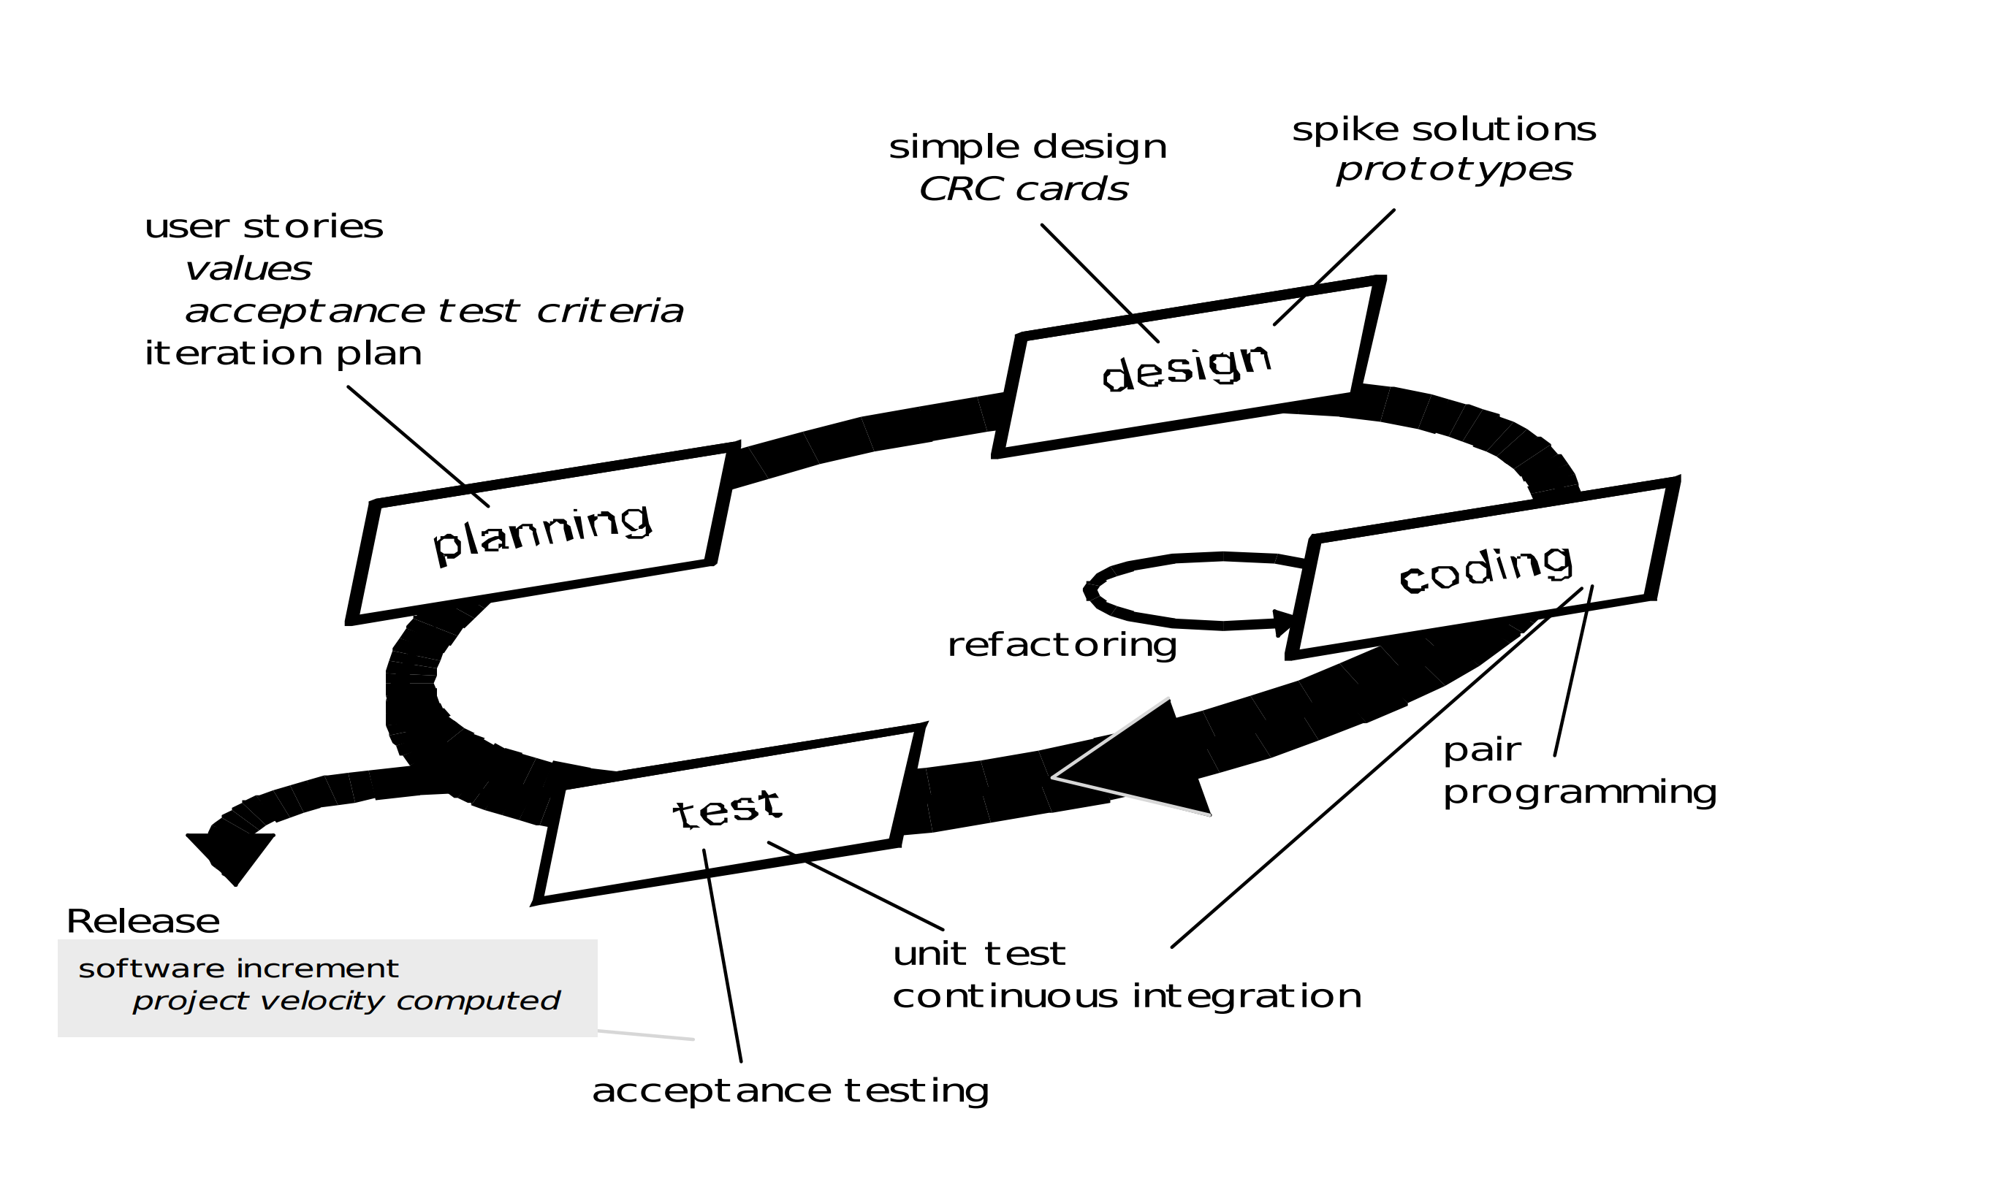

1. **Difference Between Hardware and Software:**

| **HARDWARE** | **SOFTWARE** |
| --- | --- |
| Hardware is a physical parts computer that cause processing of data. | Software is a set of instruction that tells a computer exactly what to do. |
| It is manufactured. | It is developed and engineered. |
| Hardware can not perform any task without software. | software can not be executed without hardware. |
| As Hardware are physical electronic devices, we can see and touch hardware. | We can see and also use the software but can’t actually touch them. |
| It has four main categories: input device, output devices, storage, and internal components. | It is mainly divided into System software, Programming software and Application software. |
| Hardware is not affected by computer viruses. | Software is affected by computer viruses. |
| It can not be transferred from one place to another electrically through network. | But, it can be transferred. |
| If hardware is damaged, it is replaced with new one. | If software is damaged, its backup copy can be reinstalled. |
| Ex: Keyboard, Mouse, Monitor, Printer, CPU, Hard disk, RAM, ROM etc. | Ex: Ms Word, Excel, Power Point, Photoshop, MySQL etc. |

**10.** Validation Phases

The different Validation Phases in a V-Model are explained in detail below.

Unit Testing

Unit tests designed in the module design phase are executed on the code during this validation phase. Unit testing is the testing at code level and helps eliminate bugs at an early stage, though all defects cannot be uncovered by unit testing.

Integration Testing

Integration testing is associated with the architectural design phase. Integration tests are performed to test the coexistence and communication of the internal modules within the system.

System Testing

System testing is directly associated with the system design phase. System tests check the entire system functionality and the communication of the system under development with external systems. Most of the software and hardware compatibility issues can be uncovered during this system test execution.

Acceptance Testing

Acceptance testing is associated with the business requirement analysis phase and involves testing the product in user environment. Acceptance tests uncover the compatibility issues with the other systems available in the user environment. It also discovers the non-functional issues such as load and performance defects in the actual user environment.