GENDER EQUITY IN U.S. COLLEGE SPORTS PARTICIPATION

Description of Project Goals
Description
In this project, we chose to investigate gender-based disparities in collegiate sports participation across schools in the United States. Using a dataset from Kaggle that contains annual records of male and female sports participation at most colleges, our analysis explores the patterns and trends related to gender equity in collegiate athletics.

The dataset includes variables such as the number of male and female athletes at each institution, the year of record, institution name, state, and division classification. After our initial data cleaning, the analysis focuses on comparing male-to-female participation ratios across these dimensions:
- State: Demonstrating the distribution of these ratios across states.
- Classification: Examining how institution classifications (Division I, Division II, etc.) differ in participation rates.
- School: Highlighting specific schools with particularly high gender imbalance in sports.
- Time: Tracking how overall participation ratios have changed over the years.
- Region: Aggregating state-level data into broader U.S. regions (Northeast, Midwest, South, West) to visualize regional differences.
- Revenue: Comparing the total revenue generated per university through the athletic programs through the male and female sports each year.
- Expenditure: Viewing differences in the total expenditures, for recruiting and operations, of all institutions per year by gender.

Overall, the question our analysis aimed to answer is: “How does male and female sports participation differ across U.S. colleges, and how do these differences vary by state, region, institution type, and over time?”

Importance of the Problem
The social problem of gender equality ranges across various industries and environments, extending into the world of collegiate sports. June of 2022 marked the 50th anniversary of the passage of Title IX of the Education Amendments of 1972, a law that prohibits gender discrimination in both education programs and other activities, including collegiate sports, which receive federal financial assistance. After the passage of Title IX, female athletic programs across the United States formed and women gained access to sports programs that previously were exclusively male. Universities provided funding and opportunities, and the impact goes beyond the university to the Olympic athletic teams and further to looking at societal gender equality improvements and progress. The data set for this project was chosen to examine the differences in collegiate athletics across U.S. universities between males and females. Legislation for NIL (Name, Image, and Likeness) over the past 6 years has been rapidly evolving and discussions are still active and are impacted by studies of collegiate athletics gender participation. Additionally, the results of the analysis could expand into a larger study of gender equality and participation in primary and secondary schools at both the state and federal levels. A legal impact could empower and provide opportunities to the lives of young men and women of future generations.

Exploratory Analysis
Our exploratory analysis revealed several important patterns in collegiate sports participation and funding. Between 2016 and 2018, participation increased for both men and women, with female participation actually growing at a faster rate. However, in 2019, both groups experienced a decline (Figure 7). At the state level, male participation surpassed female participation across nearly all states. While a few states exhibited more balanced ratios, the overall trend pointed to a clear gender disparity (Figure 6). We visualized these patterns using histograms and bar plots to better understand the distribution.

When analyzing participation by institutional classification, Division I-FBS schools displayed the highest male-to-female participation ratios, highlighting how institutional structure and competition level influence gender equity in sports (Figure 5). On a regional level, schools in the South and Midwest exhibited greater gender disparities than those in the Northeast and West, suggesting that geography may also play a role in access and opportunity (Figure 4). Finally, we examined the relationship between participation, revenue, and expenditure. By calculating revenue and expenditure per participant by gender over time, we observed a consistent pattern where men received more financial resources per participant than women across all years studied (Figures 1 & 2).

This preliminary data exploration showed that revenue varied widely by division and sport type, with Division I-FBS institutions and high-profile sports such as football and basketball generating the largest totals. These patterns motivated our decision to include classification and sport type as categorical predictors in our regression models, to better capture structural differences beyond participation numbers.

Solution and Insights
While our primary question focused on participation differences, the revenue analysis adds another dimension: sports and divisions that generate higher revenues may receive more institutional support, potentially influencing participation opportunities and resources available to male and female athletes. This suggests that addressing gender equity in participation may require considering the revenue structures of different sports and divisions.
We built two linear regression models to predict total athletics revenue per school year using the dataset.

The first model, Model A, included only numeric variables: total male participants, total female participants, and year. This baseline model achieved an R² of 0.079 and a root mean squared error (RMSE) of approximately $3.52 million. The coefficients indicated that each additional male participant was associated with an increase of about $42,613 in revenue, while each additional female participant was associated with a decrease of about $21,053, holding other factors constant. The positive coefficient for the year (+$26,008) suggested a general upward trend in revenue over time. However, the low R² value showed that participation counts alone could not explain much of the variation in revenue across institutions.

The second model, Model B, expanded on the baseline by adding categorical variables for institutional division (classification_name) and sport type (sports). These variables were dummy-encoded for use in the regression. Model B achieved an R² of 0.213 and an RMSE of about $3.26 million, improving the explained variance and reducing prediction error by approximately $266,000 compared to the numeric-only model.
The categorical coefficients revealed which divisions and sports are most strongly associated with revenue differences. Competing in NCAA Division I-FBS had the largest positive association, adding about $4.96 million in revenue relative to the baseline category. Sports such as Football (+$2.46M), Rifle (+$1.74M), and Basketball (+$1.65M) also had substantial positive effects. Other notable revenue drivers included Synchronized Swimming (+$1.28M), Badminton (+$1.27M), and Softball (+$1.17M). These results confirm that both institutional classification and the type of sport offered significantly influence athletics revenue, beyond what can be explained by participation counts alone.
While participation equity between men and women in college sports is gradually improving, financial equity in terms of investments, revenues, and expenses still lags behind. Revenue is heavily concentrated in certain high-profile sports (like football and basketball) and in top divisions (like NCAA Division I-FBS), which tend to be male-dominated. This structural imbalance influences where resources flow and indirectly impacts participation opportunities for women.
To address this gap, we can take the following measures:
- Targeted Investment in Women’s Sports
- Creation of Revenue Opportunities for Women’s Teams
- Equity-Based Budgeting Models
- Policy and Oversight Mechanisms
Over time, this could help align investments, revenues, and expenses with the participation equity that is already emerging in collegiate athletics.
Overall, our findings suggest that revenue disparities between schools cannot be attributed solely to the number of male or female athletes. The competitive level of the institution and the sports it sponsors, particularly high-profile or resource-intensive ones, are major factors in shaping financial outcomes. This highlights the importance of considering these structural factors when evaluating gender equity, resource allocation, or policy changes in college athletics.
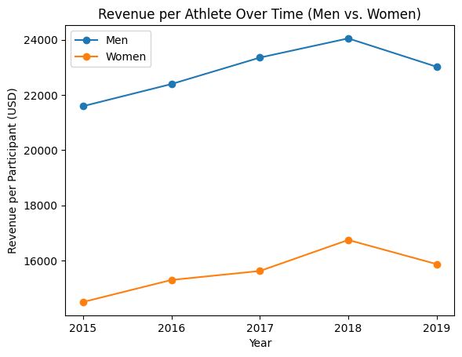
Figure 1: Revenue per Athlete Over Time

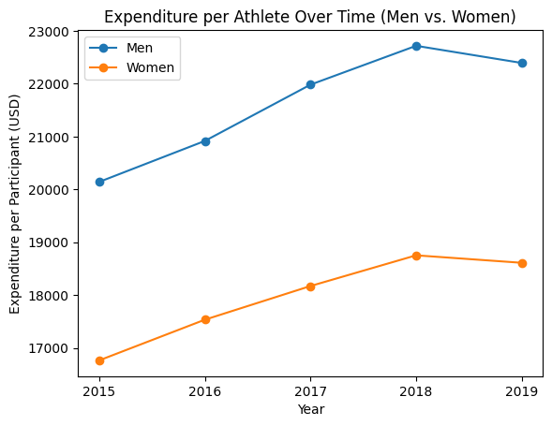
Figure 2: Expenditure per Athlete Over Time
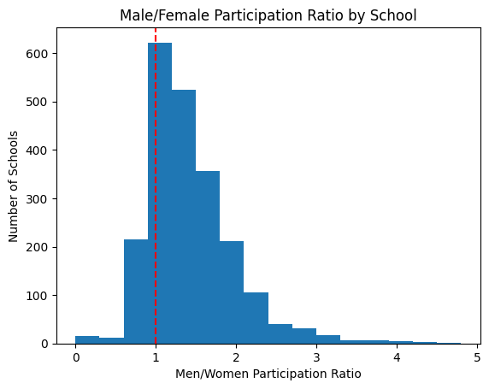
Figure 3: Male/Female Participation Ratio by School

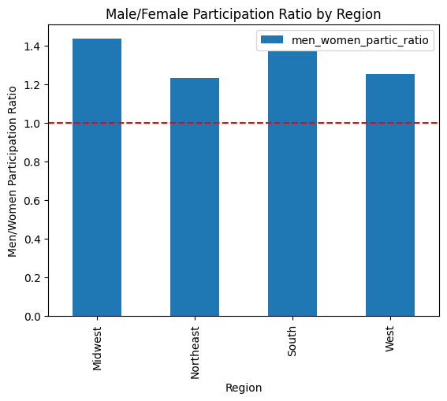
Figure 4: Male/Female Participation Ratio by Region
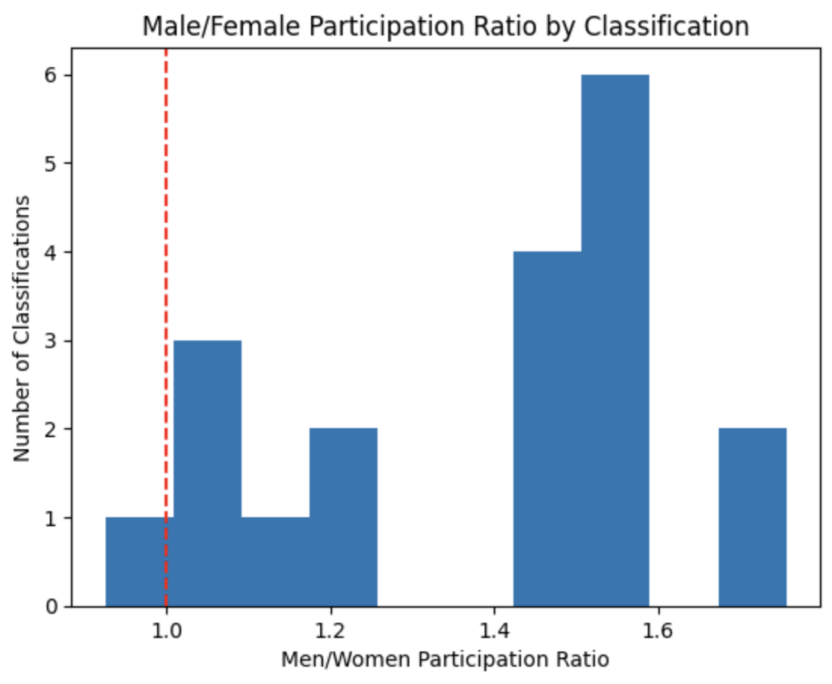
Figure 5: Male/Female Participation Ratio by Classification

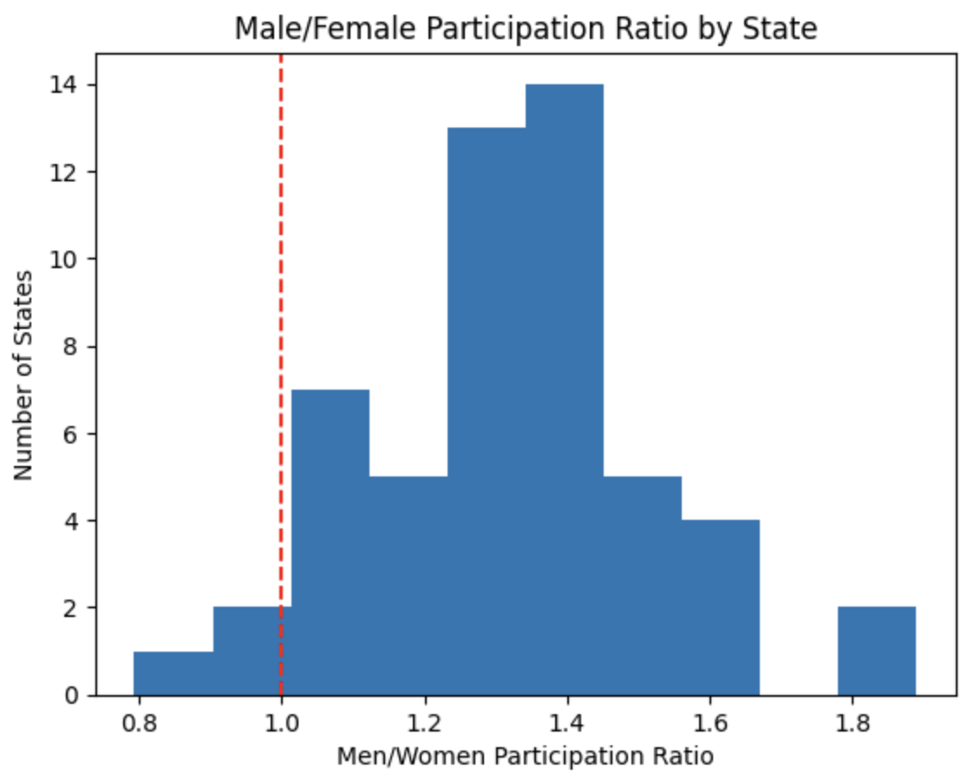
Figure 6: Male/Female Participation Ratio by State
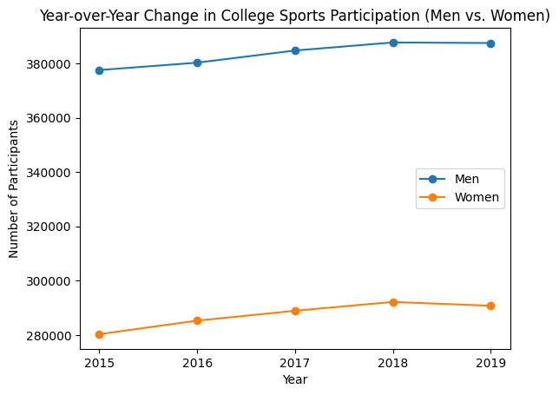
Figure 7: Change in Overall College Sports Participation
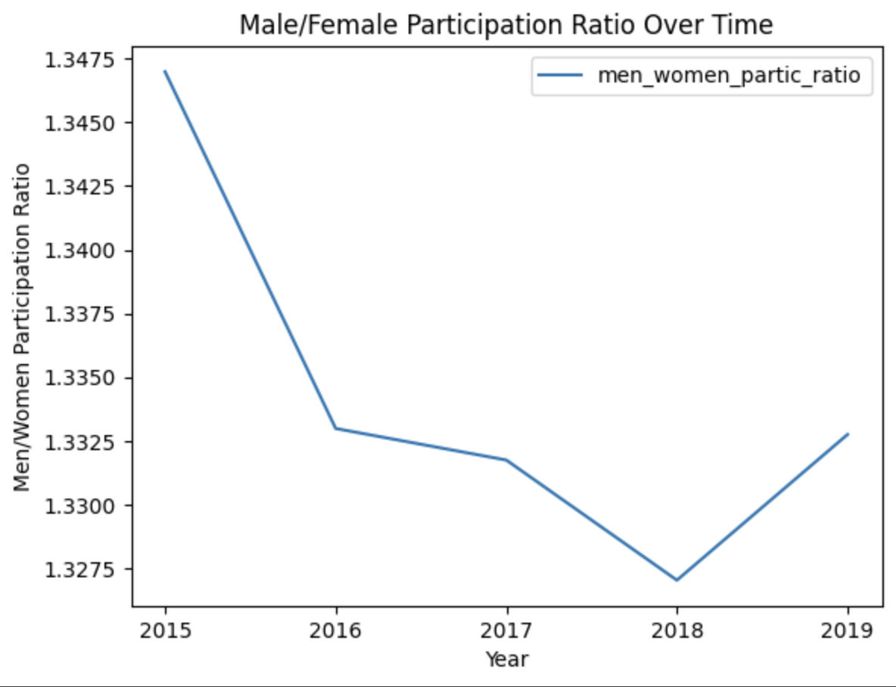
Figure 8: Overall Male/Female Participation Ratio Over Time

