1119527

PART A

ESSAY

Contents

Core processes of the CONTROLLER project: 2

Adaptive SDLC with six core processes and multiple iterations 2

Identify problem and obtain approval 2

Plan and Monitor project 2

Discover and understand details 2

Design system components 2

Build test, and integrate system components 2

Complete system tests and deploy the solution 2

Core process activities that CONTROLLER project would require: 3

Problem Identification: 3

Planning and monitoring project 3

Discover and understand details 3

Design System Components 4

Building and Testing 5

Complete system tests and deploy the solution 5

Agile Model 5

Two types of Agile Methodologies which are appropriate for given case study i.e CONTROLLER project are: 5

SCRUM methodology 5

Feature Driven Development (FDD) 6

# Core processes of the CONTROLLER project:

## Adaptive SDLC with six core processes and multiple iterations

### Identify problem and obtain approval

* This phase of SDLC means getting input from all partners, including clients, salesmen, industry specialists, and programmers. Become familiar with the strengths and weaknesses of the present system with improvement as the objective.

Roger and his team have worked out on a secure VPN between CLIENT, SERVER and CONTROLLER. They are a bit confused about how to design central CONTROLLER APPLICATION and how to set up the CLIENT and Server data on CONTROLLER. Roger has some idea of process of CONTROLLER. But he is not sure of how to design new system.

### Plan and Monitor project

* In this phase of SDLC, the team describes the requirement of the new software and decides the expense and assets required. It additionally details the risks involved and gives sub-plans to relaxing those risk. In this stage, a Software Requirement Specification document is made is made.

### Discover and understand details

* Finding out and understanding the major and minor details of the project for better and smoother performance throughout the processes.

### Design system components

* Design Specifications take place in this. This stage of SDLC begins by transforming the software specifications into a structure plan called the Design Specification. All stakeholder then review this plan and offer feedback and proposals. It's critical to have a plan for gathering and incorporating partner input to this report. Failure at this stage will surely result in cost overruns in best case scenario and all out collapse of the project in worst case scenario

In CONTROLLER project, the design specification will include the data flow from CLIENT 🡪 CONTROLLER 🡪 SERVER . Feedback from stakeholders like Roger, Gabrielle, etc

### Build test, and integrate system components

* Build includes development of software and code and attention to detail. Followed by testing, testing for defect and deficiencies in code. Fixing those until product specific goals.

In this case of CONTROLLER project, multiple testing of CLIENT, SERVER and CONTROLLER takes place before performing actual data backup processes from business entities.

### Complete system tests and deploy the solution

* As we keep getting feedback from end users, we keep making changes in the backup procedures to improve the overall performances. (Stackify, 2017)

# Core process activities that CONTROLLER project would require:

### Problem Identification:

The main problems in CONTROLLER project are:

* Roger wants to design CONTROLLER that performs specific functions but is not designed fully yet.
* Roger does plan to create a “Restore backup” option but that might result in error at later stage.

**Risk and Feasibility analysis:**

Possible risks are –

* Project collapse
* Financial loss
* Customer dissatisfaction.

**Review to customer** (Satzinger, et al., 2014)

### Planning and monitoring project

As we know a few tasks to be performed by the CONTROLLER, the backup file’s journey from CLIENT uploading, CONTROLLER transporting and SERVER receiving to store and backup is monitored. This includes the concrete specifications like screen layouts that the client will be able to see when they upload their files to be backed up by SERVER, or when they want to cancel their scheduled backups because they want to end services, etc.

**Project environment**

**Schedule the work** – for example, Client named John will ne backed up on 23rd September 5:00 pm , then 30th September 5:00PM.

**Staff allocation** Team of 10 employees will be assigned to manage the data coming from client, 20 employees to operate and manage CONTROLLER and 50 employees will manage data in Server.

**Evaluate work done, check progresses and make rectifications** (Satzinger, et al., 2014)

### Discover and understand details

* Details:
* YITSC IT team setting up data and storing business entity details.
* IT team enters all business details while setting up the CONTROLLER in order to perform all backups for the business
* The backup task details are entered and stored, and then backup tasks are scheduled and run at specific time and interval.
* One backup task is scheduled for a particular time and interval for a smoother functioning in CONTROLLER hence it is the job of IT team to assign the time after task details are entered and stored.
* The CLIENT will send data to Server to backup.
* The client will upload a file which he or she wants to get backed up by the server.
* The CONTROLLER will monitor that the backup was proceeding as normal after receiving a File Transfer activity log.
* Once the client sends his or her file to get backed up, the CONTROLLER receives a notification of File transfer activity log. After that, CONTROLLER monitors and supervises that all the backup proceedings are working fine.
* Log Activity will be stored in Log file for reference purpose (In case of error, Roger will be notified via email.
* Log activity gets recorded in Log file so that it can be used in future for reference. For any reasons, if an error occurs, Roger should be notified immediately via email.
* The final entry in log will inform CONTROLLER when Backup finishes. Hence, CONTROLLER will stop CLIENT and then SERVER and send a summary report to Roger.
* When backup finishes CONTROLLER will be informed by final entry in log and the CLIENT and SERVER will stop backing up. Summary report will be sent to Roger.
* When CLIENT decides to end services, Roger will manually remove the scheduled backups from CONTROLLER, after 6 months, he will remove the client’s backed up data not owned by client.
* When client ends service, all their backed up data and scheduled backups will be removed from CONTROLLER.

### Design System Components

The three main components of this design are:

1. CLIENT:

Requirement of business entities are to store-

contact name, business name, contact address, start date and business ABN

1. CONTROLLER

Requirement of CONTROLLER are to store-

computer name, IP address, data version date and time, total data storage capacity, current storage size, data storage path, comments and a Boolean is Current attribute

1. SERVER

Requirement of CONTROLLER are to store-

tcp port address, rsync module name, and Log file path

Tasks Schedule - schedule name, status (in progress, scheduled, complete), start date and time and a latest finish date and time.

**Design of User interface, Database of the business records, design of software classes and records** (Satzinger, et al., 2014)

### Building and Testing

The developing and testing programs used to create CLIENT, CONTROLLER and SERVER that manages system to backup Client data for as long as they require. If any defects are found, rectifying it and fixing them.

Regression and retesting is done until the customer is satisfied with the developed project.

### Complete system tests and deploy the solution

Getting regular feedbacks from clients who use the service so that changes and upgrades can be made time to time

# Agile Model

The Agile model was made in response of the rigidity of the waterfall model. Agile is an iterative procedure where the group is always re-evaluating their needs based on regular client feedback and the success of their sprints. Sprints are short work periods, maybe 2 weeks, where the team attempts to knock out high-priority tasks and release a functional item for client feedback. The Agile model rejects the idea that you can know everything about it a task at its onset.

Disadvantages of Agile model:

* Too much of Customer Feedback can lead to getting lost in project
* Lack of solid plan leading to difficulty in finding estimated deadlines and resource (Anon., n.d.)

Agile's four main values are expressed as:

* Individuals and interactions over processes and tools
* Working software over comprehensive documentation
* Customer collaboration over contract negotiation
* Responding to change over following a plan (Anon., n.d.)

In CONTROLLER project, Roger decides to change how they take client backup and so he is talking to clients about updating security their systems.

Here taking constant feedback of the client (end users) will help in knowing what the customers actually require and hence we can make changes accordingly.

For example, client is not happy about the time span in which the backup of data is done, so he or she can give feedback and administrators and they can make changes to system according to end user’s convenience.

## Two types of Agile Methodologies which are appropriate for given case study i.e CONTROLLER project are:

### SCRUM methodology

Procedure stream of scrum testing is as per the following:

* Every iteration of a scrum is known as Sprint
* Item iteration is where all details are entered to get the final product
* During each Sprint, top client stories of Product backlog are chosen and transformed into Sprint backlog
* Team deals with the defined sprint backlog
* Team checks for the daily work
* At the finish of the sprint, team deliver product functionality

CONTROLLER project might back up in iterations following SCRUM methodology

### Feature Driven Development (FDD)

This strategy is focused around "designing and building" features. In contrast to other agile strategies, FDD portrays particular and short periods of work that must be accomplished independently per feature. It includes domain walkthrough, design inspection, promote to build, code inspection and plan design. FDD creates product keeping things in the target.

* Domain object Modelling
* Development by feature
* Component/ Class Ownership
* Feature Teams
* Inspections
* Configuration Management
* Regular Builds
* Visibility of progress and results (Anon., n.d.)

In this all the tasks in one project are considered as separate tasks hence any one task will not be affected due to any challenges in other task

I believe that FDD Agile method is more preferable for this project but both can be used.

# References

Anon., n.d. *Agile Methodology & Model: Guide for Software Development & Testing.* [Online]   
Available at: https://www.guru99.com/agile-scrum-extreme-testing.html  
[Accessed 30 09 2019].

Anon., n.d. *SDLC – The Software Development Life Cycle.* [Online]   
Available at: https://www.projectmanager.com/software/use-cases/sdlc  
[Accessed 30 09 2019].

Anon., n.d. *What is Agile Methodology in Project Management?.* [Online]   
Available at: https://www.wrike.com/project-management-guide/faq/what-is-agile-methodology-in-project-management/  
[Accessed 30 09 2019].

Satzinger, J., Jackson, R. & Burd, S., 2014. *Systems Analysis and Design in changin World.* 7th ed. Boston: Cengage Learning.

Stackify, 2017. *What is SDLC?.* [Online]   
Available at: https://stackify.com/what-is-sdlc/  
[Accessed 30 09 2019].

PART B

MODELLING AND DIAGRAMMING

**Question 2 - Use case modelling**

**a) Event Table**

|  |  |  |  |  |  |  |
| --- | --- | --- | --- | --- | --- | --- |
| Event | Type | Trigger | Source | Use Case | Response | Destination |
| An event initiated by an external actor or system, time or state change of an object.  Makes the system do something. |  | Signal that tells system an event has occurred. | Noun  Actor  External System  Time | Action that system takes to produce a defined outcome (CRUD) | What output (if any) is produced by the system  Descriptive Noun | Noun  Actor  External System |
| YITCS IT team set up and store details of CLIENT | External | YITCS IT team enters and stores details of CLIENT | IT Team | Creates record for CLIENT details | Successfully scheduled backup tasks of CLIENT | IT team, CONTROLLER |
| YITCS IT team set up and store details of SERVER | External | YITCS IT team enters and stores details of SERVER | IT Team | Creates record for SERVER details | Successfully scheduled backup tasks of SERVER | IT team, CONTROLLER |
| CLIENT sends data to SERVER to get backed up | External | Client selects file to upload to SERVER for backup | CLIENT | Creates log activity | Data successfully uploaded for backup | CLIENT |
| Backup is finished | State | CONTROLLER will stop CLIENT, then it will stop SERVER | CONTROLLER | Deletes record from Scheduled Backups | Successfully Backup finished | CONTROLLER, CLIENT |
| CLIENT ends service | External | Roger removes scheduled backup from CONTROLLER | CLIENT | Deletes data from client , then deletes data from server | Service ends successfully | CLIENT |
| Removing non existent Client’s data | Temporal | Roger manually removes client’s backed up data from SERVER not owned by client **(after 6 months)** | Roger | Deletes records from backed up data | Non existent client data successfully removed from system | Roger, SERVER |

**b) Use Case Diagram**

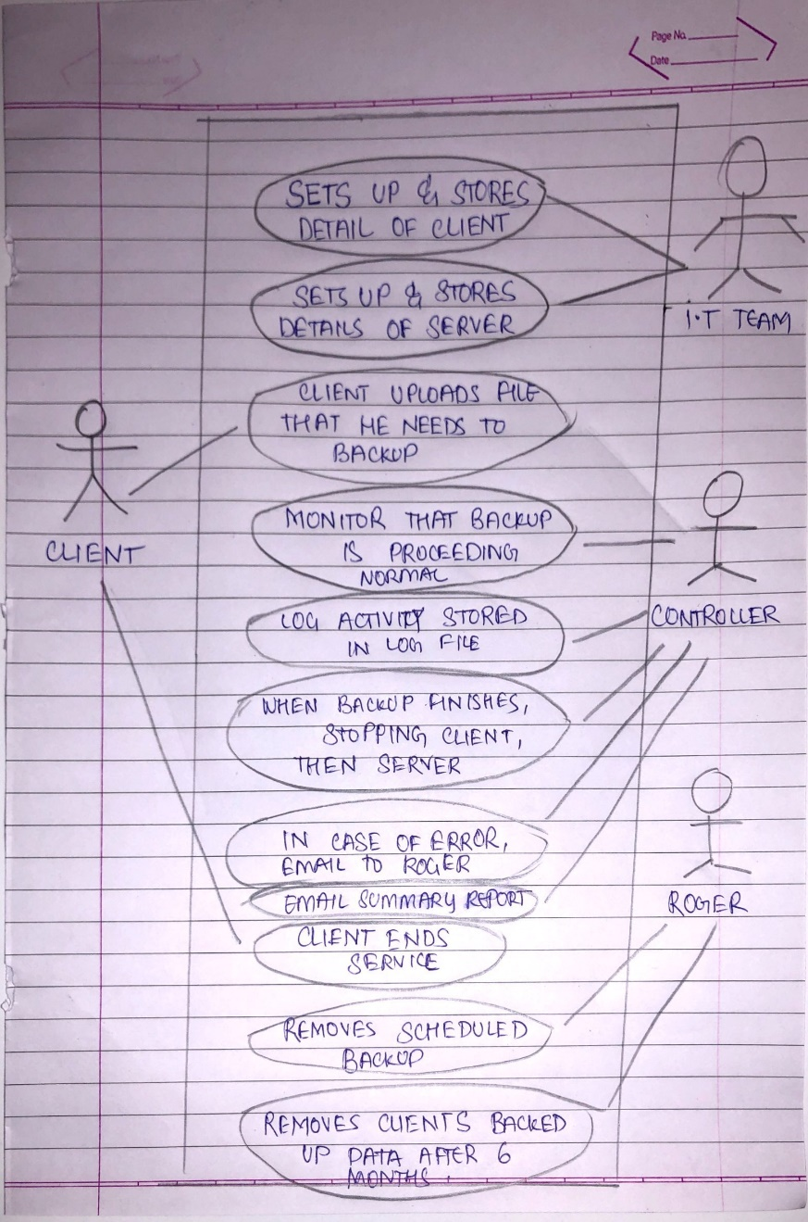

**c) Use Case Description**

|  |  |  |  |  |  |
| --- | --- | --- | --- | --- | --- |
| **Name of Use Case:** | Create offsite Backup Task | | | | |
| **Created By:** | Radha Yagnik | | **Last Updated By:** | | Radha Yagnik |
| **Date Created:** | 28/09/2019 | | **Last Revision Date:** | | 30/09/2019 |
|  | |  | | | |
| **Description:** | | Client uploads file to backup and CONTROLLER will receive a file transfer activity log | | | |
| **Actors:** | | CLIENT, CONTROLLER | | | |
| **Stakeholders:** | | Roger, CLIENT(end users), Gabrielle, employees | | | |
| **Preconditions:** | | 1. Client should have a ready set up by IT team 2. Client should have a ready scheduled backup task | | | |
| **Postconditions:** | | 1. File uploaded 2. Controller monitors backup procedure 3. Backup finishes 4. Next backup scheduled | | | |
| **Flows:** | | Actor   1. IT team schedules backup task 2. Client uploads 3. In case of service ends, Roger removes unnecessary data from system | | System   1. Controller gets notified 2. Controller monitors backup 3. Server backs up | |
| **Exceptions:** | | 1. In case of error, Roger gets an email. | | | |

**Question 3: Domain Modelling**

1. **Domain Model Class Diagram**

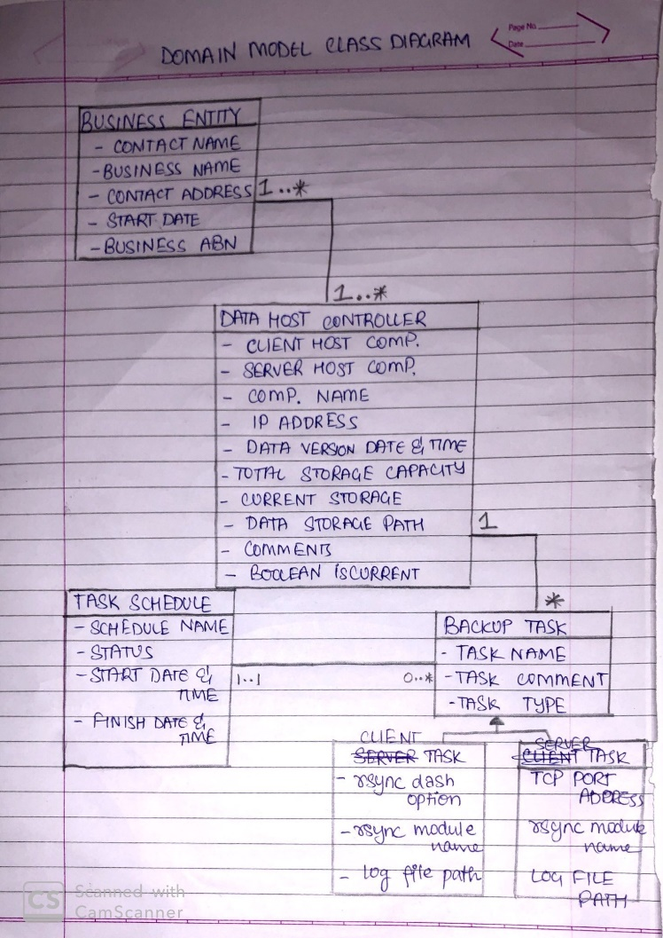

b.

**Design Class Diagram**

