**Tracking:**

Time Taken by Data store design: 1 hour

Time Taken by API and service logic: 3 hours

Time Taken By Unit testing coverage: 2 hours

**How to run API:**

1. Execute the sql server script which is in Scripts folder
2. Open the InventoryManagment.sln solution in visual studio 2019
3. Update the MyConnection value in AppSettings.json file of InventoryManagmentAPI with your InventoryDB database connection string.
4. Clean and rebuild the InventoryManagmentAPI project
5. Run the InventoryManagmentAPI
6. Once the InventoryManagmentAPI project run you will see a swagger UI page where you can check all the endpoints available in InventoryManagmentAPI project.

**Swagger UI Page:**

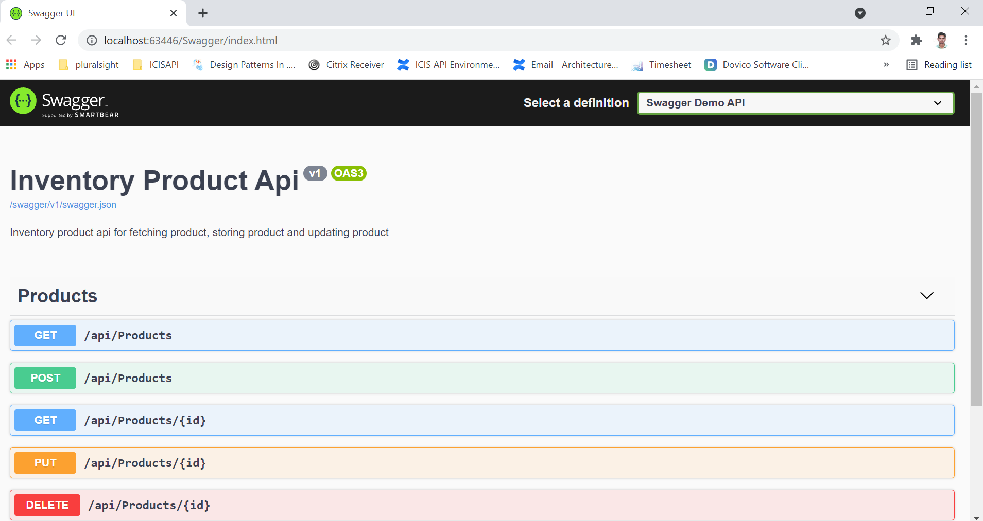

**1. GET: /api/products**

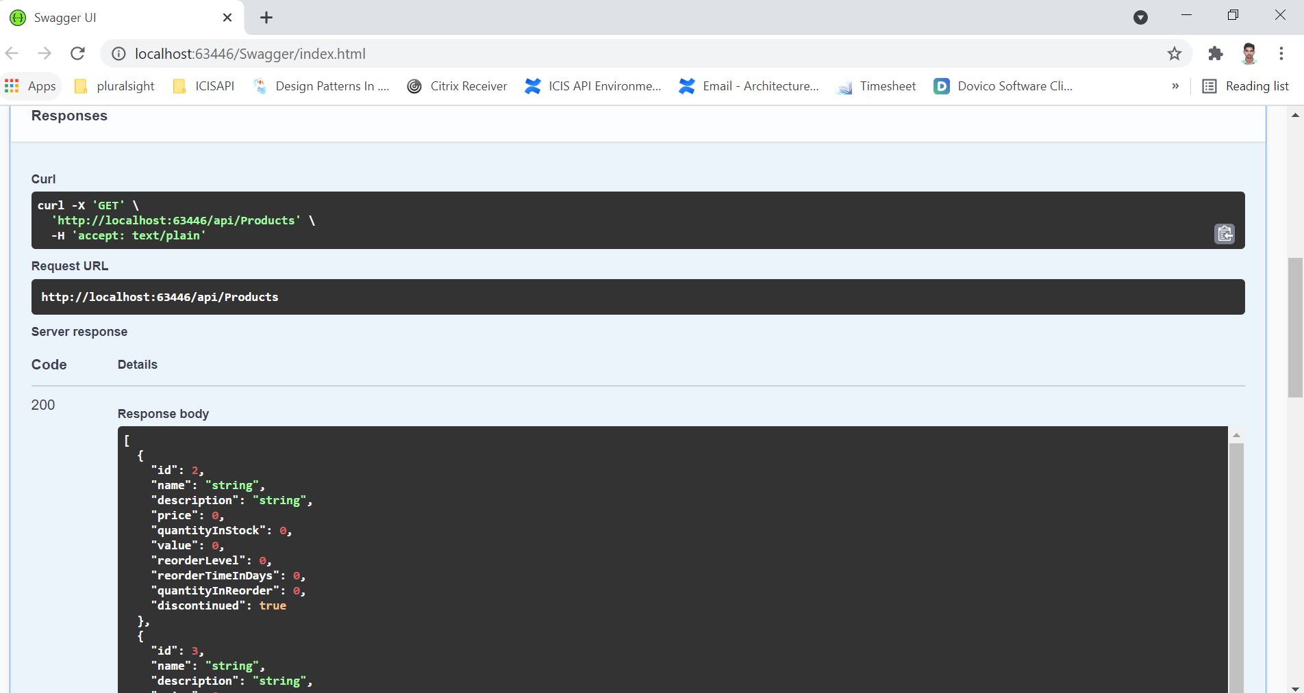

**2. POST: /api/products**

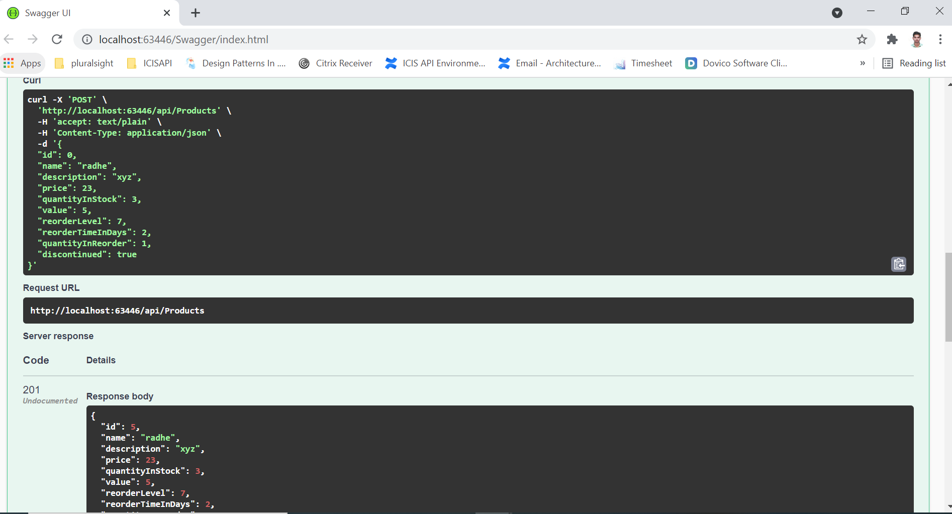

**3. GET: /api/products/id**

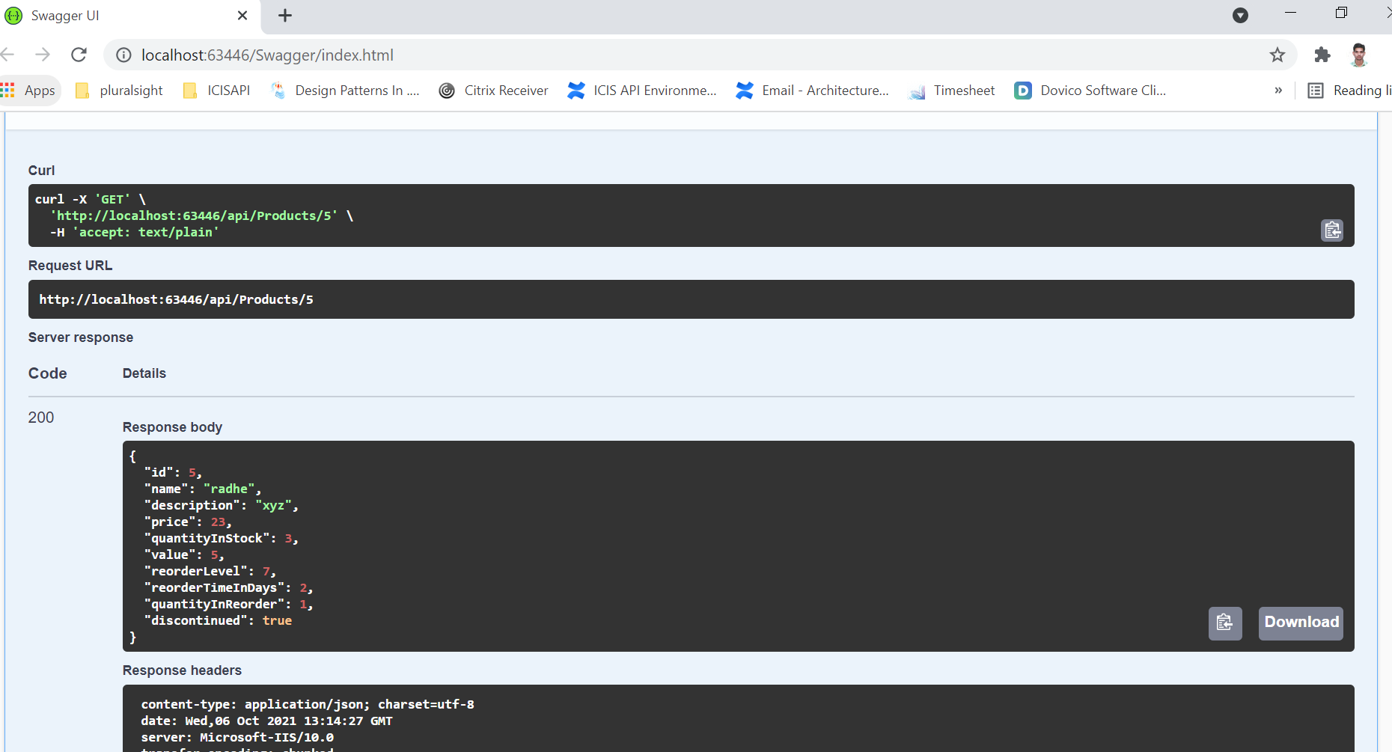

**4. PUT: /api/products/id**

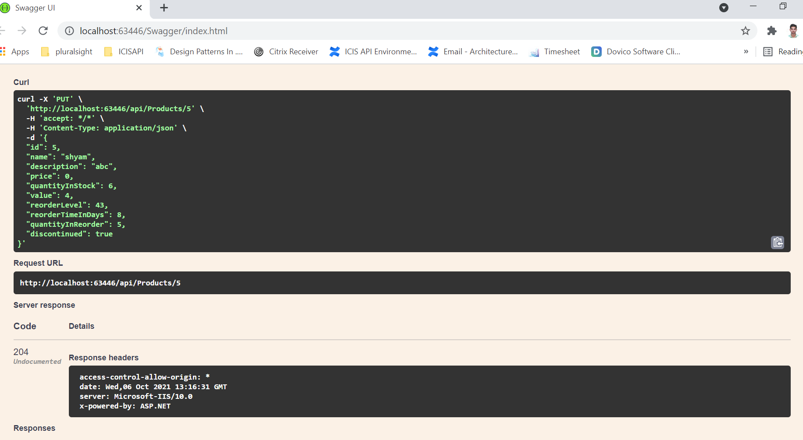

**5. Delete: /api/products/id**

