**Heroku Example to build and deploy Angular application on Heroku PaaS**

**Git Hub Repository used:** <https://github.com/radhemohan/AngularMaterialDesign>

1) Create Heroku account

2) Login to Heroku using your credentials

3) Create new Application

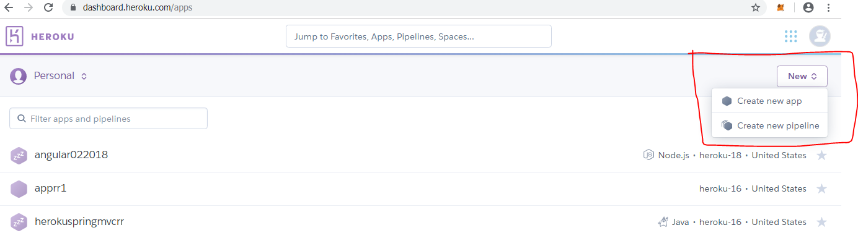

4) Provide required details.

5) Go in Deploy section and provide required details like github connection etc.

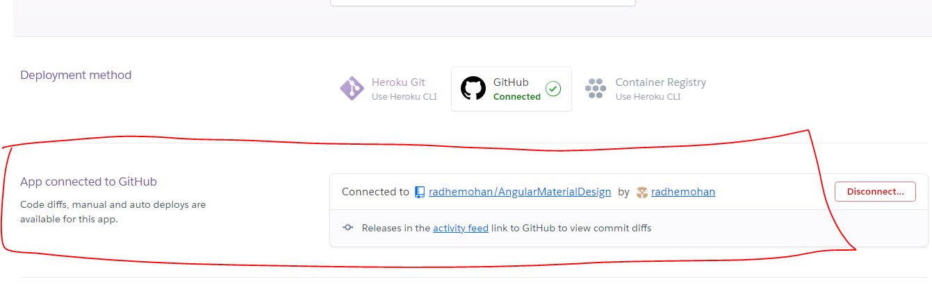

6) You can enable manual OR CI automatic deployment option.

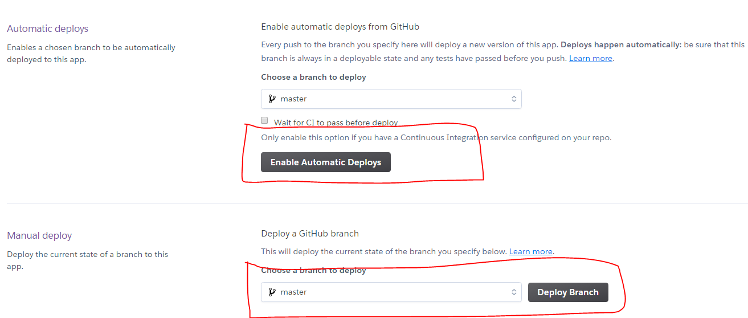

7) Click on Deploy Branch and select view logs

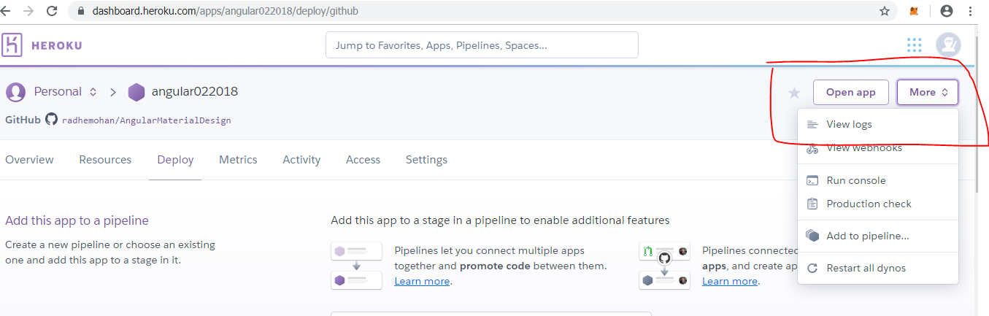

8) In log you can verify build has been started

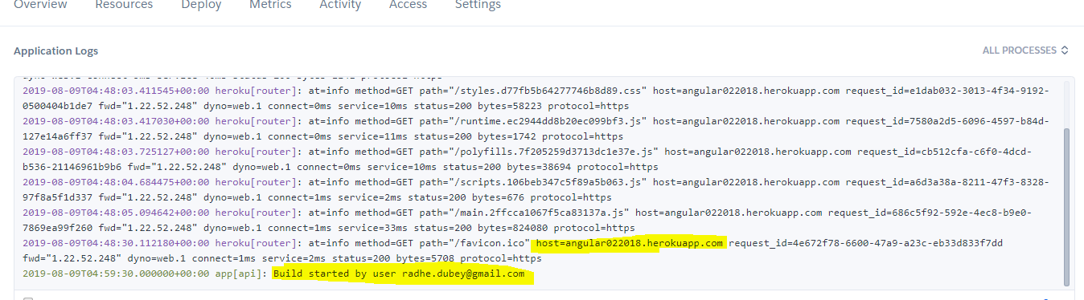

9) Once build success Then log displays as

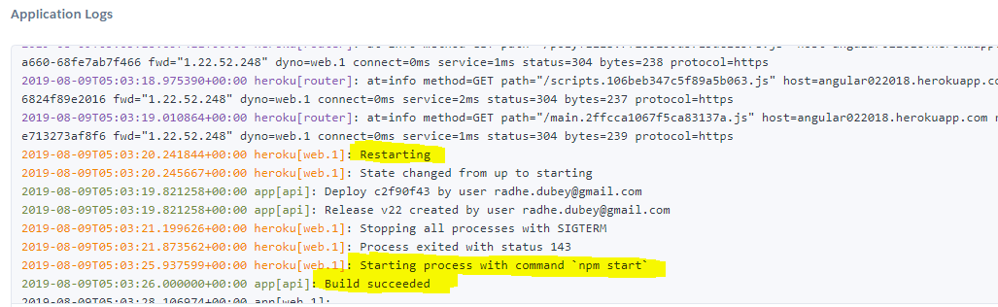

10) Now click on OpenApp. it will open you application URL in Browser tab.

