C Programming – FAQ (Interview Q&A)
Jaydeep Shah – 8-11-2025 (radhey04ec@gmail.com)

- What is difference between compiler and Interpreter?
Answer:
Feature | Compiler | Interpreter
Execution | Translate entire code at once | Line by line runtime execution
Speed (During execution) | Faster | Slower
Startup – code execution | Slow – compile & Build first | Quick – Don’t require full compilation first
Example | GCC | Python’s Interpreter

- What is difference between #include <file.h> and #include “file.h”
Answer: <file.h> : Search only standard libraries / directories
“file.h” : Search current directories first then standard directories.

- What is difference between declaration and definition?
Answer: Declaration: Tell compiler about functions, variables type (No memory allocation, Example = extern int x)
Definition Allocate memory, provide body to function (Example: int x = 10, int x)
Note: int x; is declaration + definition of the variable. if it declare globally then memory is allocated during startup of program, if it is inside function then memory is allocated during function execution.

- What are data types in C?
Answer: There are three main data types. it tells compiler about variable contains which type of data.
a) Primary: int, char, float, doube
b) Derived: Array, Pointer, structure, Union
c) User define: enum (name of Numerical constant), typedef (For providing alias name of original data-type)

- Storage class in C?
Answer: Storage class define variable lifetime, initial value and scope
Storage Class | Scope | Lifetime | Initial Value
auto (Default local variable) | Local | Till Function end | Garbage
Static | Local/ global | Till program ends | Zero
Extern | Global | Till program ends | Zero
Register | Local | Till Function ends | Garbage

Note: When you write int a = 10; inside function body, it is basically auto int a = 10; . Both are identical. Compiler already assume variable 'a' is auto type and assigned lifetime and scope accordingly.
Register storage class: it provide hint to compiler that variable would be accessed by code frequently, but in modern days this storage class largely obsolete.

- What is NULL Pointer?
Answer: Pointer that doesn’t point any valid memory location, useful to avoid error/ garbage values during process of de-referencing pointer location.
Example: int *ptr = NULL;

- What is Dangling pointer?
Answer: Pointer point to memory location which is free or deleted
Example: int *ptr = malloc(sizeof(int));
free(ptr);
*ptr = 10; //Dangling

- What is wild pointer?
Answer: Uninitialized pointer, only declaration is there but not point to any valid location yet.
Example: int *ptr; //This is wild pointer

- What is void pointer?
Answer: Pointer that hold address of any data-type. Care (Data-type information) required during de-referencing.
Example: void *ptr;
Int a = 10;
ptr = &a;

10) What is structure and Union?
Structure: All members have separate memory
Union: All members share same memory.

11) What is function pointer?
Answer: Pointer that point to function.
Use-case: This concept is useful and base of callback function mechanism. Here you pass function as argument to another function, later called pass function on certain event. This is crucial in event-driven, GUI call back operation, Interrupt handling etc.
Note: Parentheses is necessary, it indicate declaration is pointer to function eg void (*func_ptr)(int). if you write void *(func_ptr)(int) it will be interpreted as function return void pointer.
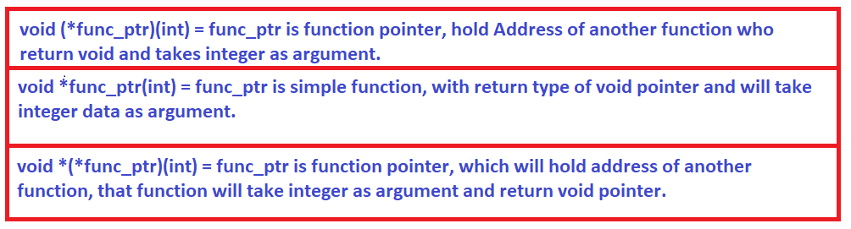
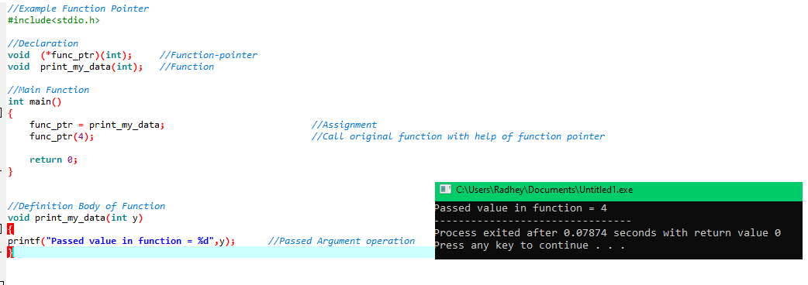
Other Example:
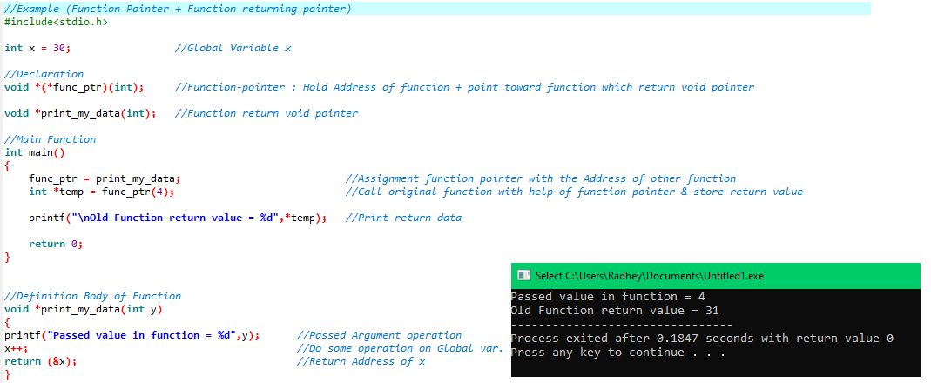

12) What is difference between const char *ptr, char * const ptr, const char * const ptr?
const char *ptr = Pointer to constant data (Data cannot change)
char * const ptr =Constant pointer (Address cannot change)
const char * const ptr = Both Data & Address constant

13) What I volatile keyword?
It tells compiler not to optimize variable, because it can change anytime (On interrupt / through hardware register).
Example:
volatile book keep_running = true;
int val = 0;
while(keep_running)
{
print("inside_loop");
val++;
}

Note: Highly optimized compiler might see val is not modified in while loop. And assume it's value remain constant.

14) What are pre-processor directives?
Answer: Command that are pre-process before compilation.
Example: #define, #include, #ifdef, #ifndef, #endif

15) What are enums in C?
Answer: Enumeration defines set of named integer constant. (Readable constant value)
enum week { MON = 1, TUE, WED}

16) Why not to use printf() insider ISR?
Answer:
a) Reentrancy issue: Not safe to call printf() if another printf() call is already in progress. Data corruption possible.
b) Execution Time: ISR must be short and execute quickly, printf() is very slow, especially if it involves formatting string and put output on serial port. That lead serious issue like missed other ISR/events.

17) Provide details about re-entrant function?
Reentrancy is ability for function to interrupt during its execution, and then safely call again from ISR (re-entered) before first call has completed. This is only possible if function not use any static or global data. printf() use shared buffer for output operation, global data inside its body. so printf() is not re-entrant function and recommended not to use inside ISR.

18) What is memory MAP of C program?
When you run C program, compiler and OS divide memory in different section.
Text segment = Code / Function (Instructions - machine code)
Data segment = Initialized global / static (int x =10)
BSS = Un- initialized global / static (int x;)
Heap = Dynamic memory allocation (malloc)
Stack = Function call frames

In embedded .map file exactly show variable memory address and it's segment.

19) What is Little-endian and Big-endian?
Little-endian: LSB Store First (INTEL)
Big-endian: MSB Store First (Motorola)

20) Difference between STACK & HEAP?
Feature | Stack | Heap
Allocation | Automatic | Manual
Lifetime | Till Function end | Till Freed
Size | Limited | Large
Speed | Faster (Handle by SP register, dedicated Hardware, auto increment-decrement) | slower (Dedicated software code, structure, manual memory management required)

21) What is typedef and it's use?
Use to create alias name of datatype.
typedef unsigned long int u32;
u32 I = 100;

22) What is output of following code?
int a = 10;
printf("%d,%d,%d",a,a<<1,a>>1)
Answer: 10,20,5 (Shift left means multiplication by 2, shift right means divided by 2).

23) Can we modify char *p = "Hello"; p[0] = 'B'; ?
Answer: Segmentation Fault; *p = "Hello" stored in read only memory.
Other possible effect: code after p[0] line will not execute or malfunction or main return without 0.
Note: We can use char p[] = "Hello" instead of pointer if modification required.

24) Why assert() and static_assert() useful?
Answer: assert() - RUN time check
static_assert() - compile time check.
Note: assert.h lib required.

#include<stdio.h>
#include<assert.h>
int main()
{
static_assert(sizeof(int)==4,"Error: not 32 bit system");
printf("32 bit system done");
return 0;
}
25) What are zero cost abstraction in C?
Writing layered code (Using macros, inline, typedef) that adds no runtime overhead/load (just text replacement).
Example:
#define GPIO_SET(x) (PORT |= (1<<x))

26) How global variable stored in Flash memory?
Answer: If variable marked const. Example: lookup table
const int lookup_table[] = { , ,,,};
Note: This is ideal answer, thing also depends on microcontroller architecture, compiler.

