C++ Quick overview
Jaydeep Shah (19 March 2024)
The C++ programming language has been undergoing upgrades since 2011. In other words, New version of C++ becomes avialble in the market every three years.


Additional benefits include speed, memory optimization, Object Oriented Programming Support (OOPS), and more close to low level programming.This is why it is highly favoured for Game development, Embedded system development, Data handelling in server or Data management.
The C++ standard library (STL) offers another benefit in the form of pre-written code that provides useful functionality for various applications. This allows for the rapid development of applications without the need to write code from scratch.
Here is some example:
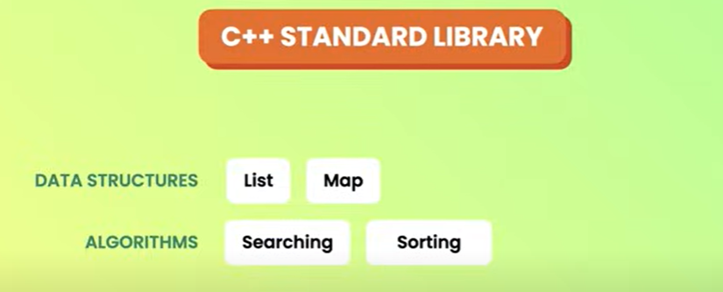

There are lots of IDE available for C++ development, but for this tutorial we are going to use Clion (Trail version – 30 days).Size is around 800 Mb.


Just create account and open Clion workspace.
Here is IDE overview
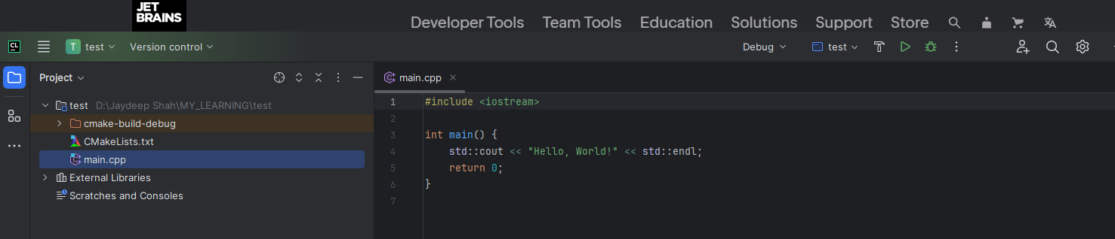
Before going further need to understand concept of namespace.
Because of OOP supports in C++, different library may have same function name and class name, for avoiding misconception our different functions and features belonging different namespace.
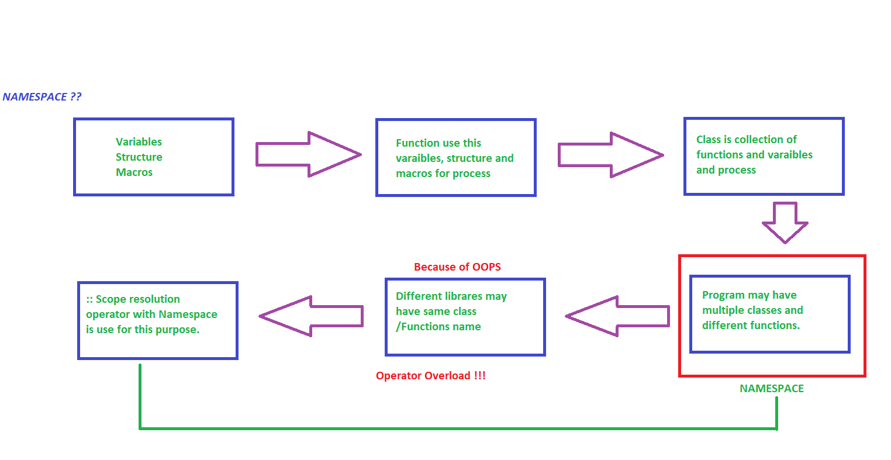
A namespace is a declarative region that provides a scope to the identifiers (the names of types, functions, variables, etc) inside it. Namespaces are used to organize code into logical groups and to prevent name collisions that can occur especially when your code base includes multiple libraries.
Here is first example:
#include <iostream>
int main()
{
std::cout << "Hello World"; //Statement - 1
return 0; //Statement - 2
}

Every statement in C++ will be terminated with (;) mark at the end.
Return -0 means program terminate sucessfully, any other number means something error during execution.

“<<” bitshift operator is actually use for shifting, but C++ allow operator overloading that cause with cout object it use as character output on screen.
“cout” is object of iostream standard namespace. That cause scope resolution is std.
OOP in C++
--Connect real life problems more accurately.
– Class is building block of Object.It is one type of user defined data type.
For example you want to store user data or employee data from one form. Users may have different types of data like Name, Gender, Email Add, Weight, Height etc.
All these individual characteristics / attributes is one type of varaible, but group of characteristic / attributes will become one class for representing user.
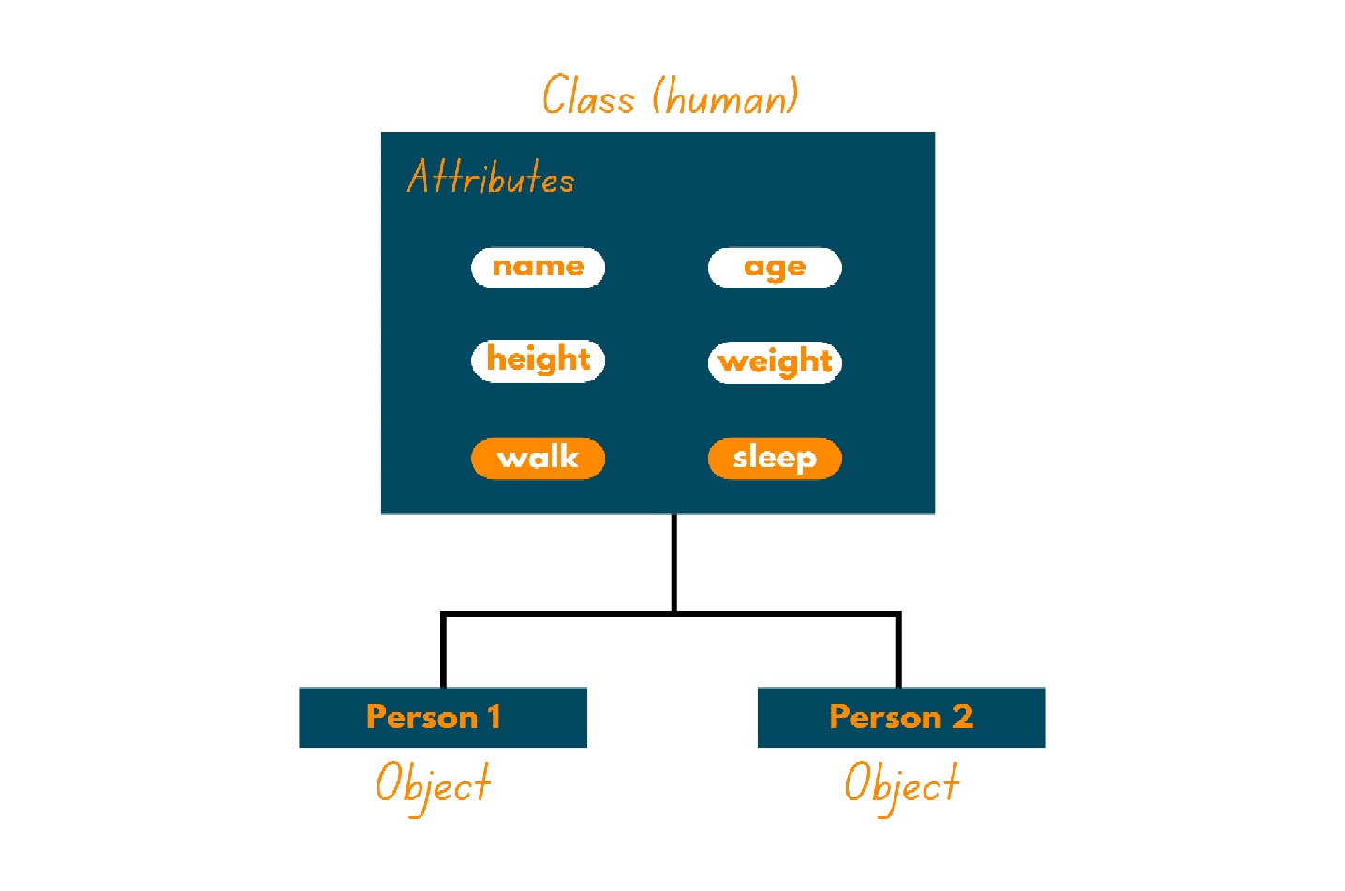
Class is not representing any data, it is only blueprint regarding object will have which type of data.

Note : Everything in C++ by default are private, so if you create object from class and try to access different attributes/characteristic form that class then you will not allow to access those attributes. You will have to declare all those as a public first.

In C++, there are three type of access modifier – public, private and protected, provide access authority to outer entitiy of class.

Private : Not possible to accesible from outer side from class, hidden for outer world.
he class members declared as private can be accessed only by the member functions inside the class. They are not allowed to be accessed directly by any object or function outside the class. Only the member functions or the friend function are allowed to access the private data members of the class.

Public : You can/Anyone can access members of class - outside from that class.
All the class members declared under the public specifier will be available to everyone. The data members and member functions declared as public can be accessed by other classes and functions too. The public members of a class can be accessed from anywhere in the program using the direct member access operator (.) with the object of that class.

Protected : Between private and public, The protected access modifier is similar to the private access modifier in the sense that it can’t be accessed outside of its class unless with the help of a friend class. The difference is that the class members declared as Protected can be accessed by any subclass (derived class) of that class as well.

Example 1:

#include <iostream>
using std:: string;
//Create one class for representing details of Office Employees
class Employee
{
//Each individual variable known as Characteristic or Attribute of Class
//Characteristic for object (object have which type of characteristic) and Attribute of Class
//Note: Default all below attributes are as private
public:
string Name;
string Company;
int Age;
//Create one member function to display object data - this function will be used by object
void Intro_Your_Self()
{
std::cout << "Name = "<< Name << std::endl;
std::cout << "Company = "<< Company << std::endl;
std::cout << "Age = "<< Age << std::endl;
}
};
int main()
{
//Create object
Employee employee1;
//store some data
employee1.Name = "Jaydeep Shah";
employee1.Company = "Amnex";
employee1.Age = 30;
//Call member function to display above data
employee1.Intro_Your_Self();
return 0;
}

Result:
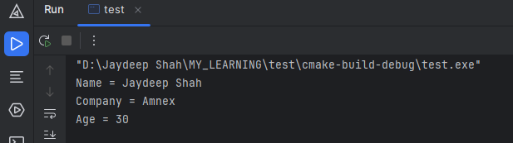

Now suppose you want to print data five times in output, you just need to copy member function. This is advantage in C++ (OOPS). This is reuseablity of the code.
Other way either you will have to copy cout statement five times or make other function which can accept these arguments and then call it five times.

