* **Industry: Entertainment, Company: Disney / Disney+**
  + x
  + For the past 97 years, Disney has been at the forefront of entertainment media and has defined the American entertainment landscape. Disney generated $69.61 billion in revenue in 2019 and currently operates in over 45 countries. Despite the size, this unprecedented pandemic has challenged all industries to reassess their business models. As of 2018-2019, Parks & Resorts generated 34% of the revenue, which has had a deleterious effect on their bottom line in 2020. Walt Disney’s theme parks and resorts were completely closed and/or operating at a significantly reduced capacity, along with the halt of their luxury cruise ships. Revenue within this industry plummeted more than 50%, and Disney would have to allocate billions of dollars ($2.3-2.7 billion) in costs to cover government regulations and safety measures in order to be compliant and continue with their operations. Although 8 of the top 10 grossing films have been from the Disney Family, the contribution of Studio productions has been stagnant at 17% of the gross revenue. The prime revenue source has been Network Media Advertisements at 41%, which presents an unfortunate challenge for the company. The constant decline in traditional television consumption is driven by the burgeoning competition streaming services, leading to a drop in advertisement revenue.
  + Focusing more on the video streaming services in the U.S., the industry grew, on average, 24.8% from 2015-2020. The market size for video streaming is currently valued at $42 billion composed of 2,602 businesses. The most significant companies in the video streaming industry consist of Netflix, Amazon Prime, and, The Walt Disney Company. Towards the end of 2019, The Walt Disney Company launched Disney+ and saw their video streaming services flourish, while their parks and resorts were negatively impacted by the current pandemic. Disney+ prioritizes exclusive programming, original shows and movies, as well as bundled streaming services. One of Disney’s competitive advantages was their vast library of beloved family movies and shows ranging from Disney, Pixar, Marvel, Lucasfilm, and National Geographic; they were able to enter the streaming industry quickly, effectively, and successfully. Among Disney’s variety of offerings, it extends past Disney+ and includes ESPN, Hulu, and Hotstar. Resulting from the COVID pandemic, Disney+ was an immediate hit as the demand for streaming services grew. As of 2021, The Walt Disney Company reports over 146 million subscribers, making gains on Netflix’s 203 million subscribers. Although The Walt Disney Company has been around for almost 100 years, Disney+ is only ~15 months old, demonstrating the potential for growth that the company can harness with effective strategies and innovations.
  + Why Disney/Disney+ is a good company for the project and what we could explore
    - Might take upto 2 years for Disney Parks to reopen. UBS expects that earnings from Disney’s theme park segment will drop 92% from last year’s $6.8 billion, with the possibility that 2021 could be even worse for the parks.”
    - Future of movie screenings/theatres
    - With vaccines coming out and reopening of theme parks, resorts, and cruises, how will that affect their streaming services?
      * Should they focus more on streaming then on theme parks, resorts, and cruises?
    - How will AR/VR affect the entertainment industry?
    - How does the introduction of Star, Disney’s streaming service for adults, make Disney more competitive against brands like Netflix and Amazon Prime?
    - Disney can possibly offer up its space as a vaccination sight
    - Community Building Marvel, Star Wars

<https://www.theguardian.com/film/2021/feb/20/streaming-disney-for-grownups-star-launch-any-good>

<https://allears.net/2020/04/20/news-analysts-offer-glimpse-into-the-future-of-disney-parks-including-possible-precautions-and-crowd-numbers/>

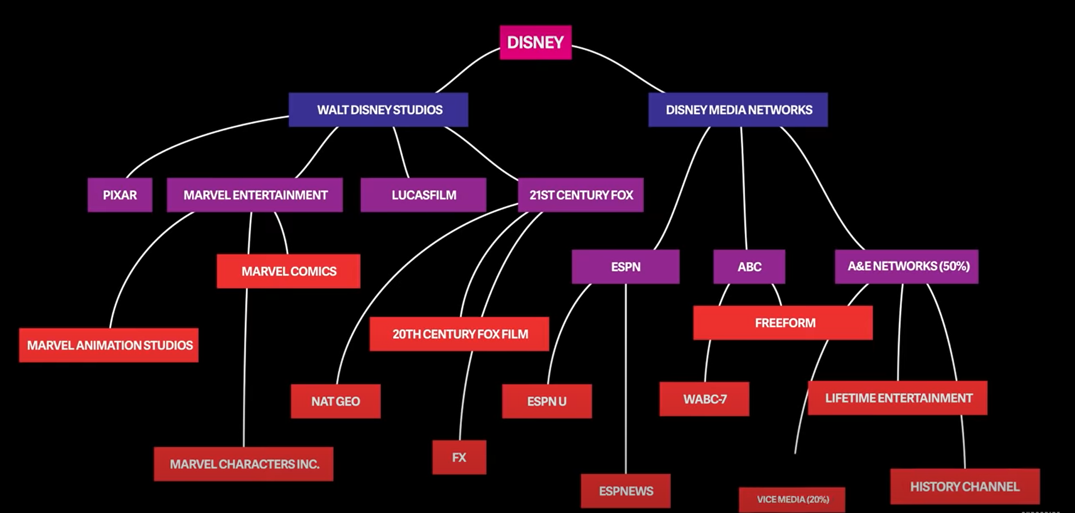

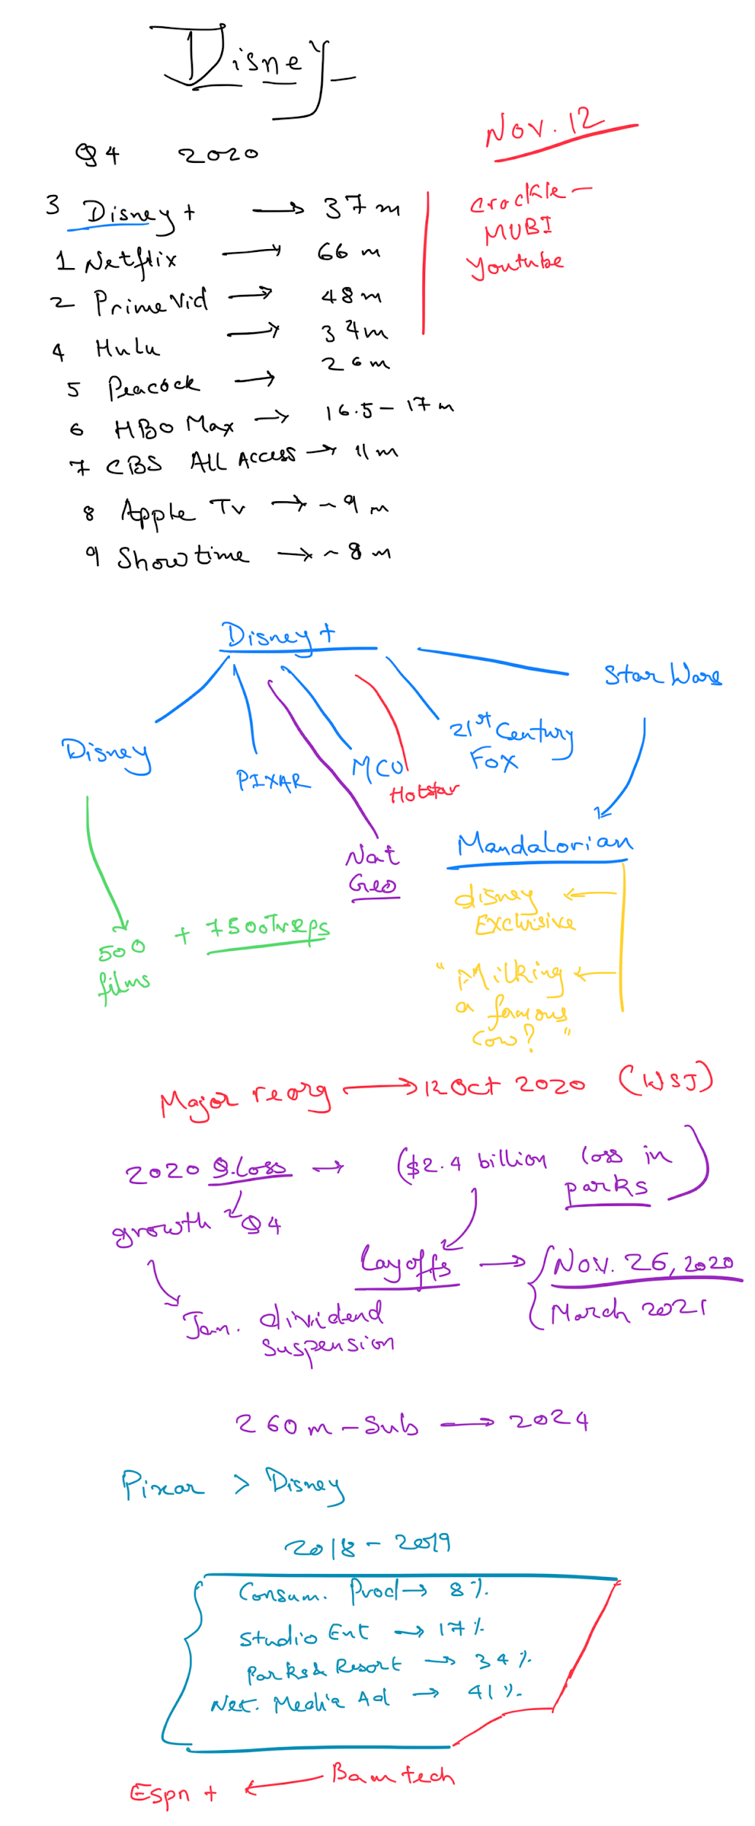

Media and entertainment industry

* U.S. media and entertainment contributes more than $717 billion to the economy and represents 1/3 of the global media and entertainment industry
* <https://www.vault.com/industries-professions/industries/media-and-entertainment>

Video Streaming Services in the US

* avg industry growth (2015-2020): 24.8%
* Market size: $42 billion
* # of businesses: 2,602
* <https://www.ibisworld.com/united-states/market-research-reports/video-streaming-services-industry/>

Disney streaming services gaining ground on Netflix (2/12/2021)

* Subscriptions to their streaming services surged to more than 146 million subscribers
* Netflix has 203 million subscribers
* “we’re confident that, with our robust pipeline of exceptional, high-quality content and the upcoming launch of our new Star-branded international general entertainment offering, we are well-positioned to achieve even greater success going forward,” Disney CEO bob Chapek
* Revenue in the quarter fell 22% to $16.25 billion but beat market expectations
* Disney reported profit of $17 million compared with $2.1 billion in the same period a year earlier
* <https://economictimes.indiatimes.com/tech/technology/disney-streaming-services-gaining-ground-on-netflix/articleshow/80872459.cms>
* <https://www.washingtonpost.com/technology/2019/01/18/netflix-fortnite-is-bigger-rival-than-hbo/>
* <https://www.pwc.com/us/en/industries/tmt/library/global-entertainment-media-outlook.html>
* <https://www.statista.com/statistics/1095372/disney-plus-number-of-subscribers-us/>
* <https://www.cnbc.com/2020/11/12/disney-dis-q4-2020-earnings.html>
* <https://thewaltdisneycompany.com/app/uploads/2021/02/q1-fy21-earnings.pdf>
* <https://www.foxbusiness.com/markets/disney-exceeds-subscriber-expectations-with-94-9-million-as-covid-19-continues-to-hammer-companys-theme-park-business>

<https://www.businesswire.com/news/home/20201112006058/en/The-Walt-Disney-Company-Reports-Fourth-Quarter-and-Full-Year-Earnings-for-Fiscal-2020>

<https://www.stock-analysis-on.net/NYSE/Company/Walt-Disney-Co/Financial-Statement/Income-Statement>