Raktsetu
eRaktKosh Blood Lakehouse: National Blood Availability & Shortage Intelligence
By
Radhey Gajera (25MCA057)
Shruti Gajipara (25MCA058)
Submitted to
Ms. Konica Soni
Assistant Professor, CMPICA

Smt. Chandaben Mohanbhai Patel Institute of Computer Applications
CHARUSAT
Changa
November 2026

Accredited with Grade A+ by NAAC,
CHAROTAR UNIVERSITY OF SCIENCE AND TECHNOLOGY
Changa

Declaration
We, Radhey Gajera (25MCA057) and Shruti Gajipara (25MCA058), students of Master of Computer Applications (MCA) at Smt. Chandaben Mohanbhai Patel Institute of Computer Applications (CMPICA), CHARUSAT, declare that the project report titled “Raktsetu: eRaktKosh Blood Lakehouse” is our own work. It was carried out under the guidance of Ms. Konica Soni.
This work has not been submitted to any other university or institute for any degree or diploma. All data sources, tools and references used in this project are acknowledged in this report.
Place: Changa
Date: ____________
____________________
Radhey Gajera (25MCA057)
____________________
Shruti Gajipara (25MCA058)

Acknowledgement
Knowledge in itself is a continuous process. At this moment of our substantial enhancement, we rarely find words to express our gratitude towards those who were constantly involved with us.
The completion of any inter-disciplinary project depends upon coordination, cooperation and the combined efforts of several resources of knowledge, creativity, skill, energy and time. With the work now accomplished, we take this opportunity to acknowledge, in these lines, everyone who contributed to it.
We would like to thank our project guide Ms. Konica Soni, I/C Principal Dr. Dharmendra Patel and I/C Dean Dr. Sanskruti Patel who advised and gave us moral support throughout the duration of our project. Without their constant encouragement we could not have achieved what we have.
We also thank the Ministry of Health and Family Welfare (MoHFW) for publishing blood stock data openly through the eRaktKosh portal, and the open-source communities behind DuckDB, dbt, FastAPI, Leaflet and OpenStreetMap, whose work made this project possible.
It is our good fortune that we had the support and well wishes of many. We are thankful to all, including those whose names may have been missed here; their contributions have not gone unnoticed.
With Sincere Regards,
Radhey Gajera (25MCA057)
Shruti Gajipara (25MCA058)

Abstract
When a patient needs blood urgently, families often phone one blood bank after another. India's eRaktKosh portal already publishes blood stock for thousands of blood centres, but it is searched one district at a time, gives no help with blood-group compatibility and does not show how old each record is.
Raktsetu solves this by building a data lakehouse on top of eRaktKosh. An async scraper collects stock for every district and saves it as immutable Parquet files. DuckDB and dbt clean the data in Bronze, Silver and Gold layers, keep a daily history and run 37 data-quality tests. Only data that passes these checks is published to a read-only database, which a FastAPI REST API serves to a responsive website.
The website offers a Smart Emergency Mode that lists compatible donor groups (including plasma and the rare Bombay group) and ranks nearby centres by freshness, trust, units and distance. It also provides a blood finder with a live map, 7-day trends, a Trust Score, rare-blood and district-shortage radars, CSV export, a donor eligibility checker and a data-health dashboard. It works on any phone and offline.
The system covers 4,716 blood centres in 35 States/UTs and 706 districts. It is supported by 98 automated code tests, 37 data tests and 146 end-to-end browser checks, all passing.
Keywords: blood availability, eRaktKosh, data lakehouse, DuckDB, dbt, FastAPI, Progressive Web App, emergency healthcare

Table of Contents
Sr. No |  | Subject | Page Number
 |  | List of Figures | 7
 |  | List of Tables | 8
1 |  | Project Profile | 9
 |  | Project Timeline (Gantt Chart) | 11
2 |  | Introduction to Tools | 12
3 |  | System Study | 17
 | 1. | Existing System | 18
 | 2. | Proposed System | 19
 | 3. | Existing vs Proposed System | 20
 | 4. | Scope of the Proposed System | 21
 | 5. | Aim and Objective of the Proposed System | 22
 | 6. | Feasibility Study | 23
 |  | Operational Feasibility | 23
 |  | Technical Feasibility | 24
 |  | Economical Feasibility | 25
4 |  | System Analysis | 26
 |  | Requirements Specification (along with System Modules) | 27
 |  | Hardware and Software Requirements | 29
 |  | Data Flow Diagram (Level 0) | 30
 |  | Data Flow Diagram (Level 1) | 31
 |  | Use Case Diagram | 32
 |  | Class Diagram | 35
 |  | Activity Diagram | 36
 |  | Sequence Diagram | 38
 |  | System Architecture | 39
5 |  | System Design | 40
 |  | ER Diagram | 41
 |  | Data Dictionary | 42
 |  | Screen Layouts | 47
6 |  | System Testing | 62
 |  | Testing Strategies | 63
 |  | Test Results Summary | 64
 |  | Test Cases | 65
7 |  | Conclusion and Limitations | 67
8 |  | Future Enhancement | 70
9 |  | Bibliography/References | 76
10 |  | Appendix | 78
 | A. | Glossary | 79
 | B. | User Manual | 80
 |  | Reporting Report (to be collected from respective internal guide)

List of Figures
Figure No. | Title | Page
Figure 1 | Project timeline (Gantt chart) | 11
Figure 2 | Data Flow Diagram (Level 0) | 30
Figure 3 | Data Flow Diagram (Level 1) | 31
Figure 4 | Use Case Diagram: Public Users | 32
Figure 5 | Use Case Diagram: Operator & External Systems | 34
Figure 6 | Class Diagram | 35
Figure 7 | Activity Diagram: Public User | 36
Figure 8 | Activity Diagram: Data Pipeline | 37
Figure 9 | Sequence Diagram | 38
Figure 10 | System Architecture | 39
Figure 11 | ER Diagram | 41
Figure 12 | Home Page & National Statistics | 48
Figure 13 | Smart Emergency Mode | 49
Figure 14 | Blood Finder | 50
Figure 15 | Blood Finder: Result Cards | 51
Figure 16 | Live Blood Map | 52
Figure 17 | 7-day Inventory Trend | 53
Figure 18 | Trust Score Explanation | 54
Figure 19 | National Network Distribution | 55
Figure 20 | Rare Blood Phenotype Radar | 56
Figure 21 | District Shortage Radar | 57
Figure 22 | Donor Eligibility & Assistance | 58
Figure 23 | Data Health & Pipeline Runs | 59
Figure 24 | Mobile Responsive Design | 60
Figure 25 | Mobile Responsive Design: Search Results | 61

List of Tables
Table No. | Title | Page
Table 1 | Comparison of existing and proposed system | 20
Table 2 | Server and developer requirements | 29
Table 3 | Client requirements | 29
Table 4 | Actors of the system | 33
Table 5 | raw_inventory (bronze.raw_inventory) | 42
Table 6 | dim_blood_banks (main_gold.dim_blood_banks) | 43
Table 7 | fct_stock_snapshot (main_gold.fct_stock_snapshot) | 43
Table 8 | fct_stock_current (main_gold.fct_stock_current) | 43
Table 9 | mart_district_status (main_gold.mart_district_status) | 44
Table 10 | mart_rare_blood_availability (main_gold.mart_rare_blood_availability) | 44
Table 11 | mart_reliability_score (main_gold.mart_reliability_score) | 44
Table 12 | mart_stock_change (main_gold.mart_stock_change) | 45
Table 13 | pipeline_runs (gold.pipeline_runs) | 46
Table 14 | Summary of test results | 64
Table 15 | Black box test cases | 65
Table 16 | Glossary of terms | 79

PROJECT PROFILE

Project Profile
Project Name: Raktsetu (eRaktKosh Blood Lakehouse)
Type of Application: Web Application (Progressive Web App) with a Data Engineering Pipeline
Project Description: Raktsetu turns the blood-stock data published by the Government of India's eRaktKosh portal into a fast, honest emergency finder. A medallion data lakehouse collects nationwide stock from every district, cleans and tests it, keeps a daily history, and publishes it to a responsive website. Patients' families can find compatible blood near them in seconds, see how fresh each record is, call or navigate to the blood centre, and officials can spot district-level shortages and export them as reports.
Data Source: eRaktKosh (Ministry of Health and Family Welfare, Govt. of India), public portal
Coverage: 4,716 blood centres across 35 States/UTs and 706 districts
Team Size: 2
Frontend: HTML5, CSS3, Vanilla JavaScript, Leaflet.js (maps), Chart.js (charts)
Backend: Python 3.12, FastAPI, Uvicorn
Data Pipeline: Async scraper (aiohttp), Apache Parquet, dbt Core (dbt-duckdb)
Database: DuckDB: analytical warehouse plus a read-only serving replica
Tools used: VS Code, uv, Git & GitHub, Docker, pytest, Playwright, Ruff
Internal Guide: Ms. Konica Soni, Assistant Professor, CMPICA

Project Timeline (Gantt Chart)
✓ The project was planned in eight phases over sixteen weeks. Some phases overlap, for example the website was built while the API was being finished.
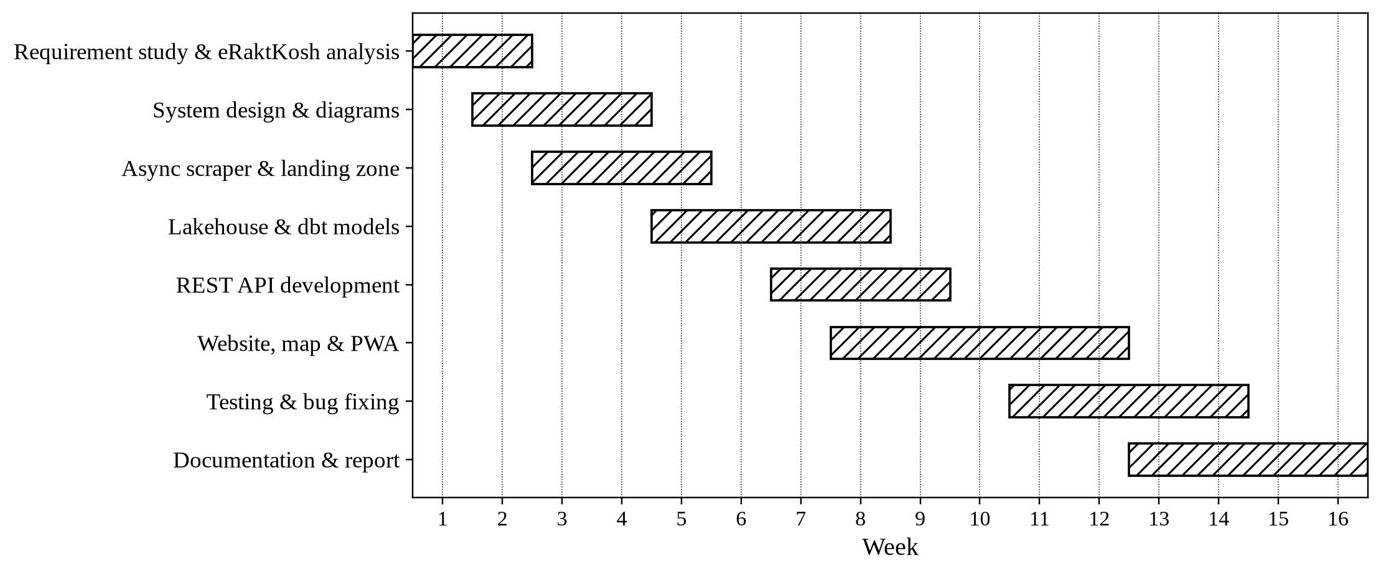
Figure 1: Project timeline (Gantt chart)

INTRODUCTION TO TOOLS

Introduction to Tools & Technology
❖ Front End:
✓ HTML5 & CSS3
• Purpose: Structure and visual design of every screen of the website.
• Features: Semantic sections, CSS Grid/Flexbox layouts, media queries, design tokens.
• Benefits: Fully responsive from 320 px phones to 1920 px desktops without any UI framework.
✓ JavaScript (ES2020)
• Purpose: All client-side behaviour: search, filters, modals, map and charts.
• Features: Fetch API, async/await, URL state sync, Geolocation API, client-side eligibility rules.
• Benefits: Zero build step and a small download, so the site loads fast on slow mobile networks.
✓ Leaflet.js
• Purpose: Interactive map of blood centres.
• Features: Custom markers, pop-ups, fit-to-results and a 'you are here' marker.
• Benefits: Lightweight open-source mapping that works well on mobile devices.
✓ Chart.js
• Purpose: National distribution chart and per-bank historical trend chart.
• Features: Bar and line charts with tooltips; gaps are shown for days without data.
• Benefits: Clear visual insight with very little code.
✓ Service Worker & Web App Manifest (PWA)
• Purpose: Installable app with offline support.
• Features: Network-first caching of the app shell, libraries and last API responses.
• Benefits: The last known inventory stays visible during network outages.

Back End & Data Engineering
❖ Back End:
✓ Python 3.12
• Purpose: Primary language for the API, scraper, pipeline CLI and tests.
• Features: Type hints, asyncio, rich standard library.
• Benefits: Readable, maintainable code with a large data ecosystem.
✓ FastAPI & Uvicorn
• Purpose: REST API serving the website and third-party clients.
• Features: Automatic OpenAPI docs (/docs), request validation with Pydantic, CSV export endpoints.
• Benefits: High performance with self-documenting, type-checked endpoints.
❖ Data Engineering:
✓ aiohttp (Async Scraper)
• Purpose: Collects blood stock for every district from eRaktKosh.
• Features: 10 concurrent requests, retries with exponential back-off, circuit breaker at 20% errors.
• Benefits: A full national crawl in minutes while staying polite to the government server.
✓ Apache Parquet
• Purpose: Immutable landing zone for every raw scrape.
• Features: Columnar, compressed files partitioned by date and hour with a SHA-256 manifest.
• Benefits: Raw data is never lost and any run can be reloaded or audited.
✓ DuckDB
• Purpose: Embedded analytical database (warehouse and serving copy).
• Features: Columnar SQL engine, reads Parquet directly, single-file database.
• Benefits: Analytics in milliseconds with no database server to install or manage.
✓ dbt Core (dbt-duckdb)
• Purpose: Transforms raw data into clean Silver and Gold tables.
• Features: Version-controlled SQL models, incremental snapshots, 37 automated data tests, lineage docs.
• Benefits: Reliable, testable and documented transformations.

Key Services & Architecture
❖ Key Services:
✓ eRaktKosh Public Portal
• Purpose: Single source of truth for blood stock in India.
• Features: District-wise availability per blood group and component for registered blood centres.
• Benefits: Official, nationwide data; every page and export credits MoHFW as the source.
✓ OpenStreetMap Nominatim
• Purpose: Geocoding of all 706 districts to map coordinates.
• Features: One-time lookup at 1 request/second, cached in data/district_coords.json.
• Benefits: Accurate 'Near me' distances without a paid geocoding service.
✓ CARTO Positron Basemap
• Purpose: Muted background map tiles.
• Features: Light, low-contrast tiles that keep blood centre markers easy to read.
• Benefits: Clean, professional map appearance.
❖ Architecture:
✓ Medallion Lakehouse (Bronze, Silver, Gold)
• Purpose: Layered data design.
• Features: Bronze keeps raw rows, Silver cleans and parses, Gold holds analysis-ready marts.
• Benefits: Each layer is testable and every number can be traced back to its raw source.
✓ Atomic Blue/Green Publishing
• Purpose: Safe release of new data to the website.
• Features: An anomaly gate checks the data, then the warehouse is copied to serving.duckdb atomically.
• Benefits: Users never see half-updated or broken data.

Development & Testing Tools
✓ uv & Ruff
• Purpose: Dependency management, linting and formatting.
• Features: Locked, reproducible environments; fast lint and format checks.
• Benefits: Consistent code quality across the team.
✓ pytest
• Purpose: Unit and integration testing of Python code.
• Features: 98 automated tests covering scraper, scoring, geocoding, CSV export and every API endpoint.
• Benefits: Regressions are caught before they reach users.
✓ Playwright
• Purpose: Automated browser (end-to-end) testing.
• Features: Drives the real website on desktop and mobile screen sizes; 146 user-flow checks.
• Benefits: Proves that features work from the user's side, not just in code.
✓ Docker & Git
• Purpose: Packaging and version control.
• Features: Container image with health check; Git history on GitHub.
• Benefits: The same build runs on any machine; all changes are tracked.

SYSTEM STUDY

Existing System
Existing System: eRaktKosh Portal (MoHFW, Govt. of India)
✓ District search: Users select a state, district, blood group and component to view stock.
✓ Facility details: Shows the blood centre name, contact details and last update time.
✓ Government data: Stock is entered by registered blood centres across India.
✓ Web access: Available as a public website with no login needed for searching.
❖ Limitations of the Existing System:
• Search works one district at a time; there is no nationwide or 'near me' view.
• No blood-group compatibility help: a family searching O- is not told which donor groups are safe.
• No indication of how fresh a record is, so months-old stock looks the same as today's.
• No history, trends or shortage view for health officials.
• No dedicated search for rare groups such as the Bombay (Oh) phenotype.
• No data export for reports and planning.

Proposed System
Raktsetu is a web platform built on a data lakehouse. It collects eRaktKosh stock for every district, cleans and validates it, keeps a daily history, and presents it through an emergency-first, mobile-friendly website. It adds clinical compatibility rules, freshness and trust indicators, distance ranking and analytics that the existing portal does not offer.
❖ Key Features
✓ Smart Emergency Mode
• Enter the patient's blood group and component; the system lists compatible donor groups (NBTC rules, including plasma and Bombay rules).
• Ranks blood centres by freshness, trust, units and distance, with one-tap Call and Directions.
✓ Blood Finder & Live Map
• Filter by state, district, component, blood group and name; sort by freshness, units, trust or distance.
• 'Near me' uses the device location to show the closest centres on a map.
✓ Freshness, Trust Score & 7-day Trend
• Every card shows when the stock was last updated and a 0–100 Trust Score.
• A trend chart shows real daily snapshots; days without data appear as gaps, never invented values.
✓ Rare Blood & District Shortage Radar
• Nationwide list of Bombay and rare-group stock.
• District-level shortage severity for each blood group, exportable as CSV.
✓ Donor Eligibility Checker
• Checks age, weight, haemoglobin, recent tattoo/surgery/illness and donation gap in the browser only.
• Shows the next eligible donation date; no personal data leaves the device.
✓ Data Health Dashboard & PWA
• Shows last sync time, fresh vs stale centres, dbt test results and recent pipeline runs.
• Installable, responsive and usable offline with the last cached data.

Existing vs Proposed System
Table 1: Comparison of existing and proposed system
Feature | Existing (eRaktKosh) | Proposed (Raktsetu)
Search scope | One district at a time | Whole country, any filter
Blood compatibility help | No | Yes (red cells, plasma, Bombay)
Nearest blood centre | No | Yes, using device location
Shows how fresh the data is | Partly (date only) | Yes, on every result
Trust / reliability score | No | Yes (0–100)
Stock history and trends | No | Yes (daily snapshots)
District shortage analysis | No | Yes, with severity score
Rare (Bombay) blood search | No | Yes, nationwide
Report export | No | Yes, CSV
Donor eligibility check | No | Yes, private, in browser
Works offline | No | Yes (PWA)
Open API for other apps | No | Yes (REST API)

Scope of the Proposed System
Raktsetu covers the full path from public eRaktKosh data to an emergency decision: data collection, quality control, history, analytics and a public website. It is an information service; it does not reserve or transfer blood, and users are always told to call the blood centre before travelling.
❖ Public User Side Scope (patients' families, doctors, donors, officials)
1. Emergency Search
Find compatible blood for a patient and call the best-ranked centres.
2. Blood Finder
Search and filter all centres, view stock per blood group, switch to the map.
3. Near Me
Use the device location to rank centres by distance.
4. Trends & Trust
View a centre's recent stock history and its Trust Score.
5. Rare Blood & Shortages
Find rare-group stock and districts that are running short.
6. Reports
Download availability and shortage data as CSV files.
7. Donor Help
Check donation eligibility and the next eligible date.
❖ Operator (Admin) Side Scope
1. Scrape
Run the nationwide crawl that writes an immutable Parquet file.
2. Load & Transform
Load the file into Bronze and build Silver/Gold tables with dbt.
3. Quality Gate
Run 37 data tests and the facility-count anomaly check.
4. Publish
Atomically release the new data to the website.
5. Monitor
Track sync age, stale centres and pipeline runs on the Data Health page.

Aim and Objectives
Aim: To build a reliable, data-driven web platform that converts India's public eRaktKosh blood-stock data into fast, trustworthy and clinically aware guidance for people searching for blood in an emergency, and into shortage intelligence for health officials.
Objectives
✓ Collect nationwide blood stock automatically and politely from every eRaktKosh district.
✓ Store raw data immutably and build cleaned, tested Bronze, Silver and Gold layers.
✓ Keep a daily snapshot history so trends can be shown honestly over time.
✓ Apply NBTC compatibility rules for red cells, plasma and the Bombay phenotype.
✓ Rank blood centres using freshness, trust, available units and distance.
✓ Show district-level shortages and rare-blood availability, with CSV export.
✓ Block publishing when data quality checks fail, so users never see broken data.
✓ Deliver a responsive, accessible, installable website that also works offline.
✓ Protect privacy: no login, no personal data stored, location never saved.

Feasibility Study
Operational Feasibility
Operational feasibility examines how well the solution fits the way people already search for blood and how easily it can be operated.
✓ User Roles: Public users search without any account. The operator runs one command (make pipeline) to refresh data.
✓ User Experience (UX): Emergency search needs only three choices and one click; results show Call and Directions buttons directly.
✓ Training: No training is needed for public users. The operator needs a short guide covering the pipeline commands.
✓ Integration with Existing Process: Raktsetu does not replace eRaktKosh; it reads its public data and adds compatibility, ranking and analytics on top.
✓ Support & Maintenance: Automated tests, the anomaly gate and the Data Health page make problems visible early.
✓ Risk Factors: If eRaktKosh changes or fails, the circuit breaker and quality gate stop the run and the last good data stays online.

Technical Feasibility
✓ Technology Stack: Python, FastAPI, DuckDB, dbt and vanilla web technologies are mature, open-source and well documented.
✓ Platform Compatibility: Runs in any modern browser on Android, iOS, Windows, macOS and Linux; installable as a PWA.
✓ Performance: DuckDB answers analytical queries over about 66,000 current stock rows in milliseconds on a laptop.
✓ Reliability: Read-only serving database and atomic publishing keep the website consistent during updates.
✓ Scalability & Maintainability: Modular code (scraper, pipeline, API, web) and dbt models can be extended independently.
✓ Development Tools: uv, Ruff, pytest, Playwright, Docker and Git provide a reproducible, tested build.

Economical Feasibility
Economic feasibility determines whether the project is cost-effective and what value it returns.
✓ Development Cost: All software used is free and open source; development was done by the two-member team.
✓ Initial Investment: No licences or paid APIs; the data source and map geocoding are free public services.
✓ Operational Cost: A single low-cost virtual server can host the API and run the daily pipeline.
✓ Cost-Benefit Analysis: Saves families time during emergencies and gives officials shortage reports without extra data entry.
✓ Social Return on Investment: Faster access to compatible blood can directly reduce delays in treatment.
✓ Scalability Cost: Costs grow slowly: DuckDB handles millions of rows on one machine before any upgrade is needed.

SYSTEM ANALYSIS

Requirement Specification (along with System Modules)
1. Data Ingestion Module:
✓ Async scrape of all districts listed in the eRaktKosh metadata catalogue.
✓ Retries with back-off, circuit breaker, minimum 6-hour run interval.
✓ Writes an immutable Parquet file plus a manifest with SHA-256 checksum.
2. Lakehouse Transformation Module:
✓ Idempotent load of Parquet into bronze.raw_inventory.
✓ dbt models: Silver staging views and Gold facts, dimensions and marts.
✓ Incremental daily snapshots; groups missing from the latest scrape count as 0 units.
3. Quality Gate & Publishing Module:
✓ 37 dbt data tests and an 80% facility-count anomaly gate.
✓ Run log in gold.pipeline_runs; atomic copy to serving.duckdb.
4. Emergency Module:
✓ Compatible donor groups for red cells, plasma and Bombay phenotype.
✓ Weighted ranking (freshness 35%, trust 30%, units 25%, distance 10%); radius search near the user.
5. Blood Finder & Map Module:
✓ Filters, sorting, pagination, URL-shareable state, grid and map views, 'Near me'.
6. Analytics Module:
✓ National distribution chart, 7-day trend, Trust Score, rare blood radar, district shortages.
7. Donor Assistance Module:
✓ Client-side eligibility rules (NBTC) with next eligible date; no data sent to the server.
8. Data Health & Export Module:
✓ Sync age, fresh/stale counts, dbt results, recent runs; CSV export of availability and shortages.
9. REST API Module:
✓ Documented endpoints under /api/v1 with validation, OpenAPI docs and health check (/healthz).
❖ Non-Functional Requirements:
✓ Performance: Search responses within about one second for nationwide queries.
✓ Privacy: No login, no personal data stored; donor check and location stay in the browser.
✓ Reliability: Website keeps serving the last good data if a pipeline run fails.
✓ Usability & Accessibility: Responsive from 320 px, 40 px touch targets, keyboard-closable dialogs.

Hardware and Software Requirements
Server / Developer Side
Table 2: Server and developer requirements
Item | Minimum Requirement
Processor | Dual-core 2 GHz or better
RAM | 4 GB (8 GB recommended)
Storage | 10 GB free disk space
Operating System | Linux, Windows 10/11 or macOS
Internet | Required for scraping eRaktKosh and map tiles
Software | Python 3.12, uv, dbt-duckdb, FastAPI, Uvicorn, Git; Docker (optional)

Client (User) Side
Table 3: Client requirements
Item | Minimum Requirement
Device | Any smartphone, tablet, laptop or desktop
Screen | 320 px wide or larger
Browser | Latest Chrome, Firefox, Edge or Safari
Internet | Needed for live data; the last data stays available offline
Location | Optional, only for 'Near me' (needs HTTPS or localhost)

Data Flow Diagram (Level 0)
✓ The context diagram shows Raktsetu as one process and the outside entities that send data to it or receive data from it.
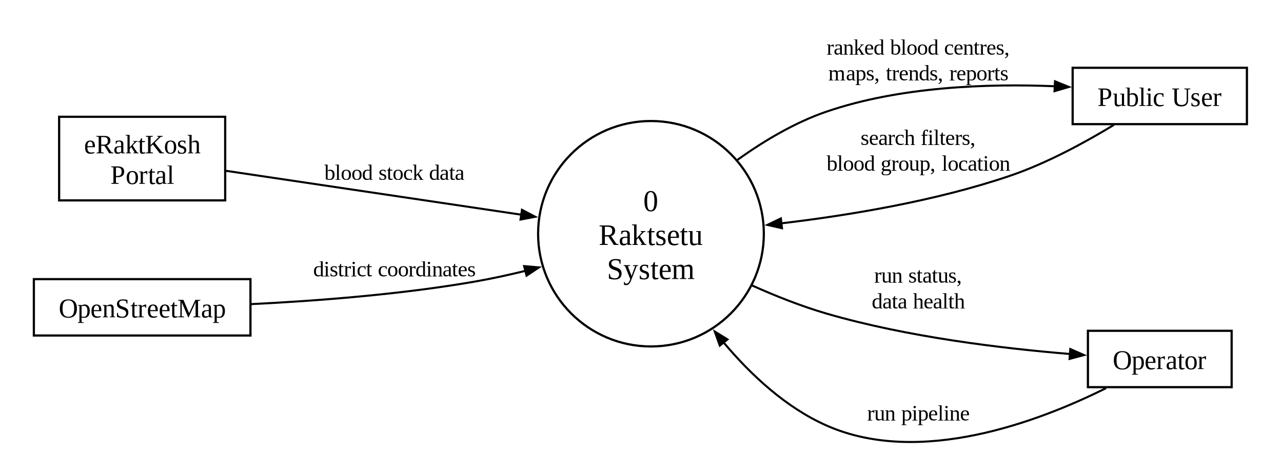
Figure 2: Data Flow Diagram (Level 0)

Data Flow Diagram (Level 1)
✓ Level 1 breaks the system into six processes and shows the four data stores between them.
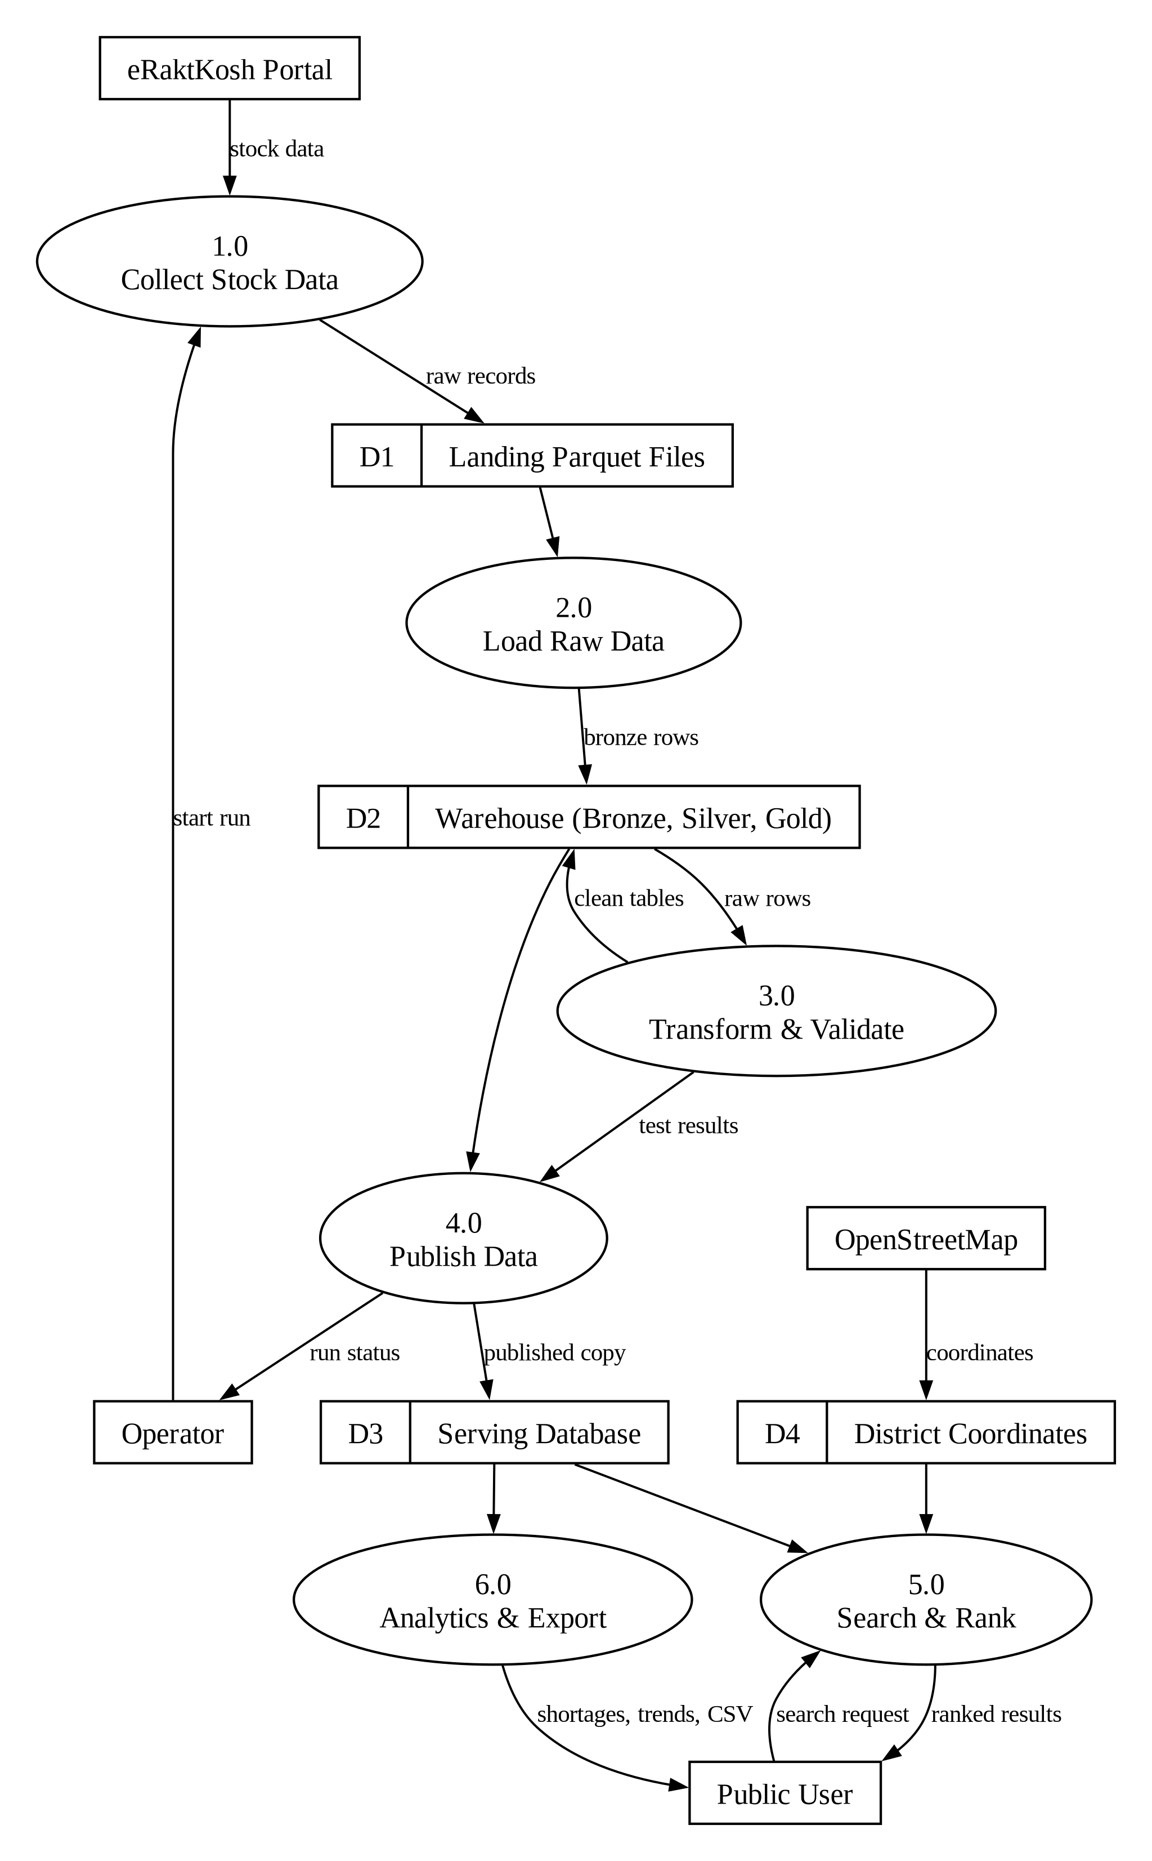
Figure 3: Data Flow Diagram (Level 1)

Use Case Diagram: Public Users
✓ Four kinds of public users use the website without logging in. «include» means the step always happens; «extend» means it is optional.
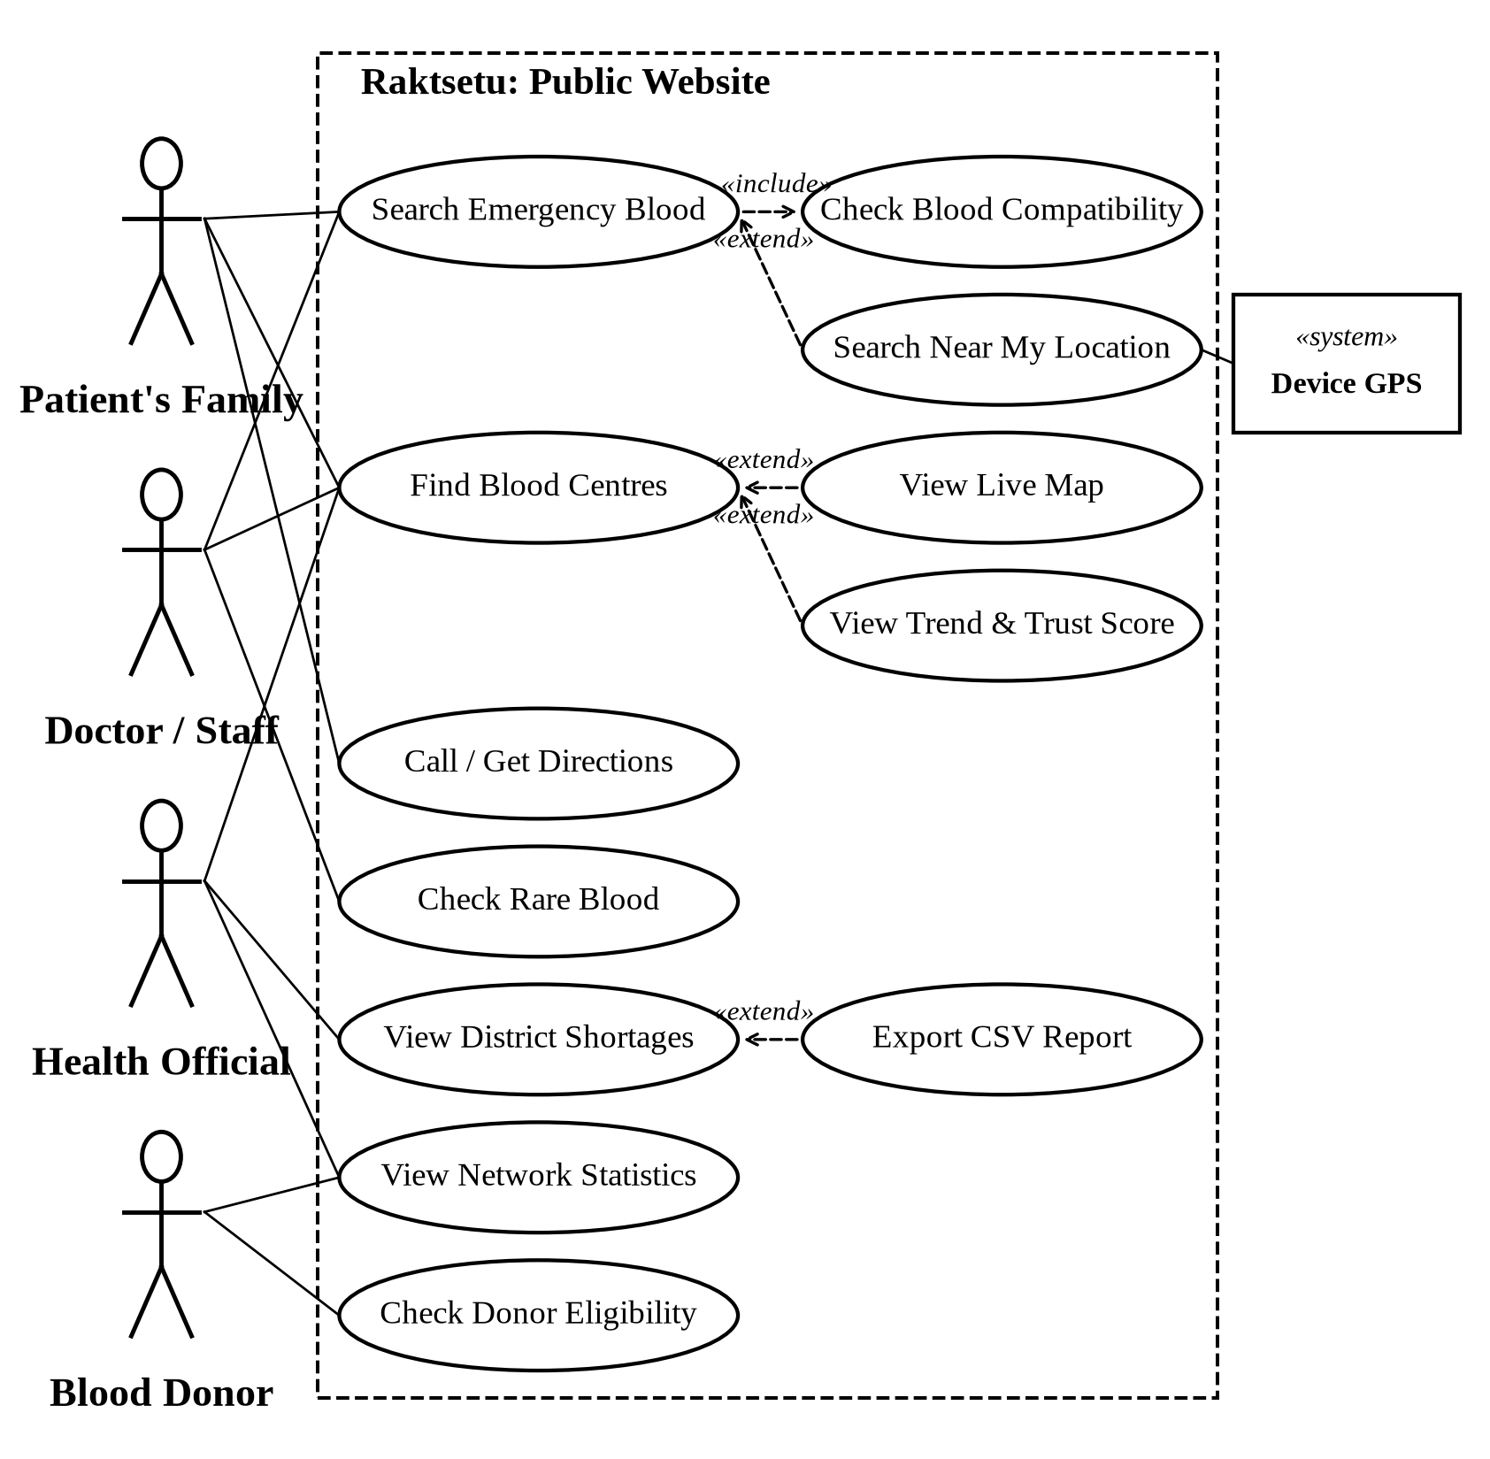
Figure 4: Use Case Diagram: Public Users

Actors of the System
Table 4: Actors of the system
Actor | Type | What they do
Patient's Family | Primary | Searches for compatible blood in an emergency and calls the centre
Doctor / Hospital Staff | Primary | Checks compatible groups, rare blood and stock trends
Health Official | Primary | Monitors district shortages and exports reports
Blood Donor | Primary | Checks donation eligibility and where blood is needed
Operator (Admin) | Primary | Runs the data pipeline and monitors data health
eRaktKosh Portal | Secondary (system) | Provides blood stock data
OpenStreetMap | Secondary (system) | Provides district coordinates and map data
Device GPS | Secondary (system) | Provides the user's location for 'Near me'

Use Case Diagram: Operator & External Systems
✓ The operator runs the pipeline, which always includes scraping, loading, transforming, testing and publishing. eRaktKosh and OpenStreetMap are external systems.
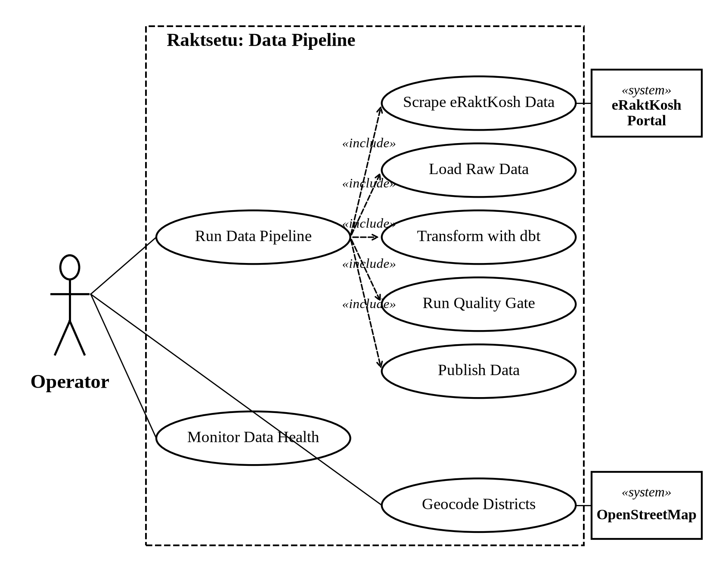
Figure 5: Use Case Diagram: Operator & External Systems

Class Diagram
✓ Main classes of the system with their attributes and operations, and how they depend on each other.
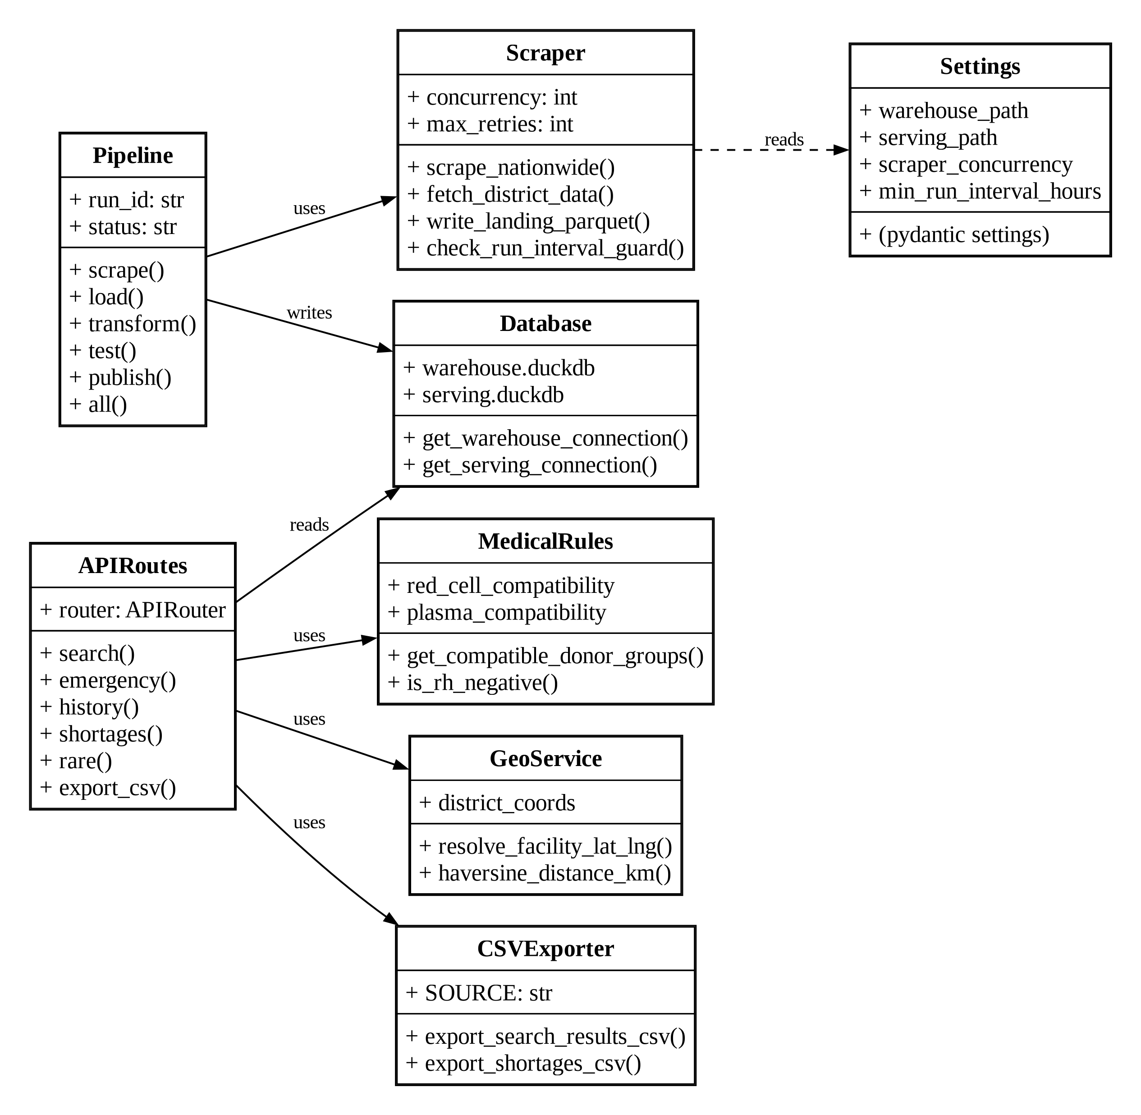
Figure 6: Class Diagram

Activity Diagram: Public User
✓ How a user finds blood: emergency search or Blood Finder, then Call or Directions.
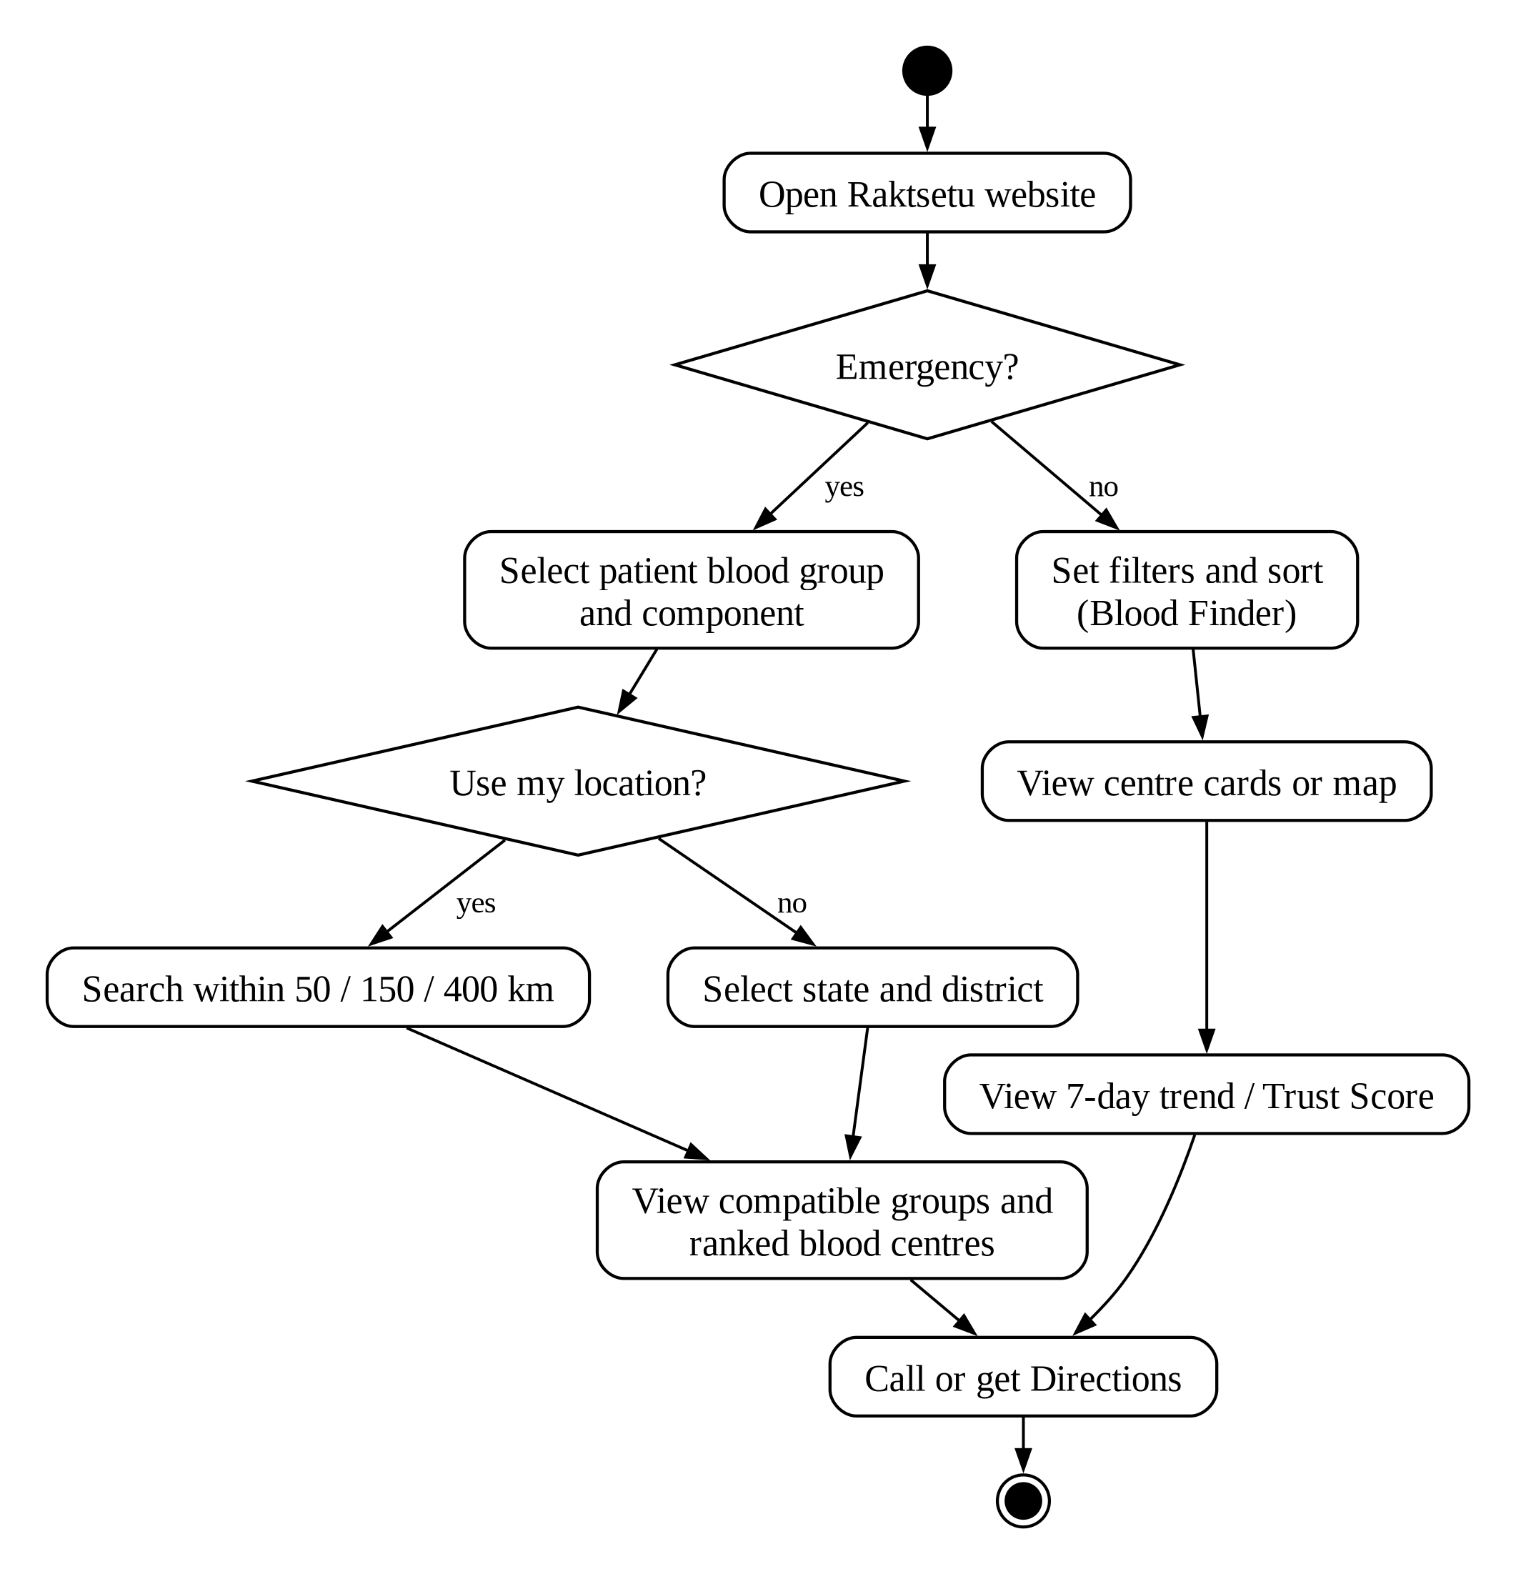
Figure 7: Activity Diagram: Public User

Activity Diagram: Data Pipeline
✓ One pipeline run from scraping to publishing, including the checks that can stop it.
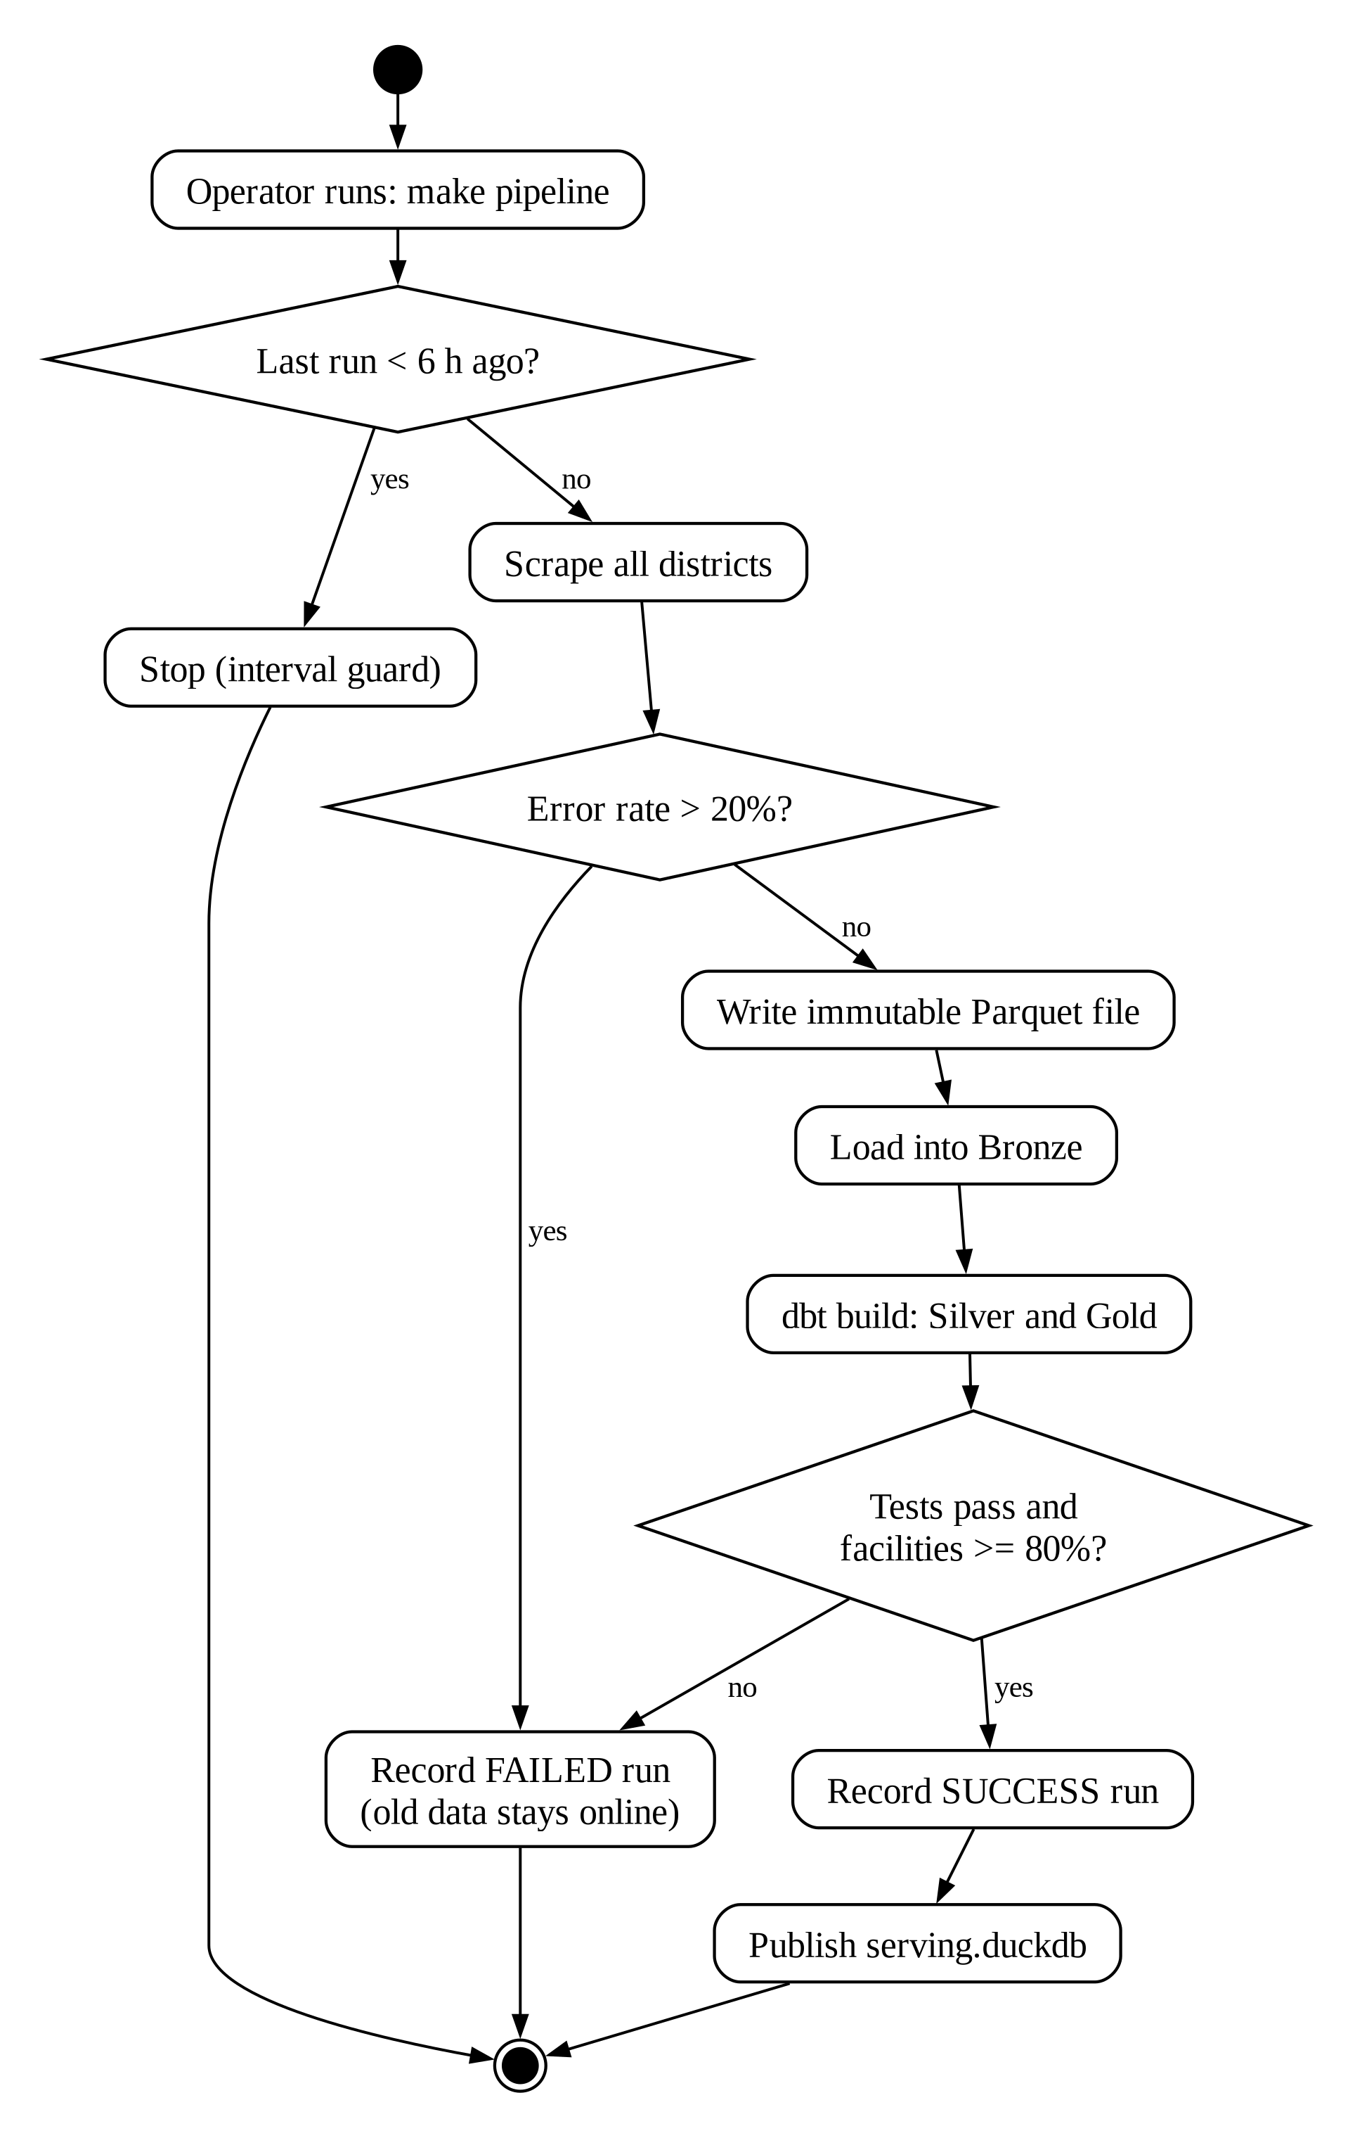
Figure 8: Activity Diagram: Data Pipeline

Sequence Diagram
✓ Messages exchanged between the user, website, API, medical rules and database during an emergency search.
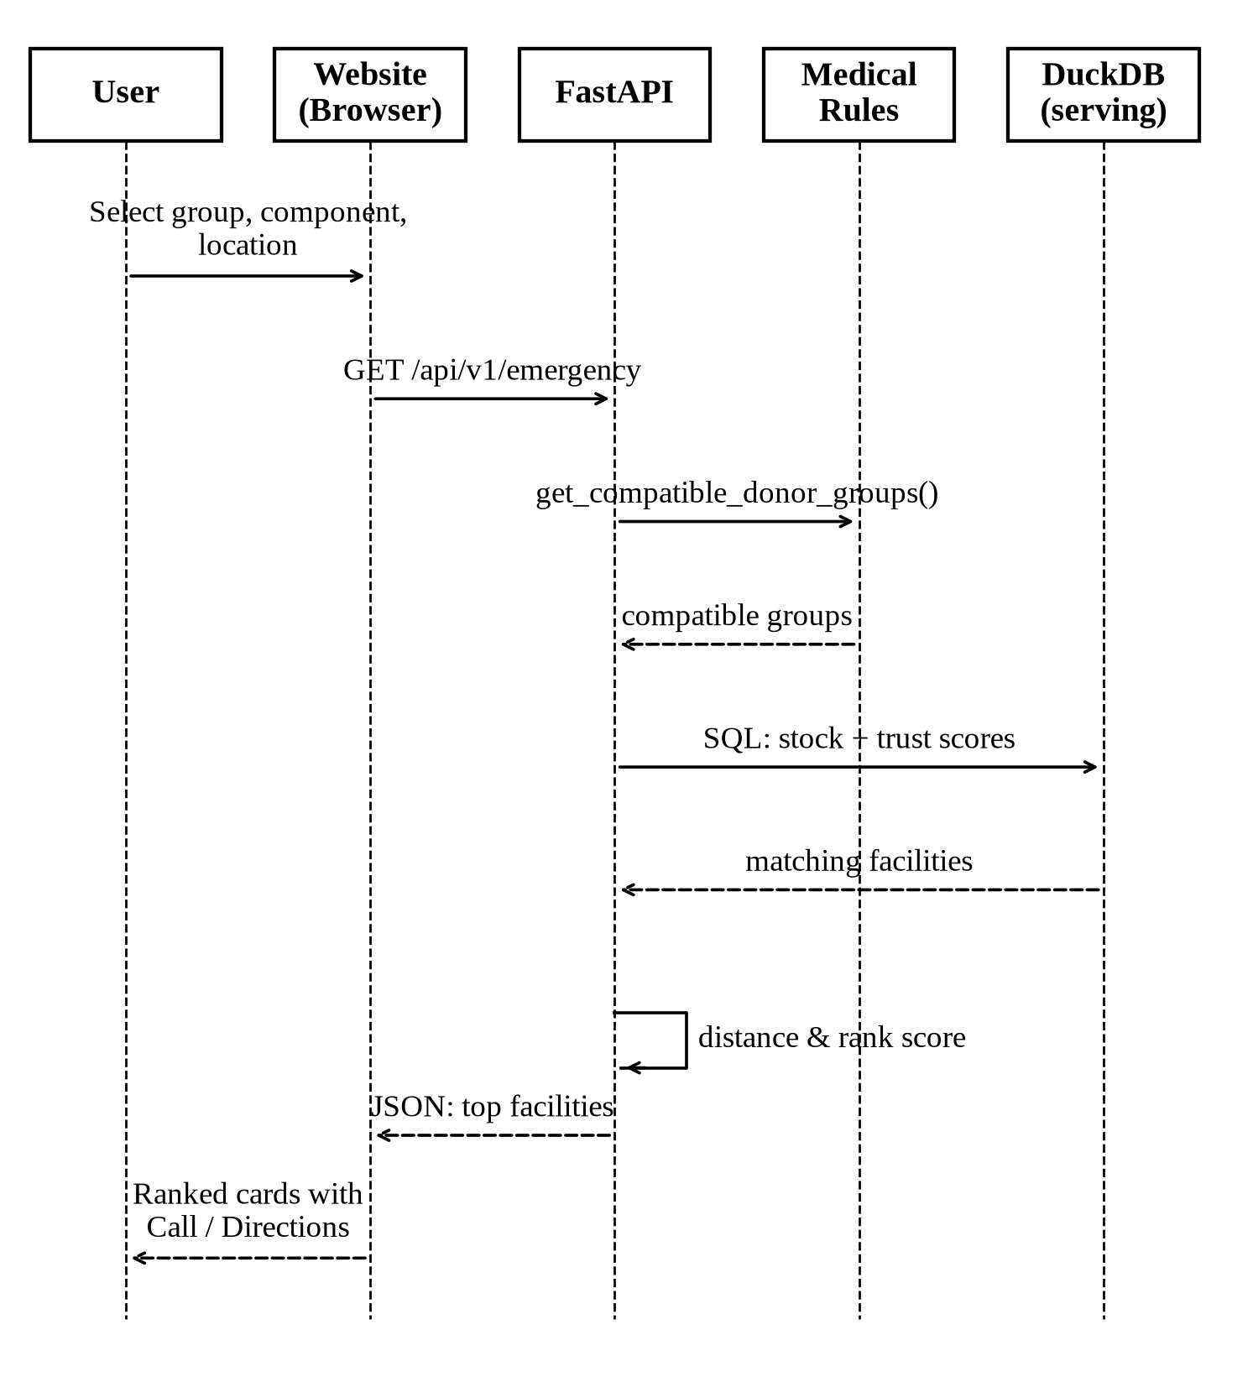
Figure 9: Sequence Diagram

System Architecture
✓ End-to-end design: from the eRaktKosh portal, through the lakehouse layers and quality gate, to the website.
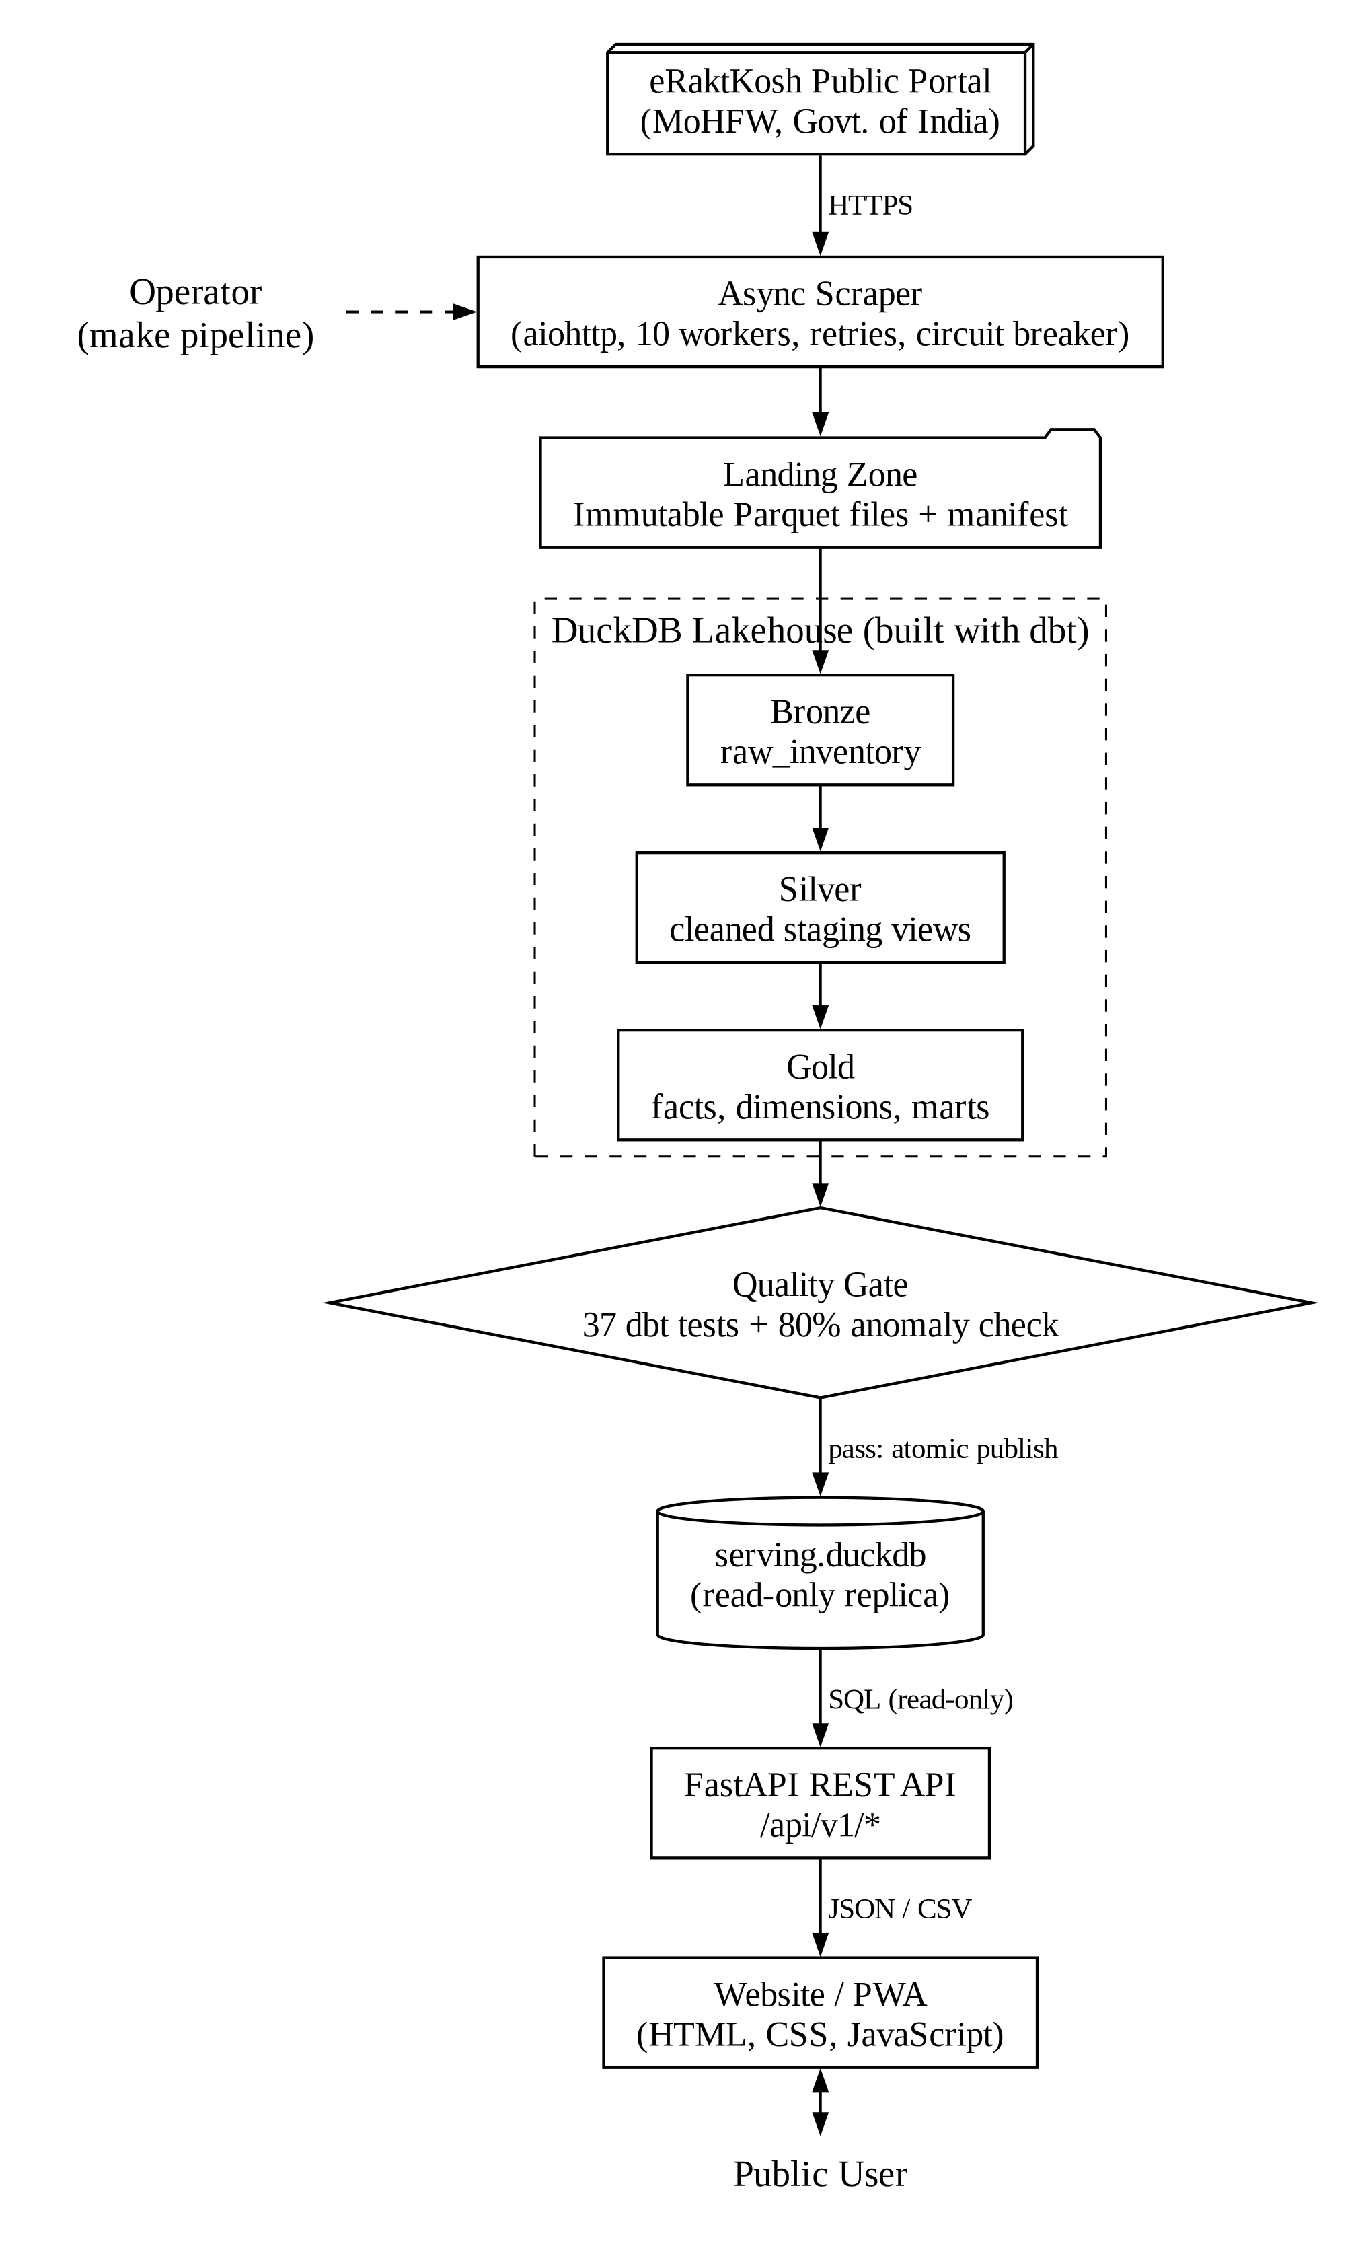
Figure 10: System Architecture

SYSTEM DESIGN

ER Diagram
✓ Entities stored in the lakehouse and how they are related. PK = primary key, FK = foreign key; underlined fields together identify a row.
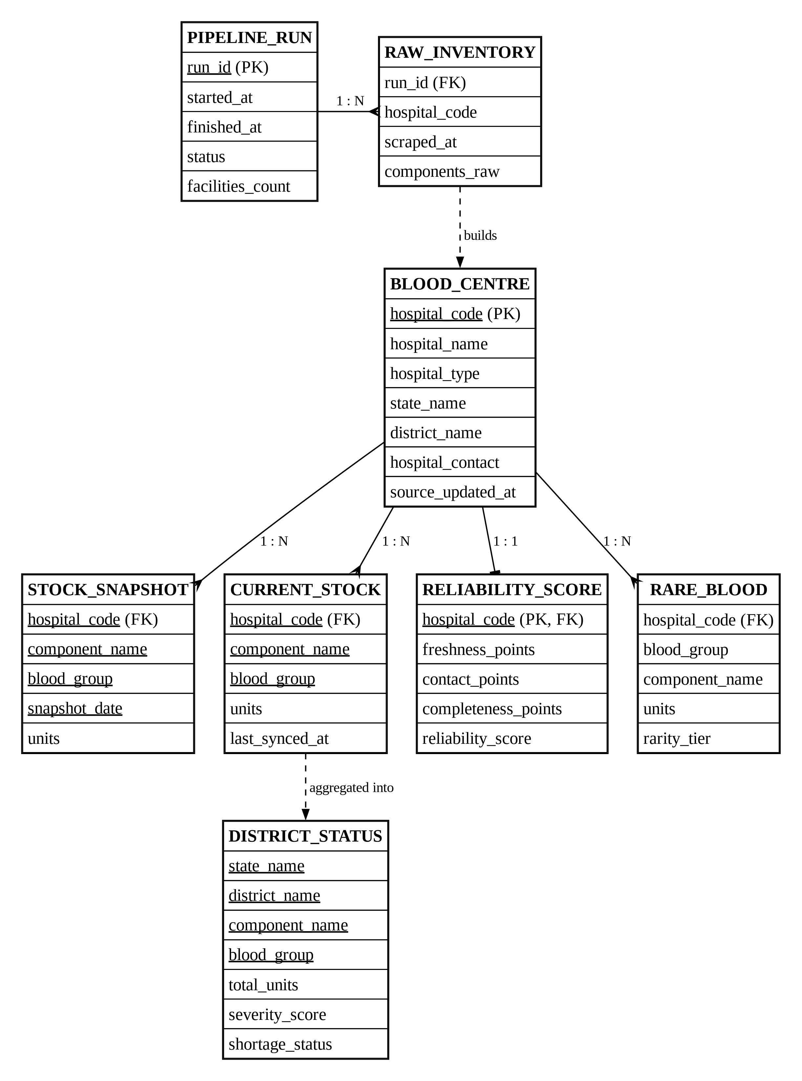
Figure 11: ER Diagram

Data Dictionary
1. Bronze Layer (Raw Data)
Table 5: raw_inventory (bronze.raw_inventory)
Field Name | Data Type | Description
run_id | VARCHAR | Unique identifier of the pipeline/scrape run
scraped_at | TIMESTAMP | Date-time when the record was scraped
hospital_code | BIGINT | Unique eRaktKosh code of the blood centre
hospital_name | VARCHAR | Name of the blood centre
state_name | VARCHAR | State or Union Territory
district_name | VARCHAR | District of the blood centre
hospital_type | VARCHAR | Ownership type (Govt, Private, Charitable)
facility_type | VARCHAR | Facility category (e.g. Blood Bank)
hospital_contact | VARCHAR | Phone, fax and e-mail as published
hospital_address | VARCHAR | Postal address of the blood centre
entry_date_raw | VARCHAR | Last stock update time as text from the source
components_raw | VARCHAR | Stock per component and blood group (JSON)
raw_payload | VARCHAR | Complete original record (JSON) for audit
ingested_at | TIMESTAMP | Date-time when loaded into Bronze

2. Gold Layer: Dimension & Facts
Table 6: dim_blood_banks (main_gold.dim_blood_banks)
Field Name | Data Type | Description
hospital_code | BIGINT | Unique eRaktKosh code of the blood centre
hospital_name | VARCHAR | Name of the blood centre
hospital_address | VARCHAR | Postal address of the blood centre
hospital_contact | VARCHAR | Phone, fax and e-mail as published
hospital_type | VARCHAR | Ownership type (Govt, Private, Charitable)
facility_type | VARCHAR | Facility category (e.g. Blood Bank)
state_name | VARCHAR | State or Union Territory
district_name | VARCHAR | District of the blood centre
source_updated_at | TIMESTAMP | Last stock update time reported by the centre
lakehouse_ingested_at | TIMESTAMP | Time of the latest scrape containing the centre

Table 7: fct_stock_snapshot (main_gold.fct_stock_snapshot)
Field Name | Data Type | Description
hospital_code | BIGINT | Unique eRaktKosh code of the blood centre
hospital_name | VARCHAR | Name of the blood centre
state_name | VARCHAR | State or Union Territory
district_name | VARCHAR | District of the blood centre
component_name | VARCHAR | Blood component (e.g. Packed Red Blood Cells)
blood_group | VARCHAR | Normalised blood group (e.g. O-, AB+, Bombay)
units | INTEGER | Units available
source_updated_at | TIMESTAMP | Last stock update time reported by the centre
snapshot_at | TIMESTAMP | Scrape time of the snapshot
snapshot_date | DATE | Calendar date of the daily snapshot

Table 8: fct_stock_current (main_gold.fct_stock_current)
Field Name | Data Type | Description
hospital_code | BIGINT | Unique eRaktKosh code of the blood centre
hospital_name | VARCHAR | Name of the blood centre
state_name | VARCHAR | State or Union Territory
district_name | VARCHAR | District of the blood centre
component_name | VARCHAR | Blood component (e.g. Packed Red Blood Cells)
blood_group | VARCHAR | Normalised blood group (e.g. O-, AB+, Bombay)
units | INTEGER | Units available
source_updated_at | TIMESTAMP | Last stock update time reported by the centre
last_synced_at | TIMESTAMP | Time of the centre's latest scrape

3. Gold Layer: Analytical Marts
Table 9: mart_district_status (main_gold.mart_district_status)
Field Name | Data Type | Description
state_name | VARCHAR | State or Union Territory
district_name | VARCHAR | District of the blood centre
component_name | VARCHAR | Blood component (e.g. Packed Red Blood Cells)
blood_group | VARCHAR | Normalised blood group (e.g. O-, AB+, Bombay)
total_reporting_banks | BIGINT | Number of centres reporting this group
stocked_banks | BIGINT | Centres with at least one unit
banks_with_zero | BIGINT | Centres with zero units
total_units | BIGINT | Total units in the district
min_facility_units | INTEGER | Lowest stock at a single centre
max_facility_units | INTEGER | Highest stock at a single centre
shortage_flag | BOOLEAN | True when total units are 5 or fewer
severity_score | INTEGER | Shortage urgency from 0 to 100
shortage_status | VARCHAR | Critical depletion / High / Moderate / Adequate

Table 10: mart_rare_blood_availability (main_gold.mart_rare_blood_availability)
Field Name | Data Type | Description
hospital_code | BIGINT | Unique eRaktKosh code of the blood centre
hospital_name | VARCHAR | Name of the blood centre
hospital_type | VARCHAR | Ownership type (Govt, Private, Charitable)
state_name | VARCHAR | State or Union Territory
district_name | VARCHAR | District of the blood centre
hospital_contact | VARCHAR | Phone, fax and e-mail as published
hospital_address | VARCHAR | Postal address of the blood centre
component_name | VARCHAR | Blood component (e.g. Packed Red Blood Cells)
blood_group | VARCHAR | Normalised blood group (e.g. O-, AB+, Bombay)
units | INTEGER | Units available
rarity_tier | VARCHAR | Rarity class of the blood group
source_updated_at | TIMESTAMP | Last stock update time reported by the centre
last_synced_at | TIMESTAMP | Time of the centre's latest scrape

Table 11: mart_reliability_score (main_gold.mart_reliability_score)
Field Name | Data Type | Description
hospital_code | BIGINT | Unique eRaktKosh code of the blood centre
hospital_name | VARCHAR | Name of the blood centre
hospital_type | VARCHAR | Ownership type (Govt, Private, Charitable)
facility_type | VARCHAR | Facility category (e.g. Blood Bank)
state_name | VARCHAR | State or Union Territory
district_name | VARCHAR | District of the blood centre
hospital_contact | VARCHAR | Phone, fax and e-mail as published
hospital_address | VARCHAR | Postal address of the blood centre
source_updated_at | TIMESTAMP | Last stock update time reported by the centre
days_since_update | BIGINT | Days since the centre last updated stock
distinct_components_count | BIGINT | Number of components the centre reports
total_units_in_stock | BIGINT | Total units across all components
freshness_points | INTEGER | Trust points for recent updates (max 50)
contact_points | INTEGER | Trust points for a valid phone (max 25)
completeness_points | INTEGER | Trust points for component coverage (max 25)
reliability_score | INTEGER | Trust Score from 0 to 100
reliability_label | VARCHAR | High (75+), Medium (40–74) or Low
reliability_tier | VARCHAR | Same as label, kept for API compatibility

Table 12: mart_stock_change (main_gold.mart_stock_change)
Field Name | Data Type | Description
hospital_code | BIGINT | Unique eRaktKosh code of the blood centre
hospital_name | VARCHAR | Name of the blood centre
state_name | VARCHAR | State or Union Territory
district_name | VARCHAR | District of the blood centre
component_name | VARCHAR | Blood component (e.g. Packed Red Blood Cells)
blood_group | VARCHAR | Normalised blood group (e.g. O-, AB+, Bombay)
current_units | INTEGER | Units in the latest snapshot
prev_snapshot_units | INTEGER | Units in the previous snapshot
delta_prev | INTEGER | Change since the previous snapshot
delta_7d | INTEGER | Change over the last 7 snapshots
risk_flag | VARCHAR | Stable, Falling or Depleted
anomaly_flag | VARCHAR | NORMAL or SUDDEN_DROP_TO_ZERO

4. Metadata
Table 13: pipeline_runs (gold.pipeline_runs)
Field Name | Data Type | Description
run_id | VARCHAR | Unique identifier of the pipeline/scrape run
started_at | TIMESTAMP | Run start time
finished_at | TIMESTAMP | Run finish time
status | VARCHAR | RUNNING, SUCCESS, SUCCESS_NO_SCRAPE or FAILED
facilities_count | INTEGER | Blood centres in the published data
tests_passed | BOOLEAN | Whether all quality checks passed
error_message | VARCHAR | Failure reason, if any
created_at | TIMESTAMP | Row creation time

Screen Layouts

Home Page & National Statistics
✓ The first screen shows live national figures: total blood centres, centres updated in the last 24 hours and centres flagged for review.
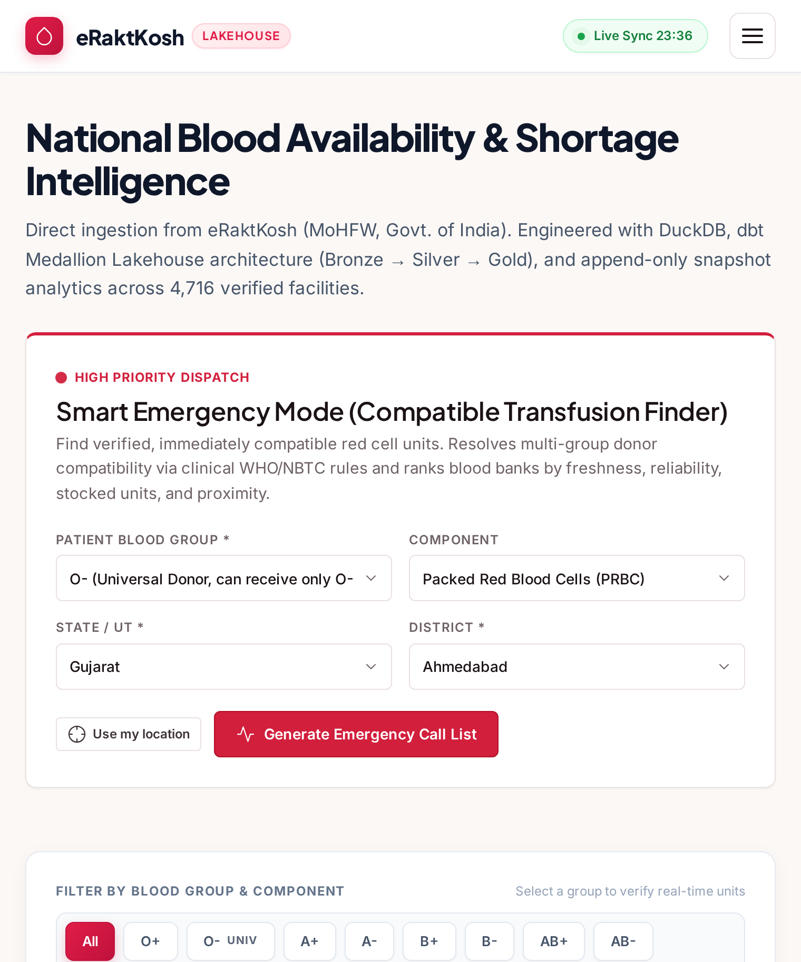
Figure 12: Home Page & National Statistics

Smart Emergency Mode
✓ The user picks the patient's blood group, component and place. The system shows safe donor groups, warnings for Rh-negative and Bombay groups, and the best centres with Call and Directions buttons.
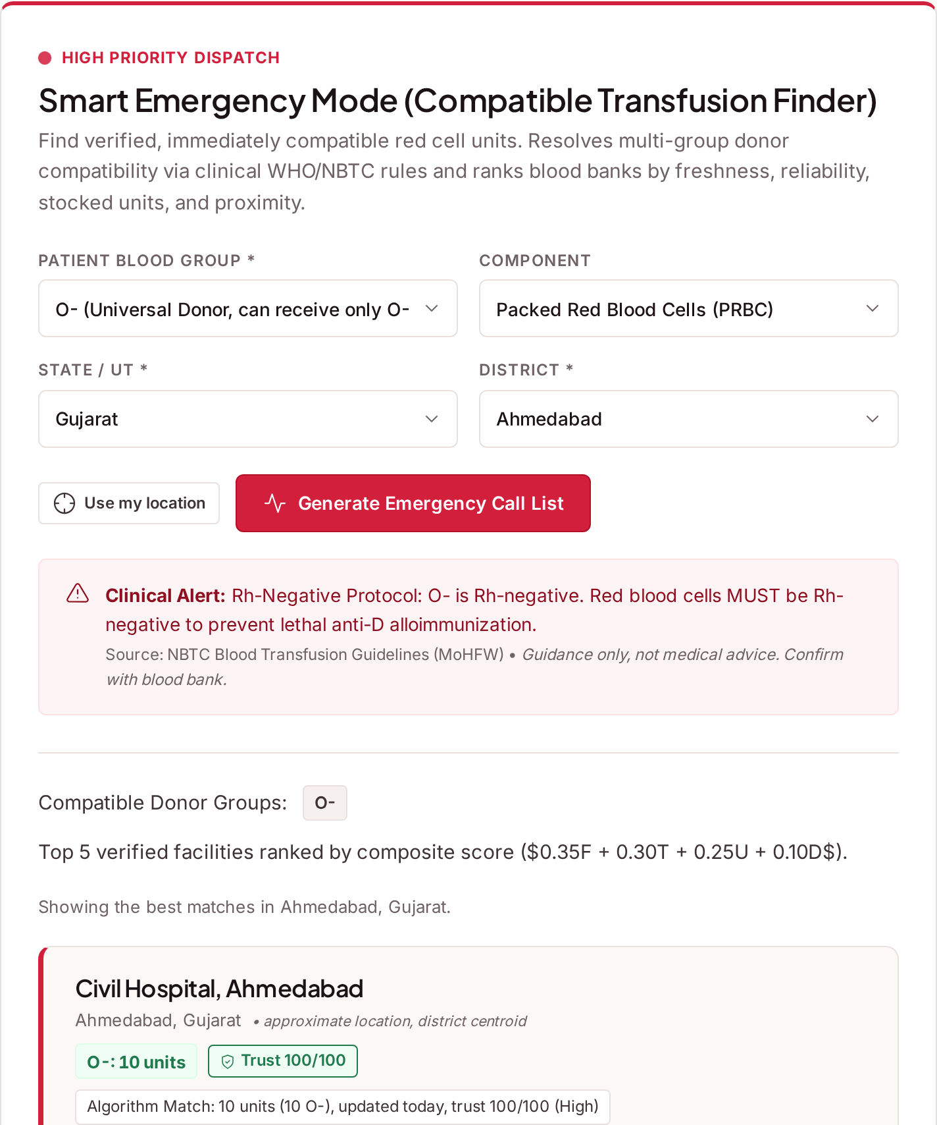
Figure 13: Smart Emergency Mode

Blood Finder
✓ Filters for state, district, component, blood group and name, with sorting by freshness, units, trust or distance.
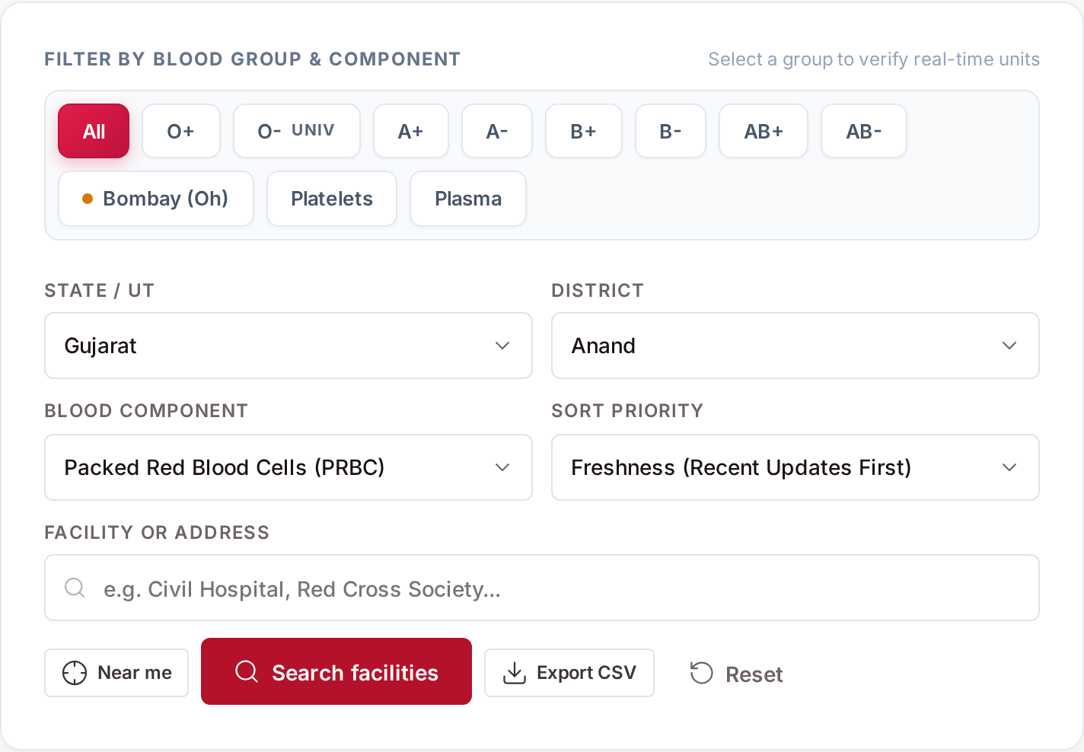
Figure 14: Blood Finder

Blood Finder: Result Cards
✓ Each card shows the centre, its location, how recently it updated, its Trust Score and the units for all eight blood groups.
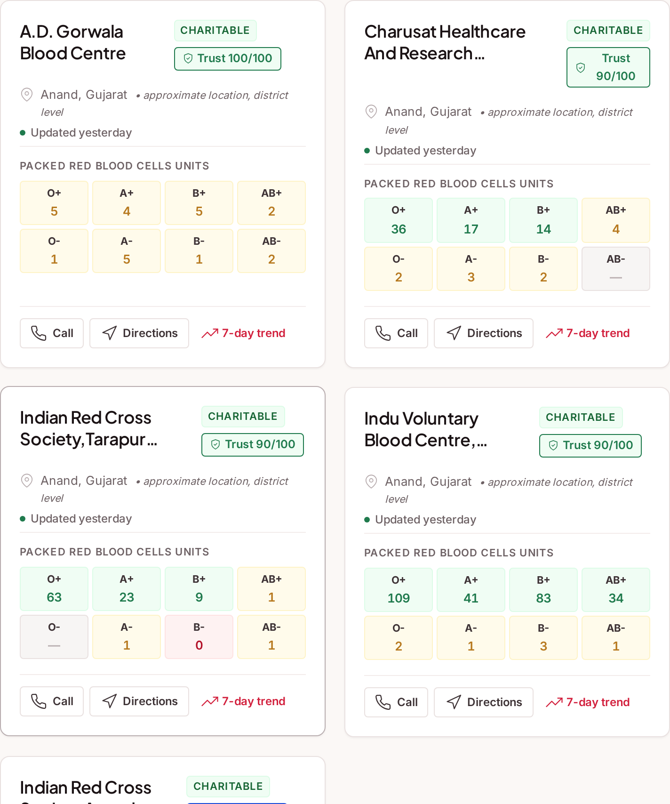
Figure 15: Blood Finder: Result Cards

Live Blood Map
✓ Search results on a map. Marker colour shows the stock level; a pop-up offers Call, Directions and the 7-day trend.
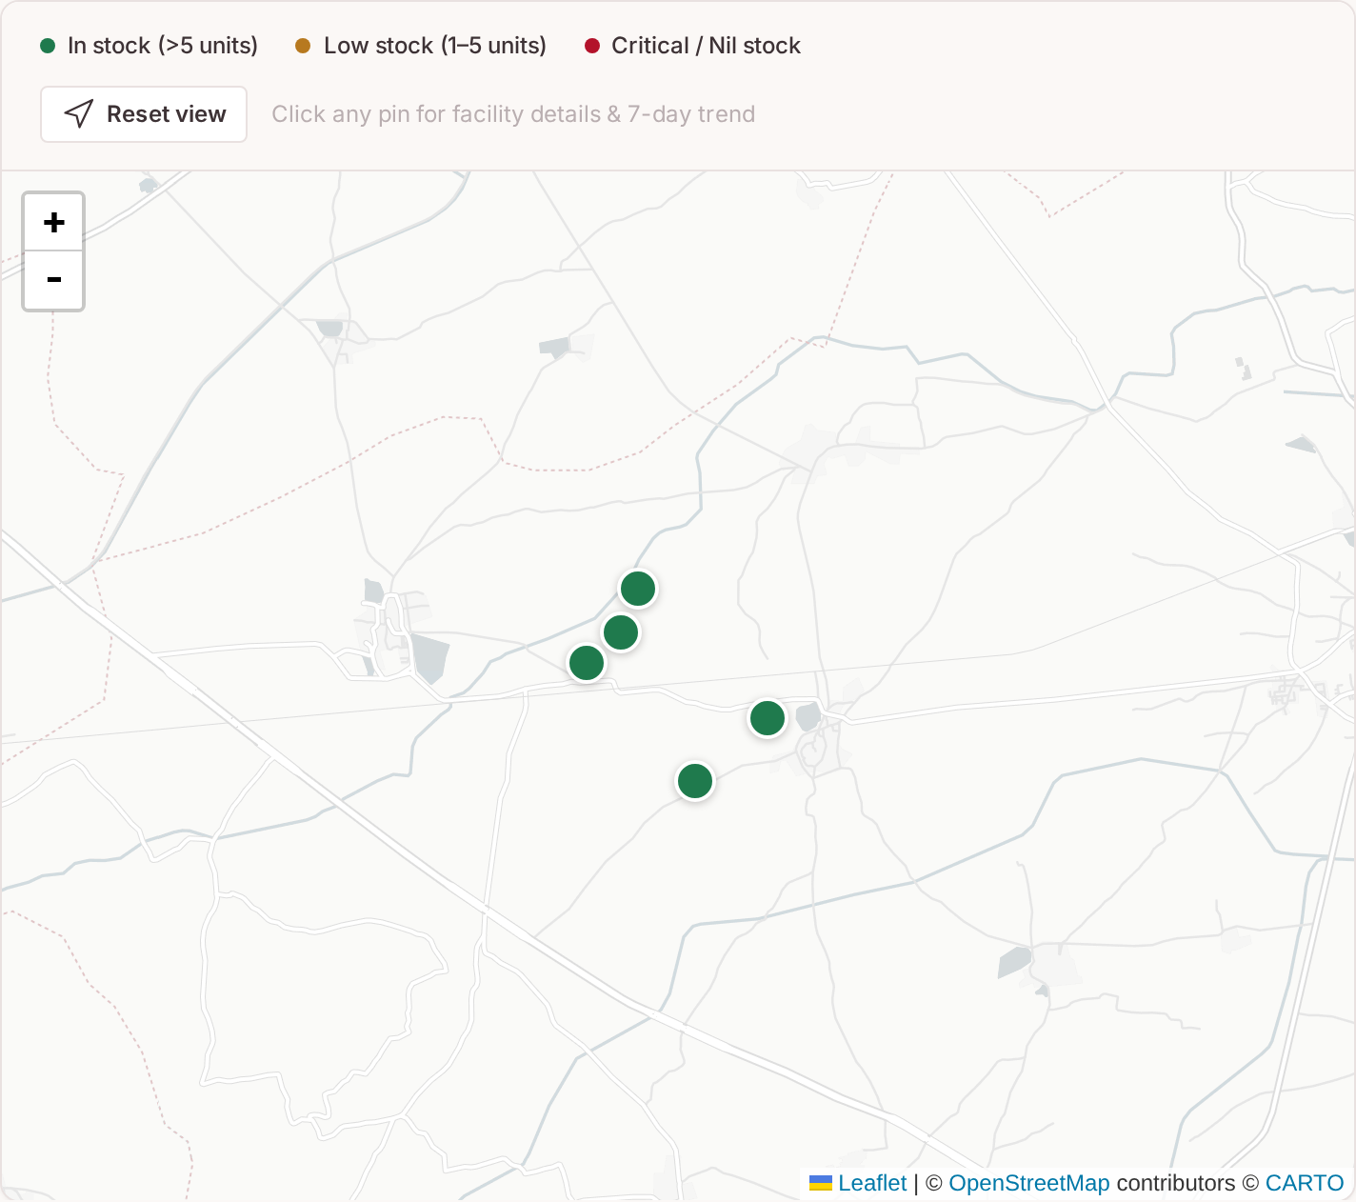
Figure 16: Live Blood Map

7-day Inventory Trend
✓ Real daily stock history per blood group, with current units, change and status.
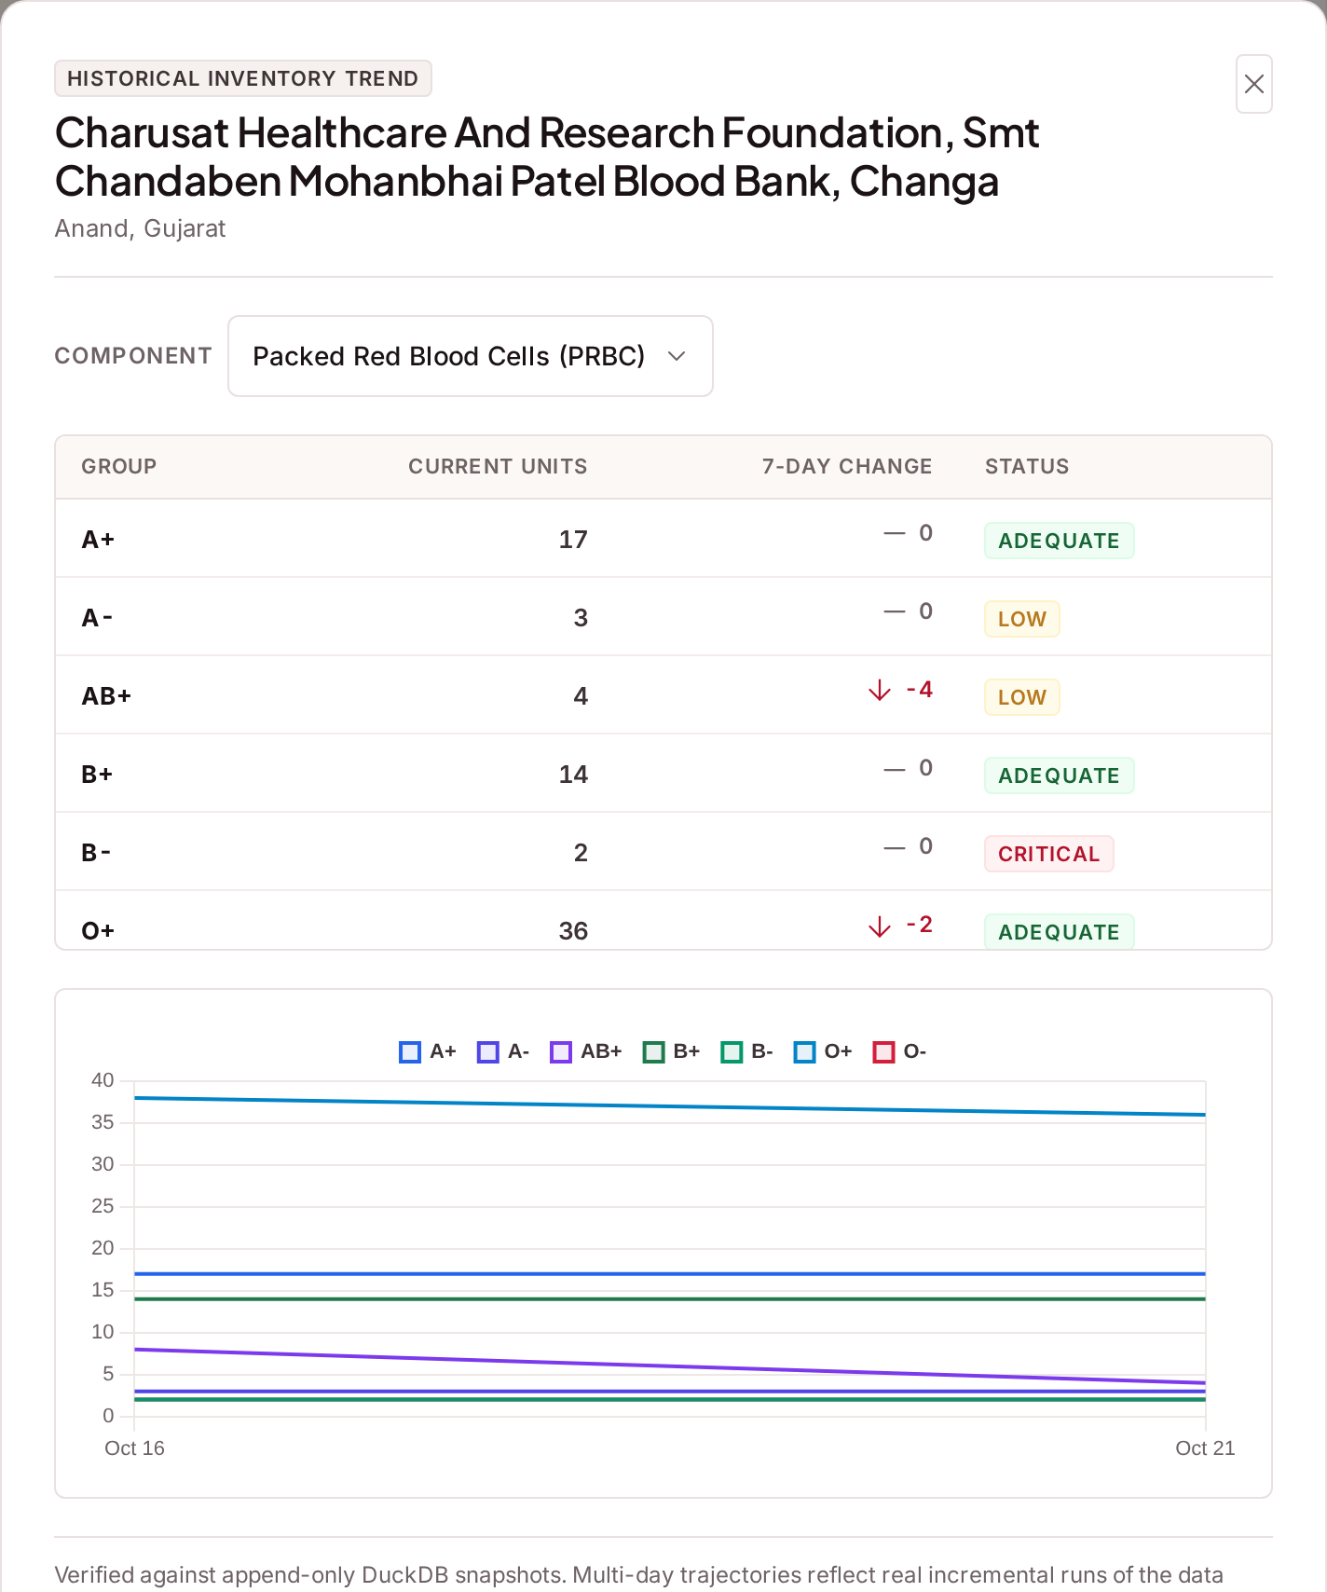
Figure 17: 7-day Inventory Trend

Trust Score Explanation
✓ How the 0–100 Trust Score is calculated: freshness (50), valid contact (25) and component coverage (25).
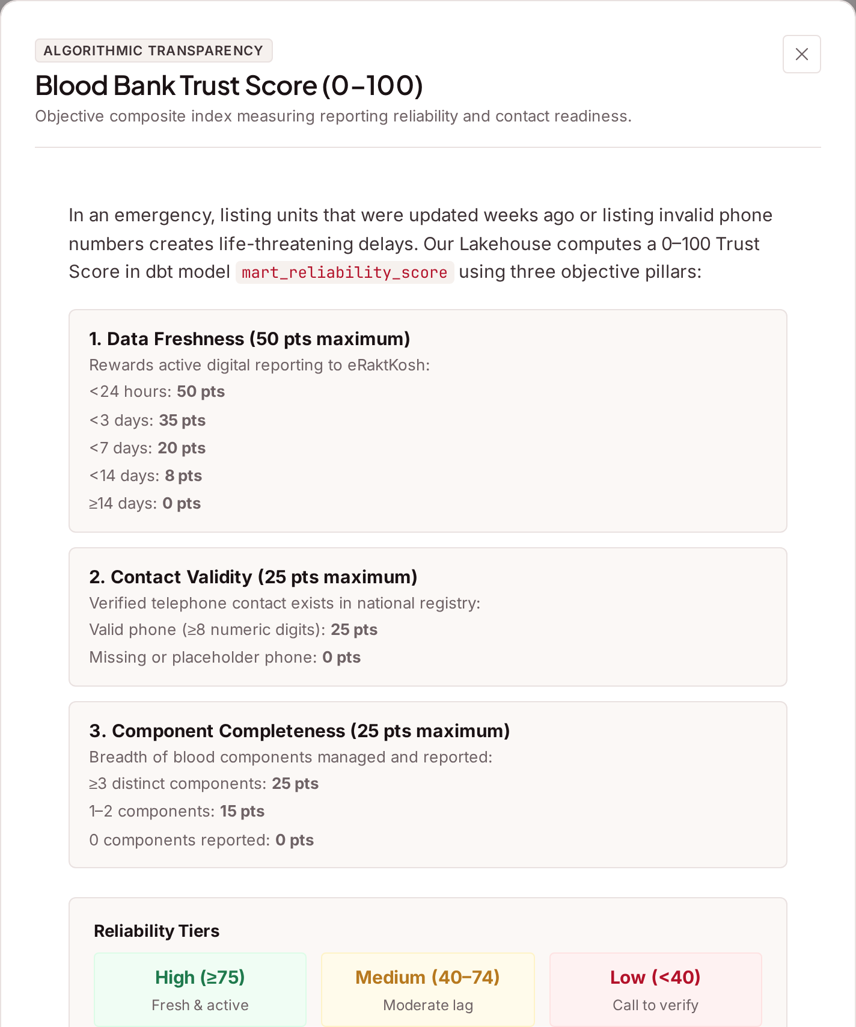
Figure 18: Trust Score Explanation

National Network Distribution
✓ Bar chart of active blood centres in the top states.
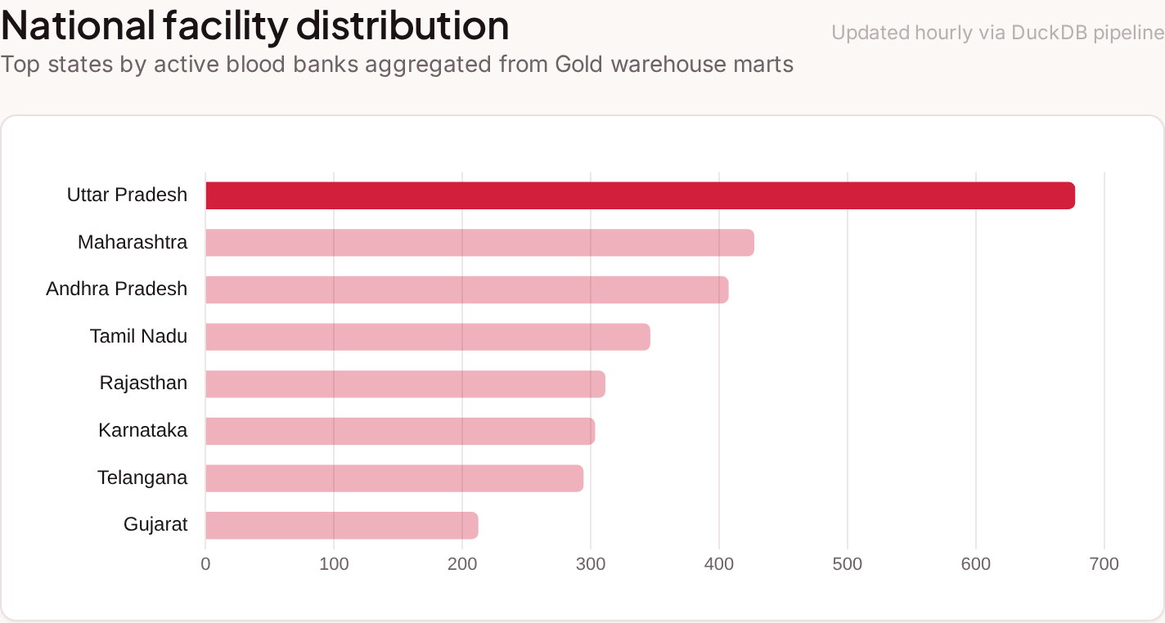
Figure 19: National Network Distribution

Rare Blood Phenotype Radar
✓ Centres across India holding Bombay and other rare blood, with contact numbers.
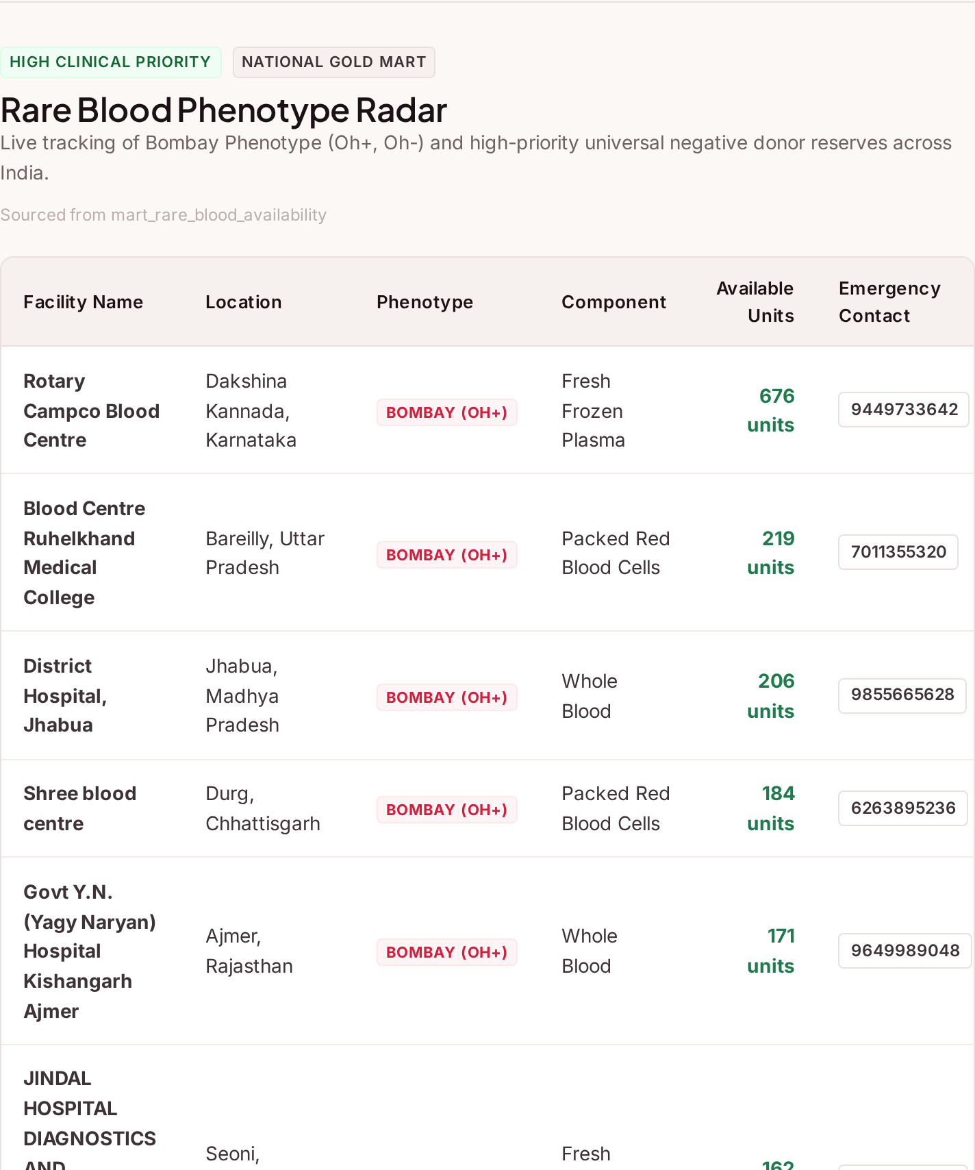
Figure 20: Rare Blood Phenotype Radar

District Shortage Radar
✓ Districts running short of the selected blood group, with CSV export for health officials.
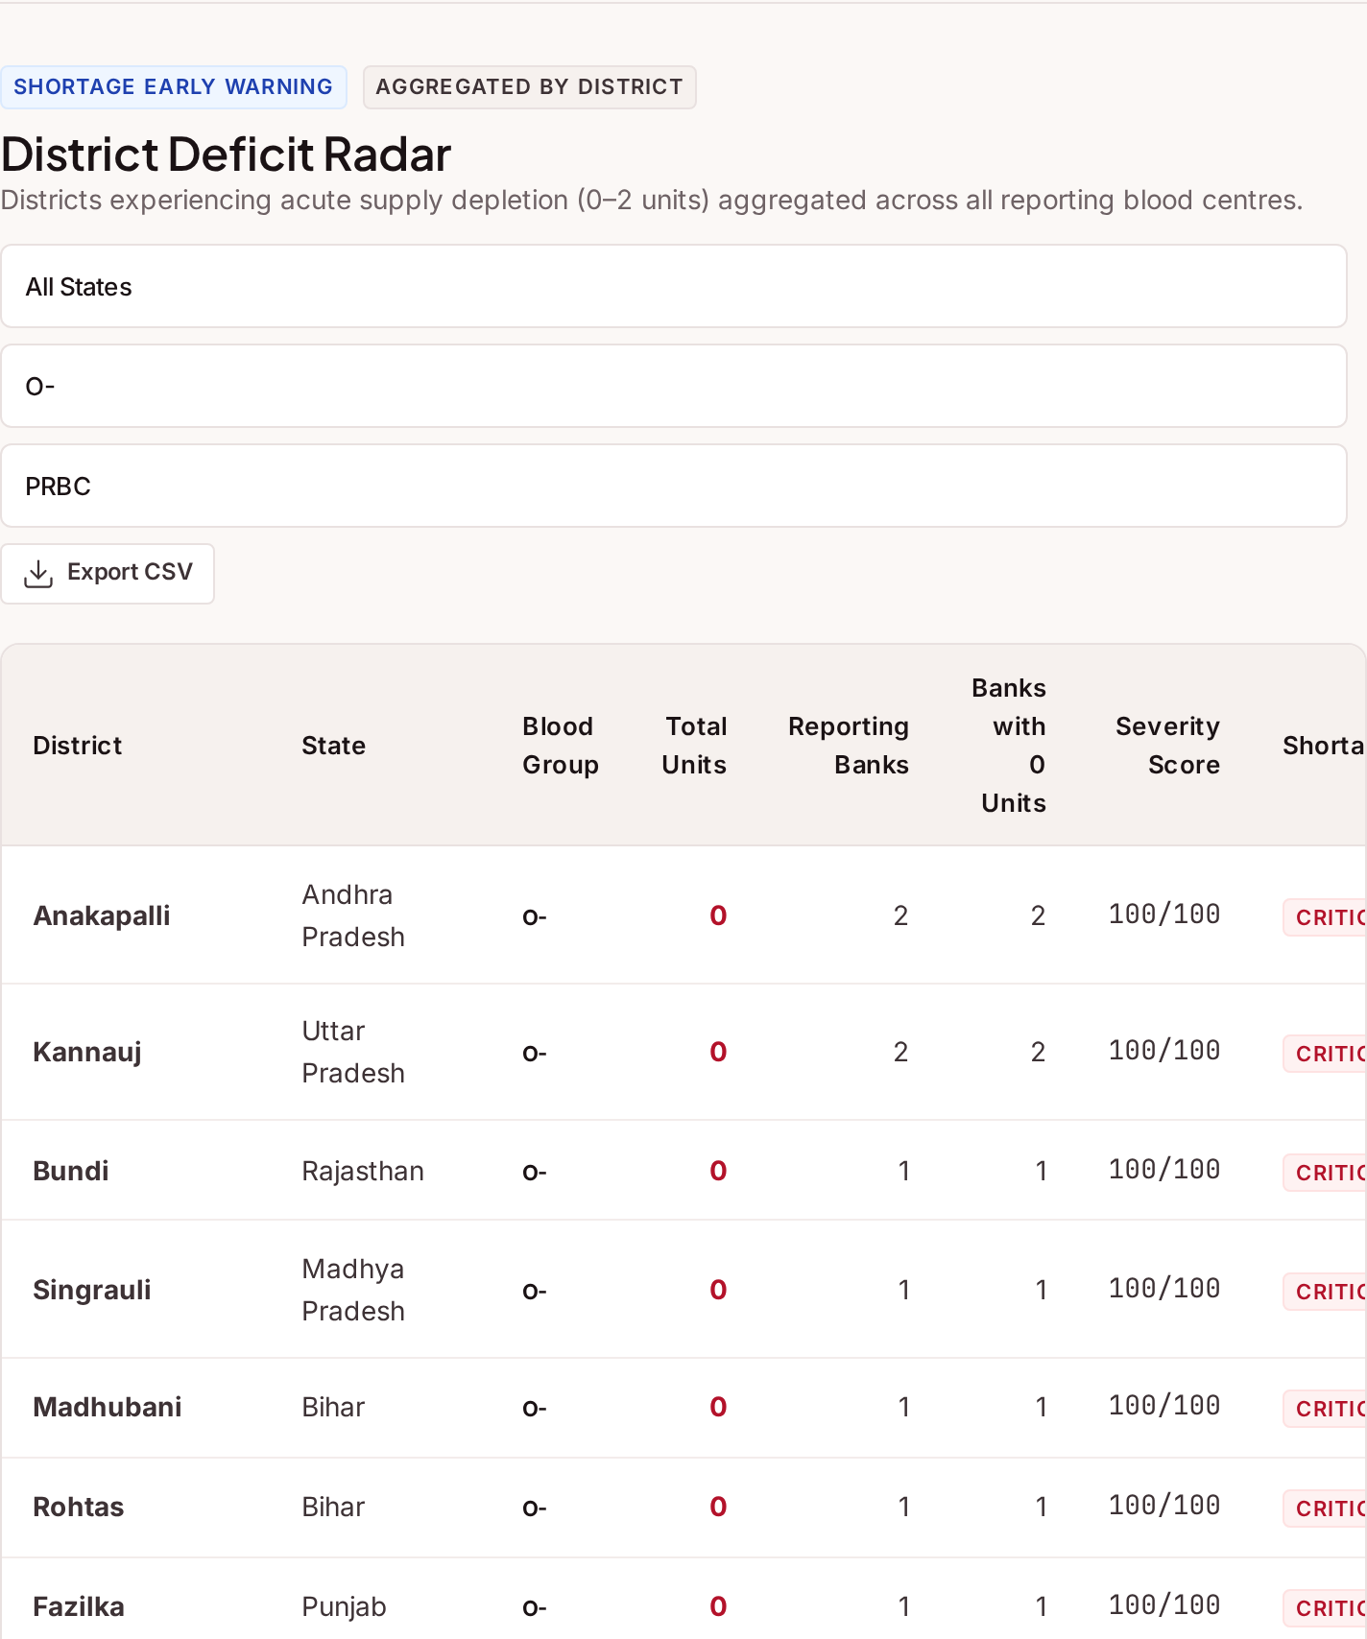
Figure 21: District Shortage Radar

Donor Eligibility & Assistance
✓ Checks in the browser whether a person can donate today, using NBTC rules.
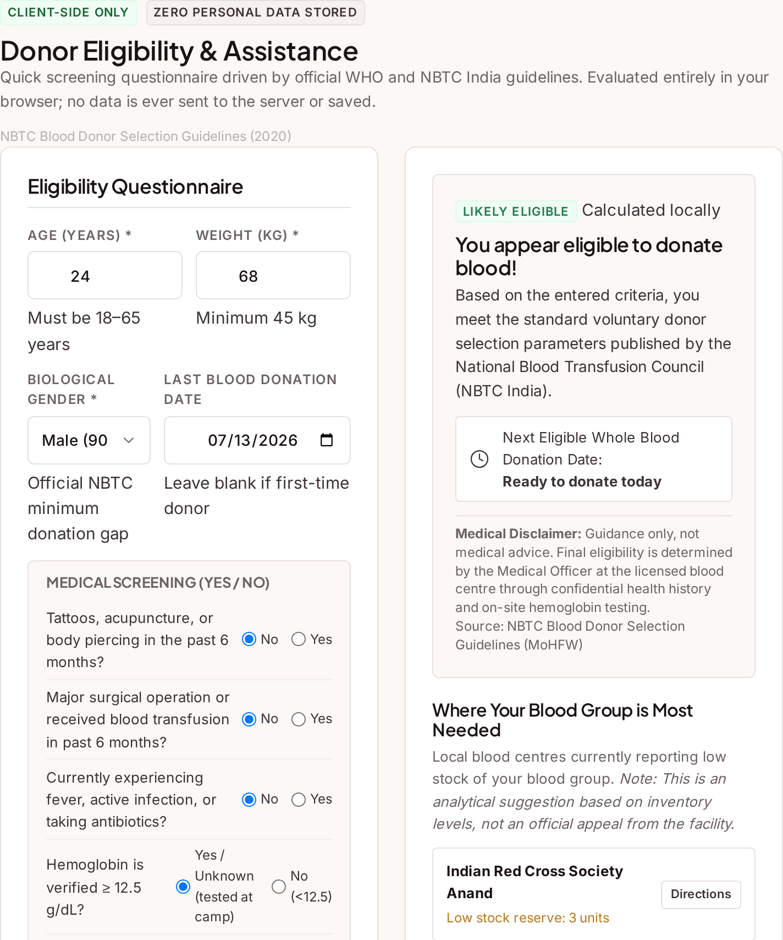
Figure 22: Donor Eligibility & Assistance

Data Health & Pipeline Runs
✓ Last successful sync, fresh and stale centres, test results and recent pipeline runs.
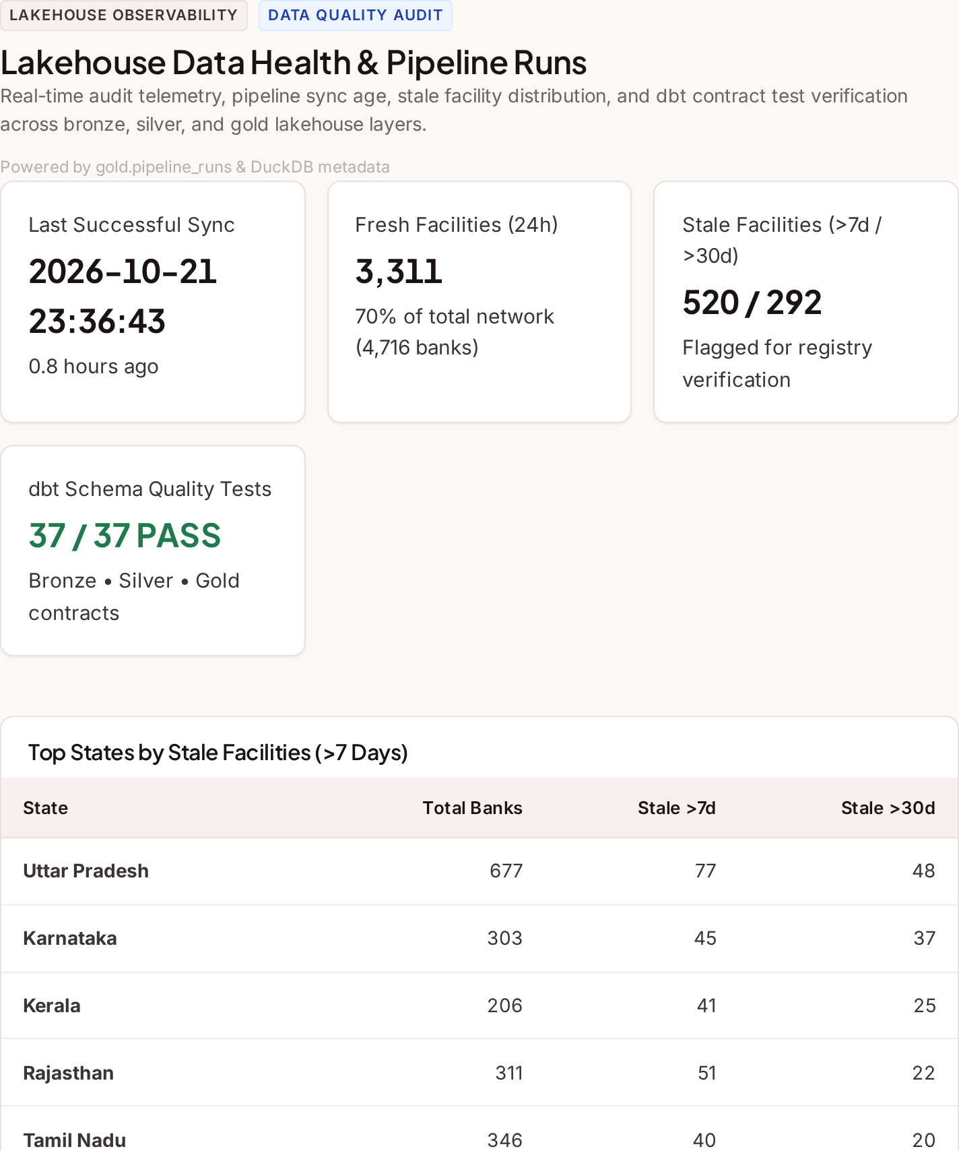
Figure 23: Data Health & Pipeline Runs

Mobile Responsive Design
✓ The same website on a phone: home screen and the menu.
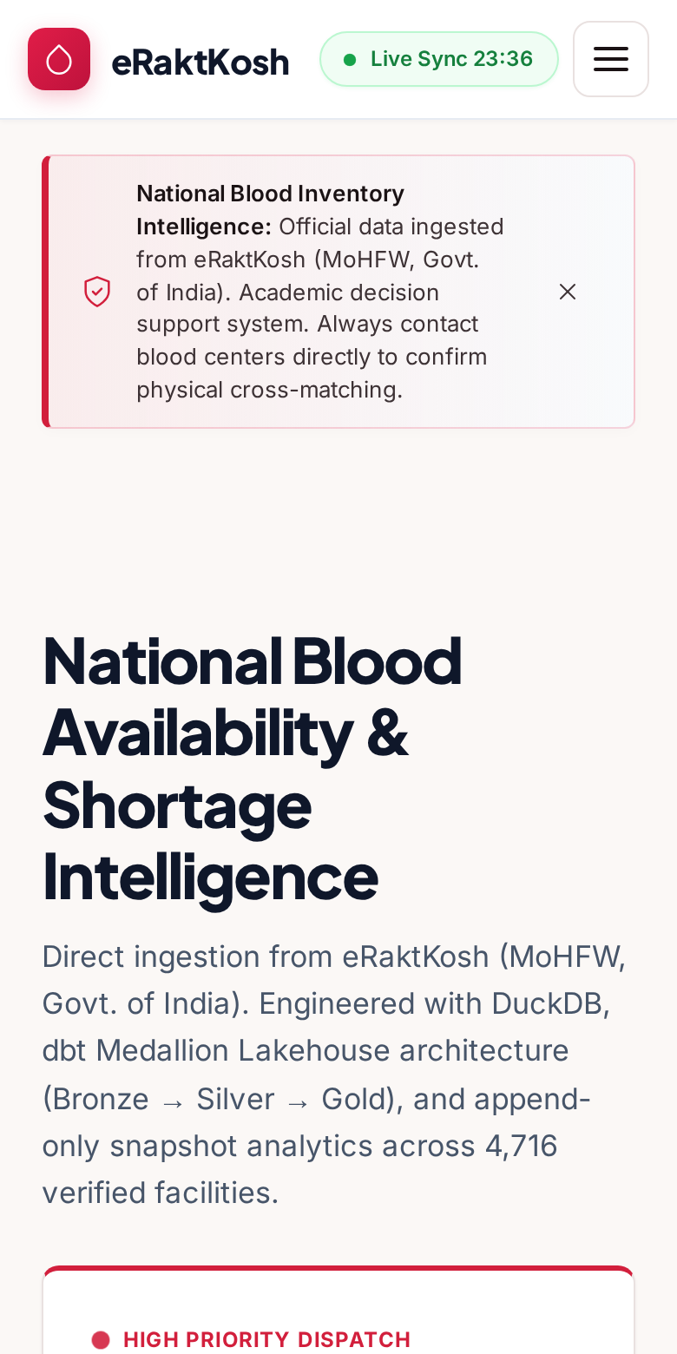 | 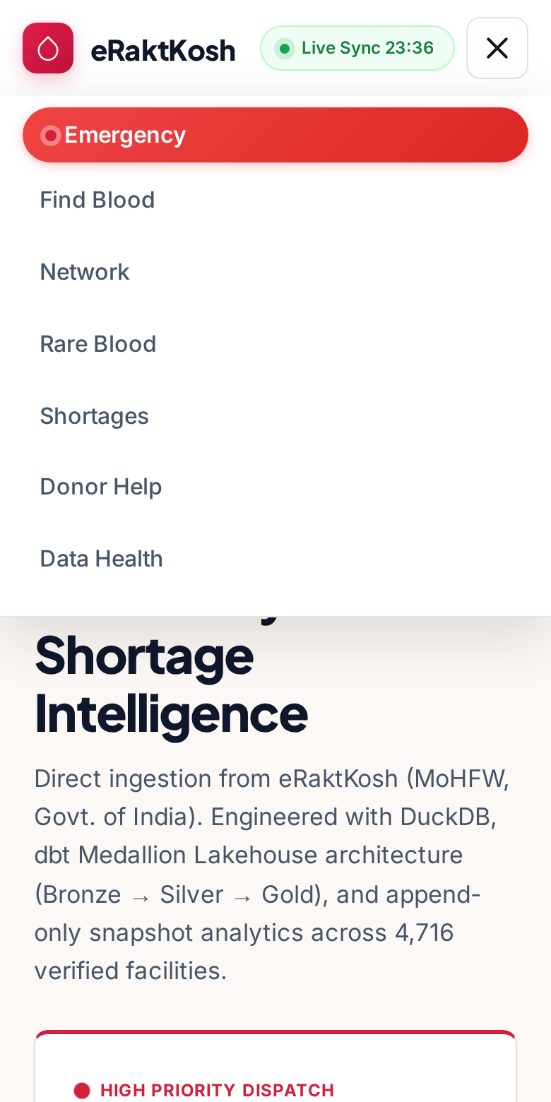
Figure 24: Mobile Responsive Design

Mobile Responsive Design: Search Results
✓ Blood centre cards and emergency results on a phone, with large Call and Directions buttons.
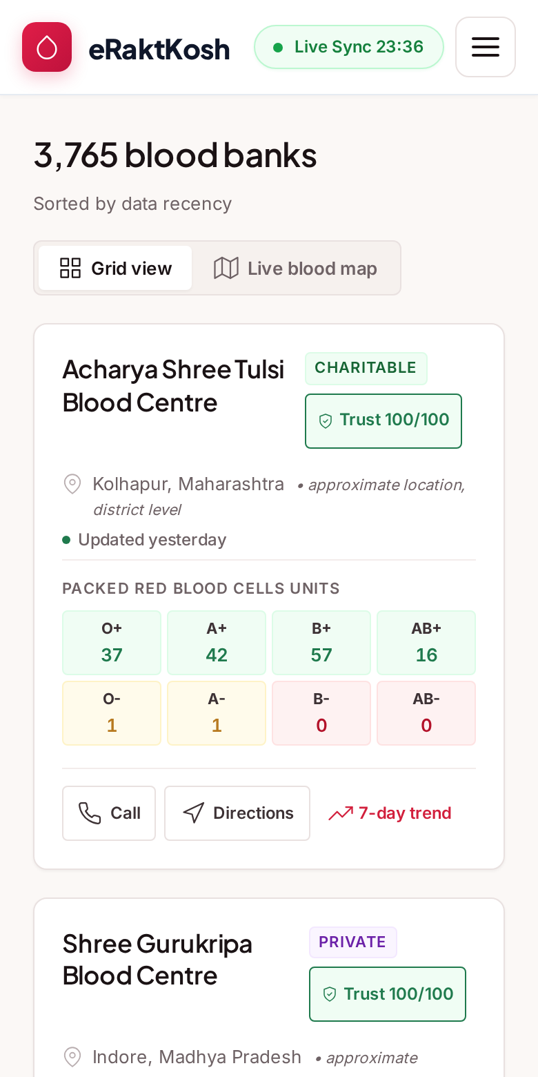 | 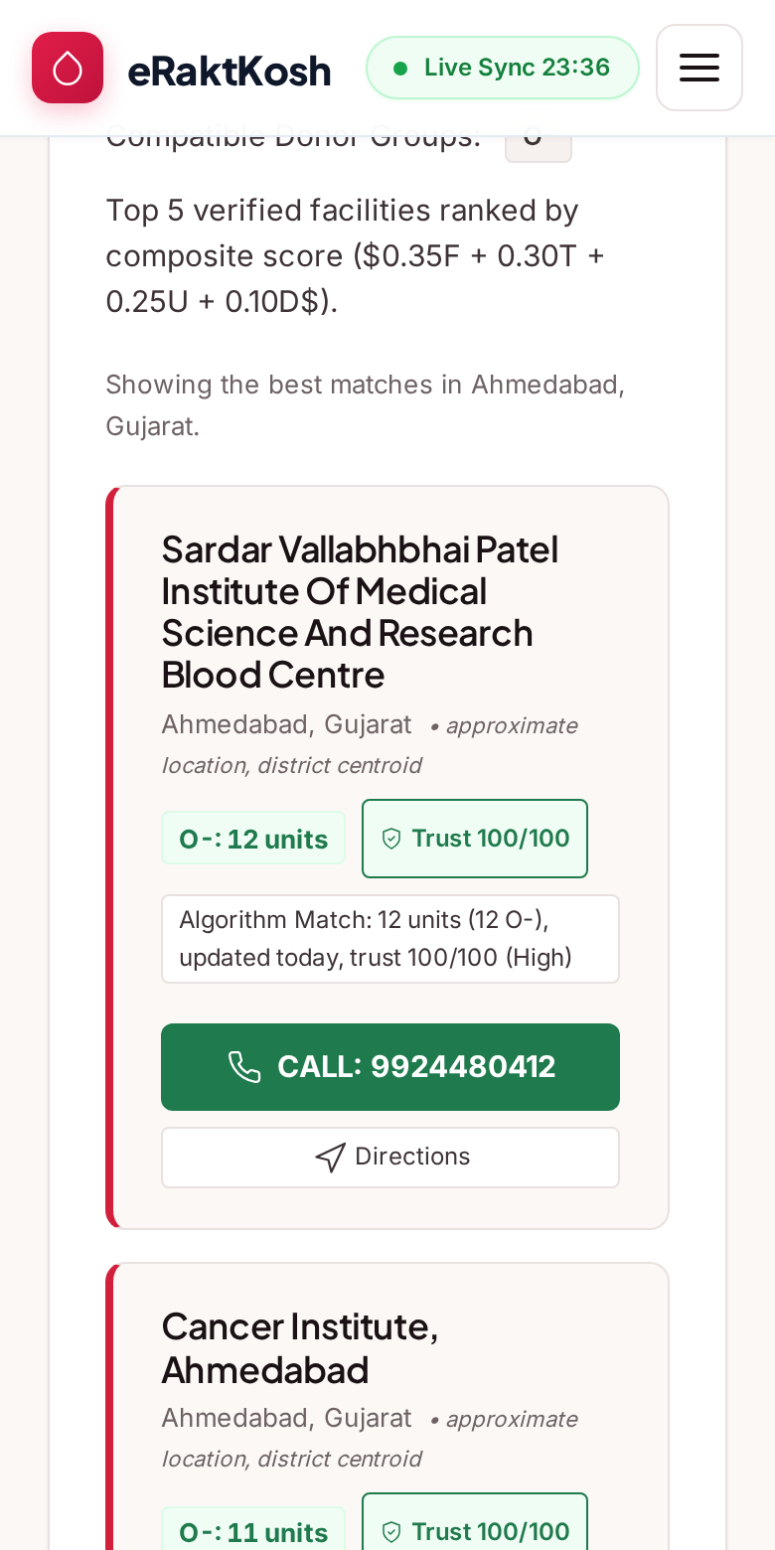
Figure 25: Mobile Responsive Design: Search Results

SYSTEM TESTING

Testing Strategies
✓ Black Box Testing: Every user flow was tested from the outside by using the real website in a browser (Playwright), on desktop and mobile screen sizes.
✓ White Box (Unit) Testing: pytest tests check the code inside: blood-group rules, Trust Score, geocoding, CSV format and the scraper safety checks.
✓ Integration Testing: Every API endpoint is called with FastAPI's TestClient against a test database.
✓ Data Quality Testing: dbt tests check that keys are unique, required values exist and values are valid in every layer. The anomaly gate checks the facility count.
✓ Responsive Testing: The layout was checked at 320, 360, 390, 768, 1024, 1280 and 1920 px widths.
✓ Offline (PWA) Testing: The website was reloaded with the network turned off to check the cache.

Test Results Summary
Table 14: Summary of test results
Test Type | Tool | Number of Checks | Result
Unit & integration tests | pytest | 98 | All passed
Data quality tests | dbt | 37 | All passed
End-to-end user flows | Playwright | 146 | All passed
Responsive layout | Playwright | 7 screen widths | No horizontal scrolling
Black box test cases | Manual + automated | 28 | All passed

Test Cases
Black box test cases: each row was checked on the running website.
Table 15: Black box test cases
Sr. No. | Scenario | Purpose | Input | Expected Output | Status
1 | Home: Load Dashboard | Verify live statistics load | Open the website | Total, fresh and flagged centre counts shown | ✔
2 | Finder: State → District | Verify dependent dropdowns | Select state Gujarat | District list is filled and enabled | ✔
3 | Finder: District Search | Verify filters apply | Gujarat, Anand, Search | Only Anand centres listed; URL updated | ✔
4 | Finder: Blood Group Filter | Verify group filter | Click B- | Centres with B- stock listed | ✔
5 | Finder: No Results | Verify empty state | Search 'zzzz-no-such-bank' | 'No matching blood centres' message | ✔
6 | Finder: Reset | Verify filters reset | Click Reset | All filters cleared; all centres listed | ✔
7 | Finder: Sort by Units | Verify sorting | Select 'Available Units' | Highest stock shown first | ✔
8 | Finder: Pagination | Verify page navigation | Click Next, Last, change page size | Correct page ranges shown | ✔
9 | Finder: Near Me | Verify location ranking | Allow location (Bengaluru) | Bangalore Urban centres about 4 km away first | ✔
10 | Card: Call Link | Verify phone link | Tap Call on a card | Opens dialer with the first phone number only | ✔
11 | Card: 7-day Trend | Verify history modal | Click 7-day trend, change component | Chart and summary table update | ✔
12 | Card: Trust Score | Verify explanation | Click Trust badge | Score method shown; closes with Esc | ✔
13 | Map: View & Pop-up | Verify map view | Switch to map, click marker | Markers and pop-up with actions shown | ✔
14 | Emergency: O- Patient | Verify compatibility | Group O-, Search | Only O- donors; Rh-negative warning shown | ✔
15 | Emergency: Bombay | Verify rare rule | Group Bombay (Oh+) | Only Bombay donors; critical warning shown | ✔
16 | Emergency: AB+ Plasma | Verify plasma rule | AB+, Fresh Frozen Plasma | Only AB donor groups listed | ✔
17 | Emergency: Invalid Group | Verify validation | API call with group 'XYZ' | Error: Unknown blood group | ✔
18 | Shortages: Filters | Verify shortage radar | State Gujarat, group AB- | Only Gujarat AB- districts listed | ✔
19 | Export: Availability CSV | Verify CSV format | Click Export CSV | Valid CSV, header on first row, all rows | ✔
20 | Export: Shortages CSV | Verify full export | Export O- nationwide | All 501 districts exported | ✔
21 | Donor: Eligible | Verify eligibility | Age 25, 70 kg, 100 days | 'Likely Eligible' shown | ✔
22 | Donor: Under Age | Verify deferral | Age 17 | 'Temporarily Deferred' with reason | ✔
23 | Donor: Future Date | Verify date validation | Last donation in future | Clear message to correct the date | ✔
24 | Data Health | Verify monitoring | Open Data Health | Sync age, runs and dbt tests shown | ✔
25 | Mobile Layout | Verify responsiveness | Open at 320–390 px width | No horizontal scroll; menu button works | ✔
26 | Offline Mode | Verify PWA cache | Load once, go offline, reload | App opens with offline notice | ✔
27 | Pipeline: Quality Gate | Verify anomaly gate | Facility count below 80% | Publish blocked; old data stays online | ✔
28 | Pipeline: Repeat Load | Verify idempotent load | Load the same Parquet twice | Second load skipped; no duplicates | ✔

CONCLUSION

Conclusion
Raktsetu shows that open government data can be turned into a practical emergency tool. The system collects blood stock for 4,716 blood centres across 35 States/UTs, cleans and tests it, keeps a daily history and serves it through a fast website that works on any phone.
Compared with searching the eRaktKosh portal one district at a time, a user can now find compatible blood near them in a few seconds, see how fresh each record is and call the centre with one tap. Health officials get district-level shortage reports that can be downloaded as CSV files.
The project also gave us hands-on experience with modern data engineering: an async scraper, a medallion lakehouse with DuckDB and dbt, automated data-quality gates, a REST API and a responsive Progressive Web App, all backed by automated tests.

Limitations
✓ Data is a periodic snapshot of eRaktKosh, not real-time; users must call before travelling.
✓ Accuracy depends on blood centres updating their stock on eRaktKosh.
✓ Locations are district centres, not exact hospital addresses.
✓ History covers only the days the pipeline has run, so long-term trends need more time.
✓ 'Near me' works only on HTTPS or localhost because browsers protect location access.
✓ The interface is available in English only.
✓ This is an academic project, not an official government service.

FUTURE ENHANCEMENT

Future Enhancement
❖ Data & Pipeline:
1. Scheduled Scraping
Run the pipeline automatically every 6–12 hours to build a longer daily history.
2. Hospital-level Geocoding
Locate each blood centre from its address instead of the district centre.
3. Time-travel Tables
Apache Iceberg or Delta Lake to query stock as it was on any past date.
4. Advanced Data Quality
Great Expectations checks for unusual values before publishing.

Future Enhancement: Analytics & Machine Learning
1. Stock Forecasting
Predict when a blood group will run out at a centre (e.g. 'O- in about 3 days').
2. Shortage Early Warning
Flag districts trending towards zero, not only those already at zero.
3. Transfer Suggestions
Recommend moving surplus units between nearby centres.
4. Seasonal Analysis
Study stock changes during dengue season, festivals and holidays.

Future Enhancement: User Features
1. Stock Alerts
E-mail or push notification when a needed group becomes available nearby.
2. Blood Centre Portal
Let centres confirm or correct their own stock to raise trust.
3. Donation Camp Calendar
Show camps in districts with shortages.
4. Multilingual Interface
Hindi and Gujarati with medically reviewed wording.
5. Voice Search & Accessibility
Voice input and a full WCAG 2.2 AA audit.

Future Enhancement: Deployment & Operations
1. HTTPS Cloud Hosting
Public deployment so 'Near me' works on every phone.
2. CI/CD
GitHub Actions running all tests and dbt checks on every change.
3. Monitoring & Alerts
Prometheus/Grafana dashboards and failure alerts for the pipeline.
4. Public API Keys
Rate-limited API access for hospitals and research groups.

Long-Term Expansion Opportunities
✓ National Integration: Partner with state blood transfusion councils for direct data feeds.
✓ Hospital Information Systems: Offer the API to hospital software for automatic stock lookups.
✓ Inter-state Coordination: Shortage maps to support movement of blood between states.
✓ Research Data: Anonymised historical datasets for public-health research.

REFERENCES

References
✓ https://eraktkosh.mohfw.gov.in/
✓ https://nbtc.mohfw.gov.in/
✓ https://fastapi.tiangolo.com/
✓ https://duckdb.org/docs/
✓ https://docs.getdbt.com/
✓ https://leafletjs.com/reference.html
✓ https://www.chartjs.org/docs/latest/
✓ https://nominatim.org/release-docs/latest/api/Search/
✓ https://carto.com/basemaps
✓ https://developer.mozilla.org/en-US/docs/Web/Progressive_web_apps
✓ https://playwright.dev/python/
✓ https://docs.pytest.org/
✓ https://github.com/radhey803/eraktkosh-blood-lakehouse

APPENDIX

Appendix A: Glossary
Table 16: Glossary of terms
Term | Meaning
API | Application Programming Interface: a way for programs to request data
Bronze / Silver / Gold | Raw, cleaned and analysis-ready layers of the lakehouse
Bombay phenotype (Oh) | A very rare blood group that can only receive Bombay blood
CSV | Comma-Separated Values: a simple table file that opens in Excel
dbt | Data Build Tool: turns SQL files into tested tables
DFD | Data Flow Diagram
DuckDB | A fast analytical database stored in a single file
ELT | Extract, Load, Transform: the order in which the pipeline handles data
FFP | Fresh Frozen Plasma
Haversine formula | Formula for the distance between two points on Earth
Lakehouse | Data design that keeps raw files and clean tables together
NBTC | National Blood Transfusion Council, Govt. of India
Parquet | A compressed, column-based file format for data
PRBC | Packed Red Blood Cells
PWA | Progressive Web App: a website that can be installed and used offline
Rh-negative | Blood without the RhD antigen (e.g. O-, A-)
Trust Score | Our 0–100 score of how reliable a centre's data is
UML | Unified Modeling Language, used for the diagrams

Appendix B: User Manual
❖ For Public Users
1. Emergency search
Open the website, choose the patient's blood group, component, state and district, then press the emergency search button. Call the top centre to confirm.
2. Near me
Press 'Use my location' or 'Near me' and allow location access to sort by distance.
3. Find blood
In Find Blood, choose filters and press Search. Switch to the map view if needed.
4. Trend and trust
On any card, press '7-day trend' or the Trust badge for details.
5. Reports
Press 'Export CSV' in Find Blood or Shortages to download a report.
6. Donor check
In Donor Help, fill in age, weight and the questions, then press Evaluate.
❖ For the Operator
1. Install
Install Python 3.12 and uv, then run: make install
2. Refresh data
Run: make pipeline (scrape, load, transform, test and publish)
3. Start the website
Run: make run, then open http://localhost:8000
4. Check data health
Open the Data Health section or run: make status
5. Rebuild this report
Run: make report

THANK YOU

