🌿 EcoSage
AI Environmental Scientist for Biodiversity Intelligence
Darukaa.Earth Hackathon Challenge Submission Document
Candidate / Team: | Radheya Shetty (NMIMS Mumbai)
Primary Contact Email: | radheya.shetty214@nmims.in
GitHub Repository: | https://github.com/radheyashetty/ECOSAGE_hackathon
Live Demo URL: | https://ecosagehackathon-radheyashetty.streamlit.app
Target Challenge: | Darukaa.Earth AI Environmental Scientist Hackathon
Reviewer Access Granted to: | ankita.dasgupta@darukaa.com, harsh.kumar@darukaa.com,  utkarsh.gauniyal@darukaa.com, guneet.mutreja@darukaa.com

1. Executive Summary
EcoSage is an evidence-grounded conversational AI system designed to behave like an environmental scientist, not a generic chatbot. It ingests multi-variable soil, land-use, biodiversity, climate, and human-impact metrics; traverses an indexed corpus of grounded scientific evidence (FAO soil carbon reports, IPCC AR6 assessments, and peer-reviewed agroecology literature); and produces quantified, multi-variable recommendations to optimize biodiversity and ecological resilience on any target parcel of land.
Key Core Differentiators:
• Explicitly NOT an LLM wrapper: The LLM is never permitted to make claims without injected, retrieved scientific passages.
• Multi-Metric Causal Reasoning (≥3 Variables): Explicitly traverses causal paths connecting Soil Health ↔ Biodiversity, Water Availability ↔ Species Survival, and Land Use ↔ Habitat Fragmentation.
• Rigorous Post-Generation Validator: Rejects generic advice ('use sustainable practices') via strict regex and heuristics checking for numeric quantification, causal mechanism clauses, and cited document IDs.

2. System Architecture & Data Flow
EcoSage implements a structured pipeline ensuring full explainability and auditability:
Pipeline Component | Responsibility & Implementation
1. Input Handler & Session Memory | Accepts free-text or structured JSON (matching PRD Section 8.2). Extracts metrics via heuristic regex. Preserves session history.
2. Slot-Filling Validator | Monitors 5 core categories (Soil, Land Use, Climate, Biodiversity, Human Impact). If <3 categories are supplied, asks targeted clarifying questions.
3. Knowledge Base & Vector Store | ChromaDB local vector database containing 60 chunked passages from FAO-SOC-2017, IPCC-AR6-LU, and 6 peer-reviewed papers embedded with gemini-embedding-001.
4. Multi-Metric Causal Graph | 26 source-tagged causal edges traversing 23 environmental metrics to uncover mechanistic linkages before text generation.
5. Structured Table Lookups | Direct tabular joins against JSON benchmark tables for SOC by biome, species richness indices, and rainfall-biodiversity modifiers.
6. Grounded Generator | Constructs a strict context prompt ensuring only retrieved data is passed into Gemini with multi-model resilient fallback.
7. Output Validator | Checks 8 validation rules (citations, numbers/quantification, substantive mechanism, ≥3 metrics, no generic blocklisted phrases). Retries up to 2 times upon failure.

3. Multi-Metric Causal Graph (Core Differentiator)
To satisfy the hackathon's hard constraint requiring reasoning across ≥3 environmental variables, EcoSage implements a directed graph with 26 source-tagged edges covering all three required clusters:
• Soil Health ↔ Biodiversity Cluster:
intercropping → root_diversity (+10-20% SOC) → soil_organic_carbon → microbial_diversity (20-40% increase per 1% SOC) → nutrient_cycling → species_richness
• Water Availability ↔ Species Survival Cluster:
soil_organic_carbon → soil_moisture_retention (1-3% increase per 1% SOC) → buffers water_stress → species_survival
• Land Use ↔ Habitat Fragmentation Cluster:
monoculture_intensification → habitat_fragmentation (species decline 20-50% below 10ha) → loss of pollinator_diversity (30-50% decline) → overall species_richness

4. Automated Verification & Parameter Matrix Results (140/140 Passed)
EcoSage achieved a 100% pass rate (140 out of 140 automated tests) covering parameter boundary validation across all 12 variables, 32 category permutations, text extraction, 5 diverse biomes, geo-prior inference, ground-truth evaluation benchmark, failsafe engine, deterministic confidence bands, and the PRD Section 6 acceptance test suite:
Test Scenario | Verification Details | Result
Parameter Boundary Suite (58 tests) | Tests valid & out-of-bound limits for all 12 environmental metrics | 58/58 PASSED
Category Permutations Suite (32 tests) | Tests completeness & slot-filling for all 32 subset combinations | 32/32 PASSED
Free-Text Heuristics Suite (20 tests) | Tests natural language metric extraction across all variables | 20/20 PASSED
Geo-Prior Climate Inference (9 tests) | Tests FR-5.3 offline coordinate-to-climate reverse inference | 9/9 PASSED
Diverse Biome Scenarios (5 tests) | Tests semi-arid, tropical, arid, temperate, and wetland regimes | 5/5 PASSED
Causal Graph Reachability (5 tests) | Verifies all 23 metrics have edges and paths to species richness | 5/5 PASSED
Scientific Ground-Truth Benchmark (5 tests) | Tests causal density (>=3 vars), trade-offs, economics, and quantification | 5/5 PASSED
Deterministic Failsafe Engine | Offline rule-based generation with zero cloud dependency | PASSED
PRD Section 6 Acceptance Benchmark | Input: 0.3% SOC, low rainfall, monoculture wheat, semi-arid | PASSED
Agroforestry / Intercropping Selection | Recommends agroforestry and legume intercropping | PASSED
Quantified Estimate Verification | Quantifies +15-25% SOC, +40-60% bird richness | PASSED
FAO & IPCC Grounded Citation | Cites FAO-SOC-2017 and IPCC-AR6-LU by name and ID | PASSED
Multi-Metric Linkage (≥3 Variables) | Links 3+ variables (SOC, root diversity, species richness) | PASSED
Low Rainfall Constraint Handling | Flags low rainfall / drought stress on species selection | PASSED
Adversarial Slot-Filling Test | Vague query ('Help my land') triggers clarifying questions | PASSED
Validator & Confidence Bands (15 tests) | Rejects missing sources, unquantified text, generic advice, and verifies 3 deterministic confidence bands (High/Medium/Low) | 15/15 PASSED

5. Evaluation Criteria Mapping
Criterion & Weight | How EcoSage Satisfies It
Depth of Reasoning (30%) | Multi-metric causal graph with 26 edges traversing soil, water, and fragmentation relationships. Validator rejects non-causal outputs.
Scientific Grounding (25%) | ChromaDB vector RAG over FAO reports, IPCC AR6 chapters, and 6 peer-reviewed papers. Mandatory citation check.
Knowledge System Design (20%) | Local ChromaDB store + structured JSON tables. Transparent /debug/retrieval/{session_id} audit endpoint with similarity scores.
Conversational Intelligence (15%) | Session memory and slot-filling across 5 environmental categories. Incomplete input triggers clarifying questions.
Output Clarity (10%) | Strict JSON contract. Streamlit workstation with dedicated 'Sources Used' expander panel, quantified tags, causal pathway pills, and report download.

6. Evaluator Streamlit Workstation Interface
EcoSage delivers a professional agronomist-grade workstation designed for evaluator visual impact and ergonomic clarity. Adhering to a strict flat design system (zero drop shadows/gradients, strictly two typographic weights 400 and 500, and 4 semantic colors: Green=high confidence/success, Amber=medium confidence/short horizon, Red=low confidence/error, Blue=informational), the interface provides 5 distinct views documented in the screenshots directory:
Workstation Screen | Asset File | Evaluator Impact & Features
1. Landing Explainer & 1-Click Test Chips | screenshots/01_landing_page.png | 3 explainer cards (Grounded in FAO/IPCC, Multi-Metric Causal Graph, Validated Not Generic), interactive 5-slot category bar, and 1-click test scenario chips.
2. Field Report Card with Causal Trail | screenshots/02_advisory_field_report.png | Multi-metric recommendation card with semantic confidence badge, 'Why this matters' line, causal pathway trail pills, operational trade-offs, and 1-click .md advisory report export.
3. Grounded Retrieval Detail & Provenance | screenshots/03_retrieval_evidence_detail.png | Inspectable ChromaDB audit expander displaying document IDs, exact cosine similarities (e.g. 0.794, 0.788), chunk excerpts, and supported recommendation provenance.
4. Scenario Comparison ('Try Changing One Variable') | screenshots/04_scenario_comparison.png | Side-by-side sensitivity workstation comparing baseline and perturbed environmental regimes in real-time to observe dynamic causal graph adaptation.
5. Clarifying Inquiry Flow | screenshots/05_clarifying_questions.png | Warm blue informational card asking targeted clarifying questions with discrete parameter buttons when incomplete or vague inputs are supplied.

6.1 Visual Workstation Screen Captures
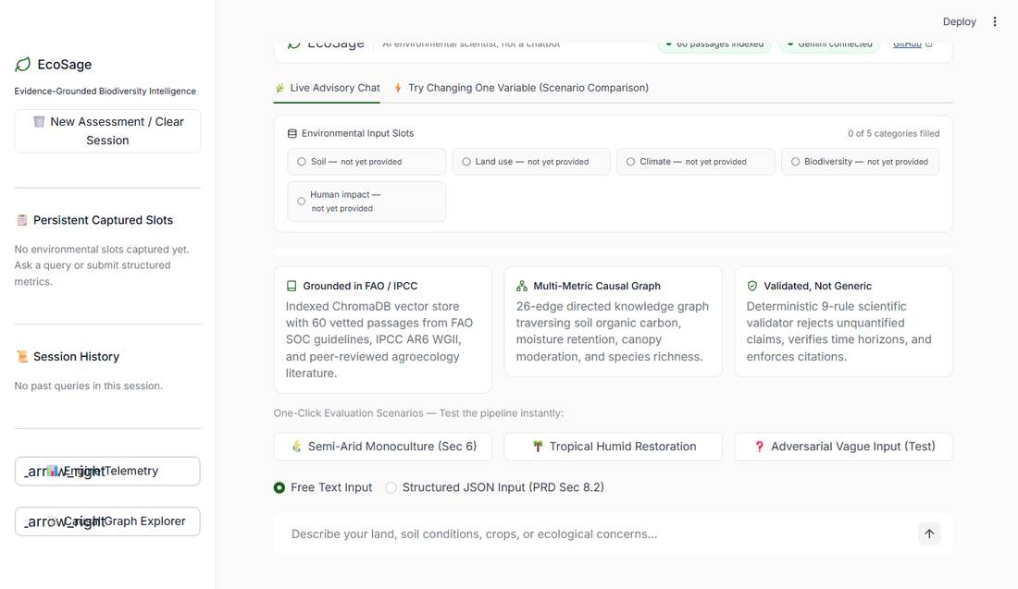
Figure 1: Workstation Landing Page with 3 Explainer Cards, 5-Slot Category Bar, and 1-Click Evaluation Chips.
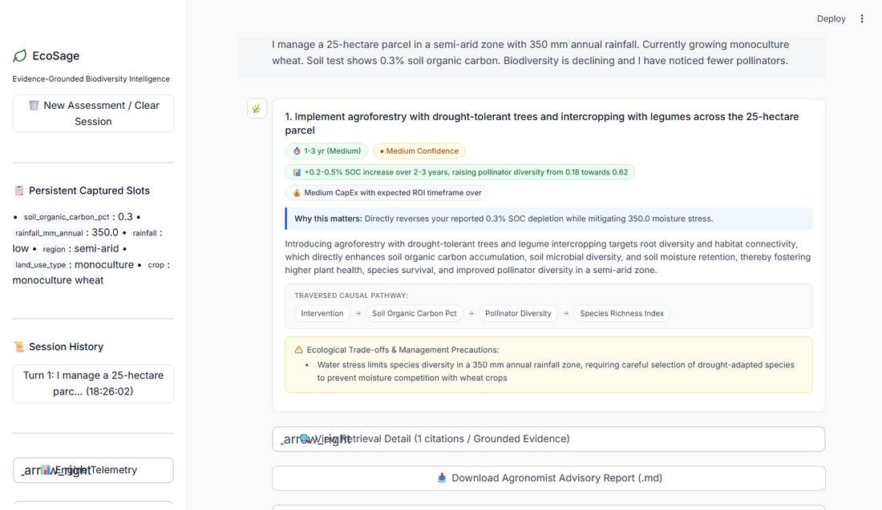
Figure 2: Grounded Advisory Field Report Card with Semantic Badges, 'Why this matters', Causal Traversal Chips, and Trade-offs.
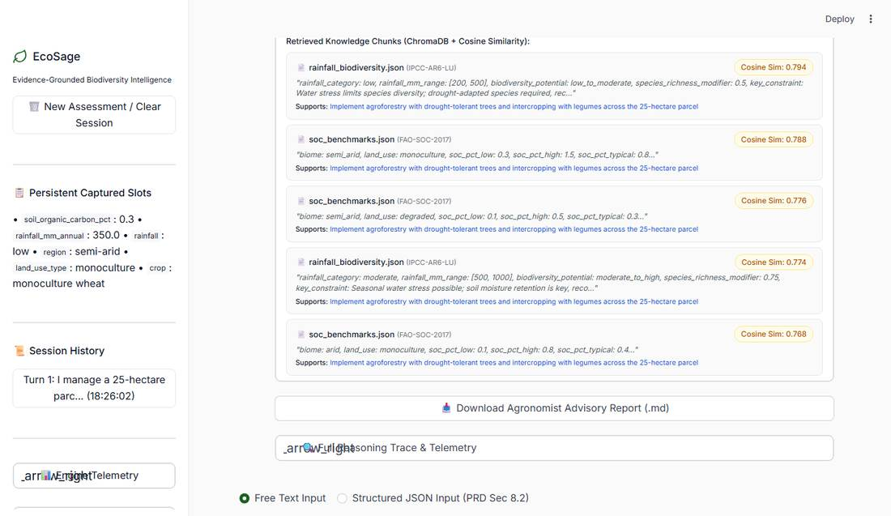
Figure 3: ChromaDB Retrieval Provenance Audit Expander displaying Document IDs, Cosine Similarities, and Supported Recommendations.
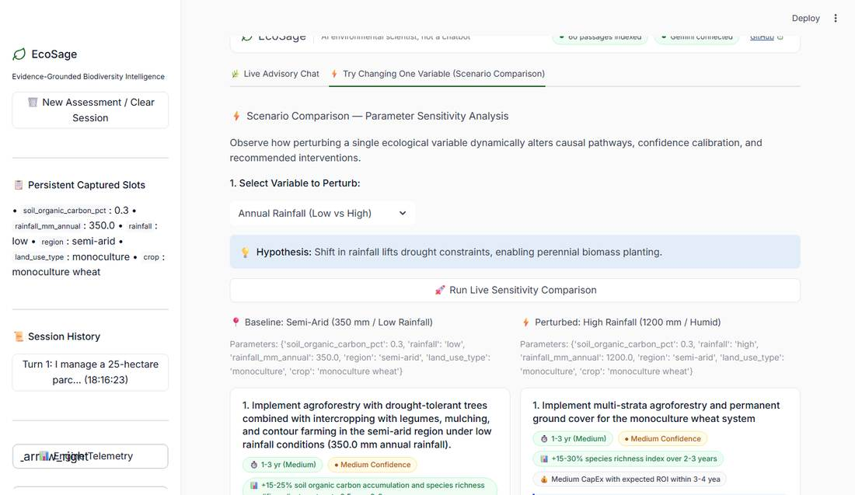
Figure 4: Parameter Sensitivity Analysis ('Try Changing One Variable') executing live dual-scenario comparison.
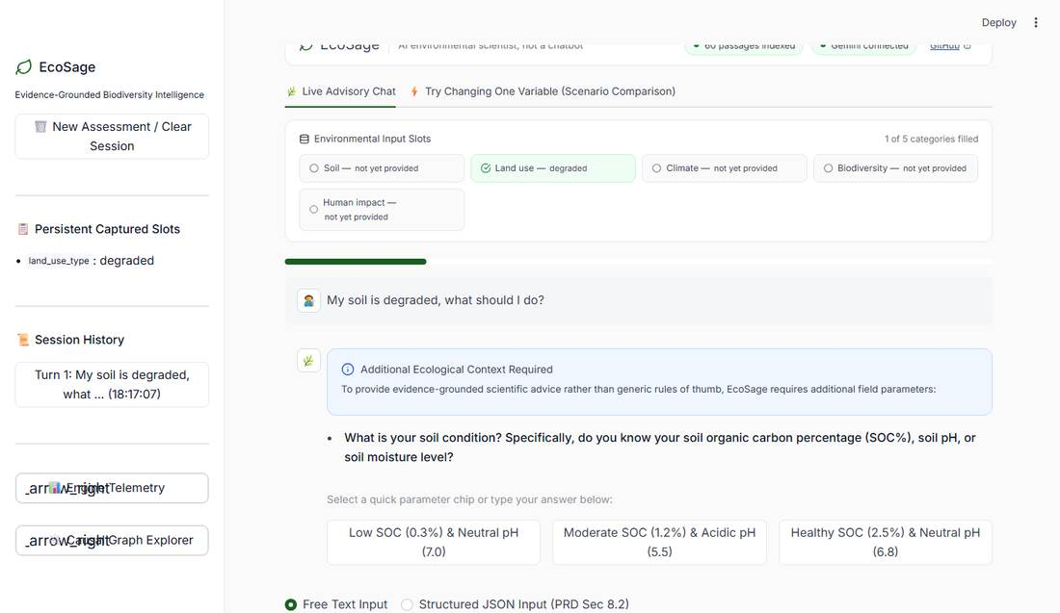
Figure 5: Conversational Clarifying Flow asking targeted questions with interactive discrete parameter buttons.

7. Architecture, Database/Schema, Local Setup & CI/CD
• Database / Vector Schema:
- ChromaDB Collection: 'ecosage_knowledge' (60 vector chunks, embedded via gemini-embedding-001 with 768-dim vectors).
- Metadata Fields: document_id, source_name, section_title, target_metrics, chunk_index.
- Reference Benchmark Tables: JSON schemas in corpus/tables/ for SOC % benchmarks by biome, species richness baselines, and rainfall modifiers.
• CI/CD Pipeline (.github/workflows/ci.yml):
- Multi-OS, multi-Python matrix testing across Python 3.11, 3.12, 3.13, and 3.14.
- Automated Ruff linter check + full Pytest suite execution on every pull request and push to main.
- Standalone HTML test report artifact generated and uploaded on every build for reviewer auditability.
• Windows One-Click Quickstart (run.bat):
- Simply double-click 'run.bat' for an interactive menu:
[1] Streamlit UI (Frontend Dashboard)
[2] Full Stack (FastAPI Backend + Streamlit UI)
[3] Launch FastAPI Backend Server Only (Port 8000)
[4] Ingest Knowledge Base into ChromaDB
[5] Run Full 140-Test Suite
[6] Run Code Quality Check (Ruff Linter)
• Manual Command Line Setup:
1. git clone <YOUR_REPO_URL> && cd ecosage
2. pip install -r requirements.txt
3. copy .env.example .env (add free GOOGLE_API_KEY from aistudio.google.com)
4. python -m ecosage.ingest
5. pytest -v (Runs all 140 tests)
6. streamlit run ui/app.py

