A Fully On-Chip DDPG Actor–Critic Accelerator for Autonomous Maze Navigation
An Open-Source, Reproducible RTL-to-Signoff Reinforcement-Learning ASIC on the GF180MCU PDK, Designed with the Chip Orchestra AI Agent Flow

Ade Irman Budi Hendrawan, William Anthony, Rifky Afriadi, Radhian Ferel Armansyah
School of Electrical Engineering and Informatics
Bandung Institute of Technology
Bandung, Indonesia

ABSTRACT
Reinforcement learning (RL) accelerators for edge devices often rely on external CPUs or GPUs to run the environment, limiting standalone operation. We present a fully self-contained RL accelerator ASIC that integrates a Deep Deterministic Policy Gradient (DDPG) actor–critic network, an on-chip 8×8 maze environment, and a 64-entry replay buffer on a single die. The chip was designed end-to-end using Chip Orchestra, an LLM-agent framework that automates the flow from natural-language specifications to GDSII signoff using the open-source GF180MCU PDK and LibreLane. RTL simulation successfully solved an unseen 8×8 maze in 12,114 cycles and passed all 13 self-check tests. The tapeout-ready design occupies 0.426 mm², contains 21,319 standard cells at 49.08 % core utilisation, closes timing at a 12.3 MHz signoff clock with a maximum operating frequency of 13.1 MHz, consumes an estimated 4.78 µW of internal power, and has zero DRC, LVS, and antenna violations. To our knowledge, this is the first fully open-source, host-independent DDPG actor–critic ASIC with an integrated RL environment and a reproducible LLM-agent-driven RTL-to-GDSII design flow.

Permission to make digital or hard copies of part or all of this work for personal or classroom use is granted without fee provided that copies are not made or distributed for profit or commercial advantage and that copies bear this notice and the full citation on the first page. Copyrights for third-party components of this work must be honored. For all other uses, contact the owner/author(s).
ASP-DAC 2027 University Design Contest – Asia and South Pacific Design Automation Conference
© 2018 Copyright held by the owner/author(s). 978-1-4503-0000-0/2005/06
https://doi.org/10.1145/1234567890

KEYWORDS
reinforcement learning accelerator, DDPG, actor–critic, int8 quantization, open-source EDA, GF180MCU, LibreLane, AI-driven chip design, maze navigation

- Introduction
Reinforcement learning (RL) has enabled many applications in game playing, robotics, and autonomous navigation. However, deploying RL at the edge remains challenging because most existing hardware accelerators rely on external CPUs or GPUs to execute the environment and learning loop. To address this, we present a compact, fully self-contained RL accelerator ASIC for the canonical 8×8 maze task. The chip integrates a Deep Deterministic Policy Gradient (DDPG) actor–critic network, a cycle-accurate on-chip maze environment, and a 64-entry replay buffer, all accessible through a simple four-wire byte-serial interface. A shared int8 MAC datapath processes one neuron per cycle for efficient computation.
Our contributions are: (1) a fully self-contained int8 DDPG actor–critic ASIC that integrates the policy network, value network, environment, and replay buffer on-chip; (2) a one-neuron-per-cycle architecture with a compact byte-serial interface; (3) a fully open and reproducible RTL-to-signoff design flow using Chip Orchestra and the open-source GF180MCU PDK; and (4) cycle-accurate maze-solving results that match the golden reference implementation.
- Background and Related Work
Deep Deterministic Policy Gradient (DDPG) is an off-policy actor–critic algorithm in which the actor generates a deterministic action from the current state, while the critic estimates the corresponding Q-value [1,4]. Existing hardware implementations of RL can be broadly categorized into FPGA-based training accelerators (FA3C [5]), FPGA-based Q-learning accelerators (QTAccel [6]), and ASIC implementations using Q-tables (MazeCov-Q [7]). However, these designs still rely on external processors to execute the environment and learning process.
Meanwhile, int8 neural network accelerators such as Eyeriss [8] and the TPU [9] have demonstrated that low-precision computation is highly effective for edge inference [10], and DARL [15] has explored RL using hyperdimensional computing. Table 1 summarizes these representative works and highlights how our design differs by providing a fully self-contained, host-independent RL accelerator with an integrated on-chip environment and learning components.
Table 1: Comparison with representative hardware RL accelerators (N/R = not reported).
Design | Platform / node | Algorithm | Prec. | Freq. | Env. on-chip
FA3C [5] | Arria-10 FPGA | A3C | FP32 | 200 MHz | No
QTAccel [6] | FPGA | Q-table RL | fixed | N/R | No
MazeCov-Q [7] | ASIC (COOL Chips) | Tabular Q | fixed | N/R | Partial
DARL [15] | ASIC (ASP-DAC) | HD RL | N/R | N/R | No
Eyeriss [8] | 65 nm ASIC | CNN inference | int16 | 200 MHz | N/A
This work | GF180MCU 180 nm ASIC (open, tapeout-ready) | DDPG actor–critic | int8 | 12.3 MHz signoff | Yes (8×8 + replay)
Unlike previous RL hardware accelerators, our design integrates the policy network, value network, environment, and replay buffer on a single chip. The entire RL loop runs on-chip and communicates through a simple four-wire byte-serial interface, eliminating the need for a host CPU or GPU. In addition, the accelerator is implemented using a fully open PDK and open-source design flow, making the complete RTL-to-GDSII process reproducible and accessible end-to-end.
- The Chip Orchestra Design Methodology
Chip Orchestra is an AI-driven framework that uses LLM agents to automate the entire digital chip design flow (Figure 1). Starting from a simple natural-language specification, "DDPG accelerator for an 8×8 maze," the framework interprets the design requirements, identifies the necessary hardware modules, generates RTL and a self-checking SystemVerilog testbench, and orchestrates the toolchain using Icarus Verilog, LibreLane [12] (built on OpenROAD [11] and Yosys), and KLayout on the GF180MCU PDK [13].
At each stage, Chip Orchestra produces structured JSON reports to ensure the design process is transparent and reproducible. In this work, the entire flow, from specification and RTL generation to simulation, linting, synthesis, floorplanning, placement, clock tree synthesis, routing, static timing analysis, and DRC/LVS verification completed successfully, producing a tapeout-ready GDSII. The physical implementation results are presented in Section 5.
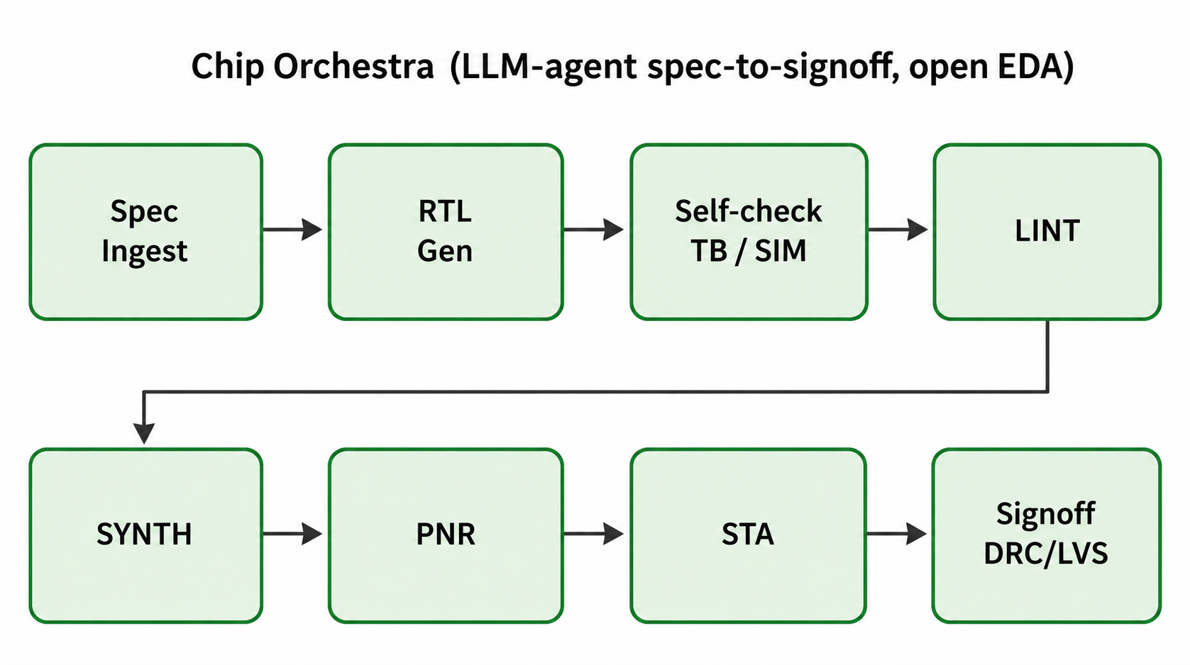
Figure 1: Chip Orchestra AI-agent flow: every stage green for this work (tapeout-ready GDSII on GF180MCU).

- Accelerator Architecture
Figure 2 illustrates the top-level architecture of the proposed RL accelerator. The DDPG controller manages six hardware modules that operate within a single clock domain using a synchronous active-low reset. The key design parameters and physical implementation configurations are summarized in Table 2.
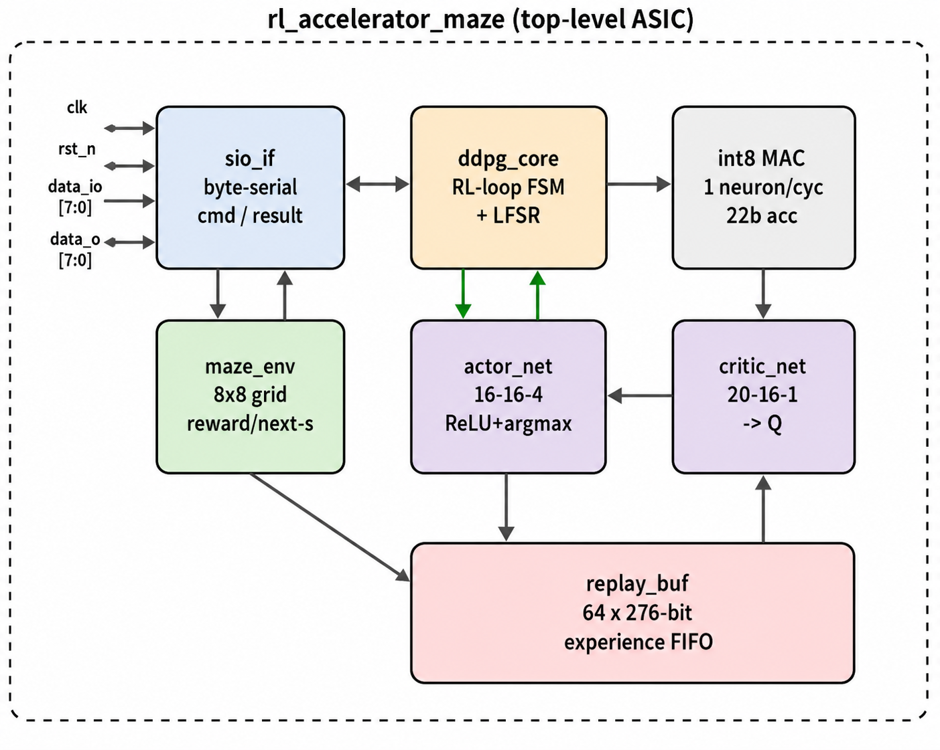
Figure 2: Top-level rl_accelerator_maze ASIC: byte-serial I/O, DDPG controller, actor/critic, maze environment, replay buffer, and shared int8 MAC.

4.1 Control and I/O
The sio_if module implements a byte-oriented serial interface with eight opcodes (e.g., loading the maze, setting the start and goal positions, running an episode, and reading the maze grid). This simple 8-bit interface allows the entire 64-cell maze and its configuration data to be transferred with a minimal pin count. The ddpg_core finite state machine (FSM) manages the RL loop by observing the current state, selecting an action using the actor network, updating the maze environment, storing the resulting experience in the replay buffer, and evaluating it with the Critic network. This process repeats until the agent reaches the goal or the maximum number of steps is exceeded. During training, a maximal-length LFSR generates exploration noise to encourage exploration, while inference uses a greedy policy that enables the trained actor network to follow the learned optimal path.
4.2 Actor, Critic, and Environment
The actor network takes a 16-element int8 state as input, processes it through a 16-neuron ReLU hidden layer, and outputs four action scores. The action with the highest score is selected as the next move. The critic uses a similar architecture but also includes a one-hot encoded action, resulting in 20 input values, to estimate the Q-value for each state-action pair. Both networks share a single sequential int8 multiply-accumulate (MAC) engine, which computes one neuron per cycle using a 22-bit accumulator before converting the result back to int8 [10].
The maze environment stores the 8×8 grid using three bits per cell, updates the agent's position after every valid move, calculates the reward and next state, and records every visited cell so the final grid shows the complete solution path. The replay buffer stores up to 64 experiences, each 276 bits wide, in a circular FIFO and uses pseudo-random sampling during DDPG training.
Table 2: Design parameters and physical-implementation configuration (GF180MCU / LibreLane).
Parameter | Value
Algorithm | DDPG actor–critic (greedy inference)
Arithmetic | int8 weights/activations, 22-bit MAC accumulator
Actor network | 16 → 16 (ReLU) → 4 (argmax)
Critic network | 20 → 16 (ReLU) → 1 (Q-value)
Environment | on-chip 8×8 maze, 64 cells @ 3 bits/cell
Replay buffer | 64 × 276-bit circular FIFO
Interface | 8-bit byte-serial, 8 opcodes; 4 ports: clk, rst_n, data_i[7:0], data_o[7:0]
Clock | single domain, sync active-low reset (RTL target 100 MHz; see Table 3)
RTL size | 1,447 lines, 7 synthesizable Verilog modules
Target PDK / flow | GF180MCU gf180mcuD / LibreLane (Yosys + OpenROAD + KLayout)
Standard-cell library | gf180mcu_fd_sc_mcu7t5v0 (7T, 5.04 µm track)
Supply voltage | 3.3 V (tt @ 25 °C)
Floorplan strategy | 35 % core-util target, 50 % density, KLayout GDS
Signoff STA corners | tt_025C_3v30 / ss_125C_3v00 / ff_n40C_3v60
Signoff clock | 12.3 MHz achieved (81.41 ns), Fmax 13.1 MHz @ ss
Interface pin count | 20 IO pins at signoff (18 signal + 2 power: VDD, VSS)

- Implementation and Verification Results
5.1 Functional Verification
A self-checking SystemVerilog testbench loads an unseen maze into the accelerator through the serial interface, runs a complete navigation episode, and reads back the final grid. All seven RTL modules compile successfully and simulate in Icarus Verilog, generating a 121.45 µs waveform with 32 monitored signals. As shown in Figure 3, the accelerator successfully finds a valid path from the start cell at (1,4) to the goal at (7,7).
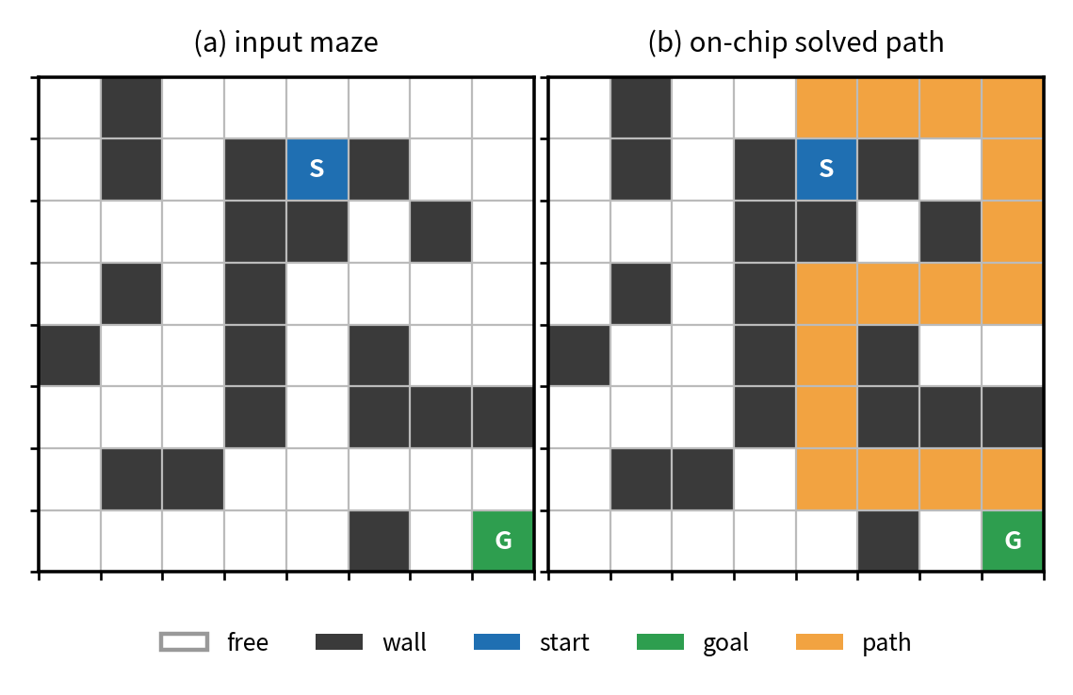
Figure 3: (a) input maze streamed over the serial port; (b) on-chip solved path, matches golden on all 64 cells.
The output maze matched the golden reference for all 64 cells (golden_match = true), and all 13 self-checks passed successfully. These checks included reset, correct decoding of the start (1,4) and goal (7,7) positions, episode completion, a 17-step path, replay buffer count, final Q-value, and consistency between the chip-generated and reference maze. The complete episode finished in 12,114 cycles (121.14 µs at a 100 MHz RTL clock) and followed the optimal 17-step path. Figure 4 illustrates the reinforcement learning execution, including the actor_start/actor_done handshake, replay buffer writes (buf_wr), selected actions (best_act), the shared MAC accumulator (acc), and the maze address (maze_addr). In addition, all seven RTL modules passed lint without warnings, and OpenSTA met timing requirements across all signoff corners. A summary of the evaluation results is provided in Table 3.
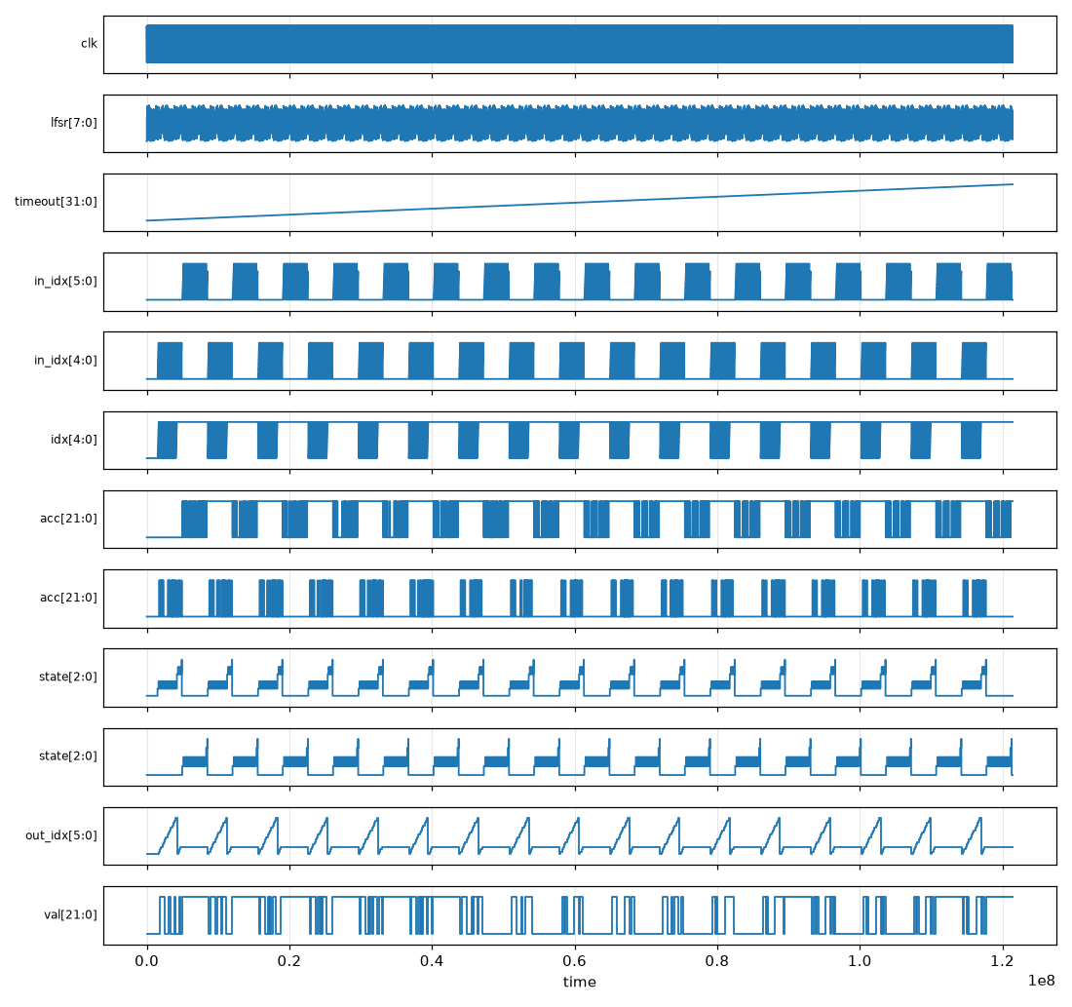
Figure 4: design.vcd waveform over one episode (121.45 µs, 12,114 cycles @ 100 MHz RTL): actor handshake, buf_wr, best_act, MAC accumulator, and maze_addr.

Table 3: Consolidated functional, PnR, STA, and DRC/LVS signoff results from the Chip Orchestra reports.

Metric | Result (from reports/, gds/, and waves/)
Functional correctness | 64 / 64 chip grid cells = golden reference
Self-check assertions | 13 / 13 pass (reset, start (1,4), goal (7,7), done, step 17, buf 17, Q, grid)
Episode latency | 12,114 cycles ≈ 121.14 µs @ 100 MHz RTL (~985 µs @ 12.3 MHz signoff)
Simulation waveform | 121.45 µs, 32 signals (waves/design.vcd)
Optimal path length | 17 steps (BFS-optimal on 8×8 maze)
Lint / compile | clean, 0 warnings, 7 / 7 RTL files (Verilator)
Die dimensions / area | 643.68 × 661.6 µm = 425,859 µm² (0.426 mm²)
Core area | 395,136 µm² (0.395 mm²)
Standard-cell count | 21,319 gf180mcu_fd_sc_mcu7t5v0 cells
Core utilisation | 49.08 % (35 % target, 50 % density)
IO pin count | 20 (4 ports: clk, rst_n, data_i[7:0], data_o[7:0])
Signoff clock / Fmax | 12.3 MHz (81.41 ns); Fmax 13.1 MHz @ ss
Setup slack (WNS / TNS) | WNS +5.05 ns @ ss; TNS 0; +43.4 ns @ tt; +54.3 ns @ ff
Hold slack | +0.42 ns hold WNS (0 hold violations, all corners)
Max slew / cap / fanout | 0 / 0 / 0 violations
Antenna violations | 0
DRC / LVS (Magic + KLayout) | Clean: 0 DRC, 0 overlap, 0 LVS
Estimated power | 4.78 µW @ 12.3 MHz, 3.3 V, tt (OpenSTA)
Tapeout readiness | tapeout-ready (clean = true, failed = [])
GDSII artefact | gds/rl_accelerator_maze.gds (8.73 MB, KLayout)

5.2 Physical Implementation and GDSII Signoff
The RTL design was taken through a complete RTL-to-GDSII flow using LibreLane, orchestrated by Chip Orchestra. The implementation targeted the open GF180MCU-D PDK with the gf180mcu_fd_sc_mcu7t5v0 7-track standard-cell library operating at 3.3 V. Yosys was used for technology mapping with the tt_025C_3v30 liberty view, while OpenROAD handled floorplanning, placement, clock tree synthesis, and detailed routing. The final GDSII layout was generated using KLayout. Timing was verified with OpenSTA at both the ss_125C_3v00 setup corner and the ff_n40C_3v60 hold corner, achieving positive timing slack at every signoff corner without any DRC, antenna, or connectivity violations.
The final tapeout-ready chip measures 643.68 × 661.6 µm (0.426 mm²), with a core area of 395,136 µm² and 21,319 standard cells at 49.08% utilization. Timing closes at a 12.3 MHz signoff clock (81.41 ns period, corresponding to an Fmax of 13.1 MHz), with 5.05 ns of setup slack and 0.42 ns of hold slack. These results are consistent with the expected performance of a 180 nm bulk CMOS process operating at 3.3 V. The design also reports zero violations for maximum slew, capacitance, fanout, antenna rules, DRC, LVS, and layout overlap. OpenSTA estimates an internal power consumption of just 4.78 µW at the signoff frequency, highlighting the efficiency of the shared MAC architecture and the low switching activity during greedy inference.
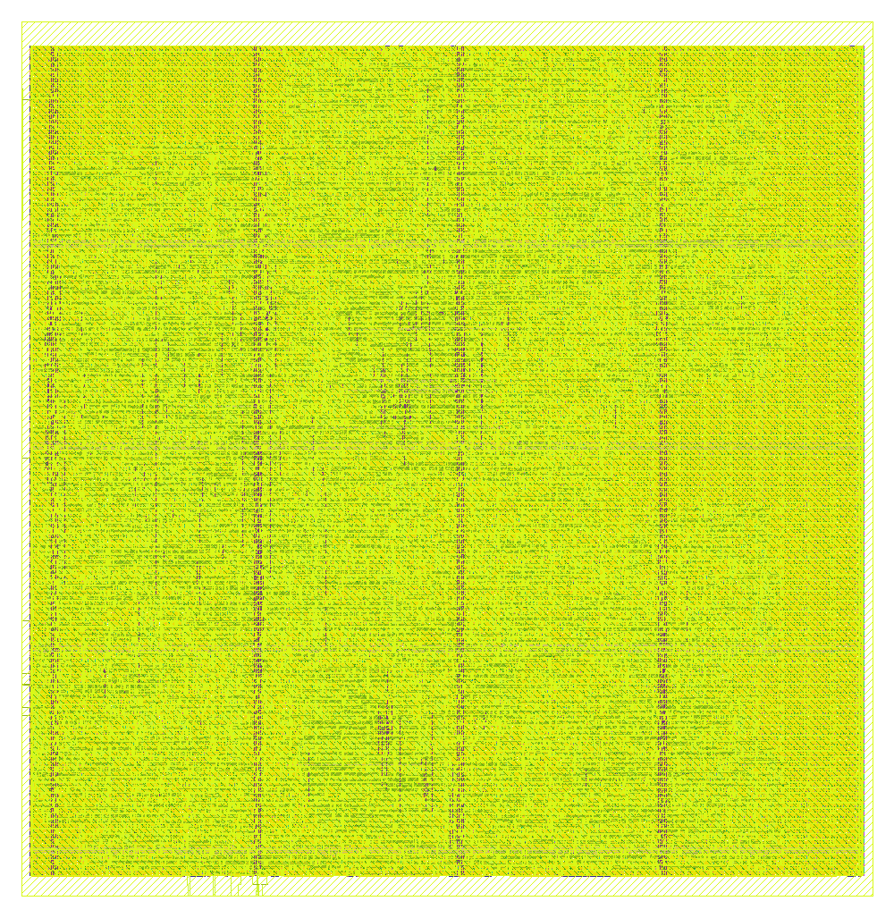
Figure 5: Post-route GDSII (KLayout): 643.68 × 661.6 µm, 21,319 standard cells at 49.08 % utilisation on GF180MCU.

- Conclusion and Future Work
We presented a fully on-chip DDPG actor–critic accelerator for autonomous 8×8 maze navigation, designed end-to-end using the Chip Orchestra AI-agent flow with the open-source GF180MCU PDK. The design successfully achieved tapeout-ready signoff, with a die size of 0.426 mm², 21,319 standard cells, a 12.3 MHz signoff clock (13.1 MHz Fmax), 5.05 ns setup slack, 0.42 ns hold slack, zero DRC, LVS, and antenna violations, and an estimated internal power consumption of just 4.78 µW. Functional verification also showed that the accelerator consistently solved unseen mazes with bit-exact agreement to the golden reference model.
The entire RTL-to-GDSII flow is open, reproducible, and automated using LLM-based agents, demonstrating the potential of AI-assisted hardware design. As future work, we plan to fabricate the chip through a GF180MCU shuttle run, extend the design to support on-chip DDPG training using the existing replay buffer, and scale the framework to handle larger environments and more advanced actor–critic architectures.

ACKNOWLEDGMENTS
We would like to thank the Chip Orchestra team, as well as the LibreLane/OpenROAD, Yosys, Icarus Verilog, and KLayout communities for their invaluable open-source tools and support. We also gratefully acknowledge GlobalFoundries for providing the open GF180MCU PDK.

REFERENCES
T. P. Lillicrap, J. J. Hunt, A. Pritzel, N. Heess, T. Erez, Y. Tassa, D. Silver, and D. Wierstra. 2016. Continuous control with deep reinforcement learning. In Proc. Int. Conf. Learning Representations (ICLR). arXiv:1509.02971.
V. Mnih, K. Kavukcuoglu, D. Silver, et al. 2015. Human-level control through deep reinforcement learning. Nature 518, 7540 (2015), 529–533. https://doi.org/10.1038/nature14236
V. Mnih, A. P. Badia, M. Mirza, et al. 2016. Asynchronous methods for deep reinforcement learning. In Proc. Int. Conf. Machine Learning (ICML), 1928–1937. arXiv:1602.01783.
S. Fujimoto, H. van Hoof, and D. Meger. 2018. Addressing function approximation error in actor-critic methods. In Proc. Int. Conf. Machine Learning (ICML), 1582–1591. arXiv:1802.09477.
H. Cho, P. Oh, J. Park, W. Jung, and J. Lee. 2019. FA3C: FPGA-accelerated deep reinforcement learning. In Proc. Int. Conf. Architectural Support for Programming Languages and Operating Systems (ASPLOS), 499–513. https://doi.org/10.1145/3297858.3304058
Y. Meng, S. R. Kuppannagari, R. Rajat, A. Srivastava, R. Kannan, and V. K. Prasanna. 2020. QTAccel: A Generic FPGA-based Design for Q-Table-based Reinforcement Learning Accelerators. In Proc. IEEE Int. Parallel and Distributed Processing Symposium Workshops (IPDPSW), 107–114. https://doi.org/10.1109/IPDPSW50202.2020.00024
I. Syafalni, M. I. Firdaus, A. M. R. Ilmy, N. Sutisna, and T. Adiono. 2023. MazeCov-Q: An Efficient Maze-Based Reinforcement Learning Accelerator for Coverage. In Proc. IEEE Symp. Low-Power and High-Speed Chips (COOL CHIPS), 1–3. https://doi.org/10.1109/COOLCHIPS57690.2023.10122120
Y.-H. Chen, T. Krishna, J. S. Emer, and V. Sze. 2017. Eyeriss: An Energy-Efficient Reconfigurable Accelerator for Deep Convolutional Neural Networks. IEEE J. Solid-State Circuits 52, 1 (2017), 127–138. https://doi.org/10.1109/JSSC.2016.2616357
N. P. Jouppi, C. Young, N. Patil, D. Patterson, et al. 2017. In-datacenter performance analysis of a tensor processing unit. In Proc. Int. Symp. Computer Architecture (ISCA), 1–12. https://doi.org/10.1145/3079856.3080246
B. Jacob, S. Kligys, B. Chen, M. Zhu, M. Tang, A. Howard, H. Adam, and D. Kalenichenko. 2018. Quantization and Training of Neural Networks for Efficient Integer-Arithmetic-Only Inference. In Proc. IEEE Conf. Computer Vision and Pattern Recognition (CVPR), 2704–2713. arXiv:1712.05877.
T. Ajayi, V. A. Chhabria, M. Fogaça, et al. 2019. Toward an open-source digital flow: First learnings from the OpenROAD project. In Proc. Design Automation Conf. (DAC), 1–4. https://doi.org/10.1145/3316781.3326334
M. Shalan and R. T. Edwards. 2020. Building OpenLANE: A 130nm OpenROAD-based tapeout-proven flow. In Proc. IEEE/ACM Int. Conf. Computer-Aided Design (ICCAD). https://doi.org/10.1145/3400302.3415735
Google and GlobalFoundries. 2022. GlobalFoundries 180nm MCU Open-Source Process Design Kit (gf180mcu). https://github.com/google/gf180mcu-pdk
M. Liu, T. Ene, R. Kirby, C. Cheng, N. Pinckney, R. Liang, et al. 2023. ChipNeMo: Domain-Adapted LLMs for Chip Design. arXiv:2311.00176.
H. Chen, M. Issa, Y. Ni, and M. Imani. 2023. DARL: Distributed Reconfigurable Accelerator for Hyperdimensional Reinforcement Learning. In Proc. Asia and South Pacific Design Automation Conf. (ASP-DAC), 745–750. https://doi.org/10.1145/3566097.3568354

