BuktiSaham
Product Requirements + Technical Requirements
Implementation Blueprint for an Explainable Indonesian Equity Research Platform
Working name • Implementation-aligned design • Version 1.1 • 19 September 2026
Reader contract
Product and governance sections define what may ship. Data, quant and engineering sections define deterministic behavior. Security, SLO and operational sections define when the platform may remain available. Once this document is approved, it can be used as the baseline for repository scaffolding, database migrations, API contracts, tests and implementation tickets.

Figure 1. North-star product loop: evidence precedes analysis, publication is gated, and every view is scored after issuance.
Document basis: this version uses the uploaded implementation blueprint as a reference, retains its evidence-first and point-in-time principles, and makes the product behavior, data contracts, module boundaries, APIs, schemas, testing and delivery plan more implementation-ready.

Document control and how to use this blueprint
Field | Value
Status | Proposed for product, engineering, quant, data, security and compliance review
Intended next step | Approve / amend decisions → freeze v1.0 baseline → create implementation epics and repository scaffold
Primary journey | Create Investment Task → Run Analysis → Recommendation with Evidence → Save Decision Packet → Monitor Outcome
MVP audience | Analyst-supervised research and paper decisions; no autonomous personalized advice or broker execution
Architecture posture | Contract-enforced modular monolith + isolated ingestion/compute workers; extraction to services only when justified
Core invariant | A published recommendation is immutable, reproducible from versioned inputs, and auditable to evidence

Contents
1. Executive summary and approval decisions
2. Product concept, users and boundaries
3. End-to-end journeys and UX requirements
4. Functional requirements and acceptance criteria
5. Recommendation, evidence and decision methodology
6. Indonesian-market calculations, valuation and simulation
7. Data sources, point-in-time pipeline and data contracts
8. Target architecture and component design
9. Domain model, database schema and data retention
10. API, event and workflow contracts
11. AI usage and guardrails
12. Security, compliance and entitlement controls
13. Non-functional requirements and SLOs
14. Testing and quality strategy
15. Deployment, observability and disaster recovery
16. Delivery roadmap, backlog and ownership
17. Approval checklist and handoff to implementation
Appendix A. API examples
Appendix B. Database table blueprint
Appendix C. Reference and verification register
Decision labels used in this document
MUST = release-blocking requirement. SHOULD = expected unless an approved ADR explains otherwise. MAY = optional extension. “Proposed” means a design choice in this blueprint; “verified source fact” means it is grounded in an official or referenced external source and still requires effective-date handling in production.

1. Executive summary and approval decisions
BuktiSaham is an evidence-first research workspace for Indonesian listed equities. It is intentionally not a “black-box stock picker.” Its product value is that a user can create a research task, run reproducible analysis, receive a scenario-led research view, inspect every material source and assumption, and later see exactly how that issued view performed after costs and corporate actions.
Figure 2. The same user journey is also the governance boundary: no generator can publish directly.

1.1 Decisions to approve now
ID | Decision | Why it matters | Reversible?
D-01 | Use “BuktiSaham” as the working name; legal/trademark review before external use. | Evidence-led promise; locally understandable; avoids certainty language. | Yes
D-02 | MVP supports research + paper decisions; no personalized suitability, custody, leverage or executable orders. | Reduces regulatory and operational scope while product-market fit is tested. | Yes
D-03 | Deterministic calculations are authoritative; local Ollama may summarize or challenge only. | Numeric results remain reproducible and testable. | Mostly
D-04 | All market rules, fees, taxes, entitlements and calendars are effective-dated data, never hard-coded constants. | IDX rules and investor/broker treatment change over time. | No for data model
D-05 | Published recommendation versions are append-only; revisions create a new version. | Preserves auditability and honest outcome scoring. | No
D-06 | Start with a modular monolith + isolated workers + PostgreSQL/Redis + local Ollama. | Fast enough for MVP without losing domain boundaries. | Yes
D-07 | Use point-in-time/bitemporal semantics for security master, filings, prices, rules and corporate actions. | Prevents look-ahead bias and makes historical replay defensible. | No
D-08 | Publication is fail-closed when evidence, entitlement, policy, reviewer or content hash is missing. | Protects trust and data rights. | No

1.2 Product success definition
A successful release lets a user answer five questions without trusting a black box:
1) What was observed? 2) What was calculated? 3) Which assumptions drive the result? 4) What would invalidate the view? 5) How did the full population of issued views perform after realistic costs?

Metric | Initial target | Release use
Evidence completeness | 100% of mandatory claims trace to immutable evidence | Hard publish gate
Deterministic reproducibility | 100% sampled reruns with same snapshots/rule versions reproduce outputs | Hard beta gate
Scenario comprehension | ≥90% of test users identify horizon, downside and invalidation | UX gate
Prohibited-claim escape | 0 in release policy test suite | Kill switch / release gate
Corporate-action reconciliation | 100% material events reconciled before affected universe is actionable | Universe gate
Run completion | ≥99% non-data-failure runs finish within target window | Operational gate

2. Product concept, users and boundaries

2.1 Product promise
“See the evidence behind every market view.” The platform converts official or licensed Indonesian market data into versioned decision packets containing a research view, scenario ranges, valuation, risk, execution feasibility, catalysts, invalidation logic, evidence lineage, reviewer status and eventual outcome score.

2.2 Target users and jobs-to-be-done
User | Primary job | Must receive | MVP boundary
Retail research reader | Understand a stock thesis and downside without reading every raw filing. | Plain-language scenario, source links, freshness, risks, invalidation. | No personalized suitability claim.
Professional user | Compare candidates and stress assumptions. | Exportable inputs, sensitivity, liquidity, method breakdown, scorecards. | Entitlement-controlled data.
Analyst | Author and revise defensible views. | PIT evidence, sector model, run diff, review workflow. | Cannot self-approve.
Compliance reviewer | Prevent prohibited, misleading or unlicensed publication. | Policy result, conflicts, audience rights, immutable audit package. | Independent approval.
Data / quant steward | Reproduce calculations and monitor quality. | Versioned lineage, backtests, drift, reconciliation. | No silent data repair.
Platform operator | Keep the service safe and recoverable. | SLOs, runbooks, kill switches, audit visibility. | Cannot override governance without break-glass logging.

2.3 Scope by release tier
Capability | P0 MVP | P1 | P2 / gated
Task setup + analysis run | Yes | - | -
Evidence-linked recommendation | Yes | - | -
Analyst review + immutable versioning | Yes | - | -
Sector-specific valuation | Selected sectors | Expand coverage | Advanced specialty models
Portfolio context | Basic feasibility | Concentration + scenario loss | Optimization
Alerts | Stale/invalidation only | Catalyst & material-change diff | Personalized alerts only after legal review
Mobile | Responsive web | Native shell optional | -
Broker handoff | No | No | Non-executable intent only after separate legal/broker approval
Order routing / custody | No | No | Out of scope unless a future separately approved program

2.4 Explicit non-goals
- Guaranteeing market direction or return.
- Autonomous AI deciding BUY/SELL without deterministic policy and human governance.
- High-frequency or intraday market-making signals.
- Using today’s constituent list to backtest historical recommendations.
- Rewriting old recommendation versions after a later data correction.
- Treating unlicensed public pages as permission for bulk production reuse.

3. End-to-end journeys and UX requirements
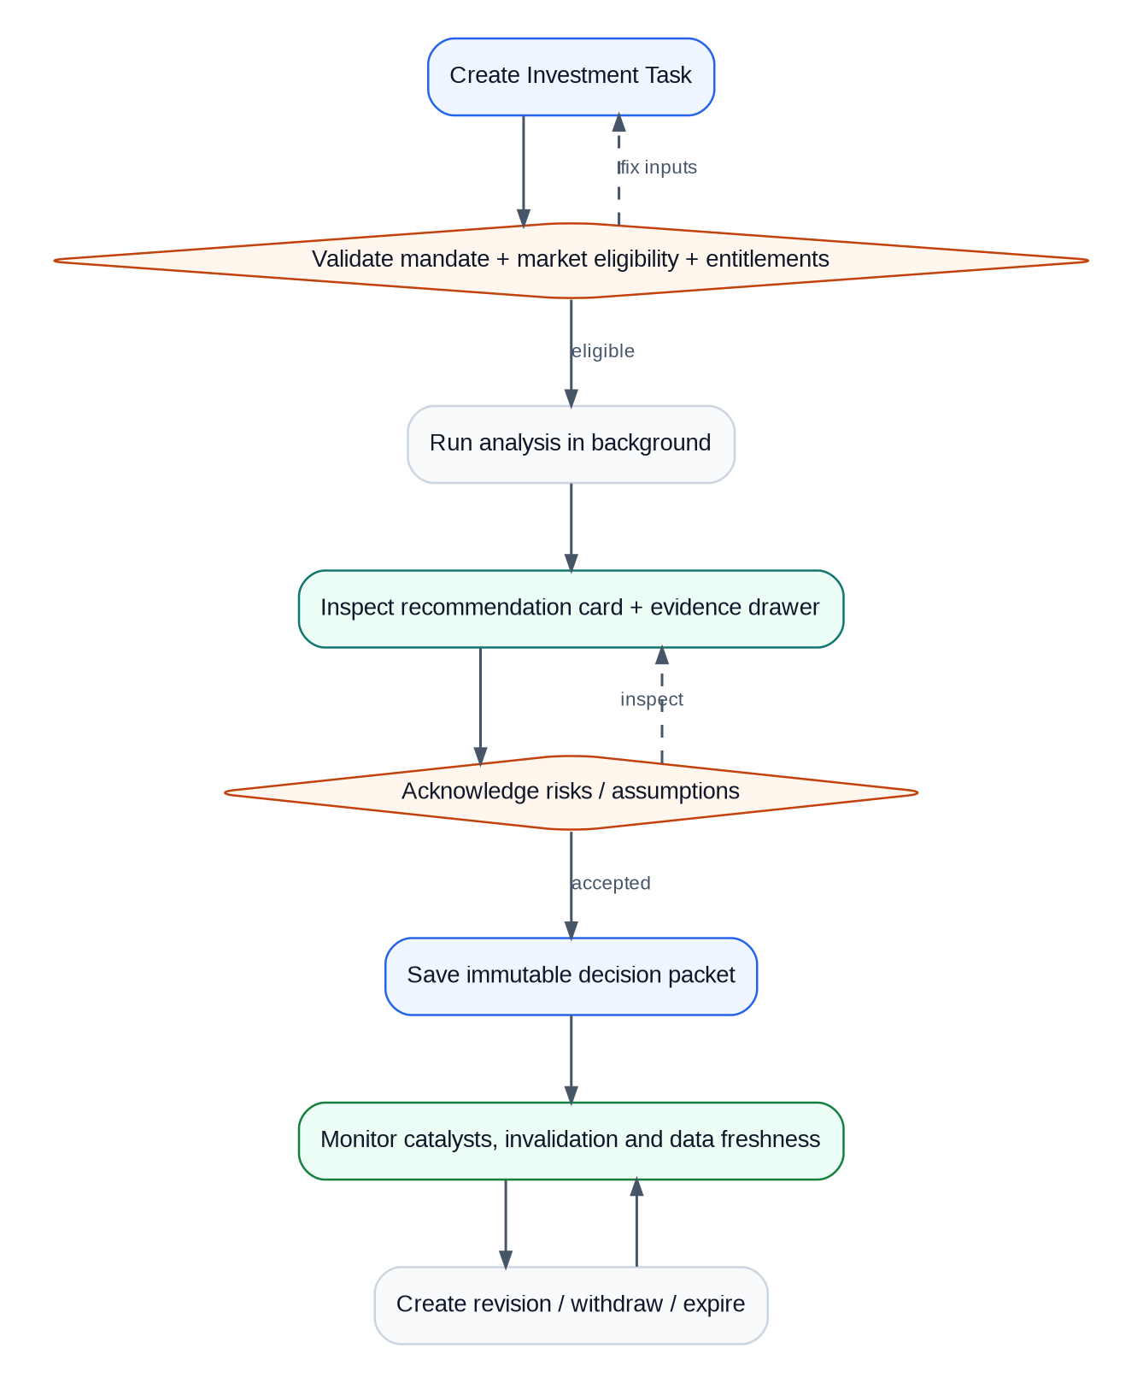
Figure 3. Primary user journey. A user can explore, but cannot save an actionable packet until validation and risk acknowledgement are complete.

3.1 Create Investment Task
The task is the reproducibility anchor. It captures what the user is asking, the eligible universe, investment horizon, capital assumptions, data entitlements and exact “as-of” time. Changing any of these creates a new task version or rerun, not an invisible mutation.
Field group | Required fields | Validation
Identity | task_id, tenant_id, creator_id, title, created_at | Server-generated IDs; actor context required.
Research intent | objective, universe, benchmark, horizon, mandate | Unknown universe or unsupported mandate blocks run.
Capital/execution | capital_idr, max_position_pct, liquidity_limit, cost_profile | Decimal values only; positive capital; profile must be effective at as_of.
Time | as_of, market_timezone, data_delay_mode | Asia/Jakarta interpretation; UTC storage.
Governance | audience, entitlement_profile, disclaimer_profile | Missing entitlement/disclaimer profile blocks actionable output.

3.2 Run Analysis
Runs are asynchronous and idempotent. The UI immediately returns a run_id, then streams or polls stage status. Each stage records start/end time, input snapshot hashes, output hash and error category. A rerun with the same task version and same idempotency key must not duplicate the run.
Stage | What happens | Failure behavior
1. Universe freeze | Resolve effective security master, board, status, sector and eligibility. | Block securities with unresolved master conflicts.
2. Evidence snapshot | Seal prices, filings, corporate actions, macro and rules known at as_of. | Stale/missing mandatory source → preview-only or blocked.
3. Normalize | Units, currency, accounting periods, corporate-action adjustments. | Quarantine affected issuer; preserve raw input.
4. Features | Compute fundamental, technical, liquidity and event features. | Partial feature set allowed only if policy defines applicability.
5. Valuation | Run sector-appropriate methods + sensitivities. | Method failure is explicit; never silently replace with an invalid method.
6. Scenarios | Generate bull/base/bear ranges and probabilities from deterministic inputs. | Probabilities must sum to 1 within tolerance.
7. Decision metrics | Compute expected net return, downside, confidence and execution feasibility. | Calculation error blocks recommendation.
8. Evidence binding | Map claims to evidence IDs and transform lineage. | Any material unbound claim blocks publish.
9. Policy evaluation | Rights, freshness, audience, conflicts, thresholds, approval requirement. | Fail closed for actionable publication.
10. Draft packet | Create draft recommendation version and explain deltas. | AI narrative may fail independently; numeric packet remains available.

3.3 Recommendation card
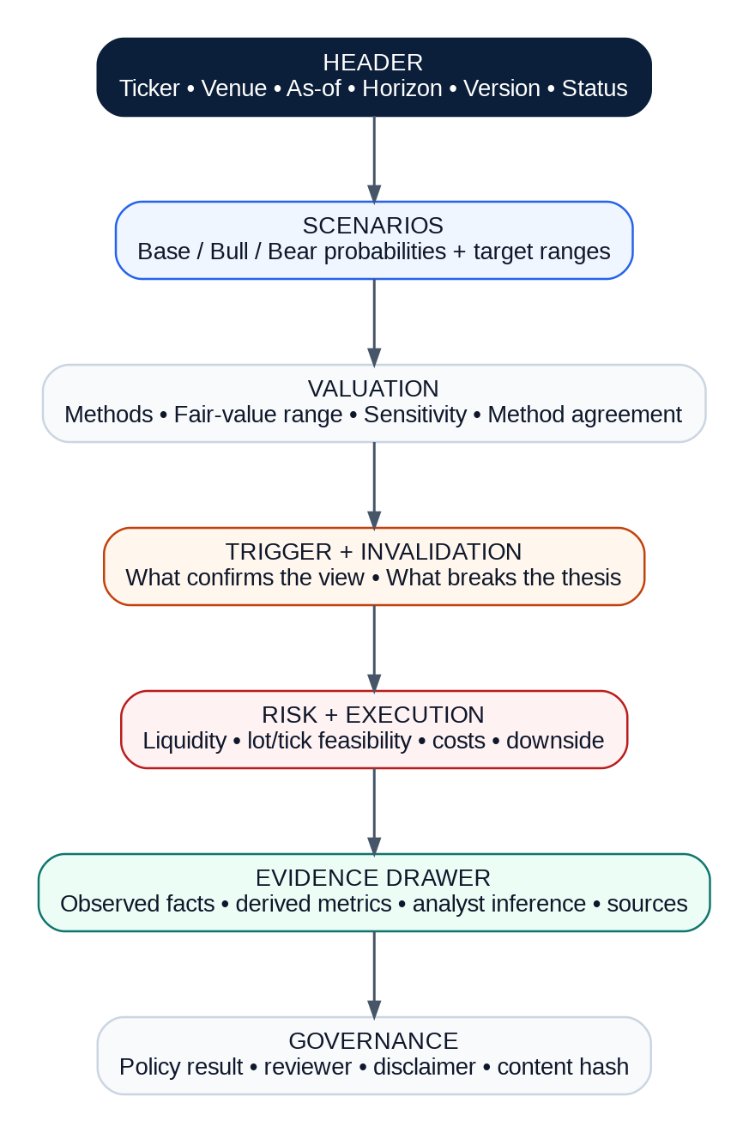
Figure 4. Recommendation card information architecture. The evidence drawer is a first-class product surface, not a footnote.

3.4 Recommendation lifecycle
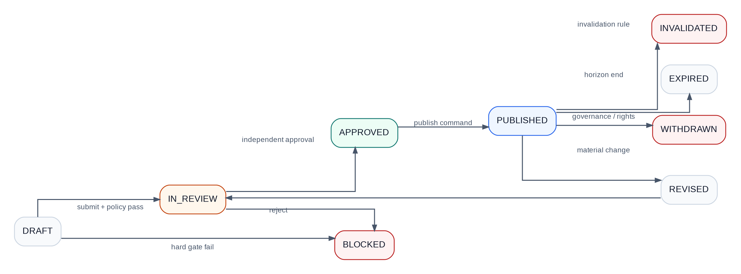
Figure 5. Append-only recommendation lifecycle. Published history is never overwritten.

4. Functional requirements and acceptance criteria
ID | Pri | Module | Normative requirement | Acceptance criterion
FR-01 | P0 | Task setup | System MUST capture universe, horizon, mandate, capital, cost/tax profile, entitlement and as-of time. | Invalid mandatory inputs block run with field-level reason.
FR-02 | P0 | As-of reproducibility | Every run MUST pin all source, rule, model and parameter versions. | A rerun from saved packet reproduces deterministic outputs within decimal tolerance.
FR-03 | P0 | Universe freeze | System MUST use effective-dated security master; historical runs may not use today’s list. | Fixture with delisted/suspended names reproduces historical eligibility.
FR-04 | P0 | Evidence drawer | Every material claim MUST resolve to source snapshot, observed/effective times, transform lineage and content hash. | 100% of publishable material claims pass referential-integrity checks.
FR-05 | P0 | Statement labels | UI MUST distinguish observed fact, derived indicator, analyst inference and recommendation. | ≥90% classification accuracy in usability test.
FR-06 | P0 | Financial normalization | System MUST preserve reported and normalized values with mapping version. | Golden filings reconcile to source totals and period logic.
FR-07 | P0 | Corporate actions | Splits, dividends, rights and symbol changes MUST be event-sourced and reconciled. | Adjusted share/price/cash path balances for 100% material events.
FR-08 | P0 | Valuation routing | System MUST select only approved sector methods and declare unavailable methods. | Bank fixture never uses EV/EBITDA as primary; telecom lease basis is consistent.
FR-09 | P0 | Scenario engine | System MUST output base/bull/bear probabilities and ranges from versioned assumptions. | Probability sum = 1.000 ±0.001; assumption diff is machine-readable.
FR-10 | P0 | Local execution | Lots, ticks, calendars and costs MUST use effective-dated rule tables. | Reference fixtures match then-effective IDX rules.
FR-11 | P0 | Recommendation policy | Action/status MUST be a deterministic function of eligibility, evidence, return/downside, confidence and execution constraints. | Policy test matrix covers all action/abstain branches.
FR-12 | P0 | Review workflow | Author, reviewer and publisher duties MUST be separable. | Self-approval and unauthorized transitions are rejected.
FR-13 | P0 | Immutable versions | Published recommendation versions MUST be append-only. | No UPDATE path exists for sealed numeric/evidence payload; revision uses supersedes_id.
FR-14 | P0 | Outcome ledger | Issued/revised/invalidated/expired/withdrawn versions MUST remain in complete aggregate scoring. | Ledger count reconciles exactly to publication events.
FR-15 | P0 | Policy fail-closed | Missing mandatory policy dependency MUST block publication. | Chaos test of policy service does not leak actionable content.
FR-16 | P0 | Audit export | Authorized reviewer MUST obtain a signed package of packet, evidence index, policy and approvals. | Export hash verifies; unauthorized actor gets 403.
FR-17 | P1 | Portfolio context | System SHOULD calculate lot feasibility, concentration, liquidity days and scenario loss. | Reference portfolio fixtures match approved formulas.
FR-18 | P1 | Alerts | System SHOULD explain exact evidence/assumption delta causing stale, revision or invalidation. | Alert deep-links to version diff and triggering evidence.
FR-19 | P1 | Comparison | User SHOULD compare candidates on normalized valuation, evidence completeness, downside and liquidity. | Same as-of and cost profile enforced for comparison.
FR-20 | P1 | Exports | User SHOULD export permitted derived tables with entitlement watermark and provenance. | Restricted datasets never appear in export payload.
FR-21 | P2 | Broker handoff | System MAY export non-executable order intent only after separate approvals. | Feature flag defaults off; no live execution route in MVP.

5. Recommendation, evidence and decision methodology
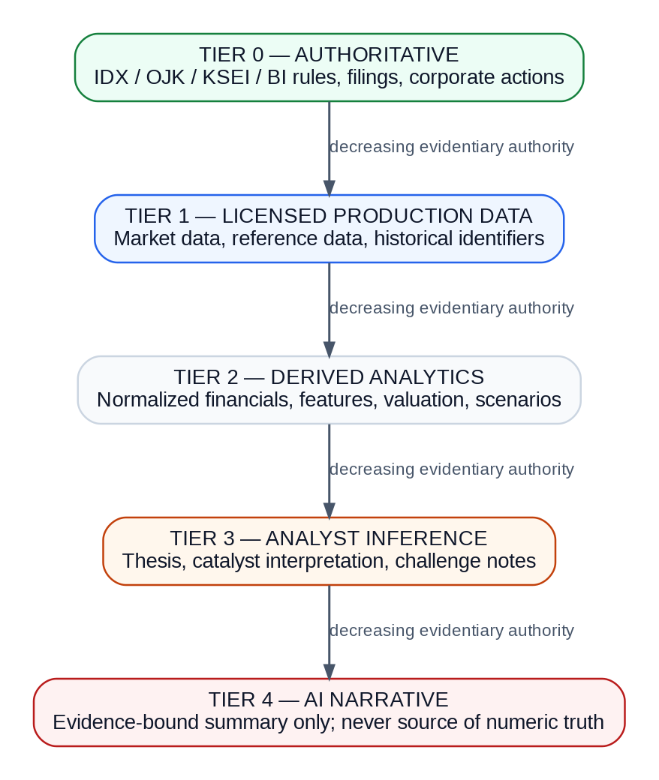
Figure 6. Evidence hierarchy. Visual emphasis never upgrades a weak evidentiary class.

5.1 Statement taxonomy
Label | Definition | Example | May change numeric result?
Observed data | Direct observation from approved source snapshot. | FY2025 revenue reported in issuer filing. | Source correction can change downstream results.
Derived indicator | Deterministic calculation over observed data. | ROE, EBITDA margin, 20-day volatility. | Yes, via deterministic formula.
Analyst inference | Human interpretation of evidence. | Margin pressure appears driven by imported inputs. | Cannot directly override deterministic numbers.
Recommendation | Policy outcome over scenario/risk/evidence metrics. | Research view: BUY / WATCH / HOLD / REDUCE / AVOID / NO-RATING. | Only via versioned policy inputs.
AI narrative | Generated explanation of already-approved evidence and outputs. | Summary of why base-case fair value changed. | No. Numeric/action mutation forbidden.

5.2 Scoring framework
The scoring system intentionally separates “how attractive the company looks” from “how safe it is to issue a view.” Missing information should reduce evidence completeness, not automatically make a company fundamentally bad.
Proposed score decomposition
Fundamental Attractiveness F (0–100) = weighted applicable rule results. Technical Context T (0–100) = trend, momentum, regime, volume and structure. Evidence Completeness E (0–100) = supported applicable evidence / required applicable evidence. Confidence C (0–100) = data quality + valuation agreement + forecast stability + liquidity/execution + catalyst evidence. Expected Net Return ERnet = probability-weighted scenario return including dividends minus effective transaction/tax/impact costs.

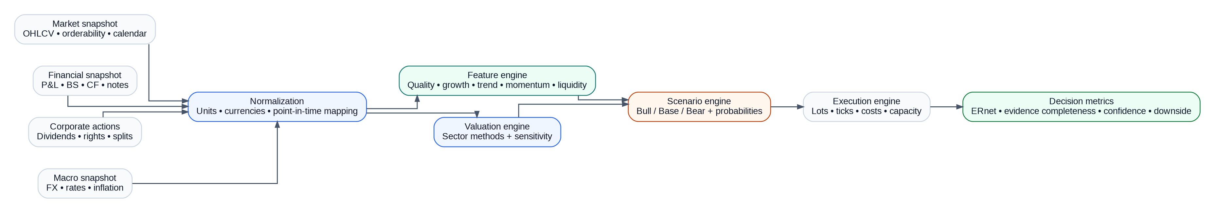
Figure 7. Deterministic research engine. The recommendation policy consumes outputs; it is not embedded inside valuation or AI code.

5.3 Proposed policy logic
Exact thresholds are configuration, not code constants. Product, quant and compliance must approve the first production parameter set after shadow calibration. The following decision order is normative even if thresholds change:
1. Check legal/audience/data entitlement eligibility. If false → NO-RATING / BLOCKED.
2. Check mandatory data freshness, corporate-action reconciliation and evidence completeness. If below hard minimum → NO-RATING or preview-only.
3. Check executability: tradable status, lot/tick feasibility, liquidity/capacity and cost model. If materially non-executable → AVOID or NO-RATING depending policy.
4. Compute fair-value distribution and scenario expected net return after effective costs.
5. Apply downside guardrail and confidence floor. A positive expected return cannot override excessive bear-case downside or weak evidence.
6. Require method agreement when multiple methods are expected for the sector; explicit single-method exceptions need an approved reason code.
7. Generate research action/status and reason codes. Human review may reject or request revision but must not silently edit deterministic outputs.
def evaluate_research_view(m):
if not m.policy_eligible:
return View.NO_RATING, ["POLICY_INELIGIBLE"]
if m.evidence_completeness < cfg.min_evidence or m.data_stale:
return View.NO_RATING, ["INSUFFICIENT_EVIDENCE"]
if not m.executable:
return View.AVOID, ["EXECUTION_CONSTRAINT"]
if m.bear_downside > cfg.max_bear_downside:
return View.WATCH, ["DOWNSIDE_GUARDRAIL"]
if m.confidence < cfg.min_confidence:
return View.WATCH, ["LOW_CONFIDENCE"]
if m.expected_net_return >= cfg.buy_hurdle and m.valuation_methods_agree:
return View.BUY, ["RETURN_HURDLE_MET"]
if m.expected_net_return <= cfg.reduce_hurdle:
return View.REDUCE, ["NEGATIVE_EXPECTED_RETURN"]
return View.HOLD, ["NEUTRAL_BAND"]

5.4 Astronacci reference: what to borrow, what not to copy
Borrow as presentation principle | Do not depend on
Scenario-led presentation: direction, time window, trigger, confirmation, target/zone, stop or invalidation. | Undisclosed proprietary formulas or claims of certainty.
Progressive disclosure: show the simple view first, then evidence and assumptions. | Historical examples without complete denominator and point-in-time replay.
Clear reevaluation logic when a trigger fails or thesis changes. | AI-generated action that bypasses deterministic policy/review.

6. Indonesian-market calculations, valuation and simulation

6.1 Market mechanics as data
As of the current IDX trading-mechanism page, Regular and Cash Market trading uses 1 lot = 100 shares and five common price-fraction bands. Production MUST load the effective exchange rule version rather than copy these values into business logic. Negotiated-market behavior is modeled separately.
Previous price band | Tick / price fraction | Order-price normalization
< Rp200 | Rp1 | Buy limit rounds down to tick; sell limit rounds up to tick.
Rp200 to < Rp500 | Rp2 | Same effective-date rule lookup.
Rp500 to < Rp2,000 | Rp5 | Same effective-date rule lookup.
Rp2,000 to < Rp5,000 | Rp10 | Same effective-date rule lookup.
≥ Rp5,000 | Rp25 | Same effective-date rule lookup.

q_exec = lot_size * floor(q_desired / lot_size)
buy_limit = tick * floor(raw_buy_price / tick)
sell_limit = tick * ceil(raw_sell_price / tick)
# Never read lot_size or tick from constants.py.
# Resolve: market_rule(venue, board, instrument_type, effective_at).

6.2 Financial normalization
- Preserve original reported value, unit, currency, period and source mapping alongside normalized value.
- Normalize reported units with Value_IDR = Value_reported × unit_multiplier × FX(if needed).
- Derive quarterly flow metrics only from cumulative flow disclosures when appropriate (for example Q2 = H1 − Q1); never difference balance-sheet stock variables.
- Map restatements and corrections bitemporally; a later correction does not alter what an earlier decision knew.
- Separate reported earnings from normalized earnings and keep evidence-linked adjustments for non-recurring items.

6.3 Sector-specific valuation
Figure 8. Sector valuation router. Methods are explicit policy, not a model’s free-form choice.
Sector | Primary methods | Required drivers | Known invalid shortcut
Banks | Residual income; justified P/B | ROE, cost of equity, NIM, credit cost, NPL/LaR, coverage, CASA/LDR, capital | EV/EBITDA as primary
Commodities | Asset NAV/DCF; mid-cycle multiples | Volume, benchmark price, FX, royalty, capex, reserve life | Perpetual peak commodity price
Consumer | DCF; P/E; EV/EBITDA | Volume, mix, pricing, CPI/input cost, distribution, working capital | Treating inflation as real growth
Telecom | SOTP; DCF; lease-consistent EV/EBITDA | ARPU, traffic, churn, spectrum, leases, capex, segment mix | Mixed lease-accounting basis
Infrastructure | Project DCF; SOTP | Tariff, volume, maintenance capex, concession, refinancing, delay | Terminal value beyond concession with no renewal probability
Property | RNAV; P/NAV; normalized earnings | Project value, remaining cost, collections, rent, debt, title | Full value for inaccessible land bank

6.4 Scenario and fair-value distribution
Each valuation produces not one “magic number” but a range under versioned assumptions. The scenario engine combines approved parameter shocks into Bull/Base/Bear outcomes. Probabilities must be separately calibrated; they are not automatically derived from valuation spread.
Scenario | Typical assumption pattern | Output
Bear | Lower volume/margins, higher discount rate, weaker FX, delayed catalyst | Fair value, return, downside, liquidity stress
Base | Management/consensus-like operating path with approved normalized assumptions | Primary fair-value range and expected net return
Bull | Upside operating case with explicitly bounded assumptions | Upside range; cannot erase base/bear risks

6.5 Corporate actions
Corporate-action logic is part of the return engine, not a display adjustment. Dividend, split, rights, bonus, merger/spin-off and symbol-change events must be represented explicitly and applied using then-effective dates.
TERP = (P_cum * N_old + P_subscription * N_new) / (N_old + N_new)
# Rights simulation must represent investor election:
# SUBSCRIBE | SELL_RIGHT | LAPSE
# Avoid double-counting dividend cash when using adjusted prices.

6.6 Point-in-time backtest and simulation
Figure 9. Point-in-time backtest timeline. The first executable session occurs after the decision snapshot; same-bar leakage is prohibited.
- Eligibility requires publication_time + ingestion_lag ≤ decision_time.
- Universe includes then-listed, suspended, delisted, failed and special-board securities when applicable; never reconstruct history from today’s survivors.
- Walk-forward parameters are frozen before the next evaluation window.
- Net performance includes effective broker/exchange/clearing/tax/stamp/spread/impact/tick costs as versioned parameters.
- Block bootstrap may be used for portfolio simulations to preserve serial and cross-sectional dependence; output must distinguish simulation from historical backtest.
- Minimum scorecard: gross/net CAGR, volatility, Sharpe/Sortino, max drawdown, hit rate, turnover, capacity, concentration, beta, tracking error, information ratio, tail loss, calibration and implementation shortfall.

7. Data sources, point-in-time pipeline and data contracts

7.1 Source tiers and licensing gates
Tier | Examples | Permitted role | Launch gate
M0 | Yahoo Finance via yfinance (.JK) | FREE-ONLY EOD/delayed market-price and best-effort fundamentals for the current MVP. | No API key or paid fallback; personal/research use only until upstream terms and distribution rights are approved.
0 | OJK, IDX rules/disclosures, KSEI, BI | Authority for rules, filings, events and macro facts. | Terms and automation rights reviewed.
1 | Future licensed IDX market/reference feed | Not enabled in the current implementation; possible later production-grade source. | Separate commercial/legal approval before adapter activation.
2 | Future commercial vendors | Not enabled while FREE_ONLY_MARKET_DATA=true. | Explicit ADR + budget + rights validation required before use.
3 | Issuer IR and reputable research | Context and analyst evidence. | Reconciled to official timestamp and clearly labeled.

Free-only MVP rule
The runnable repository MUST set FREE_ONLY_MARKET_DATA=true and MARKET_DATA_PROVIDER=yfinance. The application contains no automatic paid-provider fallback. If the free upstream is unavailable, the run fails visibly instead of silently incurring cost.

Figure 10. Data pipeline. Raw source bytes are immutable; quality repair creates a new version rather than changing history.

7.2 Point-in-time and bitemporal semantics
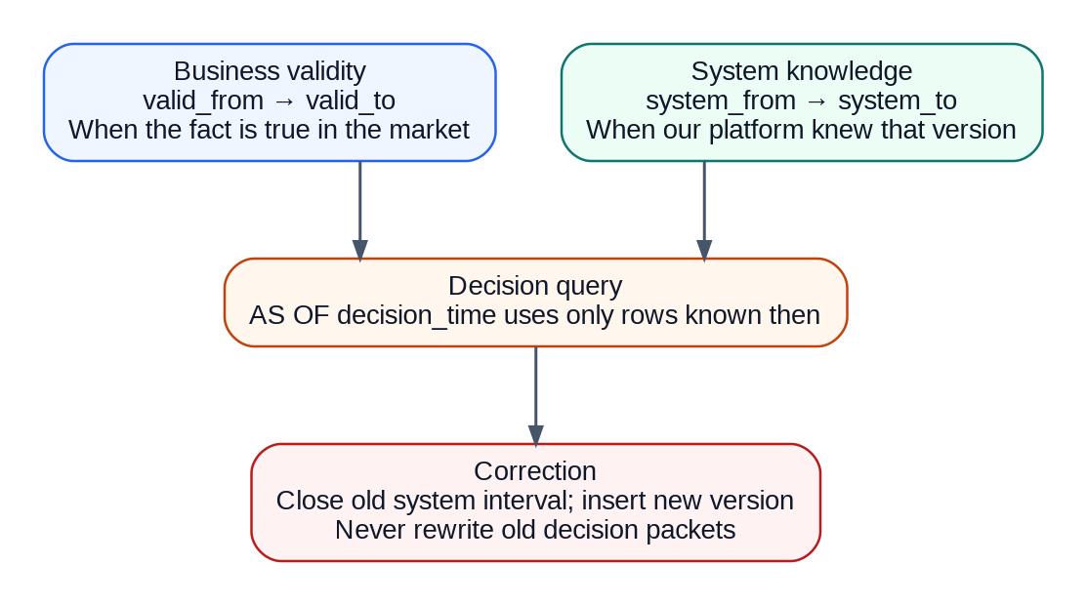
Figure 11. Two time axes are required: when a fact is valid and when the platform knew that fact.

7.3 Canonical observation contract
{
"schema_version": "1.0",
"instrument_id": "uuid",
"venue": "XIDX",
"observation_type": "DAILY_BAR",
"observed_at": "2026-09-18T09:00:00Z",
"effective_at": "2026-09-18T09:00:00Z",
"received_at": "2026-09-18T09:00:03Z",
"currency": "IDR",
"values": {"close": "1250", "volume": "1200000"},
"source_snapshot_id": "uuid",
"rule_version": "idx-equity-rule-2024-12",
"license_tags": ["NON_DISPLAY"],
"content_hash": "sha256:..."
}

7.4 Data quality controls
Control | Minimum behavior | Action on failure
Duplicate detection | Natural/business key + source event ID + checksum. | Quarantine duplicate set; do not silently drop if values conflict.
Referential integrity | 100% instrument/source/version links. | Block snapshot sealing.
Timestamp normalization | UTC storage + explicit Asia/Jakarta market context. | Reject ambiguous local timestamps.
Corporate-action reconciliation | Material events reconcile raw → adjusted price/share/cash path. | Quarantine affected instrument.
Freshness | Dataset-specific max age by audience/action. | Mark stale; block actionable publication if hard limit breached.
Schema evolution | Backward/forward compatibility rules for event/data contracts. | Route incompatible payload to dead-letter quarantine.
License tags | Every source snapshot carries rights tags and retention/export obligations. | Deny query/export when policy cannot prove entitlement.

8. Target architecture and component design
Architecture choice
Preferred MVP runtime: contract-enforced modular monolith for workflow-heavy domains, plus isolated ingestion and compute workers. Keep public schemas, IDs, event contracts, evidence format and audit semantics stable so services can be extracted later without rewriting the product model.

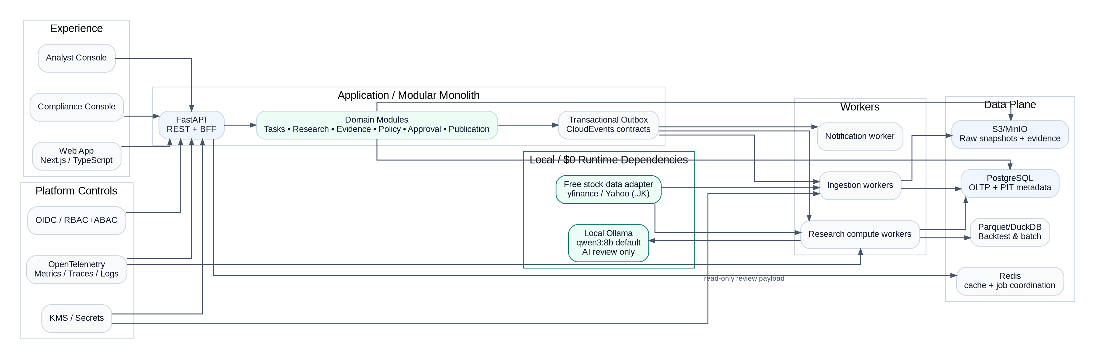
Figure 12. Target architecture. The application is simple enough to ship, while data and compute workloads remain isolated.

8.1 Recommended implementation stack
Layer | MVP choice | Why | Exit / scale path
Web | Next.js + TypeScript | Fast product iteration, SSR where useful, typed contracts. | Separate mobile client can reuse OpenAPI.
API | Python 3.12 + FastAPI + Pydantic | Natural fit for financial/quant code and contract-first REST. | Extract high-load domains behind same schemas.
Market data | Free-only yfinance adapter (Yahoo public/unofficial endpoints) | No API key/per-call charge; broad .JK coverage for EOD prototype. | Replace only through MarketDataProvider interface after rights/budget approval.
AI review | Local Ollama + qwen3:8b default | No cloud AI key or per-token bill; data stays local; AI remains non-authoritative. | Model is configurable through OLLAMA_MODEL; cloud provider is not implemented in MVP.
ORM/migrations | SQLAlchemy 2 + Alembic | Explicit transactions, mature PostgreSQL support. | Keep migrations owned by bounded module.
Workflow/jobs | PostgreSQL outbox + Redis-backed worker queue | Low operational overhead for MVP; durable event intent in DB. | Kafka-compatible log or Temporal when throughput/workflow complexity justifies.
OLTP/PIT metadata | PostgreSQL | Strong consistency, constraints, row-level security. | Partition, read replicas, domain extraction.
Time-series/batch | PostgreSQL/Timescale-compatible tables + Parquet/DuckDB for research | Good MVP economics and reproducible offline analytics. | ClickHouse/lakehouse if data scale requires.
Object evidence | S3-compatible object store | Immutable raw/evidence blobs with versioning. | Cross-region replication + object lock.
Cache | Redis | Disposable cache + job coordination. | Cluster only when needed.
Auth | OIDC provider + RBAC/ABAC in app | Enterprise-friendly identity; policy remains in domain. | Dedicated authorization service if tenancy grows.
Observability | OpenTelemetry + metrics/logs/traces backend | Portable instrumentation and correlation IDs. | Managed backend interchangeable.

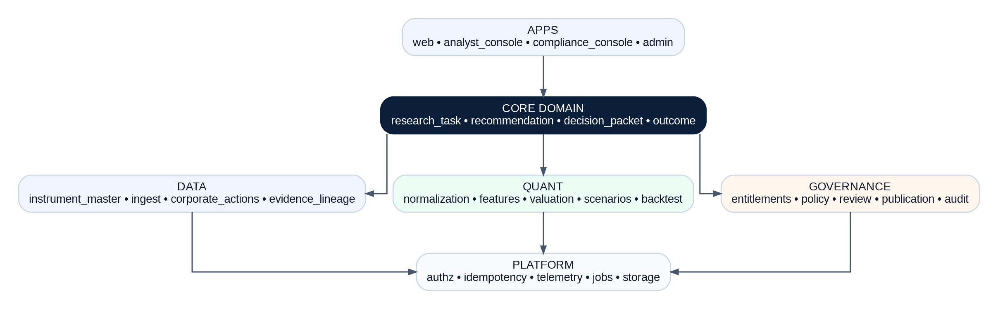
Figure 13. Source-code module map. Dependency direction points toward the core domain, not from domain to infrastructure.

8.2 Repository blueprint
buktisaham/
├─ apps/
│ ├─ web/ # Next.js user-facing research workspace
│ ├─ analyst_console/ # analyst authoring/review UI
│ └─ compliance_console/ # policy, approval, audit UI
├─ services/
│ ├─ api/ # FastAPI composition root
│ ├─ worker_ingest/ # source adapters + data quality
│ └─ worker_research/ # features, valuation, scenarios, backtests
├─ packages/
│ ├─ domain/ # entities, value objects, state machines
│ ├─ research_engine/ # pure deterministic quant functions
│ ├─ evidence/ # lineage + claim binding
│ ├─ policy/ # versioned decision rules
│ ├─ contracts/ # OpenAPI, JSON Schema, event schemas
│ └─ platform/ # authz, idempotency, telemetry, storage
├─ data/
│ ├─ adapters/ # free yfinance + future official/vendor adapters
│ ├─ pipelines/ # PIT normalization and snapshot sealing
│ ├─ quality/ # reconciliation + quarantine rules
│ └─ fixtures/ # golden PIT datasets for tests
├─ policies/ # YAML/JSON versioned policy parameters
├─ infra/ # Docker, IaC, environment modules
├─ ops/runbooks/ # incident + recovery procedures
├─ security/threat_models/
├─ docs/adr/ # architecture decision records
└─ tests/{unit,property,contract,integration,e2e,quant,security,resilience}/

8.3 Component responsibilities
Component | Owns | Must not own
Research Task | Intent, parameters, as-of, run creation. | Valuation math or publication approval.
Instrument Master | Effective symbols, boards, sectors, listing status, identifiers. | Recommendation state.
Market Ingest | Source retrieval, raw snapshots, parsing, receipt time. | Business interpretation of valuation.
Corporate Actions | Event-sourced actions and reconciliation factors. | UI presentation logic.
Research Engine | Pure financial normalization, features, valuation, scenario, execution metrics. | Authorization or mutable persistence.
Evidence Lineage | Claim→evidence mapping, transforms, hashes, export index. | Free-form claim generation.
Policy | Eligibility, freshness, audience, thresholds, action rules. | Source ingestion.
Review/Approval | Human roles, comments, approval state transitions. | Editing sealed quantitative output.
Publication | Seal packet, enforce expected version, distribute permitted content. | Creating research outputs.
Outcome Evaluator | Score complete issued population after horizon/invalidation. | Retrospectively changing action labels.

9. Domain model, database schema and data retention
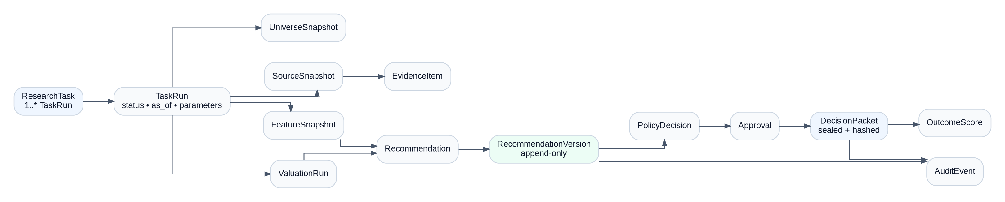
Figure 14. Core domain model. RecommendationVersion and DecisionPacket are append-only audit anchors.

9.1 Core entity invariants
Entity | Key invariant
ResearchTask | Parameters are versioned; task identity survives reruns.
TaskRun | One immutable parameter snapshot per run; stage events are append-only.
SourceSnapshot | Raw content checksum and rights tags never change.
EvidenceItem | Evidence is addressable by stable ID and binds to source snapshot + transform.
FeatureSnapshot | All feature values declare formula/version and as-of context.
ValuationRun | Method, inputs, assumptions, sensitivity grid and model version are stored together.
RecommendationVersion | Append-only; supersedes_id links revisions; sealed numeric payload immutable.
PolicyDecision | Records policy version, inputs, reason codes and pass/fail details.
Approval | Actor, role, decision, timestamp and scope; cannot be overwritten.
DecisionPacket | Hash over exact published payload + evidence index + approvals.
OutcomeScore | References the exact issued version; no cherry-picked omission.
AuditEvent | Append-only security/governance trail with correlation/causation IDs.

9.2 Minimum PostgreSQL table set
Table | Primary purpose | Key fields / indexes
instrument | Stable instrument identity. | id, venue, isin, instrument_type; unique identifiers.
instrument_version | Effective-dated symbol/board/sector/status. | instrument_id, valid_from/to, system_from/to; GiST/range index.
market_rule_version | Lots, ticks, sessions, auto-rejection metadata. | rule_set, effective range, payload_json, source_snapshot_id.
source_snapshot | Immutable source retrieval record. | id, source_type, uri, observed/effective/received, checksum, license_tags.
financial_fact | Reported + normalized PIT financial facts. | instrument_id, concept, period, values, source/effective/system times.
corporate_action | Event-sourced actions. | event_type, key dates, terms, status, source_snapshot_id.
research_task | User intent. | id, tenant_id, task_version, params_json, as_of.
task_run | Asynchronous run state. | id, task_id/version, status, snapshot_hash, idempotency_key.
feature_snapshot | Versioned derived features. | run_id, feature_name/version, numeric_value, lineage_json.
valuation_run | Sector model results. | run_id, method, version, fair_value, sensitivity_json.
recommendation_version | Research action and scenario payload. | recommendation_id, version, supersedes_id, status, sealed_payload_hash.
policy_decision | Eligibility/action policy evaluation. | recommendation_version_id, policy_version, result, reasons_json.
approval | Review decisions. | recommendation_version_id, actor, role, decision, created_at.
decision_packet | Published immutable packet. | recommendation_version_id, content_hash, evidence_manifest_uri, published_at.
outcome_score | Performance/calibration record. | packet_id, horizon, return_gross/net, drawdown, status.
audit_event | Append-only audit. | event_id, actor/workload, action, aggregate_id, correlation_id, payload_hash.

9.3 Retention classes
Class | Examples | Default posture
R1 Immutable evidence | Raw official/licensed snapshots, decision packets, audit exports | Retain per contract/regulatory policy; object versioning; deletion only by governed legal workflow.
R2 Operational records | Tasks, runs, approvals, policy decisions | Retain to support audit/outcome history; archive after active lifecycle.
R3 Rebuildable analytics | Caches, search index, some derived aggregates | May be rebuilt from authoritative data; shorter retention allowed.
R4 Restricted licensed data | Dataset-specific market/reference records | Retention/export/cloud/AI use strictly per entitlement matrix.
R5 PII/account data | User identity and access metadata | Minimize; separate from market research data; privacy retention schedule.

10. API, event and workflow contracts

10.1 API principles
- OpenAPI is normative. Client SDKs are generated from the contract, not hand-maintained.
- All commands require actor context, tenant, correlation ID and Idempotency-Key.
- State-changing commands carry expected aggregate version for optimistic concurrency.
- Queries return freshness, provenance summary and entitlement-filtered content.
- Monetary values are decimal strings; timestamps are RFC3339 UTC with market timezone metadata where relevant.
- All enums include UNKNOWN for forward compatibility.
Method | Path | Purpose | Key errors
POST | /v1/research-tasks | Create task and initial version. | 400 validation; 403 entitlement; 409 idempotency conflict
POST | /v1/research-tasks/{id}/runs | Start analysis from a specific task version. | 409 version; 422 stale/unsupported input
GET | /v1/runs/{id} | Stage status, errors, hashes and result pointer. | 403; 404
GET | /v1/instruments | Effective-dated eligible instrument search. | 403 entitlement; 409 stale master
GET | /v1/recommendations/{id}/versions/{v} | Read exact immutable version. | 403 entitlement; 404
POST | /v1/recommendations/{id}/submit | Run policy and start review. | 403 role; 409 version; 412 policy dependency
POST | /v1/recommendations/{id}/approve | Record independent approval. | 403 role; 409 state/version
POST | /v1/recommendations/{id}/publish | Seal and distribute approved version. | 409 approval/version; 451 restricted
POST | /v1/recommendations/{id}/invalidate | Create governed invalidation. | 403 role; 409 version/state
GET | /v1/audit/exports/{id} | Retrieve signed evidence package. | 403 auditor; 425 assembling

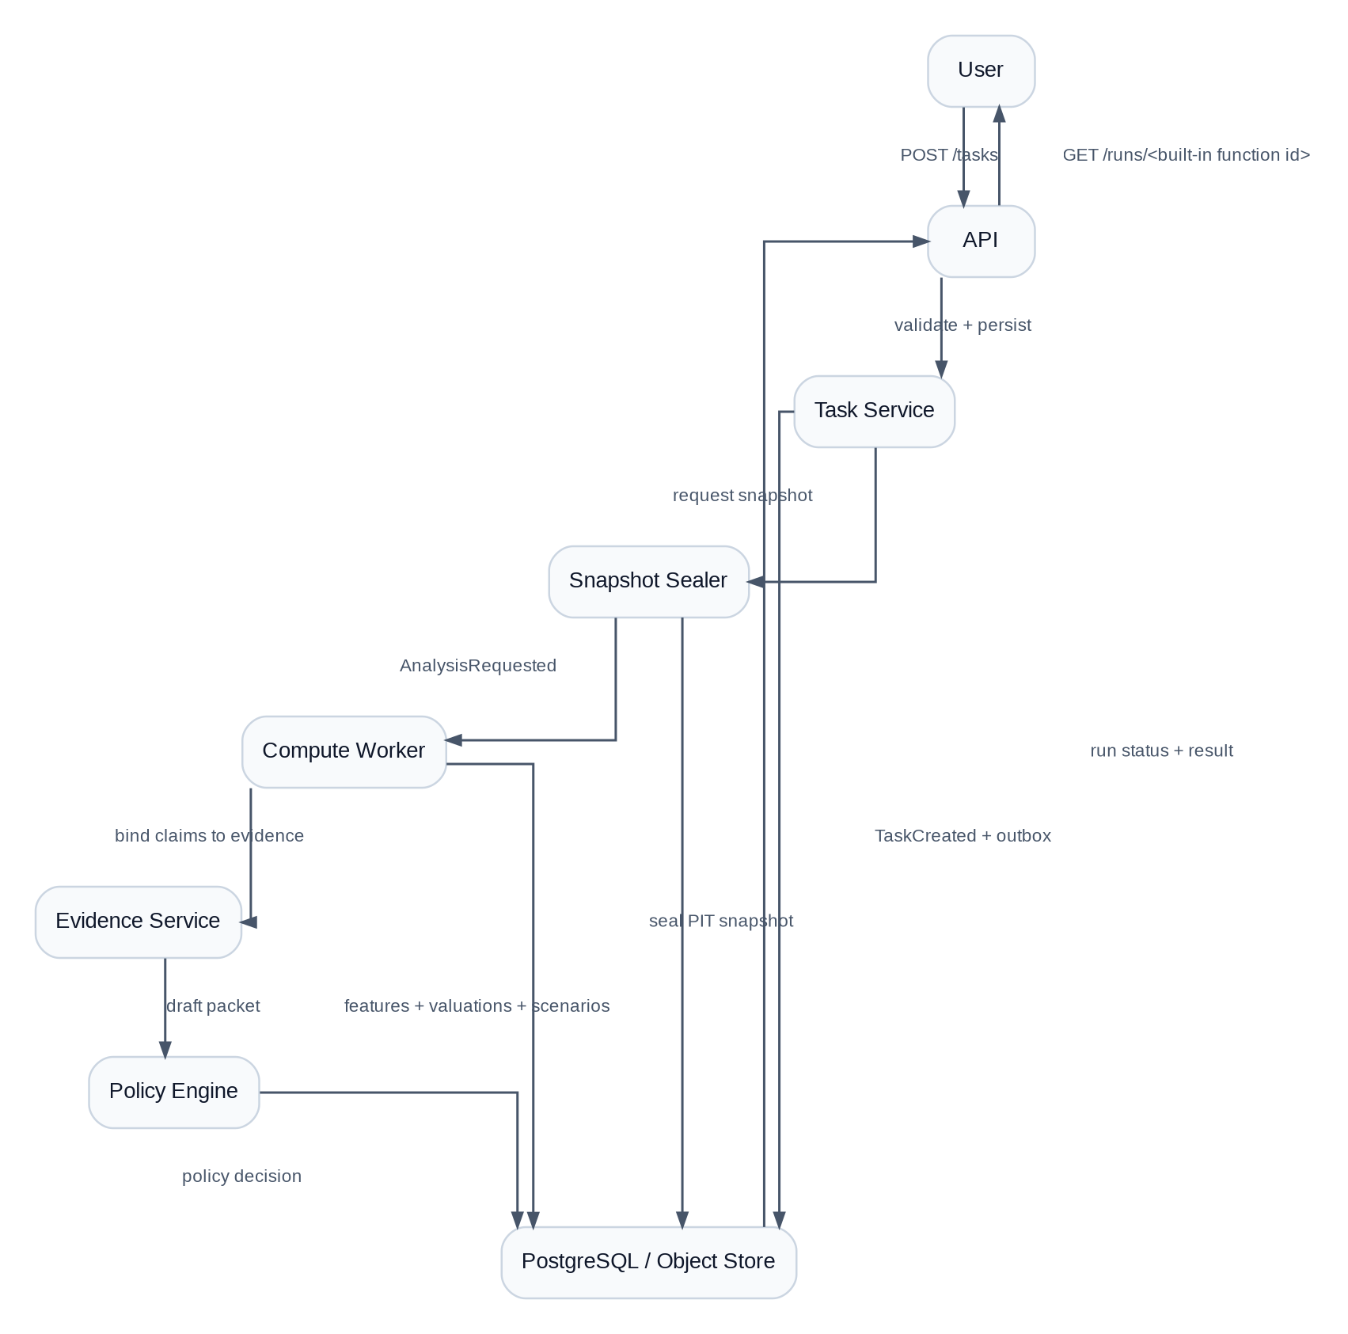
Figure 15. Run-analysis sequence. Snapshot sealing happens before compute.
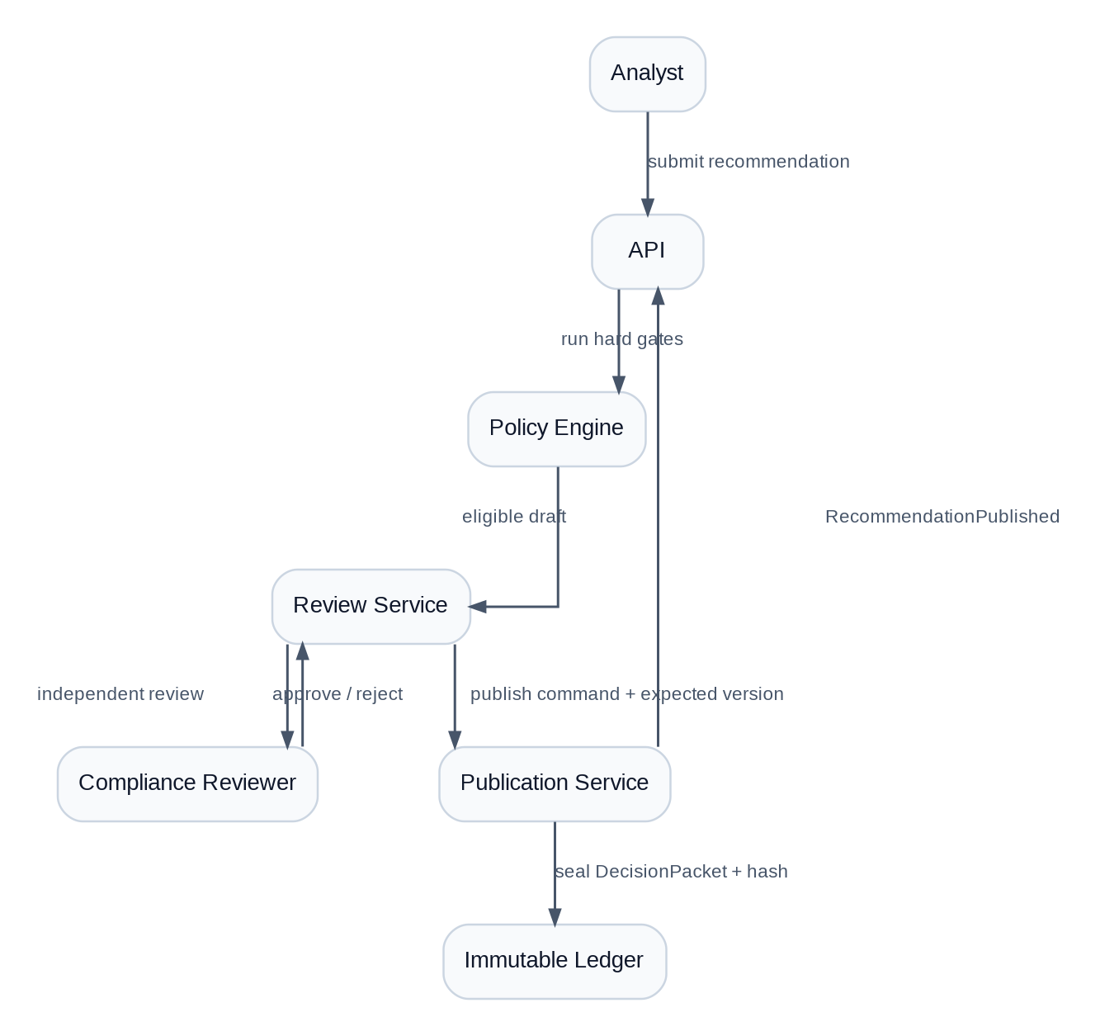
Figure 16. Publish sequence. Human review is downstream of deterministic policy and upstream of immutable sealing.

10.2 Event contracts
Events use a CloudEvents-aligned envelope. At MVP they can be persisted in a transactional outbox and dispatched to workers; the schema remains compatible with a future durable event log.
{
"event_id": "uuid",
"type": "RecommendationPublished",
"schema_version": "1.0",
"occurred_at": "...Z",
"producer": "publication",
"tenant_id": "uuid",
"aggregate": {"type": "Recommendation", "id": "uuid", "version": 7},
"correlation_id": "uuid",
"causation_id": "uuid",
"classification": "INTERNAL",
"payload": {"decision_packet_id": "uuid"},
"payload_hash": "sha256:..."
}

Core event names: SourceSnapshotSealed, InstrumentMasterUpdated, CorporateActionReconciled, AnalysisRequested, FeatureSetComputed, ValuationCompleted, RecommendationDrafted, PolicyCheckCompleted, RecommendationSubmitted, ApprovalRecorded, RecommendationPublished, RecommendationRevised, RecommendationInvalidated, RecommendationExpired and OutcomeScored.

11. AI usage and guardrails
Authority boundary
The MVP AI runtime is local Ollama (qwen3:8b by default). AI is an optional explanation layer. It may summarize evidence, generate plain-language comparisons, surface contradictions and draft analyst notes. It MUST NOT change market data, financial facts, valuation numbers, scenario probabilities, policy outcomes, approval state or publication action.

Use case | Allowed? | Control
Summarize a filing already in evidence store | Yes | Only approved evidence IDs; citations mandatory; output schema validated.
Explain why fair value changed between versions | Yes | Input is machine-generated diff; no new numbers.
Suggest questions for analyst review | Yes | Clearly labeled suggestion; cannot block/publish.
Generate a recommendation action from free-form prompt | No | Recommendation action is deterministic policy output.
Retrieve arbitrary internet source during publish | No | Publish uses approved evidence sources only.
Use any external/cloud model API in the MVP | No | The implemented MVP uses local Ollama only; no external AI API adapter or key is required.

11.1 Local Ollama runtime contract
AI_REVIEW_ENABLED=true
OLLAMA_BASE_URL=http://ollama:11434
OLLAMA_MODEL=qwen3:8b
FREE_ONLY_MARKET_DATA=true
MARKET_DATA_PROVIDER=yfinance

- The worker sends only deterministic analysis fields and approved evidence summaries to the local Ollama REST API.
- Ollama output is stored as review metadata and cannot overwrite research_action, numeric metrics, evidence hashes or policy results.
- If Ollama is unavailable, the deterministic run still completes with ai_review.status = unavailable.
- Model download is explicit through scripts/pull-model.sh; changing OLLAMA_MODEL is a reversible runtime configuration change.

11.2 Prompt/tool security
- Model registry with approved provider/model/version and kill switch.
- Evidence and tool allowlists; no arbitrary URL/tool access inside publish workflow.
- Prompt injection test corpus across filings, web content and analyst notes.
- Structured response schema validation before text is displayed.
- No secrets, PII or restricted raw data in prompts unless explicitly permitted by classification policy.
- Store prompt template version, evidence IDs, model ID and output hash for reproducibility of narrative context.

12. Security, compliance and entitlement controls
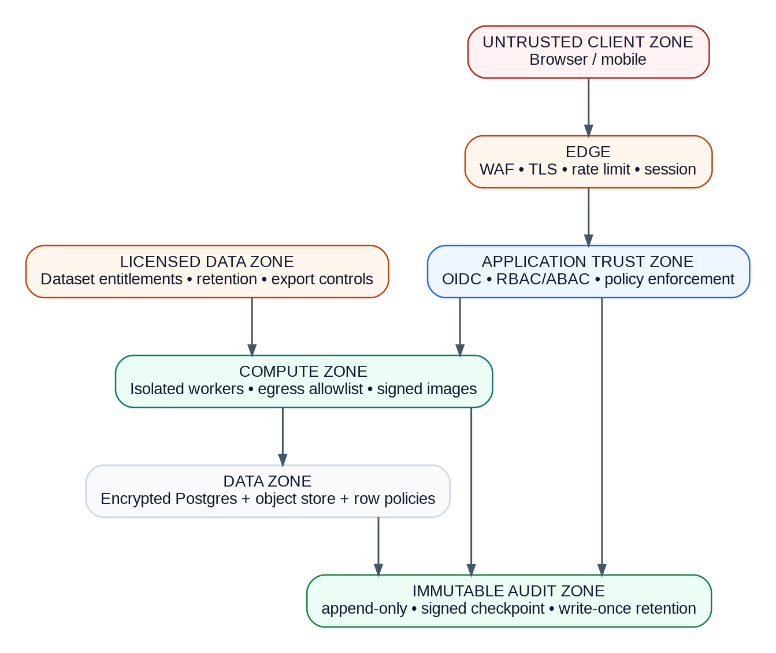
Figure 17. Security trust boundaries. Licensed data and audit evidence are separate control planes.

12.1 Authorization model
RBAC is necessary but not sufficient. Authorization also evaluates tenant, audience, instrument, dataset license, geography, data classification, action, export intent and where relevant suitability status. Policy should be centralized as testable domain rules, even if identity comes from an external OIDC provider.
Role | Typical permissions | Explicit denial
Reader | Read published/authorized packets. | No raw restricted export, no workflow mutation.
Analyst | Create tasks, run analysis, draft/revise recommendations. | Cannot independently approve own draft.
Reviewer | Review and request changes. | Cannot modify deterministic results.
Publisher/Compliance | Approve/publish within scoped policy. | Cannot bypass failed hard policy gate.
Data Steward | Quarantine/repair data, seal corrected versions. | Cannot retroactively mutate published packet.
Auditor | Read audit exports and history. | No authoring.
Operator | Operate platform, feature flags, incident response. | No content approval unless separately assigned role.

12.2 Compliance/data-rights gating
- Legal classifies research vs advice vs alerting vs personalization for the actual operating entity and target audience before public launch.
- Data governance maintains an entitlement matrix for display, non-display, storage, archive, cloud processing, derived analytics, AI/model use, API export, redistribution and deletion for every dataset.
- Publication policy verifies audience and dataset rights at request time, not only at ingest.
- All user-facing claims distinguish sourced fact, derived calculation and editorial judgment.
- Broker handoff remains disabled until suitability, execution, surveillance, recordkeeping and partner responsibilities are separately approved.

12.3 Security controls
Control family | Requirement
Identity | Phishing-resistant MFA for privileged roles; short sessions for admin; separate break-glass identities.
Secrets | KMS/HSM-backed encryption; automatic rotation; no secret in code, prompt, event or log.
Network | Private data services; controlled egress; WAF/rate limiting at edge; service-to-service identity.
Data | Encryption in transit/at rest; row/tenant policy; classification tags; object versioning and retention.
Build | Branch protection, signed commits/build provenance where feasible, SAST/SCA/secret scan/SBOM/container/IaC scan.
Audit | Append-only event ledger, signed checkpoints, immutable evidence export; operational logs are supplementary, not the only audit record.
AI | Model allowlist, prompt/tool/data policies, injection testing, schema validation, human publish approval, kill switch.

13. Non-functional requirements and SLOs
Indicator | Initial target | Measurement | Breach action
Published recommendation read availability | 99.95% monthly | Successful authorized reads / valid requests | Hold rollout; page owner; serve labeled cache if safe.
Authoring/admin availability | 99.9% monthly | Successful workflow ops | Degrade to read-only.
Recommendation read latency | p95 ≤300 ms | API edge; cache status segmented | Serve cache; shed non-critical enrichment.
Evidence page latency | p95 ≤2 s | Full lineage retrieval | Disable heavy previews; keep source index.
Licensed-feed ingest lag | Dataset-specific; target p99 ≤5 s only for licensed real-time feed | Source timestamp→canonical receipt | Mark stale; block actionability when threshold crossed.
Evidence completeness | 100% mandatory publish fields | Packet validator | Fail publication.
Run orchestration | 99% accepted runs reach terminal state | Run state machine | Alert stuck runs; safe retry.
Audit write durability | No acknowledged publish without durable audit/packet record | Transactional checks | Fail closed.

13.1 Capacity assumptions
- MVP design target: selected liquid IDX equities, EOD/delayed research, tens to low hundreds of concurrent users, background analysis rather than HFT.
- Before controlled beta, load test at 10× forecast read peak and 3× forecast ingest/compute peak.
- Partition large observation/feature tables by effective date and/or instrument hash as measured scale requires.
- Cache is an optimization only; all authoritative results must be reconstructable without cache.
- Backtests run in separate worker pool and storage path so research exploration cannot starve publication or user read paths.

13.2 Accessibility and internationalization
- WCAG 2.2 AA target: keyboard operation, screen-reader chart summaries, focus states and non-color-only risk cues.
- Primary UX Bahasa Indonesia with English technical terms only where clearer; contracts and code remain English.
- Currency/number/date formatting is locale-aware but storage is canonical decimal + ISO/RFC timestamps.
- All risk and evidence labels must remain meaningful when exported to PDF/CSV or viewed without color.

14. Testing and quality strategy
Layer | Scope | Release blockers
Unit | Money/decimal, date/calendar, lot/tick, financial normalization, valuation math. | Any deterministic failure.
Property-based | Probability sums, monotonic valuation relationships, state-machine invariants, round-trip adjustments. | Invariant counterexample.
Golden data | Known issuer filings, corporate actions, market rules and PIT snapshots. | Reconciliation outside tolerance.
Contract | OpenAPI, JSON Schema, event compatibility, idempotency, out-of-order delivery. | Breaking unversioned contract.
Integration | DB transactions, outbox/inbox, object store, auth, worker orchestration. | Data loss/duplication or unauthorized access.
Quant | Leakage, survivorship, walk-forward, costs, drawdown, capacity, calibration/Brier score, abstention quality. | Material methodology breach.
Security | Tenant isolation, authz matrix, prompt injection, exfiltration, secret handling, break-glass. | Any critical/high unresolved issue.
Resilience | Feed gaps, corrupt event, queue/db/object-store failure, clock skew, replay/restore. | Cannot fail closed or recover within target.
UX/compliance | Source/freshness/risk/invalidation comprehension and prohibited claim corpus. | <90% comprehension or any policy escape.

14.1 Definition of Done for each P0 story
1. Behavior implemented behind a contract and feature flag where applicable.
2. Unit/property tests cover happy path and boundary conditions.
3. Golden PIT fixture proves deterministic output.
4. Authorization and entitlement tests cover allow and deny paths.
5. Observability includes correlation ID, domain metrics and meaningful structured logs.
6. Failure mode is defined and user-facing message is non-misleading.
7. Migration/rollback path documented.
8. Product, engineering and relevant data/quant/compliance owner accept the story’s criteria.

15. Deployment, observability and disaster recovery
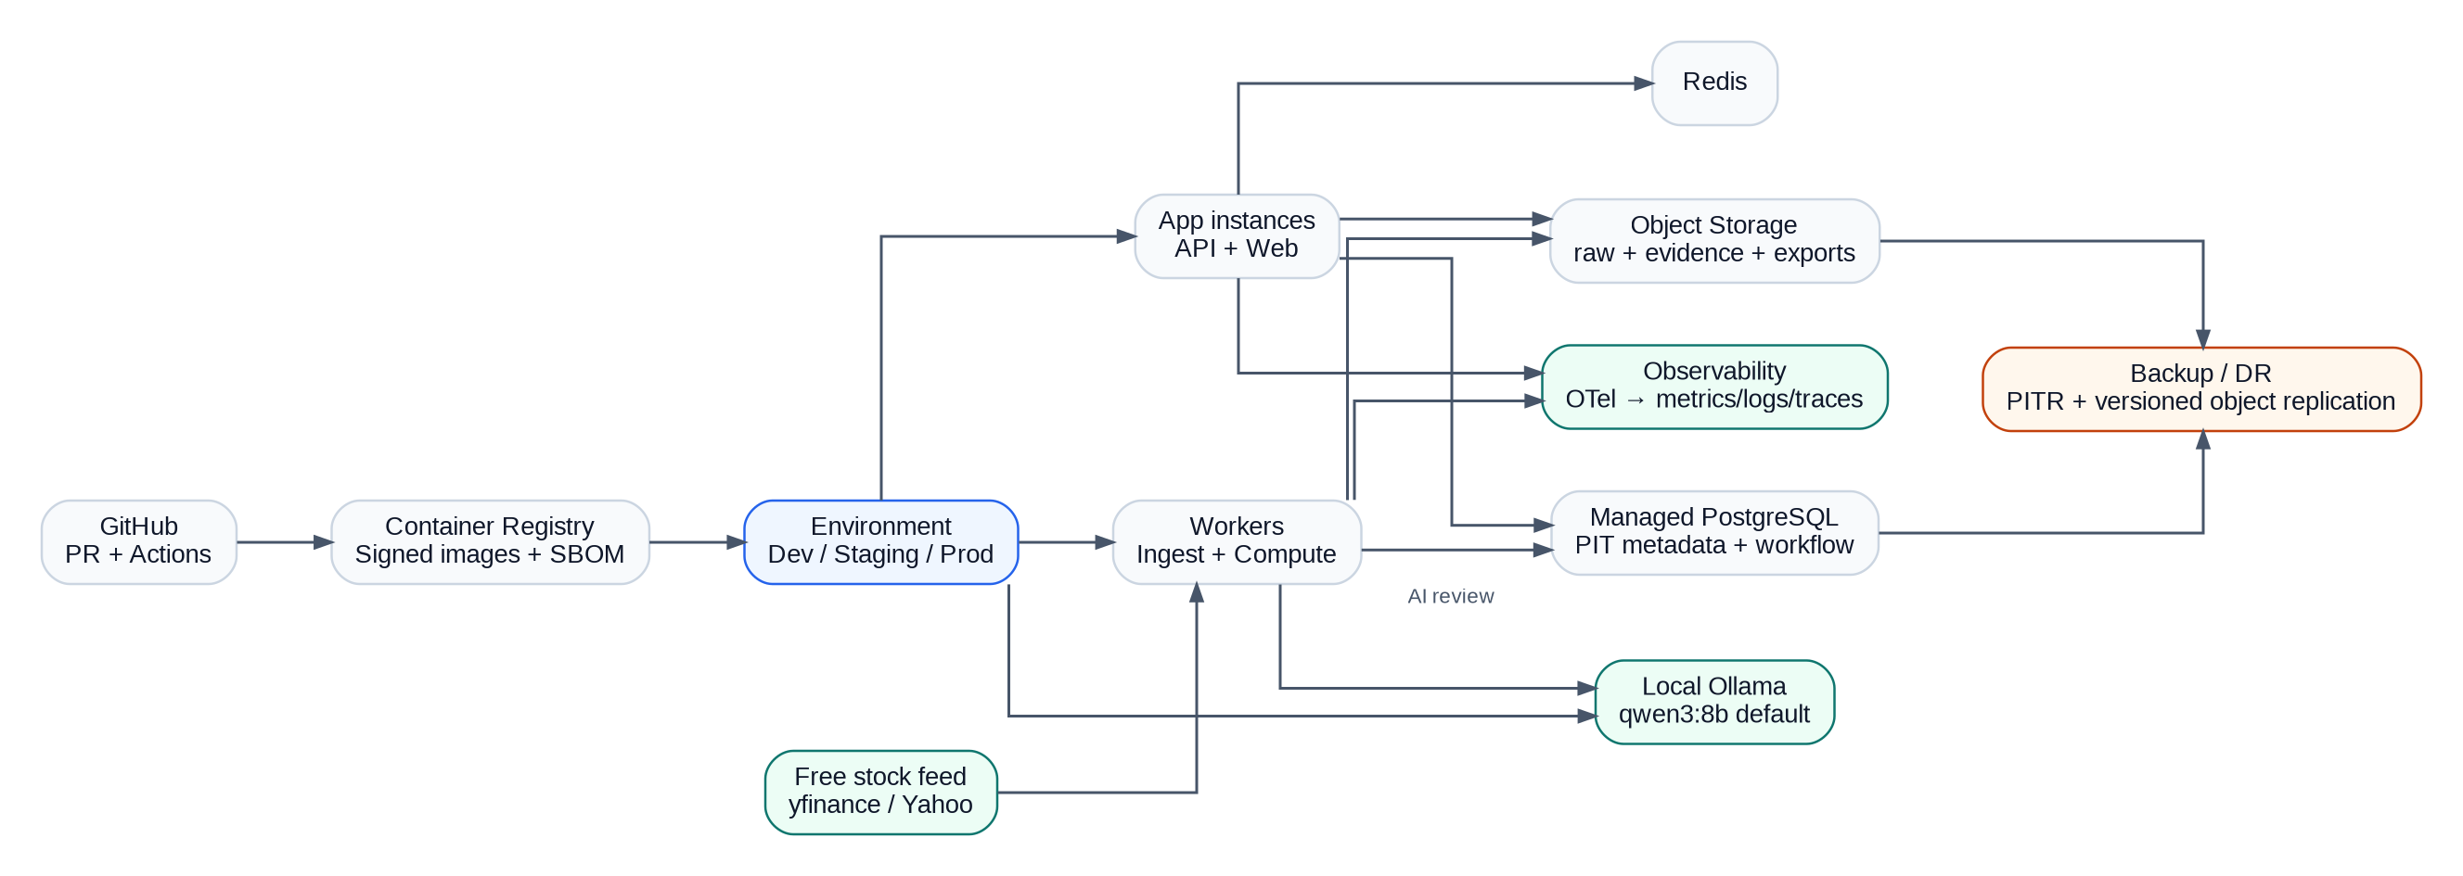
Figure 18. Deployment topology. Production data and evidence are durable; cache/search remain rebuildable.
Figure 19. CI/CD pipeline. Security, contract and PIT replay tests run before a human production approval.

15.1 Environment strategy
Environment | Data | Purpose
Local | Synthetic + curated fixtures only | Developer productivity; Docker Compose; deterministic offline tests.
CI | Ephemeral fixture datasets | Automated tests, schema compatibility, migrations.
Staging | Production-like but non-production entitlements/data rights | End-to-end, security, load, replay and UAT.
Production/private MVP | Free yfinance adapter only while FREE_ONLY_MARKET_DATA=true; official evidence where automation rights permit | Private/research deployment only; public redistribution remains gated by upstream/IDX rights review.

15.2 Observability and incident response
Figure 20. Incident loop. Data/evidence issues can automatically stop publication before they become user harm.
- Every request/run/event carries correlation_id; recommendation/version IDs appear in traces and structured logs.
- Alerts: feed gaps, stale instruments, schema failures, evidence completeness, policy dependency outage, approval latency, publish lag, outcome calibration drift and anomalous export.
- Recommended recovery objectives: recommendation metadata RPO ≤5 min / RTO ≤60 min; immutable evidence/audit near-zero RPO via object versioning/replication / RTO ≤4 h; rebuildable search/analytics RPO/RTO ≤24 h.
- Quarterly restore tests, semiannual failover rehearsal and annual cyber-recovery exercise record actual evidence, not only written procedure.

16. Delivery roadmap, backlog and ownership
Figure 21. Delivery roadmap. Audience expansion only follows evidence, legal/data rights and operational gates.

16.1 Phases and exit gates
Phase | Core deliverable | Exit gate | Rollback posture
0 Governance foundation | Legal perimeter, data RFP/rights matrix, taxonomy, threat model, source contracts. | Named approvers sign data, retention, publication and audience boundaries. | No production data flow.
1 Research kernel | PIT ingest, instrument master, corporate-action engine, deterministic normalization/valuation/backtest. | Replay + reconciliation pass on representative historical samples. | Delete non-required vendor samples per contract.
2 Analyst MVP | Task workflow, recommendation card, evidence drawer, policy/review, immutable packet. | 100% evidence completeness; shadow calibration approved. | Feature flags disable generation/publish.
3 Controlled paper beta | Limited users/universe, delayed data if licensed, scorecards and alerts. | SLO, comprehension, security and incident drills pass. | Traffic to 0%; retain audit.
4 Invited distribution | Broader web/mobile distribution, daily compliance review, monitoring. | Independent control assurance and penetration test. | Audience/instrument kill switches.
5 GA | General availability; optional separately approved integrations. | Public methodology, complete outcome ledger, DR exercise and all legal/data gates. | Read-only archive + withdrawal notices.

16.2 Implementation epics
Epic | Name | Implementation result
E1 | Foundation contracts | OpenAPI baseline, domain IDs, event envelope, money/time library, ADRs
E2 | Identity + entitlement | OIDC, tenant model, RBAC/ABAC, dataset rights matrix, audit
E3 | Instrument master | Effective-dated symbols/status/sector/board + source reconciliation
E4 | Raw ingest | Adapters, immutable object store, source snapshot registry, checksum
E5 | PIT canonical model | Bitemporal observations/financial facts/rules, schema versioning
E6 | Corporate actions | Event model, KSEI/issuer reconciliation, adjustment engine
E7 | Research engine | Normalization, features, technical context, local execution math
E8 | Valuation | Sector router + model implementations + sensitivities
E9 | Scenario engine | Versioned assumptions, probabilities, expected net return, risk metrics
E10 | Evidence lineage | Claim registry, transform lineage, content hash, evidence drawer APIs
E11 | Policy engine | Freshness, rights, threshold/action rules, fail-closed logic
E12 | Review + approval | State machine, comments, independent approval, version diff
E13 | Publication | Immutable packet seal, disclaimer/version, distribution, withdrawal
E14 | Outcome evaluator | Horizon/invalidation scoring, population reconciliation, calibration
E15 | Web experience | Task wizard, run progress, card, evidence drawer, comparisons
E16 | Operations | OTel, dashboards, alerts, runbooks, backup/restore, DR
E17 | Security hardening | Threat model, SAST/SCA, secrets, WAF, penetration test
E18 | AI explanation layer | Evidence-bound summarization, schema validation, injection tests, kill switch

16.3 Ownership and irreversible decisions
Workstream | Accountable role | First irreversible decision | Required sign-off
Product/research policy | Product Lead | Public taxonomy and research-view semantics | Product, Compliance, Legal
Data licensing + PIT | Data Lead | Licensed storage/derived-use model and time semantics | Data, Legal, Security
Quant methodology | Quant Lead | Published scoring/valuation policy version | Model Risk, Compliance
Architecture/contracts | Engineering Lead | Canonical IDs, public schemas, packet/audit format | Architecture, Security
Security/operations | Security Lead | Key hierarchy and audit trust root | Security, Risk, Operations

17. Approval checklist and handoff to implementation
Implementation may start when the following are explicitly approved:
Product scope and action taxonomy; legal research/advice boundary; initial allowed audience; data-source/rights plan; point-in-time model; architecture D-01–D-08; sector valuation coverage; recommendation policy framework; security model; SLO targets; phase-1/2 acceptance gates.

17.1 Approval checklist
Area | Approval condition
Product | Primary journey, P0 scope and non-goals accepted.
Legal/Compliance | Operator/audience/research-vs-advice boundary accepted; broker handoff remains off.
Data | Representative source samples and rights matrix available.
Quant | Sector methods, cost model, scenario framework and validation owner named.
Engineering | Architecture, repository boundaries, DB/API/event contracts accepted.
Security | Threat model, authz, secret/key, audit and incident requirements accepted.
Operations | SLOs, RPO/RTO, monitoring, restore/failover test plan accepted.
UX | Recommendation card/evidence drawer comprehension criteria accepted.

17.2 Implemented MVP handoff and next sprint
Current runnable baseline
The companion ZIP already implements Docker Compose, FastAPI, PostgreSQL, Redis/RQ, the free-only yfinance market adapter, deterministic scoring/scenarios/policy, a local Ollama review client, Next.js UI, tests and operational scripts. The next sprint should deepen point-in-time official evidence and sector valuation rather than replace these boundaries.

1. Create monorepo skeleton and CI pipeline with lint/type/unit/contract/security gates.
2. Implement money/time/decimal and effective-date primitives plus test fixtures.
3. Create PostgreSQL baseline schema: tenant, actor, instrument, instrument_version, source_snapshot, research_task, task_run, audit_event.
4. Publish OpenAPI v1 draft for task creation/run status and generate typed clients.
5. Implement transactional outbox + idempotency middleware + correlation IDs.
6. Build synthetic/fixture instrument-master and market-rule adapters before real licensed feeds.
7. Implement snapshot-sealing service and content-hash manifest.
8. Ship minimal web task wizard + run progress page using fixture data.
9. Add one end-to-end golden test: create task → seal snapshot → compute stub valuation → draft packet → policy preview.
10. Freeze ADRs for PIT semantics, immutable recommendation versioning and effective-dated market rules.

Appendix A. API examples

A.1 Create Research Task
POST /v1/research-tasks
Idempotency-Key: 8f7...
{
"title": "BBRI 6M valuation review",
"universe": {"type": "symbols", "values": ["BBRI"]},
"horizon": "P6M",
"as_of": "2026-09-18T09:00:00Z",
"capital": {"currency": "IDR", "amount": "100000000"},
"mandate": {"max_position_pct": "0.20", "max_bear_downside": "0.25"},
"cost_profile_id": "id-retail-standard-v1",
"entitlement_profile_id": "retail-delayed-v1",
"audience": "RESEARCH_USER"
}

A.2 Recommendation payload shape
{
"recommendation_id": "uuid",
"version": 3,
"instrument": {"symbol": "BBRI", "venue": "XIDX"},
"as_of": "2026-09-18T09:00:00Z",
"horizon": "P6M",
"research_view": "WATCH",
"status": "IN_REVIEW",
"scenarios": [
{"name": "BEAR", "probability": "0.25", "fair_value": "..."},
{"name": "BASE", "probability": "0.50", "fair_value": "..."},
{"name": "BULL", "probability": "0.25", "fair_value": "..."}
],
"metrics": {
"expected_net_return": "...",
"bear_downside": "...",
"confidence": "...",
"evidence_completeness": "..."
},
"valuation_methods": ["RESIDUAL_INCOME", "JUSTIFIED_PB"],
"triggers": [...],
"invalidations": [...],
"evidence_ids": ["uuid", "uuid"],
"policy": {"version": "policy-2026-09-shadow-01", "reasons": [...]},
"snapshot_hash": "sha256:..."
}

Appendix B. Database table blueprint

B.1 Recommendation version (illustrative DDL)
CREATE TABLE recommendation_version (
id UUID PRIMARY KEY,
recommendation_id UUID NOT NULL,
version INTEGER NOT NULL,
supersedes_id UUID NULL REFERENCES recommendation_version(id),
task_run_id UUID NOT NULL REFERENCES task_run(id),
instrument_id UUID NOT NULL REFERENCES instrument(id),
status TEXT NOT NULL,
research_view TEXT NOT NULL,
horizon TEXT NOT NULL,
as_of TIMESTAMPTZ NOT NULL,
scenario_payload JSONB NOT NULL,
metric_payload JSONB NOT NULL,
valuation_payload JSONB NOT NULL,
snapshot_hash TEXT NOT NULL,
sealed_payload_hash TEXT NULL,
created_at TIMESTAMPTZ NOT NULL DEFAULT now(),
UNIQUE (recommendation_id, version)
);
-- Application policy: rows linked to a published DecisionPacket are immutable.
-- Revision inserts a new row and sets supersedes_id.

B.2 Market rule version (illustrative DDL)
CREATE TABLE market_rule_version (
id UUID PRIMARY KEY,
venue TEXT NOT NULL,
board TEXT NOT NULL,
instrument_type TEXT NOT NULL,
rule_kind TEXT NOT NULL, -- LOT_SIZE | TICK_TABLE | SESSION | COST | ...
valid_from TIMESTAMPTZ NOT NULL,
valid_to TIMESTAMPTZ NULL,
system_from TIMESTAMPTZ NOT NULL DEFAULT now(),
system_to TIMESTAMPTZ NULL,
payload JSONB NOT NULL,
source_snapshot_id UUID NOT NULL REFERENCES source_snapshot(id),
content_hash TEXT NOT NULL
);

Appendix C. Reference and verification register
The implementation design intentionally treats regulations, trading mechanics, taxes and licenses as effective-dated inputs. The following references are design anchors, not permission to reuse data. Legal counsel and licensors must verify the exact 2026 terms, operator entity and intended audience before launch.
Reference family | How it is used
Uploaded source blueprint | Implementation Blueprint for an Explainable Indonesian Equity Research Platform, 19 Sep 2026. Used as the reference baseline for evidence-first design, point-in-time lineage, controlled publication, modular architecture and launch gating.
IDX | Trading Hours and Mechanism; Rule II-A / current decree for equity trading. Verified current public page states 1 lot = 100 shares in Regular/Cash markets and five common price-fraction bands; production must use effective rule versions.
OJK | POJK 29/POJK.04/2016 on Annual Reports of Issuers/Public Companies; POJK 14/POJK.04/2022 on Periodic Financial Statements; material disclosure and consumer-protection regulations as applicable.
KSEI | Corporate Action process, announcements and schedules. Used as an event/reconciliation source candidate subject to automation rights.
Bank Indonesia | JISDOR/FX methodology, inflation target and relevant rate/macro publications. Used as point-in-time macro inputs, not hard-coded forecasts.
Astronacci | Eye of Future public material. Used only as a presentation reference for scenario/trigger/invalidation grammar; no proprietary formula is assumed.
OpenAPI Initiative | OpenAPI Specification. Normative REST contract format.
CNCF | CloudEvents Specification. Event-envelope alignment.
NIST | SP 800-207 Zero Trust; AI RMF 1.0; SP 800-218 SSDF. Security/AI governance anchors.
W3C | WCAG 2.2. Accessibility target.
OpenTelemetry | Observability semantic and tracing approach.
yfinance / Yahoo Finance | Current MVP stock-data adapter. Free/no-key public-unofficial access for research; upstream terms and availability apply, and no paid fallback is enabled.
Ollama | Local REST model runtime. qwen3:8b is the default review model in the companion implementation and can be changed through OLLAMA_MODEL.

Appendix D. Companion implementation quick start
The implementation ZIP is designed for copy/commit/push use. Default runtime has zero AI API charges and no paid stock-data provider. Docker still consumes local machine/cloud compute resources if you choose to host it externally.
cp .env.example .env
./scripts/bootstrap.sh
# Web
open http://localhost:3000
# API
open http://localhost:8000/docs
# Verify policy
curl http://localhost:8000/health

Runtime | Implementation
AI review | Ollama container; qwen3:8b default; local REST /api/chat
Stock data | yfinance adapter; bare IDX ticker normalized to .JK; no paid fallback
API | FastAPI
Jobs | Redis + RQ worker
Database | PostgreSQL
Web | Next.js
Operational scripts | bootstrap/start/stop/pull-model/test/smoke/backup/restore

Implementation handoff
After approval, treat this document as the v1.1 baseline synchronized to the runnable local-Ollama/free-data implementation. Changes to one-way decisions (PIT semantics, immutable published versions, canonical IDs/contracts, evidence manifest and audit format) require an Architecture Decision Record and explicit cross-functional approval. Reversible runtime choices can evolve behind the stable contracts.

End of document

