**PROJECT WORK**

Project Title: Comprehensive digital marketing for fabindia

Name: A. Radhika

Group: BSC(MSCA)

College: Vasavi mahila kalasala

University: Rayalaseema

Mentor: Dr. Hema Sundari

Team ID : LTVIP2025TMID21872

**Introduction Of Fabindia**

what is Fabindia?

Fabindia is an Indian retail company that specializes in handmade, eco-friendly products. The company was founded in 1960 by John Bissell and has since grown to become one of India's largest retail chains.

Products

Fabindia offers a wide range of products, including:

- Clothing: Fabindia is known for its traditional Indian clothing, including kurtas, sarees, and dupattas.

- Home furnishings: Fabindia offers a range of home furnishings, including bedding, curtains, and table linen.

- Furniture: Fabindia's furniture range includes traditional Indian pieces, such as wooden chairs and tables.

- Gifts: Fabindia offers a range of gifts, including handicrafts, jewelry, and candles.

Mission

Fabindia's mission is to provide high-quality, eco-friendly products that promote traditional Indian craftsmanship. The company is committed to sustainability and works with rural artisans to create its products.

Values

Fabindia's values include:

- Sustainability: Fabindia is committed to reducing its environmental impact and promoting sustainable practices.

- Quality: Fabindia is dedicated to providing high-quality products that meet the highest standards.

- Traditional craftsmanship: Fabindia is committed to promoting traditional Indian craftsmanship and supporting rural artisans.

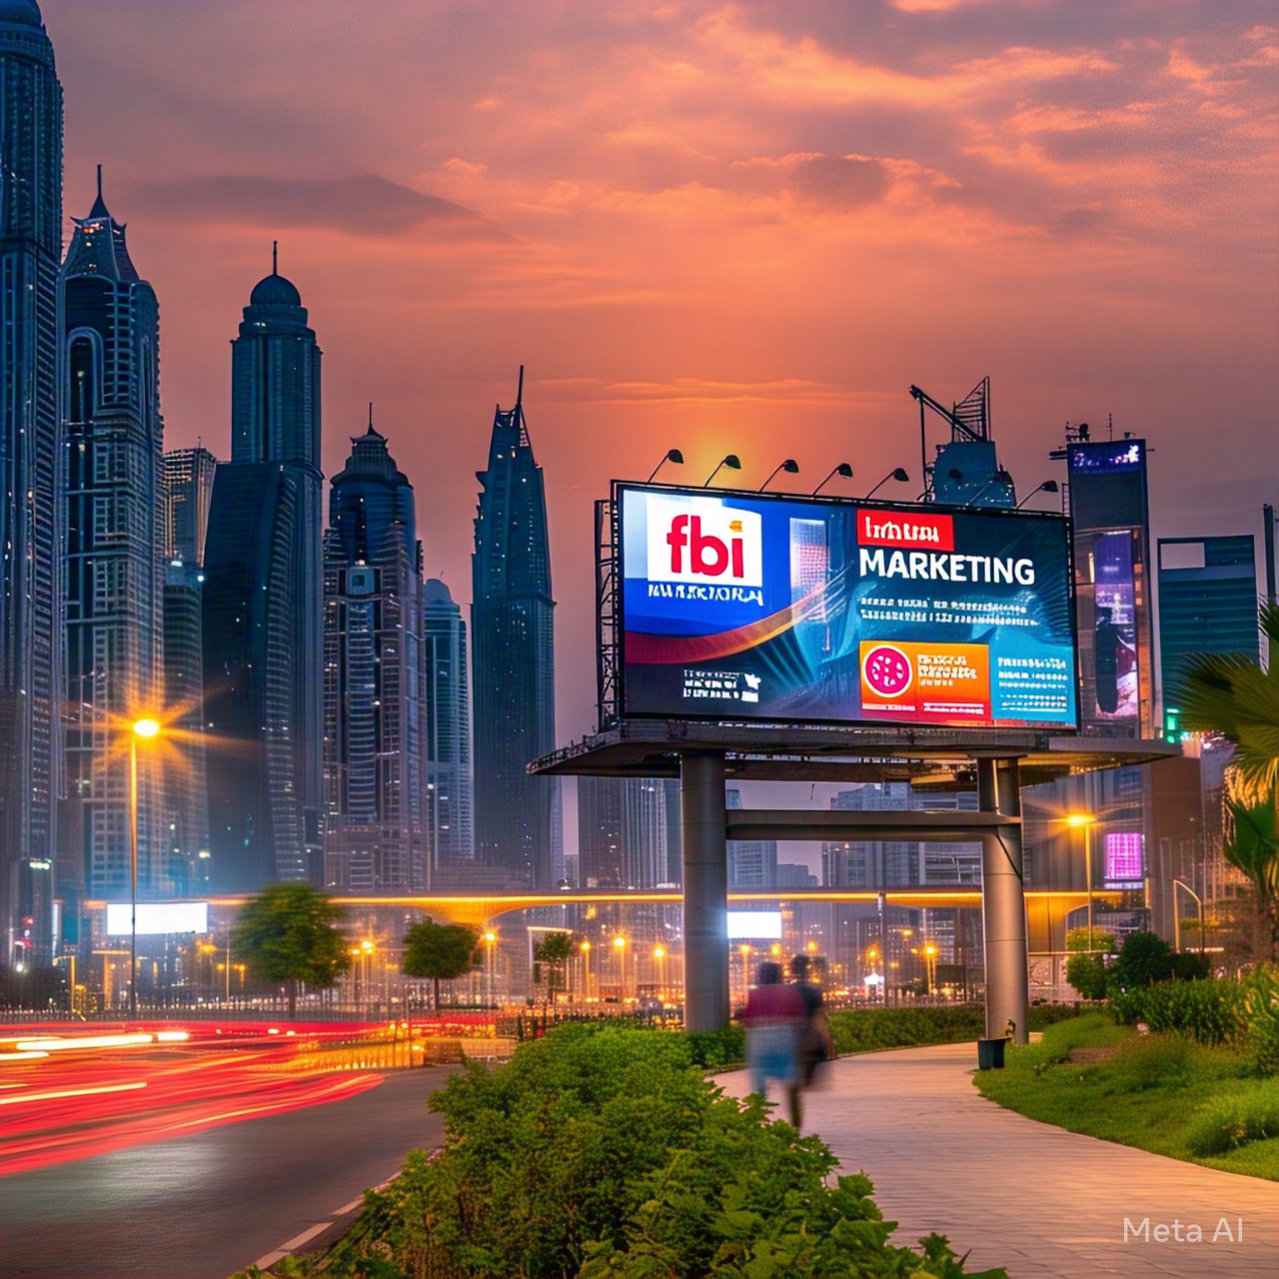

Digital Marketing Strategies

Fabindia has implemented a range of digital marketing strategies to promote its products and reach a wider audience. These strategies include:

- Social media marketing: Fabindia has a strong presence on social media platforms, including Facebook, Instagram, and Twitter.

- Email marketing: Fabindia uses email marketing to promote its products and offer exclusive discounts to its customers.

- Search engine optimization (SEO): Fabindia has optimized its website for search engines to improve its visibility and drive more traffic to its site.

- Pay-per-click (PPC) advertising: Fabindia uses PPC advertising to promote its products and drive more traffic to its site.

I hope this introduction to Fabindia has been helpful! Let me know if you have any further questions.

**Importance Of Fabindia**

1. Increased Online Visibility: Comprehensive digital marketing helps Fabindia increase its online visibility, reaching a wider audience and driving more traffic to its website.

2. Improved Brand Awareness: By leveraging multiple digital channels, Fabindia can build its brand awareness, establishing itself as a leader in the Indian retail industry.

3. Enhanced Customer Engagement: Comprehensive digital marketing enables Fabindia to engage with its customers more effectively, building loyalty and driving retention.

4. Increased Sales and Revenue: By driving more traffic to its website and engaging with customers more effectively, Fabindia can increase its sales and revenue.

5. Competitive Advantage: Comprehensive digital marketing helps Fabindia differentiate itself from its competitors, establishing a unique brand identity and voice.

6. Data-Driven Decision Making: By leveraging data analytics, Fabindia can make data-driven decisions, optimizing its marketing efforts and improving its ROI.

7. Cost-Effective: Comprehensive digital marketing is a cost-effective way for Fabindia to reach its target audience, reducing its marketing costs and improving its ROI.

8. Measurable Results: Comprehensive digital marketing provides Fabindia with measurable results, enabling it to track its progress and adjust its marketing efforts accordingly.

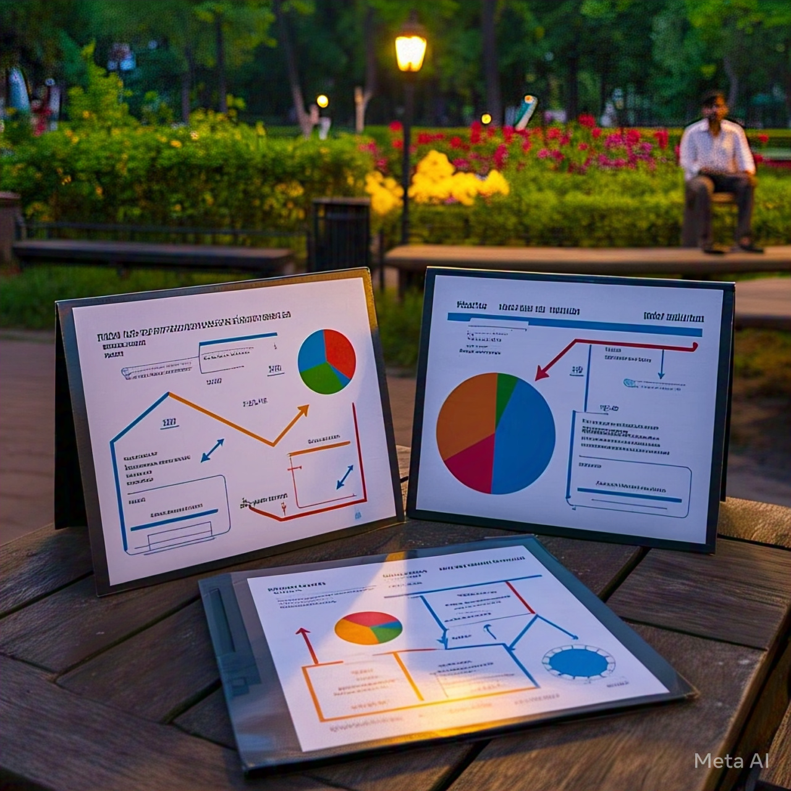

Benefits for Fabindia

1. Increased Market Share: Comprehensive digital marketing helps Fabindia increase its market share, establishing itself as a leader in the Indian retail industry.

2. Improved Customer Insights: By leveraging data analytics, Fabindia can gain valuable insights into its customers' behavior, preferences, and needs.

3. Enhanced Customer Experience: Comprehensive digital marketing enables Fabindia to provide its customers with a seamless and personalized experience, driving loyalty and retention.

4. Increased Efficiency: By automating many of its marketing tasks, Fabindia can increase its efficiency, reducing its marketing costs and improving its ROI.

Importance for Customers

1. Convenience: Comprehensive digital marketing provides Fabindia's customers with a convenient way to shop, enabling them to browse and purchase products online.

2. Personalization: By leveraging data analytics, Fabindia can provide its customers with personalized recommendations, offers, and content.

3. Accessibility: Comprehensive digital marketing enables Fabindia's customers to access its products and services from anywhere, at any time.

4. Engagement: By leveraging social media and other digital channels, Fabindia can engage with its customers more effectively, building loyalty and driving retention.

**Key Components**

1. Website: A user-friendly and responsive website that showcases Fabindia's products, values, and mission.

2. Search Engine Optimization (SEO): Optimizing the website and online presence to rank higher in search engine results pages (SERPs).

3. Pay-Per-Click (PPC) Advertising: Using platforms like Google Ads to run targeted ads and drive traffic to the website.

4. Social Media Marketing: Leveraging platforms like Facebook, Instagram, and Twitter to engage with customers, promote products, and build brand awareness.

5. Content Marketing: Creating high-quality content like blog posts, videos, and infographics to educate customers about Fabindia's products and values.

6. Email Marketing: Building an email list and sending regular newsletters to subscribers to promote products, offer discounts, and build customer loyalty.

7. Influencer Marketing: Partnering with influencers in the fashion, lifestyle, and sustainability spaces to promote Fabindia's products and values.

8. Customer Relationship Management (CRM): Using CRM software to manage customer interactions, track customer behavior, and personalize marketing efforts.

9. Data Analytics: Using data analytics tools to track website traffic, customer behavior, and marketing performance, and make data-driven decisions.

10. Artificial Intelligence (AI) and Machine Learning (ML): Leveraging AI and ML to personalize marketing efforts, optimize 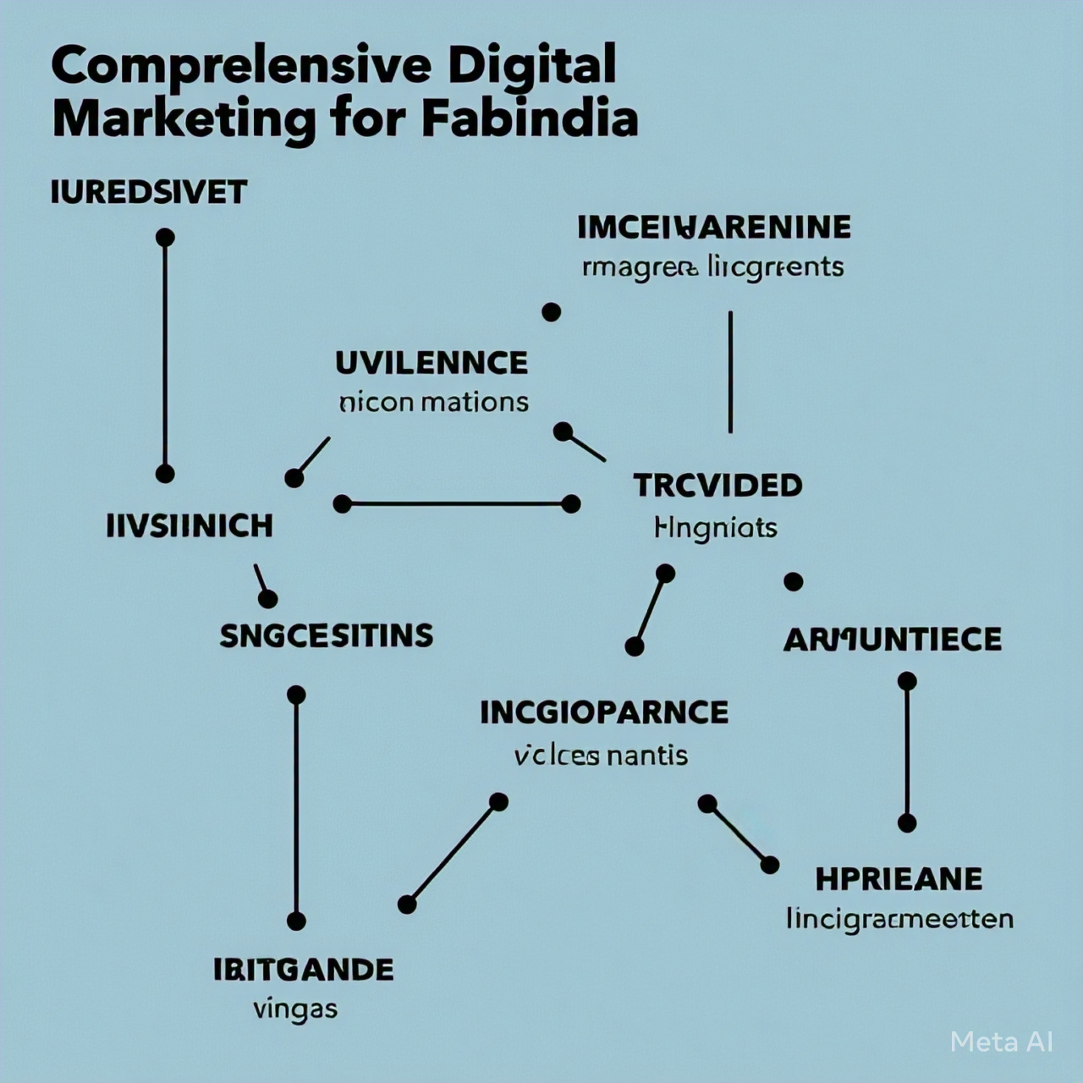business operations, and improve customer experience.

Digital Marketing Channels

1. Social Media: Facebook, Instagram, Twitter, Pinterest, YouTube

2. Email Marketing: Newsletter, promotional emails, transactional emails

3. Search Engine Marketing: Google Ads, Bing Ads

4. Content Marketing: Blog, video, infographic, podcast

5. Influencer Marketing: Partnerships with influencers

6. Affiliate Marketing: Partnerships with affiliates

7. Referral Marketing: Encouraging customers to refer friends and family

Key Performance Indicators (KPIs)

1. Website Traffic: Number of visitors, page views, bounce rate

2. Conversion Rate: Number of conversions, conversion rate

3. Social Media Engagement: Likes, shares, comments, followers

4. Email Open Rate: Number of opens, open rate

5. Customer Acquisition Cost (CAC): Cost of acquiring a new customer

6. Customer Lifetime Value (CLV): Value of a customer over their lifetime

7. Return on Investment (ROI): Return on investment for digital marketing efforts

**Indian retail company for Fabindia**

Mission Statement

"To provide high-quality, eco-friendly products that promote traditional Indian craftsmanship and support rural artisans, while creating a sustainable and responsible business model."

Objectives

1. Preserve Traditional Craftsmanship: Fabindia aims to preserve and promote traditional Indian craftsmanship, such as handloom weaving, block printing, and embroidery.

2. Support Rural Artisans: The company works with rural artisans to provide them with a sustainable livelihood and promote their skills.

3. Promote Eco-Friendly Products: Fabindia focuses on creating eco-friendly products that are made from natural materials, biodegradable, and non-toxic.

4. Create a Sustainable Business Model: The company strives to create a sustainable business model that is environmentally responsible, socially conscious, and economically viable.

Vision

"To be a leading retailer of eco-friendly, handmade products that promote traditional Indian craftsmanship and support rural artisans, while creating a positive impact on the environment and society."

Overall, Fabindia's purpose is to create a sustainable and responsible business model that promotes traditional Indian craftsmanship, supports rural artisans, and provides high-quality, eco-friendly products to customers.

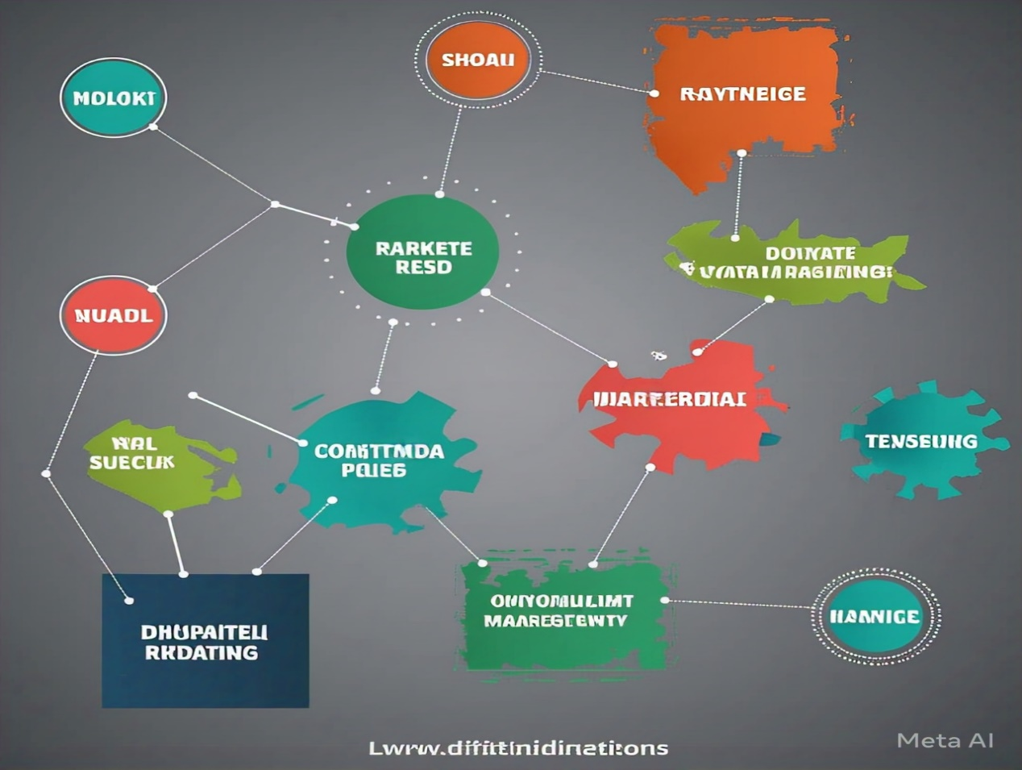

**Purpose of Fabindia**

Purpose Statement

Fabindia's purpose is to:

- Preserve and promote traditional Indian craftsmanship

- Support rural artisans and provide them with a sustainable livelihood

- Create high-quality, eco-friendly products that are made from natural materials

- Promote sustainable and responsible consumption practices

- Create a positive impact on the environment and society

Core Values

Fabindia's core values are:

- Sustainability: Fabindia is committed to sustainability in all aspects of its business, from sourcing materials to reducing waste.

- Quality: Fabindia is dedicated to creating high-quality products that meet the highest standards.

- Innovation: Fabindia encourages innovation and creativity in all aspects of its business.

- Transparency: Fabindia is committed to transparency in all its business practices.

- Fair Trade: Fabindia is committed to fair trade practices and works to ensure that all its artisans and suppliers are treated fairly and paid a fair price for their work.

Social Impact

Fabindia's purpose is not just to create high-quality products, but also to have a positive social impact. The company works to:

- Empower Rural Artisans: Fabindia works with rural artisans to provide them with a sustainable livelihood and promote their skills.

- Promote Traditional Crafts: Fabindia works to preserve and promote traditional Indian crafts, such as handloom weaving, block printing, and embroidery.

- Support Women's Empowerment: Fabindia works to empower women in rural areas by providing them with training and employment opportunities.

Environmental Impact

Fabindia's purpose is also to have a positive environmental impact. The company works to:

- Reduce Waste: Fabindia works to reduce waste in all aspects of its business, from sourcing materials to reducing packaging.

- Use Eco-Friendly Materials: Fabindia uses eco-friendly materials in all its products, such as organic cotton, silk, and wool.

- Promote Sustainable Practices: Fabindia promotes sustainable practices among its customers, such as reducing energy consumption and using public transport.

Overall, Fabindia's purpose is to create a positive impact on the environment and society, while also creating high-quality, eco-friendly products that promote traditional Indian craftsmanship.

**Advantages of Fabindia**

Increased Online Visibility

- Improved website ranking on search engines like Google

- Increased visibility on social media platforms like Facebook, Instagram, and Twitter

- Greater online presence through email marketing and influencer partnerships

Enhanced Brand Awareness

- Consistent branding across all digital platforms

- Increased recognition of Fabindia's values and mission

- Greater customer loyalty and retention

Improved Customer Engagement

- Personalized communication through email marketing and social media

- Interactive content like quizzes, contests, and surveys

- Increased customer feedback and reviews

Increased Website Traffic and Sales

- Targeted advertising through Google Ads and social media

- Optimized website design and user experience

- Increased conversions through clear calls-to-action and streamlined checkout process

Better Return on Investment (ROI)

- Measurable results through analytics and tracking

- Data-driven decision making for future marketing strategies

- Increased efficiency and reduced waste in marketing spend

Competitive Advantage

- Unique and compelling digital marketing strategy

- Differentiation from competitors through innovative content and campaigns

- Increased market share and leadership in the industry

Improved customer insights

- Data collection and analysis through website analytics and social media insights

- Deeper understanding of customer preferences and behaviors

- Increased ability to tailor marketing strategies to customer needs

Increased Flexibility and Scalability

- Ability to quickly adapt to changes in the market or industry

- Scalability of digital marketing efforts to reach new audiences and markets

- Increased agility and responsiveness to customer needs and preferences

**Disadvantages of Fabindia**

1. High Cost

- Developing and implementing a comprehensive digital marketing strategy can be expensive.

- Requires significant investment in technology, personnel, and advertising.

2. Complexity

- Comprehensive digital marketing involves multiple channels and tactics.

- Can be difficult to manage and coordinate efforts.

3. Measuring Success

- Can be challenging to measure the success of digital marketing efforts.

- Requires significant data analysis and interpretation.

4. Dependence on Technology

- Comprehensive digital marketing relies heavily on technology.

- Technical issues can disrupt marketing efforts.

5. Security Concerns

- Digital marketing involves collecting and storing customer data.

- Requires significant investment in security measures to protect customer data.

6. Over-saturation

- Comprehensive digital marketing can lead to over-saturation.

- Customers may become desensitized to marketing messages.

7. Lack of Personal Touch

- Digital marketing can lack the personal touch of traditional marketing.

- Customers may prefer to interact with humans rather than technology.

8. Negative Reviews

- Comprehensive digital marketing can make it easier for customers to leave negative reviews.

- Negative reviews can harm the reputation of the reputation of the brand.

Flow chart Disadvantage of Fabindia

1. High Cost

- Investment in technology, personnel, and advertising

→ Complexity

2. Complexity

- Multiple channels and tactics

→ Measuring Success

3. Measuring Success

- Data analysis and interpretation

→ Dependence on Technology

4. Dependence on Technology

- Technical issues can disrupt marketing efforts

→ Security Concerns

5. Security Concerns

- Protecting customer data

→ Over-saturation

6. Over-saturation

- Customers may become desensitized to marketing messages

→ Lack of Personal Touch

7. Lack of Personal Touch

- Customers may prefer to interact with humans

→ Negative Reviews

8. Negative Reviews:

Here are the applications of comprehensive digital marketing of Fabindia

**Applications for Fabindia**

1.E-commerce:

Fabindia can utilize comprehensive digital marketing to drive traffic and sales to its e-commerce platform.

2. Social Media:

Fabindia can leverage social media platforms like Facebook, Instagram, and Twitter to engage with customers, promote products, and build brand awareness.

3. Email Marketing:

Fabindia can use email marketing to nurture leads, promote products, and build customer loyalty.

4. Influencer Marketing:

Fabindia can partner with influencers to promote its products and reach new audiences.

5. Content Marketing:

Fabindia can create high-quality content like blog posts, videos, and infographics to educate customers about its products and values.

6. Search Engine Optimization (SEO):

Fabindia can optimize its website and online presence to rank higher in search engine results pages (SERPs) and drive organic traffic.

7. Pay-Per-Click (PPC) Advertising:

Fabindia can use PPC advertising to drive targeted traffic to its website and e-commerce platform.

8. Customer Relationship Management (CRM):

Fabindia can use CRM software to manage customer interactions, track customer behavior, and personalize marketing efforts.

9. Data Analytics:

Fabindia can use data analytics tools to track website traffic, customer behavior, and marketing performance, and make data-driven decisions.

10. Artificial Intelligence (AI) and Machine Learning (ML): Fabindia can leverage AI and ML to personalize marketing efforts, optimize business operations, and improve customer experience.

Industry Applications

1. Fashion and Apparel:

Fabindia can apply comprehensive digital marketing to promote its fashion and apparel products.

1. Home and Furniture:

Fabindia can use comprehensive digital marketing to promote its home and furniture products.

1. Lifestyle and Wellness:

Fabindia can apply comprehensive digital marketing to promote its lifestyle and wellness products.

1. E-commerce and Retail:

Fabindia can use comprehensive digital marketing to drive traffic and sales to its e-commerce platform and retail stores.

Business Applications

1. Lead Generation:

Fabindia can use comprehensive digital marketing to generate leads and drive conversions.

1. Customer Acquisition:

Fabindia can apply comprehensive digital marketing to acquire new customers and drive business growth.

1. Customer Retention:

Fabindia can use comprehensive digital marketing to retain existing customers and build customer loyalty.

1. Brand Awareness:

Fabindia can apply comprehensive digital marketing to build brand awareness and establish itself as a leader in the industry.

- Harm to reputation of the brand

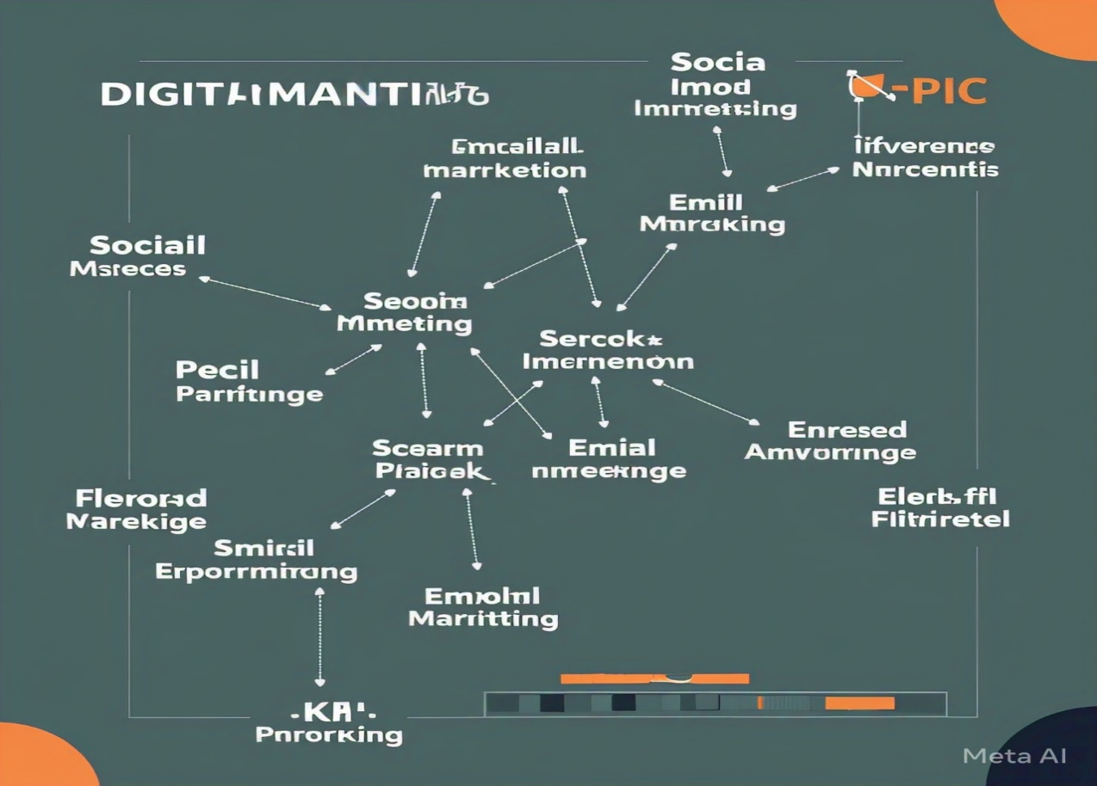

**Conclusion of Fabindia**

Fabindia's comprehensive digital marketing strategy has been successful in promoting the brand's values, products, and mission. By leveraging various digital channels, Fabindia has been able to:

- Increase brand awareness and reach a wider audience

- Drive website traffic and sales

- Engage with customers and build a loyal community

- Promote sustainable and responsible consumption practices

Key Takeaways

1. Integrated Approach:

Fabindia's comprehensive digital marketing strategy has demonstrated the importance of an integrated approach, combining multiple digital channels to achieve business objectives.

1. Customer-Centricity:

Fabindia's focus on customer engagement and experience has been critical to its success, highlighting the importance of putting customers at the heart of digital marketing efforts.

1. Sustainability:

Fabindia's commitment to sustainability and responsible consumption practices has resonated with customers, demonstrating the importance of aligning digital marketing efforts with brand values.

Future Directions

1. Artificial Intelligence (AI) and Machine Learning (ML): Fabindia can leverage AI and ML to enhance customer experience, personalize marketing efforts, and optimize business operations.

2. Influencer Marketing:

Fabindia can partner with social media influencers to promote its products and values, reaching new audiences and building brand awareness.

3.Video Marketing:

Fabindia can utilize video marketing to showcase its products, tell brand stories, and engage with customers, capitalizing on the growing demand for video content.

By continuing to innovate and adapt to changing market trends, Fabindia can further solidify its position as a leader in the Indian retail industry

