LAB Logbook

Lab 1

**CODE:**

import numpy as np

SID = 23750107

last_two_digits = int(str(SID)[-2:])

if last_two_digits < 10:

    num_elements = last_two_digits + 100

else:

    num_elements = last_two_digits

a = np.arange(num_elements)

a_2d = a.reshape(1, -1)

print(a_2d)

b = a_2d.copy()

print(b)

print(a_2d.shape)

print(b.shape)

**OUTPUT:**

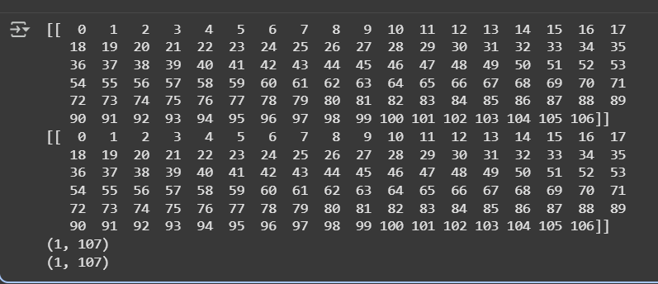

Lab 2

**CODE:**

import pandas as pd

data = pd.DataFrame({

    "relationship": ["Husband", "Wife", "Own-child", "Not-in-family", "Husband", "Wife"],

    "hours-per-week": [40, 50, 60, 20, 55, 45]

})

n = 10

def reduce_hours(x):

    return x - n

data["reduced_hours"] = data["hours-per-week"].apply(reduce_hours)

grouped_original=data.groupby(["relationship","hours-per-week"]).size().reset_index(name="count")

grouped_reduced=data.groupby(["relationship", "reduced_hours"]).size().reset_index(name="count")

print("Original Grouping (relationship + hours-per-week):")

print(grouped_original, "\n")

print("Reduced Grouping (relationship + reduced_hours):")

print(grouped_reduced)

**OUTPUT:**

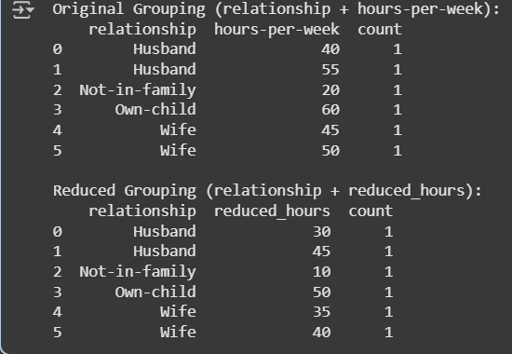

Lab 3

**CODE:**

import pandas as pd

import matplotlib.pyplot as plt

# Example DataFrame with columns 0-9

# Replace this with your actual dataset

data = pd.DataFrame({

0: [1, 2, 3, 4, 5, 6, 7, 8, 9, 10],

1: [10, 9, 8, 7, 6, 5, 4, 3, 2, 1],

2: [5, 4, 3, 2, 1, 0, -1, -2, -3, -4],

3: [2, 3, 2, 3, 2, 3, 2, 3, 2, 3],

4: [1, 3, 5, 7, 9, 11, 13, 15, 17, 19],

5: [2, 4, 6, 8, 10, 12, 14, 16, 18, 20],

6: [3, 6, 9, 12, 15, 18, 21, 24, 27, 30],

7: [1, 4, 7, 10, 13, 16, 19, 22, 25, 28],

8: [0, 1, 0, 1, 0, 1, 0, 1, 0, 1],

9: [5, 3, 1, -1, -3, -5, -7, -9, -11, -13]

})

# Select the two columns from your SID

col1, col2 = 0, 1

plt.figure(figsize=(8,6))

plt.scatter(data[col1], data[col2], c='blue', label=f'Col {col1} vs Col {col2}')

plt.xlabel(f'Column {col1}')

plt.ylabel(f'Column {col2}')

plt.title(f'Bicolour Features Interaction Diagram: Col {col1} vs Col {col2}')

plt.legend()

plt.grid(True)

plt.show()

**OUTPUT:**

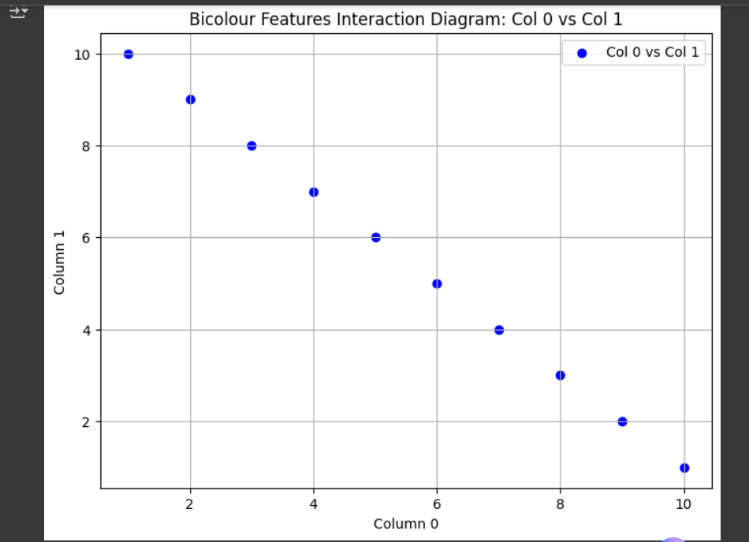

Lab 4

**CODE:**

import numpy as np

from tensorflow.keras.models import Sequential

from tensorflow.keras.layers import Dense

from tensorflow.keras.optimizers import Adam

from sklearn.model_selection import train_test_split

from sklearn.metrics import mean_absolute_error

from sklearn.preprocessing import MinMaxScaler

X = np.random.rand(1000, 10)  # 10 input features

y = np.random.rand(1000, 1)   # 1 target variable

scaler = MinMaxScaler()

X_scaled = scaler.fit_transform(X)

X_train, X_test, y_train, y_test = train_test_split(X_scaled, y, test_size=0.2, random_state=42)

model = Sequential()

model.add(Dense(10, activation='relu', input_shape=(X.shape[1],)))  # First hidden layer

model.add(Dense(5, activation='relu'))  # Second hidden layer

model.add(Dense(1))  # Output layer

model.compile(optimizer=Adam(), loss='mae', metrics=['mae'])

model.summary()

history = model.fit(X_train, y_train, epochs=10, validation_split=0.2)

mae = model.evaluate(X_test, y_test, verbose=0)[1]

print(f"Test MAE: {mae:.4f}")

**OUTPUT:**

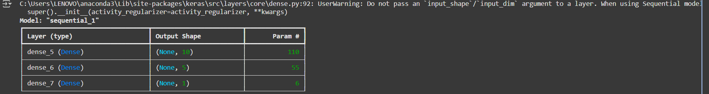

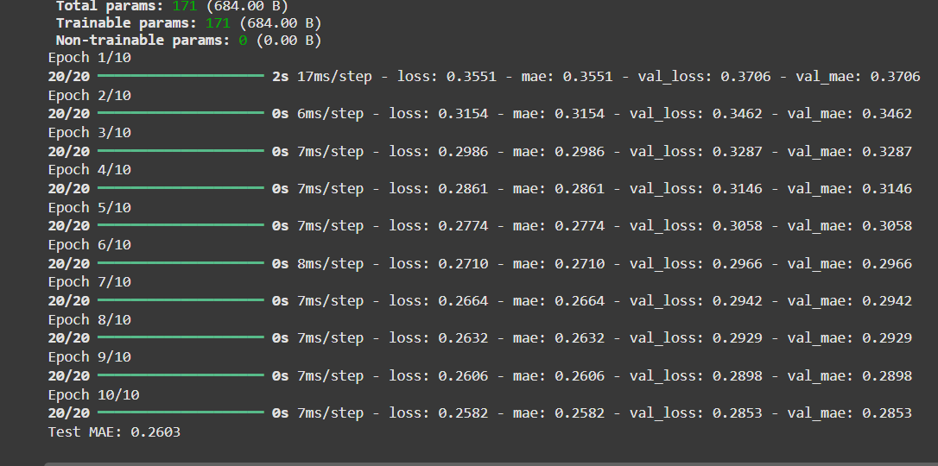

Lab 5

**CODE:**

import tensorflow as tf

from tensorflow.keras import layers, models

from tensorflow.keras.datasets import cifar10

import matplotlib.pyplot as plt

# Load dataset

(x_train, y_train), (x_test, y_test) = cifar10.load_data()

x_train, x_test = x_train / 255.0, x_test / 255.0

# Build CNN

model = models.Sequential([

    layers.Conv2D(32, (5, 5), activation='relu', input_shape=(32, 32, 3)),

    layers.MaxPooling2D((2, 2)),

    layers.Conv2D(64, (5, 5), activation='relu'),

    layers.MaxPooling2D((2, 2)),

    layers.Flatten(),

    layers.Dense(64, activation='relu'),

    layers.Dense(10)

])

# Compile model

model.compile(optimizer='adam',

              loss='mean_squared_error',

              metrics=['mae'])

# Model summary

model.summary()

# Train CNN

history = model.fit(

    x_train, y_train,

    epochs=10,

    batch_size=50,

    validation_data=(x_test, y_test)

)

# Evaluate

test_loss, test_mae = model.evaluate(x_test, y_test, verbose=2)

print(f"\nTest MAE: {test_mae:.4f}")

# Plot MAE

plt.figure(figsize=(8, 5))

plt.plot(history.history['mae'], label='Train MAE')

plt.plot(history.history['val_mae'], label='Validation MAE')

plt.title('Model MAE During Training')

plt.xlabel('Epoch')

plt.ylabel('MAE')

plt.legend()

plt.grid(True)

plt.show()

**OUTPUT:**

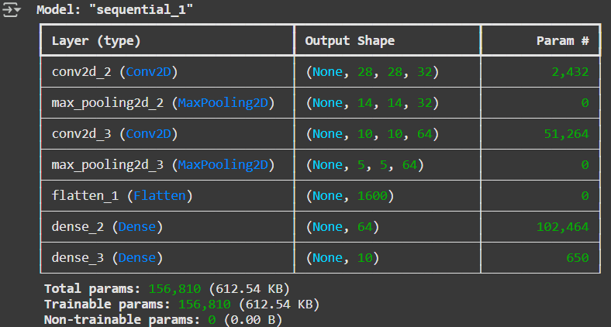

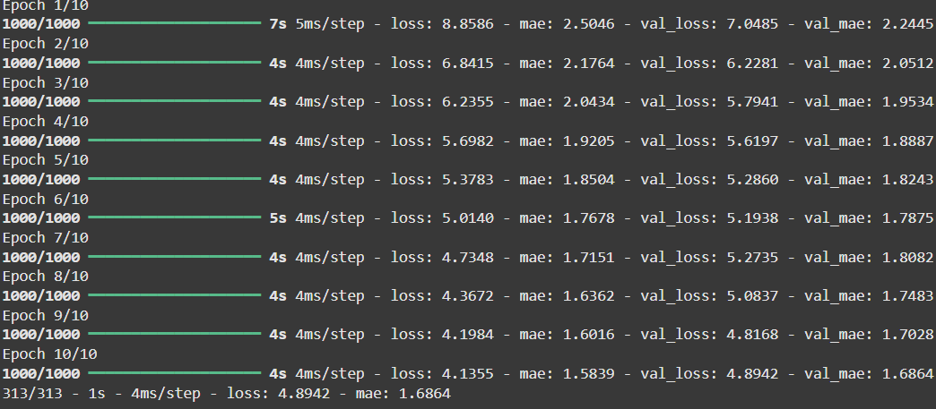

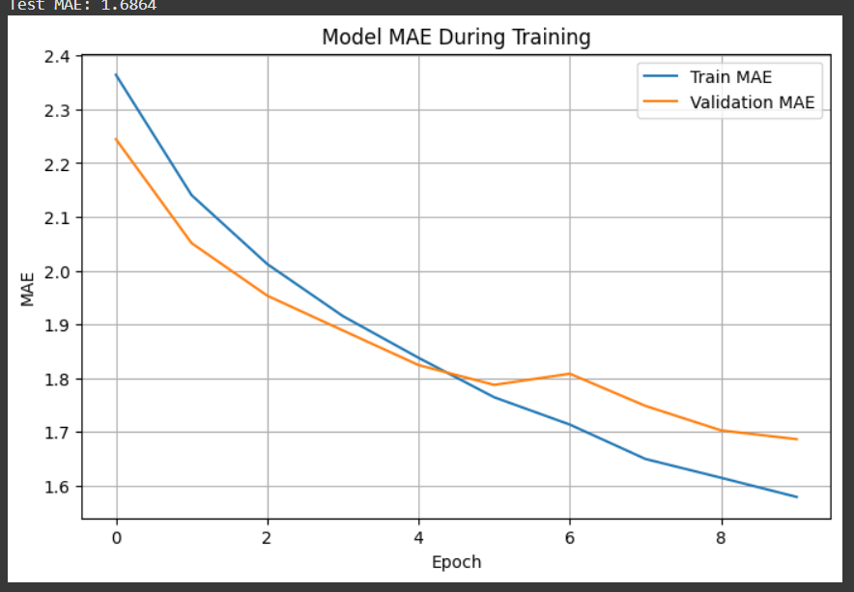

Lab 6

Lab 7

Lab 8

Lab 9

Lab 10

Lab 11

Lab 12