**A.AA.**

**आपकी आवाज़**

**BUSINESS PROPOSAL**

Prepared for e-Yantra Innovation Challenge 2023

Prepared by

Team #308

November 7, 2022

Executive Summary

This business proposal consists of the details of the creation of an online translating service for a person with disabilities (hearing and speaking or both). This is a solution to the problem of the conversation gap between people with hearing and speaking disabilities. The objective of this solution is to reduce the conversation gap between people with disabilities and us to provide an equitable environment in work culture and personal conversations. This solution aims to provide independence to the person with disabilities who needed a translator with them.

Problem

One's ability to communicate differs with time and age. Speaking is only one of many ways to communicate, and language by itself is a complicated subject in India, where a 2010 linguistic survey concluded that a whopping 780 languages were spoken. Furthermore, those possessing speech impairments accounted for 7% of the total 26.8 million PwD population recorded in the 2011 Census. Speech articulation, sound enhancement, and body movement learning are critical for making sure that the ability to communicate is not out of reach for those that cannot, and technologies are required for the same.

Solution

A platform where the sign language would be converted to text or speech and vice versa according to users' wishes would make it easier for a person with a disability and a normal person with no knowledge of sign language communicates with each other seamlessly without any disturbance or barrier.

Objectives

**Aarp ki Awaz** will aim to meet the following project objectives:

• to erase the communication gap between us and people with disability

• to create an inclusive environment

• to make people with disability self-dependent



Benefits

This project will reduce the communication gap between us and people with disabilities to a great extent which would create an inclusive environment. This also opens doors for them to be part of the corporate world hence making them financially independent. In addition to all these advantages, their mental health would also be benefitted.

List of features :

* Action to speech
* Speech to text
* Text to speech
* Text to action
* Speech to action
* Action to text
* Action Plan :

Step 1: Collecting the data from the database ( images of sign language for detection)

Step 2: Creation of the video-to-speech module using the data we create by using ml.

Step 3: Deployment of this module in an online accessible platform that is easy to use.

Step 4: And here we are ready to go !!!!

Beneficiaries :

* People with hearing disabilities to communicate with normal people who don’t know sign language

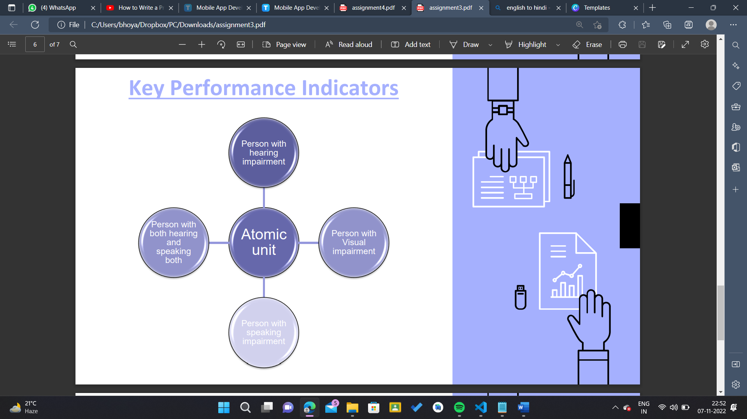

* People who have lost their eyesight to communicate with people who have difficulty in speaking. As we have the text-to-speech feature too.
* Everyone would be able to communicate with each other in one or the other way as the features that we have are sufficient for all that.

How would we earn?

1. Ad revenue: We would be adding some advertisements for some extra bucks but the convenience would be taken care of and they won’t feel that the website isn’t authentic.

2. Subscription model: This would be for the regular users of our site who use this feature a lot and enjoy it in addition to this they have built trust in us. Institutions like government institutions, and corporate companies would also need to be subscribed first to use this model.