Radhika Chauhan

University of texas at dallas | Spring 2020

Final Project

Predictive analytics using sas

Brand Choice Analysis

We have data on detergent purchased from variety of supermarkets. There are variety of choices available. We observe consumer choices from the characteristics provided by the data. As the utility varies by the characteristics of the choices of the brands and each brand has different price, market share and promotions. The customer chooses brand with highest utility. Therefore, the multinomial conditional logit(MNL) aligns perfectly. As we are considering both customer characteristics as well as product characteristics we are using conditional multinomial logit.

ANALYSIS using Multinomial conditional logit:

I used top three brands along with the brand assigned which is TIDE, ALL, PUREX and WISK. I used Multinomial logit to see how the brand specific variables (Price per unit ounce of the brand) and non-brand specific variables like the income of the households, Family size of the house hold and Race has an affect on the choice of the customer. Brands in the output are:

Brand1 – TIDE; Brand2 – ALL; Brand3 – PUREX ; Brand4 – WISK. Our base brand is TIDE.

**Model-1 – Having interaction of price and display**

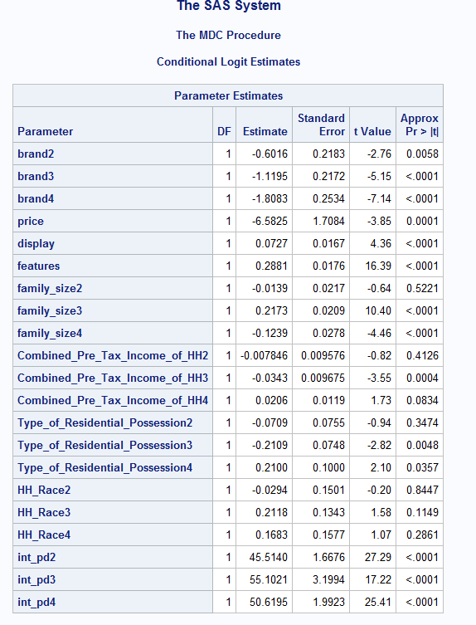

1. The order of preference of a customer going to the store and selection of brand is: Brand1>brand2>brand3>brand4.
2. Customers are less likely to prefer brand4(Wisk) as compared to other brands.
3. For any brand, as average price per unit increases by one point, the probability of selecting that brand decreases as the price coefficient is negative.
4. When a brand is featured, the probability of a customer choosing the brand increases as compared to when the brand is not featured.
5. When the brand is on display, the probability of a customer choosing that brand increases as compared to when that brand is not on display.
6. As the number of family member increases by 1 , customers are less likely to prefer wisk brand as compared to other brands. For selection of brand 2(ALL) is same as brand1 (Tide) as the coefficient is insignificant.

7. Family_size3 – This is the multinomial logit estimate for when family size increases from regular (1,2,3) to large family size (4,5,6) the selection for brand3- PUREX is more than all other brands(TIDE,ALL,WISK).

8. Combined_Pre_Tax_Income4- This is the multinomial logit estimate for when INCOME bracket increases from low to medium or medium to high for Wisk relative to other brands, given the other variables in the model are held constant, for brand 4(Wisk) is higher as compared to Brand1(Tide).

9. All Interaction terms are significant and positive. That means the more positive is display the more positive effect of price is on the customer choice, alternatively the more negative display is, the more negative effect of price is on customer selection.

Model 2 – Having interaction of Price and Feature.

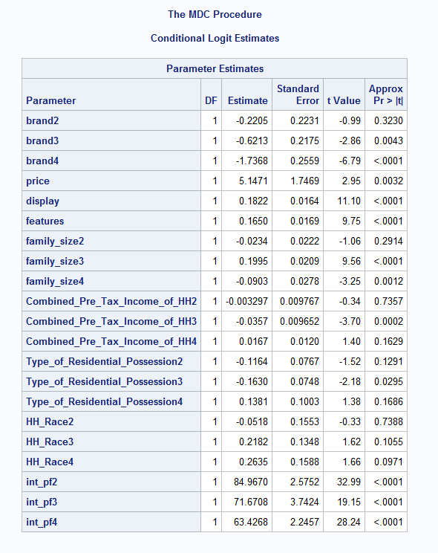

1. The order of preference of a customer going to the store and selection of brand is: brand1=brand2>brand3>brand4.

Customers are less likely to prefer brand4(wisk) as compared to other brands.

1. For any brand, as average price per unit increases by one point, the probability of selecting that brand increases as the price coefficient is postive.
2. When a brand is featured, the probability of a customer choosing the brand increases as compared to when the brand is not featured.
3. When the brand is on display, the probability of a customer choosing that brand increases as compared to when that brand is not on display.
4. As the number of family member increases by 1 , customers are less likely to prefer wisk brand as compared to other brands. For selection of brand 2(ALL) is same as brand1 (Tide) as the coefficient is insignificant.
5. Family_size3 – This is the multinomial logit estimate for when family size increases from regular (1,2,3) to large family size (4,5,6) for brand3- PUREX is more than all other brands(TIDE,ALL,WISK).
6. Family_size2- For Brand2- All as family size increases from regular to large it has same effect as compared to brand1-TIDE.
7. Combined_Pre_Tax_Income4- This is the multinomial logit estimate for when INCOME bracket increases from low to medium or medium to high for Wisk relative to other brands, given the other variables in the model are held constant, the selection for brand 4(Wisk) is same as compared to Brand1(Tide).
8. All Interaction terms are significant and positive. That means the more positive is feature the more positive effect of price is on the customer choice, alternatively the more negative feature is, the more negative effect of price is on customer selection.

Model-3 – with no interaction terms.

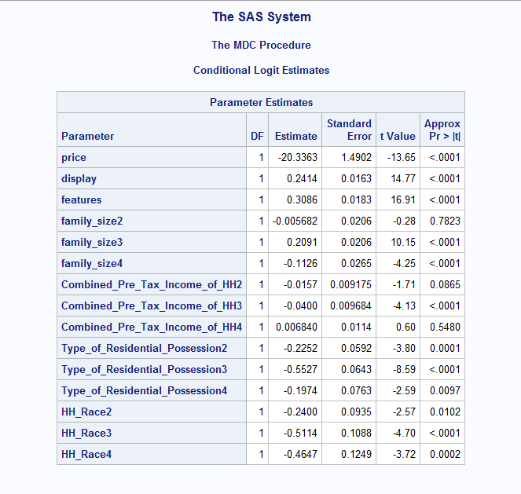

1. For any brand, as average price per unit increases by one point, the probability of selecting that brand decreases as the price coefficient is negative.
2. When a brand is featured, the probability of a customer choosing the brand increases as compared to when the brand is not featured.
3. When the brand is on display, the probability of a customer choosing that brand increases as compared to when that brand is not on display.
4. As the number of family member increases by 1 , customers are less likely to prefer wisk brand as compared to other brands.
5. Family_size2- For Brand2- All as family size increases from regular to large it has same effect as compared to brand1-TIDE.
6. Family_size4- This is the multinomial logit estimate for when family size increases from regular (1,2,3) to large family size (4,5,6)the selection for brand4-Wisk is least preferable than all other brands(TIDE,ALL,WISK).
7. Combined_Pre_Tax_Income4- This is the multinomial logit estimate for when income bracket increases from low to medium or medium to high for Wisk relative to other brands, given the other variables in the model are held constant, for brand 4(Wisk) is same as compared to Brand1(Tide).

Model with no interaction Model with price and display interaction



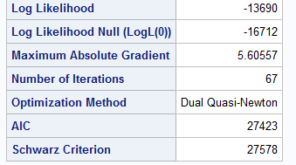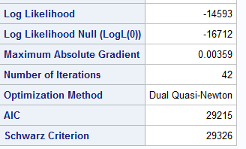

Model With Interaction of price and feature

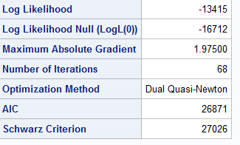As We can see Model tends to improve as interaction effect are taken in account because likelihood tends to become larger closer to 0. AIC and BIC is also decreasing as the interactions terms are added.

Conclusions:-

Higher display and feature of the brand helps in increasing the probability of choosing the brand. Lesser is the price more probability of choosing that brand.