CLUSTER COMPUTING
CSN 221

Leshna Balara 18114044
Radhika 18114060
Balne Niteesha 18114017
Karanpreet Singh 18114036
Akshat Jain 18116006
Armaan Pareek 18116017
Ashutosh Bharambe 18116019

Submitted to: Assoc. Prof .Sateesh Kumar Peddoju

Abstract

Cluster Computing is one of the most absorbing innovations in the recent past. A computer cluster is a set of loosely or tightly connected computers that work together so that, in many respects, they can be viewed as a single system. Computer clusters have each node set to perform the same task, controlled and scheduled by software. It is quite impossible for independent researchers to afford a costly super-computer and exploit all its benefits. Our project focuses on basic implementation of small heterogenous cluster. We implemented a Beowulf like cluster with master slave hierarchy. To optimize performance with minimal cost we will try to address issues of software choice , configuration, networking and implementation of algorithms for dedicated tasks.

We will also try to further enhance our knowledge on OPENACC , to further use the power of multicore systems to make the program inherently parallel and thus optimizing the execution time.

Computer Organization is the study of internal working , structuring and implementation of a computer system. This project would enable us to expand on the implementation part by maximizing the hardware and software utilities of a single computer.

Keywords: Beowulf like cluster ,heterogenous cluster , openacc ,parallel

CLUSTER COMPUTING
CSN 221

The idea of cluster computing may be odd to someone new to the computing world, but clustering computers is not a new idea. Clustering theory dates back to as early as 1970. IBM was the first company to implement the clustering theory into its design. The formal engineering basis of cluster computing as a means of doing parallel work of any sort was arguably invented by Gene Amdahl of IBM, who in 1967 published what has come to be regarded as the seminal paper on parallel processing: Amdahl's Law. A computer cluster is a single logical unit consisting of multiple computers that are linked through a LAN. The networked computers essentially act as a single, much more powerful machine. A computer cluster provides much faster processing speed, larger storage capacity, better data integrity, superior reliability and wider availability of resources. Unlike homogeneous sensor network which consists of identical nodes, a heterogeneous sensor network consists of two or more types of nodes (organized into hierarchical clusters).A heterogeneous cluster environment can contain processors and devices with different bandwidth and computational capabilities .We choose Linux as an operating system because Linux is well known for being an easy-to-use commodity, reliability and fully free for all. No other Operating System allows for this level of versatility.

Mpich + OpenACC
OpenACC is a user-driven directive-based performance-portable parallel programming model designed for scientists and engineers interested in porting their codes to a wide-variety of heterogeneous HPC hardware platforms and architectures with significantly less programming effort than required with a low-level model. OpenACC enables us to exploit the power of multicore nodes in the cluster. MPI (Message Passing Interface) is a specification for the developers and users of message passing libraries. By itself, it is NOT a library - but rather the specification of what such a library should be. MPI primarily addresses the message-passing parallel programming model: data is moved from the address space of one process to that of another process through cooperative operations on each process. We use the power of both MPI and OpenACC to not only parallelize the implementation among nodes but also to parallelize the implentation on a single node.
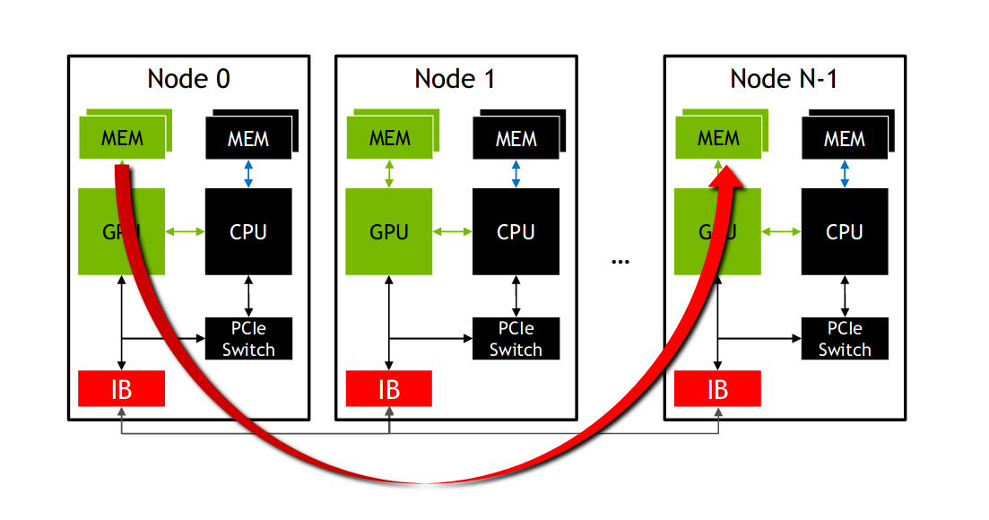

Why Linux
We choose Linux as an operating system because Linux is well known for being an easy-to-use commodity, reliability and fully free for all. No other Operating System allows for this level of versatility.

why Fedora
We initially planned on using OSCAR (Open Source Cluster Application Resourses) , which provided better support for Fedora (RedHat OS)

MPICH
MPICH is a high performance and widely portable implementation of the Message Passing Interface (MPI) standard.
MPICH and its derivatives form the most widely used implementations of MPI in the world. They are used exclusively on nine of the top 10 supercomputers (June 2016 ranking), including the world’s fastest supercomputer: Taihu Light.

alternatives explored
We initially planned on using OSCAR (Open Source Cluster Application Resourses) , but faced numerous difficulties due to old and out-of-date documentation . We resorted to mpich due to beginner friendly guides.

OpenACC
OpenACC is an open specification for compiler directives for parallel programming. By using OpenACC, developers can rapidly accelerate existing C, C++, and Fortran applications using high-level directives that help retain application portability across processor architectures.
We already had a hands-on-experience of using OpenACC due to a workshop conducted by NVIDIA with the efforts of our instructor .

IMPLEMENTATION

Installing Fedora30

Download Fedora 30 Workstation ISO File
Once the ISO file is downloaded, then burn it either in USB drive or DVD and make it bootable.

Boot Your Target System with Bootable media (USB Drive or DVD)
Reboot the target machine ,.Set the boot medium as USB or DVD from Bios settings so system boots up with bootable media.

Choose Start Fedora-Workstation-30 Live
When the system boots up with bootable media then we will get the following screen, to begin with installation on your system’s hard disk, choose “Start Fedora-Workstation-30 Live“

Select Install to Hard Drive Option

Choose Installation destination and partition Scheme
In the next screen we will see the local available hard disk, select the disk that that contains the space freed earlier and then choose how you want to create partitions on it from storage configuration tab.
If you choose “Automatic” partition scheme, then installer will create the necessary partition for your system automatically but if you want to create your own customize partition scheme then choose “Custom” option.
After creating the suitable partition move to the next window, click on Done

Configuring Mpich
#This unzips the tar file
tar -xzf mpich-3.3.1.tar.gz
#This enters the folder created on unzipping the tar file
cd mpich-3.3.1
#This will configure the prerequisites for cluster formation
./configure --disable-fortran
make
sudo make install
#If configuration is successful this command will give the version
mpiexec –version

Configuring Master Node
#Add the client computer's IP Addresses to /etc/hosts
cat /etc/hosts;
#This will create a new user named mpiuser
sudo adduser mpiuser;
#This will let you set password for mpiuser
sudo passwd mpiuser;
#Setting up SSH

#install ssh
sudo dnf install -y openssh-server;
#start ssh service on device
sudo systemctl start sshd.service;
sudo systemctl enable sshd.service;
#login to the created user 'mpiuser'
su - mpiuser
#Generate SSH keys and copy them to the machines' list of authorized_keys
ssh-keygen -t rsa
ssh mpiuser@client mkdir -p .ssh
cat .ssh/id_rsa.pub | ssh mpiuser@client 'cat >> .ssh/authorized_keys'
ssh mpiuser@client 'chmod 700 .ssh'
chmod 640 .ssh/authorized_keys
#This will create a folder in $HOME for mpiuser named cloud that is shared in cluster
mkdir cloud
exit
#Install NFS service
sudo dnf -y install nfs-utils
#add the n=given folder to /etc/exports
echo "ADD /home/mpiuser/cloud *(rw,sync,no_root_squash,no_subtree_check) to /etc/exports"
#This will open the /etc/exports folder in vi editor
sudo vi /etc/exports
#This should be run everytime ther is a change in /etc/exports
exportfs -a
#this will start the nfs service
sudo systemctl start rpcbind nfs-server
sudo systemctl enable rpcbind nfs-server

echo "ssh and nfs have been setUp\n add all cluster IPs to /etc/hosts"

Configuring Client Node
#Add the client computer's IP Addresses to /etc/hosts
cat /etc/hosts;
#This will create a new user named mpiuser
sudo adduser mpiuser;
#This will let you set password for mpiuser
sudo passwd mpiuser;

#Setting up SSH
#install ssh
sudo dnf install -y openssh-server;
#start ssh service on device
sudo systemctl start sshd.service;
sudo systemctl enable sshd.service;
#login to the created user 'mpiuser'
su - mpiusera
#Generate SSH keys and copy them to the machines' list of authorized_keys
ssh-keygen -t rsa
ssh mpiuser@master mkdir -p .ssh
cat .ssh/id_rsa.pub | ssh mpiuser@master 'cat >> .ssh/authorized_keys'
ssh mpiuser@master 'chmod 700 .ssh'
chmod 640 .ssh/authorized_keys
#This will create a folder in $HOME for mpiuser named cloud that is shared in cluster
mkdir cloud
exit
#Install NFS service
sudo dnf -y install nfs-utils
#mount the shared directory
sudo mount -t nfs master:/home/mpiuser/cloud /home/mpiuser/cloud
#to check the mounted directories
df -h
#Create a systems table in /etc/fstab
echo "Add master:/home/mpiuser/cloud /home/mpiuser/cloud nfs to /etc/fstab"
sudo vi /etc/fstab

Problems encountered: Firewall hinders in the communication established by MPICH,
thus throwing NFS (Network File System) errors , thus firewall had to be disabled

Understanding and implementing Jacobi Method
Let
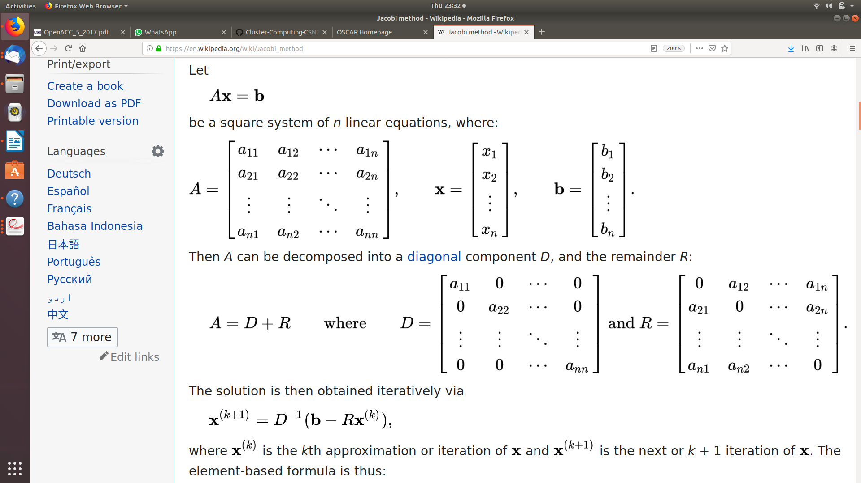

be a square system of n linear equations, where:

Then A can be decomposed into a diagonal component D, and the remainder R:
The solution is then obtained iteratively via
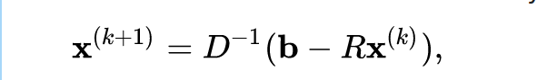

where is the kth approximation or iteration of and is the next or k + 1 iteration of . The element-based formula is thus:
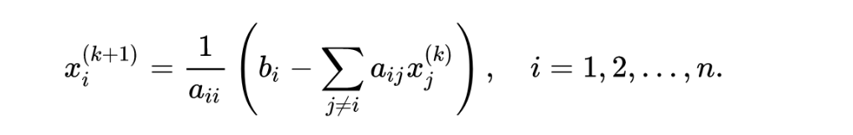

The computation of xi(k+1) requires each element in x(k) except itself. Unlike the Gauss–Seidel method, we can't overwrite xi(k) with xi(k+1), as that value will be needed by the rest of the computation. The minimum amount of storage is two vectors of size n

Identifying loops to be parallelized
Identify section of a code consuming the significant percentage of time (hot spots). We used gprof (profiling tool ) to analyze the execution time.

Using kernal construct to parallelize
The kernels construct expresses that a region may contain parallelism and the compiler determines what can safely be parallelized.
#pragma acc kernels
for (int j = jstart; j < jend; j++)
{
for( int i = 1; i < M-1; i++ )
{
Anew[j][i] = 0.25f * ( A[j][i+1] + A[j][i-1]
+ A[j-1][i] + A[j+1][i]);
error = fmaxf( error, fabsf(Anew[j][i]-A[j][i]));
}
}
#pragma acc kernels
for( int i = 1; i < M-1; i++ )
{
A[jstart][i] = Anew[jstart][i];
A[jend-1][i] = Anew[jend-1][i];
}

#pragma acc kernels async
for (int j = (jstart+1); j < (jend-1); j++)
{
for( int i = 1; i < M-1; i++ )
{
A[j][i] = Anew[j][i];
}
}

Distributing processes using mpich

Building the project
all: run
laplace2d: laplace2d.c common.h laplace2d_serial.h Makefile
mpicc -Ofast -pg laplace2d.solution.c -lm -o laplace2d
clean:
rm -f laplace2d
run: laplace2d
mpirun -np 9 --hosts rg,client,client2 ./laplace2d
profile: laplace2d
mpirun -np 2 nvprof -o laplace2d.%q{OMPI_COMM_WORLD_RANK}.nvvp ./laplace2d

TESTING

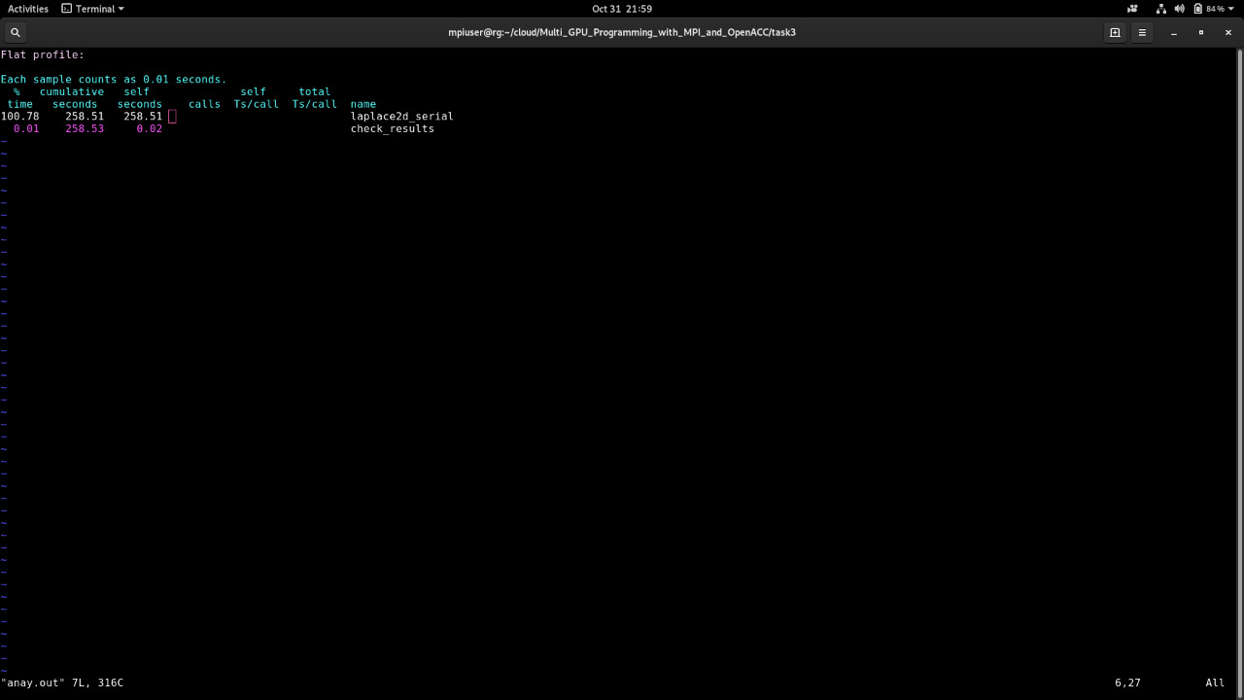
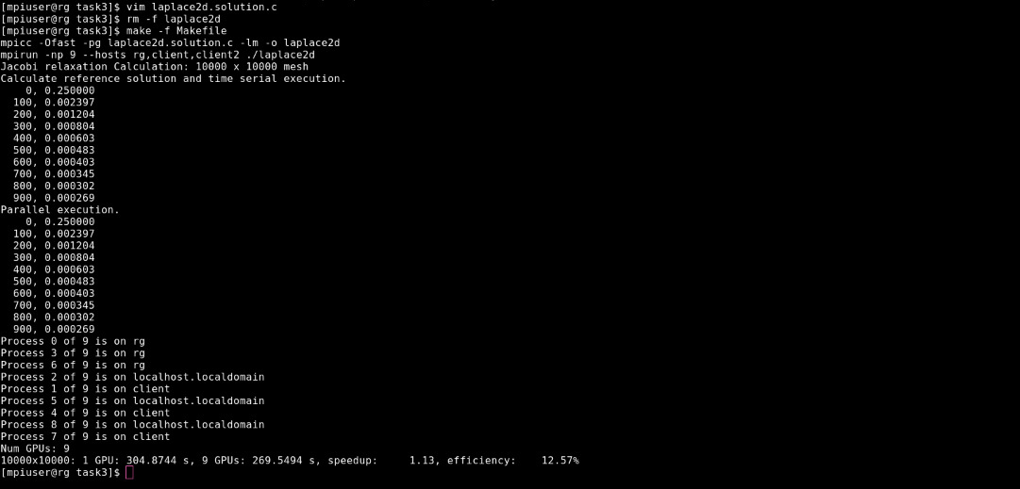

RESULT AND CONCLUSION
We noted a speedup of 1.13 . Although it can be noted that the efficiency is low.
This is a drawback of Beowulf like cluster ,they add complexity in terms of both designing the different heterogeneous elements and the additional programming effort to decide when and how to make use of the varying resources . Symmetric MPI applications will assign identical workloads to all participants in the application, which can cause load imbalance, as the execution time might be shorter on some devices due to their higher computational performance. MPI synchronization events will show this load imbalance because high-performance devices will be idle while they wait for slower devices to catch up. ITAC can visualize MPI communication and allows spotting those situation(s), where some MPI ranks must wait a significant amount of time for the synchronization with slower components of the heterogeneous cluster.There is also additional communication time which negatively effects the efficiency.

REFERENCES
[1] The Open Cluster Group , http://www.OpenClusterGroup.org
[2] MPICH, http://www-unix.mcs.anl.gov/mpi/mpich
[3] OpenMP for Next Generation Heterogeneous Clusters, https://www.usenix.org/conference/
hotpar-10/openmp-next-generation-heterogeneous-clusters
[4] Analysis and Implementation of Cluster Computing Using Linux
Operating System , IOSR Journal of Computer Engineering (IOSRJCE)
ISSN: 2278-0661 Volume 2, Issue 3 (July-Aug. 2012), PP 06-11
[5] The implementations of multi-level heterogeneous parallel computation with MPI and
OpenACC : https://doi.org/10.1190/IGC2017-061

