**EXPERIMENT-4**

Radhika C

Roll No: 13

RMCA –B

CREATE TABLE emp(EMPNO INT(4) PRIMARY KEY, ENAME CHAR(10), HIREDATE DATE, SALARY INT(5), COMMISSION INT(5));

* INSERT INTO emp(EMPNO,ENAME,HIREDATE,SALARY) VALUES (101,'RAMESH','1980-01-17',5000);
* INSERT INTO emp(EMPNO,ENAME,HIREDATE,SALARY,COMMISSION) VALUES (102,'AJAY','1985-07-05',5000,500);
* INSERT INTO emp(EMPNO,ENAME,HIREDATE,SALARY) VALUES (103,'RAVI','1981-08-12',1500);
* INSERT INTO emp(EMPNO,ENAME,HIREDATE,SALARY,COMMISSION) VALUES (104,'Nikesh','1983-03-03',3000,700);
* INSERT INTO emp(EMPNO,ENAME,HIREDATE,SALARY) VALUES (105,'Ravi','1985-07-05',3000);

Select * from emp;

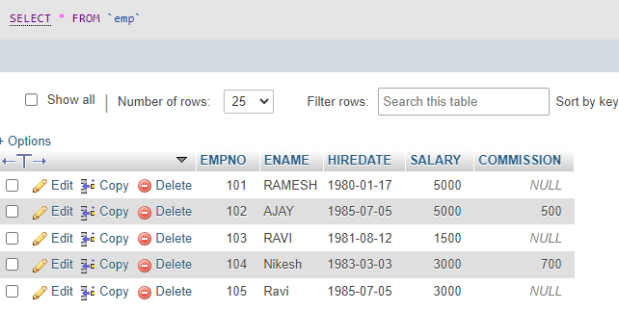

* ALTER TABLE emp ADD sal int;

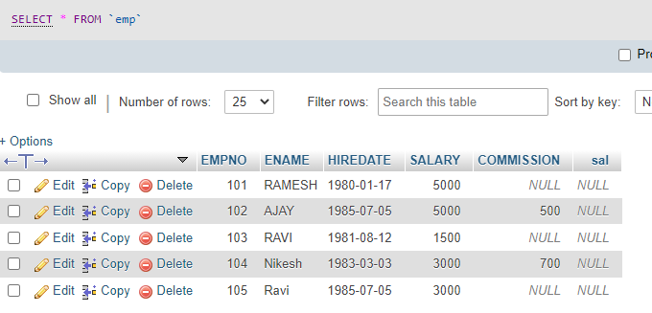

* ALTER TABLE emp DROP COLUMN sal;

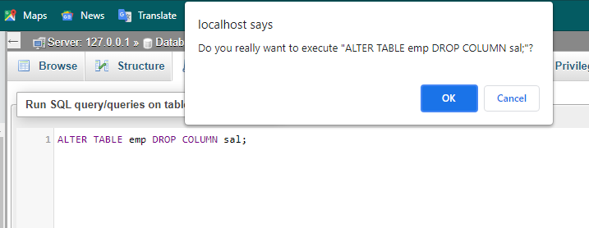

* ALTER TABLE emp MODIFY ename VARCHAR(15);

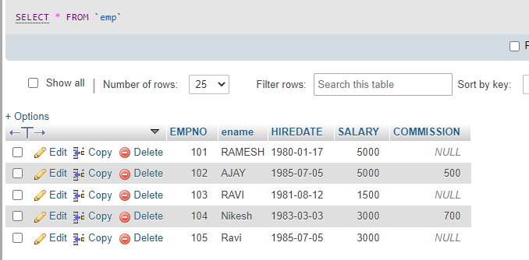

* RENAME table emp to emp1;

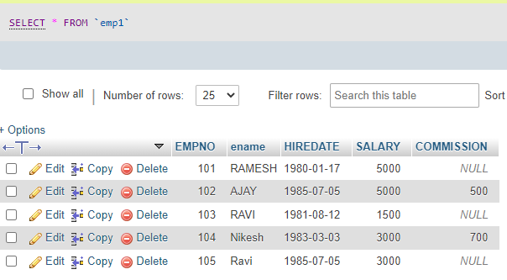

* TRUNCATE TABLE emp1;

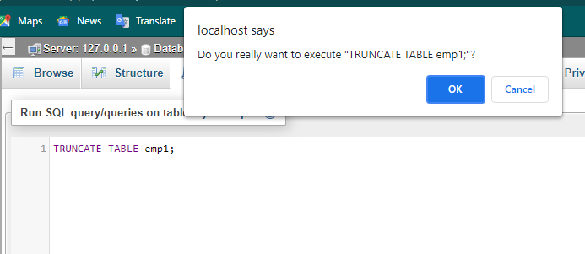

* DROP TABLE emp1;

