**Experiment: 5** Radhika C

RMCA B

Roll No: 13

1. SELECT SUM (amount) FROM borrow;

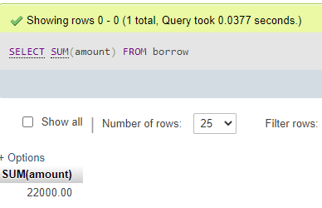

1. SELECT SUM amount) FROM deposite;

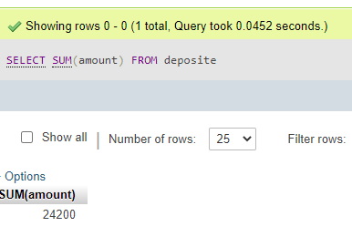

1. SELECT MAX(amount) FROM borrow WHERE bname ='karolbagh';

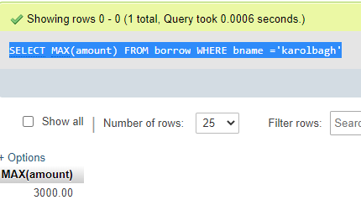

1. SELECT SUM(amount) from deposite where adate>'1995-03-01';

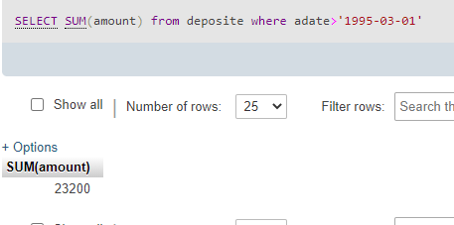

1. SELECT SUM(D1.amount) FROM deposite D1 , customer C1 WHERE C1.city = 'nagpur' AND C1.cname = D1.cname;

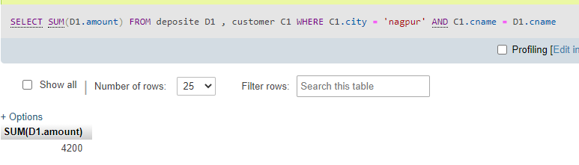

1. SELECT MAX(D1.amount) FROM deposite D1 , customer C1 WHERE C1.city = 'Bombay' AND C1.cname = D1.cname;

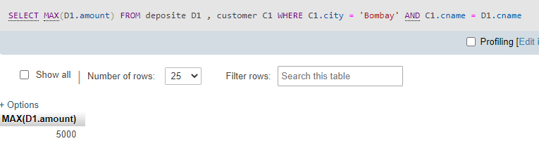

1. SELECT SUM(amount) from deposite,branch where city='bombay';

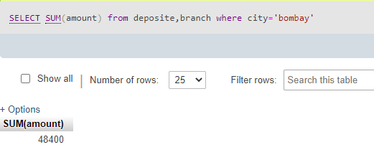

1. SELECT COUNT(DISTINCT (city)) FROM branch ;

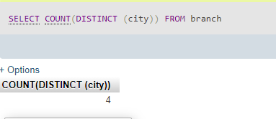

1. SELECT count(city) from customer;

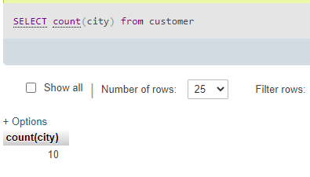

1. SELECT bname , SUM(amount) FROM deposite GROUP BY bname;

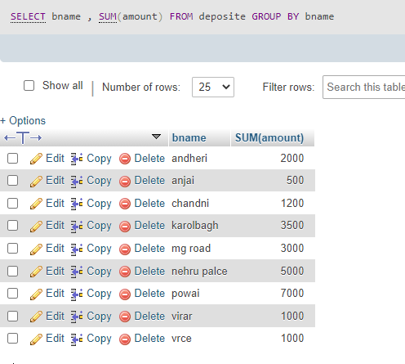

1. SELECT C1.city , SUM(D1.amount) FROM customer C1 , deposite D1 WHERE D1.cname = C1.cname GROUP BY C1.city;

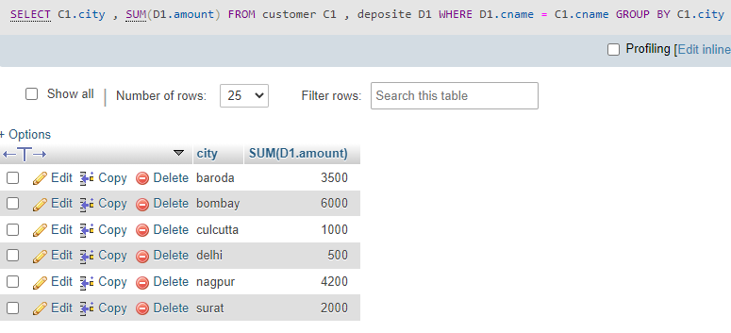

1. SELECT bname , SUM(amount) FROM borrow,customer WHERE city ='nagpur' GROUP BY bname;

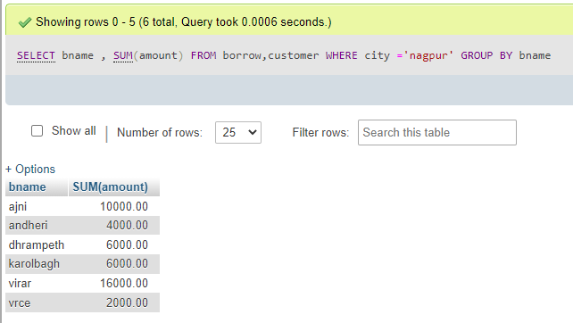

1. SELECT count(cname) from customer;

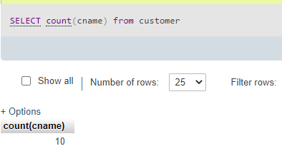

1. SELECT bname,count(*)from deposite,customer where deposite.cname = customer.cname group by bname

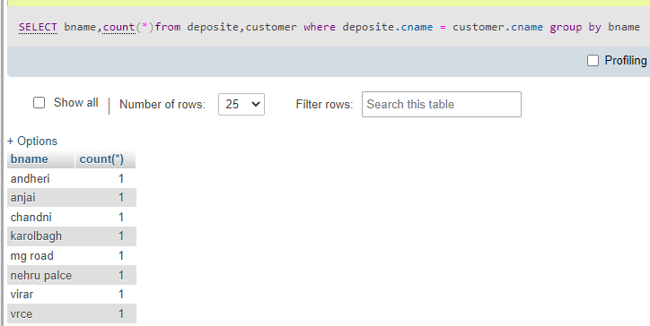

1. SELECT MAX(amount) FROM borrow WHERE bname ='vrce';

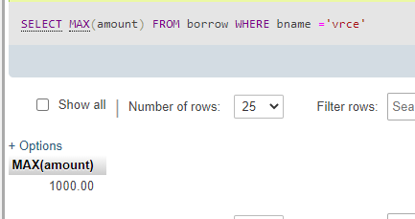

1. SELECT COUNT(DISTINCT (cname)) FROM customer WHERE cname IN ((SELECT cname FROM deposite) INTERSECT (SELECT cname FROM borrow));

