**EXPERIMENT-9**

Radhika C

RMCA –B

Roll No: 13

create table clientmaster(clientno int(100) PRIMARY KEY,cname varchar(30),city varchar(40));

* insert into clientmaster VALUES(101,"senchu","kannur");
* insert into clientmaster VALUES(102,"sobin","kannur");
* insert into clientmaster VALUES(103,"sajan","mumbai");
* insert into clientmaster VALUES(104,"siju","gujarath");
* insert into clientmaster VALUES(105,"george","kottayam");

Select * from clientmaster;

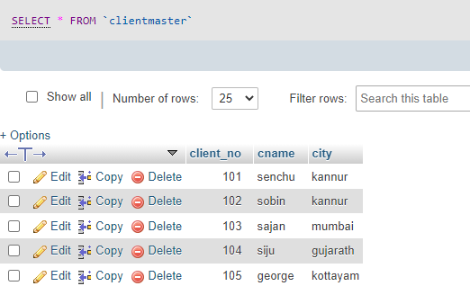

CREATE table salesorder(order_number int PRIMARY KEY ,clientno int,order_date date, FOREIGN key(clientno)REFERENCES clientmaster(clientno));

* INSERT INTO salesorder VALUES(0,101,"2013-06-01");
* INSERT INTO salesorder VALUES(1,103,"2013-02-01");
* INSERT INTO salesorder VALUES(2,103,"2013-03-21");
* INSERT INTO salesorder VALUES(3,102,"2013-03-02");
* INSERT INTO salesorder VALUES(4,105,"2013-04-02");

Select* from salesorder;

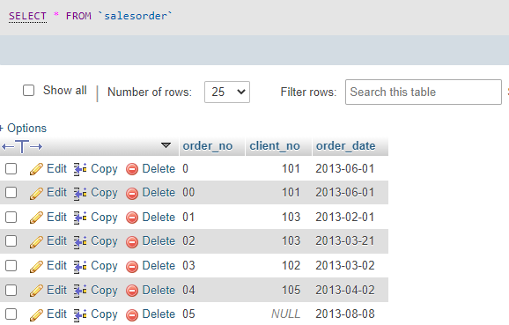

create table salesmaste(salesman_no int(100) PRIMARY KEY,sname varchar(30),city varchar(40));

* INSERT INTO salesmaster VALUES(1,"biju","mumbai");
* INSERT INTO salesmaster VALUES(2,"amith","mumbai");
* INSERT INTO salesmaster VALUES(3,"sreela","kannur");
* INSERT INTO salesmaster VALUES(4,"anoop","thrissur");
* INSERT INTO salesmaster VALUES(5,"goutham","pala");

Select * from salesmaster

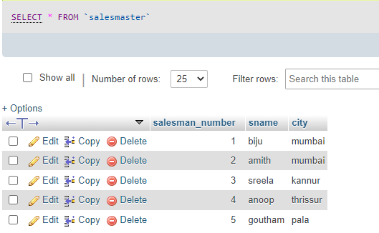

* SELECT * from salesorder where client_no in(SELECT client_no from clientmaster where cname ='sajan');

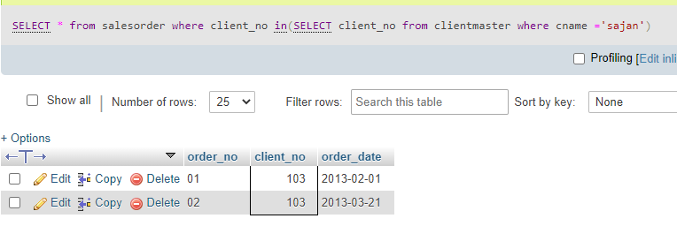

* SELECT * from clientmaster WHERE client_no in(SELECT client_no from salesmaster);

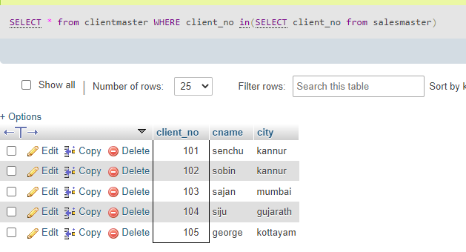

* SELECT c.cname,s.sname FROM clientmaster c,salesmaster s WHERE c.city="mumbai" and s.city IN (SELECT city FROM salesmaster where city="mumbai");

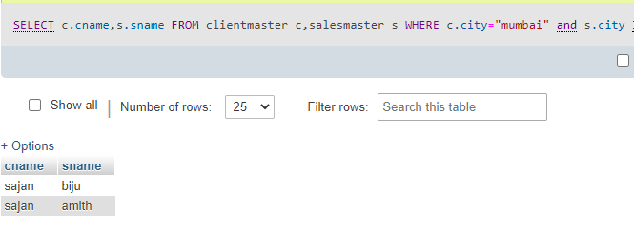

* select order_no,cname,order_date from clientmaster inner join salesorder on clientmaster.client_no=salesorder.client_no;

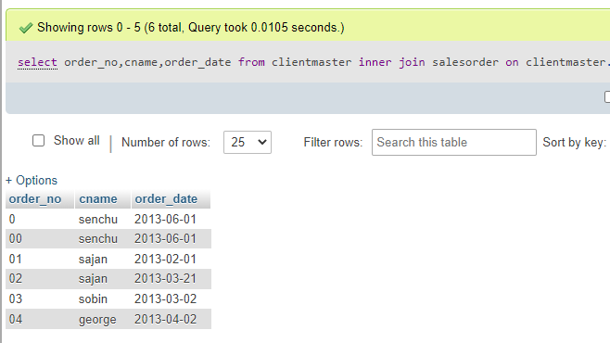

* SELECT c.cname,s.order_date,s.order_no FROM clientmaster c,salesorder s WHERE c.client_no IN (SELECT s.client_no from salesorder);

