Homogenizer (Both Homogenizer Same Content, Image change):
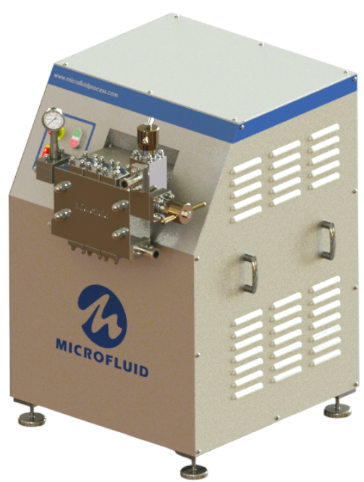

“With the Homogenization Process, You Can Visualize the Fluid”

Microfluid Process Equipment’s homogenizer manufacturing by using high-quality materials and standard industry practices.

Microfluid’s high-quality and low-maintenance cost products will increase your profit and reduce maintenance costs.

- Design and Features

Microfluid’s two-stage high-pressure homogenizer, a positive displacement reciprocating pump manufacturing with state-of-the-art technology for customized solutions for many applications.

Benefits:
  - Specially designed low-speed
  - Higher efficiency
  - Low noise and vibration
  - Easy and quick maintenance, reduce down time
  - High reliability

Features:
  - Single piece forged cylinder block
  - Friendly maintenance cylinder block
  - Hard metal coated plungers for long life
  - Single piece high strength cast iron crank case
  - Specially forged alloyed crank shaft
  - Splash lubrication
  - Two stage forged homo valves
  - Hard internal parts of homo valves for long life

- Applications







Chemical
Dairy
Home & Personal Care
Food & Beverages
Pharmaceuticals & Biotech

Or we can put as per the https://www.bertoli-homogenizers.com/product/homogenizers/raffaello-series/ha-pa34/

- Performance Chart

Max. Flow Rate LPH (GPM) | Max. Pressure in Bar (PSI) | Max. Motor HP (Kw)
500 (132) | 250 Bar (3600 PSI) | 5 HP (3.7)
600 (158) | 250 Bar (3600 PSI) | 7.5 HP (5.6)
800 (211) | 250 Bar (3600 PSI) | 10 HP (7.5)
1000 (265) | 250 Bar (3600 PSI) | 10 HP (7.5)
1200 (317) | 250 Bar (3600 PSI) | 12.5 HP (10)

- Dimensions

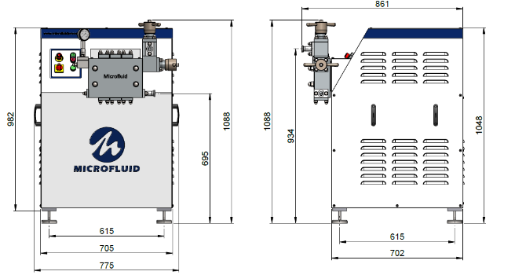

- Special Options

- Fully machine automation
- Pneumatic homogenizing valve
- Duplex and super duplex material
- Electropolished liquid end and contact parts available and many more

- Documents

PDF (Size)

