Myntra clone website

Myntra Clone Script is the best solution to start your own online shop or bookstore, and to globalize your customer base. It is the best Script that can be integrated into your existing website and it’s the best choice for people who want to market their products online. Myntra clone platform already has standard features developed that enables you to kick start your business quickly with quality. The advantage of working with us is the fact that we’ve already got the base ready for you and since the platform is highly expandable and customizable, we can easily modify it to match with your requirements.

**Languages used**: HTML,CSS,JAVASCRIPT,BOOTSTRAP,PHP,SQL

1. **INDEX PAGE:**  
   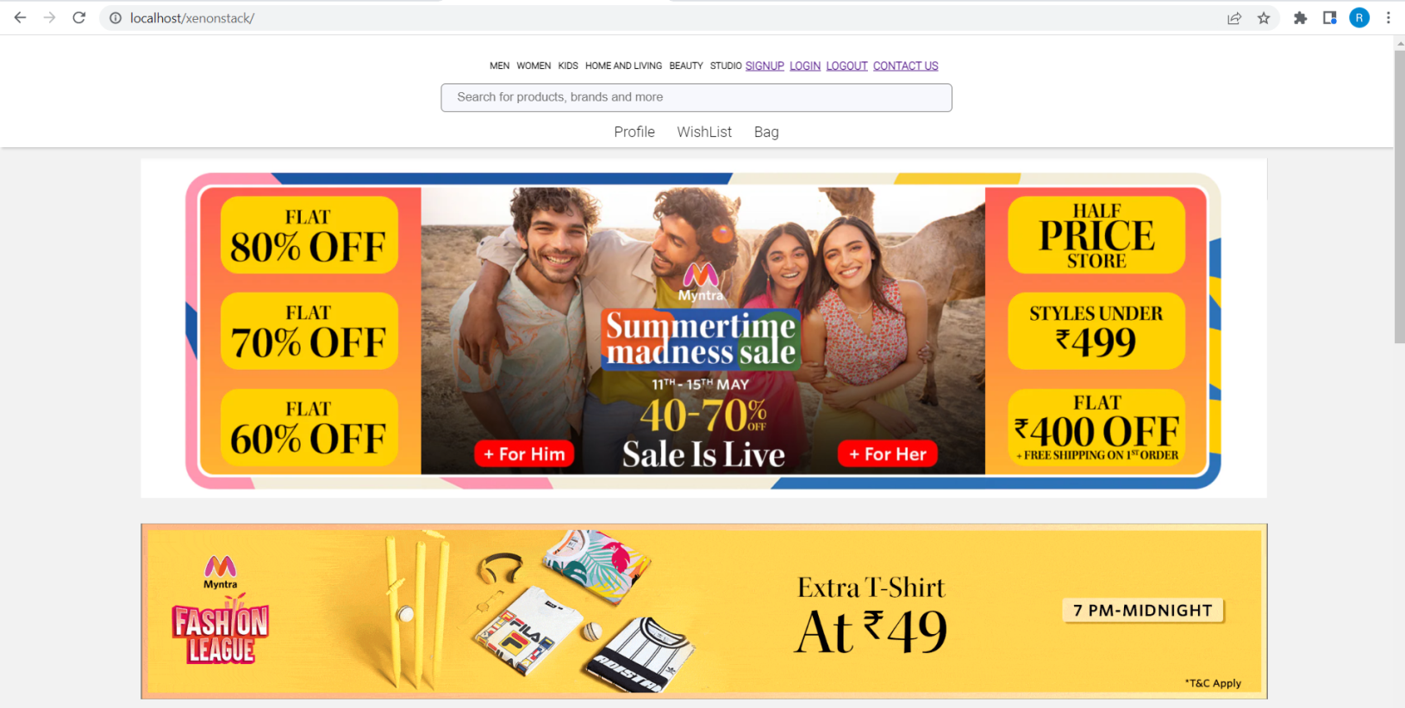

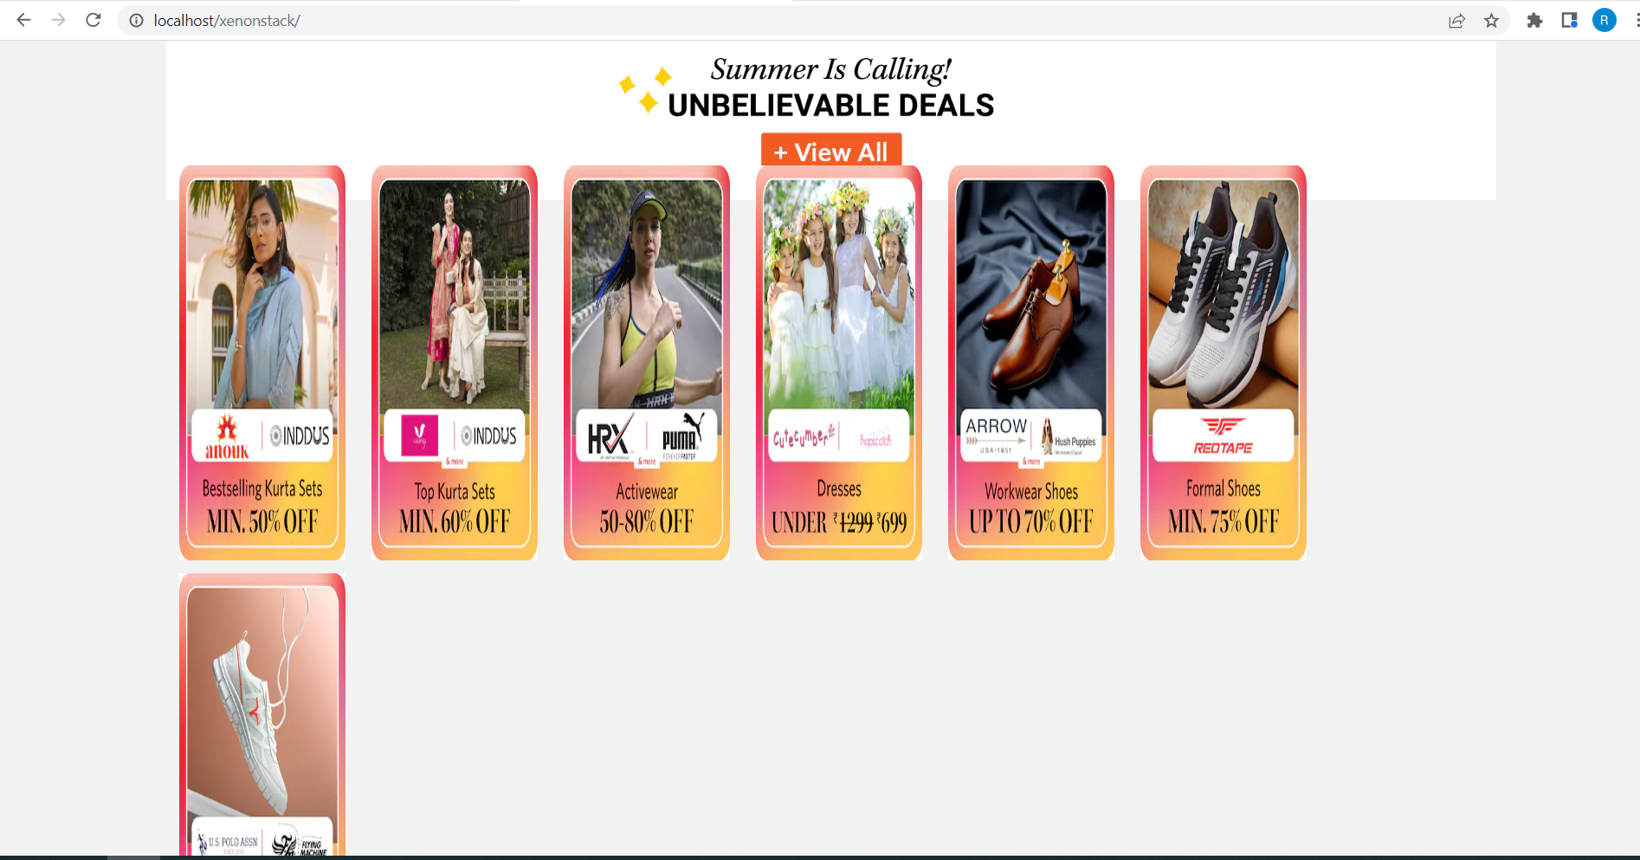

1. **Login page:**

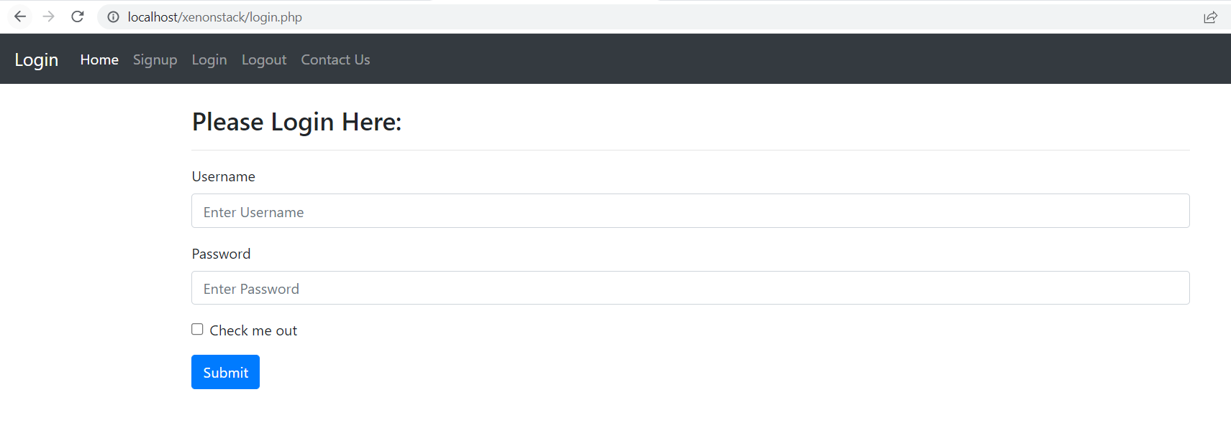

1. **Signup page:**

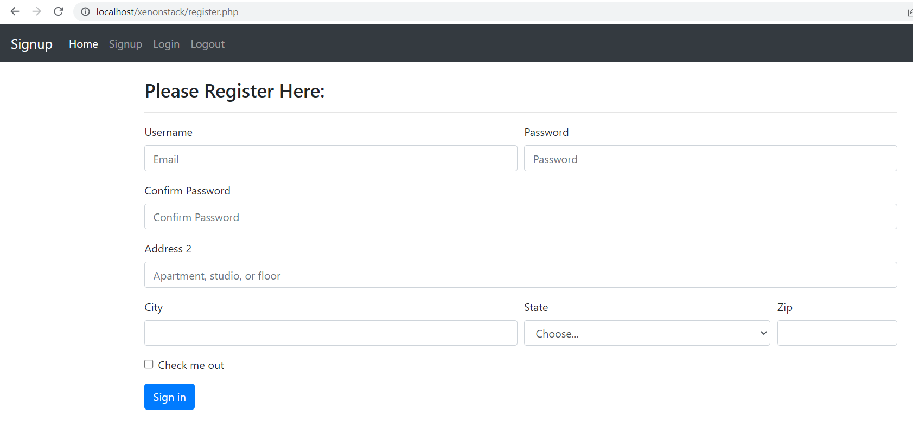

1. **Contact Us page:**

