Analyzing housing and crime trend in New York City

at758, rk539, yc2265

Data description

New York City is the most populous city in the United States and has ever been since the past 20 years or probably even more. The city has around 28,052 people per square mile. Because the city is a land of opportunities it has seen a lot of traffic from all over the world. *Due to which the real-estate prices have historically been shooting up and crime rates are expected to be ever increasing with growing population*. Our motivation for this project came from this interesting characteristic of the city and because New York City has always been an interesting data point we decided to look at the trend of housing market and crime rates in the five boroughs that this city is famous for. Our data is taken from New York University’s Furman Center for Real Estate and Urban Policy [1]. The data is presented as a very sleek user interface on the universities website and was easier to filter and search based on our requirement. The data on the website contains neighborhood information and has a selection dropdown to select the following indicators:

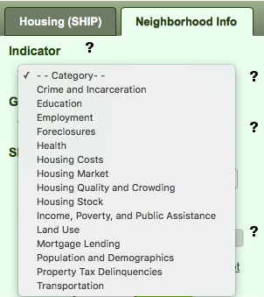

Indicator based filtering

We were particularly interested in Housing Market and Crime/Incarceration, because we think people are more likely to judge a neighborhood based on how safe it is and are likely to pay a more value for home if they find the area is safe and provides a secure standard for living. When we looked at the housing data we found that the data was recorded from 1974 to 2011. Housing data comprises of *median sale price* of a *2- 4 family size building*. Crime data consists of *Total Felonies* from the year 1990 to 2007. We needed another data source [2] for crimes so that we could see what happened after the financial housing bubble crises in 2008. Our final data trend for the visualization ranges from 1990 to 2011 for both indicators stated above. Combining multiple data sets has always been a challenge, when combining the crime data from two different sources we were cautious about the discrepancies of different naming conventions for the same indicator such as “*Total Felonies*”.

Mapping of data to visual elements

We used Leaflet.js [3] to generate our map for New York City. Because this project is particularly looking for responsiveness as a key parameter, we thought using leaflet rather than d3 would be an easier and a faster option to do. Leaflet gives us a feature to draw polygons around selected boroughs. For our visualization we used D3 two scale graph [4] for crime and housing data respectively. These scales are linear as we don’t have thousands of data points. We used the map so that it covers the entire screen on a PC, the buttons being visible. On a mobile device we hide the buttons in a menu so that the the buttons do not distract the users. Based on our TA’s Giri’s feedback we understood that bootstrap responsiveness doesn’t work well for d3 elements so we used an attribute called *viewbox*, within the frames viewport.

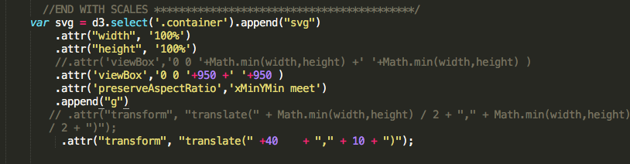

Viewbox with preserveAspectRatio attribute

Add any transformations if you have added – Radhika for maps and the graph when you place it on view. Yao for graph scales.

Our story

As the economy improves over the years, our hypothesis was that housing rates would steadily go up and as income levels go up a fair judgment to make is that crime would eventually slide. Our visualization supports this hypothesis. Our assumption is here, that the population has increased in New York City over the years. The visualization plots total number of felonies and not the total number of felonies as a percentage of population. We also see that Manhattan consistently remains the most expensive place to stay followed by Staten Island, Queens, Brooklyn and Bronx. In terms of crimes we expected the crimes to be the lowest in Manhattan but our assumption was incorrect, as Manhattan remains the top 2 of the five boroughs with the maximum number of felonies. The crime rate in Manhattan fell more than that of Brooklyn and in the period of 1994-1996 was when Brooklyn took the first place of the most number of felonies out of the five boroughs. Our hypothesis supports the general decreasing trend of crimes in New York City. We see 2 key time-points in the data set where we see housing rates fall, one is 2008, just about the year of the housing bubble crises, where we see a drop in the median prices in all 5 boroughs and the year 2002-2005 which was sort of a great time in the economy explaining the surge in median prices. The only time housing rates in Manhattan fell since 1974 was in the period of 2001 to 2002, as compared to the other 4 boroughs. While the housing rates have been unpredictable for Manhattan and other boroughs in certain periods, the crime rates have steadily decreased. Also what this tells us is that the area with the most expensive housing may not be the the one with the most safety.

References

[1] <http://datasearch.furmancenter.org>

[2] Should have crime data source from 2008 to 2011

[3] <http://leafletjs.com>

[4] <http://bl.ocks.org/d3noob/e34791a32a54e015f57d>