**SVKM’s NMIMS**

**Mukesh Patel School of Technology Management & Engineering**

**Computer Engineering Department**

Program: B.Tech. Semester: VIII

**Course: Software Project Management**

**List of Experiments**

**Experiment No.01**

PART A

(PART A: TO BE REFFERED BY STUDENTS)

**A.1 Aim:** Introduction to Microsoft Project Management Software

[**https://www.smartsheet.com/welcome-customers-home**](https://www.smartsheet.com/welcome-customers-home)

**A.2 Prerequisite: -** Understanding of Computers and Windows Operating System

**A.3 Outcome:**

**After successful completion of this experiment students will be able to**

1. Create blank project, change properties of project, build task list.
2. Identify online project management software and state its key feature

**A.4 Theory:**

Microsoft Project is a project management software program developed and sold by Microsoft, designed to assist a project manager in developing a schedule, assigning resources to tasks, tracking progress, managing the budget, and analyzing workloads.

Project creates budgets based on assignment work and resource rates. As resources are assigned to tasks and assignment work estimated, the program calculates the cost, equal to the work times the rate, which rolls up to the task level and then to any summary task, and finally to the project level.

Each resource can have its own calendar, which defines what days and shifts a resource is available. Microsoft Project is not suitable for solving problems of available materials (resources) constrained production. Additional software is necessary to manage a complex facility that produces physical goods.

**Project Management**

MS Project is feature rich, but project management techniques are required to drive a project effectively. A lot of project managers get confused between a schedule and a plan. MS Project can help you in creating a Schedule for the project even with the provided constraints. It cannot Plan for you.

A plan is a detailed action-oriented, experience and knowledge-based exercise which considers all elements of strategy, scope, cost, time, resources, quality and risk for the project.

Scheduling is the science of using mathematical calculations and logic to generate time effective sequence of task considering any resource and cost constraints. Schedule is part of the Plan. In Project Management Methodology, schedule would only mean listing of a project's milestones, tasks/activities, and deliverables, with start and finish dates. Of course the schedule is linked with resources, budgets and dependencies.

MS Project can help you −

* Visualize your project plan in standard defined formats.
* Schedule tasks and resources consistently and effectively.
* Track information about the work, duration, and resource requirements for your project.
* Generate reports to share in progress meetings.

we will take a close look at the user interface of MS Project.

MS Project UI

* Windows 7 − Click on Start menu, point to All Programs, click Microsoft Office, and then click Project 2013.
* Windows 8 − On the Start screen, tap or click Project 2013.
* Windows 10 − Click on Start menu → All apps → Microsoft Office → Project 2013.

The following screen is the Project’s start screen. Here you have options to open a new plan, some other plans, and even a new plan template.

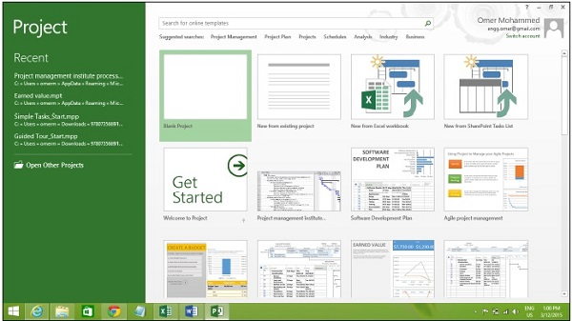

Click the Blank Project Tab. The following screen pops up.

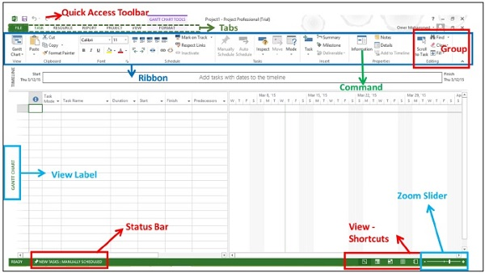

The screen should have the MS Project interface displayed. The major part of this interface are −

* Quick Access Toolbar − A customizable area where you can add the frequently used commands.
* Tabs on the Ribbon, Groups − With the release of Microsoft Office 2007 came the "Fluent User Interface" or "Fluent UI", which replaced menus and customizable toolbars with a single "Office menu", a miniature toolbar known as "quick-access toolbar" and what came to be known as the ribbon having multiple tabs, each holding a toolbar bearing buttons and occasionally other controls. Toolbar controls have heterogeneous sizes and are classified in visually distinguishable Groups. Groups are collections of related commands. Each tab is divided into multiple groups.
* Commands − The specific features you use to perform actions in Project. Each tab contains several commands. If you point at a command you will see a description in a tooltip.
* View Label − This appears along the left edge of the active view. Active view is the one you can see in the main window at a given point in time. Project includes lots of views like Gantt Chart view, Network Diagram view, Task Usage view, etc. The View label just tells you about the view you are using currently. Project can display a single view or multiple views in separate panes.
* View Shortcuts − This lets you switch between frequently used views in Project.
* Zoom Slider − Simply zooms the active view in or out.
* Status bar − Displays details like the scheduling mode of new tasks (manual or automatic) and details of filter applied to the active view.

## Create Blank Project

MS Project 2013 will display a list of options. In the list of available templates, click Blank Project.

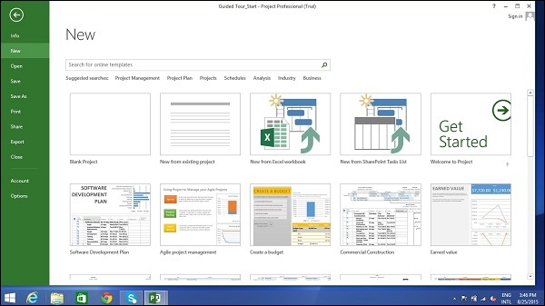

Project sets the plan’s start date to current date, a thin green vertical line in the chart portion of the Gantt Chart View indicates this current date.

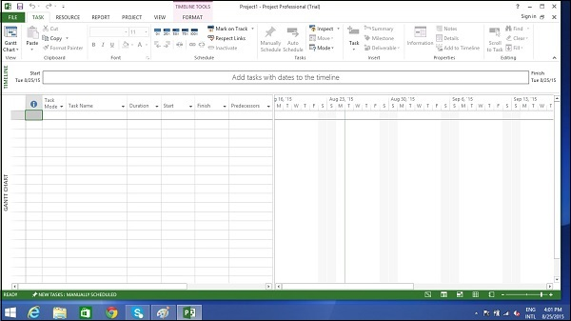

## Change File Properties

With Microsoft Windows Operating system, right clicking a file and selecting “Properties” brings up the file properties dialog box that contains version, security and other file details. You can record some top level information for your .mpp project file as well. This can be done as follows −

### Step 1: Launch MS Project

* Windows 7 − Click on Start menu, point to All Programs, click Microsoft Office, and then click Project 2013.
* Windows 8 − On the Start screen, tap or click Project 2013.
* Windows 10 − Click on Start menu → All apps → Microsoft Office → Project 2013.

### Step 2: Save Properties

Click File Tab. Under Info Tab go to Project Information. Click arrow near Project Information to click Advanced Properties. A dialog box opens, you can type in the changes as required. Click OK and don’t forget to save by clicking on Save.

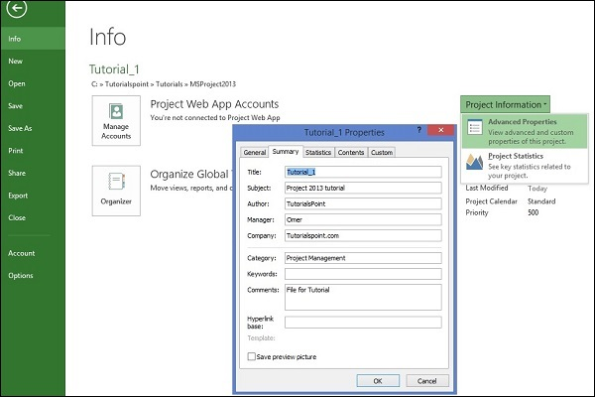

**A.5 Task to be completed in PART B**

**A.5.1. Task 1:**

**Every student needs to follow following steps and record the findings in appropriate section of PART B**

1. Identify three online project management tool and explore the same.
2. Specify key features and how to create new project.

******************

**PART B**

(PART B: TO BE COMPLETED BY STUDENTS)

**(Students must submit the soft copy as per following segments within two hours of the practical. The soft copy must be uploaded on the Blackboard or emailed to the concerned lab in charge faculties at the end of the practical in case the there is no Black board access available)**

| Roll No. | Name: |
| --- | --- |
| Program : | Division: |
| Batch: | Date of Experiment: |
| Date of Submission: | Grade : |

**B.1 Tasks given in PART A to be completed here**

*(****Students must write the answers of the task(s) given in the PART A )***

**B.2 Observations and Learning:**

*(****Students must write the observations and learning based on their understanding built about the subject matter and inferences drawn)***

**B.3 Conclusion:**

*(****Students must write the conclusive statements as per the attainment of individual outcomes listed above and learning/observation noted in section B.2)***

**B.4 Question of curiosity:**

**1.**A public library is considering the implementation of a computer-based system to help administer book loans at libraries.

i). Identify the stakeholders in such a project.

ii). What might be the objectives of such a project?

iii). How might the success of the project be measured in practical terms?

***************