Game Design Document

Fill up the Following document

1. Write the title of your project.

Fun with Maths

1. What is the goal of the game?

To develop an interest of people in maths

1. Write a brief story of your game?

People need to find the question by crossing the huddles.In this game people will have 10 questions to answer and if they give a wrong answer they would have to restart the game.

1. Which are the playing characters of this game?

* Playing characters are the ones which respond to the user based on the input from the user
* Cars, monkeys, dinos, wizards etc, are the playing characters in the game.

|  |  |  |
| --- | --- | --- |
| Number | Character Name | What can this character do? |
| 1 | Wizard _______ | The character has to cross the huddles and find question and solve it. |
| 2 |  |  |
| 3 |  |  |
| 4 |  |  |
| 5 |  |  |
| 6 |  |  |
| 7 |  |  |
| 8 |  |  |

1. Which are the Non Playing Characters of this game?

* Non Playing characters are the ones which don't have an action or a behaviour when the user interacts with the game.
* Hurdles, stones, bananas, coins, etc are non playing characters in the game.

|  |  |  |
| --- | --- | --- |
| Number | Character Name | What can this character do? |
| 1 | cactuses | obstacles |
| 2 | birds | Obstacles |
| 3 |  |  |
| 4 |  |  |
| 5 |  |  |
| 6 |  |  |
| 7 |  |  |
| 8 |  |  |

Draw your imagination of this game. What does this game look like?

* Draw the game either on your computer or on paper,
* Add images of scenes of the game to show each of the playing and non-playing characters at least once.

The game has many stages the given below is part of it:

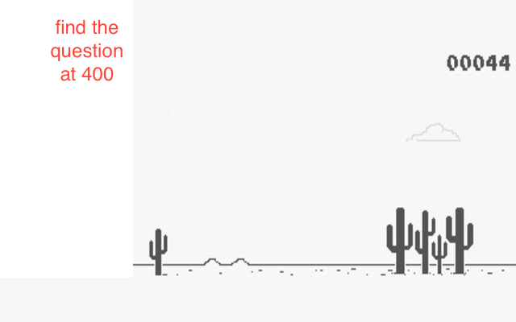

How do you plan to make your game engaging?

The game would be engaging as the level of questions get harder and when they find the question it gets difficult too.