**3D Scene Editor**

Radhika Mattoo, rm3485@nyu.edu

1.1 Scene Editor:

* Adding Objects
  + Unit Cube: **1**
  + Bumpy Cube: **2**
  + Bunny: **3**

1.2 Object Control:

* Clicking an object will select it and change its color to **white**
* Deleting a Selected Object: **C**
* Translation
  + +x, -x: **W**, **E**
  + +y, -y: **R**, **T**
  + +z, -z: **Y**, **U**
* Scaling:
  + up: **S**
  + down: **D**
* Rotation:
  + Backwards and Forwards (along Z): **F**, **G**
  + Left and Right (along X): **H**, **J**
  + In a circle (along Y): **K**, **L**
* Rendering setting of a Selected Object:
  + Wireframe: **4**
  + Flat: **5**
  + Phong: **6**

1.3 Camera Control:

* Camera Translation:
  + Left, Right: **7**, **8**
  + Up, Down: **9**, **0**
  + Zoom IN, Zoom OUT: **+**, **-**
* Orthographic vs. Perspective
  + Change **line 59** to **true** for orthographic, **false** for perspective
  + 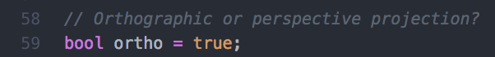
  + In **orthographic**, the light position is at **(1.0, 0.0, -1.0)**
  + In **perspective**, the light position is at **(1.0, 0.0, 1.0)**