Week 4 Internship Report
Machine Learning Model Development and Evaluation
Can a Vehicle's Specifications Predict Whether It's Marketed as Luxury?
Dataset: Car Features and MSRP (cleaned in Week 1)
Prepared using Python (pandas, NumPy, scikit-learn, seaborn, matplotlib)
August 2026

1. Introduction and Problem Framing
This report builds a supervised machine learning classifier on the Car Features and MSRP dataset used in Weeks 1-3. The business problem: can a vehicle's objective specifications (engine, fuel economy, size, drivetrain) predict whether it is marketed as a 'Luxury' model, without relying on the free-text Market Category field itself? This has genuine practical value — for example, auto-tagging incomplete listings on a marketplace, or auditing whether a manufacturer's luxury/non-luxury classification is consistent with a vehicle's actual specifications.
The task was framed as binary classification: is_luxury = 1 if the word 'Luxury' appears anywhere in the Market Category field (e.g. 'Luxury', 'Luxury,Performance', 'Crossover,Luxury'), else 0. Rows with no Market Category recorded ('Not Specified', from Week 1's cleaning) were excluded from training and evaluation, since their true label cannot be known and including them would introduce label noise rather than genuine difficulty.

2. Data Preparation
After excluding unlabeled rows, 7,823 listings remained, with a reasonably balanced class split: 58.8% non-luxury, 41.2% luxury.
df = df[df['market_category'] != 'Not Specified'].copy()
df['is_luxury'] = df['market_category'].str.contains('Luxury').astype(int)
Feature selection deliberately excluded MSRP itself. Although price is highly predictive of luxury status (as shown in Weeks 2-3), using it here would be circular for many realistic use cases — e.g. tagging a listing where price is itself unknown or is what a separate model is trying to predict. Instead, 7 numeric features (Engine HP, Cylinders, Doors, Highway/City MPG, Popularity, Year) and 3 categorical features (Vehicle Size, Driven Wheels, Transmission Type) were used — properties of the vehicle's engineering, not its price tag.
Preprocessing used a single scikit-learn ColumnTransformer, fit only on the training set and applied identically to the test set, to avoid data leakage:
preprocessor = ColumnTransformer([
('num', StandardScaler(), numeric_features),
('cat', OneHotEncoder(handle_unknown='ignore'), categorical_features),
])
X_train, X_test, y_train, y_test = train_test_split(
X, y, test_size=0.20, random_state=42, stratify=y
)
Numeric features were standardized (zero mean, unit variance) because Logistic Regression's coefficients and convergence are sensitive to feature scale; categorical features were one-hot encoded since neither model can consume raw text/category labels directly. An 80/20 stratified train-test split preserved the original class balance in both subsets.

3. Model Selection and Training
Two simple, interpretable algorithms were trained and compared, per the task's guidance to use a basic model:
Model | Why Chosen
Logistic Regression | A well-calibrated linear baseline; coefficients are directly interpretable (each feature's effect on the log-odds of 'luxury'); appropriate first model for any binary classification problem.
Decision Tree (max_depth=6, min_samples_leaf=20) | Captures non-linear feature interactions a linear model would miss (e.g. 'high horsepower AND rear-wheel drive'); depth and leaf-size limits were set explicitly to control overfitting, given trees' tendency to memorize training data unconstrained.

log_reg = Pipeline([('prep', preprocessor),
('clf', LogisticRegression(max_iter=1000, random_state=42))])
log_reg.fit(X_train, y_train)
tree = Pipeline([('prep', preprocessor),
('clf', DecisionTreeClassifier(max_depth=6, min_samples_leaf=20,
random_state=42))])
tree.fit(X_train, y_train)

4. Evaluation
Metric | Logistic Regression | Decision Tree
Test Accuracy | 78.4% | 91.4%
Precision (Luxury) | 0.772 | 0.885
Recall (Luxury) | 0.676 | 0.910
F1-score (Luxury) | 0.721 | 0.898
ROC-AUC | 0.832 | 0.969
5-fold CV Accuracy | 77.2% ± 0.8% | 91.7% ± 0.5%
Train Accuracy | 77.5% | 92.1%

4.1 Confusion Matrices
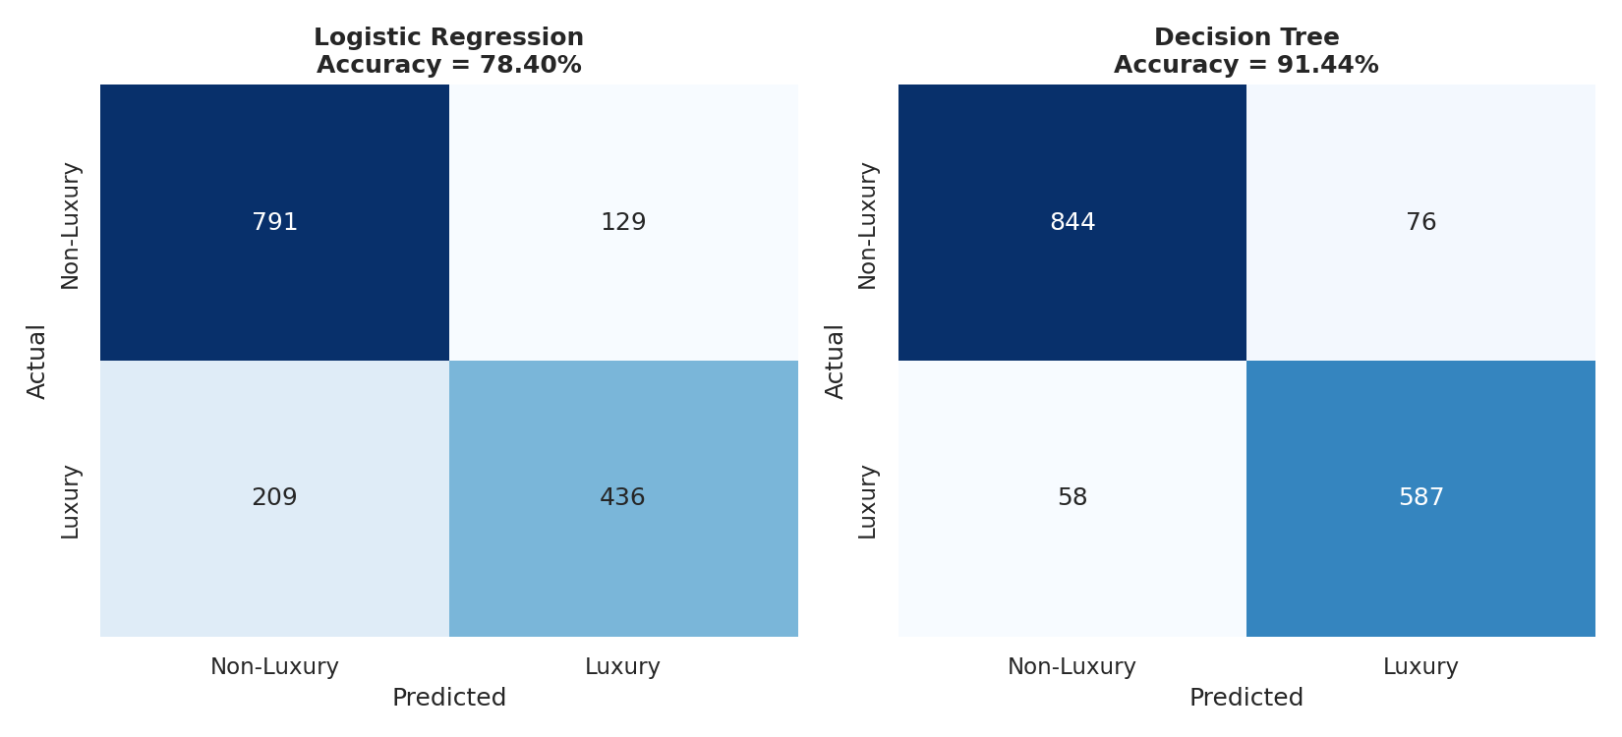
Figure 1: Confusion matrices for both models on the held-out test set (n = 1,565).
Interpretation: The Decision Tree makes far fewer errors in both directions: only 76 false positives and 58 false negatives, versus 129 and 209 respectively for Logistic Regression. Logistic Regression's higher false-negative count (209 luxury vehicles misclassified as non-luxury) suggests it under-detects luxury vehicles whose specs don't fit a simple linear boundary — likely luxury vehicles with modest engine specs (e.g. luxury compact sedans) that a straight-line decision boundary can't separate well.

4.2 ROC Curve Comparison
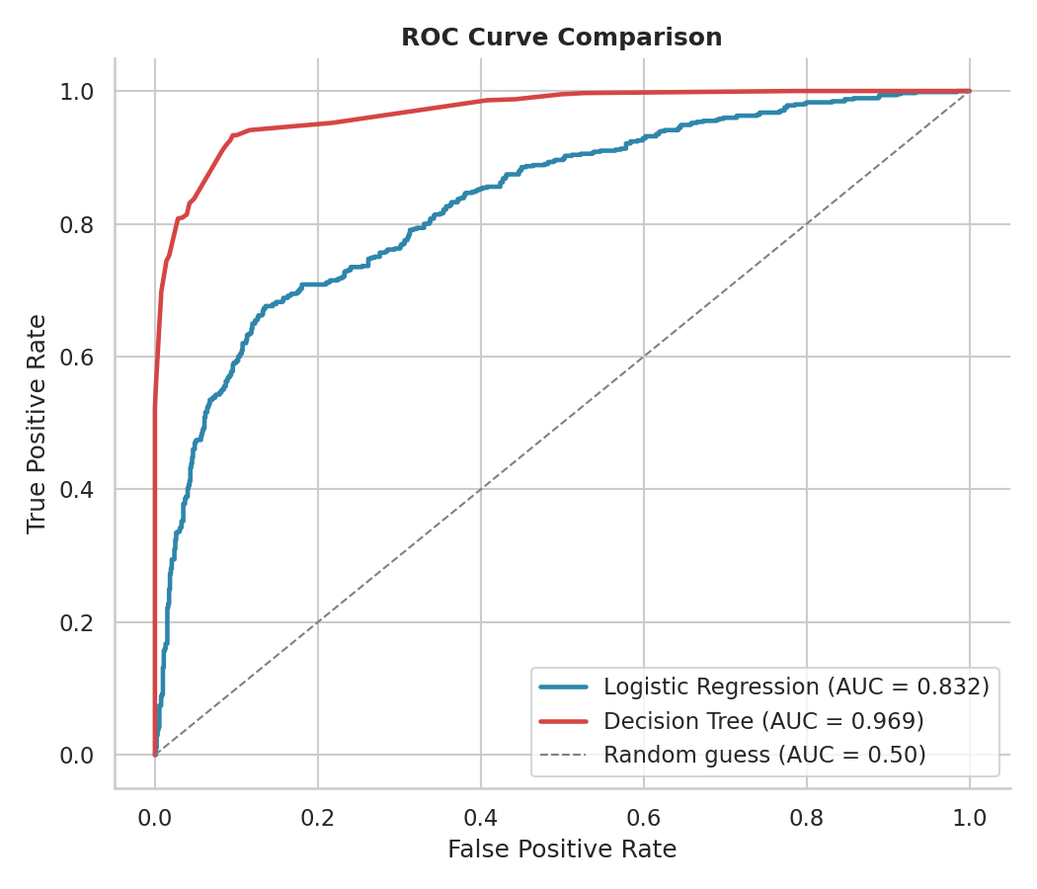
Figure 2: ROC curves for both models against a random-guess baseline.
Interpretation: The Decision Tree's ROC-AUC of 0.969 indicates near-excellent separability between classes, while Logistic Regression's 0.832 is still good but clearly inferior. This gap, combined with the confusion matrix results, indicates the true decision boundary between luxury and non-luxury vehicles is meaningfully non-linear — consistent with luxury status being defined by combinations of features (e.g. all-wheel drive + certain size classes + specific brands) rather than any single linear combination.

4.3 Feature Importance
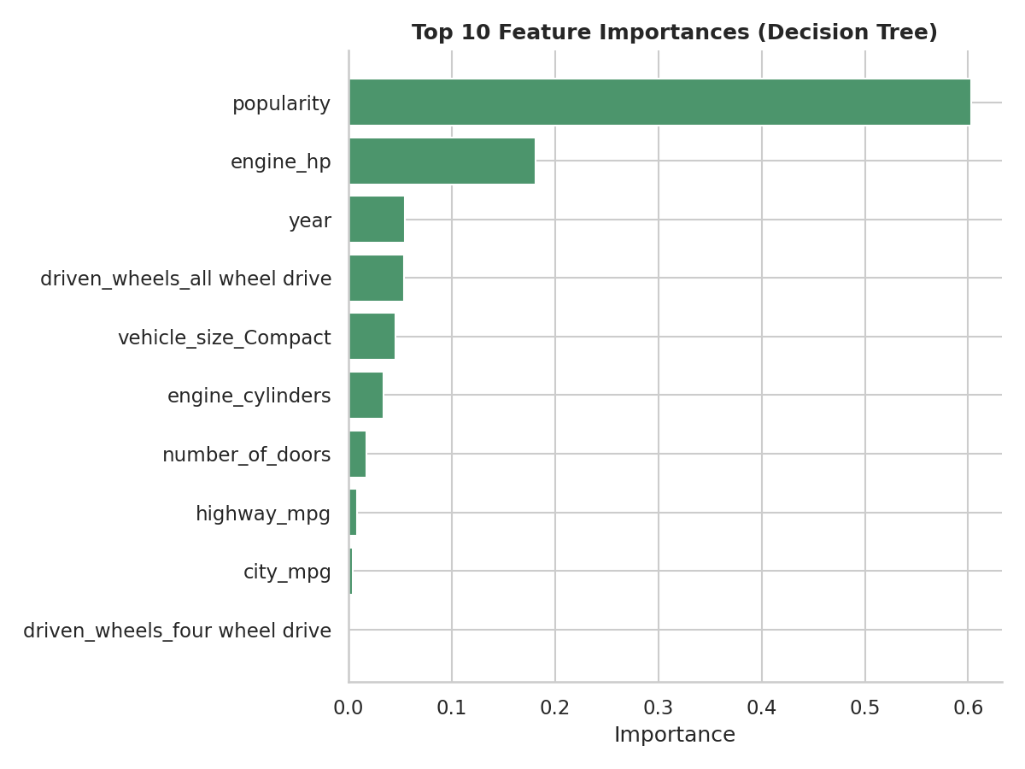
Figure 3: Top 10 feature importances from the Decision Tree model.
Critical finding: Popularity dominates the Decision Tree's importances (~60%), well ahead of Engine HP (~18%). This is an important caveat, not just a result: Popularity in this dataset is a near-constant score per manufacturer (all listings from the same make share a similar value), so the tree may be using it largely as a proxy for brand identity rather than a genuine specification-based signal. This is discussed further in Section 5 as a source of potential error.

4.4 Learning Curve (Overfitting/Underfitting Diagnosis)
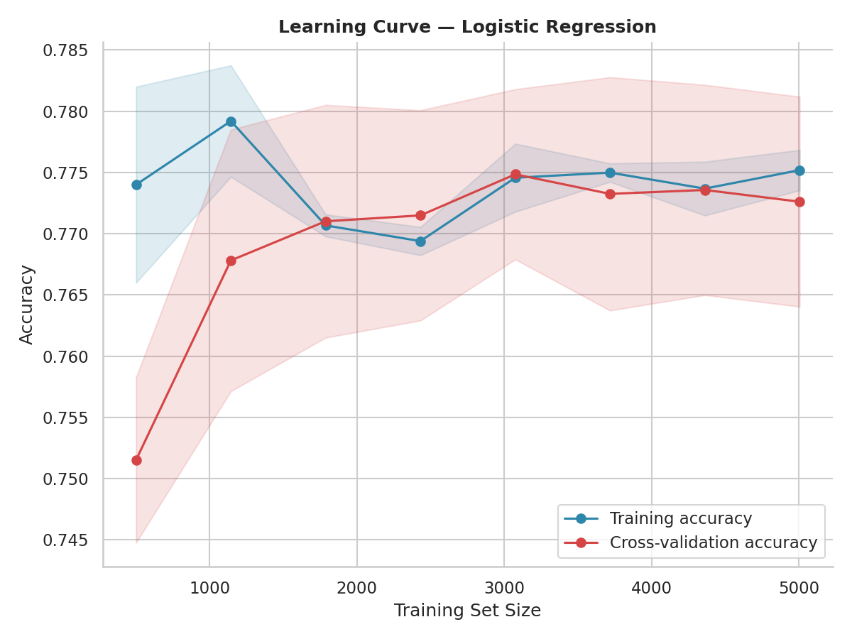
Figure 4: Learning curve for Logistic Regression — training vs. cross-validation accuracy as training set size increases.
Interpretation: Training and cross-validation accuracy converge closely (both around 77%) as the training set grows, with no widening gap — a signature of a well-fit, non-overfit model, but also of a model whose ceiling is limited by its linear form (underfitting the true, non-linear decision boundary) rather than by insufficient data. This matches the Decision Tree comparison: more data would not meaningfully help Logistic Regression here, but a more flexible model does.

5. Critical Discussion: Sources of Error and Improvement
- Popularity as a brand proxy: as flagged in Section 4.3, the Popularity feature likely encodes brand identity more than any genuine 'luxury-ness' signal. A model leaning heavily on this feature may fail to generalize to a new manufacturer not seen in training, since it has no true popularity score to draw on. A follow-up experiment should retrain both models with Popularity excluded to test how much performance depends on it.
- Label definition is a simplification: the is_luxury label is derived from a keyword match on Market Category, which is itself an imperfect, manually-assigned marketing field. Vehicles labeled 'Crossover,Luxury' or 'Exotic,Luxury,High-Performance' are all collapsed to the same positive class, which may blur genuinely different vehicle types together.
- Excluding unlabeled data introduces its own bias: the 3,376 rows with 'Not Specified' category were dropped entirely rather than imputed, which is defensible (avoids fabricating labels) but also means the model was never evaluated on the hardest, most ambiguous cases — real-world deployment accuracy may be lower than the reported test metrics suggest.
- Decision Tree depth was manually capped at 6 with a minimum leaf size of 20 specifically to prevent overfitting; without these constraints, a decision tree can reach 100% training accuracy while generalizing poorly. The close train/CV/test accuracy figures (92.1% / 91.7% / 91.4%) suggest this constraint was reasonably well chosen, though a formal hyperparameter search (e.g. GridSearchCV over max_depth and min_samples_leaf) would give more confidence than the single manually-chosen configuration used here.
- Suggested improvements: (1) retrain excluding Popularity to isolate genuine specification-based signal; (2) try an ensemble method (Random Forest or Gradient Boosting) to capture non-linear interactions with better generalization than a single tree; (3) use SHAP values instead of raw feature importances for a more rigorous, per-prediction explanation of what drives each classification; (4) collect or impute additional features (e.g. brand tier, interior materials) that more directly capture 'luxury' as a concept, rather than relying on proxies.

6. Conclusion
Both models were successfully trained and rigorously evaluated: Logistic Regression achieved a solid 78.4% test accuracy and 0.832 ROC-AUC as an interpretable linear baseline, while the Decision Tree substantially outperformed it at 91.4% accuracy and 0.969 ROC-AUC by capturing non-linear feature interactions. Cross-validation and learning curve analysis confirmed neither model is meaningfully overfit, though the critical discussion above identifies a specific, important caveat — heavy reliance on the Popularity feature as a likely brand proxy — that should be investigated before this model is trusted for a real deployment decision. This kind of honest error analysis, not just the headline accuracy number, is the most important deliverable of a first modeling pass like this one.

