Week 3 Internship Report
Statistical Analysis and Hypothesis Testing in Python
Does Transmission Type, Vehicle Size, or Horsepower Explain Price Differences in the New-Car Market?
Dataset: Car Features and MSRP (11,199 listings, cleaned in Week 1)
Prepared using Python (pandas, NumPy, SciPy, seaborn, matplotlib)
August 2026

1. Introduction & Hypotheses
This report continues the Week 1–2 work on the Car Features and MSRP dataset, now applying formal statistical hypothesis testing to questions a pricing or product analyst would genuinely want answered: does transmission type carry a real price premium, does vehicle size class meaningfully separate price tiers, are size and transmission choice related to each other, and how strongly does raw engine power predict price? Each question is framed as a testable null/alternative hypothesis pair and evaluated at the conventional significance level of α = 0.05.
# | Business Question | Null Hypothesis (H0) | Test
H1 | Does transmission type affect price? | Mean MSRP is equal for automatic and manual transmission vehicles | Welch's t-test + Mann-Whitney U
H2 | Does vehicle size affect price? | Mean MSRP is equal across Compact, Midsize, and Large vehicles | One-way ANOVA + Tukey HSD
H3 | Are size and transmission related? | Vehicle size and transmission type are statistically independent | Chi-square test of independence
H4 | Does horsepower predict price? | The slope of MSRP on engine horsepower is zero | Simple linear regression (OLS)

2. Methodology
All analyses use the 11,199-row dataset cleaned in Week 1. For the mean-based tests (H1, H2, H4), 95 exotic listings priced above $300,000 were excluded to prevent a handful of extreme luxury vehicles from dominating variance estimates; the chi-square test (H3), which only concerns category counts rather than means, uses the full dataset. Because MSRP is strongly right-skewed (confirmed visually in Section 3.2), a log10 transform was applied wherever a test's validity depends on approximately normal or symmetric data (ANOVA, regression); the two-sample comparison in H1 was additionally cross-checked with the distribution-free Mann-Whitney U test as a robustness check against non-normality.
Design choices and their justification:
- Welch's t-test (not Student's t-test) was used for H1 because Levene's test indicated significantly unequal variances between the two transmission groups (p < 0.001).
- One-way ANOVA for H2 was run on log10(MSRP) rather than raw MSRP, since ANOVA assumes roughly normal, equal-variance residuals, and the raw variable violates this; Tukey's HSD was then used as a post-hoc test to identify which specific size-class pairs differ.
- Chi-square test for H3 used the three highest-volume transmission types (Automatic, Manual, Automated Manual) to keep expected cell counts large enough for the test's validity; the small Direct Drive and Unknown categories were excluded.
- Simple linear regression for H4 modeled log10(MSRP) as a function of engine horsepower, again to satisfy the linear regression assumption of a roughly linear, homoscedastic relationship.
Effect sizes (Cohen's d, eta-squared, Cramer's V, R²) are reported alongside every p-value, since statistical significance alone does not indicate practical importance, especially with a sample this large (n > 11,000), where even small differences can be significant.

3. Analysis and Results

3.1 H1 — Transmission Type and Price
Descriptive statistics: Automatic (n = 7,877) mean MSRP = $39,133, SD = $32,714; Manual (n = 2,626) mean MSRP = $27,233, SD = $37,017.
from scipy import stats
lev_stat, lev_p = stats.levene(auto, manual) # p = 7.3e-05
t_stat, t_p = stats.ttest_ind(auto, manual, equal_var=False)
u_stat, u_p = stats.mannwhitneyu(auto, manual, alternative='two-sided')
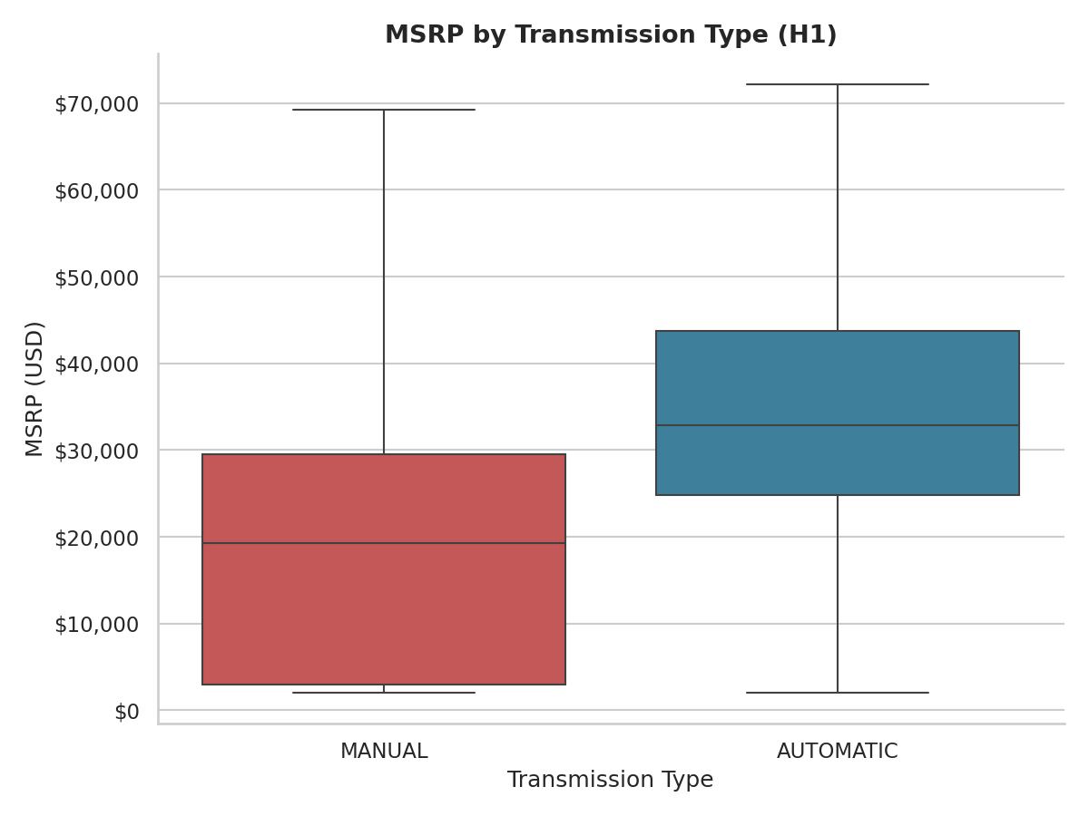
Figure 1: MSRP distribution by transmission type (extreme outliers hidden for readability).
Result: Welch's t-test: t = 14.67, p < 0.0001. The 95% CI for the difference in means (automatic − manual) is $10,310 to $13,490, and Cohen's d = 0.35 (small-to-moderate effect). The Mann-Whitney U test confirms the same conclusion (p < 0.0001), so the result is not an artifact of MSRP's skew. H0 is rejected: automatic-transmission vehicles are priced significantly higher than manual-transmission vehicles, by roughly $11,900 on average.

3.2 Normality Check
Before trusting the t-test and later ANOVA, the normality assumption was inspected visually with Q-Q plots (a formal Shapiro-Wilk test is not meaningful at this sample size, where it rejects normality for almost any real dataset).
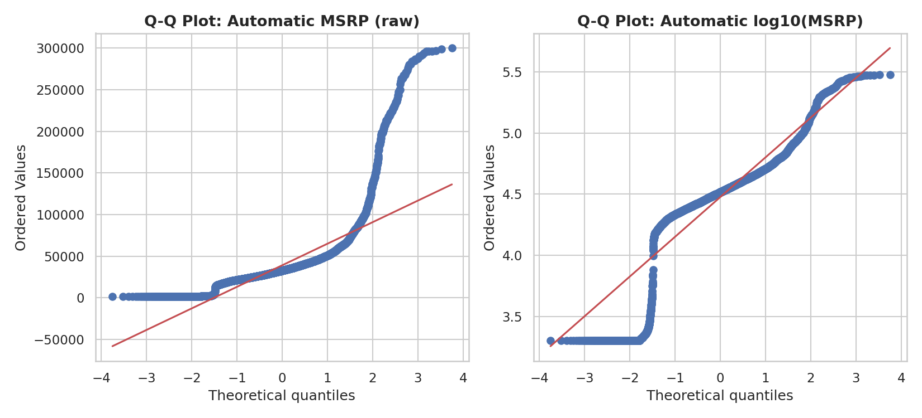
Figure 2: Q-Q plot of MSRP (automatic group) before and after log10 transformation. The raw variable deviates sharply from normality in the upper tail; the log-transformed variable tracks the reference line far more closely.
Interpretation: MSRP is right-skewed, as expected for a price variable. The t-test in H1 remains valid because with n > 7,000 the Central Limit Theorem ensures the sampling distribution of the mean is approximately normal regardless; but for the ANOVA in Section 3.3, which is more sensitive to distributional shape at the individual-observation level, the log-transformed variable was used throughout.

3.3 H2 — Vehicle Size and Price (ANOVA)
groups = [core.loc[core.vehicle_size==g,'log_msrp']
for g in ['Compact','Midsize','Large']]
f_stat, anova_p = stats.f_oneway(*groups)
tukey = stats.tukey_hsd(*groups) # post-hoc pairwise comparisons
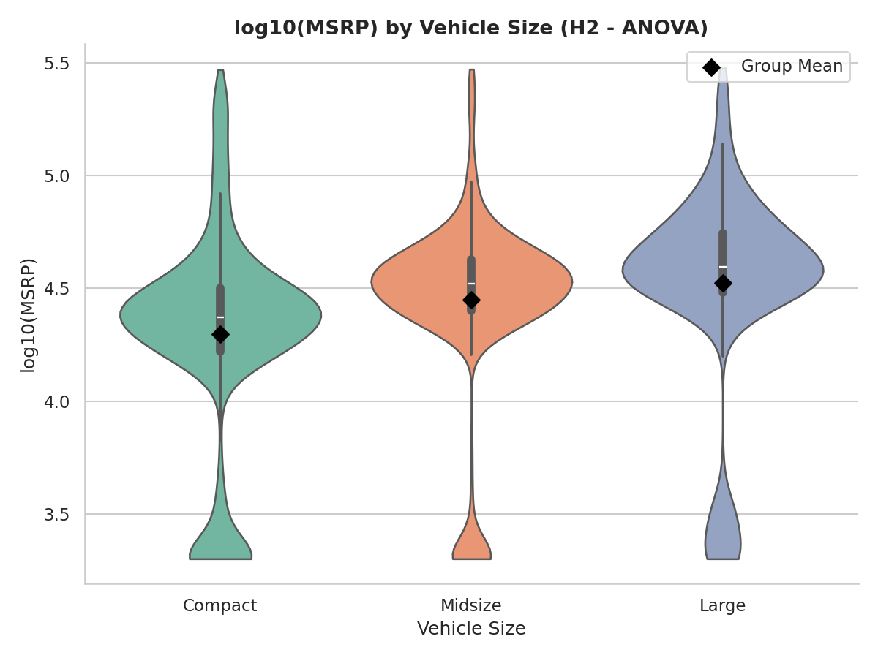
Figure 3: Distribution of log10(MSRP) by vehicle size class, with group means marked (diamonds).
Result: One-way ANOVA: F(2, 11101) = 245.35, p < 0.0001, eta-squared = 0.042 (a small-to-moderate effect — size class explains about 4.2% of the variance in log-price). Tukey's HSD post-hoc test shows all three pairwise comparisons are statistically significant (p < 0.001 for Compact-Midsize, Compact-Large, and Midsize-Large), with price increasing from Compact to Midsize to Large. H0 is rejected: vehicle size class is associated with real, statistically significant price differences.

3.4 H3 — Association Between Vehicle Size and Transmission Type
ct = pd.crosstab(df['vehicle_size'], df['transmission_type'])
chi2, chi_p, dof, expected = stats.chi2_contingency(ct)
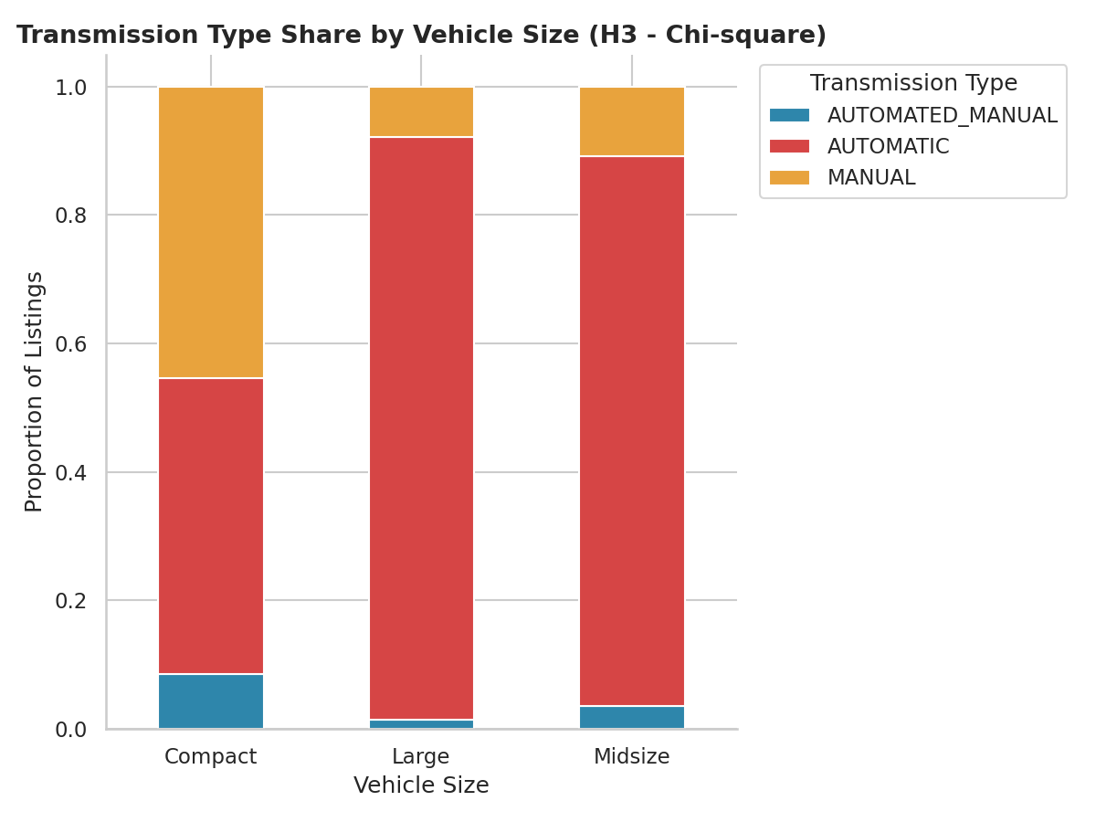
Figure 4: Share of each transmission type within each vehicle size class.
Result: Chi-square test: chi2(4, N = 11,151) = 2277.17, p < 0.0001, Cramer's V = 0.32 (a moderate association). H0 is rejected: vehicle size and transmission type are not independent. Large vehicles are disproportionately automatic (about 91% of Large listings vs. 45% manual share for Compact), consistent with manual transmissions persisting mainly in smaller, sportier or budget-oriented vehicles.

3.5 H4 — Engine Horsepower as a Predictor of Price
lin = stats.linregress(reg_data['engine_hp'], reg_data['log_msrp'])
# slope, intercept, rvalue, pvalue, stderr
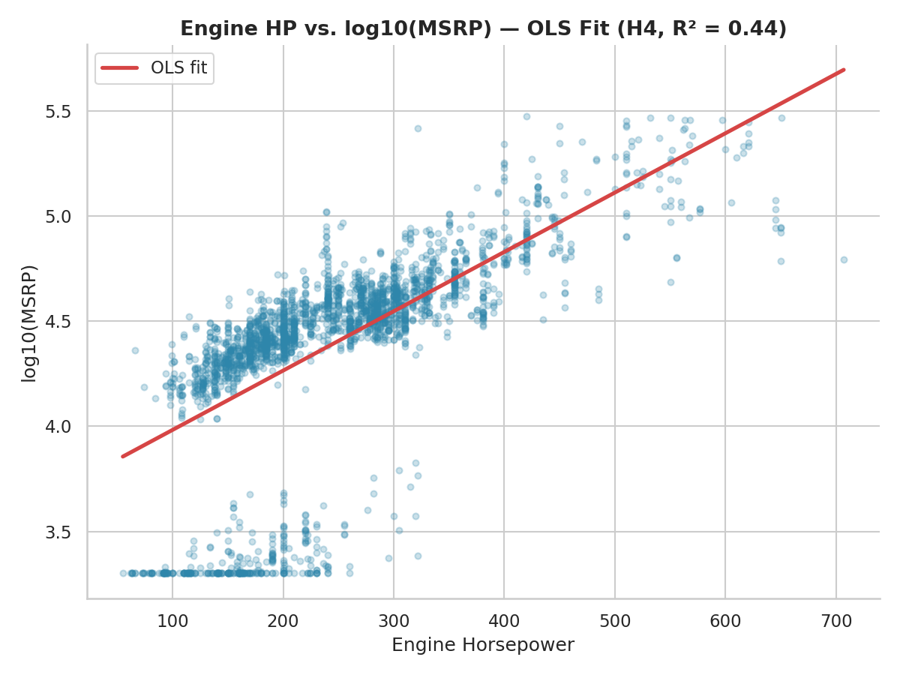
Figure 5: Engine horsepower vs. log10(MSRP), with the fitted OLS regression line.
Result: OLS regression: log10(MSRP) = 3.701 + 0.00282 × Engine HP. The slope is statistically significant (p < 0.0001; 95% CI for the slope: 0.00276 to 0.00288), and R² = 0.44 — horsepower alone explains 44% of the variance in log-price. H0 is rejected: horsepower is a strong, statistically significant linear predictor of price, though the moderate R² confirms that other factors (brand, size, market category) also matter, consistent with Week 2's findings.

4. Discussion and Conclusions
All four null hypotheses were rejected at α = 0.05, but the practical significance varies meaningfully across tests, which matters more than the p-values alone given the large sample size:
- Transmission type (H1): moderate practical effect (~$11,900 average price gap, Cohen's d = 0.35). Relevant for pricing and inventory decisions, but not a dominant driver on its own.
- Vehicle size (H2): statistically significant but a small effect in isolation (eta-squared = 0.042) — size alone is a weak standalone price predictor, though it likely interacts with other features.
- Size x transmission association (H3): a moderate, meaningful relationship (Cramer's V = 0.32) — the two variables are not interchangeable, and models using both should watch for multicollinearity-like redundancy.
- Engine horsepower (H4): by far the strongest relationship tested (R² = 0.44), reinforcing the Week 2 storytelling finding that performance, not size or transmission, is the dominant price driver in this market.
Taken together, these results give a pricing or product team statistically grounded evidence — not just visual impressions — that engine performance is the primary lever on price, transmission type carries a real but secondary premium, and vehicle size class, while significantly different across groups, contributes comparatively little on its own. A natural next step would be a multiple regression combining horsepower, size, and transmission type simultaneously to see how much incremental explanatory power each adds once the others are controlled for.
A limitation worth noting: this dataset is observational, not experimental, so these tests establish statistical association, not causation. Manufacturers do not randomly assign horsepower or transmission type to vehicles — a car's whole design and target market. Any causal claim (e.g. 'adding horsepower would raise price by X') would require a controlled study or a more complete causal model than these bivariate/one-way tests can support.

