TECHNICAL PROJECT DOCUMENTATION
WeatherPulse India
National Weather Big Data Analytics Platform
Team WeatherPulse
Problem Statement ID | 26069
Problem | National Weather Big Data Analytics Platform
MEMBERS
Name | USN
Apoorva Nayak | 4AL23CS021
Radhika Raikar | 4AL23CS115

TABLE OF CONTENTS
1. Introduction 4
1.1 Background 4
1.2 Motivation 4
1.3 Scope of the Document 4
1.4 Organisation of the Document 4
2. Problem Statement and Objectives 5
2.1 Problem Statement 5
2.2 Problem Analysis 5
2.3 Objectives 6
2.4 Requirement Coverage 6
3. Analysis of Existing Systems 7
3.1 Existing Approaches 7
3.2 Gap Analysis 7
3.3 Proposed Approach 7
4. Requirements Analysis 8
4.1 User Roles 8
4.2 Functional Requirements 8
4.3 Non-Functional Requirements 9
4.4 Software and Hardware Requirements 9
5. System Architecture 10
5.1 Architectural Overview 10
5.2 Service Responsibilities 11
5.3 End-to-End Data Flow 11
5.4 Design Decisions 12
6. Technology Stack 13
6.1 Frontend 13
6.2 Backend Microservices 13
6.3 Database and Storage 14
6.4 External APIs and Data Feeds 14
6.5 Deployment Tools 14
7. Data Collection and Ingestion 15
7.1 Sources and Collection Methods 15
7.2 Metadata Captured 15
7.3 Ingestion Steps 16
7.4 Handling Source Failure 16
8. Machine Learning and Verification Module 17
8.1 Purpose 17
8.2 Duplicate Detection 17
8.3 Fake and Misleading Report Detection 17
8.4 Event Classification 18
8.5 Verification Status Lifecycle 18
8.6 Evaluation Approach 18
9. Database Design 19
9.1 Overview 19
9.2 Core Tables 19
9.3 Relationships 19
9.4 Indexing Strategy 19
9.5 Migrations 20
10. API Design 20
10.1 REST Endpoints 20
10.2 Filter Parameters 20
10.3 ML Service Interface 21
10.4 WebSocket Interface 21
10.5 Error Handling 21
11. Dashboard and User Interface Design 21
11.1 Views 21
11.2 Severity Scale 21
11.3 Accessibility and Government Guidelines 22
11.4 Loading and Offline Behaviour 22
12. Admin Panel and Moderation Workflow 22
12.1 Purpose 22
12.2 Features 22
12.3 Moderation Workflow 23
12.4 Feedback to the Model 23
13. Real-Time Alerting 23
13.1 Architecture 23
13.2 Reliability 23
14. Security and Privacy 24
15. Deployment 24
15.1 Containerised Deployment 24
15.2 Deployment Steps 24
15.3 Background Jobs 25
16. Testing Strategy 25
16.1 Levels of Testing 25
16.2 Sample Test Cases 25
17. Scalability and Performance 26
17.1 Current Scalability Features 26
17.2 Planned Scaling Path for Big Data Volumes 26
18. Limitations and Future Scope 26
18.1 Limitations 26
18.2 Future Scope 26
19. Conclusion 27
References 27
Appendix A: Glossary 28
Appendix B: Configuration and Project Layout 28

1. Introduction

1.1 Background
India experiences a wide range of weather events, including monsoon rainfall, flash floods, thunderstorms, heatwaves, dense fog, dust storms and strong winds. Timely and reliable information about these events is essential for disaster management authorities, local administrations, farmers, journalists and ordinary citizens. The India Meteorological Department (IMD) publishes official forecasts and warnings, while a large volume of real-time ground information appears on social media, messaging platforms and citizen reports.
This information is scattered across many places, arrives in different formats, and is frequently unverified. WeatherPulse India is designed to bring these streams together into a single platform that collects, verifies, classifies and visualises weather information for the whole country.

1.2 Motivation
During severe weather, exaggerated or reposted content often spreads faster than official alerts. Decision makers need a single, trustworthy view in which every item can be traced to a real source and carries a clear verification status. The project is motivated by the need to reduce the effect of misinformation and to shorten the time between an event occurring and a verified, geo-located record of it becoming available.

1.3 Scope of the Document
This document describes the design of the WeatherPulse India platform: its requirements, architecture, technology stack, data ingestion pipeline, machine learning verification module, database design, APIs, dashboard, admin panel, security, deployment and testing approach. It is intended for evaluators, developers and future maintainers of the system.

1.4 Organisation of the Document

Chapter | Content
1-3 | Introduction, problem statement, objectives and analysis of existing systems
4 | Functional and non-functional requirements
5-6 | System architecture and technology stack
7-8 | Data ingestion pipeline and machine learning verification
9-10 | Database design and API design
11-13 | Dashboard, admin panel and real-time alerting
14-17 | Security, deployment, testing and scalability
18-19 | Limitations, future scope and conclusion
Table 1.1: Document organisation

2. Problem Statement and Objectives

2.1 Problem Statement

Problem Statement ID 26069 – National Weather Big Data Analytics Platform

The objective is to design and develop a scalable National Weather Big Data Analytics Platform capable of collecting, processing, verifying, storing and visualising real-time weather-related information for India from multiple internet-based sources. These sources may include official meteorological portals, public datasets, open APIs, websites, social media platforms and citizen-generated reports.

The platform should provide a unified mechanism for continuously ingesting weather information such as rainfall, thunderstorms, flooding, heatwaves, fog, dust storms, cyclones and strong winds. It should collect relevant metadata including date and time, city, state, GPS coordinates, source, event category, photographs, videos and textual descriptions and store the information in a centralised and structured database.

Since the volume and frequency of incoming weather information can be large, the system should employ big data processing techniques and open-source technologies to support continuous ingestion, scalable processing, spatial and time-series storage, and real-time analytics. The architecture should be capable of handling information from multiple sources without depending on manually entered or simulated data.

A major requirement of the platform is the verification and classification of incoming information. Machine learning and AI-based techniques should assist in identifying potentially fake, misleading, outdated or unreliable reports. The system should detect duplicate submissions, evaluate source credibility, validate geographical information and compare reports with available meteorological observations. Based on the available evidence, incoming reports should be automatically categorised into predefined weather-event classes.

The final system should provide a reliable and centralised view of weather-related information, helping users and authorities understand emerging weather situations, identify significant events and access verified information through maps, dashboards, alerts and analytical visualisations.

2.2 Problem Analysis
- Fragmentation: weather information is spread across IMD portals, open data portals, social media and messaging forwards.
- Lack of verification: unverified, exaggerated or old content is often presented as current.
- Duplication: the same photo or report is reposted many times, inflating the apparent severity of an event.
- Missing structure: posts rarely carry consistent location, time and category metadata.
- No unified real-time view: users cannot filter by date, place and event type in one trusted place.

2.3 Objectives

No. | Objective
1 | Collect weather data in real time from multiple sources rather than depending on a single provider.
2 | Verify collected data using AI/ML: source credibility, duplicate removal and detection of misleading reports.
3 | Visualise all data on an interactive map and dashboard that can be filtered by date, location and event type.
4 | Ensure every item shown is traceable to a real source, with no synthetic or fabricated values.
5 | Provide an Admin Panel for moderation and verification-status tracking.
6 | Build on open-source tools with a modular design that can scale as sources and users grow.
Table 2.1: Project objectives

2.4 Requirement Coverage

Problem statement requirement | How WeatherPulse India addresses it
Multi-source real-time collection | Open-Meteo, data.gov.in, IMD, BigQuery archive and citizen reports; 10-minute sync and batch workers
Metadata capture | Reports store date/time, city, state, GPS point, media references and event category
Centralised database | PostgreSQL with PostGIS
Fake and duplicate detection | ML service with pHash image hashing, GPS validation and text moderation
Automatic categorisation | Seven event categories assigned by the classification module
Dashboard and Admin Panel | SPA dashboard with filters, map, charts and moderation queue
Real-time visualisation | WebSocket service backed by Redis pub/sub
Table 2.2: Mapping of requirements to solution

3. Analysis of Existing Systems

3.1 Existing Approaches
Several channels currently provide weather information. Each serves a useful purpose, but none combines official data, citizen reports and automated verification in one view.

System | Strengths | Limitations
IMD website and apps | Authoritative forecasts, warnings, cyclone bulletins and radar | Does not merge citizen or social media reports; limited interactive filtering
Commercial weather apps | Convenient forecasts and radar for end users | Forecast-focused; no verification of ground reports; closed data
Social media (hashtags) | Fast, ground-level, often with photos and videos | Unverified, duplicated, inconsistent metadata, misinformation risk
Messaging forwards | Wide reach | No source, no traceability, no location standardisation
Open data portals | Structured, official datasets | Batch oriented; no real-time view or verification workflow
Table 3.1: Comparison of existing information channels

3.2 Gap Analysis
The gap is not a lack of data but a lack of trusted integration. What is missing is a platform that (a) collects from many sources continuously, (b) attaches structured metadata, (c) filters out duplicates and misleading content, (d) marks each record with a verification status, and (e) presents the result in an accessible, filterable dashboard.

3.3 Proposed Approach
WeatherPulse India follows four stages: Collect, Verify, Analyse and Alert. Data is collected from government and open sources and citizen reports; machine learning checks credibility and removes duplicates; events are classified into categories; and verified items are pushed to the live dashboard and map.
Overall Approach
Thus, the proposed approach creates a continuous pipeline:
Collect → Verify → Analyse → Alert & Visualise
This approach enables WeatherPulse India to convert fragmented weather information into structured, verified and actionable data, providing a centralised platform for real-time monitoring, event detection, decision support and historical weather analysis.

4. Requirements Analysis

4.1 User Roles

Role | Description
Citizen / public user | Views the live map, filters events, reads alerts and submits weather reports with location and media
Analyst / researcher | Uses filters and analytics to study trends across time, states and event categories
Administrator / moderator | Authenticates, reviews flagged reports in the moderation queue, verifies or rejects them and tracks status
System services | Ingestion workers, ML service and schedulers that run without user interaction
Table 4.1: User roles

4.2 Functional Requirements

ID | Requirement
FR1 | The system shall ingest weather data from multiple external APIs and open data portals at scheduled intervals.
FR2 | The system shall accept citizen reports containing description, city, state, GPS location, photos or videos and event category.
FR3 | The system shall collect posts tagged #IMD and other relevant weather hashtags, storing date and time with each record.
FR4 | The system shall detect and remove duplicate reports, including reposted images, using perceptual hashing.
FR5 | The system shall score source credibility and flag suspicious or misleading reports.
FR6 | The system shall automatically classify events into rainfall, thunderstorm, flooding, heatwave, fog, dust storm and strong wind.
FR7 | The dashboard shall support filtering by date, event category, location (state, city) and hashtag, and the filters shall work together.
FR8 | The dashboard shall show events on an interactive map with severity colours: green, yellow, orange and red.
FR9 | The Admin Panel shall list flagged reports and allow verify or reject actions, recorded in a moderation log.
FR10 | The system shall track and display verification status for every report.
FR11 | The system shall push verified alerts to connected clients in real time without a page refresh.
FR12 | The system shall display trends over time and across states through charts.
FR13 | The system shall keep every record linked to its source for traceability.
Table 4.2: Functional requirements

4.3 Non-Functional Requirements

Attribute | Requirement
Performance | Filtered queries use spatial and B-tree indexes; API results are paginated; external calls are batched
Scalability | Independent services that can be replicated; Redis for message fan-out; planned streaming path for higher volumes
Availability | Cached data with timestamp is shown when an external source is unreachable; no fabricated fallback data
Accessibility | Conformance to GIGW and WCAG 2.1 AA: contrast, font resizing, keyboard access, bilingual text
Security | JWT-based authentication, restricted CORS, security headers, secrets in environment files
Maintainability | Modular services, versioned SQL migrations, containerised deployment
Data integrity | No synthetic data; source and verification status stored for each record
Table 4.3: Non-functional requirements

4.4 Software and Hardware Requirements

Item | Specification
Runtime | Node.js 18 or later; Python 3.10 or later
Database | PostgreSQL 14 or 18 with PostGIS, uuid-ossp and pgcrypto; Redis 7
Containers | Docker and Docker Compose
Browser | Current versions of Chrome, Firefox, Edge or Safari
Development machine | Multi-core CPU, 8 GB RAM or more, 10 GB free storage
Network | Internet access for Open-Meteo, data.gov.in, IMD and BigQuery
Table 4.4: Software and hardware requirements

5. System Architecture

5.1 Architectural Overview
WeatherPulse India uses a modular microservice architecture designed for scalability, reliability and real-time weather data processing. A static single-page application is served by Nginx, providing users with the web dashboard, maps and analytical visualisations. Three application services handle REST APIs, real-time push communication and machine-learning-based verification. A background worker continuously collects and processes data from government and external weather sources. PostgreSQL with PostGIS provides persistent spatial and time-series storage, while Redis provides caching and publish/subscribe messaging. The services communicate through well-defined interfaces, allowing individual components to be updated or scaled independently. This architecture supports continuous data ingestion, automated verification, real-time alerts and efficient delivery of weather information to users.
Security mechanisms such as authentication, authorization and request validation protect the application and its data. The architecture also supports fault isolation, allowing failures in one service to have minimal impact on other components. Overall, the modular design provides a flexible foundation for future expansion and integration of additional weather data sources. 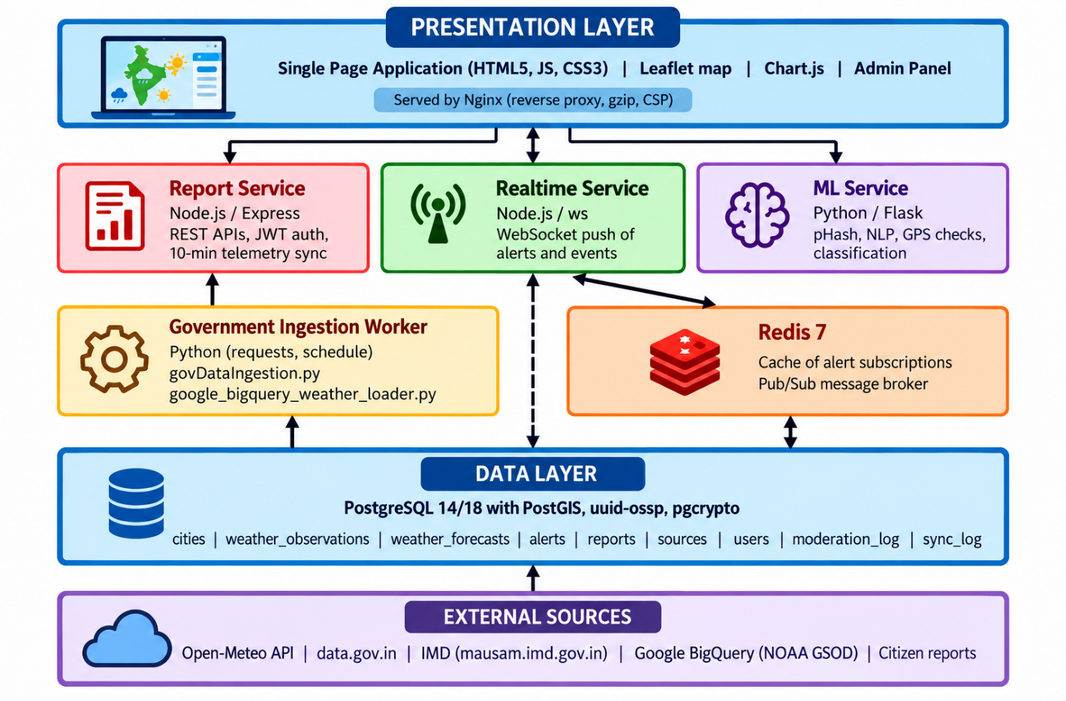

Figure 5.1: Layered architecture of WeatherPulse India

5.2 Service Responsibilities

Component | Technology | Responsibility
Frontend SPA | HTML5, JavaScript, CSS3 | Dashboard, map, charts, filters, admin views; three-state loading and offline cache
Report Service | Node.js, Express | REST endpoints, authentication, static hosting on port 8080, 10-minute telemetry sync
Realtime Service | Node.js, Express, ws | Pushes live squall warnings and sensor events to connected clients
ML Service | Python, Flask, Gunicorn | Duplicate detection, image and text verification, geospatial checks
Ingestion Worker | Python | Scheduled batch pulls from open data portals into PostgreSQL
PostgreSQL + PostGIS | SQL | Primary store with spatial indexing
Redis | In-memory | Alert subscription cache and WebSocket pub/sub
Table 5.1: Components and responsibilities

5.3 End-to-End Data Flow

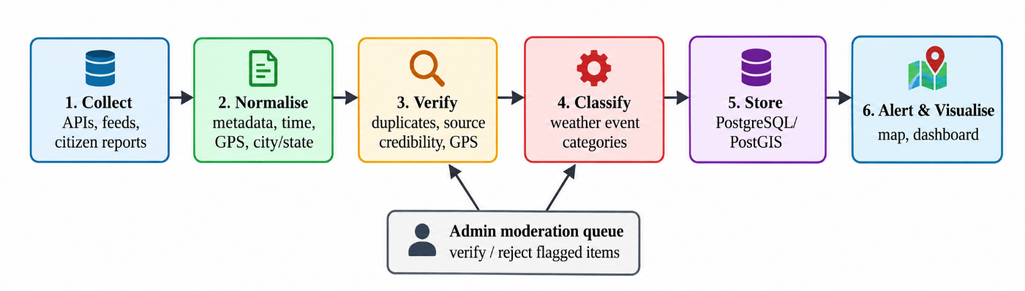
Figure 5.2: End-to-end processing pipeline
- Sources deliver observations, forecasts, warnings and citizen reports to the ingestion layer.
- Records are normalised into a common structure with time, location and source.
- The ML service checks duplicates, credibility and location plausibility, then assigns a category.
- Records are stored in PostgreSQL with a verification status.
- Verified alerts are published through Redis and pushed to clients over WebSockets.
- The dashboard queries the REST API for filtered views and analytics.

5.4 Design Decisions

Separate ML service in Python: Python was selected for machine-learning and verification tasks because it provides strong libraries for text classification, image hashing, data processing and geospatial analysis.

Separate real-time service: A dedicated real-time service handles long-lived WebSocket/SSE connections, ensuring that continuous client connections do not affect the performance of normal REST API requests.

PostGIS for location data: PostgreSQL with PostGIS was selected to efficiently store geographical coordinates, boundaries and spatial objects, enabling fast geometry queries, proximity searches and map-based filtering.

Vanilla JavaScript frontend: A lightweight Vanilla JavaScript frontend with no build step was chosen to reduce application complexity, improve portability and provide a small footprint suitable for accessibility-focused and government hosting environments.

Redis for caching and messaging: Redis is used for frequently accessed data and publish/subscribe communication, reducing database load and supporting fast delivery of real-time updates between services.

PostgreSQL for persistent storage: PostgreSQL provides reliable relational storage for users, weather observations, forecasts, alerts and verification records while supporting transactions and data integrity.

Microservice-based separation: Application responsibilities are divided into independent services so that ingestion, API processing, real-time communication and ML verification can be developed, maintained and scaled separately.

Background worker for data ingestion: Weather data collection is handled asynchronously by background workers so that large or slow external API requests do not block user-facing application services.

API-based communication: REST APIs are used for communication between the frontend and backend services, providing a simple and standard interface for retrieving weather data, alerts, reports and analytical results.

Security and role-based access: Authentication, authorization, input validation and role-based access control are incorporated to protect sensitive operations and provide different permissions for citizens, meteorologists and administrators

6. Technology Stack

6.1 Frontend

Layer | Technology | Purpose
Core | HTML5, Vanilla JavaScript (ES6+) | Single Page Application with client-side hash routing (app.js, index.html)
Styling | Vanilla CSS3 | Custom design system (styles.css) following GIGW and WCAG 2.1 AA: tricolour ribbon, high-contrast themes, font resizing
Typography | Google Fonts | Noto Sans for body and Devanagari Hindi text; Outfit for headings and numeric telemetry
Mapping | Leaflet.js 1.9.4 | Interactive map on OpenStreetMap tiles with severity markers
Charts | Chart.js 4.x | 7-day temperature curves, precipitation bars, historical anomaly graphs
Icons | Lucide Icons | Accessible SVG icons for weather states and controls
State and cache | localStorage and memory | Skeleton loading, live data and cached offline fallback with timestamp
Table 6.1: Frontend technologies

6.2 Backend Microservices

Service | Stack | Details
Report Service | Node.js 18+, Express 4.19, pg 8.11, cors 2.8, jsonwebtoken 9.0, dotenv 16.4 | Connection-pooled PostgreSQL access; endpoints /api/weather/cities, /api/weather/alerts, /api/reports, /api/auth
Realtime Service | Node.js, Express, ws 8.16, ioredis 5.3, pg 8.11 | WebSocket broadcaster subscribed to Redis channels
ML Service | Python 3.10+, Flask 3.0, Gunicorn 21.2, psycopg2-binary 2.9, shapely 2.0, numpy 1.26, Pillow 10.2, imagehash 4.3 | pHash duplicate detection; IndicBERT and multilingual heuristics for text moderation
Ingestion Worker | Python 3.10+, requests, urllib3, schedule, psycopg2 | govDataIngestion.py and google_bigquery_weather_loader.py
Table 6.2: Backend services and libraries

6.3 Database and Storage

Component | Technology | Description
Relational database | PostgreSQL 14 / 18 | Runs locally on port 5433 or in Docker
Spatial extensions | PostGIS, uuid-ossp, pgcrypto | GIST indexes, geometry points and UUID generation
Cache and broker | Redis 7 (alpine) | Alert subscription cache and pub/sub
Migrations | SQL scripts | Run by deploy/postgres/run_migrations.js
Table 6.3: Data layer

6.4 External APIs and Data Feeds

Source | Data and use
Open-Meteo API | Batched multi-location live observations (temperature, humidity, wind speed, precipitation, WMO weather codes) and 7-day forecasts
data.gov.in | Official environmental and agricultural datasets accessed with DATA_GOV_IN_API_KEY
IMD (mausam.imd.gov.in) | Synoptic warnings, squall lines, cyclone bulletins and Doppler radar telemetry
Google BigQuery | NOAA Global Surface Summary of the Day archive for historical anomaly detection
Table 6.4: External data sources

6.5 Deployment Tools

Nginx (nginx:alpine) acts as a reverse proxy and web server with gzip compression and security headers. Docker Compose orchestrates the frontend, report-service, realtime-service, ml-service and Redis. Configuration is managed through .env and .env.example files supporting local host mode. The containerized setup provides consistent development and deployment environments across different systems. Service-to-service communication is isolated through the Docker network, improving reliability and simplifying configuration. Health checks and restart policies can be used to improve service availability during failures. The modular container structure also makes it easier to scale or replace individual services without affecting the entire application.

7. Data Collection and Ingestion

7.1 Sources and Collection Methods

Source | Method | Frequency
Open-Meteo | HTTPS API, batched multi-location request | Every 10 minutes via report-service sync
data.gov.in | Authenticated API requests by ingestion worker | Scheduled batch
IMD | Warning and bulletin endpoints | Scheduled polling
BigQuery NOAA GSOD | Loader script for historical data | Batch / on demand
Citizen reports | Submitted through the platform with media | On submission
Hashtag posts (#IMD and related) | Collected and stored with metadata for verification | Continuous
Table 7.1: Data sources and collection

7.2 Metadata Captured

Field | Description
Date and time | Timestamp of the event and of ingestion
City and state | Resolved against the reference table of Indian capitals and metros
GPS location | Latitude and longitude stored as a PostGIS geometry point
Media | Photos and videos attached to a report, with perceptual hash for images
Event category | Rainfall, thunderstorm, flooding, heatwave, fog, dust storm or strong wind
Source and hashtags | Origin of the record and the hashtags it carried
Verification status | Current state of the record in the verification workflow
Table 7.2: Metadata stored for each record

7.3 Ingestion Steps

Fetch: The worker or service requests data from the source API using stored credentials and the required authentication parameters.

Validate: Responses are checked for valid structure, required fields, data types, timestamps and expected values before being processed.

Normalise: Units, timestamps, location names, coordinates and other fields are converted into a common format so that information from different sources can be compared consistently.

Transform: Source-specific data is mapped to the platform's standard weather schema, including observation details, forecast information, source metadata and geographical information.

Upsert: Records are written to PostgreSQL using appropriate unique keys, avoiding repeated insertion of the same observation while allowing updated values to replace older records.

Log: Every ingestion run is recorded in sync_log with the execution time, source, number of records processed, status and any errors encountered.

Monitor: The ingestion process tracks successful and failed requests so that administrators can identify unavailable sources or abnormal ingestion behaviour.

7.4 Handling Source Failure
If an external source is unavailable, the platform does not show an error or substitute invented values. The last successfully fetched real data is displayed and clearly labelled as cached, together with its original timestamp. This keeps the dashboard usable while preserving the rule that only real data is shown.
The system records the source failure in the ingestion logs and continues processing data from other available sources. Automatic retry mechanisms can be used for temporary network failures, while repeated failures can be flagged for administrator attention. When the source becomes available again, the worker resumes normal ingestion and updates the database with the latest real observations. This approach ensures data transparency, fault tolerance and continuity of service without introducing mock or fabricated weather information.

8. Machine Learning and Verification Module

8.1 Purpose
The ML service turns raw incoming information into verified, classified records. It addresses four needs of the problem statement: duplicate removal, detection of fake or misleading reports, verification of untrusted sources and automatic event categorisation.

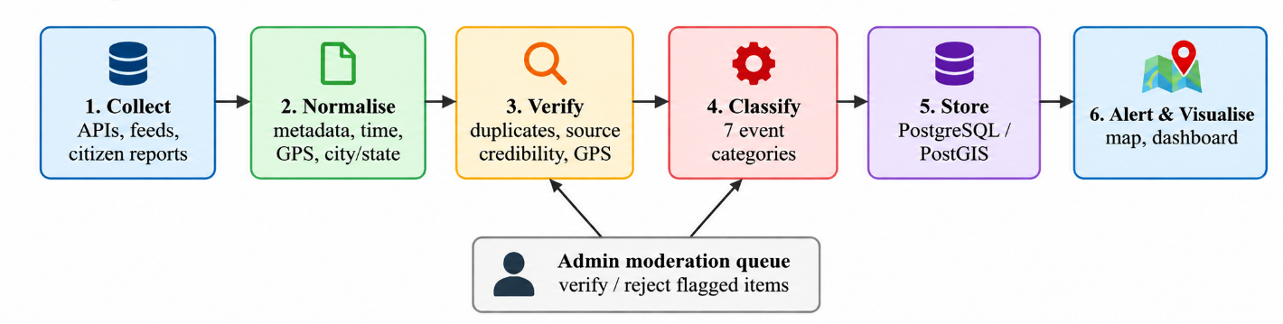
Figure 8.1: Verification and classification stages within the pipeline

8.2 Duplicate Detection
Reposted photos are a common form of misinformation. The service computes a perceptual hash (pHash) of each uploaded image using Pillow and imagehash. Unlike a cryptographic hash, a perceptual hash changes only slightly when an image is resized or compressed, so near-identical images can be found by comparing hash distance. Reports whose image hash is within a set distance of an earlier report are marked as duplicates. Text duplicates are detected by comparing normalised text together with location and time proximity.

8.3 Fake and Misleading Report Detection

Check | Description
Source credibility | Score based on who is posting and how reliable their previous reports have been; official sources rank highest
GPS plausibility | Shapely geometry checks that the reported point lies within India and near the stated city or state
Cross-verification | Comparison with official observations or warnings for the same area and time; contradictions lower confidence
Image reuse | pHash comparison with earlier reports to catch reposted photos
Text moderation | IndicBERT and multilingual heuristics to check that text is a genuine weather description across Indian languages
Table 8.1: Verification checks

8.4 Event Classification
Each accepted record is assigned to one of seven categories, using report text, hashtags and, for observations, measured values and WMO weather codes.

Category | Typical indicators
Rainfall | Rain, drizzle, downpour, precipitation values, rain WMO codes
Thunderstorm | Lightning, thunder, squall, thunderstorm codes
Flooding | Waterlogging, overflowing rivers, submerged roads
Heatwave | High temperature, heat alerts, heatstroke references
Fog | Low visibility, dense fog, fog codes
Dust storm | Dust, sand, reduced visibility from dust
Strong winds | High wind speed, gusts, damage from wind
Table 8.2: Event categories and indicators

8.5 Verification Status Lifecycle
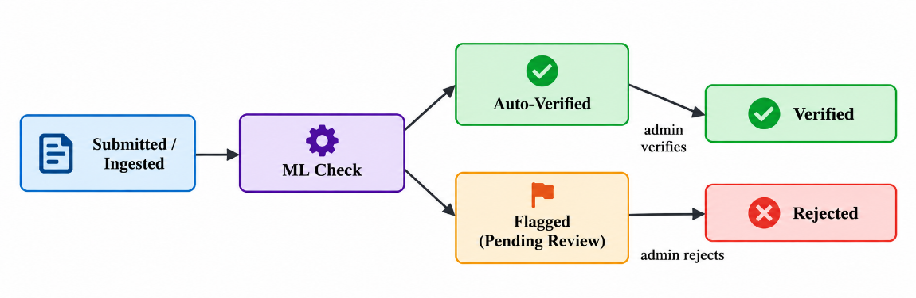
Figure 8.2: Verification status lifecycle
Records that pass all checks with high confidence are auto-verified. Records that fail or are uncertain are flagged and placed in the moderation queue, where an administrator makes the final decision. Every decision is stored in moderation_log.

8.6 Evaluation Approach
The models and rules will be evaluated on labelled samples of reports using precision, recall and F1-score for fake-report detection and per-category classification, and by measuring the duplicate detection rate against known reposted images. Thresholds will be tuned so that uncertain items go to human review rather than being silently accepted or rejected.

9. Database Design

9.1 Overview
PostgreSQL 14/18 with PostGIS is the single source of truth. The schema separates reference data, observations, forecasts, alerts, citizen reports, sources, users and audit information so that every record can be traced back to its origin.

9.2 Core Tables

Table | Purpose and key attributes
cities | Reference list of 37 Indian capitals and metros: name, state, latitude, longitude, geometry point
weather_observations | Live readings per city: timestamp, temperature, humidity, wind speed, precipitation, WMO code, source
weather_forecasts | 7-day forecasts: date, temperature max/min, rain sum, precipitation probability
alerts | Warnings and squall/cyclone events: severity level, category, area, validity period, source
reports | Citizen and social reports: text, timestamp, city, state, GPS point, media reference, image hash, category, verification status
sources | Registry of data origins with type and credibility score
users | Accounts and roles used for authentication and admin access
moderation_log | Audit trail of verify/reject decisions: report, admin, action, time, note
sync_log | Record of each ingestion run with time, source and result
Table 9.1: Core tables

9.3 Relationships
- reports reference sources (origin) and cities (location); moderation_log references reports and users.
- weather_observations, weather_forecasts and alerts reference cities.
- sync_log records which source each run belongs to.

9.4 Indexing Strategy

Index | Use
GIST on geometry columns | Location and bounding-box queries for the map
B-tree on timestamp | Date-wise filtering and time-ordered feeds
B-tree on category and verification status | Event-wise filtering and moderation queue queries
Index on state and city | Location-wise filtering
Index on image hash | Fast duplicate lookup
Table 9.2: Indexing strategy

9.5 Migrations

Migration script | Contents
01-init-postgis.sql | Enables PostGIS, uuid-ossp and pgcrypto; base tables
02-migration-indexes-moderation.sql | Indexes and moderation structures
03-weather-alerts-schema.sql | Weather alerts schema
Table 9.3: SQL migrations run by run_migrations.js

10. API Design

10.1 REST Endpoints
The Report Service exposes a REST interface used by the dashboard and admin panel. Responses are JSON. Protected endpoints require a JSON Web Token.

Endpoint | Method | Description
/api/weather/cities | GET | Current observations and forecasts for reference cities
/api/weather/alerts | GET | Active and recent alerts with severity
/api/reports | GET | List reports with filters
/api/reports | POST | Submit a citizen report with metadata
/api/auth | POST | Authenticate and obtain a JWT
Table 10.1: Primary endpoints

10.2 Filter Parameters

Parameter | Meaning
date_from, date_to | Date-wise filtering of reports and alerts
category | Event-wise filtering (rainfall, thunderstorm, flooding, heatwave, fog, dust storm, strong wind)
state, city | Location-wise filtering
status | Verification status: pending, verified, flagged or rejected
hashtag | Filter by hashtag such as #IMD
Table 10.2: Query parameters (all combinable)

10.3 ML Service Interface
The ML service is called by the report and ingestion services to verify content. It accepts a report (text, image, location) and returns duplicate status, credibility score, predicted category and recommended status. It runs under Gunicorn as a WSGI server for concurrent requests.

10.4 WebSocket Interface
Clients connect to the Realtime Service over WebSocket. The service subscribes to Redis channels and forwards new verified alerts and events to every connected client, so the dashboard updates without refreshing.

10.5 Error Handling
- Standard HTTP status codes: 400 for invalid input, 401 or 403 for authentication and authorisation errors, 404 for missing resources, 500 for server faults.
- Errors return a JSON message without exposing internal details.
- External API failures are handled by returning cached real data with a cached label.

11. Dashboard and User Interface Design

11.1 Views

View | Content
Live map | Leaflet map of India with severity-coloured markers, popups with details and source
Live feed | Latest verified events and alerts, updated in real time
Filter panel | Date range, event category, state, city and hashtag; filters apply together
Analytics | Trends over time and across states: forecast curves, precipitation bars, anomaly graphs
Report submission | Form for citizen reports with location and media
Admin Panel | Moderation queue, verification status tracking and audit history
Table 11.1: Main interface views

11.2 Severity Scale
Map markers follow IMD's own warning scale so that colours carry a familiar meaning.

Colour | Meaning
Green | No warning, normal conditions
Yellow | Watch: be aware
Orange | Alert: be prepared
Red | Warning: take action
Table 11.2: Severity levels
Because colour alone must not carry meaning under WCAG, each level also has a text label and icon.

11.3 Accessibility and Government Guidelines
- Conformance with GIGW and WCAG 2.1 AA.
- High-contrast themes and adjustable font size.
- Bilingual support: Noto Sans renders Devanagari Hindi text.
- Keyboard navigable controls and semantic HTML.
- Tricolour ribbon and official-style layout to convey institutional trust.

11.4 Loading and Offline Behaviour

State | Behaviour
Loading | Skeleton shimmer placeholders while data is requested
Live | Fresh data rendered with charts and markers
Cached offline | Last successful real data from localStorage shown with a clear cached label and timestamp
Table 11.3: Three-state resilience

12. Admin Panel and Moderation Workflow

12.1 Purpose
The Admin Panel gives authorised users control over the quality of published information. It lets moderators review reports that the ML service could not confidently verify, and provides a record of every decision.

12.2 Features
- Secure login using JWT-based authentication.
- Moderation queue listing flagged reports with evidence: text, image, location, credibility score and duplicate matches.
- Verify and reject actions with an optional note.
- Verification status tracking across all reports.
- Filtering of the queue by date, category, location and status.
- Audit history from moderation_log.

12.3 Moderation Workflow

Step | Action
1 | ML service flags a report because of low credibility, GPS mismatch, duplicate image or contradictory official data.
2 | The report appears in the moderation queue with the reasons for flagging.
3 | The administrator reviews the evidence and chooses verify or reject.
4 | The decision updates the report status and is written to moderation_log.
5 | Verified reports are published to the map and pushed to clients in real time; rejected reports are hidden from public views.
Table 12.1: Moderation steps

12.4 Feedback to the Model
Administrator decisions form a labelled dataset. Over time, verified and rejected outcomes can be used to adjust source credibility scores and to retrain or tune the classification and fake-detection components.

13. Real-Time Alerting

13.1 Architecture
Real-time delivery is handled by a dedicated Node.js service using the ws library. When a verified alert or sensor event is created, it is published to a Redis channel. The Realtime Service, subscribed to that channel, broadcasts the message to all connected WebSocket clients.

Step | Description
Event created | Report Service or ingestion worker stores a verified alert
Publish | Message is published on a Redis channel
Broadcast | Realtime Service receives and forwards it to connected clients
Render | Dashboard adds the marker and feed item without a page reload
Table 13.1: Real-time delivery steps

13.2 Reliability
- Redis decouples producers from the broadcaster, so services can restart independently.
- The client reconnects automatically after a dropped connection and reloads recent alerts through REST.
- If the socket is unavailable, the dashboard still works through periodic REST refresh.

14. Security and Privacy

Area | Measure
Authentication | JSON Web Tokens issued after login; expiry enforced
Authorisation | Admin functions restricted by role
Transport and headers | Nginx security headers including Content-Security-Policy and X-Frame-Options
Cross-origin access | cors middleware configured with allowed origins
Secrets | API keys and database credentials kept in .env files, not in source code
Database access | Parameterised queries through the pg driver to prevent SQL injection
Input validation | Validation of report text, coordinates and media before storage
Privacy | Citizen media and identity handled minimally; personal details are not exposed on public views
Auditability | All moderation actions logged with user and time
Table 14.1: Security measures

15. Deployment

15.1 Containerised Deployment

Container | Base | Role
frontend | nginx:alpine | Static files, gzip, security headers, API reverse proxy
report-service | Node.js 18+ | REST APIs and static hosting on port 8080
realtime-service | Node.js | WebSocket broadcaster
ml-service | Python 3.10+ | Flask under Gunicorn
redis | redis:7-alpine | Cache and pub/sub
Table 15.1: Services in docker-compose.yml
PostgreSQL runs locally on port 5433 or as a container. The .env file supports local host mode using localhost or host.docker.internal so containers can reach a database on the host machine.

15.2 Deployment Steps
- Install Docker, PostgreSQL with PostGIS, and copy .env.example to .env with the required keys (for example DATA_GOV_IN_API_KEY).
- Run deploy/postgres/run_migrations.js to create the schema.
- Start the services with docker-compose.
- Open the application on the configured port and verify service health.

15.3 Background Jobs
The report service runs a telemetry synchronisation every 10 minutes. The ingestion worker uses the schedule library for periodic batch loading from open data portals and the BigQuery archive.

16. Testing Strategy

16.1 Levels of Testing

Level | Scope
Unit testing | Filter logic, metadata parsing, hash comparison, category rules
Integration testing | Services with PostgreSQL and Redis; ingestion into the database
API testing | Endpoints, authentication and filter combinations
UI testing | Map, filters, charts, three-state loading and offline behaviour
Accessibility testing | Contrast, font resizing, keyboard navigation against WCAG 2.1 AA
ML evaluation | Precision, recall and F1 on labelled samples; duplicate detection checks
Performance testing | Query time with growing data volume; concurrent WebSocket clients
Table 16.1: Testing levels

16.2 Sample Test Cases

ID | Test | Expected result
T1 | Filter by category = flooding and state = Karnataka | Only matching records appear on map and list
T2 | Upload the same photo twice | Second report marked duplicate
T3 | Report with GPS outside India | Report flagged for review
T4 | Admin rejects a flagged report | Status set to rejected; entry written to moderation_log
T5 | Disconnect from Open-Meteo | Cached data shown with cached label and timestamp
T6 | New verified alert created | Dashboard shows it without page refresh
T7 | Unauthenticated call to an admin endpoint | Request rejected
T8 | Increase font size to maximum | Layout remains usable
Table 16.2: Sample test cases

17. Scalability and Performance

17.1 Current Scalability Features
- Stateless services that can be replicated behind Nginx.
- Connection pooling for PostgreSQL in the report service.
- Batched multi-location requests to Open-Meteo to reduce calls.
- Spatial and attribute indexes for filtered queries.
- Redis caching and pub/sub for fan-out of real-time events.
- Nginx gzip compression to reduce transfer size.

17.2 Planned Scaling Path for Big Data Volumes

Component | Role at higher volume
Apache Kafka | Durable, high-throughput streaming ingestion of social and sensor data
Apache Spark | Distributed processing and large-scale analytics on ingested streams
Elasticsearch | Full-text and faceted search across large report collections
Database scaling | Read replicas, table partitioning by date
Table 17.1: Planned components for larger scale
The current implementation is built with the components listed in Chapter 6. The components above are the planned extension path that the modular architecture is designed to accommodate.

18. Limitations and Future Scope

18.1 Limitations
- Social media access depends on platform APIs and their terms and rate limits.
- Verification models depend on the quality and quantity of labelled examples.
- Reference data covers 37 major cities; finer coverage requires more location data.
- External APIs may change format or availability.

18.2 Future Scope
- Streaming ingestion with Kafka and processing with Spark.
- Elasticsearch for large-scale search.
- Image and video classification of event type using computer vision.
- Mobile application and push or SMS notifications for alert subscribers.
- Integration with state disaster management systems.
- Support for additional regional languages in text moderation.

19. Conclusion
WeatherPulse India addresses a clear gap: weather information about India is abundant but scattered and often unverified. By combining government and open data with citizen reports, and by applying machine learning for duplicate removal, credibility scoring and event classification, the platform provides a single, source-traceable, real-time view of weather events.
The modular design, using an Express-based report service, a WebSocket real-time service, a Flask ML service and a PostgreSQL/PostGIS database, meets the requirements of the problem statement: real-time collection, centralised storage with rich metadata, AI-assisted verification, and a filterable dashboard with an Admin Panel. The commitment that every displayed value comes from a real, traceable source is central to the design and to the trust the platform aims to earn.

References

India Meteorological Department (IMD), Mausam Portal, official weather information and meteorological services, mausam.imd.gov.in.

Open-Meteo, Free Weather API, weather forecasts, historical weather data and meteorological models, open-meteo.com.

Open Government Data Platform India, data.gov.in, Government of India open datasets and APIs.

Leaflet, Open-Source JavaScript Library for Interactive Maps, leafletjs.com.

Chart.js, JavaScript charting library documentation, chartjs.org.

PostGIS, Spatial and Geographic Database Extension for PostgreSQL, spatial data storage and query documentation, postgis.net.

PostgreSQL, Official Documentation, relational database management, SQL, indexing and transaction management.

Node.js, Official Documentation, asynchronous server-side JavaScript runtime and application development.

Docker, Official Documentation, containerisation and application deployment.

Guidelines for Indian Government Websites (GIGW), Government of India, guidelines for usability, accessibility, security and quality of government websites.

Fast2SMS Documentation, SMS delivery services and API integration for notification systems.

SendGrid Documentation, email delivery and transactional email services.

Appendix A: Glossary

Term | Meaning
IMD | India Meteorological Department
GIGW | Guidelines for Indian Government Websites
WCAG | Web Content Accessibility Guidelines
SPA | Single Page Application
PostGIS | Spatial extension for PostgreSQL
GIST | Generalised Search Tree, an index type used for spatial data
pHash | Perceptual hash used to compare visual similarity of images
JWT | JSON Web Token used for authentication
WMO code | World Meteorological Organization weather condition code
GSOD | Global Surface Summary of the Day
Pub/Sub | Publish/subscribe messaging pattern
Table A.1: Glossary

Appendix B: Configuration and Project Layout

Item | Description
services/report-service | Node.js REST and static hosting service
services/realtime-service | Node.js WebSocket and Redis service
services/ml-service | Python Flask verification service
govDataIngestion.py | Government open data ingestion worker
google_bigquery_weather_loader.py | BigQuery historical weather loader
deploy/postgres/run_migrations.js | Executes SQL migrations
deploy/docker/frontend/ | Nginx image and configuration
docker-compose.yml | Multi-service orchestration
.env / .env.example | Configuration such as DATA_GOV_IN_API_KEY and database settings
Table B.1: Key project files

