**Daily Task**

1. Create a database Sample Database: Library

2. Create tables

● Tables:

○ Books (BookID, Title, Author, Genre, PublishedYear)

○ Members (MemberID, FirstName, LastName, MembershipDate)

○ BorrowingRecords (RecordID, BookID, MemberID, BorrowDate, ReturnDate) - set BookID, MemberID as foreign keys

● Alter table by adding phone number AFTER LAST NAME AND email after phone number

**Since there already existed database named Library and tables books,members and borrowingrecords we alter so it become as shown above structure**

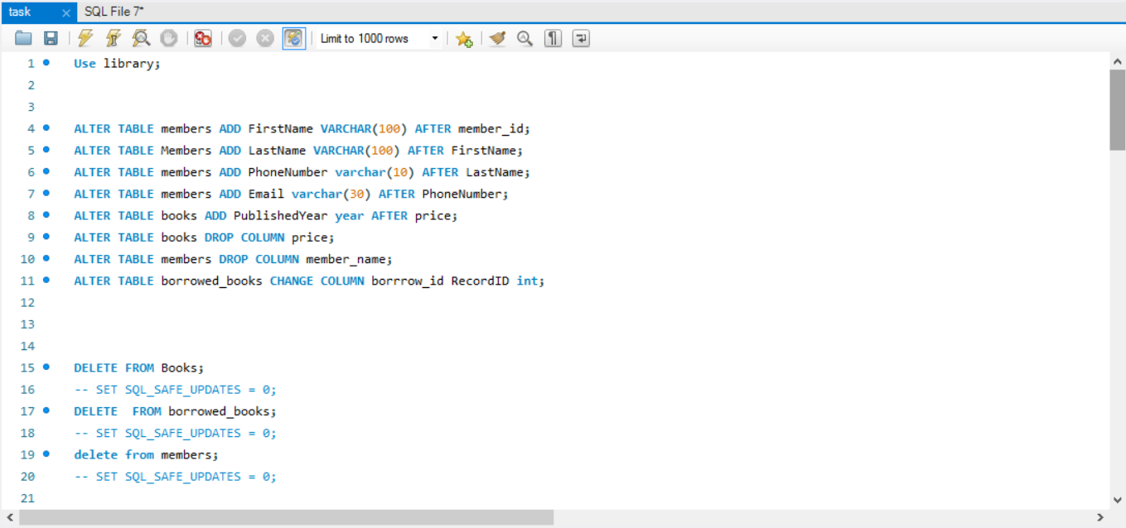

**3. Inserting Data**

**Inserting into table books**

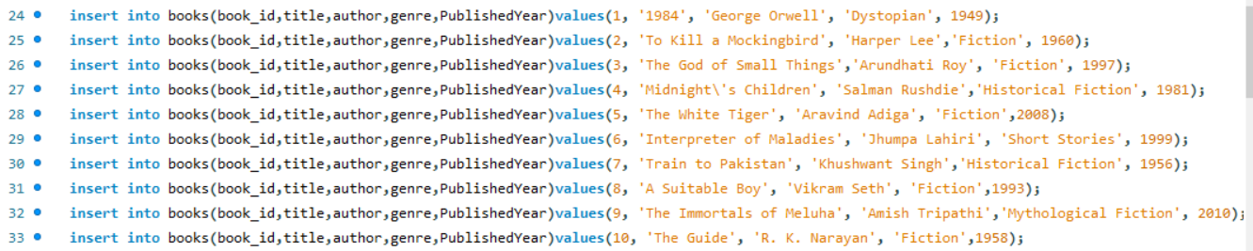

**Inserting into table members**

**Note: before entering values into table members we alter the table as it had columns phonenumber and email so as to form in structure as given in insert**

**question**

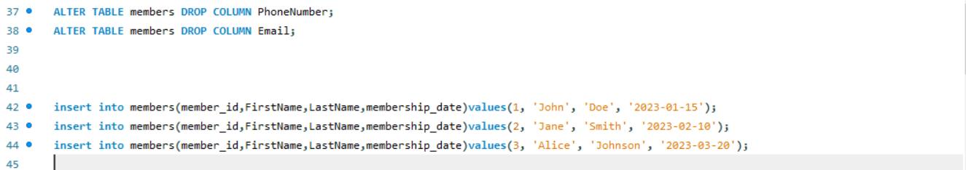

**Inserting into table borrowing records**

**Note:In previous daily activity since the name of table was borrowed_books first we enter values to table and then rename table name**

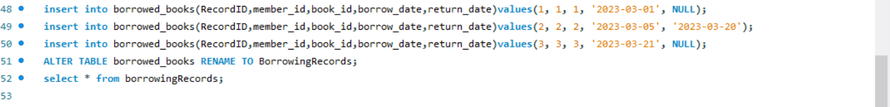

4. READ Operation

○ Using SELECT to retrieve data

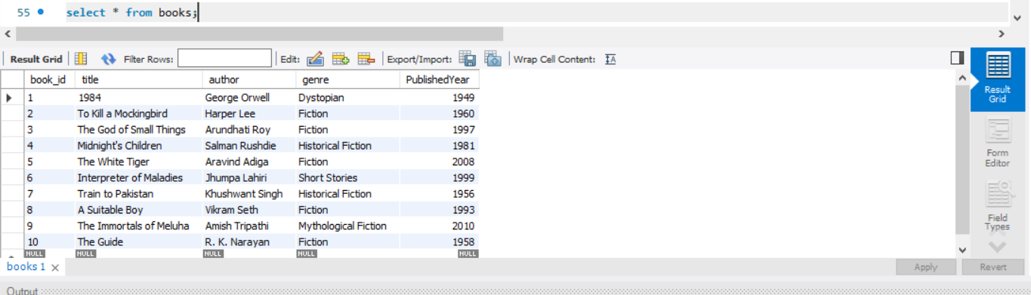

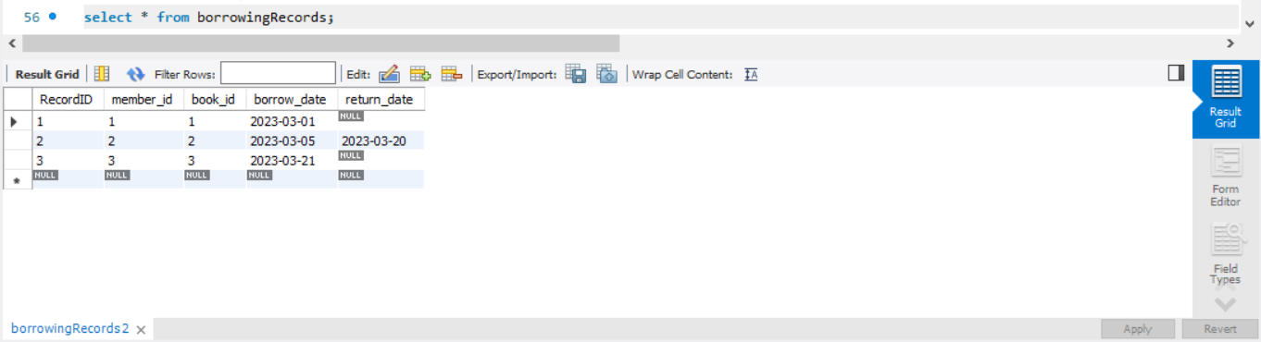

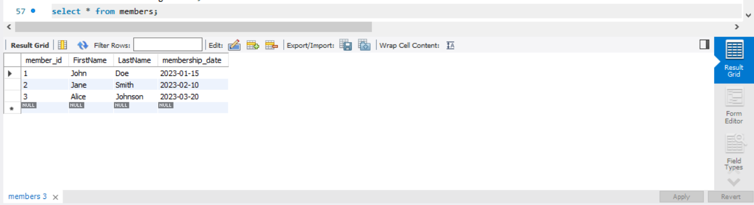

○ Select All Data

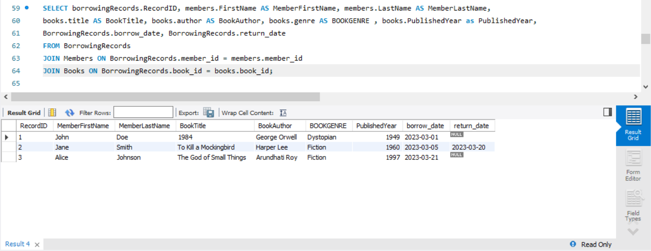

○ Select books and author from books

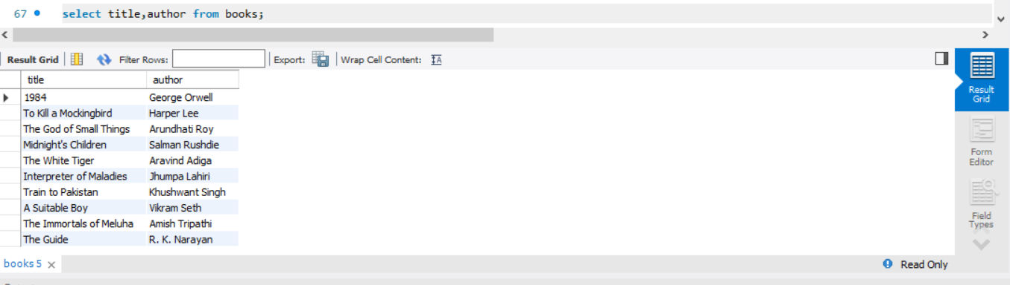

○ Select all details of books with genre 'Dystopian'

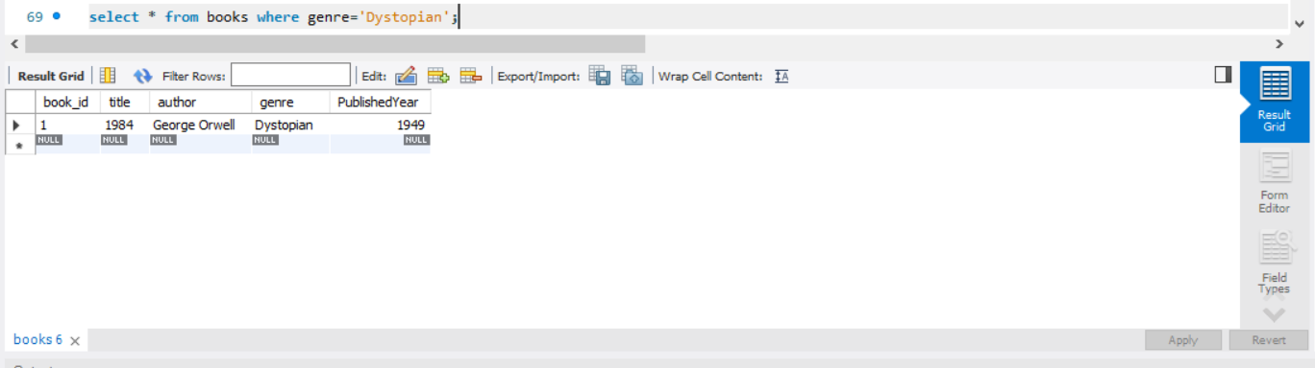

Display the details of all books in descending order of published year

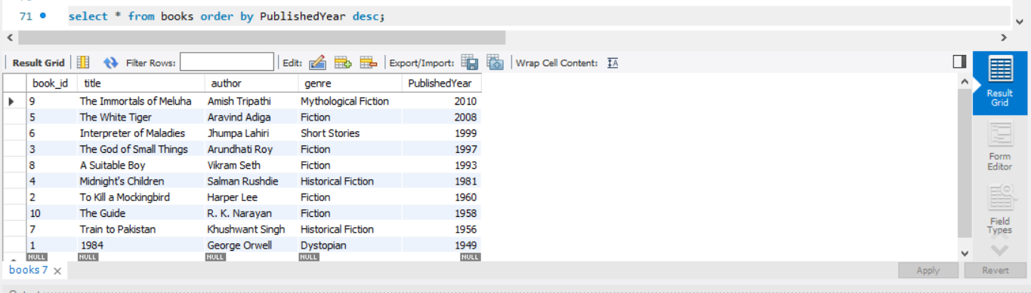

Display different genres from books

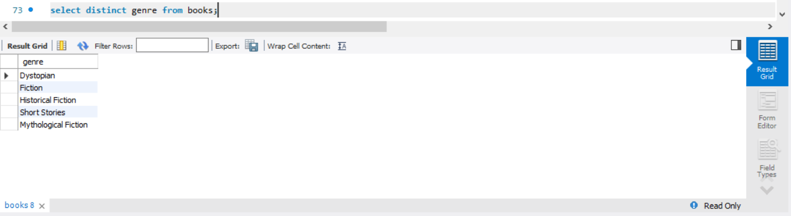

○ Count no of books in each genre

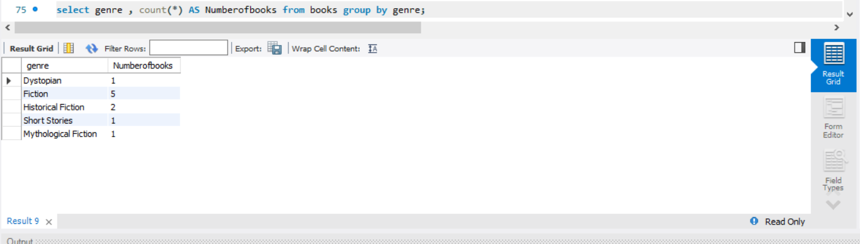

○ How many book titles are there in each genre that have more than three titles?

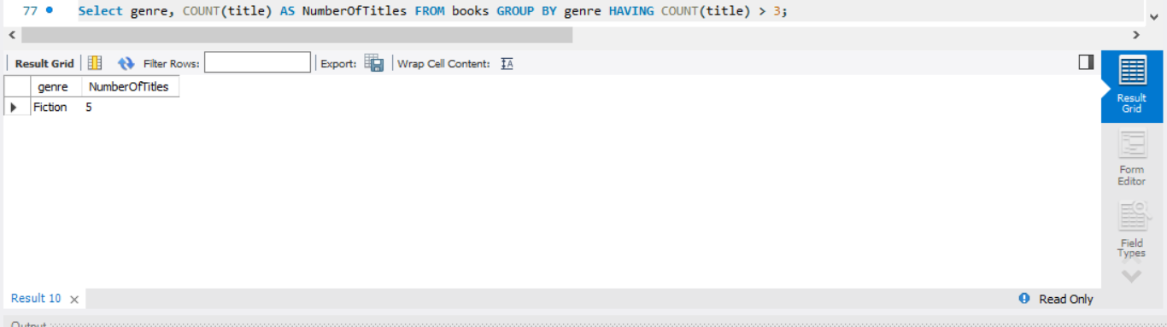

○ How many books are there in each genre, but only consider genres with more than three titles?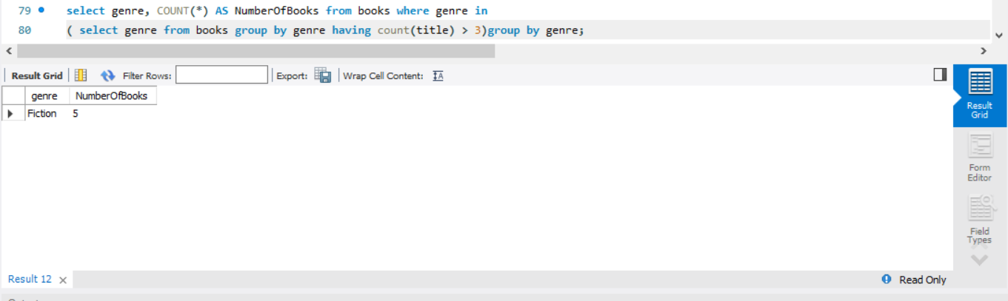

○ View borrowing records sorted by borrow date

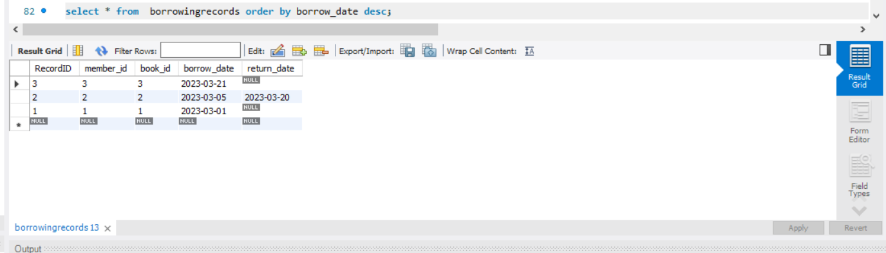

○ Count number of books borrowed by each member

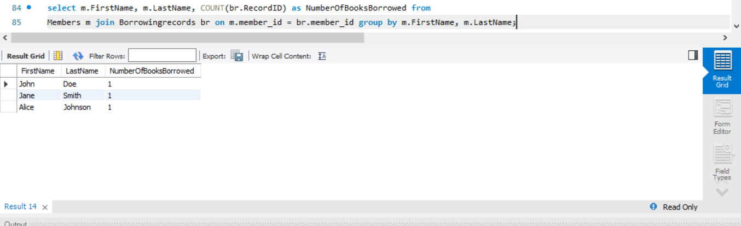

5. Using LIMIT Clause

○ Show 5 records from Books

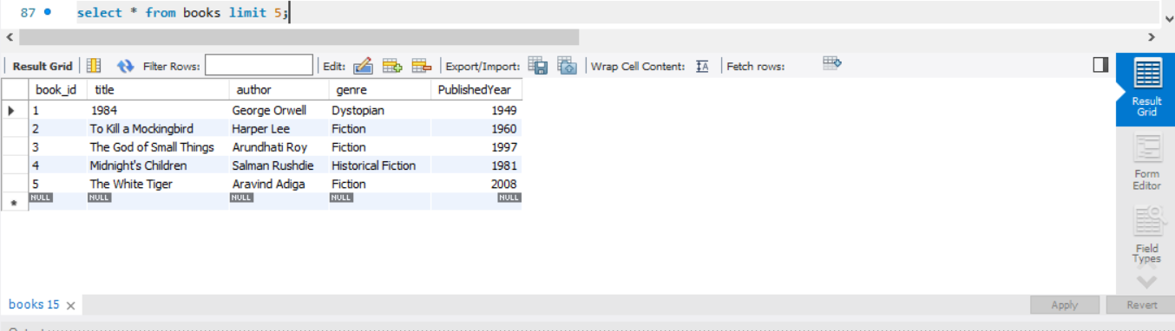

○ Retrieve the first two records from the Books table where the genre is 'Fiction'?

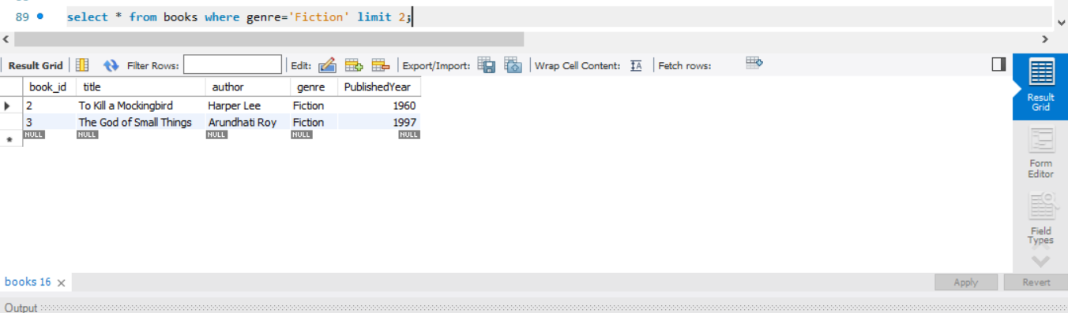

6. Updating Records

○ update the genre of the book titled '1984' to 'Classic' in the Books table?

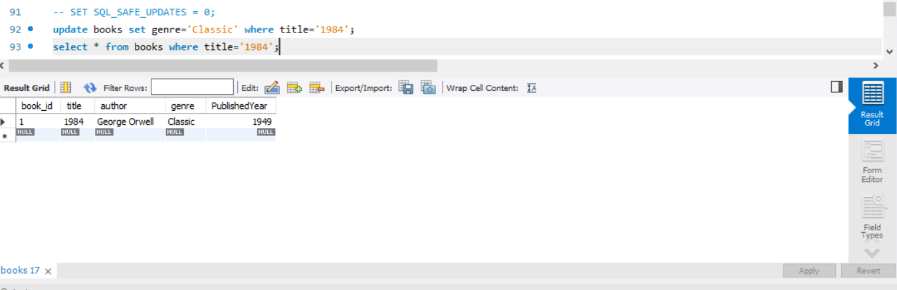

7. DELETE Operation

○ delete records from the Books table where the published year is before 1950?

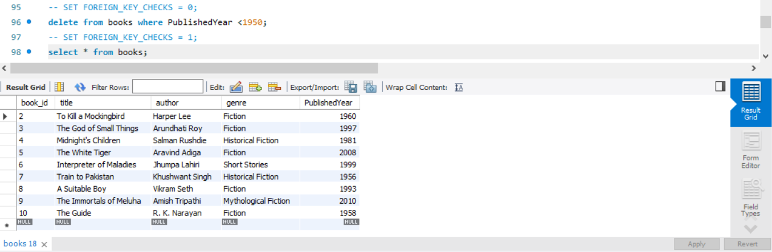

8. JOIN

● Retrieve the first name and last name of members along with the title of the books they borrowed and the borrow date?

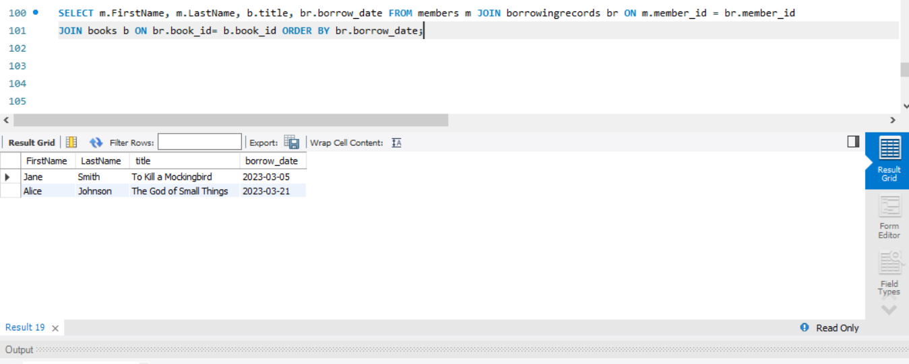

● Retrieve the first name and last name of members along with the title of the books they borrowed (if any) and the borrow date (if any), including members who haven't borrowed any books?

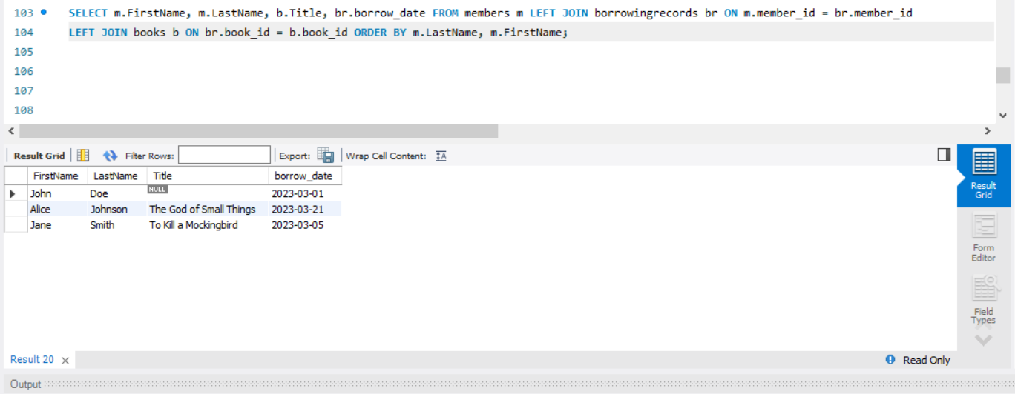

Write Queries for the following:

1. Write a query to retrieve the list of books that have never been borrowed

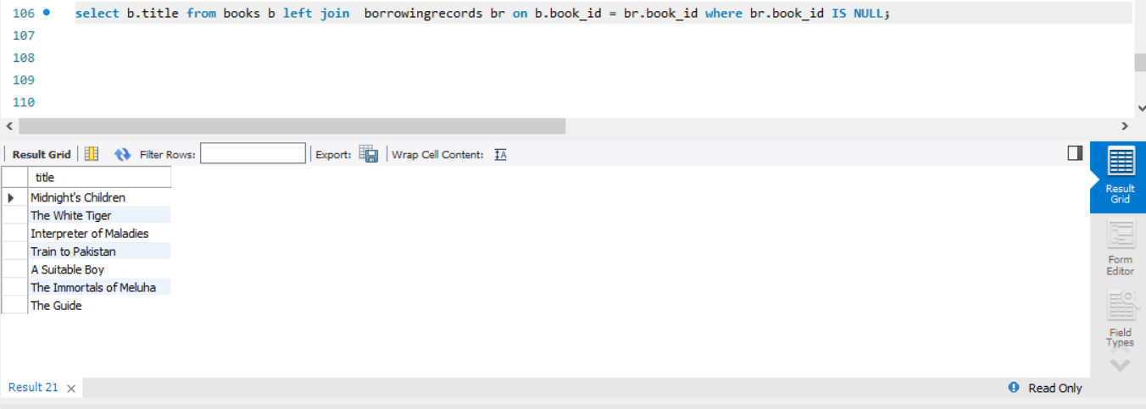

2.Write a query to retrieve all members who have borrowed more than one book.

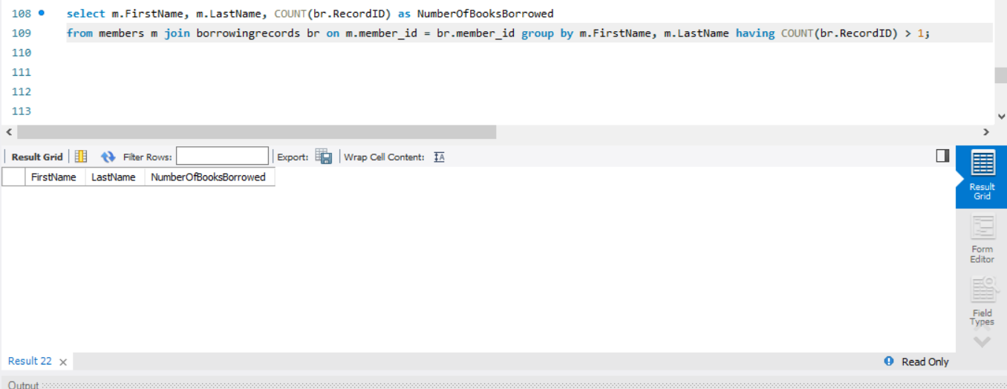

3.Write a query to find the most borrowed book and the number of times it has been borrowed

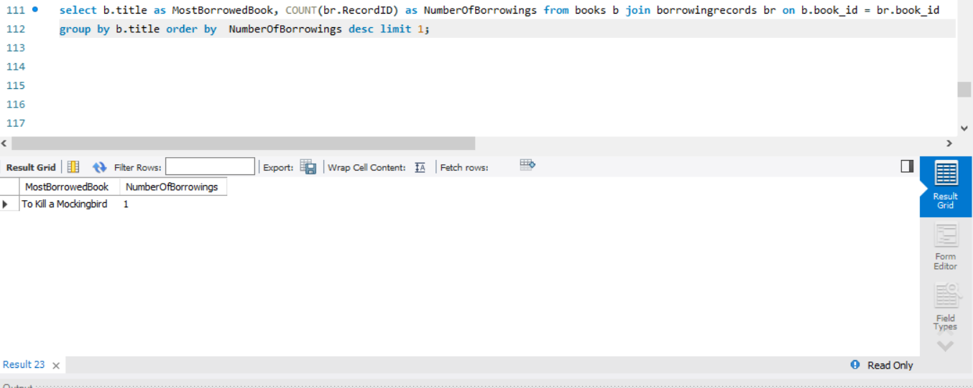

4. Write a query to retrieve all borrowing records along with member details and book details, sorted by borrowing date in descending order.

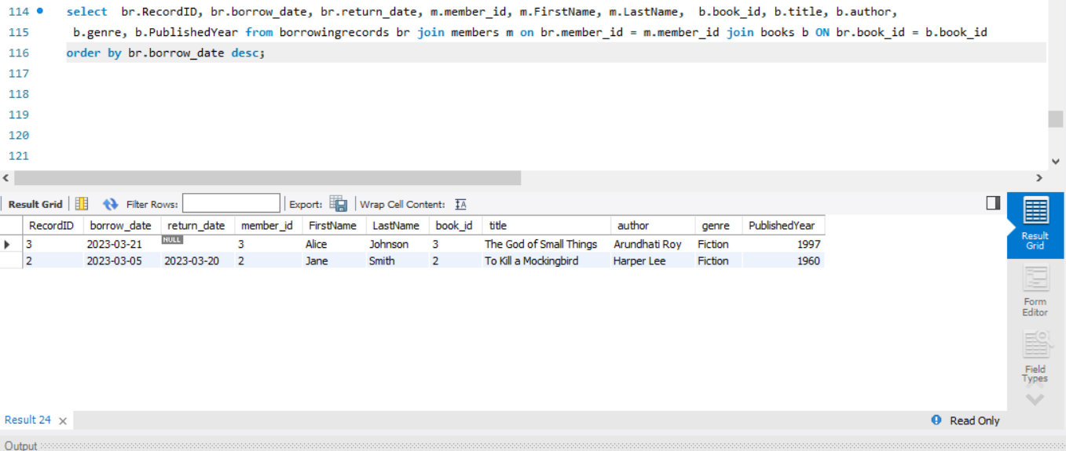

5. List Books by Genre with Total Borrowings

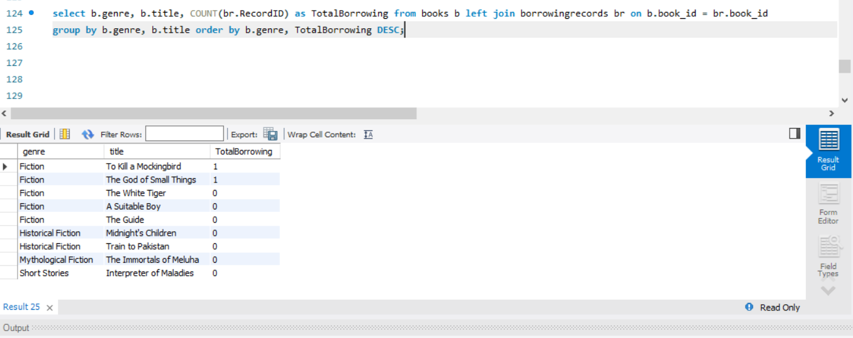

6. Count Number of Borrowings per Member.

