Experiment No.: 11

Title: To develop a dynamic countdown timer or class scheduler using JavaScript timers (setTimeout() and setInterval()) and ES6 modules (import and export) to provide real-time updates and a responsive user interface.
Software/Tools Required: HTML,CSS, JavaScript, jOuery VS Code.
Theory: JavaScript provides timer functions and ES6 modules that help developers create dynamic, organized, and interactive web applications.
1. setTimeout(): Executes a function once after a specified delay. It can be used to display notifications or perform an action after a countdown finishes.
2. setInterval(): Executes a function repeatedly at a specified time interval. It is useful for updating countdown timers, displaying the current time, and refreshing class schedules.
3. ES6 Modules (import and export): Modules allow JavaScript code to be divided into separate files for better organization and reusability. The export keyword makes functions or variables available to other files, while import allows them to be used in another module.
4.Real-Time Updates: Timer functions enable the application to update countdown values or class information automatically without requiring the user to refresh the page.
5.Responsive Layout: HTML and CSS media queries help the application adapt to different screen sizes, including desktops, tablets, and mobile devices.
By combining these features, a dynamic countdown timer or class scheduler can be developed with automatic updates, modular code, and a responsive interface.

Output:

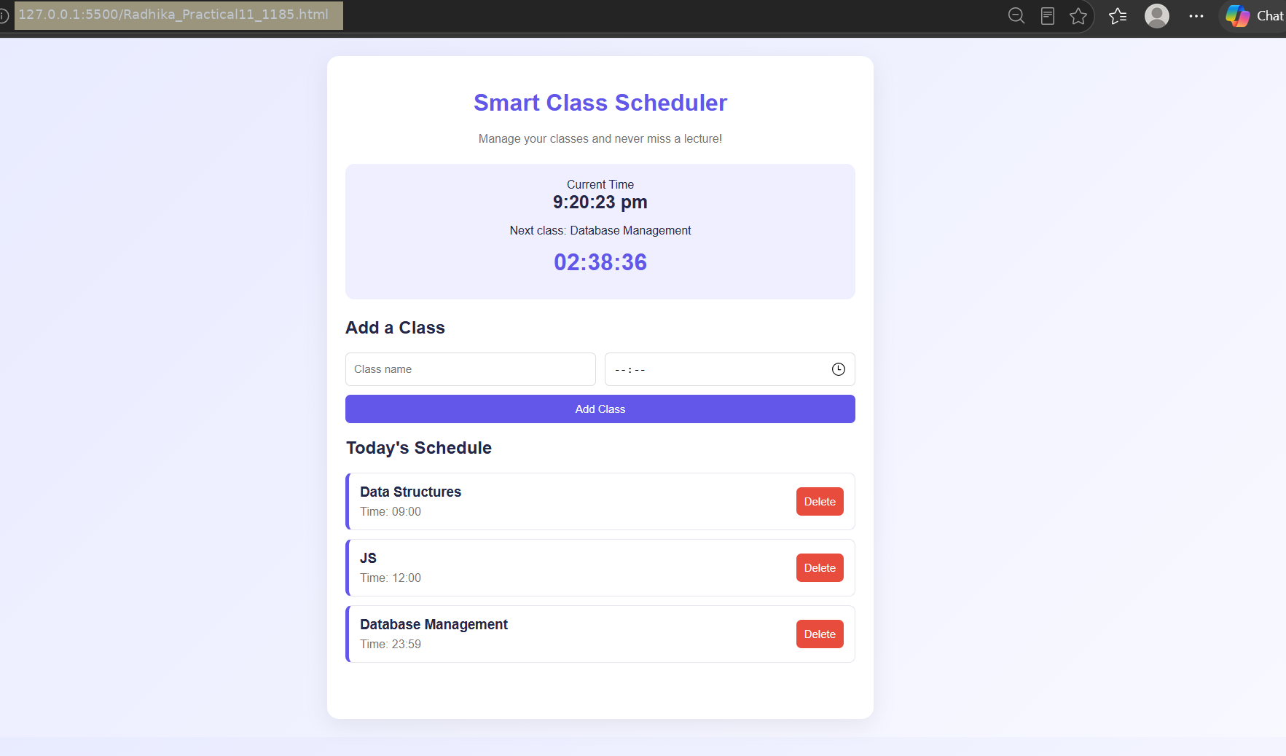
Result/Conclusion: A dynamic countdown timer or class scheduler was developed using JavaScript timer functions (setTimeout() and setInterval()) and ES6 modules (import and export). The application provides real-time updates, executes scheduled actions, organizes code into reusable modules, and adapts to different screen sizes through responsive design.

