**Fit, Fat, Goals, Lazy, Metabolism, Genes, Etc.**

**What?, Why?, How?**

Everyone wants to have a healthy lifestyle; the typical questions are Is what I'm doing today, good for my tomorrow?, Why do I need it?, and eventually,  Makes sense, but how do I/we get there?. I would like to skip past the first two questions above, as your interest in this document already indicates that you're past them and are asking the third question.

So How do we get there? ... By eating healthy?, by working out?, by having a good social life?, by having peace of mind?, or in general, by just being happy? Each and every one of the above is worth a discussion on its own. However, leaving the abstract and intangibles aside, I want to focus on how we can leverage technology to achieve this goal. Let's see how one can use some of the tools available on various platforms today, to keep us motivated towards our fitness goals.

Eating healthy alone can give you good results, but eating healthy coupled with a 30-min workout multiplies the result many times over, both physically and mentally. But what workouts? Where can I find them? In what order do I do these workouts? Is this to be done hourly, daily, or just one-time? Several fitness-centered organizations have made available various tools on the web, and on our phones, that can assist us with these questions.

I want to talk about an app that I've found very helpful, called [MyFitnessPal](https://www.myfitnesspal.com/). I use it to count calories, log workouts, track my weight, etc. Among these, personally, I emphasize on counting calories. I know most people don't count calories, or don't like counting calories, but, personally, it has helped me monitor what and how much I eat. Tracking these parameters does not have to be accurate. However, knowing and tracking *what* you eat, *when* or *how often* you eat, and*how much* you eat, has influenced me subconsciously in my decision to pick up my next snack.

**Benefits**

There are a myriad of such applications that allow us to invest unbelievably small amount of time regularly, and reap much larger benefits in return. Let's look at some of these benefits:

1. It enables us to set and track our goals.
2. It allows us to track of our activity level, and presents us with pre-configured programs that come with guidelines on how to achieve them.
3. We'll be able to see our progress LIVE right on the app.
4. The more we learn about our habits, the easier it is to be in better control of them.
5. We can customize our workout routine to our convenience on these apps.
6. We no longer have to invest in personal trainers; we have one in our pocket all the time.
7. There are plenty of workouts available *for free*.
8. It motivates us to do a quick 15-min workout at home.

**To get you started**

Below is a list of applications that I've found helpful in tracking my health and fitness, and I hope it can help you as well. However, please note that there are several other apps available on web, iStore, Play Store, and other platforms, so please explore them so as to find the one that best fits your needs.

1. [MyFitnessPal](https://www.myfitnesspal.com/):
   * Workout tracker - helps track your workout, track your heartrate, etc.
   * Meal tracker - tracks the nutritional content of the food you eat, barcode-scans the nutrition program from the packaging to suggest intake given the user-selected program
   * Logs the water intake
   * Provides a weight tracker
   * Option to synchronize with other apps
   * Blogs on healthy eating, recipes, success stories that can motivate you

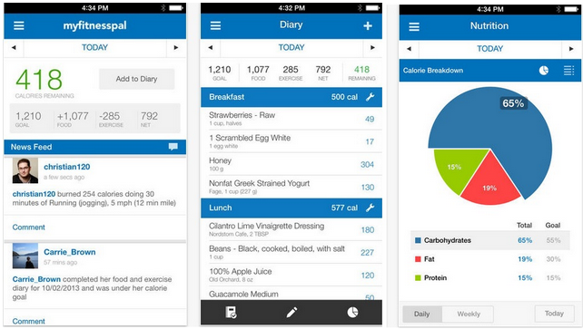

1. [MapMyFitness](http://www.mapmyfitness.com/):

* Built in GPS-technology for runners
* Import workouts from over 400 compatible devices, including Jawbone, Garmin, Polar and Fitbit
* Get credit for all the calories you burn by linking your MyFitnessPal account with MapMyFitness

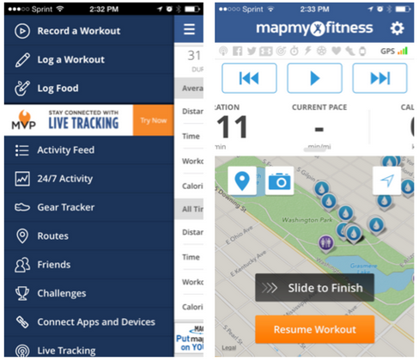

1. [Runtastic](https://www.runtastic.com/):

* Array of health and fitness products - These apps are specifically designed to cater to a specific activity.
  + - Eg: Running, Mountain biking, Abs, Legs, Sit-ups and plenty more.
* Apps can be synced with [MyFitnessPal](https://www.myfitnesspal.com/)

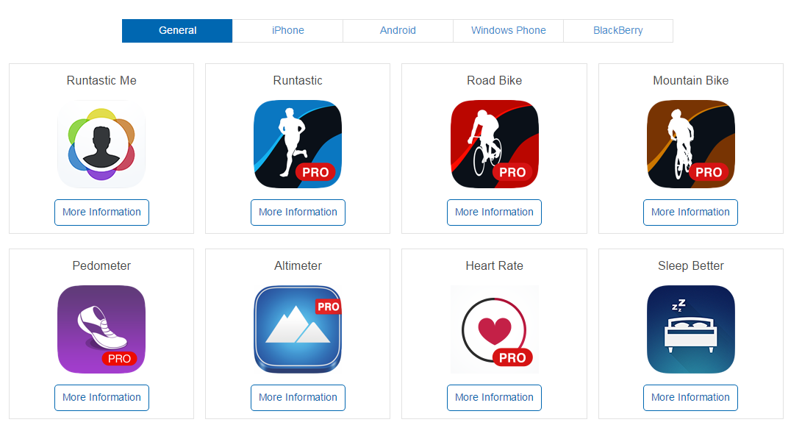

### In Conclusion

The above is just a something to help you to get you started. If you are a non-believer, I'd still hope that you take a leap of faith. There are so many sources of information online where you can find all sorts of applications and gears to help meet your needs.

After a long day at work, most of us just want to get home and relax. Some of us come home to busier jobs. However, I really hope that this article can inspire you to invest in yourself by spending as little as 20-mins a day working out and staying healthy. I would totally understand if you think it's hard. You could start with smaller steps; perhaps start with one day a week and work from there. The satisfaction of feeling better and healthier on the other side is totally worth it.

Why put off feeling better?